**Department of Electrical Engineering and   
Computer Science**

**Faculty Member:** Dr. Rehan Ahmed  **Dated:** 14/05/2023

**Semester:**  6th **Section:** BEE 12C

**EE-421:** **Digital System Design**

**Lab 13: Open Ended Lab**

Group Members

|  |  |  |  |  |  |  |
| --- | --- | --- | --- | --- | --- | --- |
|  |  | **PLO4-CLO3** | | **PLO5 -CLO4** | **PLO8 -CLO5** | **PLO9 -CLO6** |
| **Name** | **Reg. No** | **Viva / Quiz / Lab Performance** | **Analysis of data in Lab Report** | **Modern Tool Usage** | **Ethics and Safety** | **Individual and Teamwork** |
|  |  | **5 Marks** | **5 Marks** | **5 Marks** | **5 Marks** | **5 Marks** |
| Danial Ahmad | 331388 |  |  |  |  |  |
| Muhammad Umer | 345834 |  |  |  |  |  |
| Tariq Umar | 334943 |  |  |  |  |  |

**Table of Contents**

2 Open Ended Lab 3

2.1 Objectives 3

2.2 Introduction 3

2.3 Software 3

3 Lab Procedure 4

3.1 Task 1 4

3.2 Task 2 6

4 Conclusion 9

# Open Ended Lab

## Objectives

This is an exercise in using algorithmic state machine charts to implement algorithms as hardware circuits.

## Introduction

Algorithmic state machine charts (ASM charts) are graphical notations for representing algorithms. ASM charts are like flowcharts, but they have several advantages for representing algorithms in hardware. First, ASM charts can be used to represent both sequential and combinational logic. Second, ASM charts can be used to represent complex algorithms that would be difficult to represent with a flowchart. Third, ASM charts can be used to generate VHDL code for the implemented circuits.

In this lab, you will learn how to use ASM charts to represent algorithms. You will then implement several algorithms as hardware circuits using ASM charts. Finally, you will analyze the performance of the implemented circuits

## Software

Quartus Prime is a comprehensive design software developed by Intel Corporation for designing digital circuits using Field-Programmable Gate Arrays (FPGAs). It is a leading software platform in the field of digital design, offering a range of advanced tools and features that enable users to easily create, debug, and verify complex digital circuits. With Quartus Prime, users can benefit from a streamlined design flow that facilitates the creation of digital circuits from concept to implementation. It provides an intuitive graphical user interface that allows users to easily design, test, and debug their circuits. Additionally, Quartus Prime supports a variety of popular programming languages, making it a versatile platform for digital designers of all levels.

# Lab Procedure

## Task 1

Write Verilog code to implement the bit-counting circuit using the ASM chart shown in Figure 1 on a DE-series board. Include in your Verilog code the data path components needed and make an FSM for the control circuit. The inputs to your circuit should consist of an 8-bit input connected to slide switches SW7−0, a synchronous reset connected to KEY0, and a start signal (s) connected to switch SW9. Use the 50 MHz clock signal provided on the board as the clock input for your circuit. Be sure to synchronize the s signal to the clock. Display the number of 1s counted in the input data on the 7-segment display HEX0, and signal that the algorithm is finished by lighting up LEDR9.

module *task_1* (

*input* [7:0] data_in,

*input* clk,

*input* reset,

*input* s,

*output* [6:0] hex_out,

*output* led_out

);

    // Define datapath components

    reg [7:0] A;

    reg [3:0] result;

    reg done;

    // Define control circuit states

    parameter S1 = 2'b00;

    parameter S2 = 2'b01;

    parameter S3 = 2'b10;

    reg [1:0] state;

    // Define control circuit outputs

    reg load_A;

    reg shift_A;

    reg increment_result;

    reg next_state;

    // Synchronize start signal to the clock

    reg s_sync;

    always @(posedge clk) begin

        if (reset) begin

            s_sync <= 1'b0;

        end else begin

            s_sync <= s;

        end

    end

    // Control circuit

    always @(*) begin

        case (state)

            S1: begin

                // Load data into A and transition to S2 when s is asserted

                load_A = s_sync;

                shift_A = 1'b0;

                increment_result = 1'b0;

                next_state = s_sync ? S2 : S1;

            end

            S2: begin

                // Increment result and shift A to the right

                load_A = 1'b0;

                shift_A = 1'b1;

                increment_result = A[0];

                next_state = (A == 8'b0) ? S3 : S2;

            end

            S3: begin

                // Set done signal and wait for s to be deasserted

                load_A = 1'b0;

                shift_A = 1'b0;

                increment_result = 1'b0;

                next_state = (s_sync) ? S3 : S1;

            end

            default: begin

                // Invalid state, reset to S1

                load_A = 1'b0;

                shift_A = 1'b0;

                increment_result = 1'b0;

                next_state = S1;

            end

        endcase

    end

    // Datapath circuit

    always @(posedge clk) begin

        if (reset) begin

            A <= 8'b0;

            result <= 4'b0;

            done <= 1'b0;

            state <= S1;

        end else begin

            // Load data into A on S1, shift A on S2

            A <= (load_A) ? data_in : {A[6:0], 1'b0};

            // Increment result on S2

            if (increment_result) begin

                result <= result + 1;

            end

            // Set done signal on S3

            done  <= (state == S3) ? 1'b1 : 1'b0;

            // Update control circuit state

            state <= next_state;

        end

    end

*decoder* digit0(.in(result), .HEX(hex_out));

    assign led_out = (done) ? 1'b1 : 1'b0;

endmodule

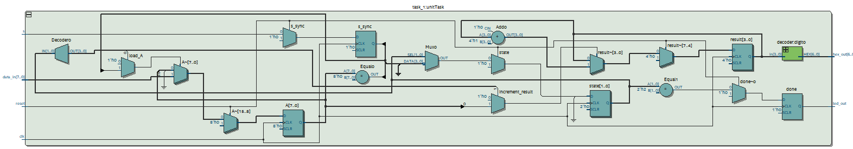

## Task 2

1. Create an ASM chart for the binary search algorithm. Keep in mind that the memory has registers on its input ports. Assume that the array has a fixed size of 32 elements.
2. Implement the FSM and the datapath for your circuit.
3. Connect your FSM and datapath to the memory block as indicated in Figure 2.
4. Include in your project the necessary pin assignments to implement your circuit on your DE-series board. Use switch SW9 to drive the Start input, use SW7...0 to specify the value A, use KEY0 for Resetn, and use the board’s 50 MHz clock signal as the Clock input (be sure to synchronize the Start input to the clock). Display the address of the data A, if found, on 7-segment displays HEX1 and HEX0, as a hexadecimal number. Finally, use LEDR9 for the Found signal.
5. Create a file called my_array.mif and fill it with an ordered set of 32 eight-bit integer numbers.
6. Compile your design, and then download and test it.

module *task_2* (

*input* wire clk,

*input* wire reset,

*input* wire [7:0] A,

*output* reg [4:0] L,

*output* reg found

);

    // Memory module for storing the sorted array

    reg [7:0] memory[0:15];

    reg [3:0] address_reg;

    reg [7:0] data_reg;

    reg write_enable;

    // FSM states

    parameter IDLE = 2'b00;

    parameter READ_MIDDLE = 2'b01;

    parameter SEARCH_LOWER = 2'b10;

    parameter SEARCH_UPPER = 2'b11;

    // FSM registers

    reg [1:0] state;

    reg [3:0] low;

    reg [3:0] high;

    reg [3:0] mid;

    always @(posedge clk) begin

        if (reset) begin

            // Initialize FSM and memory module

            state <= IDLE;

            low <= 0;

            high <= 15;

            found <= 0;

            write_enable <= 0;

            address_reg <= 0;

            data_reg <= 0;

            L <= 0;

        end else begin

            case (state)

                IDLE: begin

                    // Reset memory module

                    write_enable <= 0;

                    address_reg <= 0;

                    data_reg <= 0;

                    // Initialize search

                    low <= 0;

                    high <= 15;

                    mid <= 7;

                    state <= READ_MIDDLE;

                end

                READ_MIDDLE: begin

                    // Read middle element from memory

                    address_reg <= mid;

                    write_enable <= 0;

                    state <= state + 1;

                end

                SEARCH_LOWER: begin

                    // Check if A is in lower half of array

                    if (memory[mid-1] == A) begin

                        L <= mid - 1;

                        found <= 1;

                        state <= IDLE;

                    end else if (memory[mid-1] < A) begin

                        low   <= mid + 1;

                        mid   <= (low + high) / 2;

                        state <= READ_MIDDLE;

                    end else begin

                        high  <= mid - 1;

                        mid   <= (low + high) / 2;

                        state <= READ_MIDDLE;

                    end

                end

                SEARCH_UPPER: begin

                    // Check if A is in upper half of array

                    if (memory[mid+1] == A) begin

                        L <= mid + 1;

                        found <= 1;

                        state <= IDLE;

                    end else if (memory[mid+1] > A) begin

                        high  <= mid - 1;

                        mid   <= (low + high) / 2;

                        state <= READ_MIDDLE;

                    end else begin

                        low   <= mid + 1;

                        mid   <= (low + high) / 2;

                        state <= READ_MIDDLE;

                    end

                end

            endcase

        end

    end

    // Memory module for storing the sorted array

    always @(posedge clk) begin

        if (write_enable) begin

            memory[address_reg] <= data_reg;

        end

    end

endmodule

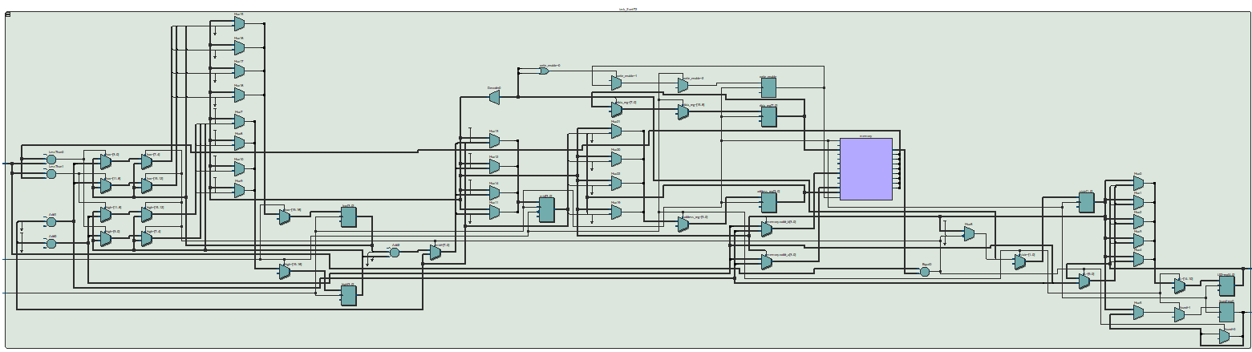

# Conclusion

In conclusion, this lab report has introduced the concept of Algorithmic State Machine (ASM) charts and highlighted their advantages over flowcharts for representing algorithms in hardware. The report has emphasized the ability of ASM charts to represent both sequential and combinational logic, complex algorithms, and their ability to generate VHDL code for the implemented circuits. The lab exercises provided an opportunity to learn how to use ASM charts to represent algorithms and implement them as hardware circuits. The performance of the implemented circuits was also analyzed. By completing this lab, the participants have gained valuable experience and understanding of ASM charts, which can be applied to future hardware design projects.