Task 1

module *task_1* (

*input*  Clk,

*input*  R,

*input*  S,

*output* Q

);

   wire R_g, S_g, Qa, Qb  /* synthesis keep */;

   assign R_g = R & Clk;

   assign S_g = S & Clk;

   assign Qa  = ~(R_g | Qb);

   assign Qb  = ~(S_g | Qa);

   assign Q   = Qa;

endmodule

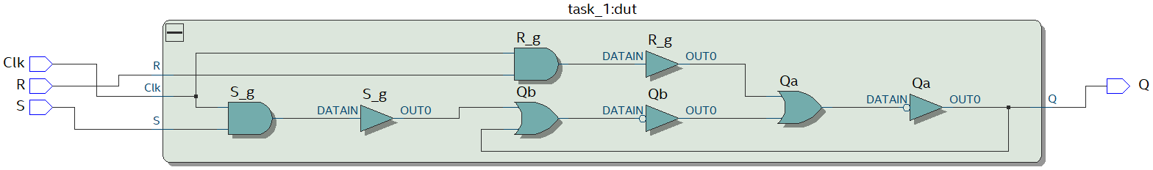



Task 2

module *task_2* (

*input*  Clk,

*input*  D,

*output* Q

);

   wire R, S, R_g, S_g, Q_a, Q_b  /* synthesis keep */;

   assign R   = ~D;

   assign S   = D;

   assign R_g = ~(R & Clk);

   assign S_g = ~(S & Clk);

   assign Q_a = ~(S_g & Q_b);

   assign Q_b = ~(R_g & Q_a);

   assign Q   = Q_a;

endmodule

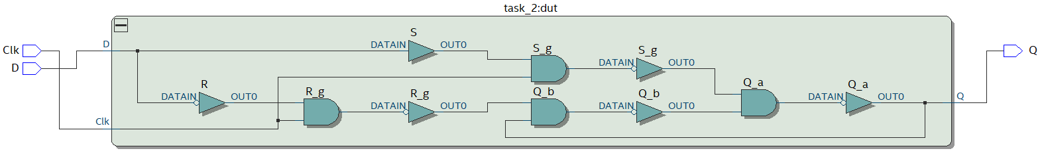



Task 3

module *task_3* (

*input*  Clk,

*input*  D,

*output* Q

);

   wire Q_m, Q_s, inv_Clk  /* synthesis keep */;

   assign inv_Clk = ~Clk;

*task_2* master_latch (

       .Clk(inv_Clk),

       .D  (D),

       .Q  (Q_m)

   );

*task_2* slave_latch (

       .Clk(Clk),

       .D  (Q_m),

       .Q  (Q_s)

   );

   assign Q = Q_s;

endmodule

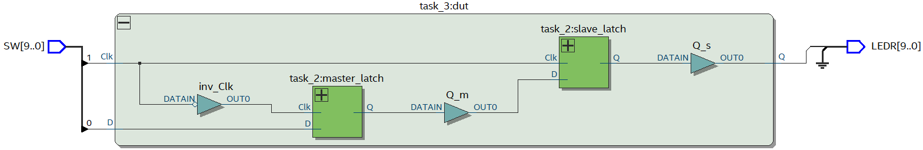



Task 4

