**Assignment #01 (CLO1)**

**(To be Submitted by 1st march 2023)**

**Question #01**

For the following differential equations, write the Transfer function, Y(s)/X(s)



**Note: For Q#02 and Q#03, Find the Required Transfer Function by hand as well as using Matlab. Please Provide Matlab Code for each Question along with results as well.**

**Question #02**

Find the transfer function X3(s)/F(s) for the system shown in figure

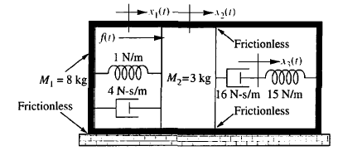

fv2=1

fv3=1

fv1=1

**Question#03**

Write the equations of motion to find 𝛉1(s)/T(s) for the rotational system shown in figure:

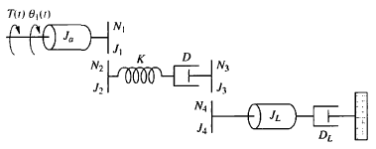

**______________________________________________________________________________**

**References: Norman S. Nise**, “Control Systems Engineering,” 5th Edition, John Wiley & Sons, 2008

**Note:** please use standard A-4 size paper for the assignment and leave reasonable

margins on the top, bottom, left & right.