Assignment # 02 (CLO2)

**Unmanned Free-Swimming Submersible Vehicle: Open-Loop Pitch Response**

**(To be submitted by 9th March 2023)**

***General Information:***

An Unmanned Free-Swimming Submersible (UFSS) vehicle is shown in Figure 1. The depth of the vehicle is controlled as follows. During forward motion, an elevator surface on the vehicle is deflected by a selected amount. This deflection causes the vehicle to rotate about the pitch axis. The pitch of the vehicle creates a vertical force that causes the vehicle to submerge or rise. The pitch control system for the vehicle is used here. The block diagram for the pitch control system is shown in Figure 2*.* In this case study, we investigate the time response of the vehicle dynamics that relate the pitch angle output to the elevator deflection input.

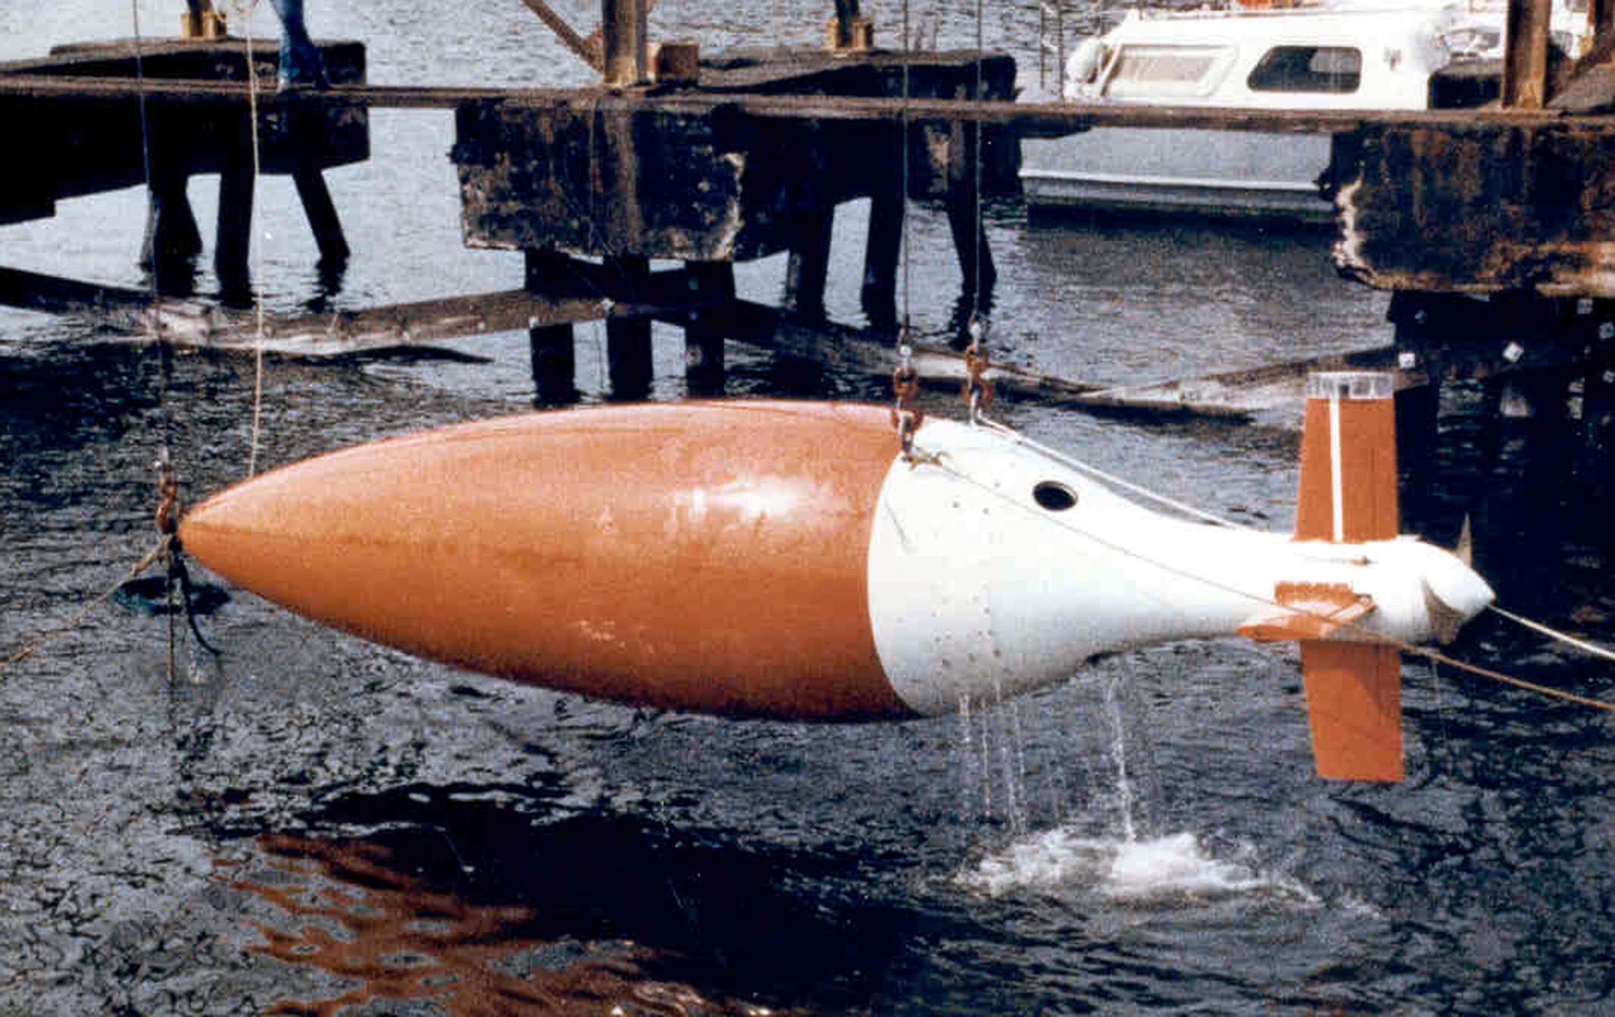

Figure-1

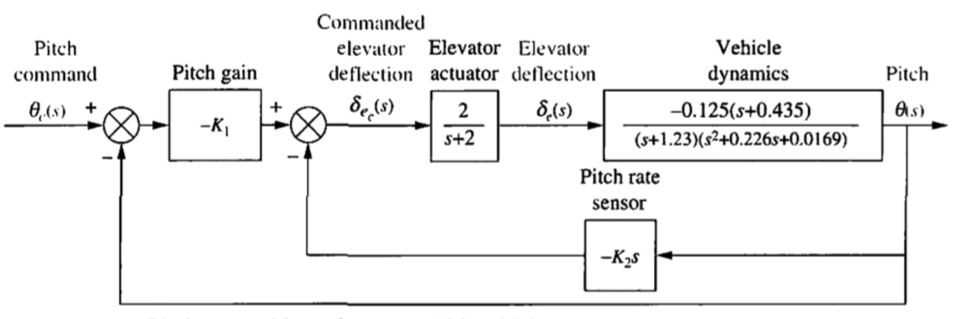 Figure-2 Pith control loop for the UFSS vehicle

The transfer function relating pitch angle, *θ(s),* to elevator surface angle, *δe(s),* for the UFSS vehicle is



***Requirements:***

1. Using only the second-order poles shown in the transfer function, predict percent overshoot, rise time, peak time, and settling time? [do it by hand]

**In MATLAB: [submit proper matlab codes and response plots]**

1. Using Laplace transforms, find the analytical expression for the response of the pitch angle to a step input in elevator surface deflection. [Use MATLAB to find the time domain expression by taking inverse Laplace transform].
2. Plot the step response of the system having just two poles [Let’s say there is pole zero cancellation. Maintain the steady state gain of system].
3. Plot the step response of the system having just two poles and a zero [Let’s say additional pole is cancelled by 5 times rule of thumb but maintain the steady state gain of your system]
4. Plot the step response of the complete system [having 3 poles and a zero].
5. Compare the responses in just 2 to 3 lines.

**References: Norman S. Nise**, “Control Systems Engineering,” 5th Edition, John Wiley & Sons, 2008

**Note:** please use standard A-4 size paper for the assignment and leave reasonable margins on the top, bottom, left & right.