

**NATIONAL UNIVERSITY OF SCIENCES & TECHNOLOGY**

**Linear Control Systems (EE-371)**

**Assignment # 3**

(CLO-3)

**Submission Details**

|  |  |
| --- | --- |
| Submitted to: | Ms. Neelma Naz |
| Submitted by: | Muhammad Umer |
| Class: | BEE-12C |
| Semester: | 6th |
| Dated: | 16/5/2023 |
| CMS ID: | 345834 |

**Problem Statement:** Consider a toy train consisting of an engine and a car. If the train only travels in one dimension (along the track), we want to apply control to the train so that it starts and comes to rest smoothly, and so that it can track a constant speed command with minimal error in steady state.

The mass of the engine and the car will be represented by and, respectively. Furthermore, the engine and car are connected via a coupling with stiffness. In other words, the coupling is modeled as a spring with a spring constant. The force represents the force generated between the wheels of the engine and the track, while represents the coefficient of rolling friction.

Figure 1

Figure 2: Free Body Diagram of Entire System

**Requirements:**

1. Construct the mathematical model of the provided system in the forms of equations of motion and find transfer function between engine’s speed and input force

**In MATLAB: [submit proper MATLAB codes and response plots]**

1. Construct the Simulink model for given system such that:

M1 = 1 kg

M2 = 0.5 kg

k = 1 N/sec

F = 1 N

 = 0.02 sec/m

g = 9.8 m/s^2

1. Plot the system’s response (x1_dot) for square wave input with frequency set to 0.001. You may leave the Units as the default Hertz. Also enter "-1" into the Amplitude field (positive amplitude steps negative before stepping positive).
2. Now Introduce a Cascaded PID controller and construct a unity feedback system. Plot the system’s response for (x1_dot) for same input.
3. Adjust the PID controller’s gain to get smallest possible error and fastest transient response. Re-plot the system’s response for (x1_dot).

# Simulink Model of Toy Train System

The given system can be modelled as the following two equations of motion:

The implementation of the above two equations in Simulink is as follows:

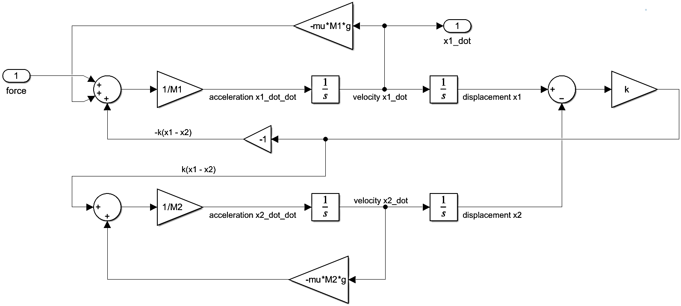

With the InitFcn* of the .slx file being:

M1 = 1;

M2 = 0.5;

k = 1;

F = 1;

mu = 0.02;

g = 9.8;

# System’s Response

With the plant model transformed into a subgroup, we can apply the required square wave input using the “Square Wave Generator” with the following settings:

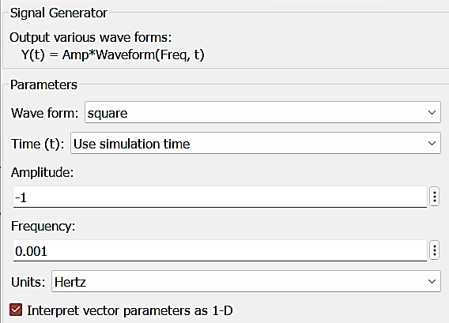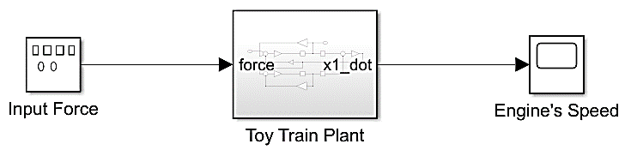

The system’s response is as follows:

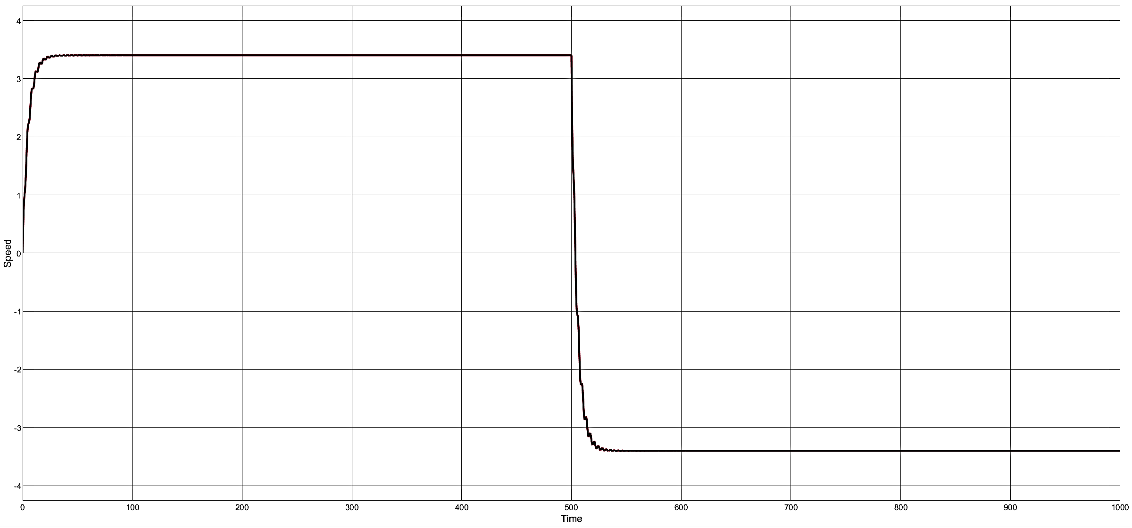

# Cascaded PID Controller

With the cascaded PID controller and unity feedback, the updated Simulink model is as follows:

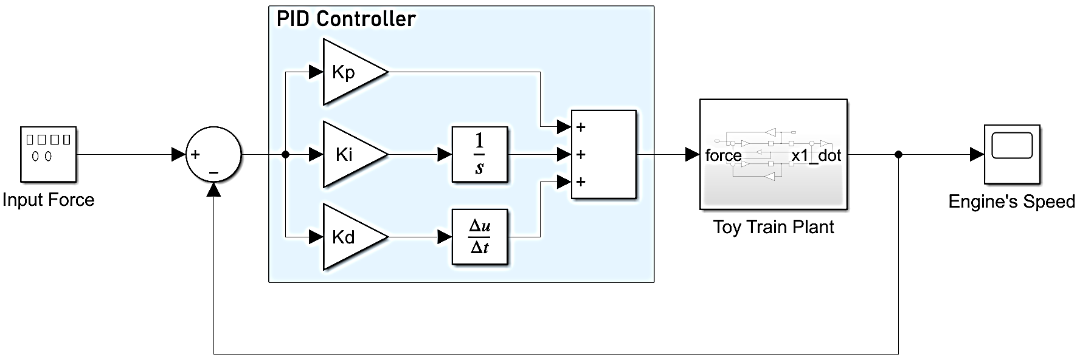

The PID controller as of this step is initialized with . These parameters yield the following system response:

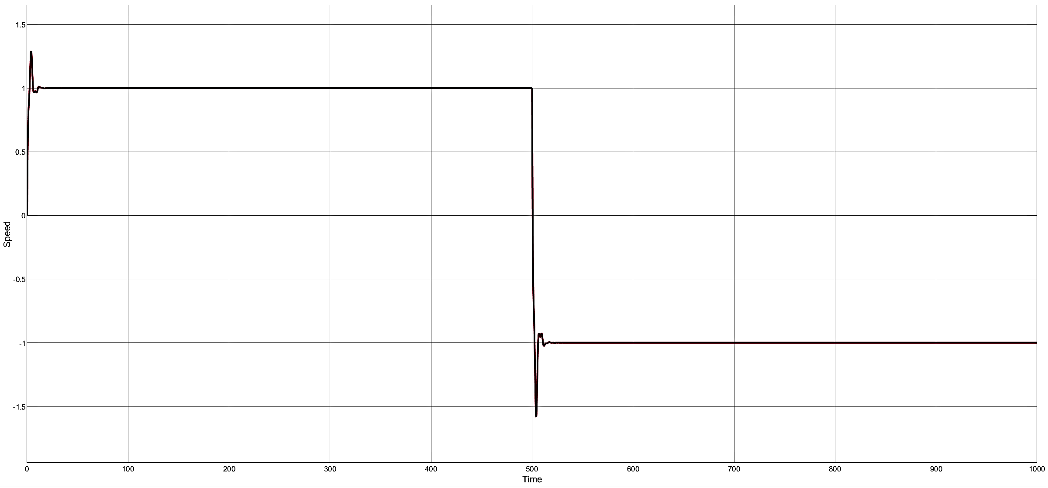

# Tuned Response

To tune the PID controller gains, we use MATLAB’s PID Tuner app and adjust the **Transient Behavior** and **Response Time** sliders to yield the fastest response and smallest possible steady state error.

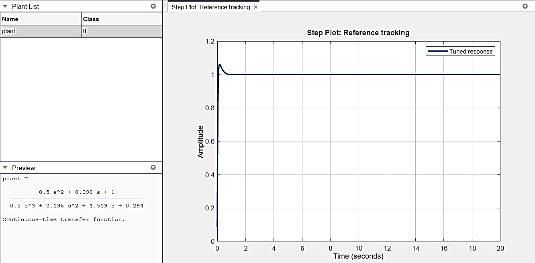

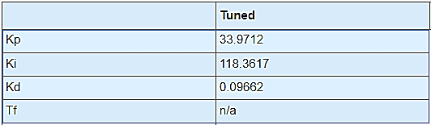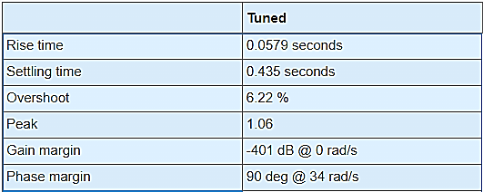

**Controller Parameters Performance Characteristics**

Which, when updated in the Simulink model, yield the following system response:

