**Department of Electrical Engineering and   
Computer Science**

**Faculty Member:** Ms. Neelma Naz  **Dated:** 9/02/2023

**Semester: 6**th **Section:** BEE 12C

**EE-371:** **Linear Control Systems**

Lab 2: Introduction to LabVIEW

Lab Instructor: Yasir Rizwan

Group Members

|  |  |  |  |  |
| --- | --- | --- | --- | --- |
| **Name** | **Reg. No** | **Lab Report Marks** | **Viva Marks** | **Total** |
|  |  | **10 Marks** | **5 Marks** | **15 Marks** |
| Danial Ahmad | 331388 |  |  |  |
| Muhammad Umer | 345834 |  |  |  |
| Tariq Umar | 334943 |  |  |  |
|  |  |  |  |  |

**Table of Contents**

2 Introduction to LabVIEW 3

2.1 Objectives 3

2.2 Introduction 3

2.3 Software 3

2.3.1 New Blocks 3

3 Lab Procedure 4

3.1 Exercise 1 4

3.2 Exercise 2 5

4 Conclusion 6

# Introduction to LabVIEW

## Objectives

The objectives of this lab are:

* Introduction to LabVIEW
* Designing a Simple VI
* Introducing Control and Simulation Module in LabVIEW

## Introduction

This lab report introduces LabVIEW, a sophisticated data acquisition and control platform used in a variety of engineering and scientific fields. The objectives of this lab are to design a simple VI (Virtual Instrument) using LabVIEW, and to introduce the Control and Simulation module in LabVIEW.

The lab begins with a brief overview of the basic concepts of LabVIEW and its main components. It then introduces the Control and Simulation module of LabVIEW, including its features and how it is used. After that, the lab will focus on the design of a simple VI and its programming. Finally, the lab will cover the use of the Control and Simulation module to simulate complex systems.

## Software

LabVIEW is a graphical programming environment that uses icons to represent instructions and commands. Its graphical approach makes it easy to understand and manipulate data. It allows the user to tailor data inputs and outputs to meet their specific needs. The Control and Simulation module in LabVIEW allows the user to simulate and analyze complex systems, such as those found in robotics, mechatronics, and autonomous systems.

### New Blocks

Following are the new blocks used in this lab:

* Numeric Control/Indicator
* While/For Loop
* Case Structure
* Logical Blocks (>, >=, <, <=, etc.)
* Numeric Blocks (Add, Subtract, Divide, etc.)
* CD Transfer Function

# Lab Procedure

## Exercise 1

Create a VI for indicating extreme temperatures. Inputs, outputs, and requirements of VI are:

**Inputs**

User will enter a maximum temperature, a minimum temperature, and the current temperature (Maximum and minimum Temperatures will be in Celsius while the current temperature will be in Fahrenheit)

**Outputs**

* Current temperature in Celsius
* String message, indicating the state of the system
* LED, indicating warning.

**Requirements**

* If the current Temperature is below the Minimum Value: “Freezing Warning” message should be displayed.
* If the current Temperature is above the Maximum value: “Heat Stroke Warning” message should be displayed.
* If the current Temperature is within limits: “System OK” message should be displayed. iv. A LED should turn red to indicate a warning message.

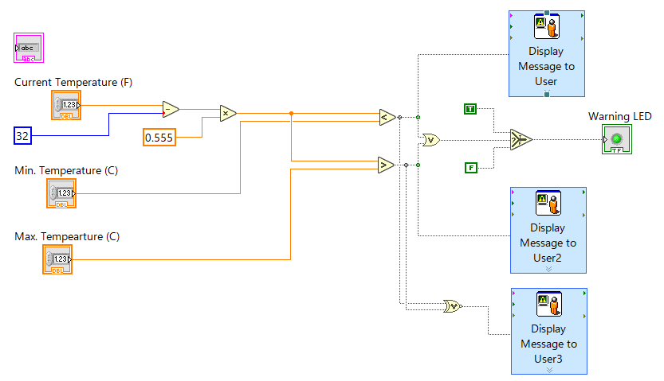

Figure : Exercise 1 – Block Diagram

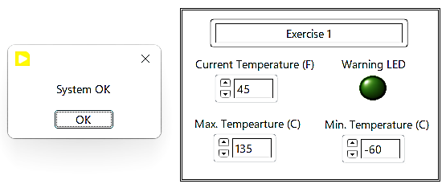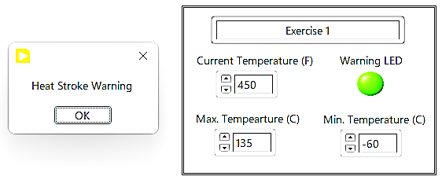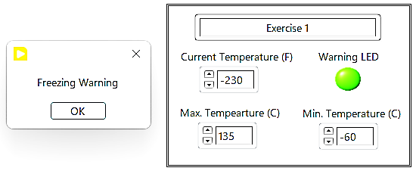

## Exercise 2

Create a VI for the following transfer functions:

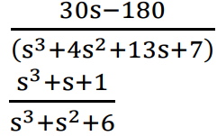

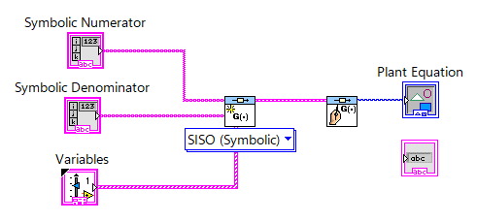

Figure : Exercise 2 - Block Diagram

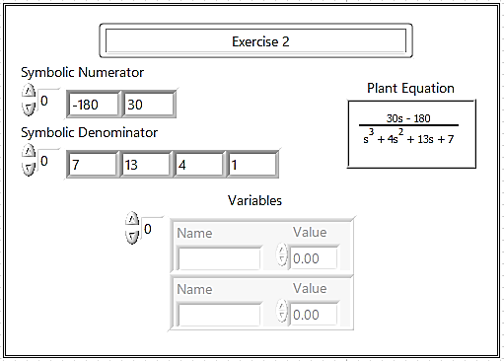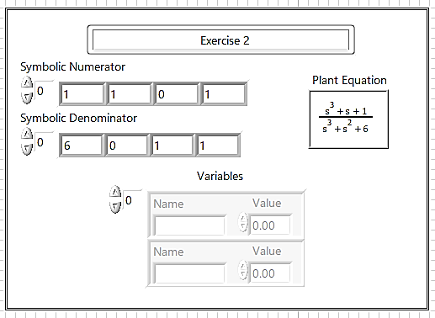

# Conclusion

In conclusion, this lab introduced LabVIEW, a powerful data acquisition and control platform that can be used in a variety of engineering and scientific fields. The lab demonstrated how to create a simple Virtual Instrument using LabVIEW, gave an overview of the Control and Simulation module, and showed how to use the module to simulate complex systems. This lab provided a brief introduction to the features of LabVIEW and its main modules, allowing for further exploration and experimentation. With LabVIEW as a powerful tool, engineers and scientists can develop efficient and reliable instruments and systems for various applications.