**Department of Electrical Engineering and   
Computer Science**

**Faculty Member:** Ms. Neelma Naz  **Dated:** 14/02/2023

**Semester**: 6th **Section:** BEE 12C

**EE-371:** **Linear Control Systems**

Lab 3: System Modeling

Lab Instructor: Yasir Rizwan

Group Members

|  |  |  |  |  |
| --- | --- | --- | --- | --- |
| **Name** | **Reg. No** | **Lab Report Marks** | **Viva Marks** | **Total** |
|  |  | **10 Marks** | **5 Marks** | **15 Marks** |
| Danial Ahmad | 331388 |  |  |  |
| Muhammad Umer | 345834 |  |  |  |
| Tariq Umar | 334943 |  |  |  |
|  |  |  |  |  |

**Table of Contents**

2 System Modeling 3

2.1 Objectives 3

2.2 Introduction 3

2.3 Software 3

3 Lab Procedure 4

3.1 Implementation of DC Motor Model in Simulink 4

3.2 Modeling of the Rotary Inverted Pendulum 5

3.2.1 Exercise 1 5

3.2.2 Exercise 2 (Pre-Lab) 6

3.2.3 Exercise 3 7

3.2.4 Exercise 4 9

3.2.5 Exercise 5 9

4 Conclusion 11

# System Modeling

## Objectives

The objectives of this lab are:

* Learn the modeling of a DC motor using the first principles
* Given a set of differential equations that describe a system, learn how to create a model in Simulink
* Given a set of differential equations describing a system, learn how to find the transfer function of the system

## Introduction

Modeling is the process of finding a mathematical model of a system. A mathematical model is a description of a system and helps us to understand the behavior of that system. Obtaining a model is usually the first step in controller design.

In this handout we will see how we can derive a model using the first principles. The first principles are the established physical laws, e.g., Kirchhoff’s voltage law, Newton’s laws of motion, etc. Modeling based on first principles doesn’t involve the value of system parameters like mass, spring constant etc. These parameters should either be known or must be estimated using system identification techniques.

Dynamical systems have some quantity that changes with time, and therefore the rate of change of that quantity is often necessary to describe that dynamical system. For this reason, most of the dynamical systems can be modeled with a set of differential equations. In this handout we will derive the model of a DC motor using first principles and will see that it is also a set of differential equations.

## Software

LabVIEW is a graphical programming environment that uses icons to represent instructions and commands. Its graphical approach makes it easy to understand and manipulate data. It allows the user to tailor data inputs and outputs to meet their specific needs. The Control and Simulation module in LabVIEW allows the user to simulate and analyze complex systems, such as those found in robotics, mechatronics, and autonomous systems.

# Lab Procedure

## Implementation of DC Motor Model in Simulink

The DC motor has an electrical part and mechanical part. When a voltage is applied to the motor, it affects the current in the armature of the motor, which in turn affects the speed of the motor. The following equations describe the behavior of a DC motor and therefore represent the model of a DC motor.

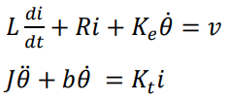

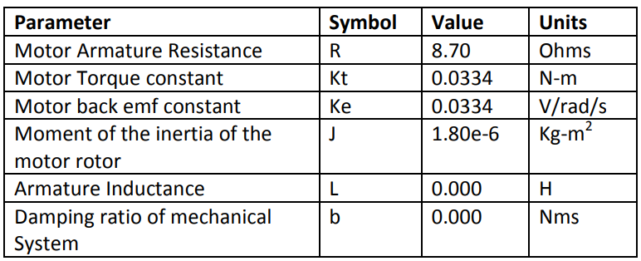

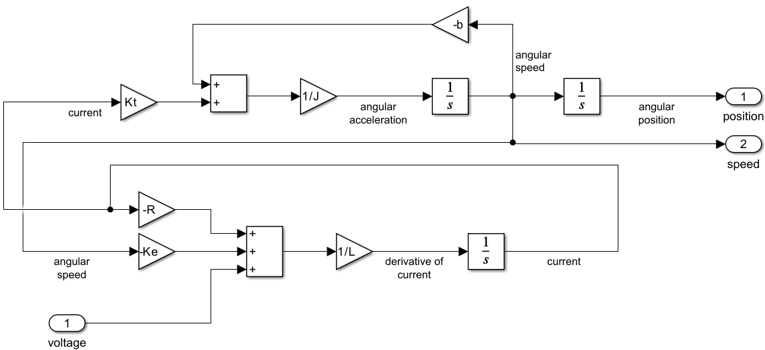

**Model Properties:** Callback InitFcn*

R = 8.70;

Kt = 0.0334;

Ke = 0.0334;

J = 1.80e-6;

L = 0.000;

b = 0.000;

## Modeling of the Rotary Inverted Pendulum

### Exercise 1

Using the following equations to make a model of the rotary inverted pendulum in Simulink.

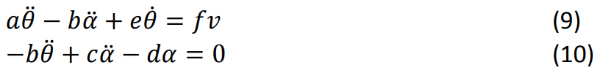

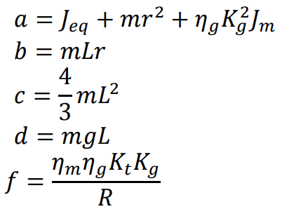

, where is the angle of the driving is motor, is the angle of pendulum arm, is the voltage of the motor in the pendulum system.

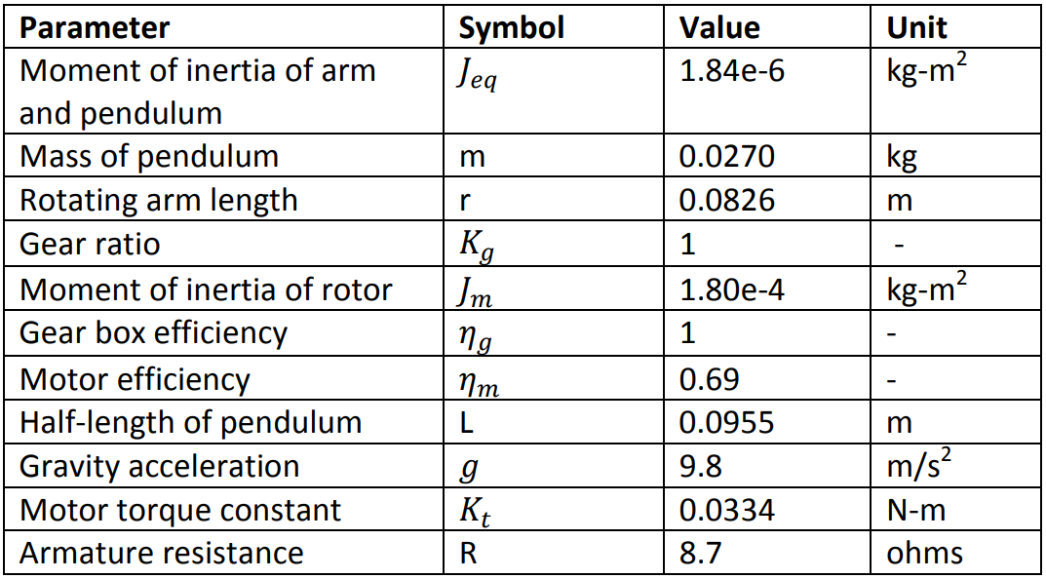

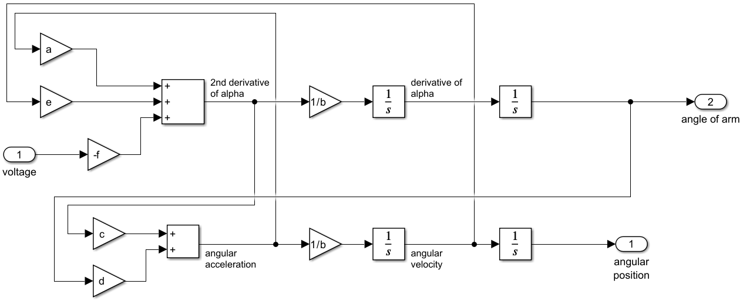

**Model Properties:** Callback InitFcn*

J_eq = 1.843e-6;

m = 0.0270;

r = 0.0826;

K_g = 1;

J_m = 1.80e-4;

n_g = 1;

n_m = 0.69;

L = 0.0955;

g = 9.9;

K_t = 0.0334;

R = 8.7;

a = J_eq + m * r ^ 2 + n_g * K_g ^ 2 * J_m;

b = m * L * r;

c = (4/3) * m * L ^ 2;

d = m * g * L;

e = 2.718;

f = (n_m * n_g * K_t * K_g) / R;

### Exercise 2 (Pre-Lab)

Use the set differential equations and the Laplace transforms to find the following transfer functions (Perform this on paper and attach scans/photos in lab report).

* Transfer function between the speed and voltage of the motor
* Transfer function between the position and voltage of the motor
* Transfer function between the position of the pendulum and voltage of the of the attached motor

**Between the speed and voltage of the motor**

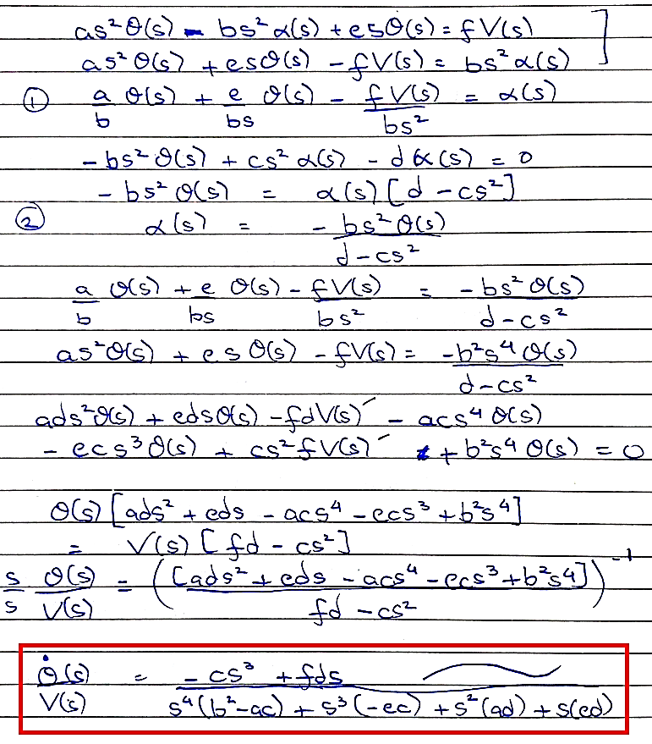



**Between the position and voltage of the motor**

It is the equivalent to the voltage and position transfer function divided by s.

**Between the position of the pendulum and voltage of the of the attached motor**

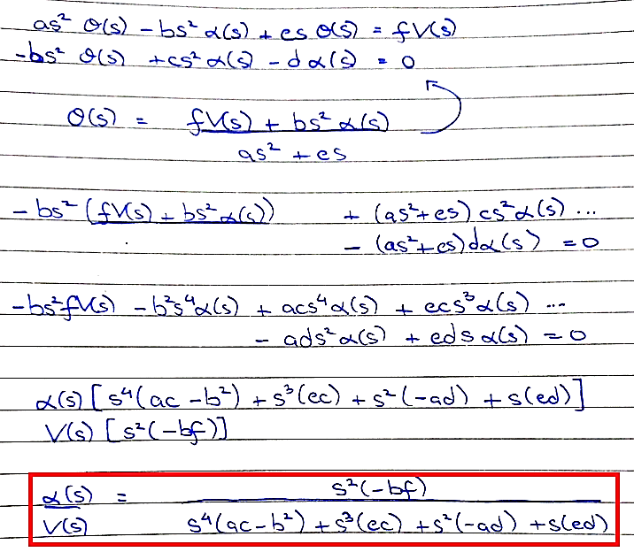

### Exercise 3

Using lab 1 procedure, create all the transfer functions of Exercise 2 in MATLAB.

**Code**

%% Variables

J_eq = 1.843e-6;

m = 0.0270;

r = 0.0826;

K_g = 1;

J_m = 1.80e-4;

n_g = 1;

n_m = 0.69;

L = 0.0955;

g = 9.9;

K_t = 0.0334;

R = 8.7;

a = J_eq + m * r ^ 2 + n_g * K_g ^ 2 * J_m;

b = m * L * r;

c = (4/3) * m * L ^ 2;

d = m * g * L;

e = 2.7183;

f = (n_m * n_g * K_t * K_g) / R;

%% Task 1

num = [-c 0 f*d 0];

den = [(b^2-a*c) -e*c a*d e*d 0];

G1 = tf(num, den);

display(G1)

%% Task 2

num = [-c 0 f*d];

den = [(b^2-a*c) -e*c a*d e*d 0];

G2 = tf(num, den);

display(G2)

%% Task 3

num = [-b*f 0 0];

den = [(a*c-b^2) e*c -a*d e*d 0];

G3 = tf(num, den);

display(G3)

**Output**

G1 =

0.0003283 s ^ 3 -6.762e-05 s

- --------------------------------------------------------

7.483e-08 s ^ 4 + 0.0008925 s ^ 3 -9.344e-06 s ^ 2 - 0.06939 s

G2 =

0.0003283 s ^ 2 -6.762e-05

- --------------------------------------------------------

7.483e-08 s ^ 4 + 0.0008925 s ^ 3 -9.344e-06 s ^ 2 - 0.06939 s

G3 =

-5.642e-07 s ^ 2

- --------------------------------------------------------

7.483e-08 s ^ 4 + 0.0008925 s ^ 3 -9.344e-06 s ^ 2 + 0.06939 s

### Exercise 4

Using lab 1 procedure, create all the transfer functions of Exercise 2 in Simulink using the Transfer function block.

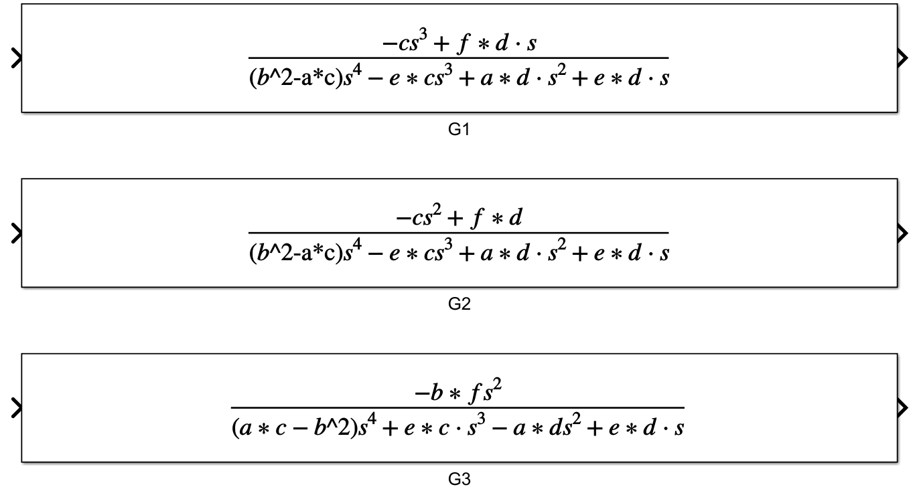

### Exercise 5

Using the lab 2 procedure, create all the transfer functions of Exercise 2 in LabVIEW.

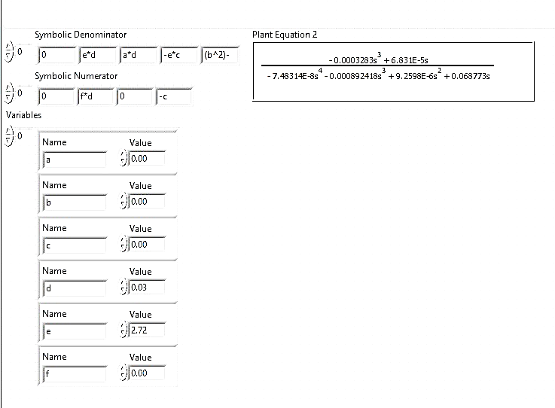

Figure : Transfer Function G1

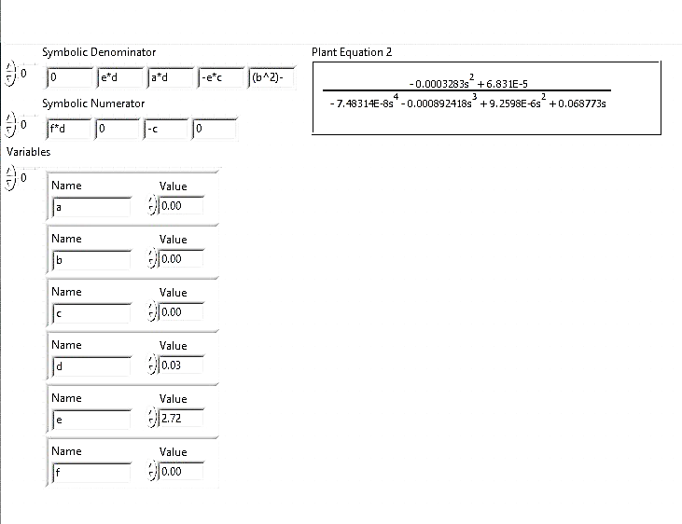

Figure : Transfer Function G2

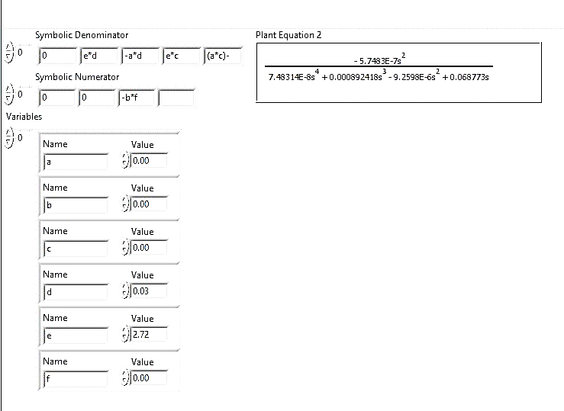

Figure : Transfer Function G3

# Conclusion

In conclusion, this lab provided a comprehensive understanding of the modelling of a DC motor using first principles and demonstrated the application of the acquired knowledge in Simulink. By creating a model in Simulink based on the differential equations that describe the system, we were able to accurately simulate the behaviour of the DC motor under various conditions. Furthermore, we learned how to derive the transfer function of a system based on the differential equations that describe it. This knowledge is essential for designing and analysing control systems for different applications.