**Department of Electrical Engineering and   
Computer Science**

**Faculty Member:** Ms. Neelma Naz  **Dated:** 04/02/2023

**Semester**: 6th **Section:** BEE 12C

**EE-371:** **Linear Control Systems**

Lab 6: Model Verification

Lab Instructor: Yasir Rizwan

Group Members

|  |  |  |  |  |
| --- | --- | --- | --- | --- |
| **Name** | **Reg. No** | **Lab Report Marks** | **Viva Marks** | **Total** |
|  |  | **10 Marks** | **5 Marks** | **15 Marks** |
| Danial Ahmad | 331388 |  |  |  |
| Muhammad Umer | 345834 |  |  |  |
| Tariq Umar | 334943 |  |  |  |
|  |  |  |  |  |

**Table of Contents**

2 Table of Figures 2

3 Model Verification 3

3.1 Objectives 3

3.2 Introduction 3

3.3 Software 3

4 Lab Procedure 4

4.1 Exercise 1 4

4.2 Exercise 2 6

5 Conclusion 6

# Table of Figures

Figure 1: Block Diagram 4

Figure 2: DC Motor Speed Response to Step, Sine, Ramp, and Random Inputs 5

Figure 3: DC Motor Position Response to Step and Triangle Input 6

# Model Verification

## Objectives

The objectives of this lab are:

* Learn how to do model verification using LabVIEW.

## Introduction

System modeling is a fundamental aspect of engineering design, which involves developing models that simulate the behavior of real-world systems. The models can be used to analyze and optimize the performance of a system before implementing it in the real world. LabVIEW is a powerful graphical programming language widely used in engineering and scientific fields for system modeling, simulation, and data analysis. It provides a user-friendly interface that allows engineers to build models of complex systems and validate their performance using various testing and verification techniques.

The purpose of this lab report is to demonstrate the process of system modeling and model verification using LabVIEW. The lab experiment involves building a model of a dynamic system using LabVIEW and verifying its performance against the actual system's behavior. The report outlines the steps involved in building the model, selecting appropriate inputs, and validating the model using experimental data.

## Software

LabVIEW is a graphical programming environment that uses icons to represent instructions and commands. Its graphical approach makes it easy to understand and manipulate data. It allows the user to tailor data inputs and outputs to meet their specific needs. The Control and Simulation module in LabVIEW allows the user to simulate and analyze complex systems, such as those found in robotics, mechatronics, and autonomous systems.

# Lab Procedure

## Exercise 1

Create a VI to do model verification of DC motor speed. Verify the model that you have derived for the DC motor speed for various signals e.g., step, square wave, triangular wave, sine wave, etc. Comment on any differences you see in the output of the model and the actual plant. Your VI should have a structure like the one shown in the figure below. Remember to use data acquisition VI and the models that you have created in earlier labs.

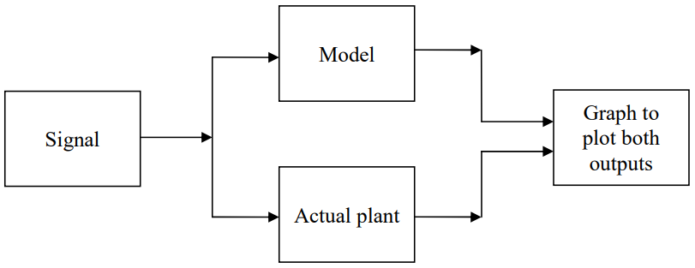

If the output of the actual plant matches the output of the derived model, then our derived model is verified. Otherwise, apply the system identification techniques that are given in your textbook to find the values of constants in your derived model. Once the new values of constants are obtained, try to verify the model again.

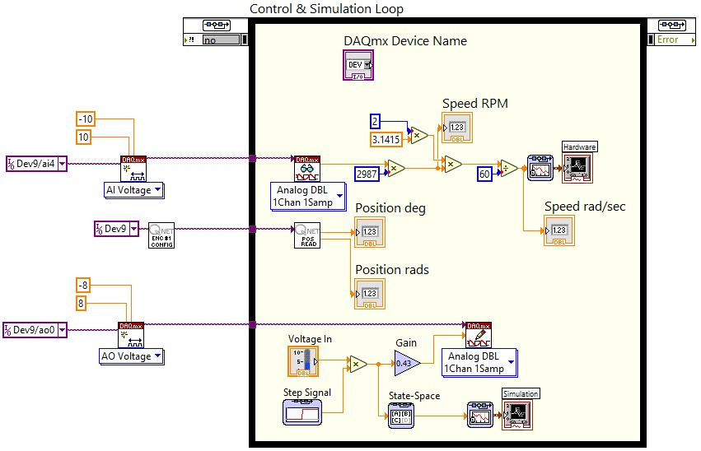

Figure : Block Diagram

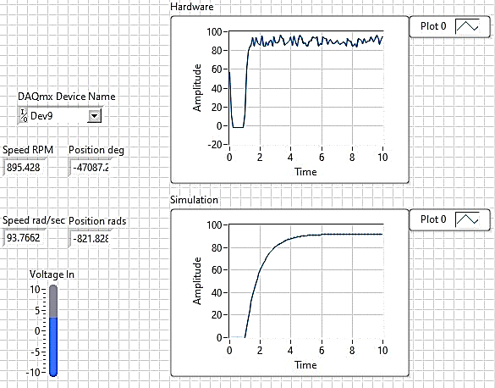 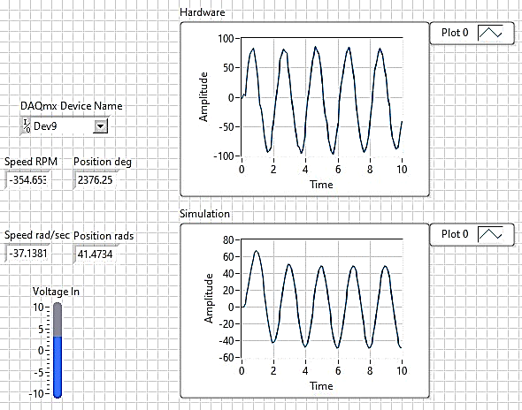

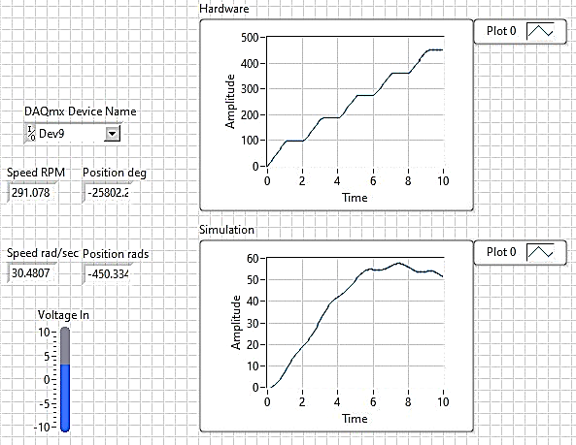 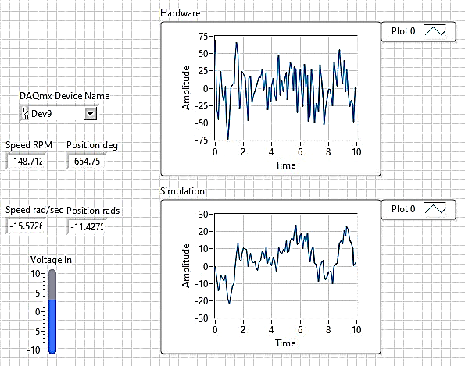

Figure : DC Motor Speed Response to Step, Sine, Ramp, and Random Inputs

## Exercise 2

Do the above exercise for DC motor position. Besides the signal listed above also verify the model for a single pulse input.

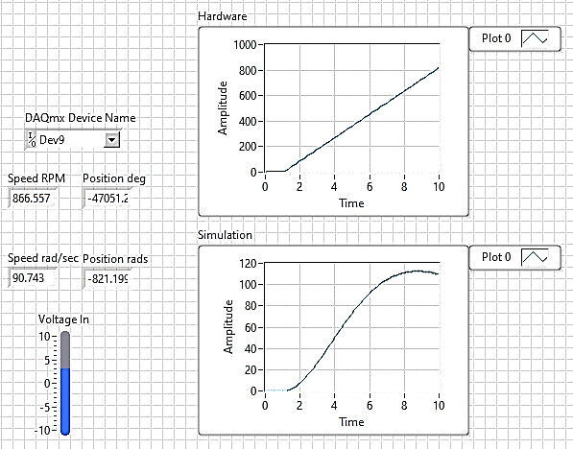 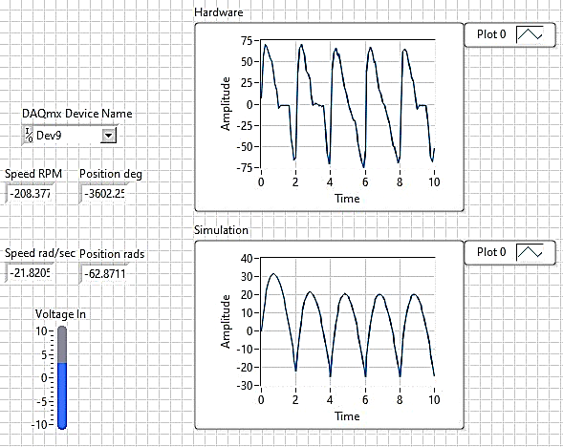

Figure : DC Motor Position Response to Step and Triangle Input

# Conclusion

In this lab report, we have demonstrated the process of system modeling and model verification using LabVIEW. We have built a model of a DC motor system and verified its response to various types of inputs, such as step, sine, ramp, etc., against the actual system's behavior using simulation. Through this experiment, we have learned that system modeling using LabVIEW is an effective way to analyze and optimize the performance of complex systems. It provides a user-friendly interface that allows engineers to build accurate models of real-world systems and validate their performance using experimental data.