**Department of Electrical Engineering and   
Computer Science**

**Faculty Member:** Ms. Neelma Naz  **Dated:** 21/03/2023

**Semester**: 6th **Section:** BEE 12C

**EE-371:** **Linear Control Systems**

Lab 8: Open Loop Control

Lab Instructor: Yasir Rizwan

Group Members

|  |  |  |  |  |
| --- | --- | --- | --- | --- |
| **Name** | **Reg. No** | **Lab Report Marks** | **Viva Marks** | **Total** |
|  |  | **10 Marks** | **5 Marks** | **15 Marks** |
| Danial Ahmad | 331388 |  |  |  |
| Muhammad Umer | 345834 |  |  |  |
| Tariq Umar | 334943 |  |  |  |
|  |  |  |  |  |

**Table of Contents**

2 Model Verification 3

2.1 Objectives 3

2.2 Introduction 3

2.3 Software 3

3 Lab Procedure 4

3.1 Speed Control in Open Loop 4

3.2 Position Control in Open loop 5

3.3 Open Loop Control of Inverted Pendulum 6

4 Conclusion 7

# Model Verification

## Objectives

The objectives of this lab are:

* Understanding the open loop control system.
* Open loop control of DC Motor.
* Open loop control of Inverted pendulum.

## Introduction

The aim of this lab report is to explore the concept of an open loop control system and its application in the control of DC motor and inverted pendulum. The open loop control system is a control system in which the output is not fed back to the input. In this type of control system, the control action is predetermined and fixed, and it does not depend on the output or feedback. The open loop control system is widely used in various engineering applications where high accuracy is not required, such as controlling the speed of a motor or the position of a pendulum. In this lab, we will investigate the open loop control of a DC motor and an inverted pendulum, and we will explore the performance of these systems.

## Software

MATLAB is a high-level programming language and numerical computing environment. Developed by MathWorks, it provides an interactive environment for numerical computation, visualization, and programming. MATLAB is widely used in various fields, including engineering, science, and finance, due to its capabilities for matrix and vector operations, implementation of algorithms, and creation of graphical representations of data.

# Lab Procedure

## Speed Control in Open Loop

* **Exercise 1:** Maintain the speed of 92rad/s by applying the required voltage (Use hit and trail method and note every voltage in your logbook).

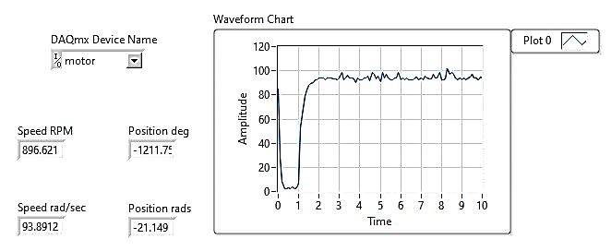

* **Exercise 2:** Take the best reading from Exercise 1 and calculate the steady state response (for step input). Note all your calculations in the logbook.

|  |  |
| --- | --- |
| **Voltage (V)** | **Speed (rad/s)** |
| 2.08 | 92.85 |
| 2.01 | 93.12 |
| 2.11 | 92.77 |

* **Exercise 3:** Are the speeds obtained by experiment (exercise 1) and by calculation (exercise 2) same? If not, what can be the possible reason.

The speeds obtained are not the same due to the presence of external disturbances in experimental setup whereas we assume ideal cases for theoretical calculations.

* **Exercise 4:** Apply the disturbance i.e., friction (by holding the motor with your hand) and try to maintain the desired speed. Comment on the obtained response.

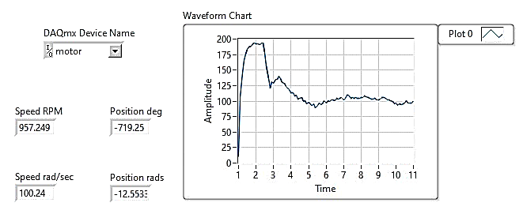

|  |  |
| --- | --- |
| **Voltage (V)** | **Speed (rad/s)** |
| 3.48 | 95.85 |
| 3.21 | 93.12 |
| 3.78 | 97.77 |

## Position Control in Open loop

* **Exercise 5:** Rotate the motor by 180o by applying the required voltage (Use hit and trail method and note very voltage in your logbook).

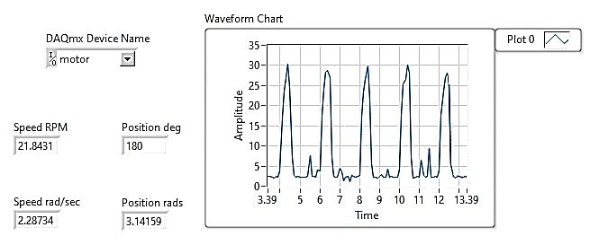

* **Exercise 6:** Take the best reading from Exercise 5 and calculate the steady state response (for step input). Note all your calculations in the logbook.

|  |  |
| --- | --- |
| **Voltage (V)** | **Position (rad)** |
| 1.32 | 3.17 |
| 1.38 | 3.11 |
| 1.36 | 3.12 |

* **Exercise 7:** Are the positions obtained by experiment and by calculation the same? If not, what can be the possible reason.

The responses obtained are not the same due to the presence of external disturbances in experimental calculations, whereas we assume ideal cases for theoretical calculations.

* **Exercise 8:** Apply the disturbance i.e., friction (by holding the motor with your hand) and try to maintain the desired position. Comment on the obtained response.

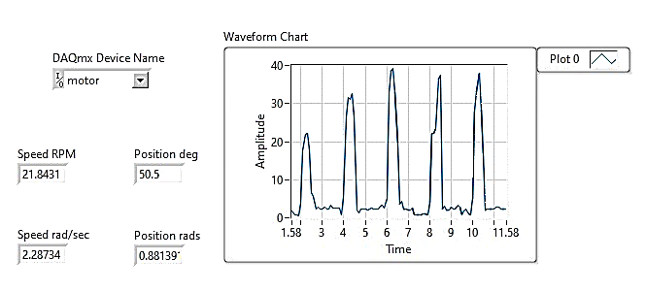

When a disturbance such as friction is applied to a DC motor, it can cause the motor to slow down or stop rotating. This, in turn, can lead to a reduction in the input torque to the motor and make it challenging to maintain the desired position. To maintain the desired position, the control system must compensate for the disturbance by adjusting the input voltage or current to the motor.

## Open Loop Control of Inverted Pendulum

When we change the input voltage of the driving unit (DC Motor) of inverted pendulum, the arm angle changes accordingly. Now we will see whether it is possible to stabilize the pendulum with no feedback (open loop).

* **Exercise 9:** Try to stabilize the pendulum by applying the required voltage. (Use hit and trail method and note every voltage in your logbook).

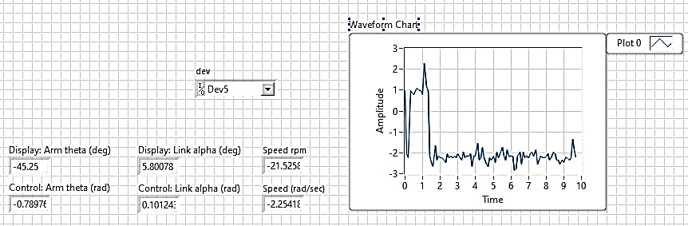

* **Exercise 10:** Take the best reading from Exercise 9 and calculate the steady state response (for step input). Note all your calculations in the logbook.

It is not possible to stabilize the inverted pendulum in an open-loop fashion and the error to the step input diverges.

* **Exercise 11:** Why is it not possible to stabilize the inverted pendulum in an open loop. (Hint: Plot pole-zero plot and comment)

In an open-loop inverted pendulum system, it is not possible to stabilize the system because the system is inherently unstable due to the presence of pole in the right half plane.

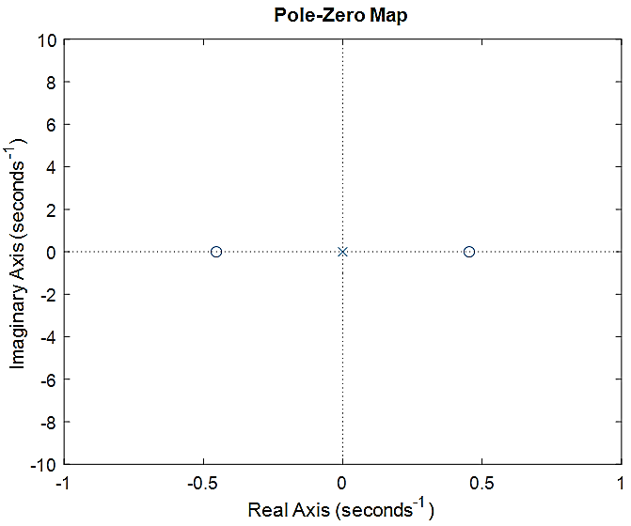

* **Exercise 12:** Why it is not possible to get the desired response in an open loop with disturbance applied?

In an open-loop inverted pendulum system, the control input to the system is not adjusted based on the output or feedback from the system. Therefore, if a disturbance is applied to the system, the control input will remain constant, and the system will not be able to respond to the disturbance in real-time. As a result, the system will be unable to maintain the desired position of the pendulum.

# Conclusion

In conclusion, this lab report has explored the concept of open loop control system and its application in the control of DC motor and inverted pendulum. We have shown that the open loop control system is a simple and efficient control system that can be used in various engineering applications. The results of this lab have demonstrated that the open loop control system can be used to control the speed of a motor or the position of a pendulum in a predictable manner. We have also shown that the performance of both systems can be improved by optimizing the control input. Overall, this lab has provided a better understanding of the open loop control system and its applications in the field of engineering.