**Department of Electrical Engineering and   
Computer Science**

**Faculty Member:** Ms. Neelma Naz  **Dated:** 21/03/2023

**Semester**: 6th **Section:** BEE 12C

**EE-371:** **Linear Control Systems**

Lab 9: Root Locus Based Design

Lab Instructor: Yasir Rizwan

Group Members

|  |  |  |  |  |
| --- | --- | --- | --- | --- |
| **Name** | **Reg. No** | **Lab Report Marks** | **Viva Marks** | **Total** |
|  |  | **10 Marks** | **5 Marks** | **15 Marks** |
| Danial Ahmad | 331388 |  |  |  |
| Muhammad Umer | 345834 |  |  |  |
| Tariq Umar | 334943 |  |  |  |
|  |  |  |  |  |

**Table of Contents**

2 Model Verification 3

2.1 Objectives 3

2.2 Introduction 3

2.3 Software 3

3 Lab Procedure 4

3.1 Exercise 1 4

3.2 Exercise 2 5

3.3 Exercise 3 6

3.4 Exercise 4 7

4 Conclusion 8

# Model Verification

## Objectives

The objectives of this lab are:

* Learn how to plot root locus in MATLAB.
* Learn how to use MATLAB to design a simple controller using the root locus.

## Introduction

In this lab report, we will explore the use of MATLAB to plot root locus and design a simple controller. Root locus is a graphical method that helps to analyze the stability and performance characteristics of a closed-loop control system by plotting the location of the closed-loop poles as the gain of the system is varied. We will demonstrate how to plot root locus in MATLAB and use it to design a controller that meets certain performance requirements such as damping ratio, settling time, and overshoot. This report serves as a practical guide for students and engineers who want to understand the root locus method and its application in controller design using MATLAB.

## Software

MATLAB is a high-level programming language and numerical computing environment. Developed by MathWorks, it provides an interactive environment for numerical computation, visualization, and programming. MATLAB is widely used in various fields, including engineering, science, and finance, due to its capabilities for matrix and vector operations, implementation of algorithms, and creation of graphical representations of data.

# Lab Procedure

## Exercise 1

Consider the open loop system:

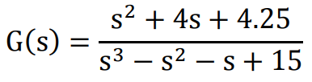

Plot the root locus for this system in MATLAB. Using the MATLAB root locus:

1. Find the values of the gain K for which the closed loop system will be stable.
2. Design a controller gain K such that the closed system is stable, and the dominant poles have an overshoot of 80%. Is a second order approximation valid for this value of K? Find the transfer function of the closed loop system.

close all

G = tf([1 4 4.25], [1 -1 -1 15])

figure

rlocus(G)

K = 3.38;

Gcl1 = feedback(series(K, G), 1)

figure

rlocus(Gcl1)



K = 3.89;

Gcl2 = feedback(series(K, G), 1)

figure

rlocus(Gcl2)





## Exercise 2

Consider the first order model of the DC motor speed vs voltage, which you have derived in your earlier labs. You get a first order model if you neglect the inductance. Using the root locus, choose a value of K such that your settling time is 1/20 secs. Find the transfer function of the system.

close all

num = 0.0334;

den = [1.566e-5, 1.11556e-3];

G = tf(num, den)

stepinfo(G)

figure

rlocus(G)

K = 0.00332;

Gcl = feedback(series(K, G), 1)

stepinfo(Gcl)



         RiseTime: 0.0308

    TransientTime: 0.0549

     SettlingTime: 0.0549

      SettlingMin: 27.0809

      SettlingMax: 29.9203

        Overshoot: 0

       Undershoot: 0

             Peak: 29.9203

         PeakTime: 0.1028

## Exercise 3

Consider the first order model of the DC motor position vs voltage that you have derived in your earlier labs. Using the root locus, choose a value of K such that your closed loop system is stable and has a settling time of 1/5 secs. Find the transfer function of the closed loop system.

close all

num = 0.0334;

den = [1.566e-5, 1.11556e-3, 0];

G = tf(num, den)

stepinfo(G)

figure

rlocus(G)

K = 0.5;

Gcl = feedback(series(K, G), 1)

stepinfo(Gcl)

figure

rlocus(Gcl)



         RiseTime: 0.1168

    TransientTime: 0.2090

     SettlingTime: 0.2090

      SettlingMin: 0.9032

      SettlingMax: 1.0000

        Overshoot: 0

       Undershoot: 0

             Peak: 1.0000

         PeakTime: 0.4971

## Exercise 4

Sketch and verify the root locus of the following transfer functions.

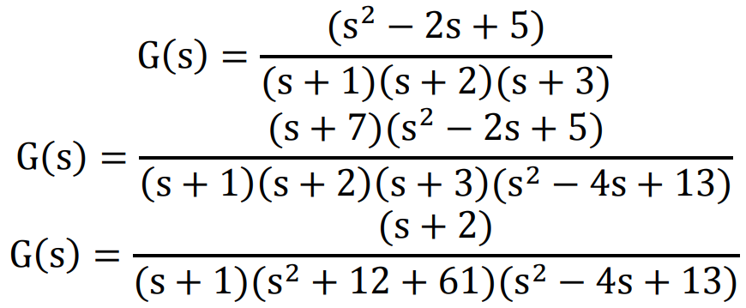







# Conclusion

In conclusion, this lab report has provided a comprehensive overview of the root locus method and its application in controller design using MATLAB. We have demonstrated how to plot root locus in MATLAB and use it to design a simple controller that meets specific performance criteria. By using MATLAB, we have shown that root locus plots can be generated quickly and efficiently, allowing for the analysis of the stability and performance characteristics of a closed-loop control system. The root locus method is a powerful tool in control system engineering that provides valuable insights into the behavior of a system in terms of its poles and zeros.