

**NATIONAL UNIVERSITY OF SCIENCES & TECHNOLOGY**

**Mobile Communication Systems (EE-451)**

Homework 3

**Submission Details**

|  |  |
| --- | --- |
| Name | CMS ID |
| Muhammad Umer | 345834 |
| Submitted to: | Dr. Syed Ali Hassan |
| Class: | BEE-12 |
| Semester: | 7th |
| Due: | 21/12/2023 |

**Problem 1 (CLO-1):**

Consider a linearly modulated signal of the form s(t) = Re{sl(t)ej2πfct}, where

$s_{l}\left(t\right)=\sum_{n=-∞}^{∞}{b_{n}p(t-nT_{s}}$)

and where all pairs of symbols bn and bm are independent for n ≠m and each bn ε {-3, -1, 1, 3}, taking the values with equal probability. Furthermore, assume the pulse p(t) is rectangular with unit height and width Ts. Sketch the power spectral density (PSD), including labeling its peak height.

**Problem 2:**

Suppose the following constellation of 8 signals for a communication system is given:



1. Find the energy of each symbol and the average symbol energy of this constellation
2. Give a complete union bound for the probability of symbol error.
3. If the basis functions are the usual ones for QPSK, give the expression of the symbol waveform as a function of time for the symbol that is indicated by the arrow.

**Problem 3:**

Two signal points Sa and Sb are shown below:

1. Suppose the noise spectral height is N0/2=25/16. Evaluate the BER if these two signals are used in a wireless communication link.
2. Suppose the two basis functions are:

Construct an expression of signal labeled Sa in terms of t and Ts.

**Problem 4:**

Let the carrier frequency be 100 MHz and let the symbol period be 1 microsecond. Consider a transmitted BPSK signal that uses the 25% excess bandwidth Root Raised Cosine pulses (you can use the definition in Wikipedia, where beta = 0.25). Using MATLAB or your favorite programming language, plot the RF modulated BPSK signal,

$$x\left(t\right)=\left[\sum_{n=1}^{8}{x_{n}p_{rrc}(t-nT_{s})}\right]cos⁡(2πf_{c}t)$$

Assume the symbol sequence $x_{n}$ be [1, -1, -1, 1, -1, -1, -1, 1].

**Problem 5:**

Using the same parameters as in Problem 4, plot the RF modulated QPSK waveform

$x\left(t\right)=\left[\sum_{n=1}^{8}{x_{n}p_{rrc}(t-nT_{s})}\right]\cos\left(2πf_{c}t\right)-\left[\sum_{n=1}^{8}{y_{n}p_{rrc}(t-nT_{s})}\right]\sin\left(2πf_{c}t\right)$

Use the same $x_{n}$ sequence as in Problem 4, and let the quadrature symbols of the signal, $y_{n}$, be [-1, -1, 1, 1, 1, -1, 1, -1].

**Problem 6:**

Consider the pulse below, plotted versus time in microseconds. Could this pulse be a Nyquist pulse for a binary transmission with a 10MHz data rate? Why or why not?



**Problem 4:**

Let the carrier frequency be 100 MHz and let the symbol period be 1 microsecond. Consider a transmitted BPSK signal that uses the 25% excess bandwidth Root Raised Cosine pulses (you can use the definition in Wikipedia, where beta = 0.25). Using MATLAB or your favorite programming language, plot the RF modulated BPSK signal,

$$x\left(t\right)=\left[\sum_{n=1}^{8}{x_{n}p_{rrc}(t-nT_{s})}\right]cos⁡(2πf_{c}t)$$

Assume the symbol sequence $x_{n}$ be [1, -1, -1, 1, -1, -1, -1, 1].

We start by making the necessary imports, definitions, and important indices.

import numpy as np

import matplotlib.pyplot as plt

plt.rcParams["mathtext.fontset"] = "stix"

plt.rcParams["font.family"] = "STIXGeneral"

fc = 100e6

Ts = 1e-6

beta = 0.25

N = 8

t = np.arange(-2 * N * Ts, 2 * N * Ts, 1 / (2 * fc))

x_n = np.array([1, -1, -1, 1, -1, -1, -1, 1])

*# Zero crossing and shift for +-Ts/(4*beta)*

zc = len(t) // 2

shift = len(np.arange(0, Ts / (4 * beta), 1 / (2 * fc))) + 1

Next, we define a function for Root Raised Cosine (RRC) pulse and substitute the zero crossing and shifts about the zero crossing with appropriate values.

*# Root Raised Cosine (Ts * 1/Ts cancels); from Wikipedia*

p_rrc = lambda t: (

    np.sin(np.pi * t / Ts * (1 - beta))

    + 4 * beta * t / Ts * np.cos(np.pi * t / Ts * (1 + beta))

) / (np.pi * t / Ts * (1 - (4 * beta * t / Ts) ** 2))

p_rrc_zc = Ts * 1 / Ts * (1 + beta * (4 / np.pi - 1))

p_rrc_shift = (beta / np.sqrt(2)) * (

    (1 + 2 / np.pi) * np.sin(np.pi / (4 * beta))

    + (1 - 2 / np.pi) * np.cos(np.pi / (4 * beta))

)

p = p_rrc(t)

p[zc] = p_rrc_zc

p[zc + shift] = p_rrc_shift

p[zc - shift] = p_rrc_shift

*# Plot*

plt.figure(figsize=(8, 4)), plt.tight_layout()

plt.plot(t, p, "k-", linewidth=1.5)

plt.xlabel("Time (s)")

plt.ylabel("Amplitude")

plt.title(r"Root Raised Cosine, $\beta$ = 0.25")

plt.grid()

plt.savefig("p4a.png", dpi=300)

plt.show()

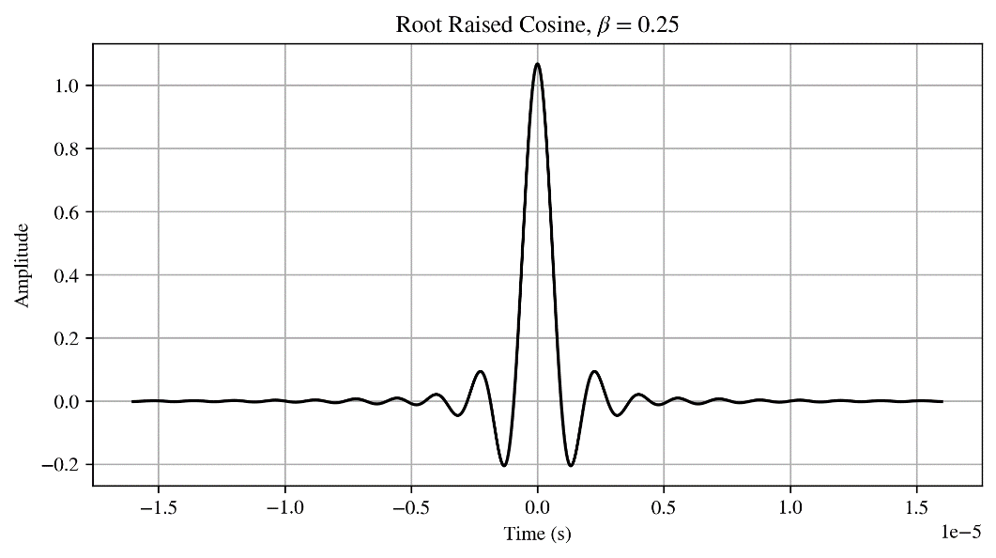

Now, we just define and plot the aggregated BPSK waveform, i.e., the complex envelope.

shifted_p = np.zeros(len(t))

interval = len(np.arange(0, Ts, 1 / (2 * fc))) + 1

x_t = np.zeros(len(t))

plt.figure(figsize=(8, 4))

plt.tight_layout()

for i in range(N):

    shifted_p[interval * i : len(p)] = p[0 : len(p) - interval * i]

    x_t += x_n[i] * shifted_p

    plt.plot(t, x_n[i] * shifted_p, linewidth=1.5)

plt.xlabel("Time (s)")

plt.ylabel("Amplitude")

plt.title(r"BPSK Waveform for Each Symbol $x_n \in \{-1, 1\}$")

plt.grid()

plt.savefig("p4b.png", dpi=300)

plt.show()

plt.figure(figsize=(8, 4))

plt.plot(t, x_t, "k-", linewidth=1.5)

plt.xlabel("Time (s)")

plt.ylabel("Amplitude")

plt.title("BPSK Signal using RRC with $\\beta$ = 0.25")

plt.grid()

plt.savefig("p4c.png", dpi=300)

plt.show()

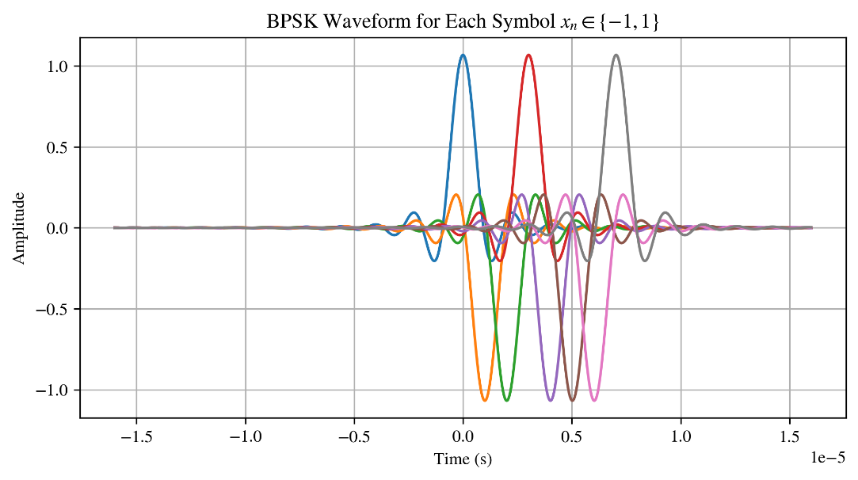

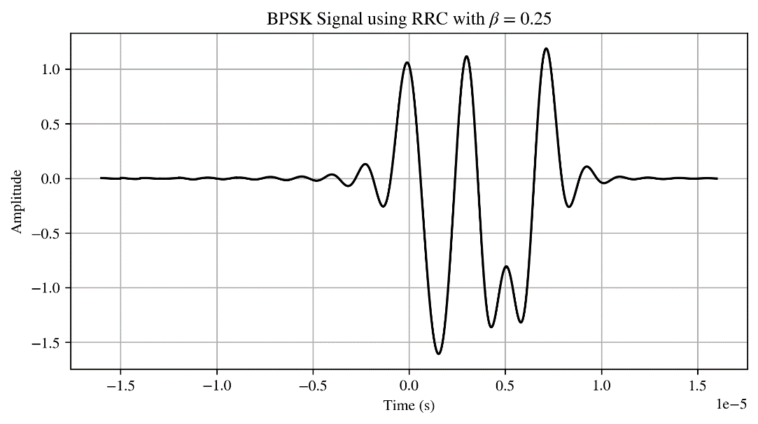

Lastly, we multiply the complex envelope with the necessary carrier wave as follows:

$$s\left(t\right)=x\left(t\right)×cos⁡(2πf_{c}t)$$

modulated_p4 = x_t * np.cos(2 * np.pi * fc * t)

plt.figure(figsize=(8, 4))

plt.plot(t, modulated_p4, "k-", linewidth=1.5)

plt.xlabel("Time (s)")

plt.ylabel("Amplitude")

plt.title("RF Modulated BPSK Signal")

plt.grid()

plt.savefig("p4d.png", dpi=300)

plt.show()

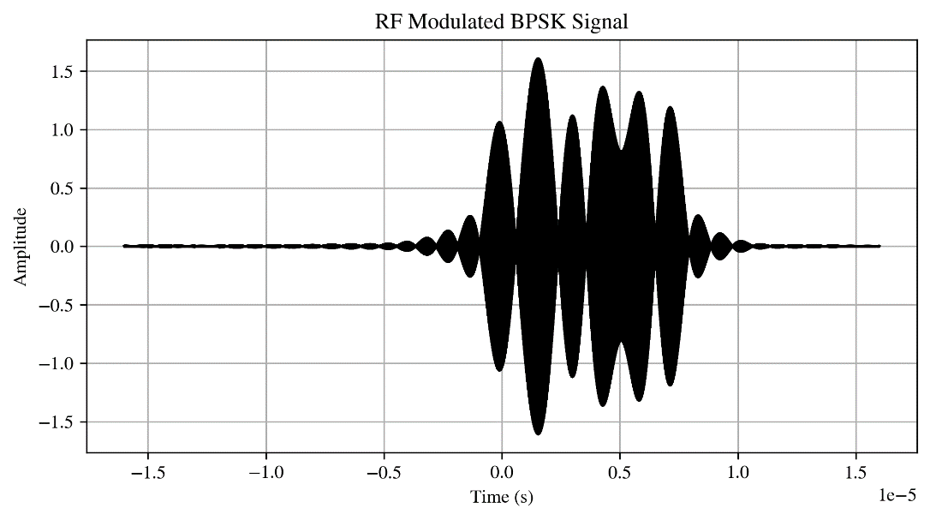

**Problem 5:**

Using the same parameters as in Problem 4, plot the RF modulated QPSK waveform

$$x\left(t\right)=\left[\sum_{n=1}^{8}{x_{n}p_{rrc}(t-nT_{s})}\right]\cos\left(2πf_{c}t\right)-\left[\sum_{n=1}^{8}{y_{n}p_{rrc}(t-nT_{s})}\right]\sin\left(2πf_{c}t\right)$$

Use the same $x_{n}$ sequence as in Problem 4, and let the quadrature symbols of the signal, $y_{n}$, be [-1, -1, 1, 1, 1, -1, 1, -1].

Continuing from the previous problem, we define $y_{n}$ and perform the same steps as before.

y_n = np.array([-1, -1, 1, 1, 1, -1, 1, -1])

shifted_p = np.zeros(len(t))

interval = len(np.arange(0, Ts, 1 / (2 * fc))) + 1

x_t = np.zeros(len(t))

y_t = np.zeros(len(t))

ax, fig = plt.subplots(2, 1, figsize=(7, 8))

for i in range(N):

    shifted_p[interval * i : len(p)] = p[0 : len(p) - interval * i]

    x_t += x_n[i] * shifted_p

    y_t += y_n[i] * shifted_p

    fig[0].plot(t, x_n[i] * shifted_p, linewidth=1.5)

    fig[1].plot(t, y_n[i] * shifted_p, linewidth=1.5)

fig[0].set_xlabel("Time (s)")

fig[0].set_ylabel("Amplitude")

fig[0].set_title(r"BPSK Waveform for Each Symbol $x_n \in \{-1, 1\}$")

fig[0].grid()

fig[1].set_xlabel("Time (s)")

fig[1].set_ylabel("Amplitude")

fig[1].set_title(r"QPSK Waveform for Each Symbol $y_n \in \{-1, 1\}$")

fig[1].grid()

plt.tight_layout()

plt.savefig("p5a.png", dpi=300)

plt.show()

plt.figure(figsize=(8, 4))

plt.plot(t, x_t, "k-", linewidth=1.5)

plt.xlabel("Time (s)")

plt.ylabel("Amplitude")

plt.title("BPSK Signal using RRC with $\\beta$ = 0.25")

plt.grid()

plt.savefig("p5b.png", dpi=300)

plt.show()

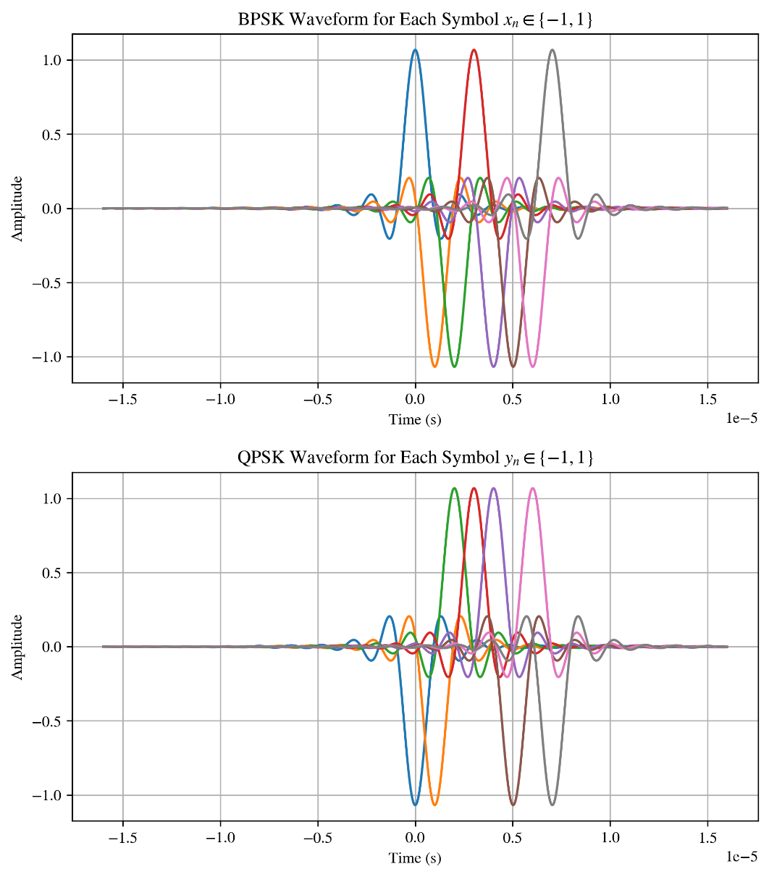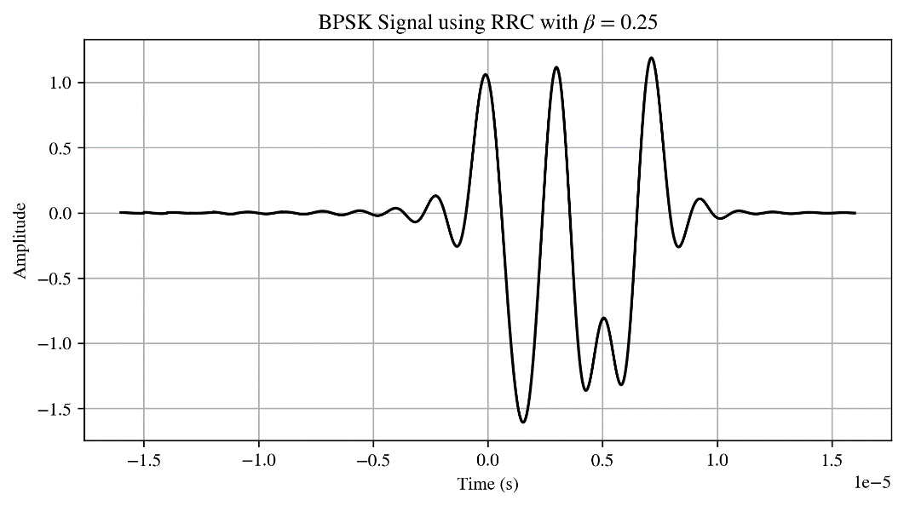

Now, we can define the modulated signal in accordance with the following formula, and visualize it:

$$x\left(t\right)=\left[\sum_{n=1}^{8}{x_{n}p_{rrc}(t-nT_{s})}\right]\cos\left(2πf_{c}t\right)-\left[\sum_{n=1}^{8}{y_{n}p_{rrc}(t-nT_{s})}\right]\sin\left(2πf_{c}t\right)$$

modulated_i = x_t * np.cos(2 * np.pi * fc * t)

modulated_q = y_t * np.sin(2 * np.pi * fc * t)

modulated_p5 = modulated_i - modulated_q

plt.figure(figsize=(8, 4))

plt.plot(t, modulated_p5, "k-", linewidth=1.5)

plt.xlabel("Time (s)")

plt.ylabel("Amplitude")

plt.title("RF Modulated QPSK Signal")

plt.grid()

plt.savefig("p5c.png", dpi=300)

plt.show()

