**GradCompass***Navigate your path to graduate admission*

**Problem**

The graduate school application process can be overwhelming and confusing for students. They may struggle to identify the right programs, professors, and mentors to guide them. Unlike undergraduate admissions, graduate admissions are field-specific and put a far greater emphasis on research.

**Solution & Service Structure**

GradCompass is a platform that provides students with the resources and support they need to navigate the graduate school application process. Following is the breakdown of the service structure.

* **Free Tier**

1. This is a great way to attract users and showcase the platform's value.
2. Consider including some additional resources besides test prep materials, like:
   1. Informational guides on different graduate programs, application timelines, funding opportunities.
   2. Sample CVs and SOPs from successful applicants.
   3. Video tutorials or webinars on application strategies.

* **Pay-Per-Service (Mentorship)**

1. This allows students to access personalized guidance without full subscription commitment.
2. Make mentorship profiles detailed, highlighting mentors' research areas, universities, and expertise.
3. You could offer different mentorship tiers based on experience or hourly rates.

* **Subscription Model**

1. This option caters to students seeking ongoing support throughout the application process.
2. Two free consultations per month with relevant mentors is a good starting point.
3. Consider offering a limited pool of free consultations per mentor to avoid overwhelming them.
4. University comparison tool using AI! Its features:
   1. Ability to compare research funding, acceptance rates, faculty expertise etc. alongside basic program information.
   2. For essay reviews, consider offering different tiers for varying turnaround times or in-depth feedback levels.

**Unique Selling Proposition (USP)**

GradCompass is a one-stop-shop for graduate school applicants. It combines a free tier with valuable resources, a pay-per-service option for mentorship, and a feature-rich subscription model with an AI-powered university comparison tool and essay review service

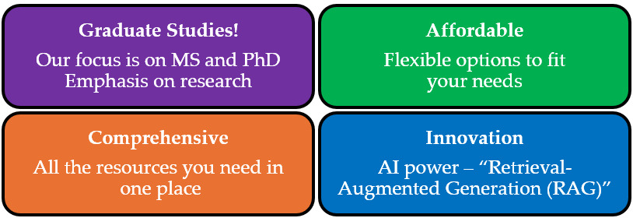

**Industry Analysis / Porter’s Five Forces**

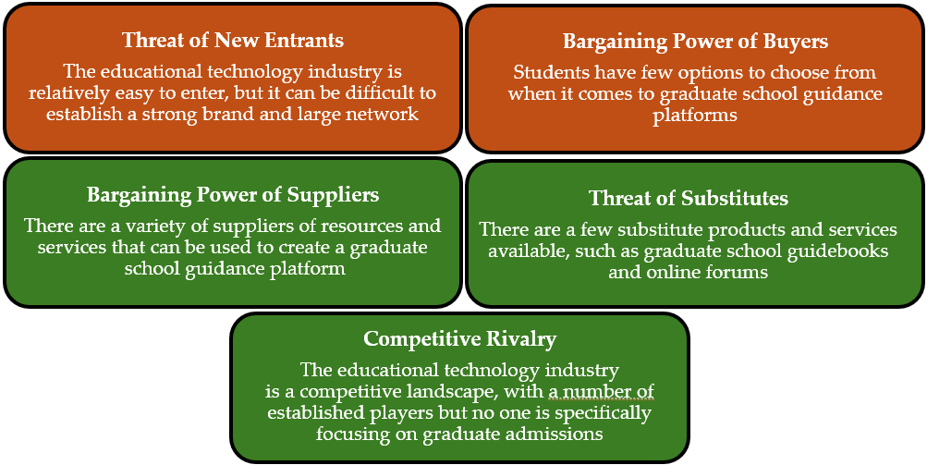

**Building a Strong Mentor Network**

* Offer clear benefits beyond recognition to incentivize participation.
* This could include access to professional development resources, workshops, or networking events.
* Implement a mentor application process to ensure qualified and experienced mentors.
* Facilitate communication between mentors and mentees with a user-friendly platform.

**Content Marketing**

Regularly create informative content like blog posts, webinars, or infographics related to graduate school applications. This attracts users to the platform and establishes your platform as a valuable resource.

**Miscellaneous Q&A**

1. Who is your product / service for?
2. What needs does your product meet?
3. Who is most likely to buy product?
4. What is the target demographic?
5. What is the target psychographic?

* **Needs Met**

1. **Streamlining program discovery:** GradCompass helps users identify relevant programs and universities based on their interests.
2. **Matching with suitable mentors:** The platform connects students with mentors who can provide personalized guidance and insights.
3. **Enhancing application competitiveness:** GradCompass offers tools like an AI-powered university comparison feature and essay review services to strengthen applications.

* **Target Demographic**

1. **Students:** GradCompass caters to individuals seeking admission to graduate programs across various disciplines.
2. **Age:** Typically, these students would be in their senior year of undergrad or recent graduates.

* **Target Psychographic**

1. **Goal-oriented:** These individuals are determined to pursue higher education and are actively seeking guidance to achieve their goals.
2. **Resourceful:** They are likely to be tech-savvy and appreciate the convenience and comprehensiveness of a one-stop online platform.
3. **Ambitious:** They are motivated to succeed in their chosen field and value the mentorship and guidance offered by GradCompass.

**TAM, SAM, and SOM**

* **TAM (Total Addressable Market)**

Represents the entire global market for GradCompass' services, encompassing all prospective graduate students worldwide.

* + According to XYZ, there are roughly around XYZ tertiary education graduates globally each year.
  + While not all graduates pursue higher education, a significant portion does. Assuming a conservative estimate of 25% interested in graduate studies, the TAM would be $→$ 
     TAM = XYZ million graduates/year * 25%
* **SAM (Serviceable Addressable Market)**

Represents the portion of the TAM that GradCompass can realistically reach with its platform.  
We'll focus on two key factors to define the SAM:

* **Geographic Focus**: Initially, GradCompass will target Pakistani graduates. According to HEC, Pakistan produces roughly XYZ graduates annually.
* **English Proficiency**: GradCompass' platform and resources are primarily in English. This limits the SAM to students comfortable using English for academic purposes. The exact percentage is debatable, but a conservative estimate suggests around 40% of Pakistani graduates have strong English proficiency suitable for graduate studies.
* **SOM (Serviceable Obtainable Market)**

Represents the most conservative estimate of the SAM that GradCompass can convert into paying customers within a specific timeframe (e.g., first year).

* **Conservative Estimate:** GradCompass will initially target 5% of the SAM.
* **Subscription Model Adoption Rate:** Not all users obtained will bother converting to paid subscriptions. A conservative estimate might be 20% of the initial estimate.

**Customer Persona**

Meet Ahmed, the Determined Pakistani Graduate Applicant

* **Demographics**
* Age: 24
* Location: Islamabad, Pakistan
* Education: Final year student at National University of Science & Technology (NUST)
* Major: Electrical Engineering
* **Psychographics**

1. **Goals:** Aspires to pursue a Master's degree in Artificial Intelligence (AI) at a prestigious university abroad.
2. **Values:** Highly ambitious and driven. Prioritizes academic excellence and international exposure.
3. **Pain Points:** Limited access to local resources on international graduate programs. Feels a disconnect with the application process for foreign universities. Seeks guidance from mentors who have experience studying abroad.

* **Behaviours**
* Actively researches universities and programs online but struggles to find information specific to Pakistani students.
* Regularly attends career fairs and information sessions at his university.
* Values the opinions of international alumni and professors who can provide insights into foreign graduate programs.
* Seeks scholarships and financial aid opportunities to support his studies abroad.
* **How Grad Compass Helps Ahmed**
* Grad Compass provides Ahmed with a platform to explore AI programs at universities worldwide, catering to international students.
* The platform's resources and guides translate well to the Pakistani context, addressing specific requirements and application procedures for Pakistani students.
* Ahmed can connect with mentors on GradCompass who have experience studying AI abroad, particularly those from Pakistan. This mentorship provides valuable cultural and academic guidance throughout the application process.
* GradCompass offers essay review services tailored to international applications, ensuring Ahmed's essays resonate with admissions committees abroad.