

**National University of Sciences & Technology**

School of Electrical Engineering & Computer Science

**CS250 – Introduction to Entrepreneurship**

**GradCompass** – Business Plan

|  |  |
| --- | --- |
| Names | CMS ID |
| Danial Ahmad | 331388 |
| Muhammad Ahmed Mohsin | 333060 |
| Muhammad Ali Farooq | 331879 |
| Muhammad Umer | 345834 |
| Syeda Fatima Zahra | 334379 |
| Faculty Member | Dr. Zunaira Saqib |
| Class | BEE 12-C |
| Date | 22/05/2024 |

**Executive Summary**

GradCompass is an innovative AI-powered platform designed to empower international students, particularly those from Pakistan, in their journey to achieve graduate school success. We offer a unique combination of personalized mentorship, an AI-driven university comparison tool, and valuable free resources, all designed to streamline the complex application process, increase acceptance rates, and provide a comprehensive support system.

* **Problem Statement:** The graduate school application process poses significant challenges, particularly for students from developing countries like Pakistan with limited access to information, mentorship, and resources. Students often struggle to identify relevant research interests and programs, find suitable professors, connect with experienced mentors, and navigate the diverse application requirements and processes.
* **Solution:** GradCompass addresses these challenges by providing a comprehensive platform with both free and premium services:
* *GradCompare:* Our AI-powered university comparison tool generates detailed comparisons of universities and programs based on user input (desired country, program, and specialization).
* *One-on-One Mentorship Services:* Students connect with experienced mentors who provide personalized guidance on various aspects of the application process, including essay review, research proposal assistance, interview preparation, and career advice.
* *Free Resources:* We offer valuable informational guides, blog posts, webinars, and sample application materials to provide students with valuable insights and resources.
* **Value Proposition:** GradCompass is a one-stop shop for graduate school applicants, offering unparalleled convenience and value. Our unique combination of AI-powered university comparison, personalized mentorship, and a freemium model caters to a wide range of needs and budgets.
* **Market & Competitor Analysis:** The global education consulting market is growing rapidly, with a significant need for specialized platforms catering to graduate school applications. While companies like *HR Pakistan* and *Kestrel Education* focus on undergraduate admissions, none particularly utilize AI to address the significant time investment required for researching schools and professors. GradCompass fills this gap by offering a dedicated platform with a powerful AI tool and a personalized approach.
* **Funding & Financial Summary:** To achieve key next steps such as *fine-tuning the AI model, improving platform security and user experience, marketing, and outreach, and recruiting mentors*, GradCompass requires an initial investment of $3,500 USD for further AI model development, platform security enhancements, and marketing efforts.

Our pricing strategy aims to provide flexibility for students, allowing them to choose the level of support that best suits their needs and budget. We project a strong revenue stream during the peak graduate application season *(July-December)* with the potential for profitability.

**Table of Contents**

2 Introduction 3

2.1 Company Description 3

2.2 Team Description 3

3 Problem & Solution 4

3.1 Problem 4

3.2 Solution 4

4 Industry & Competitor Analysis 5

4.1 Industry Insights 5

4.2 Porter’s Five Forces 6

4.3 Competitor Analysis 7

5 Unique Selling Proposition 9

6 Target Market & Customer Personas 10

6.1 Target Audience 10

6.2 Customer Persona – 1 11

6.3 Customer Persona – 2 12

7 Social Media & Online Presence 13

7.1 Instagram 13

7.2 LinkedIn 13

7.3 Facebook 14

7.4 Website 15

8 Prototype: GradCompare 16

9 Conclusion 18

# Introduction

## Company Description

* **Name:** GradCompass
* **Tagline:** Navigate your path to graduate admission
* **Logo:**

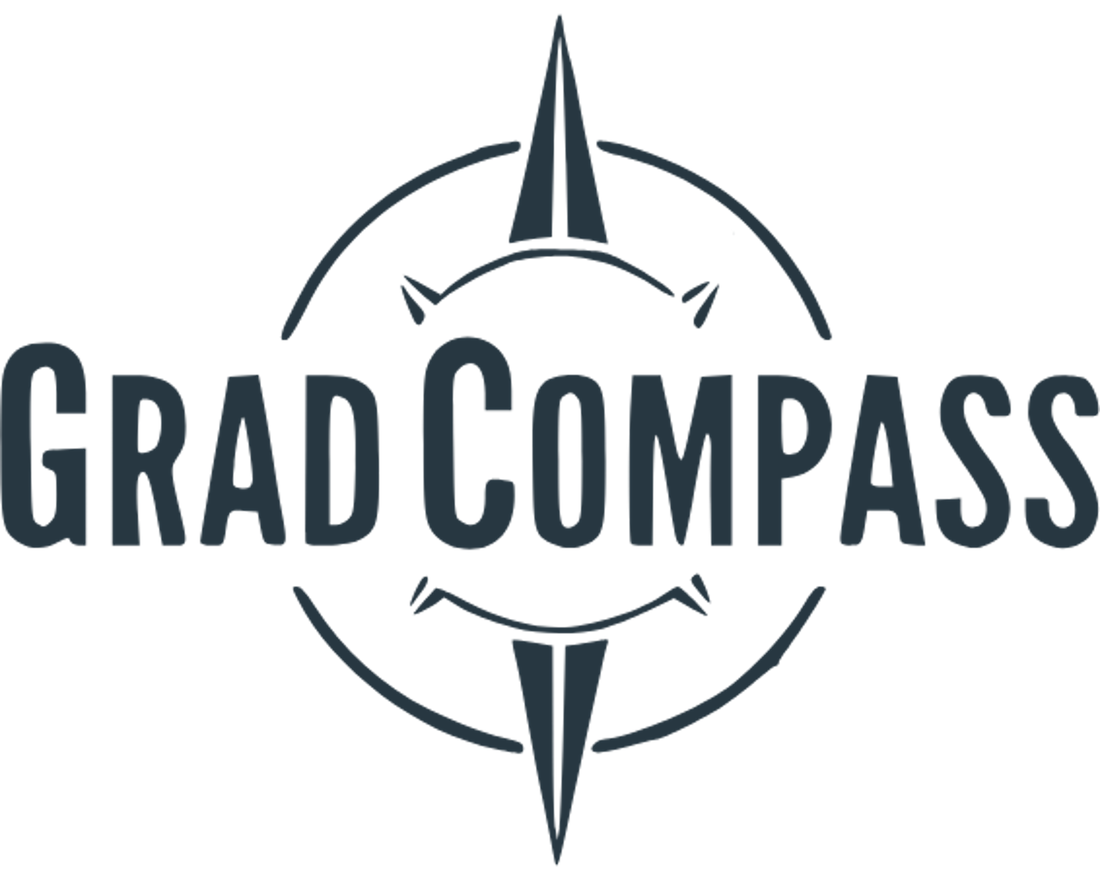

* **Mission Statement:** To empower students from diverse backgrounds to achieve their graduate school aspirations by providing accessible, personalized, and AI-driven support.
* **Vision Statement:** To be the leading platform for aspiring Pakistani graduate school applicants, connecting students with mentors and resources to navigate the complex application process with confidence and success.

## Team Description

* **Members:**

1. *Danial Ahmad:* As the Chief Operating Officer, Danial ensures the smooth operation of GradCompass. His meticulous planning and resource management skills guarantee efficient execution across all areas of the startup.
2. *Muhammad Ahmed Mohsin:* Ahmed, a PhD admit at Stanford University, is the visionary behind GradCompass. Drawing upon his personal experience navigating the graduate school application process, he provides valuable guidance and insights to our users.
3. *Muhammad Ali Farooq:* Ali, a PhD admit at Arizona State University, brings a diverse perspective to the team. His academic expertise complements Ahmed's vision, and his financial management skills ensure responsible resource allocation.
4. *Muhammad Umer:* As our Lead AI Developer, Umer possesses deep expertise in artificial intelligence. He is the mastermind behind the creation and development of our core technology, GradCompare, which provides a powerful AI-driven solution for university and program comparison.
5. *Syeda Fatima Zahra:* Fatima is a creative powerhouse, leveraging her skills in marketing, photography, and digital content creation to spearhead GradCompass's social media marketing efforts. She develops compelling content that engages our audience and builds a strong brand identity.

* **Key Skills and Expertise**

GradCompass thrives on its diverse and highly skilled team. Ahmed, our CEO with his PhD experience, brings invaluable leadership and guidance. Ali's PhD background and financial expertise complement Ahmed's vision. Umer's AI prowess ensures our technological edge, while Fatima's marketing expertise ensures strong visibility and a captivating brand image. Danial's operational expertise keeps the entire startup running smoothly and efficiently. This perfect blend of skills positions GradCompass for success.

# Problem & Solution

## Problem

* **Problem Statement:** The graduate school application process is complex and overwhelming for many students, particularly those from developing countries with limited access to information, mentorship, and resources. Students often struggle to:

1. Identify relevant research interests and programs.
2. Find suitable professors and research opportunities.
3. Connect with experienced mentors who can provide guidance.
4. Navigate the diverse application requirements and processes.

* **The 4 W’s of the Problem**
* **Who:** Primarily affects students in Pakistan aspiring to pursue graduate studies abroad, especially in research-oriented fields.
* **What:** Leads to missed opportunities, mismatched program selections, lower acceptance rates, and increased stress and anxiety for applicants.
* **Where:** Problem exists globally but is particularly pronounced in regions with limited access to educational consulting and mentorship resources, such as Pakistan.
* **When:** Arises throughout the entire graduate school application journey, from initial research and program selection to application submission and interview preparation.

## Solution

* **Product Description:** GradCompass is an AI-powered platform that provides students with personalized guidance and support throughout the graduate school application process. It offers a combination of free and premium services, including:
  + **GradCompare:** AI-powered university comparison tool; Generates detailed comparisons of universities and programs based on user-defined criteria, including research areas, faculty profiles, funding options, and more.
  + **One-on-One Mentorship Services:** Connects students with experienced mentors who provide personalized guidance on various aspects of the application process, such as essay review, research proposal assistance, interview preparation, and career advice.
  + **Free Resources:** Includes informational guides, blog posts, webinars, and sample application materials.
* **Addressing Pain Points**

1. GradCompare helps students overcome the challenge of finding relevant programs by providing detailed information and comparisons based on their specific interests and goals.
2. Our platform connects students with experienced mentors who have relevant experience and expertise in their desired field, providing personalized guidance and support.
3. offers a variety of free resources, such as guides, webinars, and sample materials, to help students prepare strong applications.

* **Making a Difference in Customer’s Life**

By providing a comprehensive and supportive platform, GradCompass helps students navigate the complex graduate school application process with greater confidence and ease. It reduces stress and anxiety, increases chances of acceptance into desired programs, empowers students to make informed decisions, and saves valuable time and effort. This ultimately allows students to focus on their academic goals and achieve their full potential.

* **Monetization Strategy (how we plan to make money)**

Our pricing strategy aims to provide flexibility for students, allowing them to choose the level of support that best suits their needs and budget. The revenue generated through premium subscriptions and additional services will be used to further develop the platform, attract more mentors, and expand its reach to a wider audience. Specifically, following pricing structure is utilized:

* **Base Package:** 1-month access to GradCompare + 4 hours of personalized mentorship = Rs. 15,000
* **Additional Mentor Hours:** Rs. 8,000 per hour
* **Mentor Revenue Split:** 85% for the mentor, 15% for GradCompass
* **Essay Review/Evaluation:** Rs. 7,000 per essay review

# Industry & Competitor Analysis

**Industry:** GradCompass operates within the growing educational consulting market (Figure 1), specifically targeting the graduate school application segment.

## Industry Insights

The global education consulting market is experiencing significant growth, fueled by the increasing demand for higher education and the complexities of navigating the admission process. GradCompass operates within this dynamic market, specifically targeting the graduate school application segment, particularly for research-oriented programs.

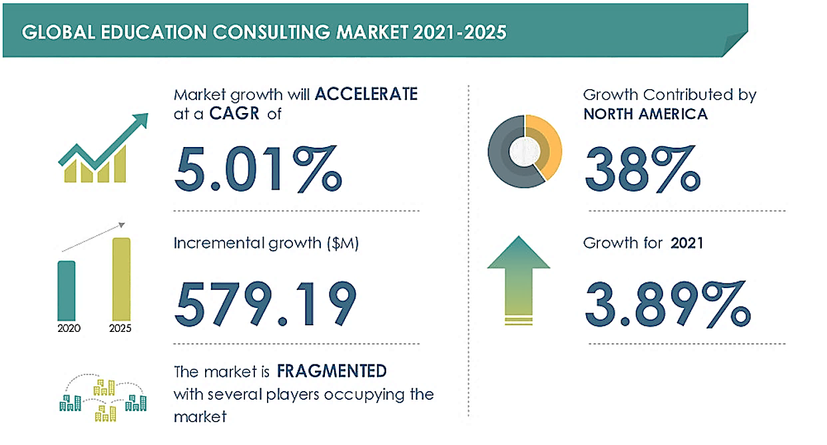

Figure 1: Latest Education Consulting Market forecast and analysis (2021-2025),  
*Source: Technavio*

* **TAM** (Total Addressable Market)

*The World Bank estimates that over 220 million students are currently enrolled in tertiary education worldwide* [[Source: WorldBank](https://www.worldbank.org/en/topic/tertiaryeducation)]. Assuming a conservative estimate of *15%* pursuing graduate studies, the TAM for GradCompass's services encompasses approximately *33 million potential graduate students globally*.

* **SAM** (Serviceable Addressable Market)

*Focusing on Pakistan, the Higher Education Commission (HEC) reports an annual production of around 445,000 graduates* [[Source: HEC](https://www.hec.gov.pk/english/universities/hes/Pages/HEDR-Statistics.aspx)]. However, GradCompass's platform and resources are primarily in English, limiting its SAM to students comfortable using English for academic purposes. Conservatively, this could be estimated as around 40% of Pakistani graduates, resulting in a SAM of approximately *178,000 potential users annually*.

* **SOM** (Serviceable Obtainable Market)

Within the first two years, GradCompass aims to capture a conservative 5% share of the SAM in Pakistan, translating to serving over *8,900 Pakistani graduates* seeking international graduate school opportunities.

## Porter’s Five Forces

1. **Threat of New Entrants** (Moderate to High)

* **Low Barrier to Entry:** It is relatively easy to enter the educational consulting market, particularly for online platforms. This is due to low capital requirements and the accessibility of technology.
* **Difficult to Build Brand and Network:** While entering is easy, building a strong brand and establishing a network of reputable mentors is challenging. Establishing trust and credibility with students and mentors requires time, effort, and a successful track record.

1. **Bargaining Power of Buyers** (Moderate)

* **Limited Options for Students:** Graduate school applicants have limited options for reputable and specialized consulting services, particularly for those seeking research-oriented programs. This gives students some bargaining power as they can choose the platform that best meets their specific needs.
* **Limited Price Sensitivity:** Students are typically highly motivated to achieve their graduate school aspirations and are willing to invest in services that offer valuable support and increase their chances of acceptance. This makes them less price-sensitive and increases the potential for GradCompass to charge premium rates for its services.

1. **Bargaining Power of Suppliers** (Moderate)

* **Diverse Resources and Services:** The availability of diverse resources and services in the educational consulting market gives suppliers (mentors, AI tools, etc.) significant bargaining power. GradCompass must carefully manage its relationships with suppliers to ensure access to high-quality mentors and technology.

1. **Threat of Substitutes** (Low)

* **Few Alternatives:** While alternatives exist, such as guidebooks, online forums, and university websites, they often lack the personalized guidance and comprehensive support that GradCompass offers. The lack of personalized services makes these alternatives less effective for students seeking tailored assistance with their graduate applications.

1. **Competitive Rivalry** (Moderate)

* **Competitive Landscape: The** educational consulting market is highly competitive, with various players offering similar services. The key differentiators lie in the specialization, the use of technology, and the quality of mentorship provided.
* **No Clear Focus on Graduate Admissions:** While some competitors offer services for graduate admissions, there is no clear focus on research-oriented programs, creating an opportunity for GradCompass to specialize in this niche market.

## Competitor Analysis

The educational consulting landscape in Pakistan is characterized by several players, each catering to a specific segment of the market. While several agencies offer services for postgraduate admissions, GradCompass stands apart by specializing in graduate research applications, leveraging AI tools, and offering personalized mentorship.

Here's a comparative analysis of GradCompass's key competitors:

* **HR Pakistan**

1. **Strengths:** HR Pakistan is a well-established competitor, offering a wide range of services for students across all levels of higher education, including postgraduate admissions. They provide free consultations and support with application documents, interview preparation, and visa processing.
2. **Weaknesses:** HR Pakistan's broad focus, encompassing both undergraduate and postgraduate admissions, may dilute their expertise in navigating the complexities of graduate research applications. They lack dedicated AI-powered tools for efficient university comparison, rely on traditional methods for program research, and provide limited information on research opportunities and faculty expertise. Their consultant profiles lack transparency, making it difficult for students to assess their experience and research interests.

* **Kestrel Education**

1. **Strengths:** Kestrel Education focuses on holistic student development, offering services beyond admissions, including career development, personal growth, and social-emotional learning. They provide unique services like summer schools and exchange programs, emphasizing experiential learning and practical skills development.
2. **Weaknesses:** Kestrel's broader target audience, encompassing both secondary and tertiary levels, may not fully address the specific needs of graduate students seeking research-oriented programs. Their website lacks clear information on their postgraduate services, making it difficult for prospective graduate students to understand the depth and effectiveness of their offerings in this niche.

* **Crossroad Consultants**

1. **Strengths:** Crossroad Consultants offers a broad range of services, including career counseling, visa assistance, and scholarship guidance, catering to students applying to universities in various countries.
2. **Weaknesses:** Crossroad Consultants lack the specific focus on graduate research applications and the AI-powered tools that GradCompass leverages. Their services, while valuable, are not as tailored to the unique needs of research-focused graduate applicants.

* **Our Competitive Advantage**
* **AI-Powered Efficiency:** While competitors offer some form of university information, GradCompass's GradCompare tool distinguishes itself by providing AI-powered, detailed comparisons of programs, based on user-specific needs. This saves students countless hours of manual research and streamlines their program discovery process.
* **Specialized Expertise:** GradCompass specializes in graduate research applications, allowing us to offer a deeper understanding of the unique challenges and requirements of this segment. Our mentors have specific expertise in research-oriented fields and are well-versed in navigating the complex application process for these programs.
* **Personalized Mentorship:** Our mentors provide individualized guidance and support, available online and accessible to a wider audience. This ensures students receive tailored advice and support based on their specific academic goals, research interests, and career aspirations.

Table 1: Competitive Analysis Table

|  |  |  |  |  |
| --- | --- | --- | --- | --- |
| **Feature** | **GradCompass** | HR Pakistan | Kestrel Education | Crossroad Consultants |
| **Product Quality** | *High* (AI-powered tools, personalized mentorship) | *Moderate* (broad range of services) | *Varied* (broad target audience) | *Moderate* (traditional approach) |
| **Product Fidelity** | *Transparent* (detailed mentor profiles, clear program information) | *Limited* (basic program information, limited consultant transparency) | *Unclear* (limited information on graduate services) | *Limited* (website details, focus on application process) |
| **After-Sales Service** | *Limited* (focus on the application process) | Unclear (lack of detailed information on post-application support) | *Unclear* (services unclear) | *Limited* (focus on application process) |
| **Customer Service** | *Responsive* (online platform, accessible mentorship) | *In-person only* | *Online & Offline* | Online |
| **Price** | *Freemium* (free resources, paid premium tier) | *Free consultations, service fees* | *Varies* (by service) | *Varies* (by service) |

# Unique Selling Proposition

GradCompass is a comprehensive and AI-driven platform that provides personalized mentorship and resources to help students navigate the complex graduate school application process, especially for research-oriented programs.

**Graduate Studies!**

Our focus is on MS and PhD  
Emphasis on research

**Comprehensive**

All the resources you need in one place

**Innovation**

AI powered  
*\*Retrieval-Augmented Generation (RAG)*

1. **Focus on Graduate Education:** Specializes in supporting students seeking admission to research-intensive graduate programs, addressing a specific niche market.
2. **Personalized Mentorship:** We offer tailored guidance and support from experienced mentors with specific expertise, creating a personalized experience for students. This mentorship provides all the resources you need in one place, from essay review to interview preparation and career advice.
3. **AI-Powered University Comparison**: Sets GradCompass apart by offering a unique and efficient tool for program discovery. GradCompare leverages \**Retrieval-Augmented Generation (RAG)*, an innovative AI technology that allows for fact-checking and ensures the accuracy of the information provided.

* **Differentiation (what makes us different)**

Currently, mentor programs primarily focus on undergraduate studies abroad, and while forums exist online, they lack personalization and comprehensive support. GradCompass fills this gap by offering a dedicated platform specifically designed for graduate school applicants, particularly those seeking research-oriented programs.

Furthermore, we address the critical need for efficient program research by offering GradCompare, which significantly reduces the time students spend searching for professors, their contacts, and research interests.

* **Sustainability (and is our solution sustainable?)**

GradCompass's sustainability rests on its unique value proposition, which combines a powerful AI tool with a specialized focus on graduate education, particularly for research-oriented programs. *While other startups may utilize AI, we aim to build a strong brand image for both mentors and students by offering competitive benefits and showcasing a portfolio of successful students who have gained acceptance to their desired programs through our services.* This fosters **trust** and **loyalty**, making it more likely that students and mentors will choose GradCompass over other platforms. We are committed to **continuous innovation**, incorporating new features and resources to stay ahead of the curve and maintain our position as the leading platform for graduate school applications.

# Target Market & Customer Personas

## Target Audience

GradCompass primarily focuses on Pakistani students aspiring to pursue graduate studies abroad. We cater to those who seek personalized guidance and mentorship to navigate the complexities of international graduate applications.

1. **What Needs Does Your Product or Service Meet?**

Our platform addresses the need for comprehensive information on international graduate programs, simplifies the application process, and provides access to expert mentorship, ultimately increasing students' chances of admission success.

1. **Who Is Most Likely to Buy Your Product or Service?**

Ambitious students with strong academic backgrounds who recognize the value of personalized guidance and are willing to invest in premium services to achieve their graduate school aspirations.

1. **Demographics:**

* **Age:** 22-28
* **Location:** Primarily Pakistan, with potential expansion to other developing countries.
* **Education Level:** Undergraduate students in their final year or recent graduates.

1. **Psychographics:**

* **Goal-Oriented:** Driven to achieve their graduate school aspirations.
* **Resourceful:** Tech-savvy and comfortable using online platforms.
* **Ambitious:** Seeking to advance their careers and make a positive impact.

## Customer Persona – 1

*“Meet Ahmed, the determined Pakistani graduate applicant”*

* **Demographics**
* Age: 24
* Location: Islamabad, Pakistan
* Education: Electrical Engineering, final year student at National University of Science & Technology (NUST)
* **Psychographics**

1. **Goals:** Aspires to pursue a PhD degree in Electrical Engineering at a prestigious university in the USA.
2. **Values:** Highly ambitious and driven. Prioritizes academic excellence and international exposure.
3. **Pain Points:** Limited access to local resources on international graduate programs. Feels a disconnect with the application process for foreign universities. Seeks guidance from mentors who have experience studying abroad.

* **Behaviors**
* Actively researches universities and programs online but struggles to find information specific to Pakistani students.
* Regularly attends career fairs and information sessions at his university.
* Values the opinions of international alumni and professors who can provide insights into foreign graduate programs.
* Seeks scholarships and financial aid opportunities to support his studies abroad.
* **How Grad Compass Helps Ahmed**
* GradCompare helps Ahmed efficiently identify relevant Electrical Engineering PhD programs at universities across the USA, filtering by research areas, faculty expertise, and funding opportunities. This saves him countless hours of manual research and ensures he focuses on programs that truly align with his goals.
* Ahmed connects with mentors on GradCompass who have experience studying Electrical Engineering in the USA, particularly those from Pakistan. These mentors provide valuable cultural and academic guidance throughout the application process, addressing specific challenges faced by Pakistani students.
* GradCompass offers essay review services tailored to international applications, ensuring Ahmed's essays resonate with admissions committees abroad.
* Ahmed has access to free resources like informational guides, blog posts, and webinars that provide insights into the application process, funding options, and life as a graduate student in the USA.

## Customer Persona – 2

*“Meet Fatima, the aspiring computer scientist”*

* **Demographics**
  + Age: 23
  + Location: Lahore, Pakistan
  + Education: Biotechnology, recent graduate from the University of Karachi
* **Psychographics**

1. **Goals:** Aspires to pursue a Masters degree or PhD in Biotechnology or a related field at a renowned university in Europe, known for its cutting-edge research in biotechnology.
2. **Values:** Driven by a desire to make a positive impact on society through scientific advancements.
3. **Pain Points:** Feels uncertain about the specific area of biotechnology to specialize in for her graduate studies. Struggles to find detailed information about research labs and faculty working on her areas of interest at international universities.

* **Behaviors**
  + Actively involved in research projects during her undergraduate studies, potentially with publications or presentations at conferences.
  + Seeks opportunities to gain practical experience through internships or volunteer work in research labs or biotechnology companies.
  + Networks with professors and professionals in the field to gain insights into career paths and opportunities in biotechnology.
* **How Grad Compass Helps Fatima**
* GradCompare helps Fatima pinpoint Biotechnology programs in Europe that align with her research interests and career goals. It allows her to compare universities based on specific research areas, faculty expertise, and funding opportunities, providing a clear path for her research specialization.
* Fatima connects with mentors on GradCompass who have experience in Biotechnology research in Europe, offering personalized guidance and insights into the field. This mentorship helps her refine her research interests, navigate the complex application process, and prepare for potential interviews.
* GradCompass provides Fatima with access to free resources like informational guides, blog posts, and webinars that address specific challenges faced by international students, including funding options and visa requirements for studying in Europe.
* GradCompass offers essay review services tailored to international applications, ensuring that Fatima's essays effectively communicate her unique strengths and research interests to admissions committees abroad.

# Social Media & Online Presence

## Instagram

GradCompass's Instagram page is a vibrant hub for international students navigating the graduate school application journey. With **over 270 followers** and many engaging posts, we connect with students, share valuable insights, and inspire them to achieve their academic goals. Our team of highly experienced mentors, including esteemed Erasmus Mundus Scholars and incoming PhD students at renowned US institutions, provides invaluable guidance and strategies to enhance application success. Follow us for:

* Expert advice and insights from our team of mentors
* Regular updates on GradCompass's progress and initiatives
* Inspiring success stories of students who have achieved their graduate school goals with our support

**Link:** <https://www.instagram.com/gradcompass/>

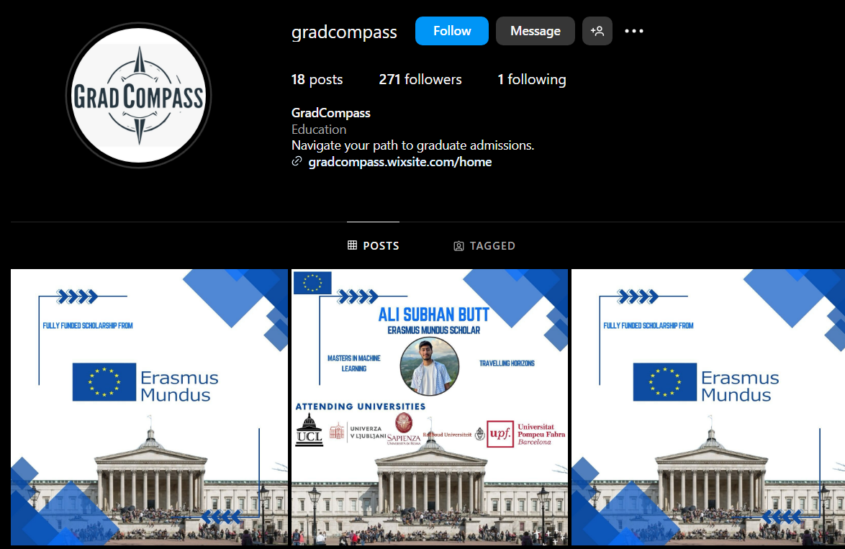

## LinkedIn

GradCompass's LinkedIn page serves as a professional platform for connecting with our network of over **480 followers**. We are dedicated to supporting international students through the complexities of graduate school applications and fostering a community of academic excellence. Our team of highly experienced mentors, including esteemed Erasmus Mundus Scholars and incoming PhD students at renowned US institutions, are actively involved in the GradCompass community. They have highlighted their commitment to our mission by mentioning GradCompass in their portfolios, showcasing their dedication to providing invaluable guidance and strategies for application success.

**Link:** <https://www.linkedin.com/company/gradcompasss/>

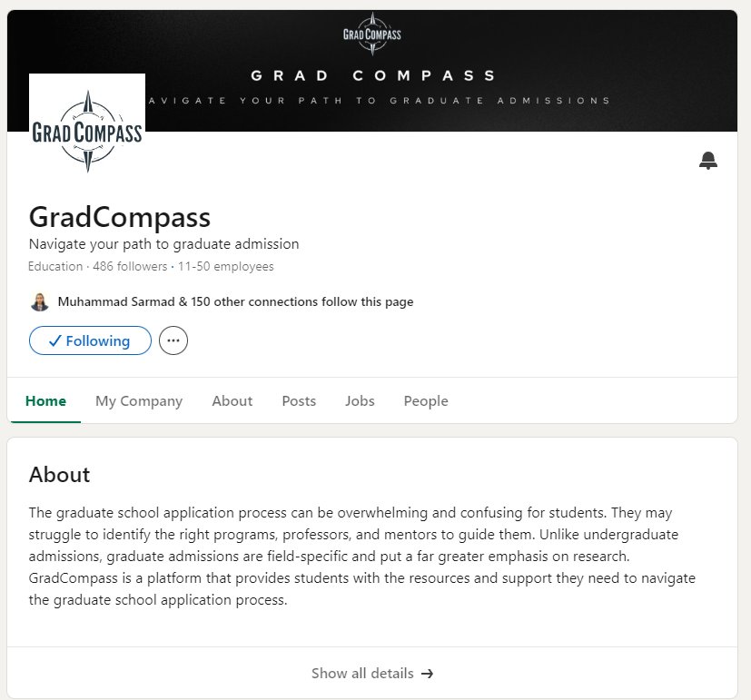

## Facebook

GradCompass's Facebook page is a vibrant online community where we connect with international students aspiring to pursue graduate studies. We share valuable insights, expert advice, and inspiring stories to support students on their academic journeys. Join our Facebook community for:

* Regular Updates: Stay informed about the latest trends, resources, and opportunities in graduate admissions.
* Expert Insights: Access valuable advice and tips from our team of mentors, covering a wide range of academic fields and research areas.
* Inspiring Stories: Be motivated by the success stories of students who have achieved their graduate school goals with our support.

**Link:** <https://www.facebook.com/profile.php?id=61557897663233>

## Website

GradCompass's website is a comprehensive resource for international students navigating the graduate school application process. It provides a clear and user-friendly platform for accessing our services, exploring helpful resources, and connecting with our community. Following is the breakdown of key sections:

* **About Us:** This section introduces GradCompass, outlining our mission and goals. It highlights how we empower students through personalized guidance, innovative tools, and a supportive community.
* **Home:** The homepage provides an overview of GradCompass, showcasing our key features and services. We emphasize our commitment to helping students achieve their academic goals through AI-powered tools and expert mentorship.
* **Our Services:** This page details the various services offered by GradCompass, including mentoring, essay writing support, CV creation, and the GradCompare tool. Each service is described in terms of its benefits and how it supports students in their application process.
* **Blog:** The blog section contains insightful articles and posts that provide tips, advice, and guidance on different aspects of graduate school applications. We cover topics like writing a Statement of Purpose (SoP), preparing for interviews, and finding scholarships.
* **GradCompare:** This page has a demo of the GradCompare tool, which uses AI to generate detailed comparison documents for universities and programs based on user inputs. It highlights the tool's capabilities in comparing curricula, faculty, funding opportunities, and more.

**Link:** <https://gradcompass.wixsite.com/home/>

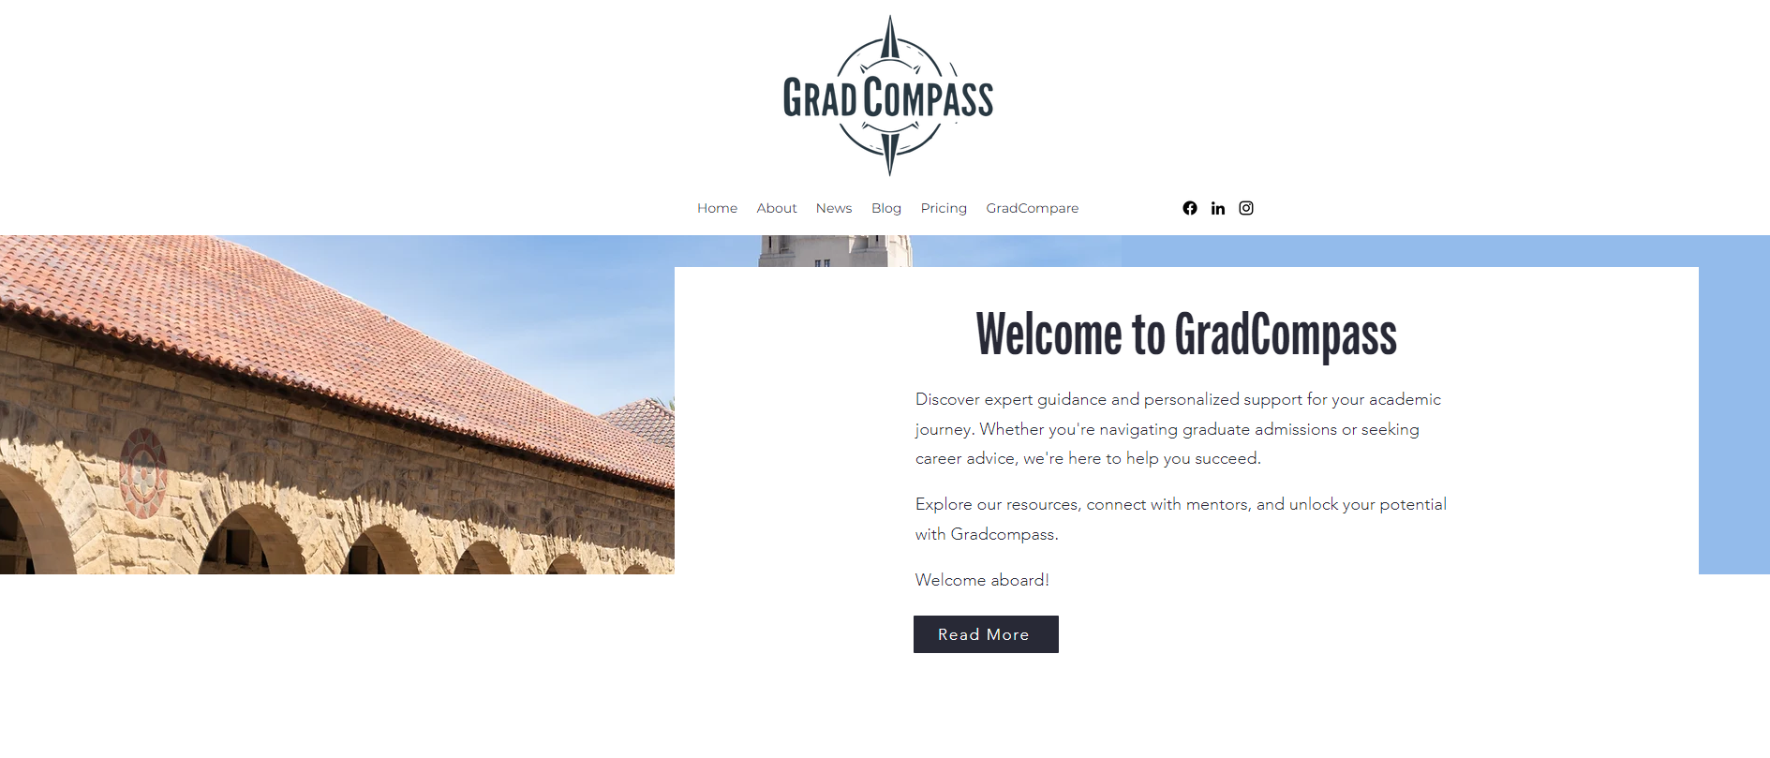

# Prototype: GradCompare

GradCompare is the heart of GradCompass, offering a powerful and unique tool for students seeking to navigate the complex world of graduate school applications. By utilizing cutting-edge AI technology, GradCompare streamlines the research process and provides comprehensive comparisons of universities and programs, saving you countless hours of manual searching.

Following is an overview of how this AI tool works:

1. **User Input:** You simply input your desired country, university, and specialization for your graduate studies.
2. **Data Extraction:** GradCompare utilizes web scraping techniques to gather information from university websites, faculty profiles, and Google Scholar to gather data on professors and their recent research interests.
3. **Data Processing:** The extracted data undergoes a process of indexing and optimized tokenizing, preparing it for AI analysis.
4. **AI-Powered Generation:** We use a fine-tuned Gemini 1.5 model to generate a detailed comparison document based on your input. This document includes:

* **General Overview:** A concise overview of the university's research labs and their accomplishments in your chosen specialization.
* **Accomplishments:** Highlights key achievements, publications, and projects of the university's labs.
* **Comparison Table:** A clear and concise table comparing:
* **QS Ranking:** The university's ranking according to the prestigious QS World University Rankings.
* **Estimated Stipend Amount:** Information on potential funding and scholarships available for graduate students in your specialization.
* **Core Research Areas:** The primary research areas within your specialization at the university.
* **Relevant Active Faculty Members:** A list of professors actively conducting research in your area of interest.

**Link:** <https://gradcompass.wixsite.com/home/gradcompare>

* **Interface**

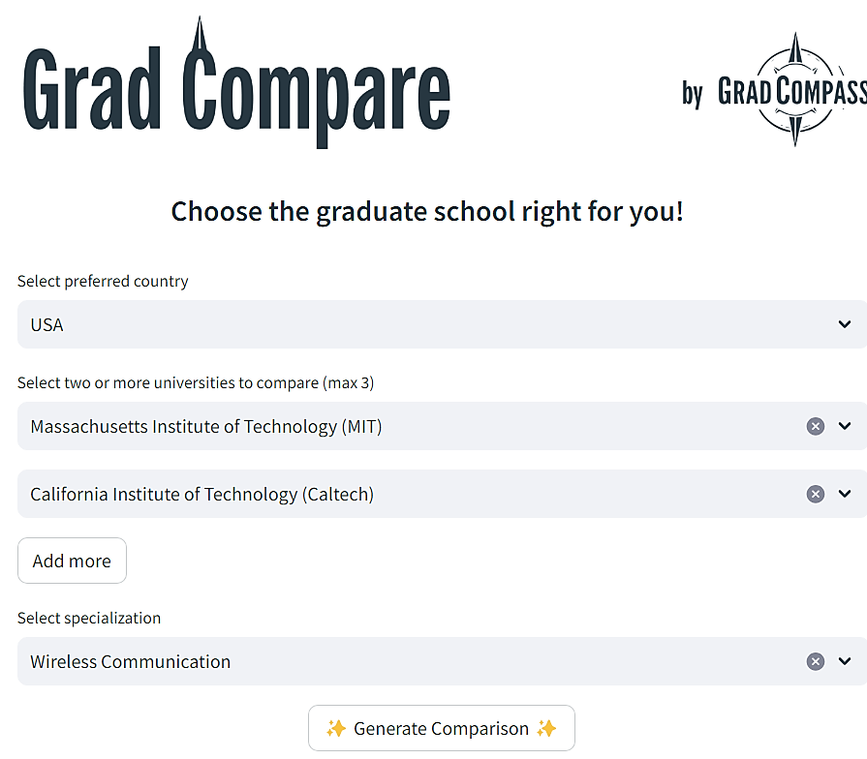

* **Sample Output**

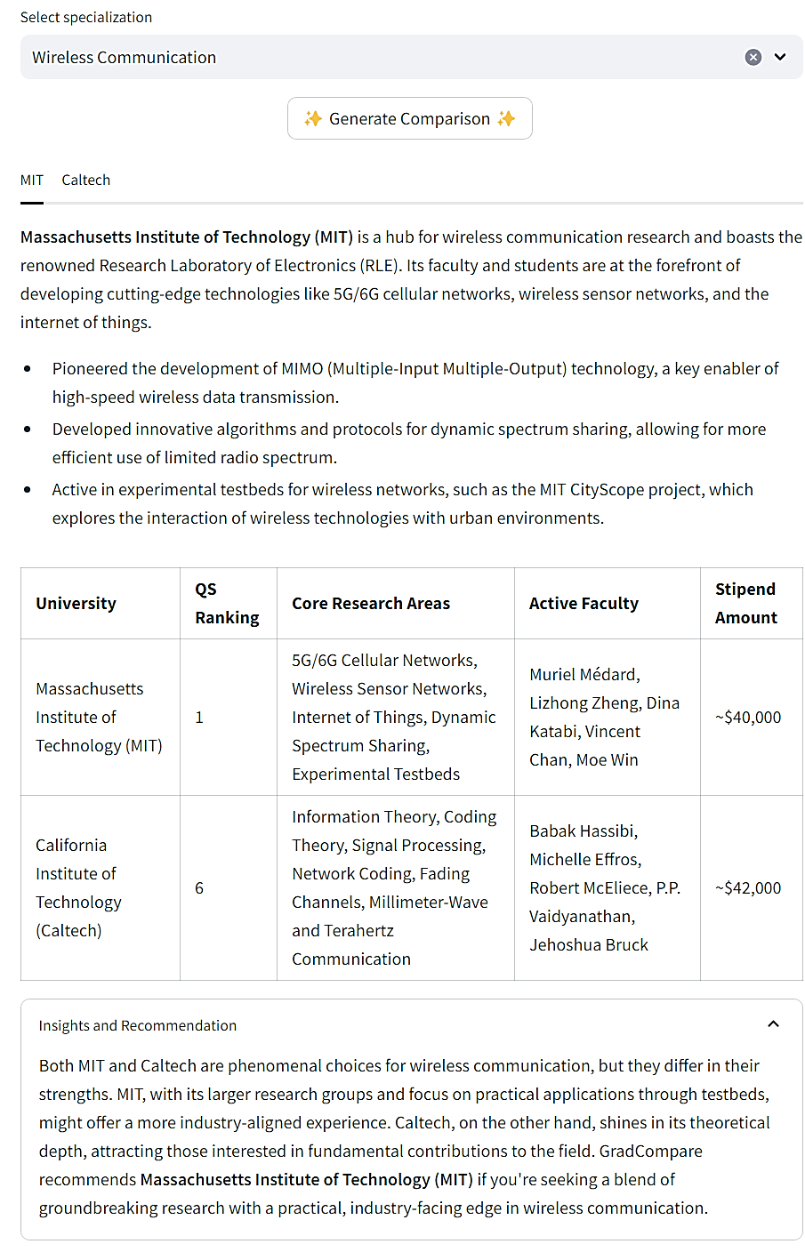



# Conclusion

GradCompass presents a compelling solution to the challenges faced by international students navigating the complex landscape of graduate school applications, particularly those seeking research-oriented programs. Our AI-powered platform, combined with personalized mentorship from experienced professionals, offers a unique blend of efficiency, support, and tailored guidance that empowers students to achieve their academic aspirations.

By leveraging the power of technology, we are disrupting the traditional approach to educational consulting. GradCompare, our AI-powered university comparison tool, saves students countless hours of manual research, while our network of dedicated mentors provides personalized support throughout the application process. This combination of innovative technology and personalized guidance creates a one-stop shop for graduate school applicants, addressing a specific gap in the market and offering a comprehensive solution that is unmatched by competitors.

*“The future of graduate admissions lies in innovation and accessibility. GradCompass is poised to lead this transformation, empowering students from diverse backgrounds to achieve their academic goals and contribute to a brighter future. As we continue to evolve and expand our platform, we are confident in our ability to make a lasting impact on the world of education and provide a truly transformative experience for aspiring graduate students.”*