

**NATIONAL UNIVERSITY OF SCIENCES & TECHNOLOGY**

**Robotics (EE-381)**

Assignment 1 (CLO-1 [C2])

**Group Members**

|  |  |  |
| --- | --- | --- |
| **Name** | **CMS ID** | **Question(s) Attempted** |
| Muhammad Abdullah Sohail | 343642 | Q2 – Part 1, Q3 – Part 3 |
| Muhammad Ahmed Mohsin | 333060 | Q1 – Part 1, Q2 – Part 2 |
| Muhammad Umer | 345834 | Q1 – Part 2&3 |
| Hassan Rizwan | 335753 | Q3 – Part 1&2 |

**Submission Details**

|  |  |
| --- | --- |
| Instructor | Dr. Hafsa Iqbal |
| Class | BEE – 12 |
| Group | GP – 1 |
| Semester | 8th |
| Dated | 28/02/2024 |

1. **Demonstrate** the following properties of rotation matrix:

* Columns and rows of the rotation matrix are mutually orthogonal. [5 marks]
* ${\left(R_{i}^{j}\right)}^{T}={\left(R_{i}^{j}\right)}^{-1}$ [5 marks]
* $R\left(θ_{1}\right)R\left(θ_{2}\right)=R(θ_{1}+θ_{2})$ [5 marks]

1. **Identify** the type of Robot Configuration that the ABB 140 Robot (see Fig.1) has. Also, plot the work envelope of robots shown in Fig. 1 and Fig. 2.

[10 marks]

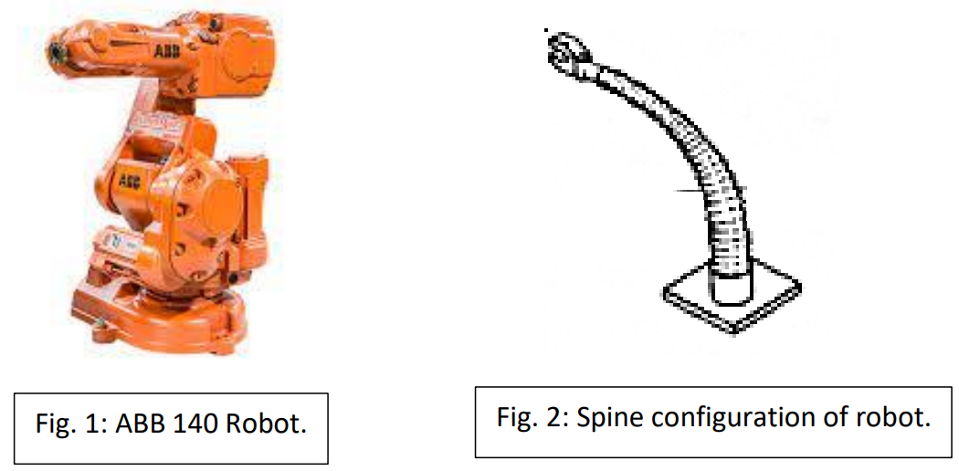

1. Drive the 3D rotation transformation matrix around x, y and z axis without using the dot product and **explain** through plotting frames. [15 marks]

**Authors Contributions.** Mention each author’s contribution at the end of each question **(Mandatory)**.

* Author 1.
* Author 2.

**Copying.** Copying is highly discouraged, and it will lead to **a significant loss (90-95 %) of marks.**

* Copying includes using **sentences, variables, code, formats from others and AI tools**. Discussion is appreciated but attempt the tasks on your own (which would make it look original).