|  |  |
| --- | --- |
| **Phone**  +62831 3408 6899  **Email**[muhdanfyan@gmail.com](mailto:muhdanfyan@gmail.com)  **LinkedIn**linkedin.com/in/muhdanfyan  **Address**Masjid Ali Hizaam  Makassar, Indonesia  2017 - 2018Backend Developer (Non-Formal)**Pondok Informatika**  2006 - 2011Bachelor of Computer Science**University of Dipa Makassar** | **Muhdan Fyan Syah Sofian**  Backend Developer  I am Muhdan Fyan Syah Sofian, S.Kom, born on December 4, 1988. Have a great interest in the world of IT Learning & education. Now I am the founder and chairman of a place which combined IT learning and Islamic education called Pondok Informatika.  **Front End Developer (2021 – Present, SatuKebaikan Foundation)**  *Built Web Crowd Funding with React JS Work with Team*  **Project Manager (**2021 – present,Malmora Affiliate)  *Responsible for planning to ensure are completed within budget. Manage and Control Software Developers Team*  **Back End Developer** (Jan-July 2021 PT. JAGONA ERA TECHNOLOGY)  *Built Web Administrator with CI, Rest-API, Design Sprint with SCRUM Management. Work with Team*  **Full Stack Developer** (2020 – 2021, Magau Group)  *Built landing pages, Rest API Consume, built web CMS administrator*  **Mentor, Founder, & Leader** (2017 – present Pondok Informatika)  *Mentoring and Managing the staffs and the Students*  **Web Developer**(2013 – 2015, CV. Visual Data)  *Built Online Shop Web with CMS opencart & costumization with PHP*  **IT Staff & Database** (2011 – 2012, STIBA Makassar)  *Manage database and student registration administration Built Desktop Application for Academic System Graphic Designer & IT Support System* |

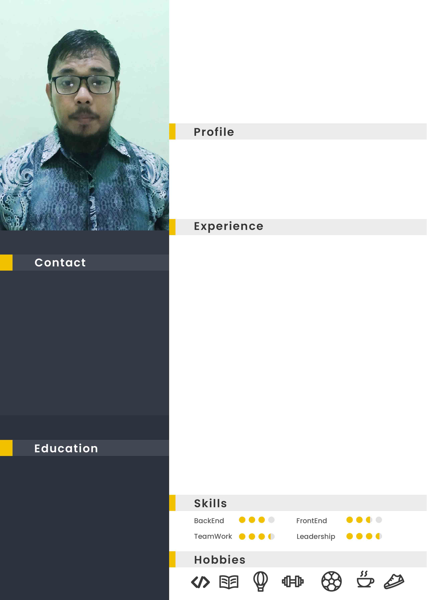



**Muhdan Fyan Syah Sofian**

**Portofolio**

|  |  |
| --- | --- |
| Programming Language :  PHP, JS, Golang | Skills / Expertise :  Backend, Crud, Rest Api, Graphql, Etc |
| Framework / Library / DB :  Codeigniter, Lumen, Node, Express,  ReactJS, NextJS, ChakraUI VueJS, Gin, Gorm,  MYSQL, MongoDb, MariaDB | Other Skills:  Front End Developer, Photoshop Designer, FullStack PHP |

**Pegas Belajar (WEB)**

Website Test Psikologi dengan menggunakan PHP Framework Codeigniter, database MYSQL

TechStack: **Codeigniter PHP Framework, MySQL, JS(Soal)**

[*https://github.com/muhdanfyan/pegasbelajar*](https://github.com/muhdanfyan/pegasbelajar)

**Bazarwi (MarketPlace & Event)**

Website Marketplace & Sistem informasi Publikasi Bazar dan Pameran dengan menggunakan Codeigniter & MySQL

TechStack: **Codeigniter PHP Framework, MySQL**

[*https://simleg-dprdsulteng.com/*](https://simleg-dprdsulteng.com/)

**SIMLEG SulTeng(CMS Admin & REST API)**

Website Sistem Informasi Manajemen Legislatif dan Agenda Rapat Pemda DPRD Provinsi Sulawesi Tengah, memiliki fitur diantaranya : Manajemen Rapat DPRD, Manajemen File Hasil Rapat, Absensi, REST API untuk *consume* SILMEG Prov Sulteng (playstore & appstore), dlln.

TechStack: **Codeigniter PHP Framework, MySQL, piCRUD**

[*github.com/muhdanfyan/simleg-be*](https://github.com/muhdanfyan/simleg-be)| [*simleg-dprdsulteng.com/*](https://simleg-dprdsulteng.com/)

**Tahfidzbaubau(School Web Profil + Tahfidz Online)**

Website profile sekolah SMP ataupun SMA dan sederajat untuk menunjang transparasi informasi dan promosi sekolah.

TechStack: **Codeigniter PHP Framework, MySQL, adminLTE**

[*tahfizbaubau.com/*](https://simleg-dprdsulteng.com/)

**PICRUD(CRUD Generator)**

Merancang sebuah starter untuk CMS Administator buatan sendiri dengan menggunakan PHP Framework Codeigniter, GroceryCRUD Generator, MYSQL, REST API,

TechStack: **Codeigniter PHP Framework, MySQL, adminLTE**

[*github.com/muhdanfyan/picrud*](https://github.com/muhdanfyan/picrud)

**crudgo-mysql**

an application that exposes a basic REST-API server for CRUD operations for managing Persons (id,firstName,lastName, age), make a check that the reader might have basic knowledge of SQL and Golang. In case of learning more about Golang, would suggest going through

TechStack: **Golang, Mux, Gorm, MySQL, REST API**

[*github.com/muhdanfyan/crudgo-mysql*](https://github.com/muhdanfyan/crudgo-mysql)

**crudapi-golang**

Simple CRUD webservice dengan bahasa GoLang, disini saya menggunakan Echo sebagai minimalis webframeworknya.

TechStack: **Golang, Echo Framework, SQLite, REST API**

[*github.com/muhdanfyan/crudapi-golang*](https://github.com/muhdanfyan/crudapi-golang)

**restfull-express**

JS Backend membuat RESTful API dengan express, mongo.

TechStack: **Node, Express, MongoDB, REST API**

[*https://github.com/muhdanfyan/belajar-restfull-express*](https://github.com/muhdanfyan/belajar-restfull-express)

**onlineshop_golang**

Web Toko online dengan golang. TechStack: Golang, Gorm, Postgresql, REST API. Fiturnya adalah: - Home Page - Register, Login, Profile User - Products Page - Single Product Page - Shopping Cart - Checkout :Shipping Cost Calculation, Payment Gateway - Order History - Admin Panel: Dashboard, Manage Products, Manage Orders, Manage Users, Reports, Configuration.

TechStack: **Golang, Gorm, Postgresql, REST API**

[*github.com/muhdanfyan/onlineshop_golang*](https://github.com/muhdanfyan/onlineshop_golang)