**BOT COUNSELLER**

TESTING

Prepared by

MUHAMMAD HASSAN (1612195)

MUHAMMAD DANIYAL(1612238)

**Test Cases:**

1. **Login:**

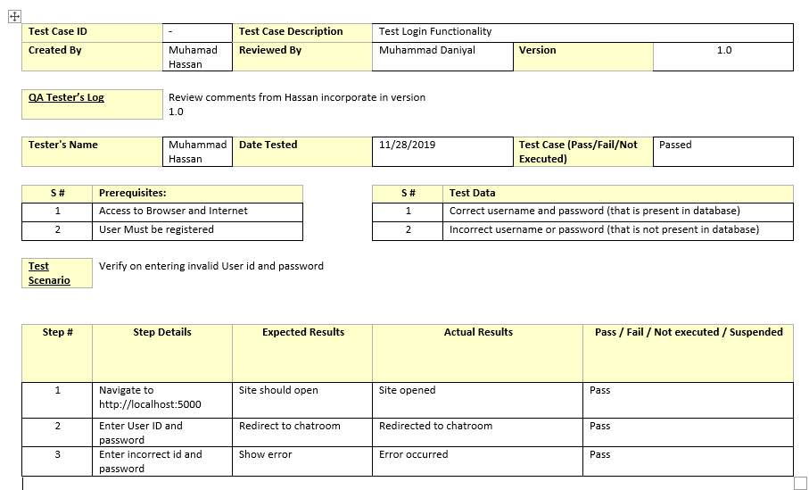

**2)REGISTER**

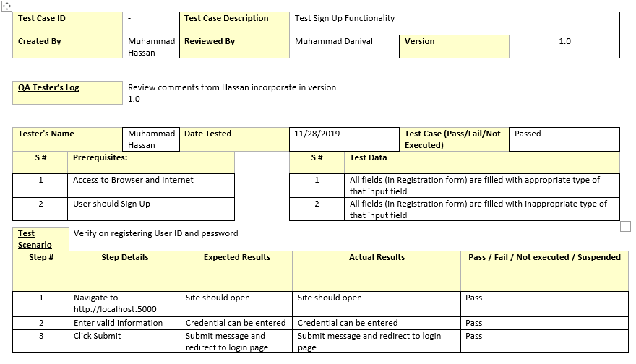

**3) CHAT**

