|  |  |
| --- | --- |
| **BOT COUNSELOR** | **Abstract**  This project is entitled to portray the audience includes all the information that has been used to developed the Chat Bot, making sure that the audience gets the clear understanding of the project  Muhammad Daniyal 1612238  Muhammad Hassan 1612195 |

Contents

**1.****PROPOSAL iv**

2.Introduction v

3.Objective v

4.Problem Description v

5.Methodology vi

6.Project Scope vi

7.Feasibility Study vi

8.Solution Application Areas vii

9.Tools/Technology vii

10.Expertise of the Team Members vii

11. Milestones viii

14.References x

3.Introduction 13

**3.2 Document Conventions 13**

**3.3 Intended Audience and Reading Suggestions 13**

**3.4 Product Scope 13**

**3.5 References https://hellotars.com/chatbot-templates/healthcare/rk958m/personal-counselling-chatbot 13**

4. Overall Description 13

**4.1 Product Perspective 13**

**4.2 Product Functions 13**

**4.3 User Classes and Characteristics 14**

**4.4.1 Design and Implementation Constraints Required time: June 2020 Tools and Technologies: Python Flask, Neural Network Security: Login Authentication 14**

**4.5 User Documentation 14**

**4.6 Assumptions and Dependencies 14**

5. External Interface Requirements 14

**5.1 User Interfaces 14**

**5.2 Hardware Interfaces 14**

**5.3 Software Interfaces 15**

**5.4 Communications Interfaces 15**

6. System Features 15

**6.1 Login 15**

**6.1.1 Description 15**

**6.1.3 Functional Requirement 16**

**6.2 Registration 16**

**6.2.1 Description 16**

**6.2.2 Stimulus/Response Sequences 16**

**6.3 Chat 16**

**6.3.1 Description 16**

**6.4 Blog posting 16**

**6.4.1 Description 16**

**6.4.2 Stimulus/Response Sequence 16**

**6.5 Reviews 16**

**6.5.1 Description 16**

**6.5.2 Stimulus/Response Sequence 17**

**6.6 Admin rights 17**

**6.6.1 Description 17**

**6.6.2 Stimulus/Response Sequence 17**

7. Other Nonfunctional Requirements 17

**7.1 Performance Requirements 17**

**7.2 Safety Requirements 17**

**7.3 Security Requirements 17**

**7.4 Business Rules 17**

**CONTEXT DIAGRAM 18**

**Acknowledgement**

We might want to communicate unique gratitude to our consultant Mr. Naveed Ghani for getting us out in the readiness and execution of our Project (BOT COUNSELOR.) He helped us leading examination on this undertaking from which we came to think about a great deal of stuff

Furthermore, I want to thank my parents and companions who helped me all through the fruitful finishing of this task, which without their help would not have been conceivable.

Bot Counselor

FYP Project Proposal

## Supervisor

Naveed Ghani

## Submitted by

Muhammad Hassan

(1612195)

Muhammad Daniyal

(1612238)

**Faculty of Computing and Engineering Sciences**

Shaheed Zulfiqar Ali Bhutto Institute of Science and Technology, Karachi.

[April 7th 2020]

# Introduction

Chatbots are the new generation computer programs that perform intelligent human conversation. It has three parts. The first one is typed or spoken input from the user in natural language, second is the typed or spoken output from the chatbot and then the process of passing the input through the program so that an understandable output is produced. This whole process is repeated until the end of the conversation is reached. The Career counselling bot is a system designed for users where they can ask any career related questions like best field to choose, latest trending course, etc. Even if the user does not frame sentence properly system will understand the query and answer accordingly. The user doesn’t need to follow any specific format to ask questions. NLP (Natural Language Processing) concept has been used that is concerned with programming computers so that natural language is processed and used in order to get output to user.

# Objective

The purpose of a chat bot system is to simulate a human conversation; the chat bot architecture integrates a computational algorithm and language model to emulate information chat communication between a human user and a computer using natural language.

# Problem Description

After students’ high school education, there comes the time when student has to decide which career should be s(he) pursue. At that time, most students don’t know where to go now. The guidance at that time, which career to be selected is named as career counselling.

Career counseling, also known as career guidance, is counseling designed to help with choosing, changing, or leaving a career [1].

Career counselling is one of the major part in student’s life. Students mostly find difficulties while choosing their career. And the availability of counselors is also a big issue. So the bot will be trained to look after the counselling issues faced by student and try to suggest them about their fields.

# Methodology

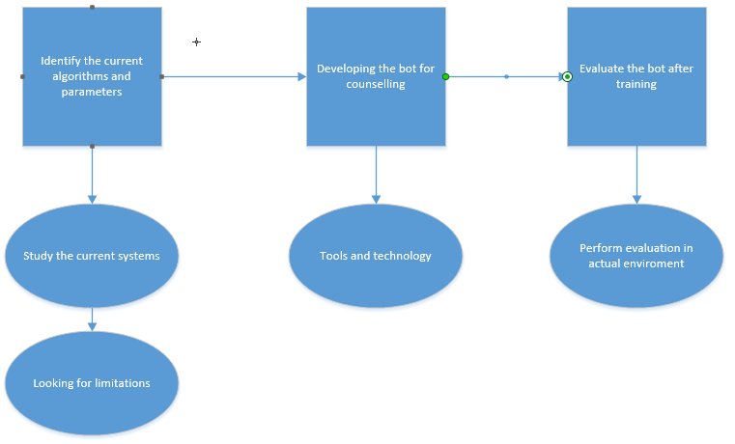

# Project Scope

The whole education industry is under the umbrella of our bot. counselling is one of the major need of person. so the scope is well enough to help the people related to such field.

# Feasibility Study

With above defined scope, would you be able to meet your project schedule? Do mention following aspects:

* + 1. **Risks Involved**:

**Less dataset volume**; there is no dataset available for above mentioned project. **Solution:** So, dataset will be collected by self.

**No query available:** due to fixed programming, chatbot can stuck if any unsaved query is presented in front of them. **Solution:** plenty amount of data set will be provided.

**Update:** bot is pre-programmed, so it has limited amount of information (provided at the time of training). **Solution:** need to update time to time.

**Resource Requirement**:

* + - * 1. Survey
        2. Training dataset
        3. Different counselling sources for results.

# Solution Application Areas

**Is your project of some real value?**

Yes. Because these is no bot available to counsel student and guide them for their career and future.

**Which industry or application domain you are targeting?**

Mostly education industry lack in counselling student. So, this can be used to counsel the students.

**How that target domain may benefit from your solution?**

Education institutes are lacking counselling facility. And hiring a counselor results in huge amount of money. The trained bot will help the institutes for counselling their students.

# Tools/Technology

Visual Studio Code

(Neural Network)

# Expertise of the Team Members

**Are all team members pre-equipped with the level of knowledge needed for the successful completion of this project?**

Theoretically and the concept is clear to the team. And the implementation part is to be practiced. And by the end of the session, a running product will be developed.

**Have you people studied the relevant course by now?**

Artificial Intelligence is the core course for this project and offered in this semester. So, learning and understanding will be done time to time.

**Is this project of equal interest to all team members?**

Yes, the team is interested in developing the system that will help in counselling the upcoming students.

**10. FEATURES**

1) Counselor blogs will be shown on the homepage.

2)Registration of Counselor will be done by Admin.

3)Student can register themselves.

4)Student can give reviews on the website.

5)Counsellor can see the chat between the Student and the Bot.

6)Admin can delete Counselor and Student.

7) Counselor can delete his own blog.

8)Admin can delete Counselor Blog.

9)Student can delete his own review.

10)Chat can only be done by the Student.

11)Admin can delete reviews.

# 11. Milestones

FYP I

* SRS
* SDS
  + Creating UML
  + questionnaire
* Data gathering
  + Google form
  + Distribution of questionnaire
* Coding
  + Basic design

FYP II

* Dataset compilation
  + Creating trainable data
* Artificial Algorithm
  + Implementing algorithm
  + Training the bot
* Testing
  + Testing the bot

**12**. **Project**

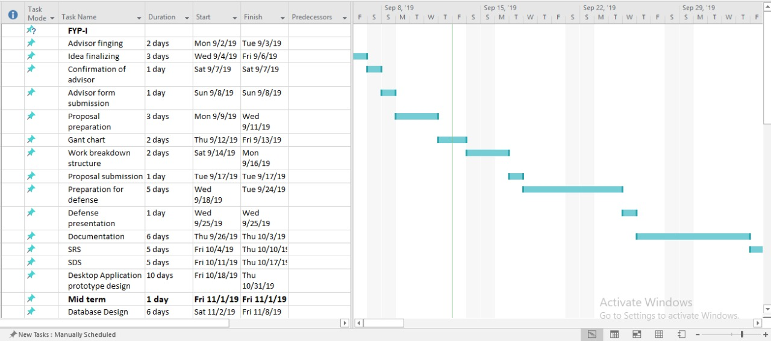

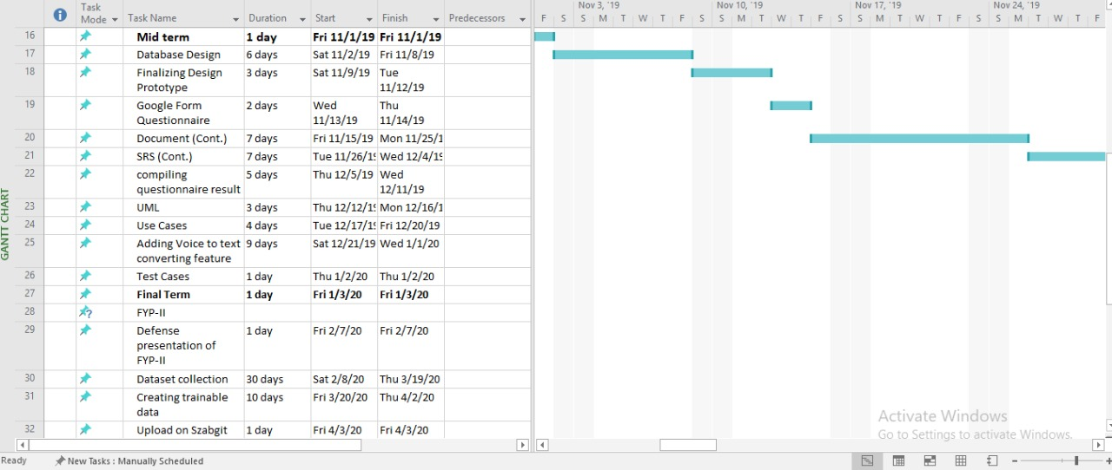

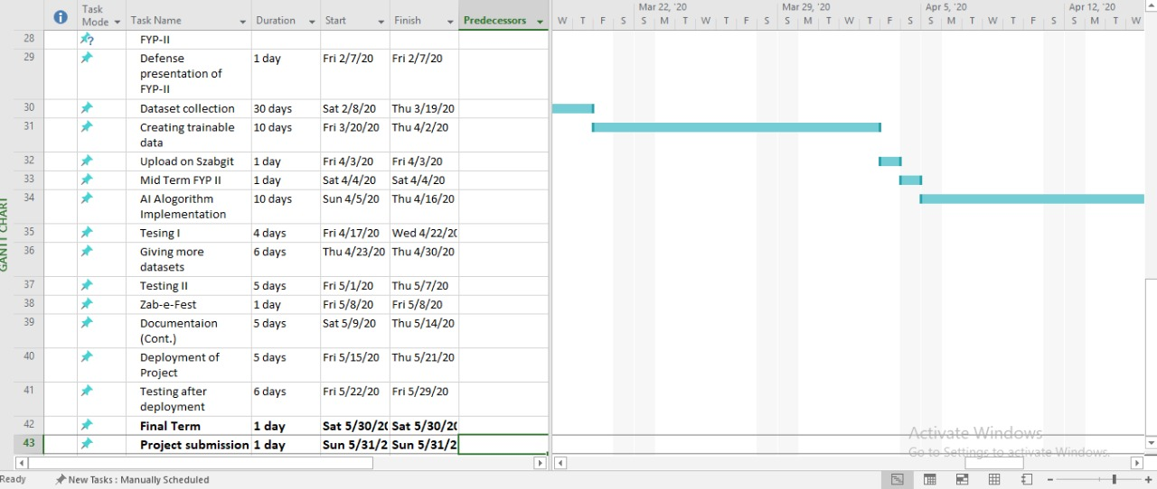

**13. Work Breakdown Structure**

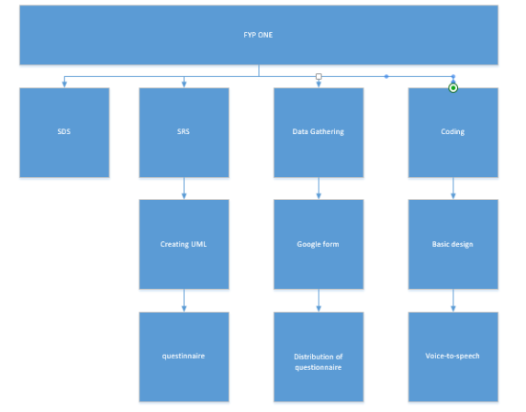

# 14. References

[1] – Good Therapy: <https://www.goodtherapy.org/learn-about-therapy/issues/career-counseling>

Software Requirements Specification

BOT COUNSELLER

Version 2.0 approved

# Introduction

## Purpose: The aim of career counselling bot is to carry out a conversation between both human and machine. Some knowledge has been embedded into the machine so that it identifies the sentences and making a decision itself as response to answer a question. BOT COUNSELLER will be used as assistant which will help the user to select the specific field.

## Document Conventions

**ML:** MACHINE LEARNING

**NN:** NEURAL NETWORK

## Intended Audience and Reading Suggestions

THIS PROJECT is an AI based field counselling web application used by high school students.

This PROJECT is useful for field counselling of Students especially who wants to take admission in university across PAKISTAN.

## Product Scope

The whole education industry is under the umbrella of our bot. counselling is one of the major need of person. So the scope is well enough to help the people related to such field.

## References <https://hellotars.com/chatbot-templates/healthcare/rk958m/personal-counselling-chatbot>

<https://chatbotsmagazine.com/a-therapist-bot-actually-works-e27c72b9632e>

<https://woebot.io/>

# Overall Description

## Product Perspective

Context Diagram / DFD attached at the end

## Product Functions

Functional Hierarchy Diagram attached at the end

## User Classes and Characteristics A student will be able to maintain his\her profile. And the chat between the student and bot will be saved directly in database.

## Operating Environment Desktop Computer or laptop Browsers which have minimum support for HTML-5

### Design and Implementation Constraints Required time: June 2020 Tools and Technologies: Python Flask, Neural Network Security: Login Authentication

## User Documentation

Manual Document will be made in the end of the Project Submission to help out the Users

## Assumptions and Dependencies

The student must have knowledge of, how to operate computer and mobile. And can access browser. The application is fully web based, so user must know how to use browser.

# External Interface Requirements

## User Interfaces

* Web based GUI for input of data from user by using bootstrap
* Authentication of registration.

## Hardware Interfaces

* Core i3(min) or more
* 20gb hard disk
* 4gb Ram
* Mouse
* Keyboard
* Monitor/Led

.

## Software Interfaces

* Windows 7 / 8 / 10 Operating system
* Programming language used: PYTHON
* SQL

## Communications Interfaces

Hypertext Transfer Protocol will be used for communication between the user and the server.

# System Features

**LOGIN / SIGNUP**

To **LOGIN** User first has to SIGN-UP for the account to access the chat bot . In which they’ll be required to fill their **Name Email** and **Password**.

**BLOG POSTING**

In BLOG POSTING there will be **Title** and **Content** where in Title you can enter the Title of the Content and in the box below you can write the information related to the title

**REVIEWS**

User can post Review related to the counselor. They can also **UPDATE** and **DELETE** it as well.

**COMMENTS**

Student and Counsellor can comments on the blog. They can also **UPDATE** and **DELETE** it as well.

**ADMIN RIGHTS**

* Registration of Counselor will be done by the ADMIN
* ADMIN can delete his own BLOG
* ADMIN can delete Reviews

**CHAT**

You’ll be provide Chat-room in which Student can chat with the counselor.

## Login

### Description

This feature allows any user to login into the web application, if the user doesn’t login in will not be able to perform its desired function. The admin will also login to manage the page.

### Stimulus/Response Sequences

* User/Admin/Counsellor
* System responds for entering password
* System prompts for successful completion if correct details entered.

### Functional Requirement

REQ-1: necessary to fill both fields of username and password

REQ-2: username and password must be valid

REQ-3: user must be registered

## Registration

### Description

Before the user can access the web application, its necessary for the user to be registered first.

### Stimulus/Response Sequences

* Enter name, user name, email, password.
* System responds registered successfully
* System prompts for successful completion if correct details entered

## Chat

### Description

After login user will be allowed to chat

## Blog posting

### Description

Blogs are the research of counselors and can be posted on site and can be viewed by anyone whether the visitor is a part of it or not

### Stimulus/Response Sequence

* Enter title of project
* Enter content of blog
* Picture if needed

## Reviews

### Description

Student can give Reviews on the websites and they can delete their own review

### Stimulus/Response Sequence

Student will have to register themselves. Then they can redirect to the page and add reviews and update and delete as well

## Comments

### Description

Student and counsellor both can comment on the blogs and they can delete their own review

### Stimulus/Response Sequence

Must be registered on the site. Then they can redirect to blog page and can add review and update and delete as well

## Admin rights

### Description

Registration of Counsellor will be done by Admin. As well as, admin can remove each and every thing from the site whether it’s a blog, review, comment, user him/her self.

### Stimulus/Response Sequence

Admin cannot be created. There can be only one admin that was created manually and fed into database.

# Other Nonfunctional Requirements

## Performance Requirements

Application will be reliable, responsive and secured. There will be real time guidance and support related to bidding of order and also creation of documents with easy

## Safety Requirements

There are no such safety requirements, the application/system will not harm anyone.

## Security Requirements

For Reusability: classes and functions will be reused in implementations,  
For Reliability: we will use try catch to handle exceptions to secure Application from crashing.  
For Flexibility: system will be module based and classes-based working in parallel.  
For Interoperability: web application will be connected to web server via APIs

## Business Rules

The User can access following features

1) LOGIN (all users)

2) SIGN UP (students)

2) CHAT (student)

3) REVIEWS (student)

4) BLOGS (counsellor)

5) COMMENTS (Student & Counsellor)

## CONTEXT DIAGRAM

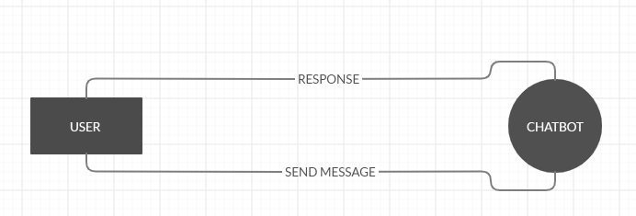

**HIERARICAL DIAGRAM**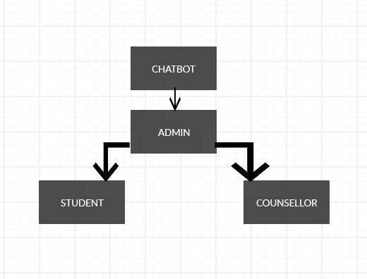

SDS (SOFTWARE DESIGN SPECIFICATION)

**1. Introduction**

**1.1 Purpose of this document**

This software design document describes the architecture and system design of Bot Counselor, a question answering system for education industry. It is intended to outline the system structure for the project manager and stakeholder and provide technical guidance to development team.

**1.2 Scope of the development project**

This will be similar to what was written in the SRS. Bot Counselor is an AI chatbot that receives questions from the user, tries to understand the question and provide appropriate answer. It does by converting and English sentence into machine friendly query, looking up in trained model for necessary information to answer the question and finally returning the answer in natural language.

The main objective is to develop a bot that provides such service that will help the user in selection of the undergraduate field.

The goal is to provide the students of intermediate and A-level to provide counselling about, which field they should enroll in.

**1.3 Definitions, acronyms, and abbreviations**

* **Chatbot:** An interface, usually text based, specializing in mimicry of natural language conversation.
* **HTML:** Hyper Text Markup Language, a standardized system for tagging text file to achieve font, color, graphic and hyperlink effects on webpage.
* **JSON:** JavaScript Object Notation, a data interchange format that is commonly used in exchanging the data over the internet.
* **Flask:** it is a python framework for the development of web application.
* **Neural network:** it is an Artificial Intelligence concept for the training of machine
* **MVC:** Model View Controller. It is now considered as standard concept/framework for the development of web application

**Sqlalchemy:** it is an api to manage database in safe secure and easy way

**1.4 References**

* **For content related:** <http://www.cci.drexel.edu/SeniorDesign/2016_2017/DrexelChatbot/DrexelChatbotDD.pdf>

**1.5 Overview of document**

* **Introduction:** provides an overview of application, explains objective and goal of project and describe the structure of document
* **System over view:** gives general description of functionality of context and design of bot counselor.
* **System architecture:** break the project down into various subsystems, defines how those subsystems interact.
* **Data design:** describes the organization of data in mongodb database implemented for bot counselor.

**2. System architecture description**

* 1. **Section Overview**

Most of the search engines today, like google, use a system to rank web pages. When user enter a query, the query is interpreted as keyword and system returns list of highest ranked web pages which may have answer to query. Them user must go through web pages to find the answer they are looking for. Bot counselor, however, will try to understand the query and provide a definitive answer.

* 1. **General Constraints**

as the application is developed in python, the only limitation of end result will be the speed of the bot. to overcome this issue, it is advised to the user to have a high-speed internet connection and a good processor, this will be beneficial for the user.

* 1. **Data Design**
     1. **Database design**

Users

|  |  |
| --- | --- |
| Id | Integer |
| Username | Varchar |
| Image file | Varchar |
| Email | Varchar |
| Password | Varchar |

Admin

|  |  |
| --- | --- |
| Id | Integer |
| Username | Varchar |
| Email | Varchar |
| Password | Varchar |

Messages

|  |  |
| --- | --- |
| Id | Integer |
| Message | Varchar |
| Sender | Varhar |
| Date time | Dateteime |
| User id | Integer (fk) |

Blogs

|  |  |
| --- | --- |
| Id | Integer |
| Title | Varchar |
| Date posted | Datetime |
| Content | Text |
| Image file | Varchar |
| User id | Integer (fk) |

Reviews

|  |  |
| --- | --- |
| Id | Integer |
| Date posted | Datetime |
| Content | Text |
| User id | Integer (fk) |

Comments

|  |  |
| --- | --- |
| Id | Integer |
| Date posted | Datetime |
| Content | Text |
| User id | Integer (fk) |
| Blog id | Integer (fk) |

* + 1. **Dataset questions**

|  |  |  |  |  |  |  |  |  |  |  |
| --- | --- | --- | --- | --- | --- | --- | --- | --- | --- | --- |
| **Questions** | **Option A** | | **Option B** | | **Option C** | | **Option D** | | | **Option E** |
| **About Youth** | Help others | | Explore world | | Make money | | Build stuff | | |  |
| **Well done job?** | Assets | | Neat environment | | Creating something | | Solving problem | | |  |
| **Ultimate goal** | Understand humans | | Invent something | | Be president | | Make better world | | |  |
| **Interested in** | Technology | | Learning computer | | Intellectual ideas | | Knowing nature | | |  |
| **You like to do** | Singing | | Vlogging | | Computing | | Surfing internet | | | Thinking ideas |
| **Favorite class** | Performing | | Human behavior | | Deep thinking | | experimenting | | |  |
| **Like to help others?** | Yes | | No | |  | |  | | |  |
| **Know how machine working** | Yes | | No | |  | |  | | |  |
| **You are?** | | Ambitious | | Go with flow | |  | |  |  | |
| **Socializing?** | | Yes | | Sitting at home | |  | |  |  | |
| **Concerned about state of environment** | | Yes | | No | |  | |  |  | |
| **Interested in body heal** | | Yes | | No | |  | |  |  | |
| **Like working with hand and outdoor** | | Yes | | No | |  | |  |  | |
| **Graphic\web design** | | Yes | | No | |  | |  |  | |
| **Good at numbers** | | Yes | | No | |  | |  |  | |
| **Work with people** | | Yes | | No | |  | |  |  | |
| **Friends know you for** | | Organizer | | Go with gut feelings | | Showing initiative | | Job done |  | |
| **People consider you** | | Risk taker | | Logical | | Generous | | Cool headed |  | |
| **After 20 years** | | Entrepreneur | | Doctor | | Actor | | Engineer | Computer scientist | |
| **Free time activities** | |  | |  | |  | |  |  | |

.

* 1. **Program Structure**

Flask is being used to develop the frontend and web application. Flask is the framework of python that is used to develop the web app. The nature of flask is minimalistic. This nature gives us a lot of freedom in how to structure our project. By getting advantage from this flexibility of the framework, the project will be based on Model View Controller concepts.

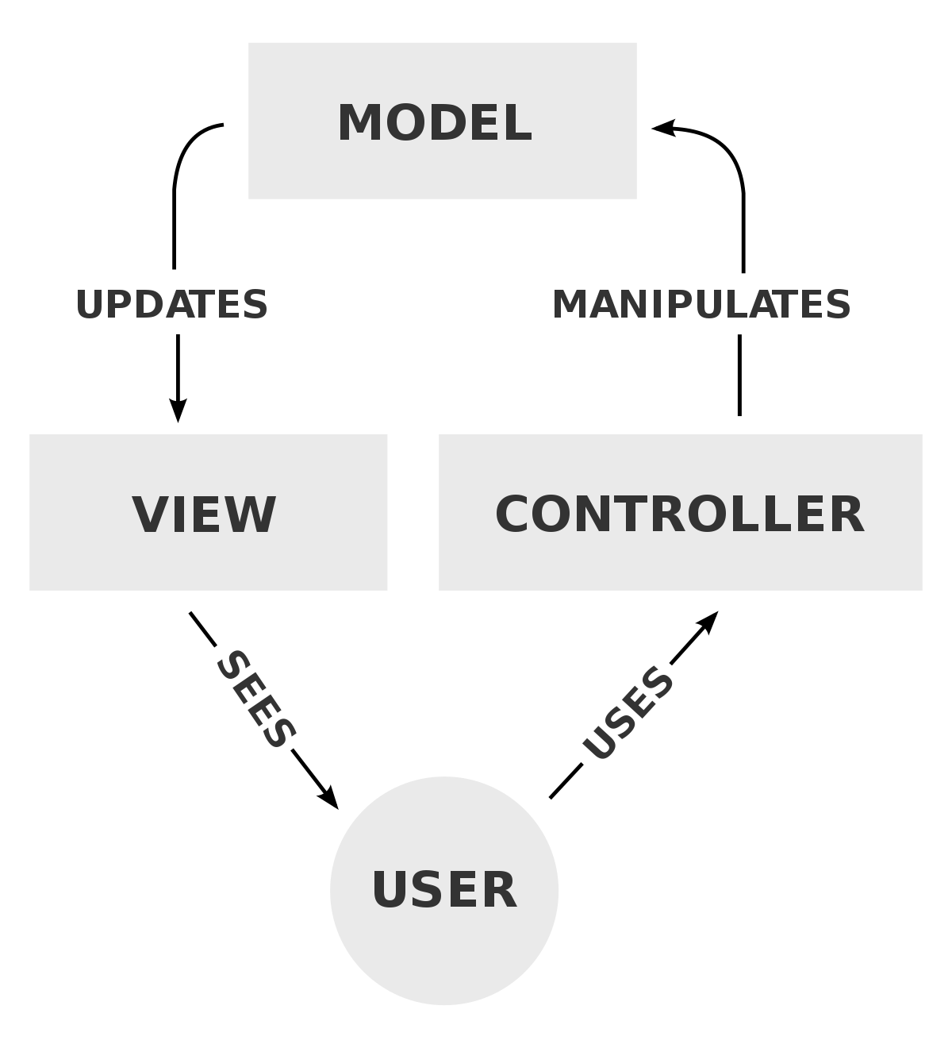

* 1. **Alternatives Considered**N/A.

1. **Detailed description of components**  
     
   1. **Section Overview**  
      The end product (chatbot) will be the mixture of many components. Each component will be playing a huge roll in the development of the bot. every feature of the bot will go through all the component of the bot. The components are Flask, Neural Network, MongoDB while features are chatting, sign in, sign up.
   2. **Component n Detail (include a sub-section for each component)**
      1. **Flask:**

|  |  |
| --- | --- |
| Identification | Flask |
| Type | Initial File |
| Purpose | To start application and medium for user interface and server requests |
| Function | ‘app’ is the base attribute for the flask. Other functions are based upon this attribute. Every web page of the application has a function associated. |
| Subordinates | ‘Model View and Controller’ concept is implemented. |
| Dependencies | None |
| Interfaces | In views, all the pages are available. All of them are developed on bootstrap studio. So, all the interfaces are integrated in view page. |

|  |  |
| --- | --- |
| Resources | Flask itself is a resource for the application. So, it doesn’t require any resource to operate for further operation. A browser is needed to showcase the results of flask. |
| Processing | Flask, a framework works the way you want it to work. the is no specific structure for flask to work on. But bot counsellor will be developed using MVC frame work  Flask is initiated by creating app I,e the object of flask  app = Flask(__name__)  and route ‘/’ oi followed  @app.route(‘/’)  def <functionName>():  return <some web page> |
| Data | Flask does not have concern with data. It doesn’t require any data to process. It just works to send request to the server and send response to the user. Data from the form is travelled by request of flask to the server. |

* + 1. **Login:**

|  |  |
| --- | --- |
| Identification | LOGIN |
| Type | Class |
| Purpose | Process by which an individual gains access to his / her profile by identifying and authenticating themselves. |
| Function | Login are used to gain access to and control of Users to get excess of his/her Chatroom. It requires Username and Password. This function will log in a user based being matched in MONGO-DB |
| Subordinates | The screen contains link to Registration Screen |
| Dependencies | It should be connected with the server, which is connected with the database for validation. |
| Interfaces | Designed using HTML, CSS, BOOTSTRAP and JAVASCRIPT using simple colors |
| Resources | System must be connected to MONGO-DB in order to fetch login details |
| Processing | Data which will be provided by the user is to validate it’s information |
| Data | Data is provided in login in the form of INPUT , |

* + 1. **Register**

|  |  |
| --- | --- |
| Identification | SIGNUP |
| Type | Class |
| Purpose | It will allow unregistered candidates to become a member of the system. |
| Function | It will register the new User. It requires the form which has to be filled by the user. |
| Subordinates | The screen contains link to the login page. |

|  |  |
| --- | --- |
| Dependencies | It should be connected with the server, which is connected with database for update. |
| Interfaces | Designed using HTML, CSS BOOTSTRAP |
| Resources | System must be connected to MONGO-DB in order to register user |
| Processing | Data which will be provided by the user will be validated. |
| Data | Data will be provided in the form of INPUT |

* + 1. **Sqlalchemy:**

|  |  |
| --- | --- |
| Identification | Sql alchemy |
| Type | DATABASE connection |
| Purpose | It connects the database |
| Function | It performs crud operation using from database |
| Subordinates | NONE |
| Dependencies | NONE |
| Interfaces | NONE |
| Resources | Sql alchemy should be installed |
| Processing | It makes connection using code and performs crud operation using code |
| Data | Data is saved in schema format |

1. **User Interface Design**
   1. **Section Overview**

Just like every chat container, bot counselor will be a simple design. And a couple of common ingredients will be there and that are login and registration form. This will help us to maintain the chat that is done with the bot. Further details are followed by headings below.

* 1. **Interface Design Rules**

N/A

* 1. **GUI Components**  
     GUI components are the web pages that will be shown to the user. Following are the ones that will be shown x

**USECASE**

**1)**

|  |  |
| --- | --- |
| **ID:** | **1** |
| **Title:** | LOGIN |
| **Description:** | THROUGH THIS FEATURE USER WILL BE ABLE TO ACCESS HIS/HER PROFILE |
| **Primary Actor:** | THE USER HIMSELF/HERSELF |
| **Preconditions:** | THERE WILL BE A SIMPLE WEB PAGE THAT WILL ASK THE USER TO SIGN IN TO ACCESS THE PROFILE |
| **Postconditions:** | AFTER LOGGING IN, USER WILL BE ABLE TO ACCESS THE PROFLE AND CONTINUE CHATTING WITH THE BOT |
| **Main  Success Scenario:** | AT THE BIGENNIHG, USER WILL BE SHOWN A WEB PAGE IN WHERE S(HE) WILL BE ASKED TO ENTER EMAIL AND PASSWORD. ON ENTERING THE ASKED DETAILS, S(HE) WILL BE REDIRECTED TO THE CHATROOM |
| **Extensions:** | THERE IS A POSSIBILITY THAT USER WILL ENTER WRONG PASSORD OR MAY NOT HAVE ACCOUNT AND JUST FILLING THE FIELD. THIS WILL GIVE EXCPETION THAT LIKE ‘USER NOT FOUND’ OR ‘WRONG EMAIL OR PASSWORD’ |
| **Frequency of Use:** | EVERY TIME WHEN USER VISITS WEB PAGE |
| **Status:** | DESIGN IS COMPLETED AND IMPLEMENTATION IS LEFT |
| **Owner:** | BOTH THE TEAM MEMBERS |
| **Priority:** | HIGH. CAUSE IT WILL ACCESS THE PROFILE |

**2)**

|  |  |
| --- | --- |
| **ID:** | **2** |
| **Title:** | REGISTER |
| **Description:** | USER WILL CREATE HIS PROFILE TO GET ACCESS TO THE CHATROOM |
| **Primary Actor:** | STUDENT HIMSELF/HERSELF |
| **Preconditions:** | THERE WILL BE A SIGNUP OPTION AVAILABLE FOR NEW USER |
| **Postconditions:** | AFTER LOGGIN IN , STUDENT WILL BE ABLE TO ADD REVIEW |
| **Main  Success Scenario:** | TO MAKE USER A PERTICIPENT OF THE PROTAL SO THAT HE WILL BE ABLE TO AVAIL THE BOT COUNSELLING |
| **Extensions:** | WHEN USER GIVE WRONG DETAILE OR NOT ACCORDING TO THE GIVEN INSTRUCTIONS |
| **Frequency of Use:** | FIRST TIME ONLY WHEN USER IS NEW |
| **Status:** | DESIGN IS COMPLETED AND IMPLIMENTATION IS LEFT |
| **Owner:** | BOTH OF TEAM MEMBERS |
| **Priority:** | HIGH, AS CREATING PROFILE IS IMPORTANT |

**3)**

|  |  |
| --- | --- |
| **ID:** | **3** |
| **Title:** | CHAT |
| **Description:** | USER WILL CHAT WITH THE COUNSELLOR |
| **Primary Actor:** | USER HIMSELF/HERSELF |
| **Preconditions:** | - |
| **Postconditions:** | HE WILL BE ABLE TO GET THE ANSWER |
| **Main  Success Scenario:** | THE USER WILL BE ASKED SOME QUESTION ABOUT BY COUNSELLOR |
| **Extensions:** | _ |
| **Frequency of Use:** | CHAT |
| **Status:** | IMPLEMENTATION AND DESIGN IS COMPLETED |
| **Owner:** | USER / COUNSELLOR |
| **Priority:** | - |

|  |  |
| --- | --- |
| **ID:** | **4** |
| **Title:** | REVIEWS |
| **Description:** | THROUGH THIS FEATURE USER WILL BE ABLE TO GIVE REVIEW |
| **Primary Actor:** | THE USER HIMSELF/HERSELF |
| **Preconditions:** | ONLY THOSE CAN ADD REVIEWS WHO ARE SIGNED IN |
| **Postconditions:** | AFTER LOGGING IN, USER WILL BE ABLE TO ACCESS THE PROFLE AND CAN ADD REVIEW |
| **Main  Success Scenario:** | USER CAN ADD REVIEWS |
| **Extensions:** | THERE IS A POSSIBILITY THAT USER WILL HAVE TO LOGGED IN FIRST TO ADD REVIEW |
| **Frequency of Use:** | ___ |
| **Status:** | DESIGN IS COMPLETED |
| **Owner:** | BOTH THE TEAM MEMBERS |
| **Priority:** | HIGH. |

|  |  |
| --- | --- |
| **ID:** | **5** |
| **Title:** | COMMENTS |
| **Description:** | THROUGH THIS FEATURE USER WILL BE ABLE TO WRITE COMMENTS ON BLOGS |
| **Primary Actor:** | THE USER HIMSELF/HERSELF |
| **Preconditions:** | ONLY THOSE CAN WRITE COMMENTS WHO ARE SIGNED IN |
| **Postconditions:** | AFTER LOGGING IN, USER WILL BE ABLE TO ACCESS THE BLOG AND CAN WRITE COMMENT |
| **Main  Success Scenario:** | USER CAN WRITE COMMENTS |
| **Extensions:** | THERE IS A POSSIBILITY THAT USER WILL HAVE TO LOGGED IN FIRST TO ADD REVIEW |
| **Frequency of Use:** | ___ |
| **Status:** | DESIGN IS COMPLETED |
| **Owner:** | BOTH THE TEAM MEMBERS |
| **Priority:** | HIGH. |

|  |  |
| --- | --- |
| **ID:** | **6** |
| **Title:** | BLOG |
| **Description:** | THROUGH THIS FEATURE USER WILL BE ABLE TO ADD BLOG |
| **Primary Actor:** | THE USER HIMSELF/HERSELF |
| **Preconditions:** | ONLY THOSE CAN ADD BLOGS WHO ARE SIGNED IN |
| **Postconditions:** | AFTER LOGGING IN, USER WILL BE ABLE TO ACCESS THE PROFLE AND CAN ADD BLOG |
| **Main  Success Scenario:** | USER CAN ADD BLOG |
| **Extensions:** | THERE IS A POSSIBILITY THAT USER WILL HAVE TO LOGGED IN FIRST TO ADD BLOG |
| **Frequency of Use:** | ___ |
| **Status:** | DESIGN IS COMPLETED |
| **Owner:** | BOTH THE TEAM MEMBERS |
| **Priority:** | HIGH. |

**GANNT CHART**



**REGISTER**

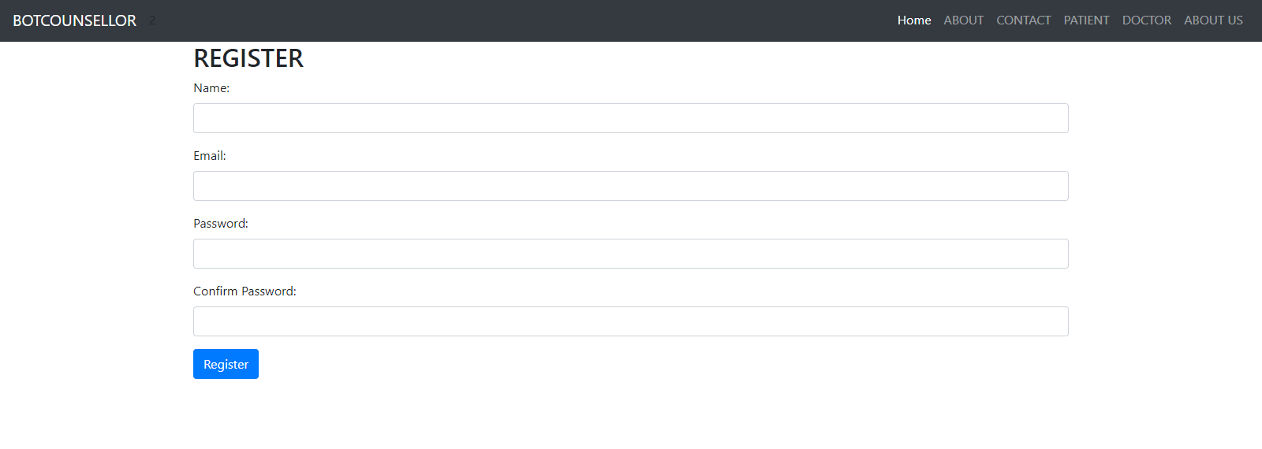

**LOGIN**

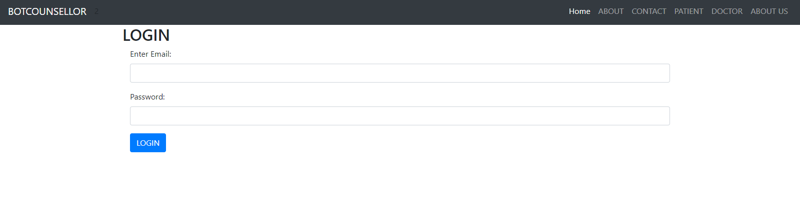

**ACCOUNT**

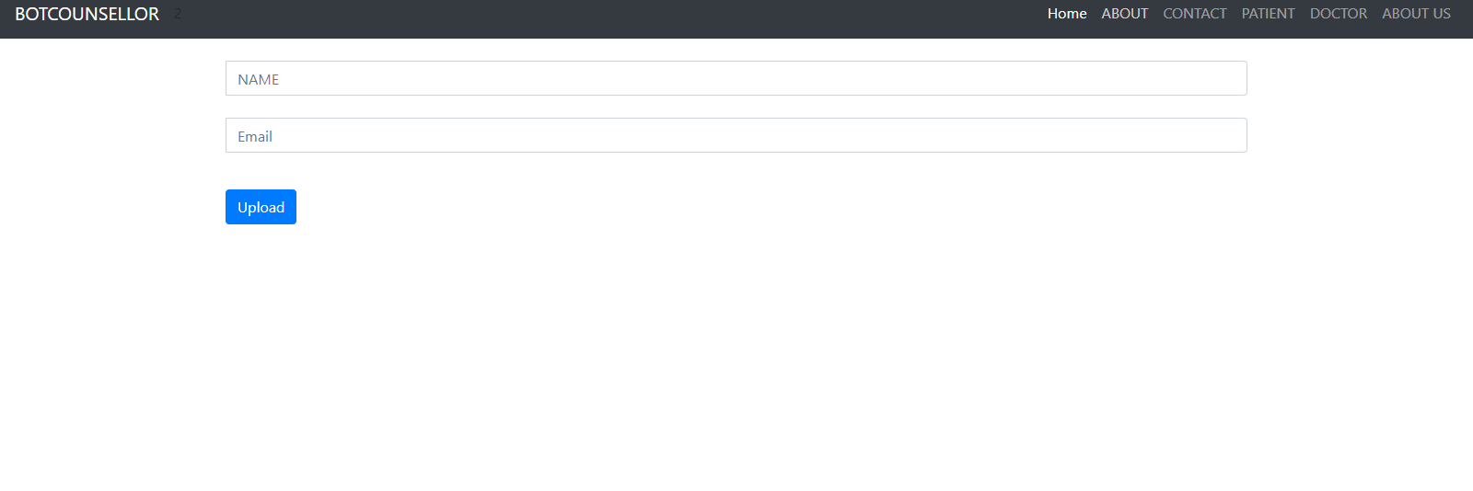

**CHAT**

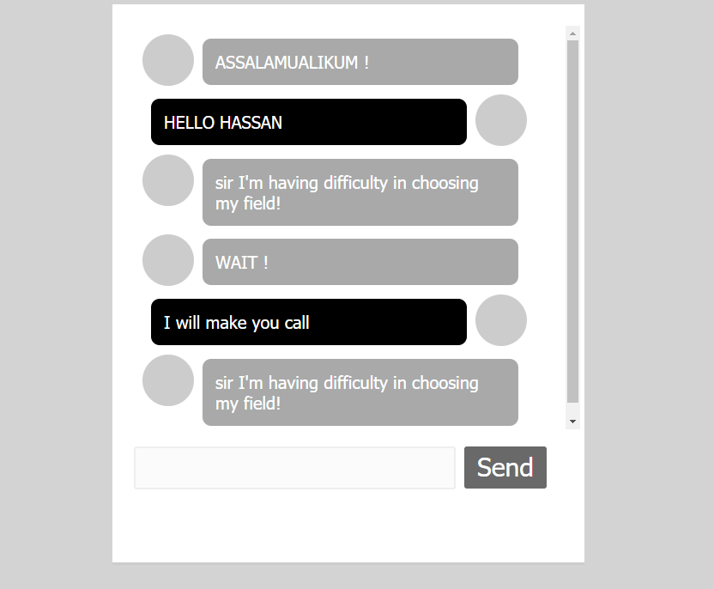

**REVIEWS**

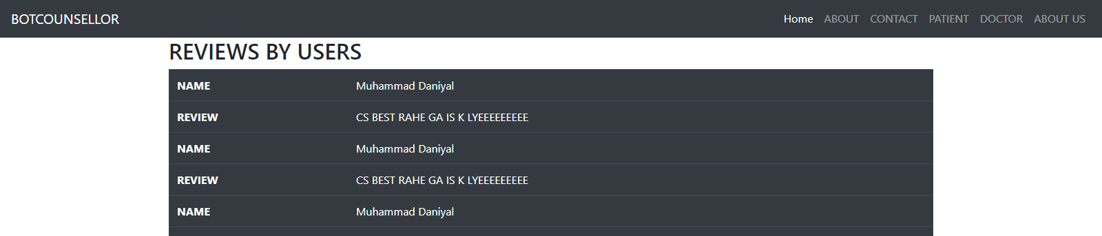

* 1. **Detailed Description**

|  |  |
| --- | --- |
| **Public login()** |  |
| **Input** | Email, Password |
| **Output** | Page Render, error |
| **Description** | This function will take username and password as input in form and validate them. And output will result accordingly. Will be rendered to chatroom on right input or get error on bed input. |

|  |  |
| --- | --- |
| **Public register()** |  |
| **Input** | Username, Email, Password, Confirm Password |
| **Output** | Page Render, Error |
| **Description** | This function will take the mentioned fields from the from and validate whether the given information is in correct format and then generate the result accordingly. |

|  |  |
| --- | --- |
| **Public send()** |  |
| **Input** | Void |
| **Output** | Void |
| **Description** | This function will send the user entered message from designated text area and send that message to the server. Then server will respond according to the entered message. |

1. **Reuse and relationships to other products**

Just like every other software, the reusability of classes and functions will always be looked after, in order to use them in future for further modification. For the bot counselor, the class that involves training will be constant in every modification, unless any new method is found. Webpages are made using bootstrap and bootstrap’s source file will remain as it is for further development and modification. And code can be integrated in html format files. Model classes are also a part of reusable classes. And those can be modified with the advancement in features and user data requirement. In a nut shell, each and every component can be used in future for further modification and advancement in the end project. The only limitation is that the project is centralized so updating will stop the services of bot.

1. **Design decisions and tradeoffs**

Use this section to motivate any decisions that will help the reader understand the design that your team is using. This section can also capture good ideas that were abandoned and the reasons for leaving them out of the design.

1. **Pseudocode for components**
   1. **Flask:**

App = flask(__name__)

@App.route(‘/’)

Def fucntionName():

Function definition

Return webpage

* 1. **Login:**

@app.route(‘/login’)

Def login():

User = input from form

Validate() // from database

Return webpage

* 1. **Register:**

@app.route(‘/register’):

Def register():

User = input from form

Db.insert(user) //into database

Return webpage

* 1. **Comment:**

Comment = input from input field

Db.insert(comment(givenBy, review))

* 1. **Review:**

Revew = input from input field

Db.insert(review(givenBy, review))

* 1. **Chat:**

Message = input from chatroom

Db.insert(message, sendby, time)

Respone = aiClass(message)

Return (web page, response)

* 1. **Sql**

Db = sqlAlchemy//create object

Db.sessionadd() //to insert into database

Db.query() //to read from database

1. **Appendices**

Other used algorithms and machine learning algorithms are:

* 1. **Neural network:**

there are two ways of creating chatbot. First, we write all the logic that would be able to take any question and give any appropriate response. This would be adding lots of rules manually and it will tale lots of time and effort. It will also not be reusable for any other domain. The second method is machine learning. Using neural network will allow us train the neural net with a set of questions and answers and if a new question is passed to neural net, the neural net will try to provide an appropriate answer.

* 1. **Python:**

We selected python as our main programing language because it has the highest number of libraries of artificial intelligence field, as well as each member on development team are reasonably familiar with python.

* 1. **Modelize:**

Since we are not sure how well some algorithms will perform, modulizing subsystems will allow us to retire poorly-functioning algorithms and introduce new ones without breaking entire system.

The following list presents the diagrams that should be included at appropriate places

**DIAGRAMS**

* + 1. **Class diagram:**

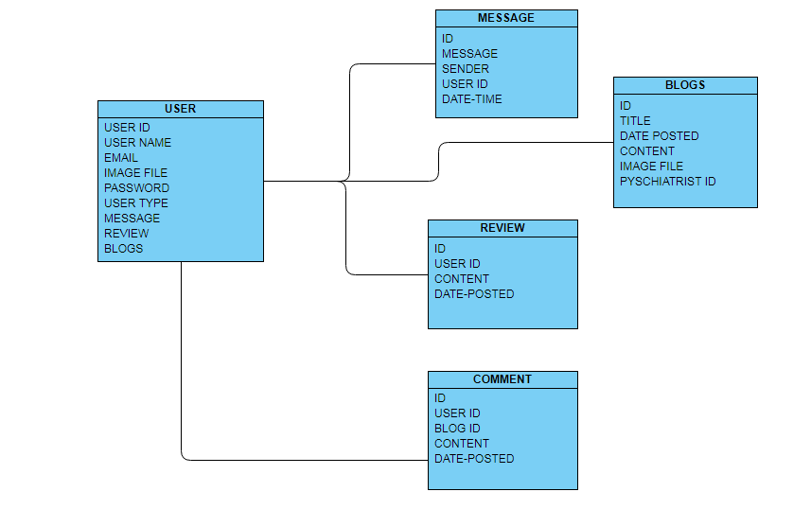

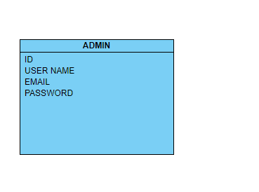

* + 1. **Object diagram:**

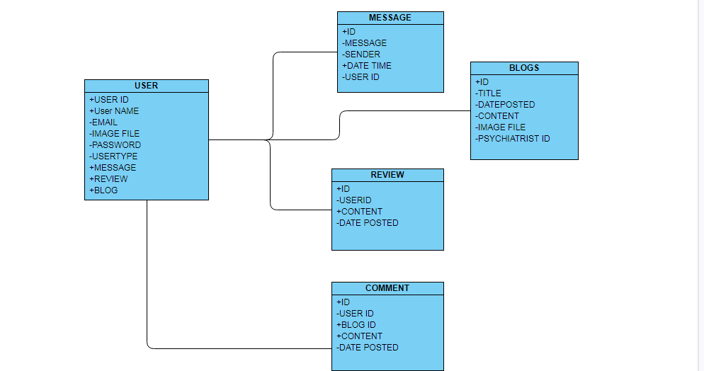

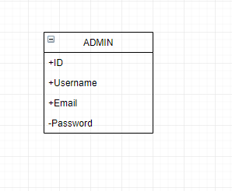

* + 1. **Sequecne diagram:**
       1. **Chat:**

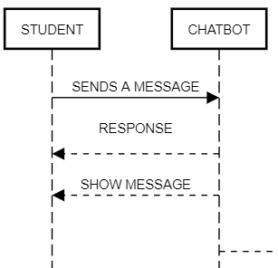

* + - 1. **Login:**

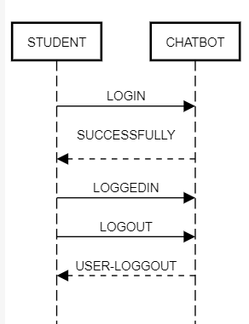

* + - 1. **Register:**

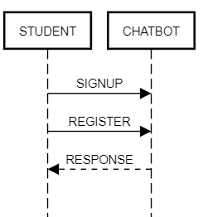

**4.3.3.4:Reviews**

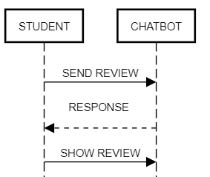

**4.3.3.5 : BLOGS**

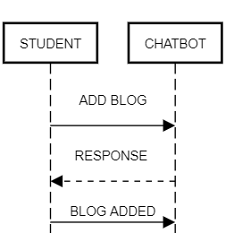

* + 1. **Activity Diagram:**

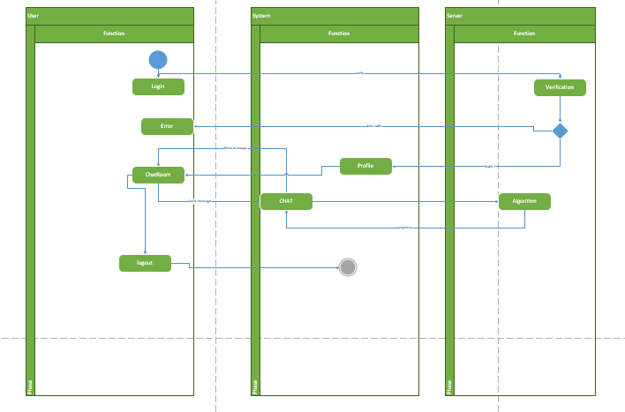

* + 1. **Collaboration diagram:**

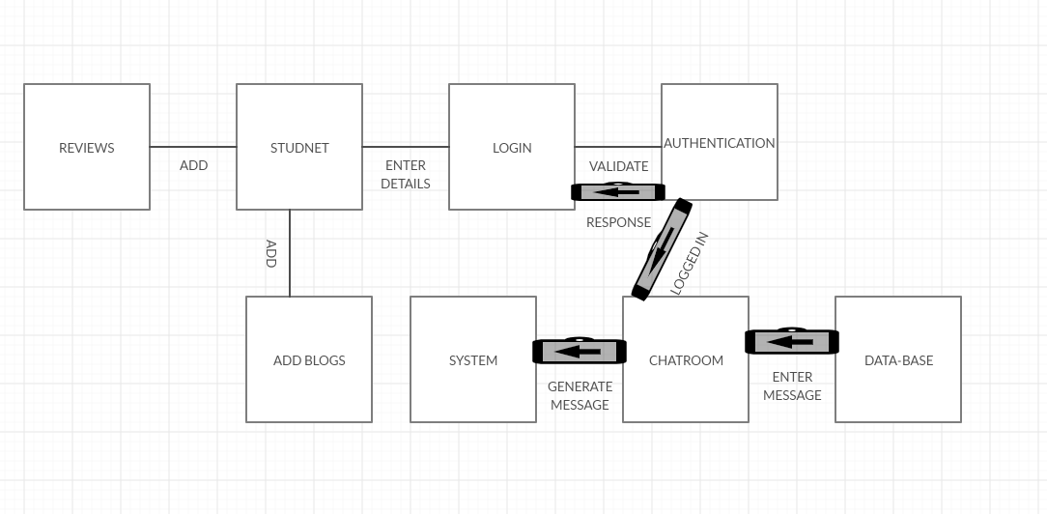

* + 1. **Use Case diagram:**

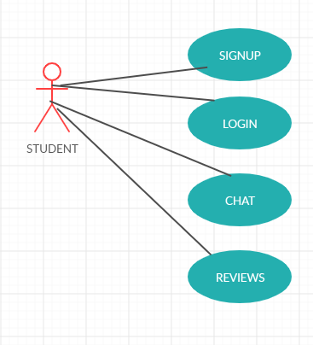

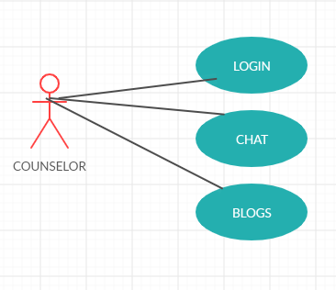

* + 1. **Component diagram:**



* + 1. **Deployment diagram:**

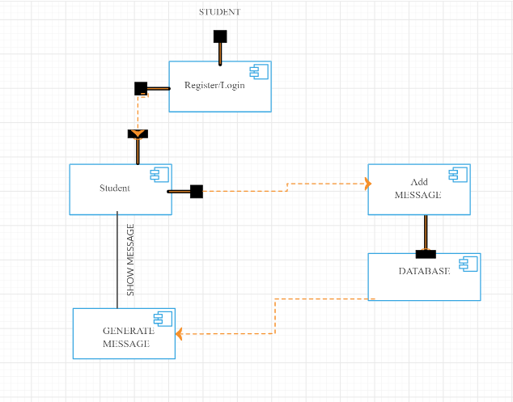

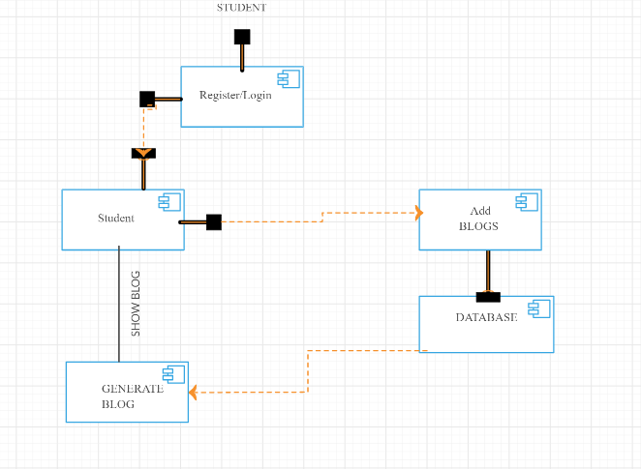

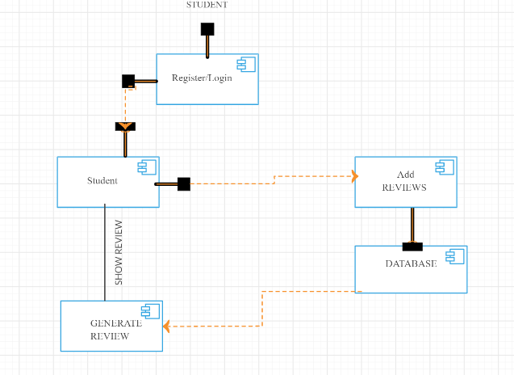

* + 1. **State Block diagram:**

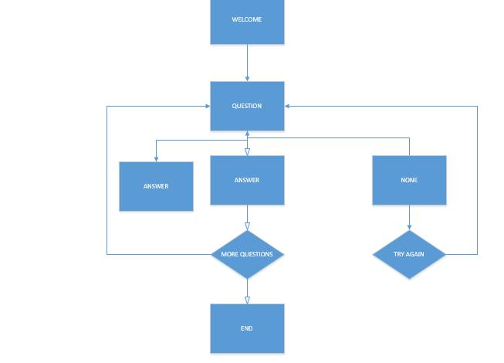

* 1. **ERD:**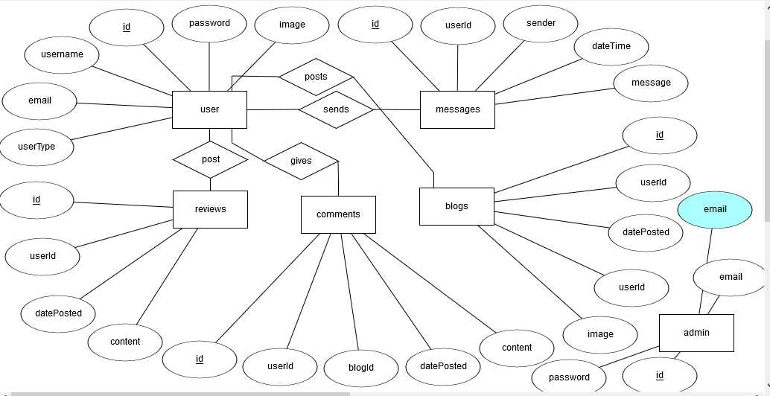

**SEQUENCE DIAGRAM**

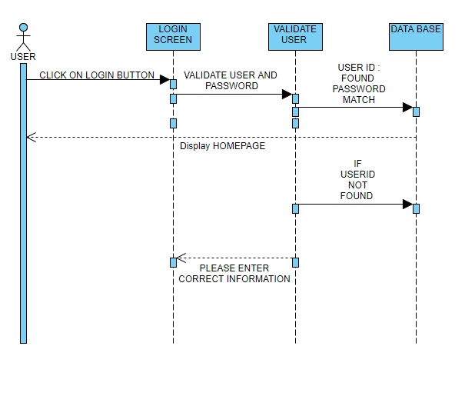

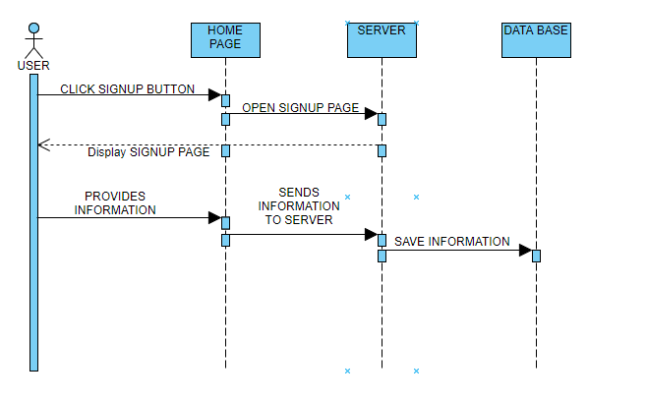

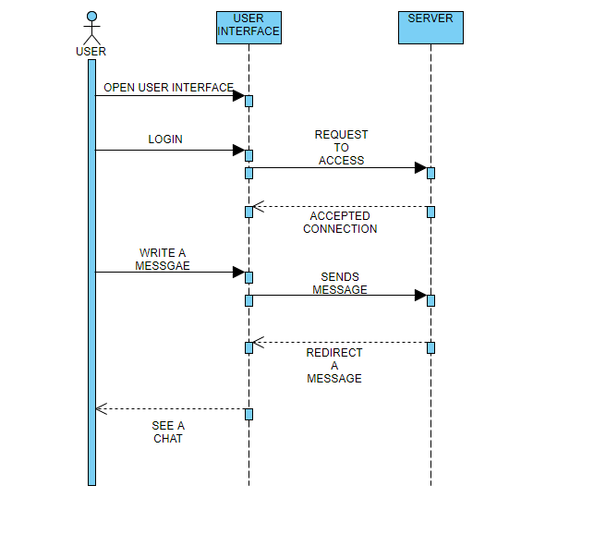

**CONTEXT DIAGRAM**

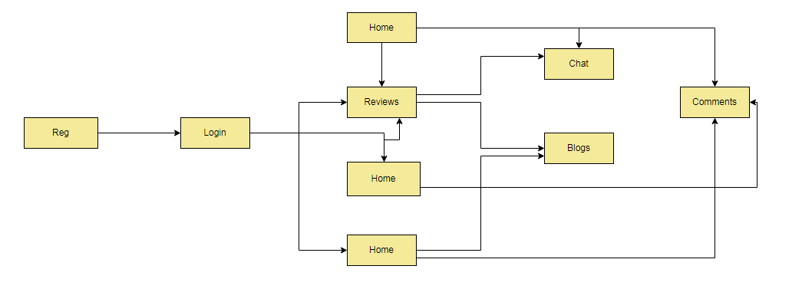

**TEST CASES**

|  |  |  |  |  |  |  |  |  |  |  |
| --- | --- | --- | --- | --- | --- | --- | --- | --- | --- | --- |
| **Test Case ID** | | 1 | **Test Case Description** | | Test Login Functionality | | | | | |
| **Created By** | | Muhamad Hassan | **Reviewed By** | | Muhammad Daniyal | | **Version** | | 1.0 | |
|  |  |  |  |  |  |  |  |  |  |  |
| **QA Tester’s Log** | | Review comments from Hassan incorporate in version 1.0 | | | |  |  |  |  |  |
|  |  |  |  |  |  |  |  |  |  |  |
| **Tester's Name** | | Muhammad Hassan | **Date Tested** | | 11/28/2019 | | **Test Case (Pass/Fail/Not Executed)** | | Passed | |
|  |  |  |  |  |  |  |  |  |  |  |
| **S #** | **Prerequisites:** | | |  | **S #** | **Test Data** | | | | |
| 1 | Access to Browser and Internet | | |  | 1 | Login credentials | | | | |
| 2 | User Must be registered | | |  | 2 |  | | | | |
|  |  |  |  |  |  |  |  |  |  |  |
| **Test Scenario** | Verify on entering invalid User id and password | | | | | |  |  |  |  |
|  |  |  |  |  |  |  |  |  |  |  |
|  |  |  |  |  |  |  |  |  |  |  |
| **Step #** | **Step Details** | | **Expected Results** | | **Actual Results** | | | **Pass / Fail / Not executed / Suspended** | | |
|
| 1 | Navigate to http://localhost:5000 | | Site should open | | Site should open | | | Pass | | |
| 2 | Enter User ID and password | | Credential can be entered | | Credential can be entered | | | Pass | | |
| 3 | Click Submit | | User is logged in | | Please Enter the Valid User ID and Password | | | Failed. Because User ID entered is not presented in database. | | |

|  |  |  |  |  |  |  |  |  |  |  |
| --- | --- | --- | --- | --- | --- | --- | --- | --- | --- | --- |
| **Test Case ID** | | 2 | **Test Case Description** | | Test Sign Up Functionality | | | | | |
| **Created By** | | Muhammad Hassan | **Reviewed By** | | Muhammad Daniyal | | **Version** | | 1.0 | |
|  |  |  |  |  |  |  |  |  |  |  |
| **QA Tester’s Log** | | Review comments from Hassan incorporate in version 1.0 | | | |  |  |  |  |  |
|  |  |  |  |  |  |  |  |  |  |  |
| **Tester's Name** | | Muhammad Hassan | **Date Tested** | | 11/28/2019 | | **Test Case (Pass/Fail/Not Executed)** | | Passed | |
| **S #** | **Prerequisites:** | | |  | **S #** | **Test Data** | | | | |
| 1 | Access to Browser and Internet | | |  | 1 | All fields (in Registration form) are filled with appropriate type of that input field | | | | |
| 2 | User should Sign Up | | |  | 2 | Click “Submit Data”. | | | | |

|  |  |  |  |  |  |  |  |
| --- | --- | --- | --- | --- | --- | --- | --- |
| **Test Scenario** | Verify on registering User ID and password | | |  |  |  |  |
| **Step #** | **Step Details** | **Expected Results** | **Actual Results** | | **Pass / Fail / Not executed / Suspended** | | |
|
| 1 | Navigate to http://localhost:5000 | Site should open | Site should open | | Pass | | |
| 2 | Enter valid information | Credential can be entered | Credential can be entered | | Pass | | |
| 3 | Click Submit | Submit message and redirect to login page | Submit message and redirect to login page. | | Pass | | |

|  |  |  |  |  |  |  |  |  |  |  |
| --- | --- | --- | --- | --- | --- | --- | --- | --- | --- | --- |
| **Test Case ID** | | 3 | **Test Case Description** | | Test of Chatbot | | | | | |
| **Created By** | | Muhammad Hassan | **Reviewed By** | | Muhammad Daniyal | | **Version** | | 1.0 | |
|  |  |  |  |  |  |  |  |  |  |  |
| **QA Tester’s Log** | | Review comments from Hassan incorporate in version 1.0 | | | |  |  |  |  |  |
|  |  |  |  |  |  |  |  |  |  |  |
| **Tester's Name** | | Muhammad Hassan | **Date Tested** | | 11/28/2019 | | **Test Case (Pass/Fail/Not Executed)** | | Pass | |
|  |  |  |  |  |  |  |  |  |  |  |
| **S #** | **Prerequisites:** | | |  | **S #** | **Test Data** | | | | |
| 1 | Access to Internet, Browser and Keyboard Mouse. | | |  | 1 |  | | | | |
| 2 | User can Chat | | |  | 2 |  | | | | |
|  |  |  |  |  |  |  |  |  |  |  |
| **Test Scenario** | Verify on entering valid User ID and password | | | | | |  |  |  |  |
|  |  |  |  |  |  |  |  |  |  |  |
| **Step #** | **Step Details** | | **Expected Results** | | **Actual Results** | | | **Pass / Fail / Not executed / Suspended** | | |
|
| 1 | Navigate to http://localhost:5000/chat | | Site should open | | Site should open | | | Pass | | |
| 2 |  | | Credential can be entered | | Credential can be entered | | | Pass | | |
| 3 |  | | Entering text | | Getting response | | | Pass | | |

|  |  |  |  |  |  |  |  |  |  |  |
| --- | --- | --- | --- | --- | --- | --- | --- | --- | --- | --- |
| **Test Case ID** | | 4 | **Test Case Description** | | REVIEW | | | | | |
| **Created By** | | Muhamad Hassan | **Reviewed By** | | Muhammad Daniyal | | **Version** | | 1.0 | |
|  |  |  |  |  |  |  |  |  |  |  |
| **QA Tester’s Log** | | Review comments from Hassan incorporate in version 1.0 | | | |  |  |  |  |  |
|  |  |  |  |  |  |  |  |  |  |  |
| **Tester's Name** | | Muhammad Hassan | **Date Tested** | | 11/28/2019 | | **Test Case (Pass/Fail/Not Executed)** | | Passed | |
|  |  |  |  |  |  |  |  |  |  |  |
| **S #** | **Prerequisites:** | | |  | **S #** | **Test Data** | | | | |
| 1 | Access to Browser and Internet | | |  | 1 |  | | | | |
| 2 | Student can Review | | |  | 2 |  | | | | |
|  |  |  |  |  |  |  |  |  |  |  |
| **Test Scenario** | Verify on entering invalid User id and password | | | | | |  |  |  |  |
|  |  |  |  |  |  |  |  |  |  |  |
|  |  |  |  |  |  |  |  |  |  |  |
| **Step #** | **Step Details** | | **Expected Results** | | **Actual Results** | | | **Pass / Fail / Not executed / Suspended** | | |
|
| 1 | Navigate to http://localhost:5000 | | Site should open | | Site should open | | | Pass | | |
| 2 | Enter Review | | Credential can be entered | | Credential can be entered | | | Pass | | |
| 3 | Click Submit Review | | Generate Review | | Review is posted | | | Pass | | |

|  |  |  |  |  |  |  |  |  |  |  |
| --- | --- | --- | --- | --- | --- | --- | --- | --- | --- | --- |
| **Test Case ID** | | 5 | **Test Case Description** | | BLOG | | | | | |
| **Created By** | | Muhamad Hassan | **Reviewed By** | | Muhammad Daniyal | | **Version** | | 1.0 | |
|  |  |  |  |  |  |  |  |  |  |  |
| **QA Tester’s Log** | | Review comments from Hassan incorporate in version 1.0 | | | |  |  |  |  |  |
|  |  |  |  |  |  |  |  |  |  |  |
| **Tester's Name** | | Muhammad Hassan | **Date Tested** | | 11/28/2019 | | **Test Case (Pass/Fail/Not Executed)** | | Passed | |
|  |  |  |  |  |  |  |  |  |  |  |
| **S #** | **Prerequisites:** | | |  | **S #** | **Test Data** | | | | |
| 1 | Access to Browser and Internet | | |  | 1 |  | | | | |
| 2 | ADD BLOG | | |  | 2 |  | | | | |
|  |  |  |  |  |  |  |  |  |  |  |
| **Test Scenario** | Verify on entering invalid User id and password | | | | | |  |  |  |  |
|  |  |  |  |  |  |  |  |  |  |  |
|  |  |  |  |  |  |  |  |  |  |  |
| **Step #** | **Step Details** | | **Expected Results** | | **Actual Results** | | | **Pass / Fail / Not executed / Suspended** | | |
|
| 1 | Navigate to http://localhost:5000 | | Site should open | | Site should open | | | Pass | | |
| 2 | ADD BLOG | | Credential can be entered | | Credential can be entered | | | Pass | | |
| 3 | Click ADD BLOG | | Generate Blog | | Blog is added | | | Pass | | |

|  |  |  |  |  |  |  |  |  |  |  |
| --- | --- | --- | --- | --- | --- | --- | --- | --- | --- | --- |
| **Test Case ID** | | 6 | **Test Case Description** | | COMMENT | | | | | |
| **Created By** | | Muhamad Hassan | **Reviewed By** | | Muhammad Daniyal | | **Version** | | 1.0 | |
|  |  |  |  |  |  |  |  |  |  |  |
| **QA Tester’s Log** | | Review comments from Hassan incorporate in version 1.0 | | | |  |  |  |  |  |
|  |  |  |  |  |  |  |  |  |  |  |
| **Tester's Name** | | Muhammad Hassan | **Date Tested** | | 11/28/2019 | | **Test Case (Pass/Fail/Not Executed)** | | Passed | |
|  |  |  |  |  |  |  |  |  |  |  |
| **S #** | **Prerequisites:** | | |  | **S #** | **Test Data** | | | | |
| 1 | Access to Browser and Internet | | |  | 1 |  | | | | |
| 2 | Student can Review | | |  | 2 |  | | | | |
|  |  |  |  |  |  |  |  |  |  |  |
| **Test Scenario** | Verify on entering invalid User id and password | | | | | |  |  |  |  |
|  |  |  |  |  |  |  |  |  |  |  |
|  |  |  |  |  |  |  |  |  |  |  |
| **Step #** | **Step Details** | | **Expected Results** | | **Actual Results** | | | **Pass / Fail / Not executed / Suspended** | | |
|
| 1 | Navigate to http://localhost:5000 | | Site should open | | Site should open | | | Pass | | |
| 2 | Enter comment | | Credential can be entered | | Credential can be entered | | | Pass | | |
| 3 | Click present | | Generate comment | | Comment posted | | | Pass | | |

**Log form**



SHAHEED ZULFIKAR ALI BHUTTO INSTITUTE OF SCIENCE &

TECHNOLOGY KARACHI CAMPUS

**Form IV**: Student Log Form

Title: BOT COUNSELLOR

Supervisor: Naveed Ghani Batch/Sec: BSCS 8C/D Group #: 33

Reg. # (Group members): Muhammad Hassan (1612195) Muhammad Daniyal (1612238)

|  |  |  |  |  |
| --- | --- | --- | --- | --- |
| **Sr.** | **Task Assigned** | **Due** | **Task Completed (S)** | **Date (S)/Sign.** |
| 1 | Blogs Posting | 3/03/20 | yes | Naveed Ghani |
| 2 | Reviews | 15/03/20 | yes | Naveed Ghani |
| 3 | Comments | 15/03/20 | yes | Naveed Ghani |
| 4 | GUI Enhancement | 10/04/20 | yes | Naveed Ghani |
| 5 | Training of Model | 21/04/20 | yes | Naveed Ghani |
| 6 | Complete Login functionality. | 1/05/20 | yes | Naveed Ghani |

Supervisor’s Authentication (Completed report):_______________________ Dated:________________

FYP Coordinator Authentication:__ ________________ Dated: 29/06/20_________

# 

# User Manual

**BOT COUNSELOR**

Muhammad Hassan (1612195)

Muhammad Daniyal (1612)

Advisor name: Naveed Ghani

Final Year Project 2020

Szabist, Karachi

# General Information

## System Overview

## The aim of career counselling bot is to carry out a conversation between both human and machine. Some knowledge has been embedded into the machine so that it identifies the sentences and making a decision itself as response to answer a question. BOT COUNSELLER will be used as assistant which will help the user to select the specific field.

## Project References

The following list provides complete information of the tools that were used in developing the system

Visual Studio Code

(Neural Network)

## Manual Organization

The manual is divided into three sections defined in the list below

* General Information
* System summary
* Getting started

## 1.4 Acronyms and Abbreviations

**ML:** MACHINE LEARNING

**NN:** NEURAL NETWORK

GUI( Graphical user interface)

# 

# 2.0 System Summary

**FEATURES**

**HOME:**

This feature will show all the List of the BLOGS.

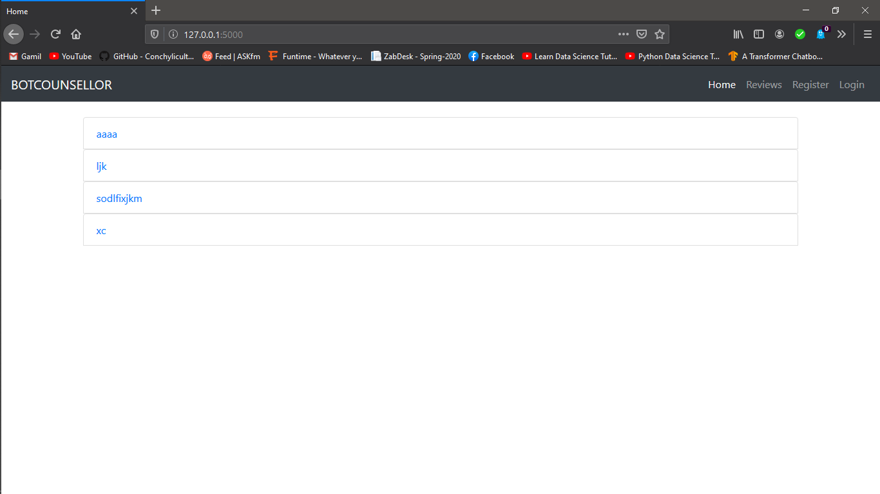

**LOGIN:**

Admin, Counsellor and Student will Should to the account to excess the chatroom

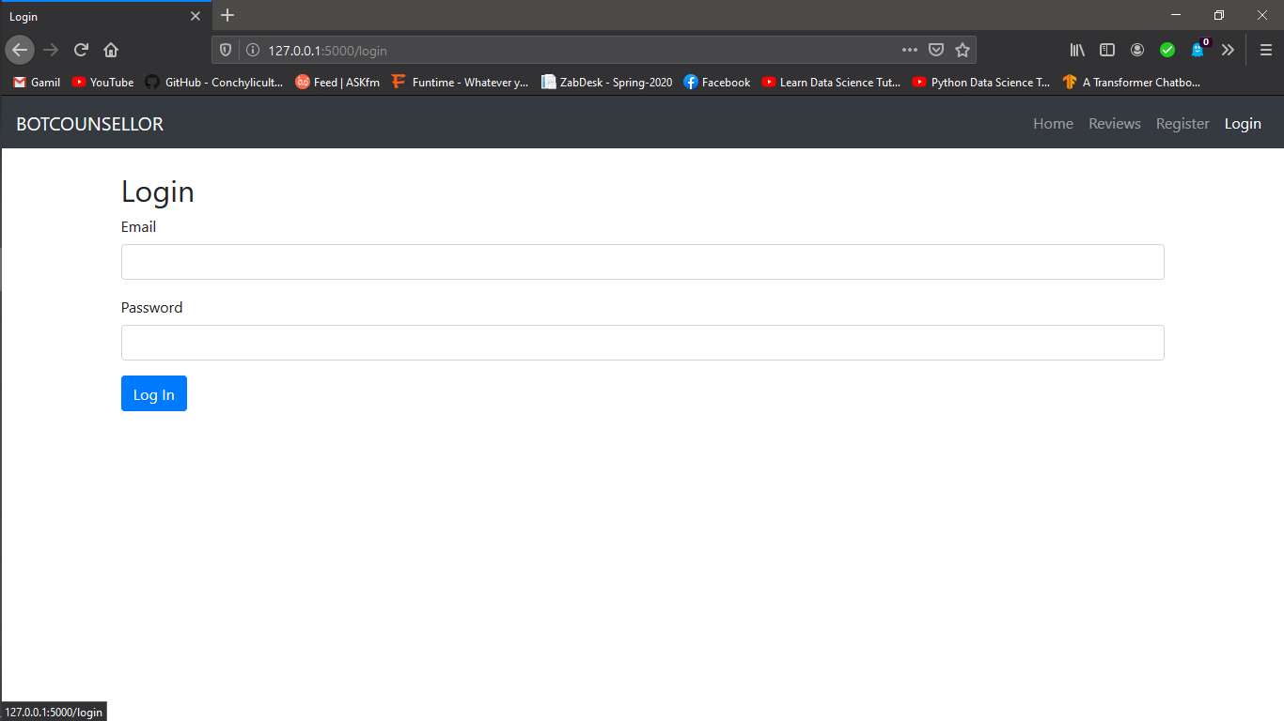

**REGISTER:**

Student can register themselves, Counsellor can be registered by the ADMIN only, they cannot register themselves.

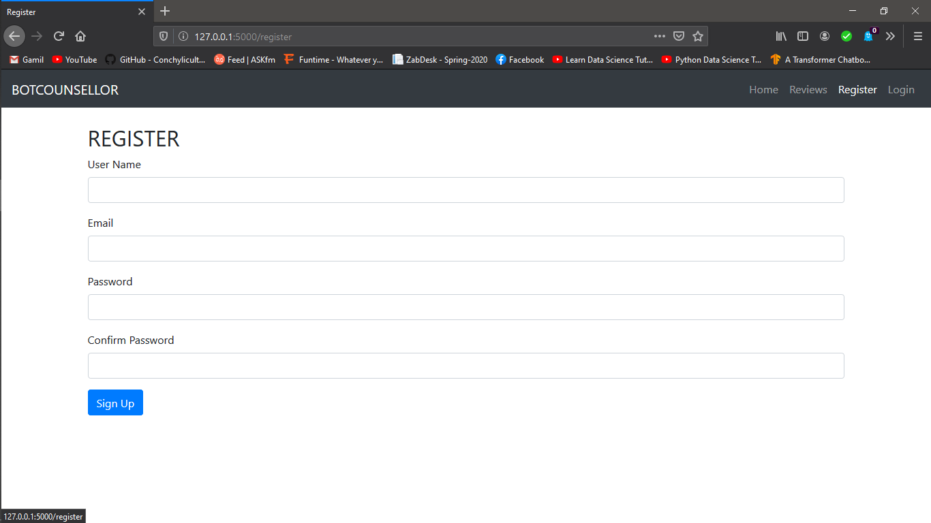

**BLOGS:**

Blogs can be shown to anyone; Student and Counsellor can comment on the blogs if they are logged in with their ID’s. Counsellor can update and delete their own blogs as well.

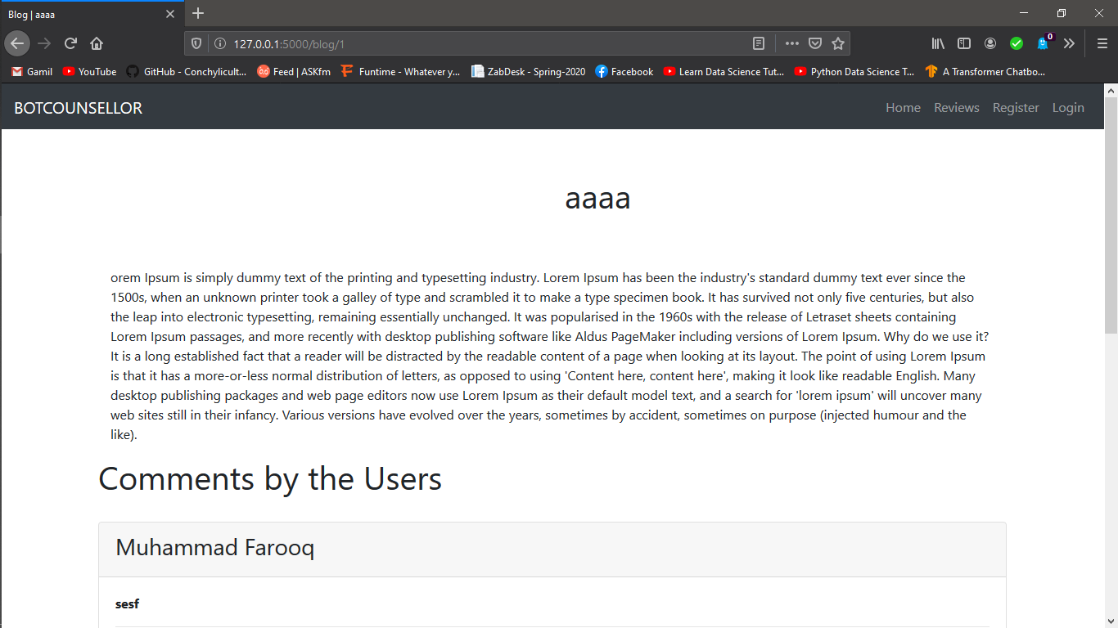

**REVIEWS:**

Reviews will be shown to everyone, Student can also update / delete his/her own Reviews if they are logged in.

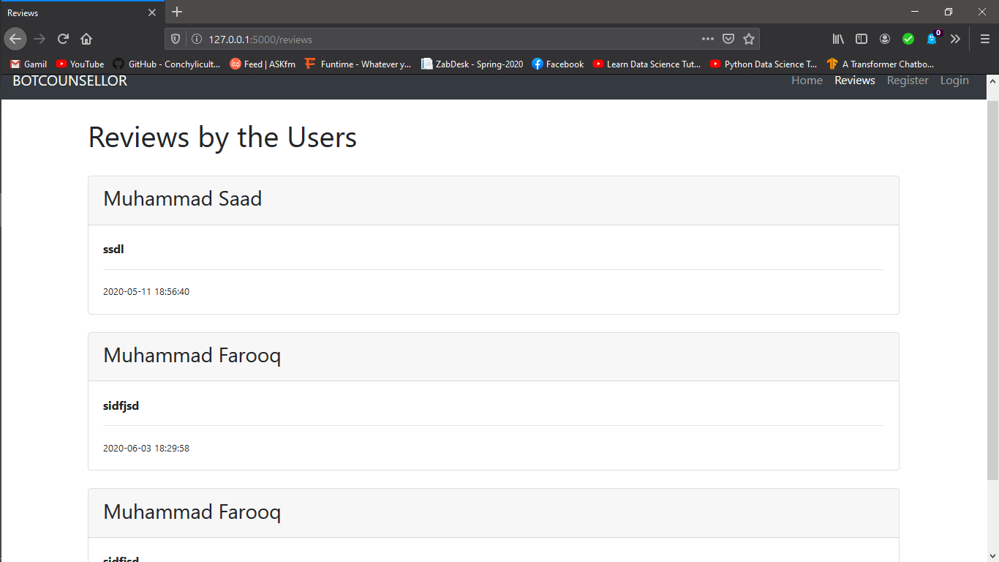

**CHATROOM:**

Only Students are allowed to chat, Counsellor can see the chat but they cannot chat with the students.



# 2.0 Getting Started

There are 3 types of users associated with our site.

1. Admin
2. Student
3. Counsellor

So lets breakdown the workflow with respect of users.

1. STUDENTS

After visiting site, student will be able to see homepage that has the list of blogs posted by counsellor. Student can open blogs and can read the blogs and comments followed by the blogs as well. In the same navigation penal, he will be able to see the reviews of other students as well. Furthermore, he can login to the site with login credentials if he is already registered to the portal and if not, he can register himself to the portal anytime. After logging in, he can add comments to the blogs posted by the counsellor. He can have counselling from the bot about the field to choose for his career. And he can post reviews as well. That’s all student can do at this stage.

Briefly, he can add comments, reviews and do chats

1. Counsellor

Same as student, counsellor can see home and all stuff. But the thing is, he cannot register himself. Only admin can register counsellor. After counsellor is registered, he can post blog and can comment as well, but cannot give reviews. He can read chats of student and bot as well.

Briefly, he can add blogs and comments and can read chats only

1. Admin

Admin is the most powerful user of all. He can read each and every thing and can remove anything anytime and any user as well. He cannot be registered nor created new. Once created manually, that’s the only admin. After logging in, he can delete blogs, comment, reviews and users as well.