Bot Counselor

FYP Project Proposal

Supervisor
Naveed Ghani

Submitted by

Muhammad Hassan
(1612195)
Muhammad Daniyal
(1612238)

Faculty of Computing and Engineering Sciences
Shaheed Zulfiqar Ali Bhutto Institute of Science and Technology, Karachi.

[April 7th 2020]

Introduction
Chatbots are the new generation computer programs that perform intelligent human conversation. It has three parts. The first one is typed or spoken input from the user in natural language, second is the typed or spoken output from the chatbot and then the process of passing the input through the program so that an understandable output is produced. This whole process is repeated until the end of the conversation is reached. The Career counselling bot is a system designed for users where they can ask any career related questions like best field to choose, latest trending course, etc. Even if the user does not frame sentence properly system will understands the query and answer accordingly. The user doesn’t need to follow any specific format to ask questions. NLP(Natural Language Processing) concept has been used that is concerned with programming computers so that natural language is processed and used in order to get output to user.

Objective
The purpose of a chat bot system is to simulate a human conversation; the chat bot architecture integrates a computational algorithm and language model to emulate information chat communication between a human user and a computer using natural language.

Problem Description
After students high school education, there comes the time when student has to decide which career should be s(he) pursue. At that time, most students don’t know where to go now. The guidance at that time, which career to be selected is named as career counselling.

Career counseling, also known as career guidance, is counseling designed to help with choosing, changing, or leaving a career[1].

Career counselling is one of the major part in student’s life. Students mostly find difficulties while choosing their career. And the availability of counselors is also a big issue. So the bot will be trained to look after the counselling issues faced by student and try to suggest them about their fields.

.

Methodology

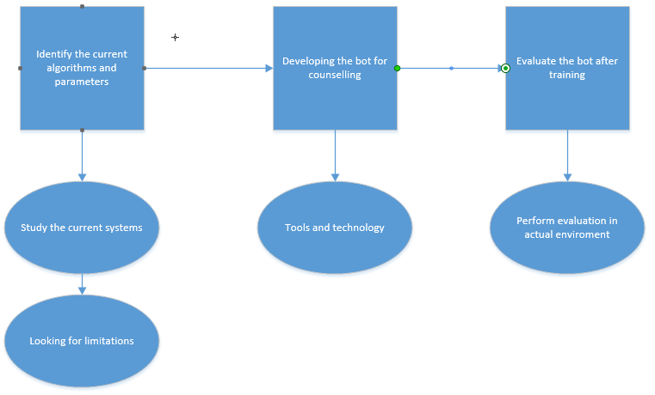

Project Scope
The whole education industry is under the umbrella of our bot. counselling is one of the major need of person. so the scope is well enough to help the people related to such field.

Feasibility Study
With above defined scope, would you be able to meet your project schedule? Do mention following aspects:
    - Risks Involved:
        - Less dataset volume; there is no dataset available for above mentioned project. Solution: So dataset will be collected by self.
        - No query available: due to fixed programming, chatbot can stuck if any unsaved query is presented in front of them. Solution: plenty amount of data set will be provided.
        - Update: bot is pre-programmed, so it has limited amount of information (provided at the time of training). Solution: need to update time to time.
    - Resource Requirement:
        - Survey
        - Training dataset
        - Different counselling sources for results.

Solution Application Areas
Is your project of some real value?
Yes. Because these is no bot available to counsel student and guide them for their career and future.
Which industry or application domain you are targeting?
Mostly education industry lack in counselling student. So this can be used to counsel the students.
How that target domain may benefit from your solution?
Education institutes are lacking counselling facility. And hiring a counselor results in huge amount of money. The trained bot will help the institutes for counselling their students.

Tools/Technology
Visual Studio Code
(Neural Network)

Expertise of the Team Members
Are all team members pre-equipped with the level of knowledge needed for the successful completion of this project?
Theoretically and the concept is clear to the team. And the implementation part is to be practiced. And by the end of the session, a running product will be developed.
Have you people studied the relevant course by now?
Artificial Intelligence is the core course for this project and offered in this semester. So, learning and understanding will be done time to time.
Is this project of equal interest to all team members?
Yes, the team is interested in developing the system that will help in counselling the upcoming students.

10. FEATURES
1) Counselor blogs will be shown on the homepage.
2)Registration of Counselor will be done by Admin.
3)Student can register themselves.
4)Student can give reviews on the website.
5)Counsellor can see the chat between the Student and the Bot.
6)Admin can delete Couselor and Student.
7) Counselor can delete his own blog.
8)Admin can delete Counselor Blog.
9)Student can delete his own review.
10)Chat can only be done by the Student.
11)Admin can delete reviews.

11. Milestones
FYP I
- SRS
- SDS
  - Creating UML
  - questionnaire
- Data gathering
  - Google form
  - Distribution of questionnaire
- Coding
  - Basic design
FYP II
- Dataset compilation
  - Creating trainable data
- Artificial Algorithm
  - Implementing algorithm
  - Training the bot
- Testing
  - Testing the bot

12. Project Schedule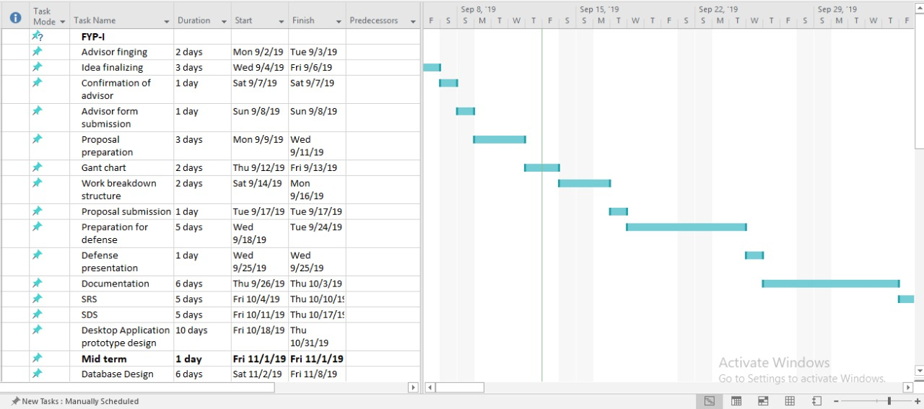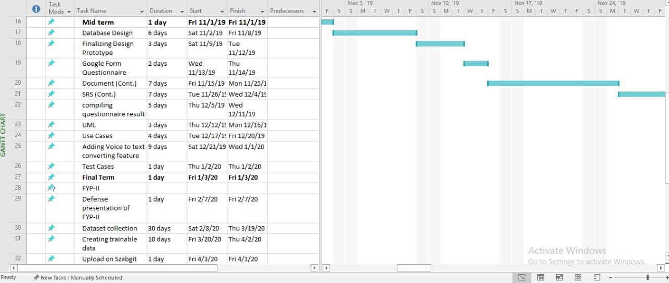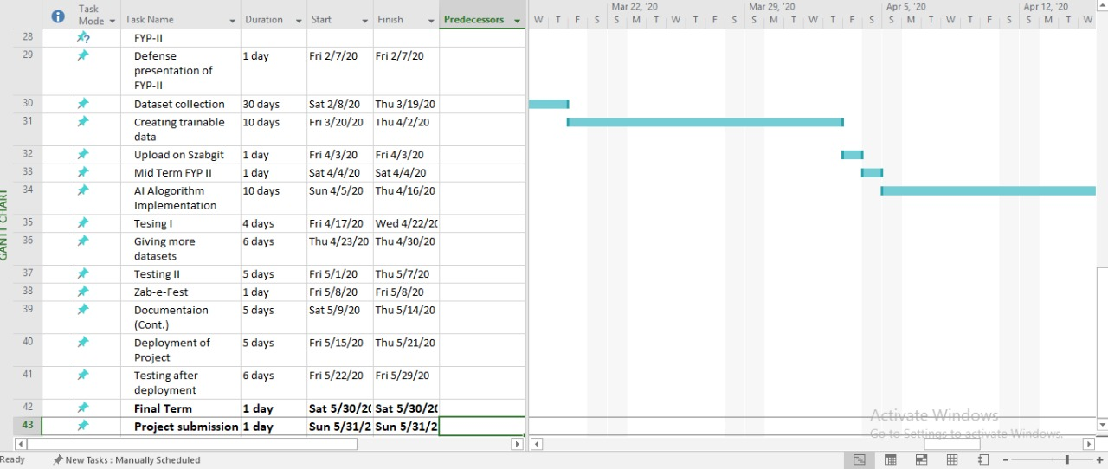

13. Work Breakdown Structure 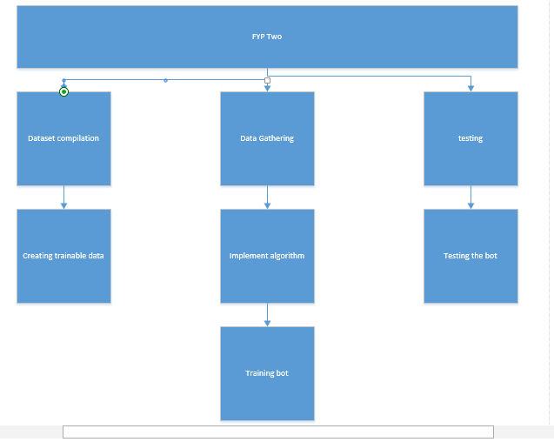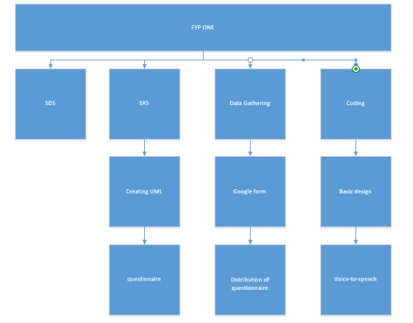

14. References

[1] – Good Therapy: https://www.goodtherapy.org/learn-about-therapy/issues/career-counseling

