Sistem Pemantauan Karbon (SPK): Digital Carbon Accounting Platform for Emissions Tracking and Reporting
Muhammad Ibrahim Al-Imran Bin Mohd Isa¹, Noreen Izza Arshad²
^{1,2}Department of Computer and Information Sciences, Universiti Teknologi PETRONAS, 32610 Seri Iskandar, Perak, Malaysia
Corresponding email: [student email], [supervisor email]
Abstract
Malaysia's planned carbon tax and National Climate Change Bill will require organisations to report auditable Scope 1 and Scope 2 greenhouse gas emissions, yet many still rely on spreadsheets or one-off calculators that do not validate entries, forecast emissions or show tax exposure. This paper presents Sistem Pemantauan Karbon (SPK), a role-based web platform built with Python, Streamlit and SQLite that converts activity data into carbon dioxide equivalent (CO₂e) and carbon tax using Malaysian SEDG emission factors. Each submission is screened by a z-score and duplicate rule, flagged entries are held for approval, and every entry, approval and withdrawal is kept in an auditable ledger. A STIRPAT model estimated by ridge regression forecasts emissions six months ahead, a what-if simulator estimates the effect of reduction measures, and an AI advisor answers questions from the figures on the user's page. The platform was developed in five Scrum sprints with five international oil and gas companies as case data. On the held-out year 2025, the STIRPAT model reached a weighted absolute percentage error of 1.45% for Scope 1, 11.12% for Scope 2 and 1.51% for total emissions, against 6.40%, 18.33% and 6.81% for a linear trend. All 78 unit tests passed, 52 of 56 system test cases passed in a recorded session, and in user acceptance testing with 20 respondents 97.3% of executed test cases passed, with a mean System Usability Scale score of 77.4. The work shows that validated entry, an audit trail, driver-based forecasting and grounded explanation can be combined in one lightweight tool. Future work will add spreadsheet upload, hosted deployment and measured monthly data.
Keywords GHG Protocol, STIRPAT, Ridge Regression, Anomaly Detection, System Usability Scale, Large Language Model
INTRODUCTION
Background
Malaysia confirmed in Budget 2026 that a carbon tax would be introduced, first for the iron, steel and energy sectors [1], at a reported rate of MYR 15 per tonne of carbon dioxide equivalent (CO₂e) [2]. The National Climate Change Bill establishes a measurement, reporting and verification (MRV) system as the basis for carbon pricing [3]. Under the GHG Protocol, direct emissions from sources an organisation owns or controls (Scope 1) are reported separately from indirect emissions from purchased energy (Scope 2) [4]. Once these emissions are taxed, an error in the data becomes an error in the bill, so every reported total must be correct and traceable.
Problem Statement
Four problems motivated this project. First, many organisations, particularly small and medium enterprises (SMEs), still collect emission data in spreadsheets spread across departments [5], commercial carbon accounting software is costly and difficult to integrate [6], and the free Malaysian calculators compute a footprint for one organisation at a time [7], [8]. Second, reported totals are hard to audit, because they are seldom traceable to the activity record, the emission factor used and the person who approved it. Third, existing tools are retrospective: they do not forecast emissions, simulate reduction measures or show tax liability over time. Fourth, non-specialist decision makers find emission figures hard to interpret, and a language model that could explain them may give plausible but false answers unless it is grounded in reliable data [9], [10].
Objectives and Scope of Study
The objectives were (i) to calculate Scope 1 and Scope 2 emissions and carbon tax with Malaysian emission factors under role-based access for company, government and IT users; (ii) to keep an auditable ledger that traces every figure to its submission, emission factor and approval; (iii) to provide STIRPAT forecasting, a what-if simulator and a grounded AI advisor; and (iv) to verify the calculations with automated tests and evaluate usability with users. The study covered Scope 1 and Scope 2 only. Five international oil and gas companies (bp, Chevron, ConocoPhillips, Equinor and ExxonMobil) served as case data because they publish consistent annual emission, production, revenue and energy figures, and the Malaysian context was applied through SEDG emission factors and a ringgit tax rate. The platform was built as a locally run prototype with open-source tools, which kept the work feasible within one semester.
LITERATURE REVIEW
Carbon Accounting Practice and Tools
Reviews of carbon accounting research report that corporate emission figures lack transparency, reliability and comparability [11], and studies of information-system architectures for digital carbon accounting call for identity management and traceable records to support digital MRV [12]. Inconsistency also comes from the choice of emission factor: the Peninsular Malaysia grid factor is 0.774 kg CO₂e/kWh in the SEDG calculator [13], 0.740 in the MGTC calculator [7] and 0.78 in the Maybank calculator [8]. Table 1 compares SPK with these calculators, with company sustainability data hubs [14] and with the near-real-time Carbon Monitor-Power dataset [15]. The Malaysian calculators produce a single footprint, while the data sources are static or national in scope; none of them combines validation of submitted data, forecasting and tax liability for several organisations.
Table 1 Comparison of existing tools and data sources with SPK
Feature | SEDG calculator | MGTC SME calculator | Maybank calculator | Company data hubs | Carbon Monitor-Power | SPK
Scope 1 and 2 from activity data | Yes | Yes | Yes | No | No | Yes
Malaysian emission factors | Yes | Yes | Yes | No | No | Yes
Several organisations in one view | No | No | No | No | Yes | Yes
Time series of emissions | No | No | – | Annual | Daily | Monthly
Forecast of future emissions | No | No | – | No | No | Yes
What-if reduction scenarios | No | No | – | No | No | Yes
Carbon tax liability in MYR | No | Indicative | – | No | No | Yes
Validation and approval of data | No | No | – | – | – | Yes
Role-based access and audit log | No | No | – | – | – | Yes
Conversational AI assistant | No | No | – | No | No | Yes

Based on publicly available descriptions of each tool; “–” means the feature is not described.
Data Validation and Forecasting
Anomaly detection methods for time series range from simple statistical rules to learned models [16]. A rule that flags a value lying several standard deviations from its own history is transparent and adapts to each series, which suits emission sources with few past values, where every flag must be explained to a human approver. For forecasting, the STIRPAT model restates the IPAT identity as a stochastic regression in which environmental impact depends on population, affluence and technology [17]; its logarithmic coefficients can be read as elasticities, and further terms can be added without losing this property [18]. Because the drivers are strongly correlated, ridge regression [19] is commonly used to estimate them, as in provincial studies of Hubei [20] and Shandong [21]. A review of 147 carbon emission prediction models found statistical models to be the most common type [22], but the STIRPAT studies reviewed for this project worked at national, provincial or city level with annual data, and none was found that applied the model to monthly company data inside a monitoring tool. For evaluation, the mean absolute percentage error (MAPE) becomes unstable when actual values are close to zero [23], which matters for small Scope 2 values.
AI Assistants for Climate Data
Grounding a language model in authoritative sources improves its answers on climate topics: ChatClimate, which gave GPT-4 access to the IPCC AR6 reports, produced answers that experts judged more accurate [10]. None of the carbon tools reviewed grounded an assistant in its own live figures. The gap addressed by SPK is therefore the combination, in one lightweight platform, of validated data entry with an audit trail, driver-based monthly forecasting and a grounded assistant.
METHODOLOGY
Development Approach and Timeline
SPK was developed with the Scrum framework [24] in five sprints during the FYP II semester, each ending with a working increment that was reviewed with the supervisor and committed to a Git repository. Table 2 lists the sprints and their deliverables, and Figure 1 shows the timeline against the FYP II milestones. The first sprint rebuilt the FYP I prototype in Python, Streamlit and SQLite; the next three added the company dataset and STIRPAT forecast, the SEDG factors, ledger, PDF statement and AI advisor, and the three user roles; and the fifth sprint covered user acceptance testing and defect fixes.
Table 2 Sprint plan and deliverables of FYP II
Sprint | Period | Main deliverables
S1 | 19–25 Sep 2026 | Python and Streamlit rebuild with four pages, login, SQLite data entry and carbon calculator; first unit tests
S2 | 6–8 Oct 2026 | Company workbook for five oil and gas companies; STIRPAT ridge forecast with train and test metrics
S3 | 15–23 Oct 2026 | SEDG factors and power consumption entries; duplicate rule; grounded AI chatbot; ledger seeded from the workbook; PDF carbon tax statement
S4 | 24 Oct – 9 Nov 2026 | Company, government and IT roles with row-level filtering; shared page base class; security fixes
S5 | 11–20 Nov 2026 | System test, user acceptance testing with 20 respondents and defect fixes

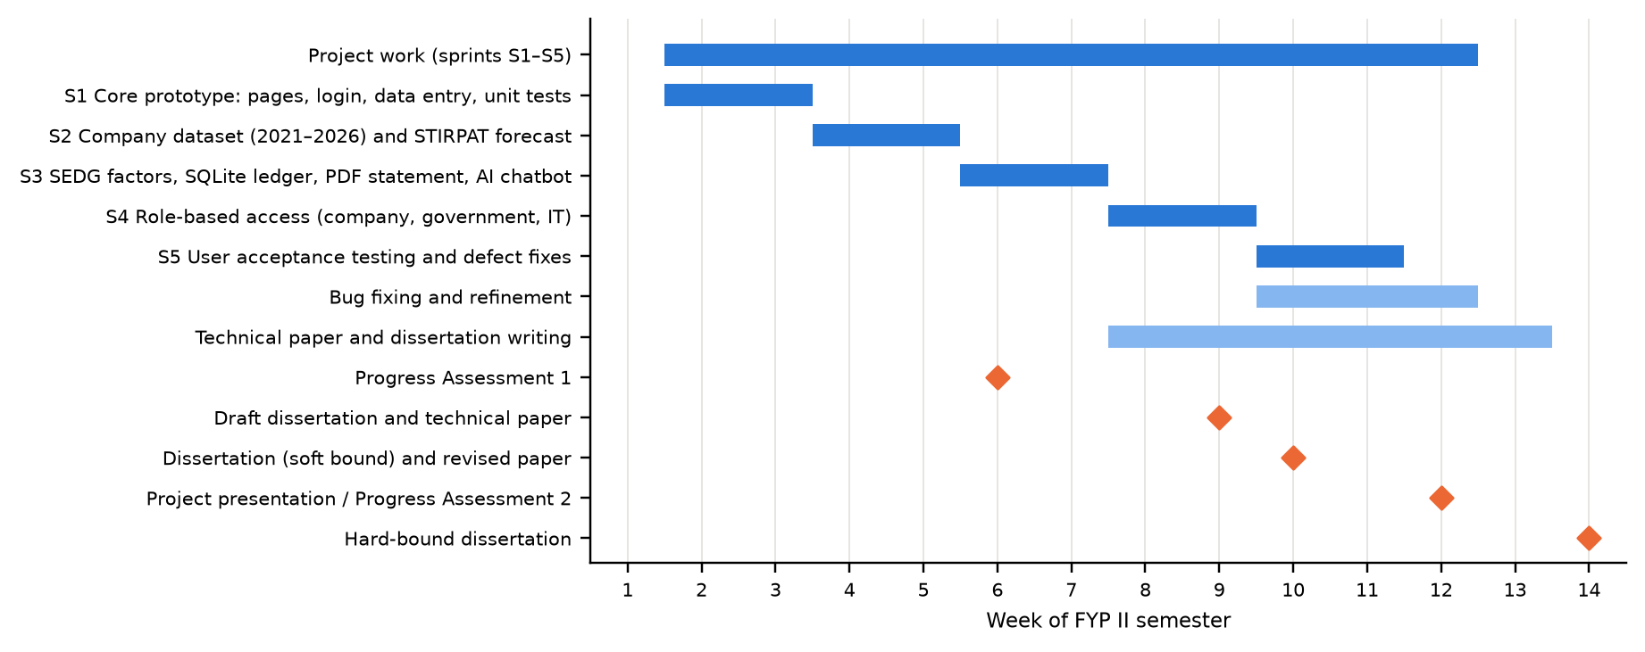
Figure 1 Timeline of the FYP II sprints, writing tasks and assessment milestones (weeks of the semester)
System Architecture
The platform was implemented in Python 3.12, with Streamlit for the interface, scikit-learn for modelling, Plotly for charts, SQLite for storage and ReportLab for PDF statements. Its four layers are shown in Figure 2. The processing modules do not depend on Streamlit, so they can be unit-tested. Company users see only their own company's rows; government officers see all companies and issue tax statements but cannot enter data; IT administrators can also view the audit log.
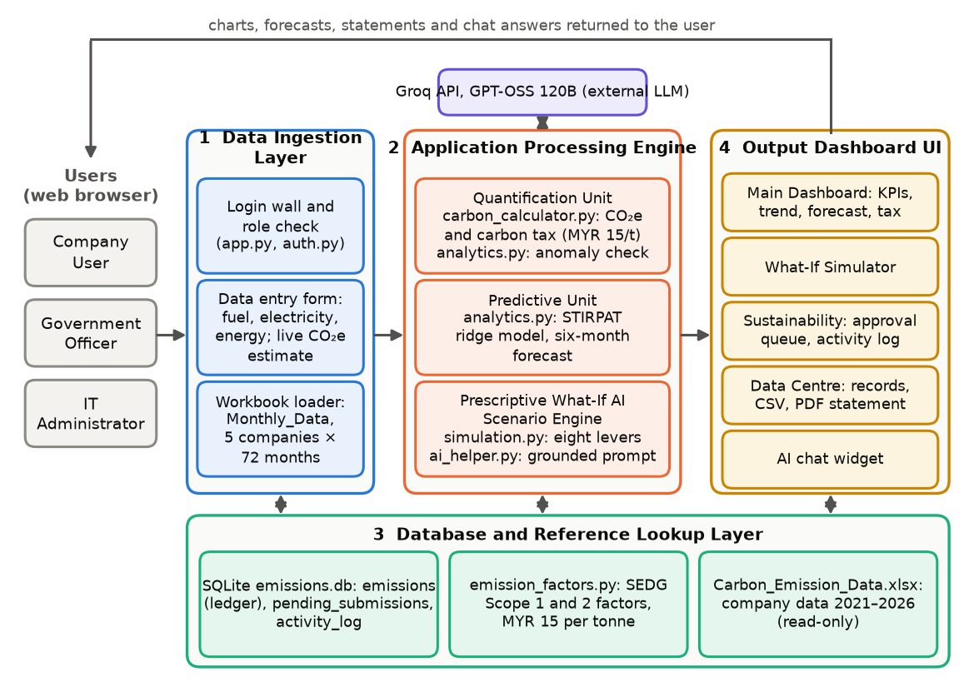
Figure 2 System architecture of SPK
Emission, Tax and Anomaly Rules
Activity data Q is converted with the SEDG emission factor EF [13], and the tax is charged at rate r, by default MYR 15 per tonne. A submitted quantity x is compared with the mean μ and standard deviation σ of the approved history of the same source:
$CO_{2}e = Q × EF, Tax = \frac{CO_{2}e}{1000} × r, z = \frac{|x − μ|}{σ}$ (1)
An entry is flagged when z exceeds 2.5 and the source has at least five approved records. A source with less history is scored on CO₂e against the approved entries of the other sources in its scope, and only unusually high values are flagged; this fallback was added after user testing. An entry is also flagged when the source already has an entry for that month. Flagged entries wait in an approval queue and count towards no total until approved, and records are never deleted: replaced and withdrawn entries keep their rows with a new status, so the lineage of every total is preserved.
Dataset and Forecasting Model
Annual data for 2021 to 2025 for the five companies was taken from their reports and disaggregated into months with the additive first-difference Denton method [25], so that the months sum to the reported totals; 2026 was projected as a synthetic year and excluded from fitting. For company i in month t, emissions I were related to production P, revenue A and energy intensity T:
$ln I_{it} = α_{i} + b ln P_{it} + c ln A_{it} + d ln T_{it} + ε_{it}$ (2)
The Scope 2 model adds a company-specific yearly trend. Coefficients were estimated by ridge regression with λ = 0.005, following [21], trained on 2021 to 2024 and tested on the twelve months of 2025. The baselines were the ordinary least squares (OLS) time trend of the earlier prototype and a seasonal naïve forecast that repeats the 2024 value of each month. The main accuracy measure was the weighted absolute percentage error, which, unlike MAPE, is not distorted by small Scope 2 values [23]:
$WAPE = \frac{\sum{|y − ŷ|}}{\sum{y}} × 100\%$ (3)
AI Advisor
For each question, the current page summarises the figures it displays, using only rows that the user's role may see, and sends the summary with a system prompt to the GPT-OSS 120B model through the Groq API. The prompt requires the model to quote only those figures, to state when data is missing and to keep answers short.
Testing and Evaluation
The platform was evaluated at three levels. First, 78 automated unit tests written with Python's unittest framework checked the calculation, access, simulation, report, analytics and data modules against a temporary database. Second, the 56 black-box test cases were executed on the running system in a screen-recorded session of 19 minutes, and the result of each case was logged with its time in the recording. Third, in user acceptance testing, 20 respondents gave consent, used the demonstration accounts and completed an online questionnaire with the same 56 test cases, the ten-item System Usability Scale (SUS) [26], ten feature statements on a five-point scale and three open questions. SUS scores were computed in the standard way on a scale of 0 to 100 [26].
RESULTS
System Implementation
All twelve functional requirements were implemented, and Figures 3 to 8 are screenshots of the running platform. Access is checked at login, and a government officer who opens the Data Entry tab sees an Access Restricted message (Figure 3). The Main Dashboard (Figure 4) shows cards for total, Scope 1 and Scope 2 emissions and carbon tax, and the monthly trend with the six-month STIRPAT forecast.
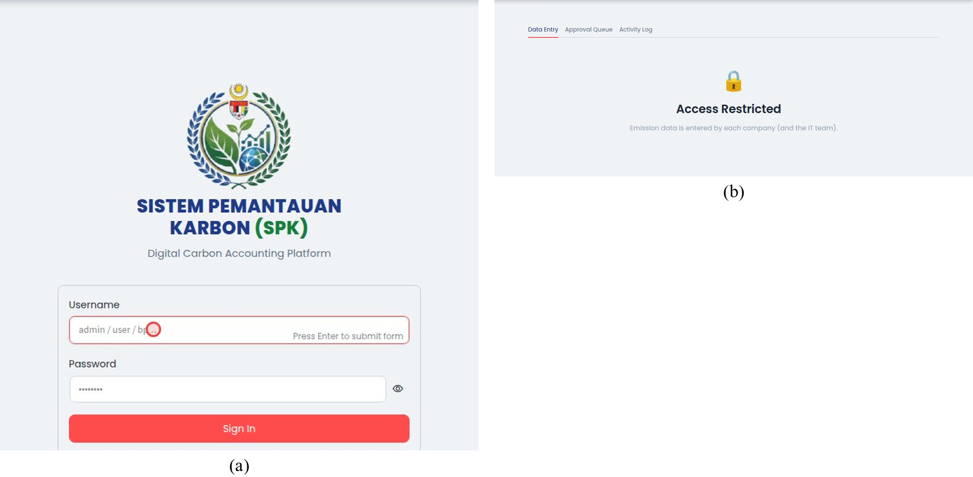
Figure 3 (a) Login page with demonstration accounts; (b) Data Entry restricted for a government officer
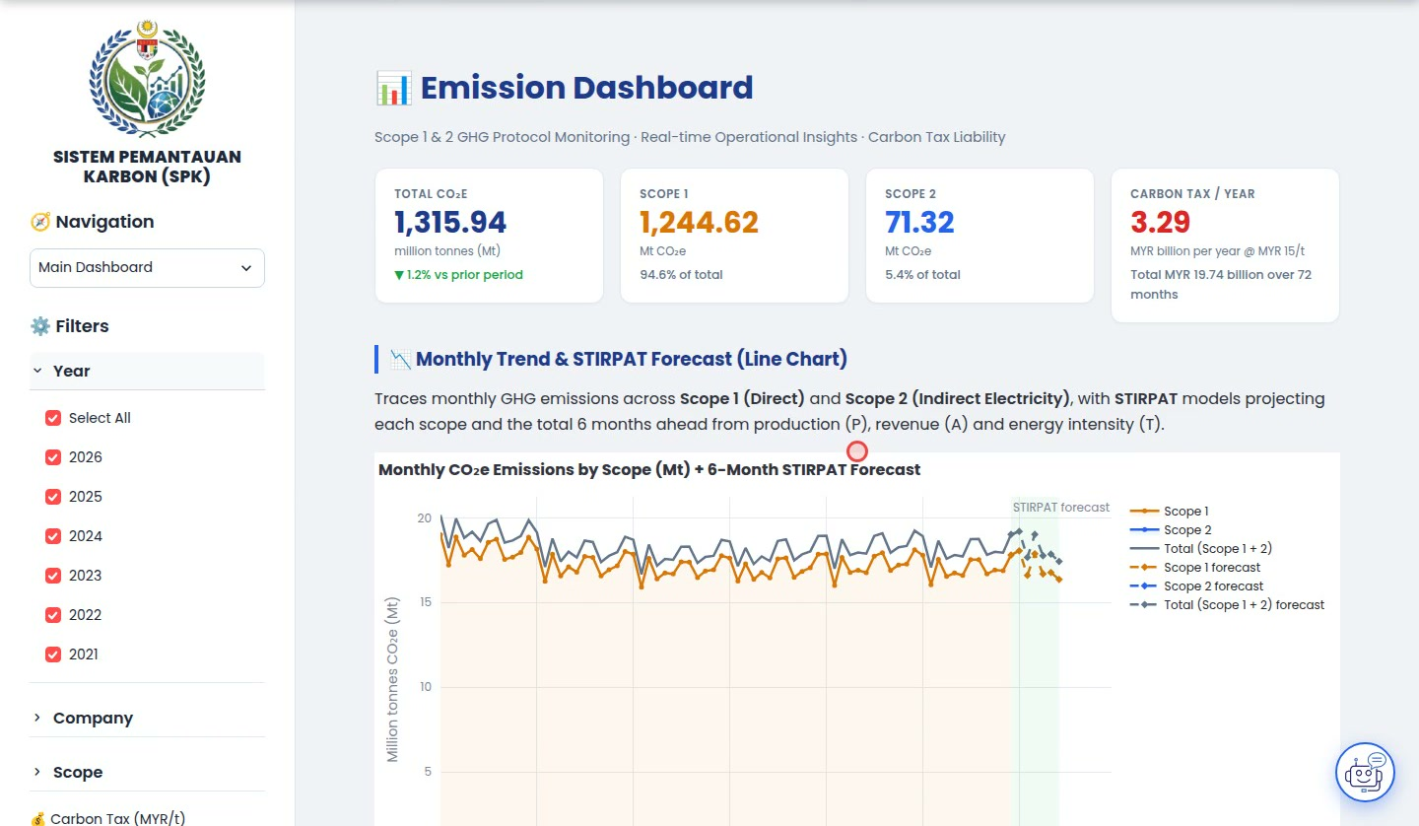
Figure 4 Main Dashboard with KPI cards, filters and the monthly trend with STIRPAT forecast
The What-If Simulator (Figure 5) applies reduction levers and shows the simulated emissions, the tax saving and the reduction by source. A 20% cut in natural gas, 20% fleet electrification and a 10% cut in electricity reduced total emissions by 7.7%, against 3.8%, 3.8% and 0.2% for the same levers applied singly.
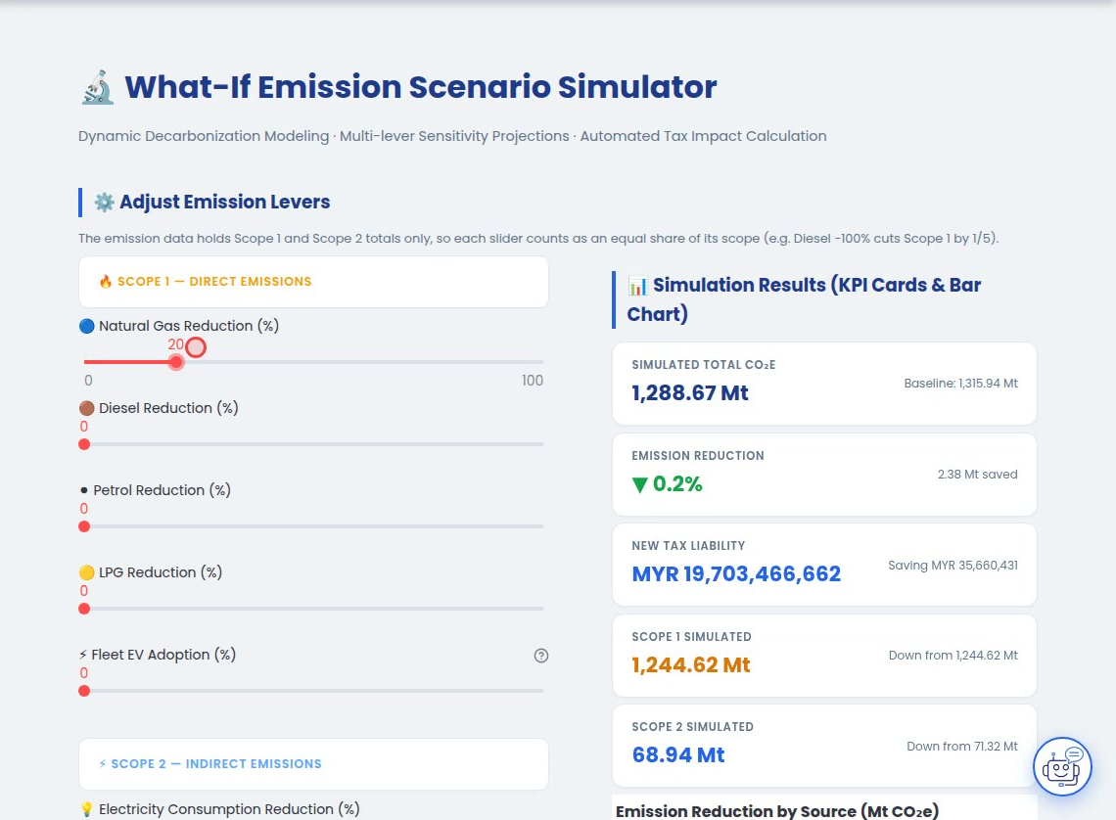
Figure 5 What-If Simulator with emission levers and simulation results
In data entry (Figure 6), the CO₂e and tax of a record are estimated as it is typed. A diesel quantity of 15,100 L, about ten times the usual monthly value, was flagged at 414.1 standard deviations above its history of 1,507.1 ± 32.8 L and sent for approval. Flagged entries appear as cards in the approval queue, and the AI advisor answers from the figures on the page (Figure 7): asked which company had the highest Scope 1 emissions, it named ExxonMobil with 88.10 Mt for 2026, as shown on the dashboard. Government officers and IT administrators can download a three-part PDF carbon tax statement with company details, monthly emissions and a tax invoice (Figure 8).
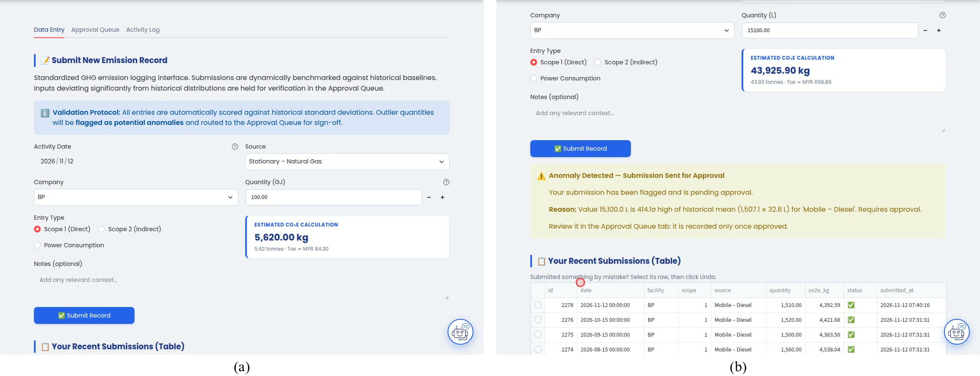
Figure 6 (a) Data entry with live CO₂e estimate; (b) anomaly flagged and sent for approval
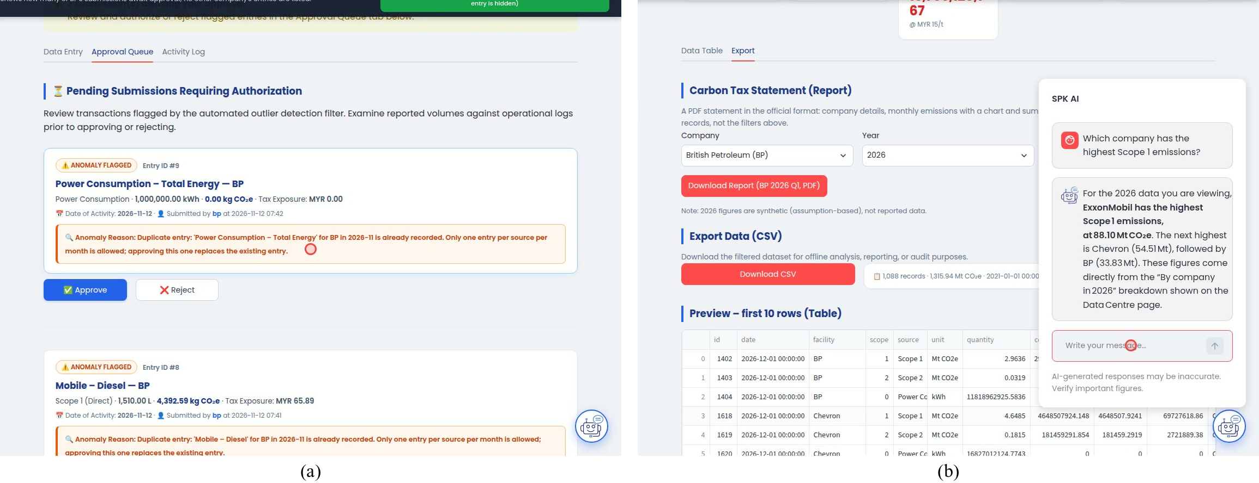
Figure 7 (a) Approval queue with flagged entries; (b) AI advisor answering from the page data
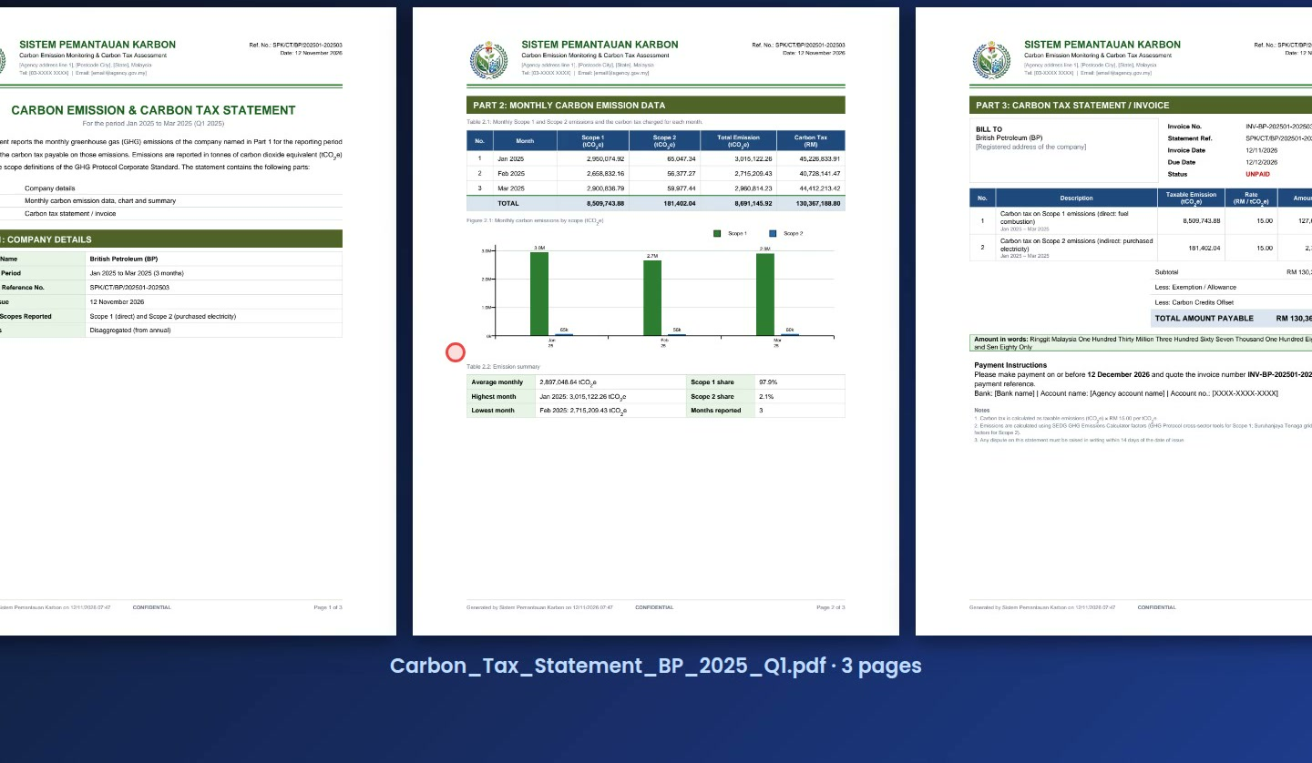
Figure 8 Generated three-page PDF carbon tax statement (bp, Q1 2025)
Forecasting Accuracy
Over 2021 to 2026 the five companies emitted 1,315.94 Mt CO₂e (94.6% in Scope 1), or MYR 19.74 billion of tax at MYR 15 per tonne. Table 3 compares the forecasting models on the test year, and Figure 9 plots the monthly values. STIRPAT reduced the WAPE of the OLS trend by more than three-quarters for Scope 1 and total emissions and by about 40% for Scope 2, and it also outperformed the seasonal naïve forecast. The trend line cannot reproduce the seasonal pattern and underestimates every month of 2025. For January to June 2027 the model forecasts 108.91 Mt CO₂e, 1.1% above the same months of 2026.
Table 3 Forecast accuracy on the held-out test year 2025
Measure | Scope 1 | Scope 2 | Total
STIRPAT WAPE (%) | 1.45 | 11.12 | 1.51
STIRPAT MAPE (%) | 1.46 | 39.29 | 1.70
STIRPAT test R² | 0.9991 | 0.9843 | 0.9992
OLS trend WAPE (%) | 6.40 | 18.33 | 6.81
Seasonal naïve WAPE (%) | 4.26 | 12.30 | 3.69

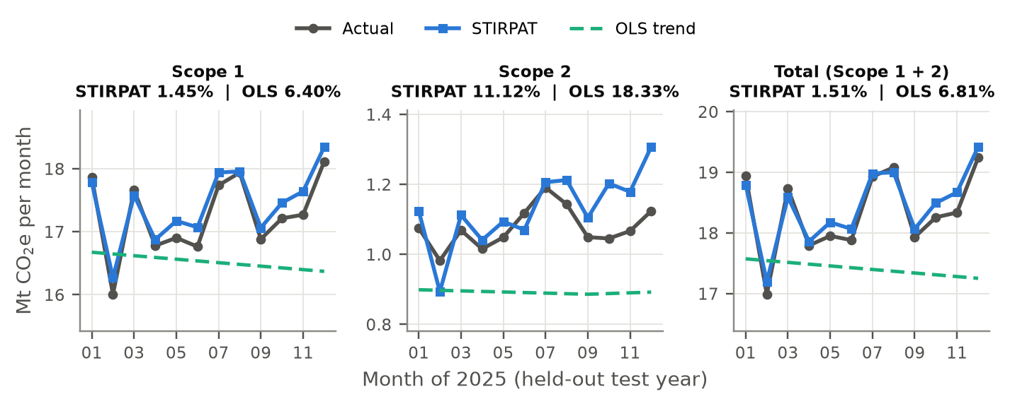
Figure 9 Actual, STIRPAT and OLS trend monthly emissions in 2025 (titles give the test WAPE)
Unit and System Testing
All 78 unit tests passed (Table 4); Figure 10 shows the output of the test run, module by module and for the full suite. In the recorded system test, 52 of the 56 cases passed, two failed and two passed partially, and Figure 11 shows frames from the recording with the verdict of each case. The failures were a power consumption entry flagged as a duplicate because the workbook already held monthly energy totals (TC-SUS-07) and an undo action without a confirmation message (TC-SUS-08). The partial results were Data Centre filters that appeared unticked (TC-DC-03) and a no-data warning that could not be triggered because every company has data for every period (TC-DC-07).
Table 4 Unit test results by module
Test module | Main behaviour tested | Passed
test_core | Emission and tax calculation, SEDG factors, input checks | 7 / 7
test_auth | Login, case-insensitive usernames, permissions, row filtering | 4 / 4
test_ai_helper | Request content, rate-limit retry, safe failure message | 3 / 3
test_simulation | Lever mapping and averaging, full reduction, scope totals | 9 / 9
test_report | Statement totals, quarters, amount in words, missing data | 7 / 7
test_analytics | Totals, filters, search, anomaly rule, CSV safety, STIRPAT, chatbot context | 29 / 29
test_data_manager | Submission, approval, rejection, duplicates, undo, rollback, anomaly fallback | 19 / 19
Total |  | 78 / 78

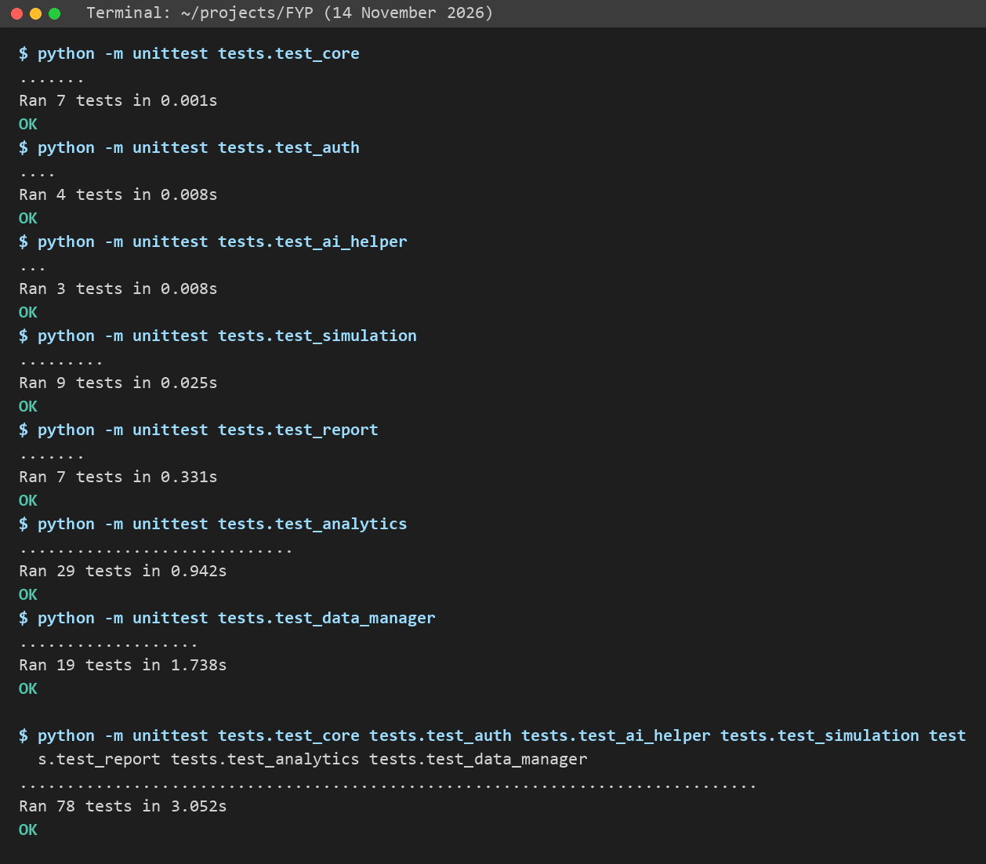
Figure 10 Output of the unit test run on 14 November 2026
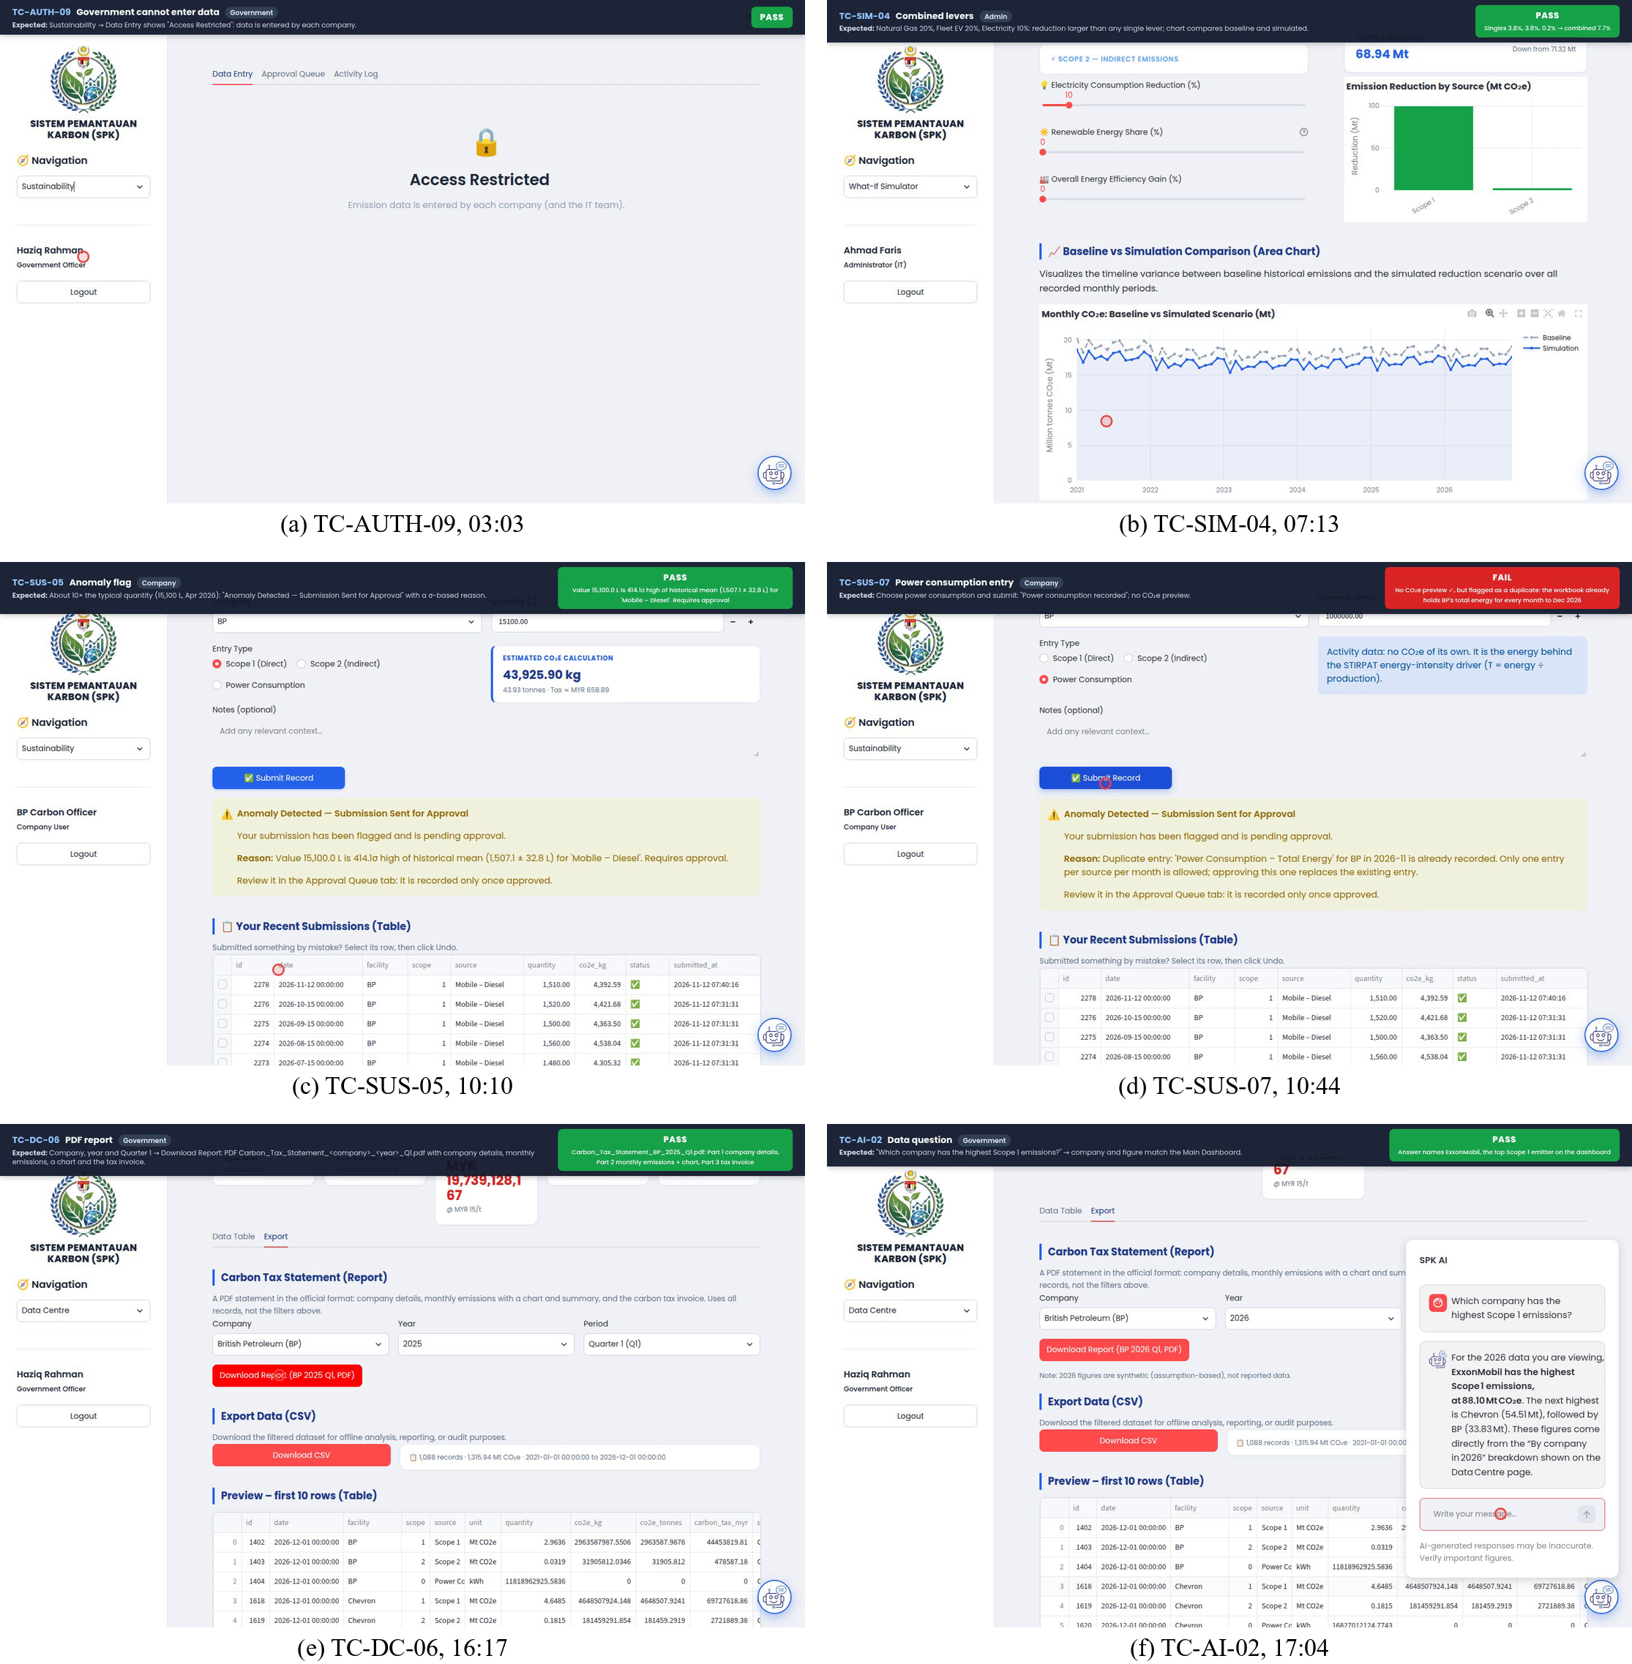
Figure 11 Frames from the recorded system test with the verdict of each case: (a) government officer cannot enter data; (b) combined what-if levers; (c) anomaly flag; (d) power consumption entry (fail); (e) PDF report; (f) AI advisor data question
User Acceptance Testing
The 20 respondents were six computer science or IT students, four each from petroleum engineering, chemical engineering and business management, and two from other fields; their mean familiarity was 3.05 out of 5 for Scope 1 and Scope 2 accounting and 2.80 for Malaysia's carbon tax. They made 1,120 test-case judgements: 1,015 Pass, 28 Fail and 77 Not tested, so 97.3% of executed cases passed (Table 5). Twenty failures came from the two data-entry defects already seen in the system test (11 and 9 reports), and 15 of the 20 respondents met at least one of them. One respondent found that a first entry for a source with no history was not screened (TC-SUS-05); the anomaly rule was then extended to score such entries against the rest of their scope, and a unit test was added.
Table 5 User acceptance test outcomes by module (n = 20)
Module | Pass | Fail | Not tested | Passed (%)
Authentication and access | 218 | 0 | 22 | 100.0
Main Dashboard | 174 | 2 | 4 | 98.9
What-If Simulator | 138 | 0 | 2 | 100.0
Sustainability (data entry) | 237 | 21 | 22 | 91.9
Data Centre | 124 | 3 | 13 | 97.6
AI advisor | 124 | 2 | 14 | 98.4
Total | 1,015 | 28 | 77 | 97.3

The mean SUS score was 77.4 (SD 9.1; range 57.5 to 92.5), and 17 respondents scored at or above the commonly cited average of 68 [27] (Figure 12). Agreement was highest that the platform would help an organisation prepare for the carbon tax (mean 4.05; 80% agreed) and lowest for entering data and handling flagged entries (3.15; 40%) and for trust in the figures (3.25; 40%). The What-If Simulator was named most often as the most useful feature, because it shows the tax saving of each action.
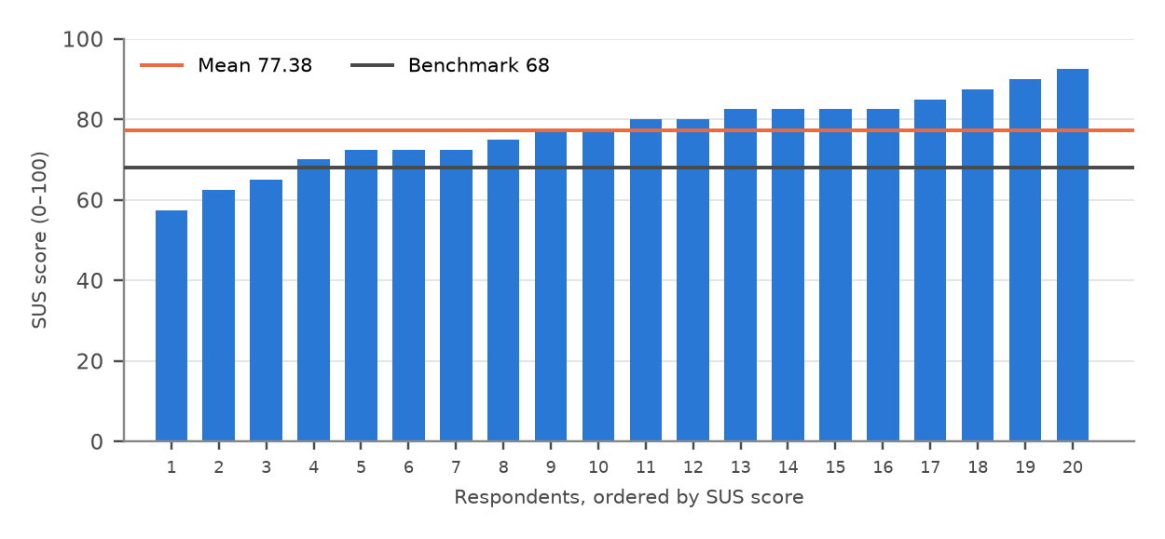
Figure 12 SUS score of each respondent with the mean and the benchmark of 68
DISCUSSION
The results meet the four objectives. The ledger and approval workflow make each total traceable to a submission, an emission factor and an approver, which addresses the opacity reported for corporate carbon data [11]. The driver-based model explained the test year far better than the time trend of the earlier prototype. Its Scope 1 elasticities have a physical reading: a 1% rise in production or energy intensity was associated with a 0.86% or 0.89% rise in emissions, while revenue, which swung with oil and gas prices, had almost no effect (−0.06%). This agrees with the provincial study of Shandong, where energy structure and energy consumption intensity had the largest elasticities [21]. The accuracy must still be read with care, because the monthly series were disaggregated from annual totals, the test used the actual 2025 drivers and the 2026 drivers are synthetic. The results show that the model reproduces the annual relationships and the seasonal pattern, not that measured monthly emissions could be predicted to within 1.5%.
The three levels of testing agree. The recorded system test found the same data-entry defects and the same Data Centre filter problem that respondents later reported, which indicates that the failures came from the platform rather than from respondent error. A SUS mean of 77.4 lies between the “Good” and “Excellent” adjective ratings of Bangor et al. [28], but the two data-entry defects affected three-quarters of the respondents and matched the lowest feature rating, so fixing them should improve the experience more than adding features. The moderate trust in the figures is consistent with the use of disaggregated and synthetic data. Factor choice also matters financially: the SEDG and MGTC factors differ by 34 t CO₂e (MYR 510) per GWh of Peninsular electricity, so a national MRV system needs one official set of factors.
CONCLUSION
SPK shows that validated data entry, an auditable ledger, driver-based forecasting, scenario simulation and a grounded AI advisor can be combined in one lightweight, role-based platform for Malaysia's coming carbon tax. The STIRPAT model reached a WAPE of 1.51% for total emissions against 6.81% for a linear trend, all 78 unit tests passed, 52 of 56 system test cases passed, and users gave a mean SUS score of 77.4. The study was limited to five international companies with disaggregated data, 20 student respondents and a locally run prototype. Future work should fix the remaining data-entry defects, let companies upload monthly data from spreadsheets, store hashed credentials in a hosted server database, use measured monthly data, compare STIRPAT with machine learning models and evaluate the AI advisor's accuracy systematically.
ACKNOWLEDGMENT
The authors thank the twenty respondents who tested SPK and completed the questionnaire, and Universiti Teknologi PETRONAS for supporting this Final Year Project.
REFERENCES
[1] KPMG Malaysia, “2026 Budget – Indirect tax perspective,” KPMG Tax Services Sdn. Bhd., Kuala Lumpur, Malaysia, Oct. 2025. [Online]. Available: https://assets.kpmg.com/content/dam/kpmgsites/my/pdf/2025/10/budget2026-tl-indirect-tax-perspective.pdf.coredownload.inline.pdf
[2] The Star, “Carbon tax rate of RM15 a tonne being considered,” The Star, Nov. 6, 2025. [Online]. Available: https://www.thestar.com.my/business/business-news/2025/11/06/carbon-tax-rate-of-rm15-a-tonne-being-considered
[3] Bernama, “National Climate Change Bill unveils MRV system, basis for carbon price implementation,” Bernama, Mar. 13, 2026. [Online]. Available: https://bernama.com/en/news.php?id=2534105
[4] World Resources Institute and World Business Council for Sustainable Development, The Greenhouse Gas Protocol: A Corporate Accounting and Reporting Standard, rev. ed. Washington, DC, USA: WRI and WBCSD, 2004.
[5] Hedgehog, “Overcoming data collection challenges in carbon accounting for SMEs,” Jun. 9, 2025. [Online]. Available: https://www.hhc.earth/knowledge-base/articles/carbon-data-collection-challenges-sme
[6] Market.us, “Carbon accounting software market size, share, growth analysis,” Rep. ID 179566, Feb. 2026. [Online]. Available: https://market.us/report/carbon-accounting-software-market/
[7] Malaysian Green Technology and Climate Change Corporation, “SME carbon footprint calculator,” 2026. Accessed: Nov. 11, 2026. [Online]. Available: https://lcosbasic.mgtc.gov.my/
[8] Maybank, “Carbon footprint calculator and ESG readiness test,” myimpact SME Hub, n.d. Accessed: Nov. 11, 2026. [Online]. Available: https://www.maybank2u.com.my/maybank2u/malaysia/en/myimpactsme/sustainability/esg-tools.page
[9] L. Huang et al., “A survey on hallucination in large language models: Principles, taxonomy, challenges, and open questions,” ACM Trans. Inf. Syst., vol. 43, no. 2, Art. no. 42, 2025, doi: 10.1145/3703155.
[10] S. A. Vaghefi et al., “ChatClimate: Grounding conversational AI in climate science,” Commun. Earth Environ., vol. 4, Art. no. 480, 2023, doi: 10.1038/s43247-023-01084-x.
[11] J. Marlowe and A. Clarke, “Carbon accounting: A systematic literature review and directions for future research,” Green Finance, vol. 4, no. 1, pp. 71–87, 2022, doi: 10.3934/GF.2022004.
[12] M.-F. Körner, M. Schober, T. Ströher, and J. Strüker, “Digital carbon accounting for accelerating decarbonization: Characteristics of IS-enabled system architectures,” in Proc. Americas Conf. Inf. Syst. (AMCIS), 2023, Paper 2. [Online]. Available: https://aisel.aisnet.org/amcis2023/sig_green/sig_green/2
[13] Capital Markets Malaysia, “SEDG greenhouse gas emissions (GHG) calculator: User guide for small and medium enterprises (SMEs) in Malaysia,” Kuala Lumpur, Malaysia, 2025. [Online]. Available: https://www.capitalmarketsmalaysia.com/sedg-ghg-calculator/
[14] Equinor ASA, “Climate – Sustainability data hub,” 2026. Accessed: Oct. 6, 2026. [Online]. Available: https://sustainability.equinor.com/climate
[15] B. Zhu et al., “CarbonMonitor-Power near-real-time monitoring of global power generation on hourly to daily scales,” Sci. Data, vol. 10, Art. no. 217, 2023, doi: 10.1038/s41597-023-02094-2.
[16] A. Blázquez-García, A. Conde, U. Mori, and J. A. Lozano, “A review on outlier/anomaly detection in time series data,” ACM Comput. Surv., vol. 54, no. 3, Art. no. 56, 2021, doi: 10.1145/3444690.
[17] T. Dietz and E. A. Rosa, “Rethinking the environmental impacts of population, affluence and technology,” Hum. Ecol. Rev., vol. 1, no. 2, pp. 277–300, 1994.
[18] R. York, E. A. Rosa, and T. Dietz, “STIRPAT, IPAT and ImPACT: Analytic tools for unpacking the driving forces of environmental impacts,” Ecol. Econ., vol. 46, no. 3, pp. 351–365, 2003, doi: 10.1016/S0921-8009(03)00188-5.
[19] A. E. Hoerl and R. W. Kennard, “Ridge regression: Biased estimation for nonorthogonal problems,” Technometrics, vol. 12, no. 1, pp. 55–67, 1970, doi: 10.1080/00401706.1970.10488634.
[20] C. Rao, Q. Huang, L. Chen, M. Goh, and Z. Hu, “Forecasting the carbon emissions in Hubei Province under the background of carbon neutrality: A novel STIRPAT extended model with ridge regression and scenario analysis,” Environ. Sci. Pollut. Res., vol. 30, pp. 57460–57480, 2023, doi: 10.1007/s11356-023-26599-w.
[21] D. Kong, Z. Dai, J. Tang, and H. Zhang, “Forecasting urban carbon emissions using an Adaboost-STIRPAT model,” Frontiers Environ. Sci., vol. 11, Art. no. 1284028, 2023, doi: 10.3389/fenvs.2023.1284028.
[22] Y. Jin, A. Sharifi, Z. Li, S. Chen, S. Zeng, and S. Zhao, “Carbon emission prediction models: A review,” Sci. Total Environ., vol. 927, Art. no. 172319, 2024, doi: 10.1016/j.scitotenv.2024.172319.
[23] H. Hewamalage, K. Ackermann, and C. Bergmeir, “Forecast evaluation for data scientists: Common pitfalls and best practices,” Data Mining Knowl. Discovery, vol. 37, pp. 788–832, 2023, doi: 10.1007/s10618-022-00894-5.
[24] K. Schwaber and J. Sutherland, “The Scrum guide,” 2020. [Online]. Available: https://scrumguides.org/
[25] F. T. Denton, “Adjustment of monthly or quarterly series to annual totals: An approach based on quadratic minimization,” J. Amer. Statist. Assoc., vol. 66, no. 333, pp. 99–102, 1971, doi: 10.1080/01621459.1971.10482227.
[26] J. Brooke, “SUS: A ‘quick and dirty’ usability scale,” in Usability Evaluation in Industry, P. W. Jordan, B. Thomas, B. A. Weerdmeester, and I. L. McClelland, Eds. London, U.K.: Taylor & Francis, 1996, pp. 189–194.
[27] J. Sauro and J. R. Lewis, Quantifying the User Experience: Practical Statistics for User Research, 2nd ed. Cambridge, MA, USA: Morgan Kaufmann, 2016.
[28] A. Bangor, P. Kortum, and J. Miller, “Determining what individual SUS scores mean: Adding an adjective rating scale,” J. Usability Stud., vol. 4, no. 3, pp. 114–123, 2009.

