Sistem Pemantauan Karbon (SPK): Digital Carbon Accounting Platform for Emissions Tracking and Reporting
Muhammad Ibrahim Al-Imran Bin Mohd Isa¹, Noreen Izza Arshad²
^{1,2}Department of Computer and Information Sciences, Universiti Teknologi PETRONAS, 32610 Seri Iskandar, Perak, Malaysia
Corresponding email: [student email], [supervisor email]
Abstract
Malaysia's planned carbon tax and National Climate Change Bill will require organisations to report auditable Scope 1 and Scope 2 greenhouse gas emissions, yet many still rely on spreadsheets or one-off calculators that do not validate entries, forecast emissions or show tax exposure. This paper presents Sistem Pemantauan Karbon (SPK), a role-based web platform built with Python, Streamlit and SQLite that converts activity data into carbon dioxide equivalent (CO₂e) and carbon tax using Malaysian SEDG emission factors. Each submission is screened by a z-score and duplicate rule, flagged entries are held for approval, and every entry, approval and withdrawal is kept in an auditable ledger. A STIRPAT model estimated by ridge regression forecasts emissions six months ahead, a what-if simulator estimates the effect of reduction measures on emissions and tax, and an AI advisor answers questions from the figures on the user's page. Five international oil and gas companies formed the case dataset, with annual data for 2021 to 2025 disaggregated into months. On the held-out year 2025, the STIRPAT model reached a weighted absolute percentage error of 1.45% for Scope 1, 11.12% for Scope 2 and 1.51% for total emissions, against 6.40%, 18.33% and 6.81% for a linear trend. All 77 unit tests passed. In user acceptance testing with 20 respondents, 97.3% of executed test cases passed, the mean System Usability Scale score was 77.4, and 80% agreed that the platform would help an organisation prepare for the carbon tax. The work shows that validated entry, an audit trail, driver-based forecasting and grounded explanation can be combined in one lightweight tool.
Keywords GHG Protocol, STIRPAT, Ridge Regression, Anomaly Detection, System Usability Scale, Large Language Model
INTRODUCTION
Malaysia confirmed in Budget 2026 that a carbon tax would be introduced, first for the iron, steel and energy sectors [1], at a reported rate of MYR 15 per tonne of carbon dioxide equivalent (CO₂e) [2]. The National Climate Change Bill establishes a measurement, reporting and verification (MRV) system as the basis for carbon pricing [3]. Under the GHG Protocol, direct emissions from sources an organisation owns or controls (Scope 1) are reported separately from indirect emissions from purchased energy (Scope 2) [4]. Once these emissions are taxed, an error in the data becomes an error in the bill, so every total must be correct and traceable.
Practice has not kept pace with policy. Many organisations, particularly small and medium enterprises (SMEs), still collect emission data in spreadsheets spread across departments [5], and commercial carbon accounting software is costly and difficult to integrate [6]. The free Malaysian calculators compute a footprint for one organisation at a time [7], [8]; they keep no record of submissions, do not check values against history and do not forecast emissions or tax. Non-specialist decision makers also find emission figures hard to interpret, and a language model that could explain them may give plausible but false answers unless it is grounded in reliable data [9], [10].
This paper reports the design and evaluation of Sistem Pemantauan Karbon (SPK). Its objectives were (i) to calculate Scope 1 and Scope 2 emissions and carbon tax with Malaysian factors under role-based access; (ii) to keep an auditable ledger tracing every figure to its submission, factor and approval; (iii) to provide STIRPAT forecasting, a what-if simulator and a grounded AI advisor; and (iv) to verify the calculations with unit tests and evaluate usability with users.
LITERATURE REVIEW
Reviews of carbon accounting research report that corporate emission figures lack transparency, reliability and comparability [11]. Part of the inconsistency comes from the choice of emission factor: the Peninsular Malaysia grid factor is 0.774 kg CO₂e/kWh in the SEDG calculator [12], 0.740 in the MGTC calculator [7] and 0.78 in the Maybank calculator [8]. These Malaysian tools produce a footprint, but not a validated record over time of the kind an MRV system requires.
For forecasting, the STIRPAT model restates the IPAT identity as a stochastic regression in which environmental impact depends on population, affluence and technology, so that its logarithmic coefficients can be read as elasticities [13]. Because these drivers are strongly correlated, ridge regression [14] is commonly used to estimate them, for example in a provincial study of Shandong [15]. The STIRPAT studies reviewed for this project worked at national, provincial or city level with annual data, and none was found that applied the model to monthly company data inside a monitoring tool. For evaluation, the mean absolute percentage error (MAPE) becomes unstable when actual values are close to zero [16].
Grounding a language model in authoritative sources improves its answers on climate topics: ChatClimate, which gave GPT-4 access to the IPCC AR6 reports, produced answers that experts judged more accurate [10]. None of the carbon tools reviewed grounded an assistant in its own live figures. The gap addressed by SPK is therefore the combination, in one lightweight platform, of validated entry with an audit trail, driver-based monthly forecasting and a grounded assistant.
METHODOLOGY
Architecture
SPK was developed in five Scrum sprints in Python 3.12, with Streamlit for the interface, scikit-learn for modelling, Plotly for charts, SQLite for storage and ReportLab for PDF tax statements. Its four layers are shown in Figure 1. Company users see only their own company's rows; government officers see all companies and issue tax statements but cannot enter data; IT administrators can also view the audit log.
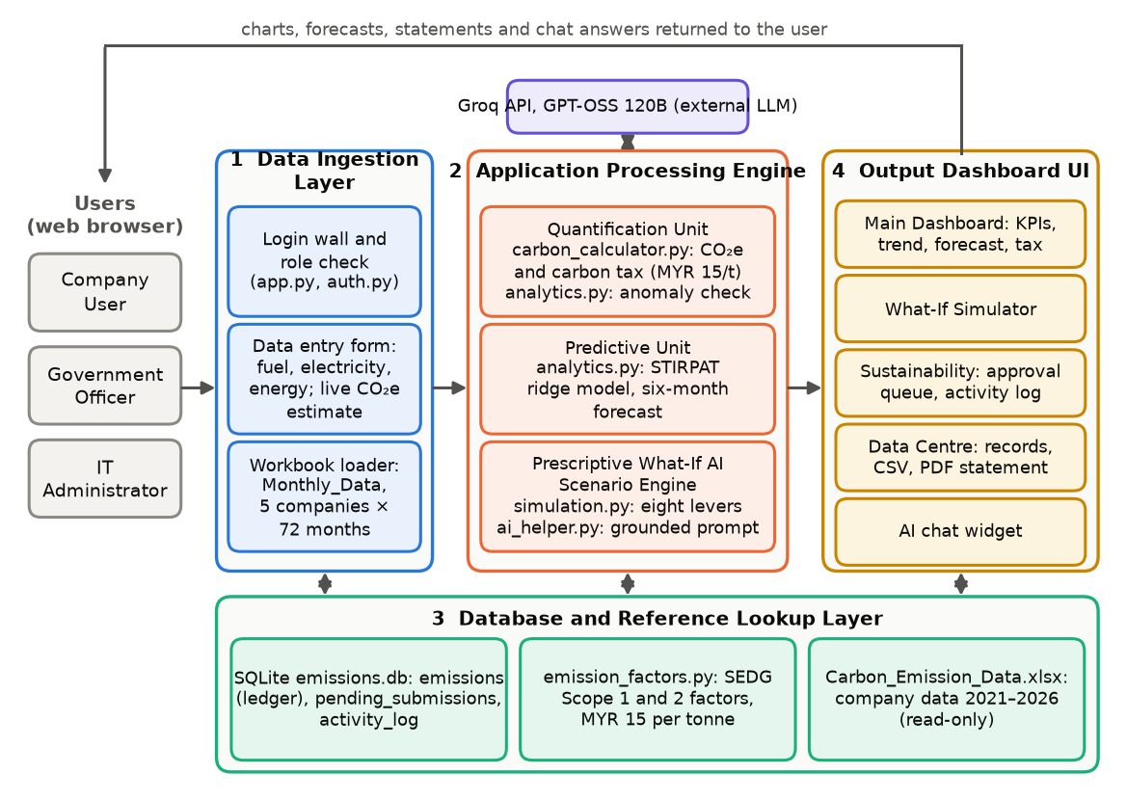
Figure 1 System architecture of SPK
Emission, Tax and Anomaly Rules
Activity data Q is converted with the SEDG emission factor EF [12], and the tax is charged at rate r, by default MYR 15 per tonne. A submitted quantity x is then compared with the mean μ and standard deviation σ of the approved history of the same source:
$CO_{2}e = Q × EF, Tax = \frac{CO_{2}e}{1000} × r, z = \frac{|x − μ|}{σ}$ (1)
An entry is flagged when z exceeds 2.5 and the source has at least five approved records, or when the source already has an entry for that month. A transparent z-score rule was chosen over a learned detector because every flag must be explained to a human approver. Flagged entries wait in an approval queue and count towards no total until approved, and records are never deleted: replaced and withdrawn entries keep their rows with a new status, so the lineage of every total is preserved.
Dataset and Forecasting Model
Annual data for 2021 to 2025 for bp, Chevron, ConocoPhillips, Equinor and ExxonMobil was taken from company reports and disaggregated into months with the additive first-difference Denton method [17], so that the months sum to the reported totals; 2026 was projected as a synthetic year and excluded from fitting. For company i in month t, emissions I were related to production P, revenue A and energy intensity T:
$ln I_{it} = α_{i} + b ln P_{it} + c ln A_{it} + d ln T_{it} + ε_{it}$ (2)
The Scope 2 model adds a company-specific yearly trend. Coefficients were estimated by ridge regression with λ = 0.005, following [15], trained on 2021 to 2024 and tested on the twelve months of 2025. The baselines were the ordinary least squares (OLS) time trend of the earlier prototype and a seasonal naïve forecast. The main accuracy measure was the weighted absolute percentage error, WAPE = Σ|y − ŷ| / Σy × 100%, which, unlike MAPE, is not distorted by small Scope 2 values [16].
AI Advisor and Evaluation
For each question, the page summarises the figures it displays from rows the user's role may see and sends the summary to the GPT-OSS 120B model through the Groq API, with a prompt requiring the model to quote only those figures. Seventy-seven unit tests covered the calculation, access, forecasting and data modules. In user acceptance testing, 20 consenting respondents used the demonstration accounts and completed an online questionnaire with 56 black-box test cases, the ten-item System Usability Scale (SUS) [18], ten feature statements on a five-point scale and three open questions.
RESULTS
Forecasting Accuracy
All twelve functional requirements were implemented. Over 2021 to 2026 the five companies emitted 1,315.94 Mt CO₂e (94.6% in Scope 1), or MYR 19.74 billion of tax at MYR 15 per tonne. Figure 2 compares the forecasts with the actual values of the test year. The STIRPAT WAPE was 1.45% for Scope 1, 11.12% for Scope 2 and 1.51% for total emissions, with a test R² of 0.999, 0.984 and 0.999. This is a reduction of more than three-quarters from the OLS trend (6.40%, 18.33% and 6.81%) for Scope 1 and the total and of about 40% for Scope 2. STIRPAT also outperformed the seasonal naïve forecast (4.26%, 12.30% and 3.69%). The trend line cannot reproduce the seasonal pattern and underestimates every month of 2025.
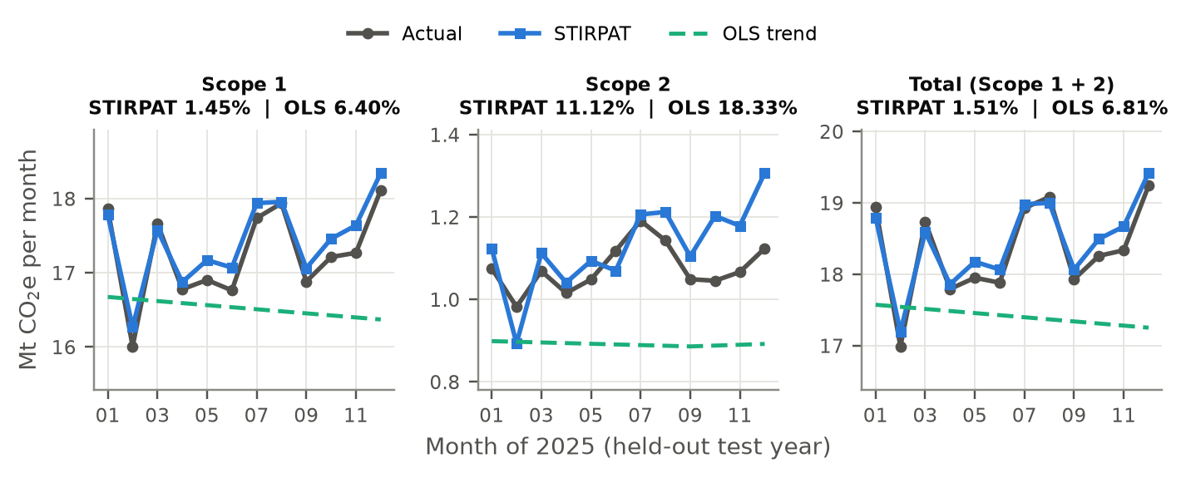
Figure 2 Actual, STIRPAT and OLS trend monthly emissions in 2025 (titles give the test WAPE)
Unit and User Acceptance Testing
All 77 unit tests passed. The respondents made 1,120 test-case judgements: 1,015 Pass, 28 Fail and 77 Not tested, so 97.3% of executed cases passed (Table 1). Twenty failures came from two data-entry cases: a power consumption entry flagged as a duplicate because the workbook already held monthly energy totals (11 reports), and an undo action that gave no confirmation (9 reports). The mean SUS score was 77.4 (SD 9.1; range 57.5 to 92.5), and 17 respondents scored at or above the commonly cited average of 68 [19]. Agreement was highest that the platform would help an organisation prepare for the carbon tax (mean 4.05; 80% agreed) and lowest for entering data and handling flagged entries (3.15; 40%) and for trust in the figures (3.25; 40%).
Table 1 User acceptance test outcomes by module (n = 20)
Module | Pass | Fail | Not tested | Passed (%)
Authentication and access | 218 | 0 | 22 | 100.0
Main Dashboard | 174 | 2 | 4 | 98.9
What-If Simulator | 138 | 0 | 2 | 100.0
Sustainability (data entry) | 237 | 21 | 22 | 91.9
Data Centre | 124 | 3 | 13 | 97.6
AI advisor | 124 | 2 | 14 | 98.4
Total | 1,015 | 28 | 77 | 97.3

DISCUSSION
The results meet the four objectives. The ledger and approval workflow make each total traceable to a submission, an emission factor and an approver, which addresses the opacity reported for corporate carbon data [11]. The Scope 1 elasticities have a physical reading: a 1% rise in production or energy intensity was associated with a 0.86% or 0.89% rise in emissions, while revenue, which swung with oil and gas prices, had almost no effect (−0.06%). The accuracy must still be read with care, because the monthly series were disaggregated from annual totals, the test used the actual 2025 drivers and the 2026 drivers are synthetic. The results show that the model reproduces the annual relationships and the seasonal pattern, not that measured monthly emissions could be predicted to within 1.5%.
A SUS mean of 77.4 lies between the “Good” and “Excellent” adjective ratings of Bangor et al. [20], but the two data-entry defects affected half of the respondents and matched the lowest feature rating, so fixing them should improve the experience more than adding features. Factor choice also matters financially: the SEDG and MGTC factors differ by 34 t CO₂e (MYR 510) per GWh of Peninsular electricity, so a national MRV system needs one official set of factors.
CONCLUSION
SPK shows that validated data entry, an auditable ledger, driver-based forecasting, scenario simulation and a grounded AI advisor can be combined in one lightweight, role-based platform for Malaysia's coming carbon tax. The STIRPAT model reached a WAPE of 1.51% for total emissions against 6.81% for a linear trend, all unit tests passed, and users gave a mean SUS score of 77.4. The study was limited to five international companies with disaggregated data, 20 student respondents and a locally run prototype. Future work should fix the data-entry defects, support spreadsheet upload and hashed credentials in a server database, use measured monthly data and evaluate the AI advisor's accuracy systematically.
ACKNOWLEDGMENT
The authors thank the twenty respondents who tested SPK and Universiti Teknologi PETRONAS for supporting this Final Year Project.
REFERENCES
[1] KPMG Malaysia, “2026 Budget – Indirect tax perspective,” KPMG Tax Services Sdn. Bhd., Kuala Lumpur, Malaysia, Oct. 2025. [Online]. Available: https://assets.kpmg.com/content/dam/kpmgsites/my/pdf/2025/10/budget2026-tl-indirect-tax-perspective.pdf.coredownload.inline.pdf
[2] The Star, “Carbon tax rate of RM15 a tonne being considered,” The Star, Nov. 6, 2025. [Online]. Available: https://www.thestar.com.my/business/business-news/2025/11/06/carbon-tax-rate-of-rm15-a-tonne-being-considered
[3] Bernama, “National Climate Change Bill unveils MRV system, basis for carbon price implementation,” Bernama, Mar. 13, 2026. [Online]. Available: https://bernama.com/en/news.php?id=2534105
[4] World Resources Institute and World Business Council for Sustainable Development, The Greenhouse Gas Protocol: A Corporate Accounting and Reporting Standard, rev. ed. Washington, DC, USA: WRI and WBCSD, 2004.
[5] Hedgehog, “Overcoming data collection challenges in carbon accounting for SMEs,” Jun. 9, 2025. [Online]. Available: https://www.hhc.earth/knowledge-base/articles/carbon-data-collection-challenges-sme
[6] Market.us, “Carbon accounting software market size, share, growth analysis,” Rep. ID 179566, Feb. 2026. [Online]. Available: https://market.us/report/carbon-accounting-software-market/
[7] Malaysian Green Technology and Climate Change Corporation, “SME carbon footprint calculator,” 2026. Accessed: Nov. 11, 2026. [Online]. Available: https://lcosbasic.mgtc.gov.my/
[8] Maybank, “Carbon footprint calculator and ESG readiness test,” myimpact SME Hub, n.d. Accessed: Nov. 11, 2026. [Online]. Available: https://www.maybank2u.com.my/maybank2u/malaysia/en/myimpactsme/sustainability/esg-tools.page
[9] L. Huang et al., “A survey on hallucination in large language models: Principles, taxonomy, challenges, and open questions,” ACM Trans. Inf. Syst., vol. 43, no. 2, Art. no. 42, 2025, doi: 10.1145/3703155.
[10] S. A. Vaghefi et al., “ChatClimate: Grounding conversational AI in climate science,” Commun. Earth Environ., vol. 4, Art. no. 480, 2023, doi: 10.1038/s43247-023-01084-x.
[11] J. Marlowe and A. Clarke, “Carbon accounting: A systematic literature review and directions for future research,” Green Finance, vol. 4, no. 1, pp. 71–87, 2022, doi: 10.3934/GF.2022004.
[12] Capital Markets Malaysia, “SEDG greenhouse gas emissions (GHG) calculator: User guide for small and medium enterprises (SMEs) in Malaysia,” Kuala Lumpur, Malaysia, 2025. [Online]. Available: https://www.capitalmarketsmalaysia.com/sedg-ghg-calculator/
[13] T. Dietz and E. A. Rosa, “Rethinking the environmental impacts of population, affluence and technology,” Hum. Ecol. Rev., vol. 1, no. 2, pp. 277–300, 1994.
[14] A. E. Hoerl and R. W. Kennard, “Ridge regression: Biased estimation for nonorthogonal problems,” Technometrics, vol. 12, no. 1, pp. 55–67, 1970, doi: 10.1080/00401706.1970.10488634.
[15] D. Kong, Z. Dai, J. Tang, and H. Zhang, “Forecasting urban carbon emissions using an Adaboost-STIRPAT model,” Frontiers Environ. Sci., vol. 11, Art. no. 1284028, 2023, doi: 10.3389/fenvs.2023.1284028.
[16] H. Hewamalage, K. Ackermann, and C. Bergmeir, “Forecast evaluation for data scientists: Common pitfalls and best practices,” Data Mining Knowl. Discovery, vol. 37, pp. 788–832, 2023, doi: 10.1007/s10618-022-00894-5.
[17] F. T. Denton, “Adjustment of monthly or quarterly series to annual totals: An approach based on quadratic minimization,” J. Amer. Statist. Assoc., vol. 66, no. 333, pp. 99–102, 1971, doi: 10.1080/01621459.1971.10482227.
[18] J. Brooke, “SUS: A ‘quick and dirty’ usability scale,” in Usability Evaluation in Industry, P. W. Jordan, B. Thomas, B. A. Weerdmeester, and I. L. McClelland, Eds. London, U.K.: Taylor & Francis, 1996, pp. 189–194.
[19] J. Sauro and J. R. Lewis, Quantifying the User Experience: Practical Statistics for User Research, 2nd ed. Cambridge, MA, USA: Morgan Kaufmann, 2016.
[20] A. Bangor, P. Kortum, and J. Miller, “Determining what individual SUS scores mean: Adding an adjective rating scale,” J. Usability Stud., vol. 4, no. 3, pp. 114–123, 2009.

