Sistem Pemantauan Karbon (SPK): Digital Carbon Accounting Platform for Emissions Tracking and Reporting

by

Muhammad Ibrahim Al-Imran Bin Mohd Isa
22006656

Dissertation submitted in partial fulfilment of
the requirements for the
Bachelor of Computer Science (Hons)
(Computer Science)

SEPTEMBER 2026

Universiti Teknologi PETRONAS
32610 Seri Iskandar
Perak Darul Ridzuan

CERTIFICATION OF APPROVAL
Sistem Pemantauan Karbon (SPK): Digital Carbon Accounting Platform for Emissions Tracking and Reporting

By

Muhammad Ibrahim Al-Imran Bin Mohd Isa
22006656

A project dissertation submitted to the
Computer Science Programme
Universiti Teknologi PETRONAS
in partial fulfilment of the requirement for the
BACHELOR OF COMPUTER SCIENCE (Hons)
(COMPUTER SCIENCE)

Approved by,

_______________________
(Dr Noreen Izza Bt Arshad)

UNIVERSITI TEKNOLOGI PETRONAS
BANDAR SERI ISKANDAR, PERAK
September 2026

CERTIFICATION OF ORIGINALITY
This is to certify that I am responsible for the work submitted in this project, that the original work is my own except as specified in the references and acknowledgements, and that the original work contained herein have not been undertaken or done by unspecified sources or persons.

________________________________________________
(MUHAMMAD IBRAHIM AL-IMRAN BIN MOHD ISA)

ABSTRACT
Malaysia has announced a carbon tax, initially for the iron, steel and energy sectors, and is preparing a Climate Change Bill that makes carbon accounting mandatory. Many organisations, particularly small and medium enterprises, still track their Scope 1 and Scope 2 greenhouse gas emissions in spreadsheets or one-off calculators that cannot validate entries, forecast emissions or show tax exposure. This project developed Sistem Pemantauan Karbon (SPK), a role-based digital carbon accounting platform built with Python and Streamlit that turns activity data into audited emission and carbon tax figures. Data entered by a company is converted to carbon dioxide equivalent (CO₂e) with Malaysian SEDG emission factors, screened by a z-score and duplicate rule, and held for approval when flagged, and every entry, approval and withdrawal is kept in an SQLite ledger with an activity log. A STIRPAT model fitted by ridge regression forecasts emissions six months ahead, a what-if simulator estimates the emission and tax effect of reduction measures, and an AI advisor chat answers questions from the figures on the user's page. Company, government and IT administrator roles control what each user can see and do. Five international oil and gas companies served as the case dataset; their annual data for 2021 to 2025 was disaggregated into months and 2026 was projected as a synthetic year. On the held-out 2025 data, the STIRPAT model reached a weighted absolute percentage error of 1.45% for Scope 1, 11.12% for Scope 2 and 1.51% for total emissions, against 6.40%, 18.33% and 6.81% for a linear trend baseline. All 77 automated unit tests passed. In user acceptance testing with 20 respondents, 97.3% of the executed test cases passed, the mean System Usability Scale score was 77.4, and 80% agreed that the platform would help an organisation prepare for the carbon tax. The data-entry workflow and users' trust in the figures were identified as the main areas for improvement.

ACKNOWLEDGEMENT
I would like to thank everyone who contributed to the completion of this project. My deepest gratitude goes to my supervisor, Dr Noreen Izza Bt Arshad, for the advice, guidance and patience given throughout both phases of the Final Year Project, and for the encouragement to justify every design decision with evidence.
I would also like to thank the twenty respondents who spent their time testing the system and completing the questionnaire. Their reports of failed test cases and their suggestions for improvement were the most useful input received during the project.
My appreciation also goes to the Final Year Project coordinators and the lecturers of Universiti Teknologi PETRONAS for the knowledge and support provided during my studies.
Finally, I am grateful to my family and friends for their encouragement, understanding and moral support, which carried me through the development, testing and writing of this project.
TABLE OF CONTENTS
CERTIFICATION OF APPROVAL ii
CERTIFICATION OF ORIGINALITY iii
ABSTRACT iv
ACKNOWLEDGEMENT v
LIST OF FIGURES viii
LIST OF TABLES ix
ABBREVIATIONS AND NOMENCLATURES x
CHAPTER 1 INTRODUCTION 1
1.1 Background 1
1.2 Problem Statements 3
1.3 Aims and Objectives 4
1.4 Scope of Study 4
1.5 Significance of Study 5
CHAPTER 2 LITERATURE REVIEW 6
2.1 Overview of Corporate Carbon Accounting and the GHG Protocol 6
2.2 Carbon Pricing and Carbon Tax Policy in Malaysia 7
2.3 Existing Carbon Accounting Software and Adoption Challenges 8
2.4 Data Quality, Anomaly Detection and Forecasting in Emissions Reporting 9
2.4.1 Data Quality and Anomaly Detection 9
2.4.2 Emission Forecasting with Trend Models and STIRPAT 9
2.4.3 Temporal Disaggregation of Annual Data 11
2.5 Artificial Intelligence Assistants for Climate Data 11
2.6 Existing Competitor Analysis 11
2.7 Summary and Research Gap 12
CHAPTER 3 METHODOLOGY 13
3.1 Project Development 13
3.1.1 Requirement Gathering and Analysis 14
3.1.2 Sprint Plan 15
3.2 System Architecture 15
3.2.1 Use Case Design 16
3.2.2 Database Design 17
3.2.3 Security and Access Control 18
3.3 Emissions and Carbon Tax Calculation 18
3.4 Anomaly Detection and the Data Pipeline 19
3.4.1 Reported Company Data 20
3.4.2 Data Entry, Anomaly Screening and Approval 21
3.5 Forecasting Model 22
3.6 AI Advisor Chat 24
3.7 What-If Simulation Logic 25
3.8 Tools and Technologies 25
3.9 Testing and Evaluation 26
CHAPTER 4 RESULTS AND DISCUSSION 27
4.1 System Implementation Overview 27
4.1.1 Login and Role-Based Access 27
4.1.2 Main Dashboard 27
4.1.3 What-If Simulator 28
4.1.4 Sustainability: Data Entry, Approval and Audit Log 29
4.1.5 Data Centre and Carbon Tax Statement 30
4.1.6 AI Advisor Chat 31
4.2 Dataset Overview 31
4.3 Forecasting Results 32
4.3.1 Accuracy on the Test Year 32
4.3.2 Interpretation of the Elasticities 34
4.3.3 Six-Month Forecast 34
4.4 Unit Testing 35
4.5 User Acceptance Testing 36
4.5.1 Respondent Profile 36
4.5.2 Test Case Outcomes and Defects 36
4.5.3 System Usability Scale 37
4.5.4 Feature-Specific Evaluation 38
4.5.5 Qualitative Feedback 39
4.6 Findings and Discussion 39
4.6.1 Achievement of the Objectives 39
4.6.2 Usefulness, Usability and Trust 40
4.6.3 Effect of Emission Factor Choice 40
CHAPTER 5 CONCLUSION AND RECOMMENDATIONS 41
5.1 Conclusion 41
5.2 Limitations 41
5.3 Recommendations and Future Work 42
REFERENCES 43
APPENDICES 50
Appendix A: Project Gantt Chart (FYP II) 51
Appendix B: Additional System Interface Screenshots 52
Appendix C: User Acceptance Testing Questionnaire and Test Case Outcomes 57
Appendix D: Emission Factors Used in SPK 61
Appendix E: Selected Source Code 62

LIST OF FIGURES
Figure 1.1: Annual Scope 1 and Scope 2 emissions of the five case companies, 2021–2025 (company reports) 2
Figure 3.1: Agile Scrum framework adopted for the project 13
Figure 3.2: System architecture of SPK 16
Figure 3.3: Use case diagram of SPK 17
Figure 3.4: Entity relationship diagram 18
Figure 3.5: End-to-end data pipeline of SPK 20
Figure 3.6: Activity diagram of emission submission, anomaly screening and approval 22
Figure 3.7: STIRPAT training, testing and forecasting workflow 23
Figure 3.8: Sequence diagram of a grounded chatbot answer 24
Figure 4.1: (a) Login page; (b) Data Entry restricted for a government officer 27
Figure 4.2: Main Dashboard with KPI cards and monthly trend 28
Figure 4.3: What-If Simulator with levers and simulation results 29
Figure 4.4: (a) Data entry with live CO2e estimate; (b) anomaly flagged and sent for approval 30
Figure 4.5: AI advisor chat answering from the page data 31
Figure 4.6: Monthly Scope 1 and Scope 2 emissions by company, 2021–2026 32
Figure 4.7: Actual, STIRPAT and OLS trend monthly emissions in the test year 2025 (all five companies; titles give the test WAPE) 33
Figure 4.8: STIRPAT forecast of total emissions, January–June 2027 35
Figure 4.9: Respondent profile: (a) academic background; (b) prior familiarity 36
Figure 4.10: User acceptance test outcomes: (a) by module; (b) test cases reported as failed 37
Figure 4.11: SUS score of each respondent with the mean and the benchmark of 68 38
Figure 4.12: Agreement with the feature-specific statements (n = 20) 38
Figure A.1: Gantt chart of FYP II activities and milestones 51
Figure B.1: Monthly trend with STIRPAT forecast and the model accuracy table (Main Dashboard) 52
Figure B.2: Company bar chart and company × month heatmap (Main Dashboard) 52
Figure B.3: Carbon tax analysis chart and total liability (Main Dashboard) 53
Figure B.4: AI scenario analysis in the What-If Simulator 53
Figure B.5: Approval queue with flagged entries (company user) 54
Figure B.6: Activity and audit log (IT administrator) 54
Figure B.7: Data Centre with filters, summary cards and the record table 55
Figure B.8: Carbon tax statement and CSV export options (Data Centre, government officer) 55
Figure B.9: Pages of the generated PDF carbon tax statement (bp, Q1 2025) 56

LIST OF TABLES
Table 2.1: Comparison of existing tools and data sources with SPK 12
Table 3.1: Functional requirements 14
Table 3.2: Non-functional requirements 15
Table 3.3: Sprint plan and deliverables 15
Table 3.4: Role permission matrix 18
Table 3.5: Selected SEDG emission factors used by SPK 19
Table 3.6: Variables of the company dataset (Monthly_Data, 5 companies × 72 months = 360 rows) 20
Table 3.7: Levers of the What-If Simulator 25
Table 4.1: Emissions and carbon tax by company, January 2021 – December 2026 32
Table 4.2: STIRPAT model performance, elasticities and OLS baseline 33
Table 4.3: Unit test results by module 35
Table 4.4: Defects reported in user acceptance testing 37
Table 4.5: Summary of open-ended feedback (number of respondents) 39
Table 4.6: Achievement of the project objectives 39
Table C.1: Test cases in the questionnaire and respondent outcomes 57
Table C.2: SUS items and mean response of the 20 respondents 59
Table D.1: Scope 1 and Scope 2 emission factors 61

ABBREVIATIONS AND NOMENCLATURES
Abbreviations
AI | Artificial Intelligence
API | Application Programming Interface
AR6 | Sixth Assessment Report of the IPCC
CAGR | Compound Annual Growth Rate
CBAM | Carbon Border Adjustment Mechanism (European Union)
CO₂e | Carbon dioxide equivalent
CSV | Comma-Separated Values
ERD | Entity Relationship Diagram
ESG | Environmental, Social and Governance
FYP | Final Year Project
GEF | Grid Emission Factor
GHG | Greenhouse Gas
GJ | Gigajoule
GWP | Global Warming Potential
IPAT | Impact = Population × Affluence × Technology
IT | Information Technology
kboe/d | Thousand barrels of oil equivalent per day
kWh | Kilowatt-hour
LLM | Large Language Model
MAPE | Mean Absolute Percentage Error
MRV | Measurement, Reporting and Verification
Mt | Million tonnes
MYR | Malaysian Ringgit
NSRF | National Sustainability Reporting Framework
OLS | Ordinary Least Squares
PDF | Portable Document Format
R² | Coefficient of determination
RMSE | Root Mean Square Error
SEDG | Simplified ESG Disclosure Guide
SME | Small and Medium Enterprise
SPK | Sistem Pemantauan Karbon, the platform developed in this project
SQL | Structured Query Language
STIRPAT | Stochastic Impacts by Regression on Population, Affluence and Technology
SUS | System Usability Scale
TNB | Tenaga Nasional Berhad
UAT | User Acceptance Testing
UML | Unified Modeling Language
WAPE | Weighted Absolute Percentage Error
Nomenclature
I | Environmental impact; here, monthly emissions in Mt CO₂e
P | Population term; here, monthly production in thousand barrels of oil equivalent
A | Affluence term; here, monthly revenue in USD million
T | Technology term; here, energy intensity in GWh per million barrels of oil equivalent
b, c, d | Elasticities of emissions with respect to P, A and T
α_{i} | Company-specific intercept (fixed effect) of company i
δ_{i} | Company-specific yearly trend in the Scope 2 model
β₀, β₁ | Intercept and slope of the OLS trend baseline
λ | Ridge regression penalty
z | Standard score of a submitted quantity against its history
μ, σ | Mean and standard deviation of approved historical quantities

CHAPTER 1
INTRODUCTION

1.1 Background
In the last decade, climate change and the emissions of greenhouse gases (GHGs) have been at the heart of corporate governance and national policy. The Earth's energy imbalance is primarily caused by emissions from burning fuel and using electricity; the extent to which different greenhouse gases warm the Earth is compared by using global warming potentials (GWPs) expressed in carbon dioxide equivalent (CO2e) [1]. The GHG Protocol Corporate Accounting and Reporting Standard was created by the World Resources Institute (WRI) and the World Business Council for Sustainable Development (WBCSD) and differentiates the emission sources of an organisation into direct emissions from sources the company owns or controls (Scope 1), indirect emissions from purchased electricity, steam, heating and cooling (Scope 2), and all other indirect emissions in the value chain (Scope 3) [2].
This has begun to be integrated into national policy in Malaysia. In Budget 2026, the government confirmed the plan to implement a carbon tax in 2026, initially targeting the iron, steel and energy industry, and a mechanism to support the National Carbon Market Policy and the National Climate Change Bill was mentioned without any specific rate being provided [3], [4] and a MYR 15 per tonne CO2e was later reported [5]. The Climate Change Bill establishes a system of measurement, reporting and verification (MRV) as the foundation for carbon pricing and makes carbon accounting mandatory [6] and [7]. The implementation of the tax was later delayed and Middle East uncertainty was mentioned as one of the reasons [8] and that the tax policy was in the final stage [12] and a national carbon market policy was started in April 2026 [9] and [10]. The disclosure requirements are also getting stricter: the National Sustainability Reporting Framework (NSRF) was introduced in 2024 [13] and IFRS S2 climate disclosures will be mandatory for large Main Market issuers from 1 January 2025 [14]. However, exporters are not spared of outside pressure, as the European Union's Carbon Border Adjustment Mechanism (CBAM) has imposed a requirement on Malaysian exporters to accurately report on their emissions for steel, aluminium, cement, fertilisers, electricity and hydrogen products [15]. The grid emission factors (GEF) published by the Energy Commission (Suruhanjaya Tenaga) for Peninsular Malaysia, Sabah and Sarawak [16] are used by Malaysian organisations for Scope 2.
The oil and gas industry is one of the industries most likely to be adversely affected by such a tax. The industry releases substantial amounts of Scope 1 and Scope 2 emissions due to flaring, venting and fugitive methane as well as fuel combustion, it is not meeting the international climate targets and companies' public commitments to clean energy haven't matched their actions and investments [17, 18, 19, 20]. The five companies that are included in the case data set for this project reported their Scope 1 and Scope 2 emissions in Figure 1.1. Together they emitted 220 Mt CO2e in 2025, which corresponds to a liability of about MYR 3.3 billion a year at MYR 15 per tonne.
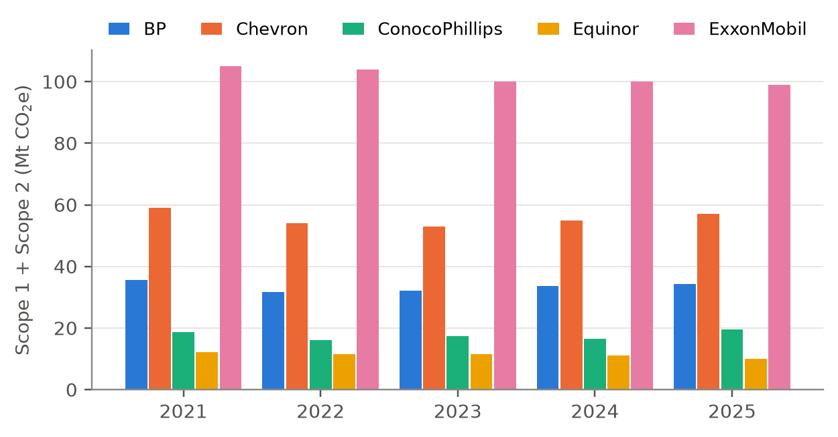
Figure 1.1: Annual Scope 1 and Scope 2 emissions of the five case companies, 2021–2025 (company reports)
At best practice is lagging behind policy in most organisations, especially in small and medium organisations (SMEs). Carbon accounting continues to be manual with spreadsheets and the information required is spread across departments, facilities and file formats [21]. There are commercial carbon accounting software packages available but they are too expensive, too difficult to integrate with current systems, and have insufficient staff trained in the operation [22]. Körner et al. [23] indicate that decarbonisation still does not have an efficient way of accounting for emissions, but McDonald et al. [24] note that results are difficult to compare due to competing ways of accounting. This project has responded by creating Sistem Pemantauan Karbon (SPK), an automated, lightweight, role-based web platform that automates emission calculations, raises red flags over questionable emission data before it reaches the audited record, and translates emission data into forecasts and carbon tax numbers that can be used to plan.

1.2 Problem Statements
This project is motivated by four interrelated problems.
First, organisations are still using disjointed manual spreadsheets to record emissions, resulting in errors and to emissions data spread across departments [21]. The free Malaysian tools, such as the SEDG GHG Emissions Calculator and the calculators of the Malaysian Green Technology and Climate Change Corporation (MGTC) and Maybank, compute a footprint for one organisation at a time [25]–[27]. They have no record of submissions or compare new values with history.
Secondly, reported emissions are not transparent enough to be audited. Existing measurement systems are generally not transparent, reliable or comparable [28] and a total in a report is not necessarily easily traceable to the fuel bill/utility invoice, the emission factor used, or the individual that entered and approved the measurement. The MRV system and a carbon tax outlined in the Climate Change Bill will rely on accurate and reliable emissions data [6], [15].
Third, existing tools are retrospective. The annual totals are compiled in company sustainability reports or data hubs after the end of the year [29] [30]. They don't predict emissions nor simulate their effects if mitigation actions are implemented, and the carbon tax liability is not always listed alongside the emissions amount, so the data is not used to guide investment choices [31].
Fourth, there is difficulty for non-specialists to interpret the carbon data. It is not always the case that government officers/managers responsible for taking government decisions on the figures are very familiar with scopes, emission factors, or forecasting models. Large language models can describe such data in simple terms, but can make plausible but false statements [32] unless backed up by reliable sources [33].

1.3 Aims and Objectives
This project was designed to create, prototype and test a light-weight system with a role-based digital carbon accounting with automated emission calculation, an auditable accounting of each emission, and a predictive forecast of emissions and carbon tax. The goals proposed at the design phase were updated based on the final design and the evaluation conducted:
- To develop an online carbon accounting tool that automatically ingests and computes Scope 1 and 2 emissions and carbon tax liability based on Malaysian SEDG emission factors and has role based access for company, government, and IT users.
- To create a structured database with auditable data-lineage ledger and approval workflow so that all emission figures can be traced to their submission, emission factor and approval.
- To create an AI-driven forecasting and scenario modelling and simulation system, which includes the STIRPAT model fitted using ridge regression to predict emissions six months in advance, a what-if simulator for carbon tax mitigation scenarios and an AI advisor chat, supported by data from the platform.
- To check the calculations using automatic unit tests and to assess the usability and usefulness of the platform with the System Usability Scale (SUS) user acceptance test.

1.4 Scope of Study
The project created an activity-based accounting platform, predictive analytics and a Web application to create a carbon accounting and forecasting platform. A STIRPAT model is used for forecasting emissions and tax liability, and a what-if simulation engine is used for support of mitigation decisions. The scope is limited by:
- Only Scope 1 and 2 emissions are included. We do not include Scope 3 in our analysis, as no tax proposal is currently available to cover scope 3, and data from scope 3 is the least reliable one [34]. Chevron's scope 2 data is market based, while the other companies reported it is location based.
- Five international oil and gas companies (bp, Chevron, ConocoPhillips, Equinor and ExxonMobil) have been selected as the case data is published annually across all Scopes 1 and 2 and has been consistently published across all other production, revenue and energy data. The annual values for 2021-2025 were broken down into monthly values and 2026 values were estimated synthetically. The Malaysian context is used by applying SEDG emission factors and MYR tax rate.
- A tax on Scope 1 and Scope 2 emissions with a flat rate of MYR 15 per tonne of emission, whose rate is adjustable from the dashboard. Thresholds and sector coverage are not included in modelling due to them not being announced.
- Three user roles are demonstrated using demonstration accounts: Company users (one per company), Government officer and IT administrator.
- The platform is a working prototype that works locally using Streamlit and SQLite. Not included is production hosting, single sign-on and integration with government systems.
- The usability was tried by 20 students from different programmes, not practising officers of the government or officers of the companies.

1.5 Significance of Study
SPK demonstrates, for regulators, the utility of a single perspective on the emissions, forecasts and tax exposure of a group of companies to support the MRV system to be planned under the Climate Change Bill. In the business world, it provides an opportunity to validate information prior to reporting and to evaluate the impact of reduction actions on the tax liability, without the expense and integration hassle of enterprise software. On the academic side the project uses the STIRPAT framework which is normally applied at the country-province city level [35]–[37] but is applied at the company-month level in this project and is supplemented by an operational workflow for data entry and an AI assistant based on the data displayed on the screen.

CHAPTER 2
LITERATURE REVIEW

2.1 Overview of Corporate Carbon Accounting and the GHG Protocol
The GHG Protocol is the most widely used framework for corporate GHG inventories and provides a common, comparable GHG reporting framework for organisations. The Corporate Standard requires a company to define its scope of operation (Scope 1, Scope 2) by operational control, financial control or equity share and requires it to account for and report on the emissions within its scope separately, while reporting on Scope 3 emissions is not required [2]. Value chain emissions are likely to account for the bulk of a company's footprint, but Scope 3 is also the most difficult to track [38] and in their analysis of the technology sector Klaaßen and Stoll [34] found that half of the emissions in the corporate report were in Scope 3. Therefore, Scope 1 and Scope 2 accounting is a defensible and immediate starting point for SPK to be scoped to an organisation's owned and controlled operations.
This GHG Emissions Calculator, developed for Malaysian SMEs (Small and Medium Enterprises), was based on the GHG Protocol and suggested the operational control approach, and emissions were calculated by multiplying the activity data by an emission factor and a global warming potential [25]. The GWP values used are from the IPCC Sixth Assessment Report (AR6), where fossil methane is assigned a GWP of 29.8 for a 100-year time horizon and a GWP of 273 for a 20-year time horizon, while nitrous oxide is assigned a GWP of 273 for a 100-year time horizon. For Scope 2 it applies the energy commission's grid emission factors, these are: 0.774kg CO2e/kWh for Peninsular Malaysia, 0.525 for Sabah, and 0.199 for Sarawak, the Peninsular factor was 0.757 a year ago and must be recorded [16].
In practice, it is important to select the proper factor. The same cost of electricity generates a different footprint due to the different values used for the Peninsular factor in the two calculators: 0.740 kg CO2e/kWh for the MGTC calculator and 0.78 [26] [27] for the Maybank calculator. The second source of inconsistency in Scope 2 arises since the GHG Protocol offers a location-based option (using average grid factors) or a market-based option (using contracts and certificates). Stachelscheid and Dutzi [39] analysed the disclosures of 102 chemical and pharmaceutical companies from Europe in 2019–2023 and concluded that there are significant inconsistencies in Scope 2 reporting, with many disclosures lacking clarity on the methodology and most of those that reported using the GHG Protocol [40] reporting inconsistently.
The conclusions of these reviews are consistent: He et al. [41] detected four research streams (carbon disclosure, management, performance and assurance) in 117 accounting papers, Marlowe and Clarke [28] pointed to low transparency, reliability and comparability, while McDonald et al. [24] advocated for a more coherent approach. These findings are in line with the scope limitation of SPK to Scope 1 and Scope 2, the use of a single set of Malaysian factors and recording the basis of each figure.

2.2 Carbon Pricing and Carbon Tax Policy in Malaysia
A carbon price converts GHG accounting from a merely abstract concept into an actual cost and provides an incentive for organisations to reduce their GHG emissions either through a carbon tax or a carbon emissions trading scheme. According to the World Bank [42] 28% of global emissions were being covered by a direct carbon price in 2025, and carbon taxes and trading systems generated over USD 100 billion last year (2024). There is positive, but limited, evidence of effectiveness. A review of ex-post studies by Green [43] showed that aggregate reductions ranged from 0% to 2% per year, and that carbon taxes did better than trading schemes, although most of the prices were low; a subsequent meta-analysis by the same authors of 21 schemes showed aggregate reductions of 5% to 21% (4% to 15% after accounting for publication bias) [44].
In Budget 2026, it was confirmed that Malaysia's carbon tax will be implemented in the iron, steel and energy industry and will be based on the National Carbon Market Policy and the Climate Change Bill [3] and [4]. The first phase will presumably focus on direct (Scope 1) emissions, and, at MYR 15 per tonne, most of the companies analysed by Kong [14] will experience a reduction in profitability of 5% or more. The MRV system underpinning the carbon pricing and the mandatory carbon accounting is established under the Climate Change Bill [6] [7]. The tax has been postponed to 2026 [8] pending the completion of the regulatory and policy framework [9] and commentators have called for a credible pricing framework [45].

Yong [15] points out that a successful carbon tax relies on accurate and reliable GHG information, and that the typical SME will have limited budgets and technical resources to develop it. This is the context for the carbon tax module of SPK, which charges a per tonne cost on the Scope 1 and Scope 2 emissions calculated by the module, meaning that organisations will have an ongoing view of their potential liability rather than a calculation at the end of the year.

2.3 Existing Carbon Accounting Software and Adoption Challenges
The carbon accounting software market is growing quickly. Of which about 70% is held in cloud, and more and more platforms are providing predictive emissions modelling, and anomaly detection. The problems with adoption consistent across market study: high costs of purchasing, implementing and maintaining the platforms deters small businesses, integration with existing enterprise systems requires specialised expertise, trained persons to interpret emissions data are in short supply [22], and the lack of uniformity in standards results in users needing to create bespoke workflows [46]. While the number of potential users is estimated to be around 40% SMEs, enterprise deployments can cost more than USD 500,000 [47]. Research on SMEs has found that resources and time are scarce, relevant data is sometimes stored in several different locations, or is not recorded systematically, and that spreadsheets become cumbersome to use over time [21]. The findings helped inform the design goal of SPK: a browser-based tool that requires nothing more than enterprise integration and does not require data on the activities that SMEs already maintain.
The research literature on information systems is in the same direction. Based on a structured literature review, Körner et al. [23] identified the characteristics of digital carbon accounting architectures and called for enhanced user and identity management and interoperable registries to enable digital MRV, while Rajendra [48] suggested a green technology module for accounting and sustainable financial reporting. Typically, the interface is called a dashboard. Bhattacharya and Zaman [49] compare an ESG dashboard to a dashboard in a car, which displays a handful of reliable metrics, alerts users when it needs their attention, and supports decision-making; and Sanatkumar and Berka-Harnmeijer [31] demonstrated using action research how an integrated decision-support tool was used to consider economic and environmental considerations simultaneously. Monitoring is also shifting to higher frequencies: from near real-time power generation to quarterly GHG accounts [51].
The companies in this project provide their data in annual tables in reports, data sheets and web data hubs [29], [30], [52]–[57] and industry bodies provide aggregated performance data [58]. They are authoritative but static – not filterable across companies, not projectable forward, and are not testable using a reduction measure.

2.4 Data Quality, Anomaly Detection and Forecasting in Emissions Reporting

2.4.1 Data Quality and Anomaly Detection
A mistake in the data submitted (e.g., a unit entered is incorrect or an extra digit) automatically affects the emission totals and the tax. A fixed-ratio rule, such as marking up when it is four times or more than four times the historical average and down when it is one tenth or less, is simple to apply, but it does not take into account the typical range of variation of each source. Some of the techniques for outlier detection for time series in the literature are classification by Blázquez-García et al., [59] estimation-based methods which flag points if they exceed a threshold, usually a multiple of the standard deviation, allowing each series to have its own threshold. It is challenging to pick a more complex detector: Schmidl et al. [60] tested 71 algorithms on 976 time series, and Zhang et al. [61] compared 17 algorithms and gave an advice on which algorithm to use among the compared ones. If there are a limited number of historical values in each source, a transparent z-score rule is better to use than a detector learned from the data, as every flag can be given to a person who has to approve it.

2.4.2 Emission Forecasting with Trend Models and STIRPAT
The easiest forecast is to draw an “ordinary least squares” (OLS) line through the past emissions data and to extrapolate that line. It is time transparent and readable by all non-technical users, but does not provide any explanation of the reason for changing emissions, it only requires time as an input. The IPAT identity, on the other hand, states that environmental impact is the result of population, affluence and technology. It was rephrased as a stochastic model, STIRPAT, by Dietz and Rosa [62] to allow estimation of the effects of each driver from data rather than assuming that they are proportionate, and more recently it was used to model the effects of population and affluence on national CO2 emissions [63]. Coefficients are elasticities in its logarithmic form and York et al. [64] demonstrated that it can be expanded with more terms without losing this property. Schneider [37] gives an overview of the bases and extensions of IPAT, ImPACT and STIRPAT, and cautions about issues of cross-sectional dependence and non-stationarity in panel data, while Hwang et al. [65] connect IPAT and Kaya decompositions to satellite derived CO2 fluxes.
OLS estimates are unstable because the drivers of STIRPAT are often highly correlated. To overcome this, ridge regression is used to shrink the coefficients [66] and is now a widely used estimator for STIRPAT. Rao et al. [36] applied an extended STIRPAT model with ridge regression and scenario analysis to the case of Hubei Province, Cooray and Özmen [67] introduced ridge and lasso regression into the STIRPAT framework to examine the STIRPAT model for institutions across 22 European Union countries, and Liu et al. [68] included age structure and climate variables in a cross-country analysis. Kong et al. [35] fitted an 80-20 split of training and validation data and chose a penalty of 0.005 using CV into their STIRPAT model for Shandong Province.
Jin et al. [69] studied 147 carbon emission prediction models, with the result that the most common are statistical models, followed by neural networks. The above STIRPAT studies are conducted at the national, provincial or city level, based on annual data and rarely at the company level, on a monthly basis. Machine learning is being used in climate problems more and more [70, 71] and can be more accurate if there are many series related to the problem [72] but in this case 5 companies and 60 months of reported months, an interpretable regression model is more appropriate. Forecasts should also be validated on data after they were used to train the model [73],[74] and the mean absolute percentage error (MAPE) is unstable for series with values near zero [75]. This is important because in some cases, the value of scope 2 is very small and for this reason a weighted error is reported along with MAPE for SPK.

2.4.3 Temporal Disaggregation of Annual Data
Companies report emissions once a year, while monitoring and forecasting requires data on a monthly basis. Temporal disaggregation estimates a series of high frequency that is consistent with the known series of low frequency. Denton [76] suggested modifying a monthly or quarterly indicator to sum to the annual indicators, yet with minimal changes between months. This is still in use by statistical offices. Disaggregation has been extended to many candidate indicators using sparse regression by Mosley et al. [77]; disaggregation has been implemented into the DisaggregateTS package by Mosley et al. [78] and Eurostat [51] has applied temporal disaggregation to create quarterly GHG accounts.

2.5 Artificial Intelligence Assistants for Climate Data
Climate text analysis has been enhanced by LMs tailored to climate text. ClimateBERT was pre-trained on over two million climate-related paragraphs [79] and, to ensure up-to-date and accurate responses, large language models were further provided external climate knowledge, such as databases of recent company data [80]. To provide GPT-4 with access to the IPCC AR6 reports, Vaghefi et al. [33] created ChatClimate, which was found to yield more accurate responses by experts when using the grounded hybrid version of GPT-4. This is important because LLM's can hallucinate, meaning they can come up with plausible but incorrect text [32]. The studies guided the choice of the exact numbers on the user's page, clearly marking out whether numbers were quoted or not and indicating when the data was missing or synthetic.

2.6 Existing Competitor Analysis
The most recent Malaysian tool is the SME Carbon Footprint Calculator developed by MGTC. An SME inputs its annual fuel and electricity consumption and gets a Scope 1 and Scope 2 footprint, split by fuel/energy type and with region-specific grid factors, a visualisation of the footprint as a tree and an indicative internal carbon price [26]. But it is an indicative one-shot estimate: its disclaimer reads “The result is not verified and cannot be relied upon for regulatory reporting, audit or financial decision making and does not maintain a monthly log, does not perform plausibility check and has no multi-user or role-based workflow and no forecast or what-if function.” Table 2.1: SPK compared to this calculator and other tools and data sources reviewed above.
Table 2.1: Comparison of existing tools and data sources with SPK
Feature | SEDG calculator | MGTC SME calculator | Maybank calculator | Company data hubs | Carbon Monitor-Power | SPK
Scope 1 and 2 calculated from activity data | Yes | Yes | Yes | No | No | Yes
Malaysian emission factors | Yes | Yes | Yes | No | No | Yes
Several organisations in one view | No | No | No | No | Yes | Yes
Time series of emissions | No | No | – | Annual | Daily | Monthly
Forecast of future emissions | No | No | – | No | No | Yes
What-if reduction scenarios | No | No | – | No | No | Yes
Carbon tax liability in MYR | No | Indicative | – | No | No | Yes
Validation and approval of submitted data | No | No | – | – | – | Yes
Role-based access and audit log | No | No | – | – | – | Yes
Conversational AI assistant | No | No | – | No | No | Yes
Based on publicly available descriptions of each tool and on use of the MGTC calculator; “–” means the feature is not described.

2.7 Summary and Research Gap
The review validates three converging forces: a domestic carbon tax that puts companies in a direct financial position to take responsibility for the accuracy of carbon data [3] [14]; a carbon accounting software market that is still expensive and difficult for SMEs to access [22] [47]; or ongoing issues with data quality due to manual, disorganized data collection [21] [28]. Three gaps follow. While Malaysian carbon tools can generate a footprint for one organisation, they lack an auditable and validated carbon ledger, which is essential in an MRV system. STIRPAT forecasting is validated at the regional scale, and has not often been used to forecast at the company level on monthly time series or incorporated into a monitoring tool. The most efficient way to use AI for climate data is to use authoritative sources, but none have been used for a carbon dashboard's live data. SPK tackles all three on one platform, which is detailed in the next chapter.

CHAPTER 3
METHODOLOGY

3.1 Project Development
The project used the Agile software development principles of Scrum [81] as depicted in Figure 3.1. The platform was developed in the following manner: It was built in two-week increments (sprints), where each sprint would begin with items from the product backlog and end with a working increment, which was checked against the objectives of Chapter 1 and reviewed with the supervisor before the next two-week iteration. This was a good fit for the project due to the loosely coupled nature of the concerns (ingestion, validation w/ rules, analytics & forecasting, AI advisor), which were built and integrated as they were needed and the requirements evolved. All changes were made to a git repository from which the dates in Table 3.3 were extracted.
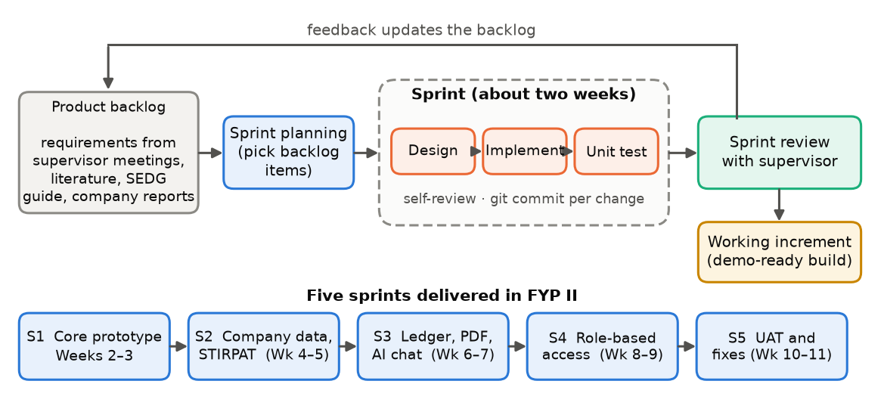
Figure 3.1: Agile Scrum framework adopted for the project
During FYP II the FYP I prototype was changed in three ways. In the first sprint the prototype, React and Node.js, where the state was stored in a JSON file, was rebuilt using Python, Streamlit and SQLite, so that the calculations, the forecasting model and the interface are in the same language and the ledger is stored in a transactional database. In the second sprint, three facilities' synthetic data were swapped for data reported by five oil and gas companies, providing several years of data to the forecasting model. The three in-company roles in the prototype (Data Clerk, Sustainability Manager, Executive) were changed to company, government and IT administrator roles in the fourth sprint, following the climate change bill [6] to include a role for a regulator to monitor all companies, and the views were opened to all roles, meaning that data entry and approval became company roles and forward-looking views became available to all roles.

3.1.1 Requirement Gathering and Analysis
The requirements were collected via the supervisor meetings, SEDG calculator guide, Malaysia carbon tax announcement, company sustainability reports and literature research in chapter 2. Three roles of users were found. A user of the company enters and verifies the emission data of the company itself. The data does not enter and is not approved by the government, it is only monitored by a government officer who issues carbon tax statements. The platform is maintained by the IT administrator who can see all of the features including the audit log. The functional requirements are shown in Table 3.1 and the non-functional requirements are shown in Table 3.2.
Table 3.1: Functional requirements
ID | Requirement | Roles
FR1 | Users log in with a username and password; what they can see and do depends on their role. | All
FR2 | The dashboard shows total, Scope 1 and Scope 2 emissions, filtered by year, company and scope. | All
FR3 | Carbon tax liability is estimated at an adjustable rate (default MYR 15 per tonne CO₂e). | All
FR4 | Monthly emissions are forecast six months ahead and the forecast accuracy is shown. | All
FR5 | Reduction levers can be simulated, showing the effect on emissions and carbon tax. | All
FR6 | Activity data (fuel, electricity, energy) is entered and converted to CO₂e with SEDG factors. | Company, IT
FR7 | Statistical outliers and duplicate months are flagged and held for approval. | Company, IT
FR8 | Approvers approve or reject flagged entries; users can undo their own entries. | Company, IT
FR9 | Records can be searched, filtered and exported as CSV. | All
FR10 | A PDF carbon tax statement can be generated for a company and period. | Government, IT
FR11 | Logins and data actions are recorded in an audit log visible to IT. | IT
FR12 | An AI chatbot answers questions using the figures on the current page. | All

Table 3.2: Non-functional requirements
Attribute | Requirement and how it is met
Security | Rows are filtered by role before any page or the chatbot sees them; passwords are compared in constant time; values written into HTML are escaped; exported CSV cells that start with a formula character are neutralised; the AI key is read from an environment variable.
Reliability | Database writes run in transactions that roll back on error; a failed AI request returns a safe message without stopping the page.
Traceability | Every record keeps its submitter, approver and timestamps; replaced and withdrawn entries are kept with their status rather than deleted.
Usability | All pages share one layout, sidebar and chart style and explain each chart in an observation box.
Performance | The workbook is parsed once and cached until the file changes; PDF statements are built only when requested.
Maintainability | Calculation logic is kept in modules that do not depend on Streamlit, so it can be unit-tested; every page inherits a shared base class.

3.1.2 Sprint Plan
Table 3.3 summarises the five sprints of FYP II and the main increment of each. The full schedule is shown as a Gantt chart in Appendix A.
Table 3.3: Sprint plan and deliverables
Sprint | Period | Main deliverables
S1 | 19–25 Sep 2026 | Python and Streamlit rebuild with four pages, login, SQLite data entry and carbon calculator; code organised into utility modules; first unit tests; review with supervisor.
S2 | 6–8 Oct 2026 | Company workbook (Carbon_Emission_Data.xlsx) for five oil and gas companies; STIRPAT ridge forecast with train and test metrics; what-if levers revised.
S3 | 15–23 Oct 2026 | SEDG emission factors and power consumption entries; one-entry-per-month duplicate rule; Groq chatbot grounded in page data; ledger seeded from the workbook; PDF carbon tax statement.
S4 | 24 Oct – 9 Nov 2026 | Company, government and IT roles with row-level filtering; shared Page base class; security fixes.
S5 | 11–20 Nov 2026 | User acceptance testing with 20 respondents; defect fixes.

3.2 System Architecture
SPK is a client-server Web application that is segmented into 4 conceptual layers as outlined in the design phase (Figure 3.2): Data Ingestion Layer, Application Processing Engine, Database and Reference Lookup Layer, and Output Dashboard UI.
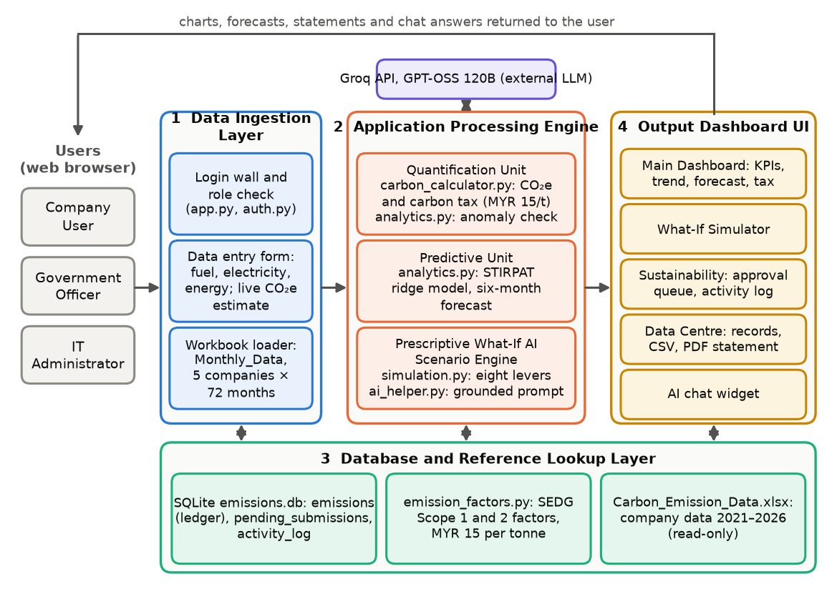
Figure 3.2: System architecture of SPK
The Data Ingestion Layer contains the user-facing entry point (router, app.py) that requires user to be logged in and has the correct role, as well as a data entry form that receives activity data and a loader that reads and validates the company workbook. The Application Processing Engine consists of three units. The Quantification Unit takes activity data and translates it into CO2e and carbon tax (carbon_taxer.py) and checks for any anomalies in each submission (analytics.py). The Predictive Unit is for prediction of emissions, and it is based on the STIRPAT model (analytics.py). The Prescriptive What-If AI Scenario Engine reduces the levers (simulation.py) used in the AI scenario, and it constructs grounded requests to the Groq API that hosts the GPT-OSS 120B language model (ai_helper.py). They are all free of Streamlit and thus can be unit-tested. The Database and Reference Lookup Layer contains the SQLite ledger and three tables and the read-only company workbook. The Output Dashboard UI is divided into four Streamlit pages (Main Dashboard, What-If Simulator, Sustainability and Data Centre), with each page having a base class that inherits the elements from the sidebar, navigation, filters and floating AI chat widget.

3.2.1 Use Case Design
The use case diagram is given in figure 3.3. All three roles inherit the common use cases of a registered user: logging in and out, viewing the dashboard and forecast, running simulations, asking the chatbot and exporting data. The entries are submitted, approved, rejected and undone by company users and the IT administrator; carbon tax statements are generated by the government officer and the IT administrator; and only the IT administrator is able to view the audit log.
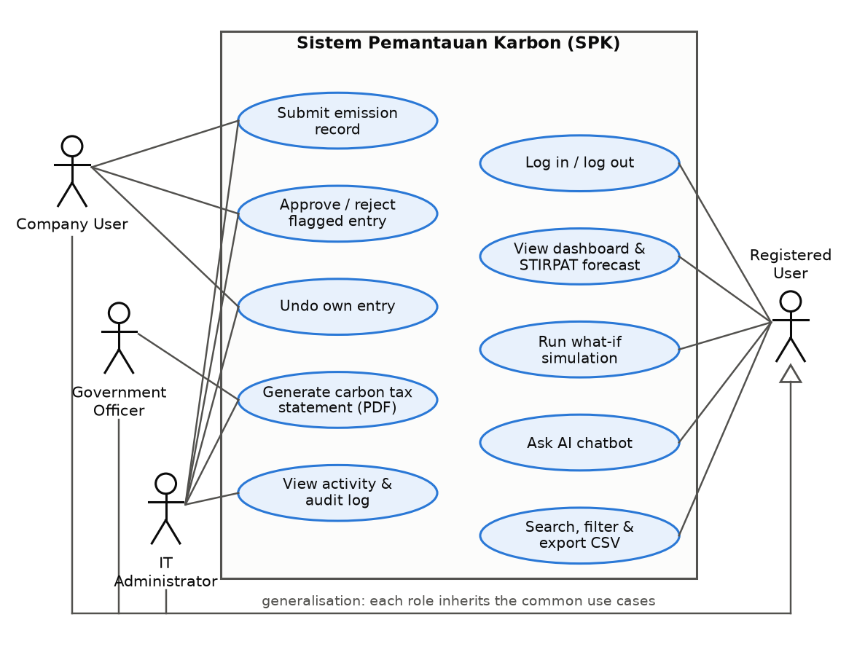
Figure 3.3: Use case diagram of SPK

3.2.2 Database Design
The entity relationship diagram is shown in figure 3.4. The emissions table is the ledger: companies are represented by the rows as are emission sources and months, with the quantity, CO2e, submitter, approver and status. Flagged entries are sent to pending_submissions until they are approved, or rejected, they then enter the ledger. The activity_log table contains all login, logout, submission, approval, rejection and withdrawal information. Entries will never be deleted: an entry that is replaced or withdrawn will still have its row, but with an updated status, thus keeping the lineage of each total intact. The users are defined in the authentication module, and the ledger is seeded from the Monthly_Data sheet in the workbook when the workbook is initially created.
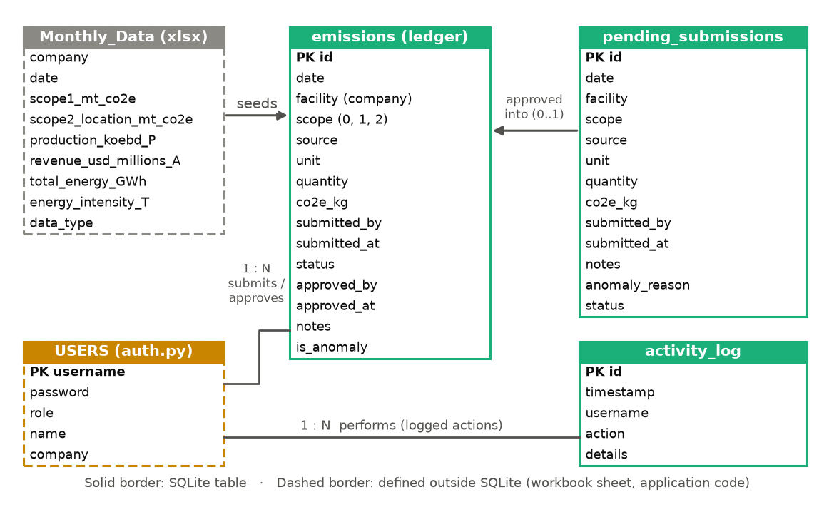
Figure 3.4: Entity relationship diagram

3.2.3 Security and Access Control
Access is controlled by the permission matrix in Table 3.4. Before any user accesses any page, chart, export or the chatbot, the company user's data is filtered to their company which when they log out, the whole session is cleared and the next user on the same browser will receive none of the data or chat history. The other safeguards are enumerated in security in Table 3.2; SQL statements have parameters too. The demonstration accounts are embedded within the code, but if it's deployed into production, it should be stored in a secure store with hashed credentials.
Table 3.4: Role permission matrix
Capability | Company user | Government officer | IT administrator
Companies visible | Own company | All | All
Submit emission data | Yes | No | Yes
Approve or reject flagged entries | Own company | View only | Yes
Generate PDF carbon tax statement | No | Yes | Yes
View activity and audit log | No | No | Yes
Dashboard, simulator, chatbot, CSV export | Own data | Yes | Yes

3.3 Emissions and Carbon Tax Calculation
The activities are converted to CO2e using a source-specific emission factor for each activity reading. All factors are sourced from the GHG Emissions Calculator for Malaysian SMEs by Capital Markets Malaysia (Capital) under the Simplified ESG Disclosure Guide (SEDG) [25]. The Scope 1 factors are based on the GHG Protocol cross-sector tools and the Scope 2 factors are the Energy Commission's grid emission factors [16]. The factors selected are listed in Table 3.5 and the complete list of factors is provided in Appendix D.
Table 3.5: Selected SEDG emission factors used by SPK
Emission source | Unit | kg CO₂e per unit
Stationary combustion, natural gas | GJ | 56.2
Stationary combustion, diesel | L | 2.95
Stationary combustion, coal | kg | 1.82
Mobile combustion, petrol | L | 2.288
Mobile combustion, diesel | L | 2.909
Mobile combustion, LPG | L | 1.473
Grid electricity, Peninsular Malaysia (TNB) | kWh | 0.774
Grid electricity, Sabah (SESB) | kWh | 0.525
Grid electricity, Sarawak (Sarawak Energy) | kWh | 0.199
Grid electricity, Kulim Hi-Tech Park (NUR) | kWh | 0.540

The spread of the grid factors between the grids is very wide throughout the country due to the mix of generation per grid: Peninsular Malaysia's grid factor is high as they have a significant proportion of coal and gas generation while the Sarawak's grid factor is low as it is based mainly on hydropower. Using the GHG Protocol's operational boundary, electricity is considered Scope 2 and fuel is considered Scope 1. The platform excludes fugitive emissions from refrigerants and fugitive process emissions. The emissions of a record and its carbon tax are calculated as:
CO₂e (kg) = Activity data × Emission factor (3.1)
Tax (MYR) = [CO₂e (kg) ÷ 1,000] × Rate (MYR per tonne) (3.2)
The SEDG method involves multiplying the data on activities by an emission factor, as well as by the appropriate GWP. However, the emission factors in Table 3.5 are already expressed in CO2e, meaning that the AR6 GWP for methane and nitrous oxide do not need to be applied again. The default rate is MYR 15/tonne, which is the rate that is reportedly being considered [5]. The dashboard allows the user to alter the rate, say to compare with Singapore's S$45 per tonne [82].

3.4 Anomaly Detection and the Data Pipeline
The end-to-end data pipeline is presented in Figure 3.5. There are two incoming lines for data. For the reported data path, annual data from company reports is extracted and disaggregated to a monthly level, and stored in the workbook, read and checked by the loader, and used for dashboard, forecast and simulator. The operational data entry path involves a business user providing activity information, the validation of this data, the conversion to CO2e, screening against approved history, then saving to ledger and/or queuing for approval. Both paths result in the same output: charts, exports, PDF statements and the data on the AI advisor's page. No numbers that are manually entered into a dashboard can impact a dashboard total until the numbers have been screened or approved.
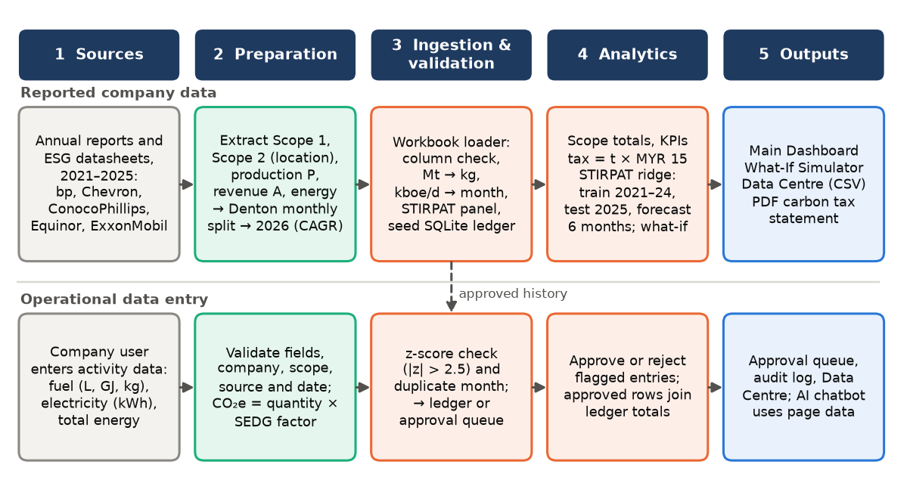
Figure 3.5: End-to-end data pipeline of SPK

3.4.1 Reported Company Data
Annual data for the years 2021–2025 was gathered from the annual reports, ESG data sheets, and online data hubs of bp, Chevron, Equinor and ExxonMobil [29], [30] [52]–[57]. The variables are described in Table 3.6. Chevron's Scope 2 values are market based as location based values are only reported from 2023; ConocoPhillips's production is operated rather than net, to match its operated emissions; ExxonMobil's energy use is reported only rounded; and Equinor's 2025 Scope 1 and Scope 2 total in the dataset (10.09 Mt) differs slightly from its reported 10.2 Mt after a boundary reassessment.

Table 3.6: Variables of the company dataset (Monthly_Data, 5 companies × 72 months = 360 rows)
Variable | Unit | Description
scope1_mt_co2e | Mt CO₂e | Direct (Scope 1) emissions of operated assets
scope2_location_mt_co2e | Mt CO₂e | Indirect (Scope 2) emissions, location-based (Chevron market-based)
production_koebd_P | kboe/d | Hydrocarbon production; STIRPAT driver P after conversion to a monthly volume
revenue_usd_millions_A | USD million | Sales and other operating revenues; STIRPAT driver A
total_energy_consumption_GWh | GWh | Total energy consumed by operations
energy_intensity_GWh_per_mmboe_T | GWh/mmboe | Energy divided by production; STIRPAT driver T
data_type | text | “Disaggregated (from annual)” for 2021–2025, “Synthetic 2026” for 2026

To disaggregate flow variables (Scope 1, Scope 2, revenue and energy), a first-difference Denton disaggregation method was applied that was additive, weighted by the number of days for each month, and by a seasonal profile, that resulted in the twelve months summing up to the reported annual figures. Production was reported on a daily rate which was disaggregated to achieve a day-weighted monthly average equal to the annual average. A co-moving company-level activity shock (a first-order autoregressive process with a standard deviation of 1%) affects production, energy consumption and Scope 1 emissions as well as revenue flows each month, which ensures that the monthly correlation between drivers and emissions is preserved, and a check sheet verifies that the monthly dollar amounts sum to the annual dollar amounts. Assumed to maintain the same seasonality, values for 2026 were projected by applying each variable's compound annual growth rate for 2021 to 2025 to the 2025 value. The synthetic rows are marked as such and appear on the dashboard with a warning, but will never be used to fit the forecasting model.

3.4.2 Data Entry, Anomaly Screening and Approval
The fixed-ratio plausibility rule in the FYP I prototype was replaced by an adaptive (statistical) plausibility rule. The quantity submitted is compared to the approved history of the same emission source using the following standard score:
z = |x − μ| ÷ σ (3.3)
If there are 5 or more approved submissions from the source and z > 2.5, then the submission is flagged. If there are fewer than 5 approved submissions from the source, or if the history should be identical, then no score is calculated. If the Company has already submitted for the same source in the same month, a submission will also be flagged as it is not allowed to submit multiple entries for a single source in a single month. Flagged entries are inserted into the pending_submissions table, along with a written explanation for the flag, such as “Value 15,100.0 L is 414.1σ high of historical mean”, and the value does not add to any totals until it is approved. If an entry is approved it is added to the ledger, and the previous entry for that month is replaced and marked as “replaced”. A user can also reverse his own approved entry, making it “withdrawn” and restoring any entry it replaced. Figure 3.6 shows this workflow.
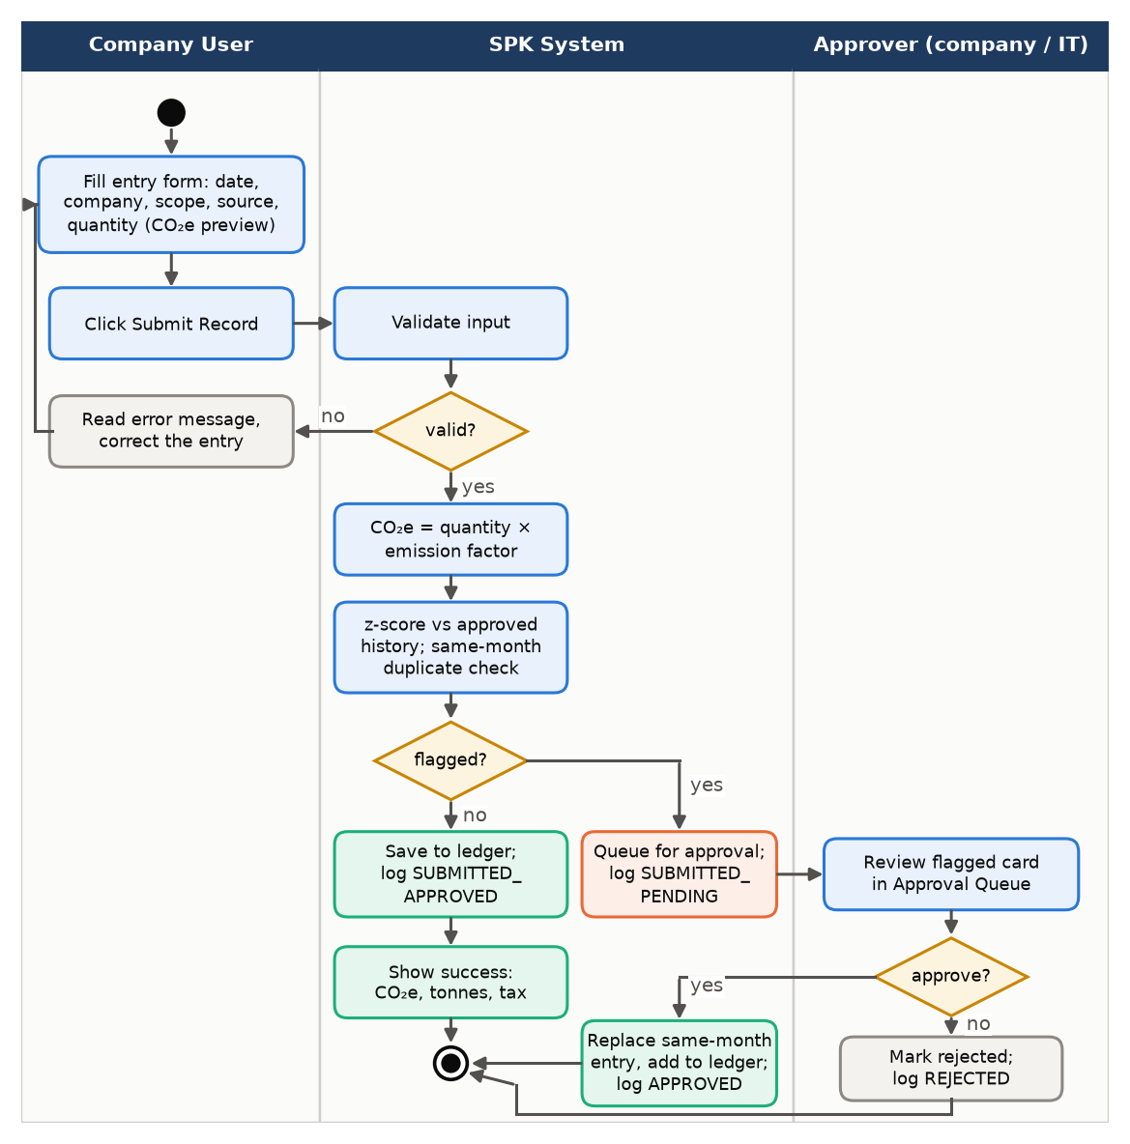
Figure 3.6: Activity diagram of emission submission, anomaly screening and approval

3.5 Forecasting Model
The FYP I prototype calculated the emissions using an OLS linear trend fitted independently to each monthly series, making it easy to explain, but inputting only the time series. The Predictive Unit was developed using the STIRPAT model [62] and the OLS trend remained as baseline to be evaluated for FYP II:
ŷ_{t} = β₀ + β₁t, t = 0, 1, …, N − 1 (3.4)
STIRPAT relates impact I to population P, affluence A and technology T:
I = a · P^{b} · A^{c} · T^{d} · e (3.5)
For a company, I is monthly emissions (Scope 1, Scope 2 or their total), P is production volume in the month (the daily rate multiplied by the days in the month), A is revenue and T is energy intensity. Taking logarithms and giving each company i its own intercept gives the estimated form:
ln I_{it} = α_{i} + b ln P_{it} + c ln A_{it} + d ln T_{it} + ε_{it} (3.6)
The use of electricity sources, e.g., renewable electricity, which is not captured by scope 2, is a crucial parameter for the companies, and companies P and A and T purchase renewable electricity (not captured) [39]. The model is therefore extended to include a company-specific time trend δit, following the extended STIRPAT approach of York et al. [64] and t in years. The drivers are correlated, so they are estimated by ridge regression [66] which minimises:
Σ (y − Xβ)² + λ Σ β², λ = 0.005 (3.7)
The penalty λ = 0.005 follows Kong et al. [35]. The model was tested with the chronological split of the reported months as 80/20, with January 2021 to December 2024 used for training purposes, and the 12 months of 2025 used for testing. The series from each company were fit with OLS baseline over the same training months. The weighted absolute percentage error (WAPE), MAPE, root mean square error (RMSE) and R2 were used to measure test errors.
WAPE = Σ |y − ŷ| ÷ Σ y × 100%, MAPE = (1/n) Σ |(y − ŷ) ÷ y| × 100% (3.8)
WAPE weights each error by the size of the emissions, so it is not distorted by a company whose Scope 2 is close to zero [75]. The dashboard reports accuracy as 100% minus WAPE.
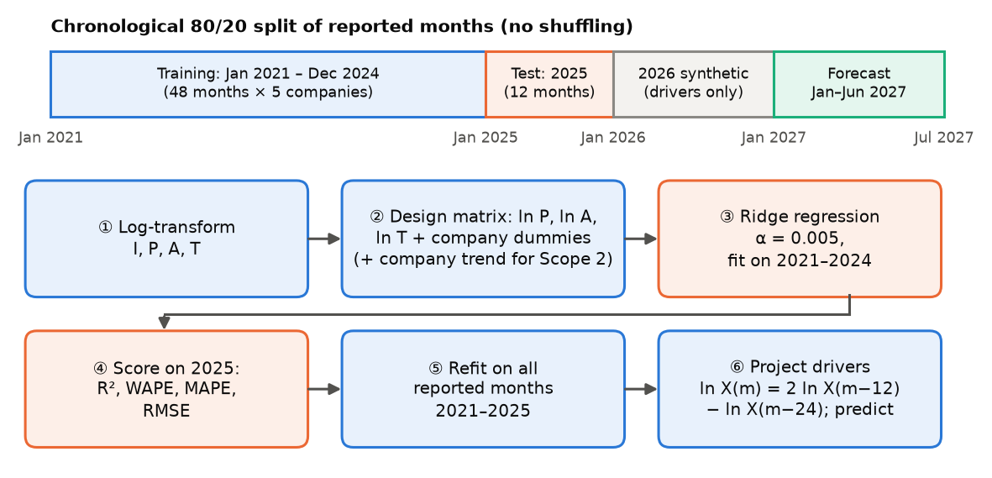
Figure 3.7: STIRPAT training, testing and forecasting workflow
Once the model is fitted it is refitted on all reported months in the list 2021-2025. Each future driver is assumed to increase its value by the same percentage that it did in the previous year to forecast January to June 2027, thereby maintaining the seasonal relationship:
ln X(m) = 2 ln X(m − 12) − ln X(m − 24) (3.9)
The driver values for 2026 are taken from the synthetic year and are included in Equation 3.9. This model is fitted for all companies and the forecast for a user's choice is the total of the selected companies' forecasts.

3.6 AI Advisor Chat
SPK AI is a generative AI advisor, which is part of the Prescriptive What-If AI Scenario Engine. It is displayed as a floating chat panel on all pages, and as a scenario analysis panel on the What-If Simulator, and it calls the Groq API, which is in the format of OpenAI chat completions, using the GPT-OSS 120B model. The sequence of a question is depicted in figure 3.8. When users type a question into the box, the page constructs a plain-text version of just what it displays for the current filters, such as the values of KPIs, the annual and company totals, seasonality and the STIRPAT forecasts and their accuracy. Because this summary is constructed from rows that the user's role can view, the company user's question will never send other company's figures to the model.
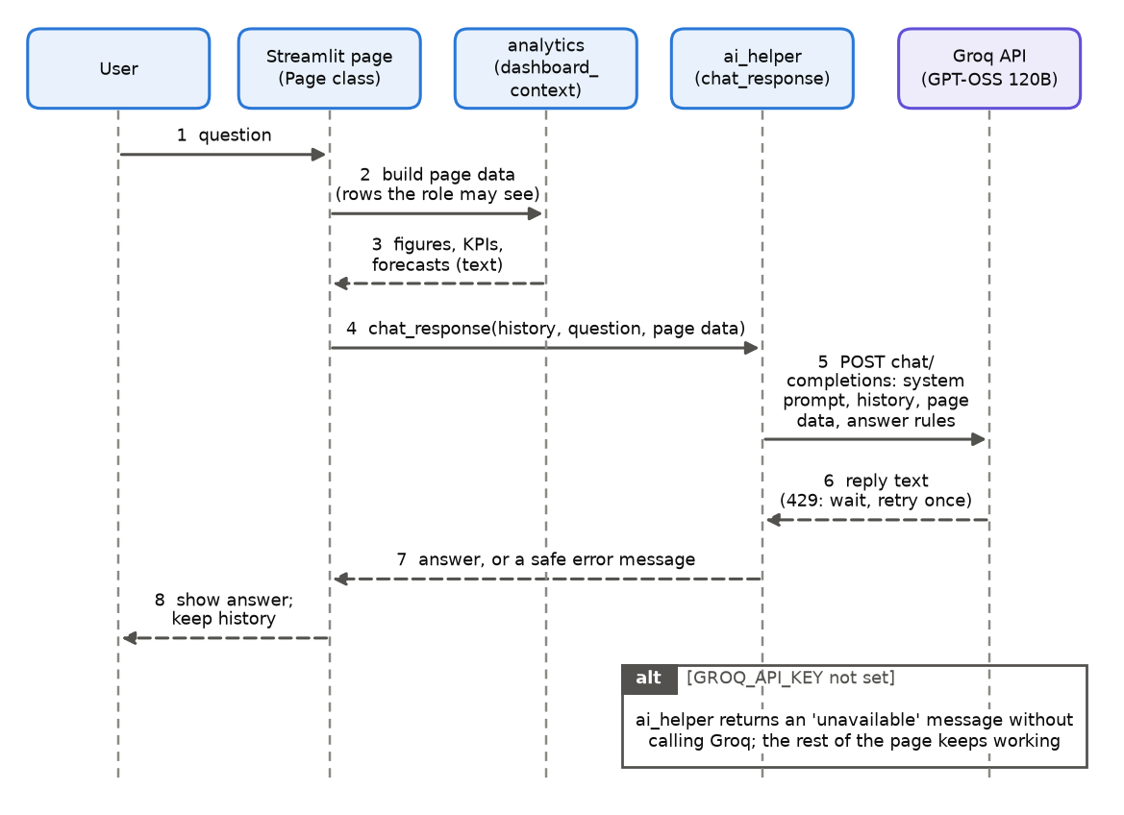
Figure 3.8: Sequence diagram of a grounded chatbot answer
The question includes a system prompt, the conversation history, the page content, and a brief reminder of the guidelines for the answer. The system prompt instructs the model to quote the numbers in its page data, not to make up numbers, to say when it doesn't have the data it needs, to answer simple questions in one to three sentences, and analytical questions in at most six bullet points, and describe only controls that are found in the platform. Next to each question, the reminder is repeated so that models are more likely to follow instructions close to the questions. A rate limited request will be retried once, and a failed request will result in a safe message being returned with no interruption to the page.

3.7 What-If Simulation Logic
What-If Simulator is a user modeling tool to simulate decarbonisation measures relative to the baseline emissions. The three levers of the FYP I prototype (solar share, fleet VE share and energy efficiency) were extended to the eight percentage levers, shown in Table 3.7 and corresponding to the SEDG emission sources. If multiple levers are applied to the same source, their percentages will be averaged and the simulated emissions of a record is:
E_{sim} = E_{base} × (1 − mean lever fraction of the record's source) (3.10)
Each Scope 1 lever has the same impact on Scope 1 and each Scope 2 lever has the same impact on Scope 2; for this reason, the workbook contains totals for Scope 1 and Scope 2, and not totals for each fuel. The tax saving is equal to the reduction in tonnes times the tax rate.
Table 3.7: Levers of the What-If Simulator
Lever | Range (%) | Emission sources affected
Natural gas reduction | 0–100 | Stationary natural gas, mobile CNG
Diesel reduction | 0–100 | Stationary and mobile diesel and biodiesel blends
Petrol reduction | 0–100 | Stationary and mobile petrol
LPG reduction | 0–100 | Stationary and mobile LPG
Fleet EV adoption | 0–100 | Mobile petrol (averaged with petrol reduction)
Electricity consumption reduction | 0–100 | All grid electricity sources
Renewable energy share | 0–100 | All grid electricity sources
Overall energy efficiency gain | 0–50 | All grid electricity sources

3.8 Tools and Technologies
The development of the platform was done using Python 3.12. The web interface, page routing, widgets and session state are all provided by streamlit 1.64, the emission data is loaded, filtered and aggregated by pandas 3.0 and NumPy 2.5, the ridge regression is fitted by scikit-learn 1.9, and the interactive line, bar, area and heatmap charts are drawn by Plotly 7.1. The ledger, approval queue and audit log are stored in SQLite using python's sqlite3 module, the company workbook is read using openpyxl and the PDF carbon tax statement is created using ReportLab 5.1. The AI advisor makes a call to the Groq API over HTTPS using the requests library. The user acceptance questionnaire was created using Microsoft Forms, and the code was developed in Visual Studio Code with version control using Python's unittest framework and Git and GitHub.

3.9 Testing and Evaluation
The platform was tested on two levels. The platform has been tested at two different levels. The calculations were verified by unit testing, which is done by writing 77 automated tests with Python's unittest framework that check the calculator, authentication, analytics, simulation, report and data manager modules and database tests are performed on a temporary SQLite file to not affect the real ledger. The platform was evaluated by user acceptance testing which involved 20 respondents, who used demonstration accounts, and filled out a online questionnaire (Appendix C). It comprised a consent and profile section, 56 black-box test cases in 6 modules for each passed, failed, or not tested, the 10-item System Usability Scale [83], 10 feature-specific statements using 5-point agreement scale, an overall satisfaction rating and three open questions.
Each respondent's SUS score was computed as usual: odd items (positively worded items) whether the response was 1, the contribution was 0 and whether the response was 2, the contribution was 1, etc., but for even items (negatively worded items), the contribution was 0 if the response was 5, and 1 if the response was 4. The sum of the contributions was multiplied by 2.5 to yield a score from 0 to 100 [83]. The average score is generally considered to be 68, across systems [84].
SUS = 2.5 × [Σ_{odd} (r − 1) + Σ_{even} (5 − r)] (3.11)

CHAPTER 4
RESULTS AND DISCUSSION

4.1 System Implementation Overview
All twelve functional requirements in Table 3.1 were implemented. The main interfaces are presented below, and further screenshots are given in Appendix B.

4.1.1 Login and Role-Based Access
The login page with the demonstration accounts is displayed in figure 4.1(a). Once signed in, items not in a person's role are replaced with an “Access Restricted” message, like the “Access Restricted” message for a government officer opening the Data Entry tab as seen in Figure 4.1(b).
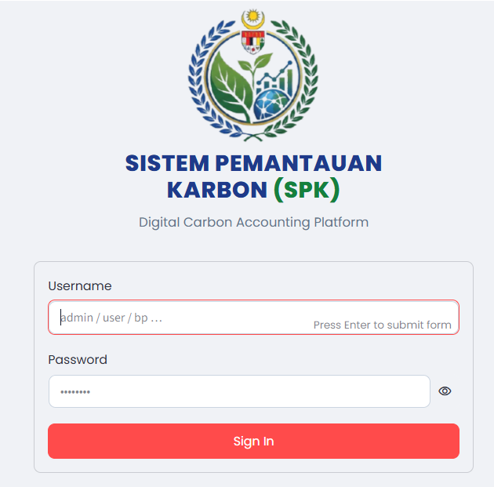  (a) | 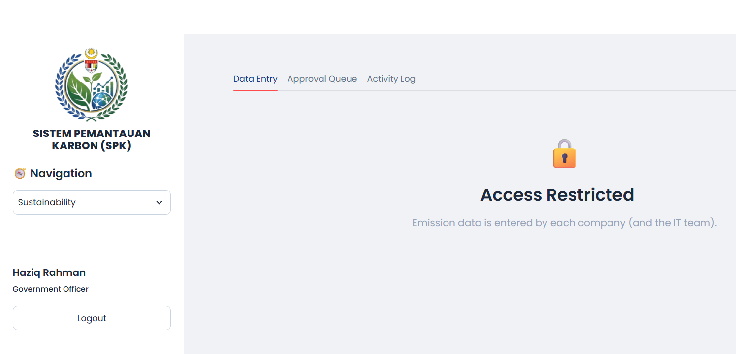  (b)
Figure 4.1: (a) Login page; (b) Data Entry restricted for a government officer

4.1.2 Main Dashboard
Four KPI cards are shown on the Main Dashboard (Figure 4.2): total emission, Scope 1, Scope 2 and carbon tax per year. The total card shows the average difference between the first half and second half of the months selected. All charts are updated with side bar filters for year, company & scope, and tax rate. Below the cards is the monthly trend chart with Scope 1, Scope 2 and total trend lines and dashed STIRPAT forecast for the next six months, followed by the accuracy table in Section 4.3 (Figure B.1 in Appendix B), company bar chart and heatmap, and the carbon tax chart.
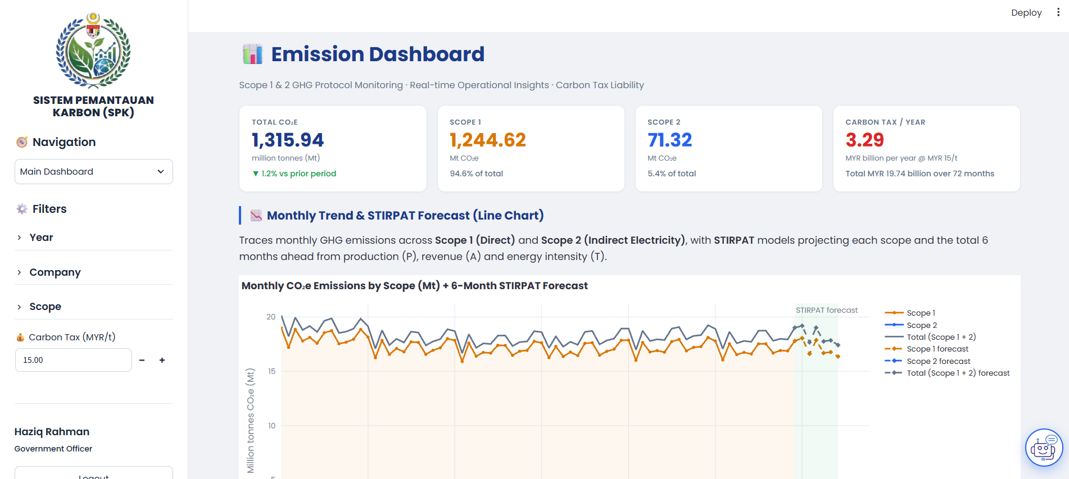
Figure 4.2: Main Dashboard with KPI cards and monthly trend

4.1.3 What-If Simulator
The What-If Simulator (Figure 4.3) situates the Scope 1 and Scope 2 levers on the left and the results on the right: simulated total emissions, the reduction, the new tax liability/saving and the simulated Scope 1 and Scope 2 totals. It is presented in the form of a bar chart for the reduction by source and an area chart to show the comparison with the baseline and simulated monthly emissions. A 20% reduction in natural gas, a 20% roll-out of EVs in the fleet, and a 10% reduction in electricity all reduced emissions by 7.7%, whereas each of these levers would have reduced emissions by 3.8%, 3.8% and 0.2%, respectively. The AI Scenario Analysis button passes the scenario to the language model, and it provides feedback regarding the scenario's realism, savings, first step and main risk (Appendix B).
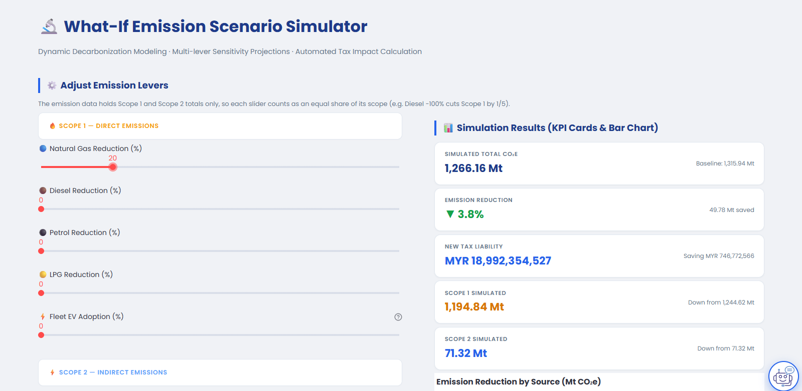
Figure 4.3: What-If Simulator with levers and simulation results

4.1.4 Sustainability: Data Entry, Approval and Audit Log
There are three tabs on the Sustainability page. In Data Entry (Figure 4.4(a)), the user selects the date, company, scope and source and types a quantity, while quantities of CO2e, tonnes and tax are estimated as they type: For stationary natural gas, 100 GJ is equivalent to 5,620 kg CO2e (MYR 84.30) and for mobile diesel it is 290.90 kg CO2e (MYR 4.36). The reason for the unusual submission is that approximately ten times the normal monthly amount of 1,507.1 L (historical average mean of 15,100 L) was flagged as 414.1 standard deviations above the historical average mean of 1,507.1 L ± 32.8 L (Figure 4.4(b)).
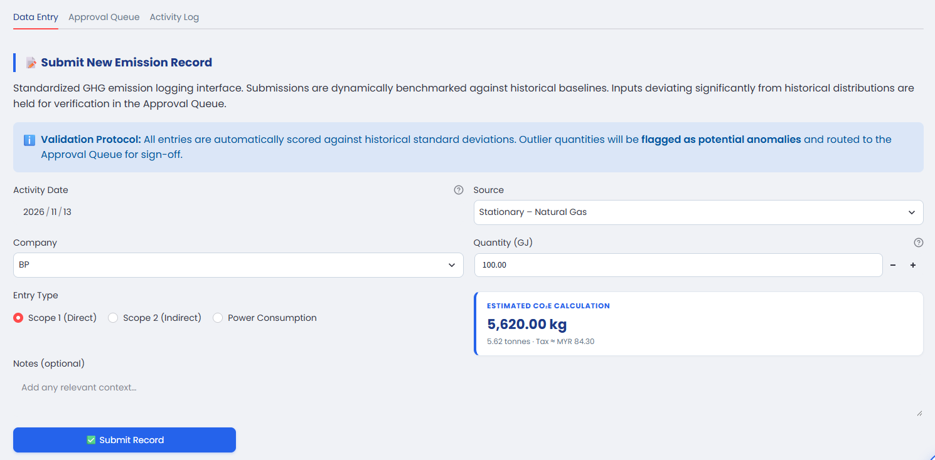
(a)
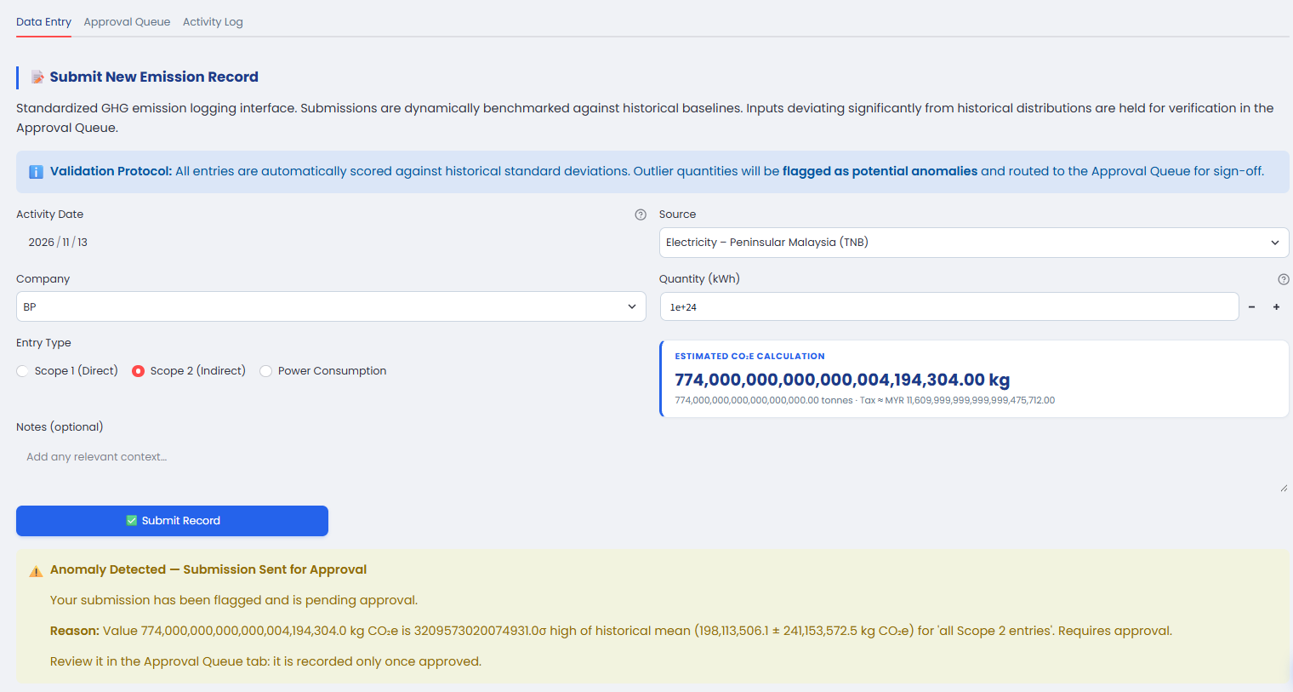
(b)
Figure 4.4: (a) Data entry with live CO₂e estimate; (b) anomaly flagged and sent for approval

The Approval Queue (Figure B.5 in Appendix B) displays each flagged item on a card, with the quantity, CO2e, tax exposure, submitter, reason and Approve and Reject buttons for the company's approvers. A user can only view the Activity Log tab if they are an IT administrator, and it contains all of the logins, submissions, approvals and rejections as well as all withdrawals with the user's name and time. It can be filtered and exported (Appendix B).

4.1.5 Data Centre and Carbon Tax Statement
Filters, search and paging are provided on the Data Centre to view all entries in the ledger and then a monthly summary for each company (Figure B.7 in Appendix B). The Export tab exports the filtered data to a CSV file and, if that filtered data consists of company details, monthly emissions data (with chart and summary), and carbon tax invoice, it produces those same three files for government officials and IT administrators (Figure B.9 in Appendix B).

4.1.6 AI Advisor Chat
The chatbot appears on the button at the bottom of each page and continues chatting when the user switches to another page. The government officer queried the company with the highest Scope 1 emissions and the answer given is ExxonMobil with 88.10 Mt for the 2026 data presented, which corresponds to the dashboard. The panel reminds the users that the AI-generated responses are liable to be wrong.
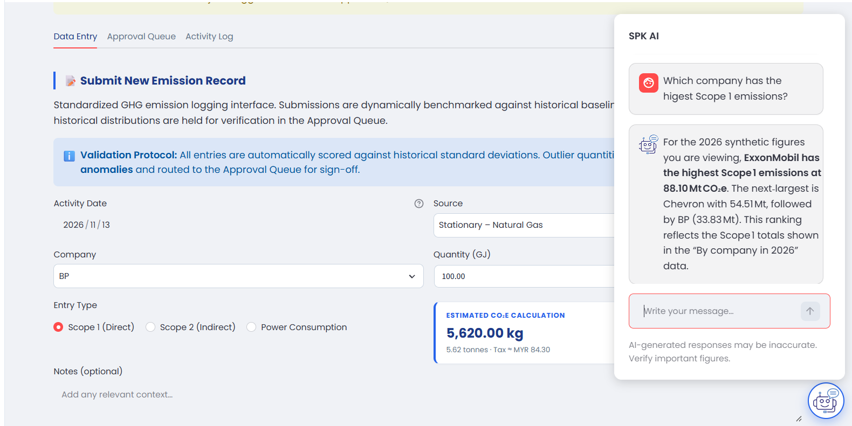
Figure 4.5: AI advisor chat answering from the page data

4.2 Dataset Overview
This figure corresponds to the monthly Scope 1 and Scope 2 emissions for the five companies from January 2021 to December 2026 as displayed in Figure 4.6. The monthly series maintain the same seasonal form as in the disaggregation and the seasonal level of each company's annual reports. The combined total of ExxonMobil and Chevron dominates throughout with a reduction from 230.4 Mt CO2e in 2021 to 220.1 Mt in 2025, a 4.5% decrease.
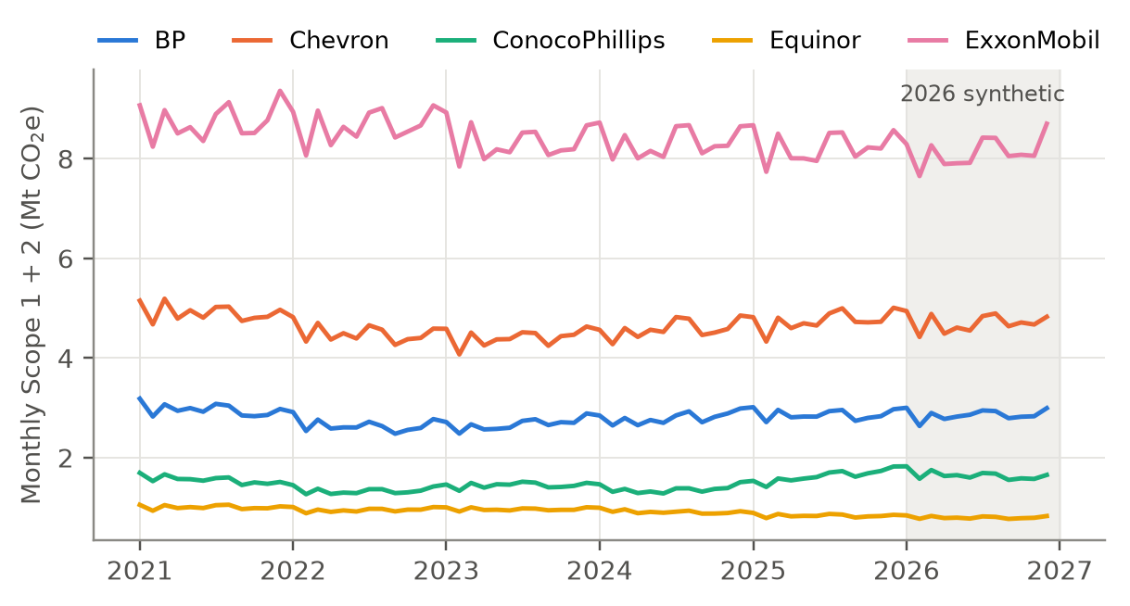
Figure 4.6: Monthly Scope 1 and Scope 2 emissions by company, 2021–2026
The 6 years of data are summarised in Table 4.1. Most of these companies' emissions footprint would be captured by a carbon tax that targets direct emissions (as most likely would be the case with Malaysia's first phase), as 94.6% of all emissions fall under Scope 1. ExxonMobil accounts for 46.0% of total. The 1,315.94 Mt CO2e for the period represents MYR 19.74 billion (MYR 3.29 billion per year) at MYR 15 per tonne.
Table 4.1: Emissions and carbon tax by company, January 2021 – December 2026
Company | Scope 1 (Mt) | Scope 2 (Mt) | Total (Mt) | Share (%) | Tax at MYR 15/t (MYR bn)
BP | 195.03 | 6.81 | 201.84 | 15.3 | 3.03
Chevron | 324.51 | 10.00 | 334.51 | 25.4 | 5.02
ConocoPhillips | 101.58 | 6.42 | 108.00 | 8.2 | 1.62
Equinor | 65.40 | 0.50 | 65.90 | 5.0 | 0.99
ExxonMobil | 558.10 | 47.58 | 605.69 | 46.0 | 9.09
Total | 1,244.62 | 71.32 | 1,315.94 | 100.0 | 19.74
2026 values are synthetic.

4.3 Forecasting Results

4.3.1 Accuracy on the Test Year
Table 4.2 presents results from the three models of STIRPAT, OLS trend baseline (3.4) on the training years (2021-2024) and held-out test year (2025). The actual monthly totals (summed across the five companies) from 2025 are compared in figure 4.7 with both forecasts.
Table 4.2: STIRPAT model performance, elasticities and OLS baseline
Measure | Scope 1 | Scope 2 | Total (Scope 1 + 2)
Train R² (2021–2024) | 0.9983 | 0.9870 | 0.9982
Test R² (2025) | 0.9991 | 0.9843 | 0.9992
Test WAPE (%) | 1.45 | 11.12 | 1.51
Accuracy = 100 − WAPE (%) | 98.55 | 88.88 | 98.49
Test MAPE (%) | 1.46 | 39.29 | 1.70
Test RMSE (Mt per company-month) | 0.074 | 0.034 | 0.074
Elasticity b (ln P) | 0.858 | 2.219 | 0.862
Elasticity c (ln A) | −0.055 | −0.378 | −0.067
Elasticity d (ln T) | 0.885 | 2.837 | 0.853
OLS trend baseline: test WAPE (%) | 6.40 | 18.33 | 6.81
OLS trend baseline: test MAPE (%) | 8.29 | 59.23 | 8.89
Elasticities are from the model refitted on 2021–2025. The Scope 2 model also contains company-specific trends.
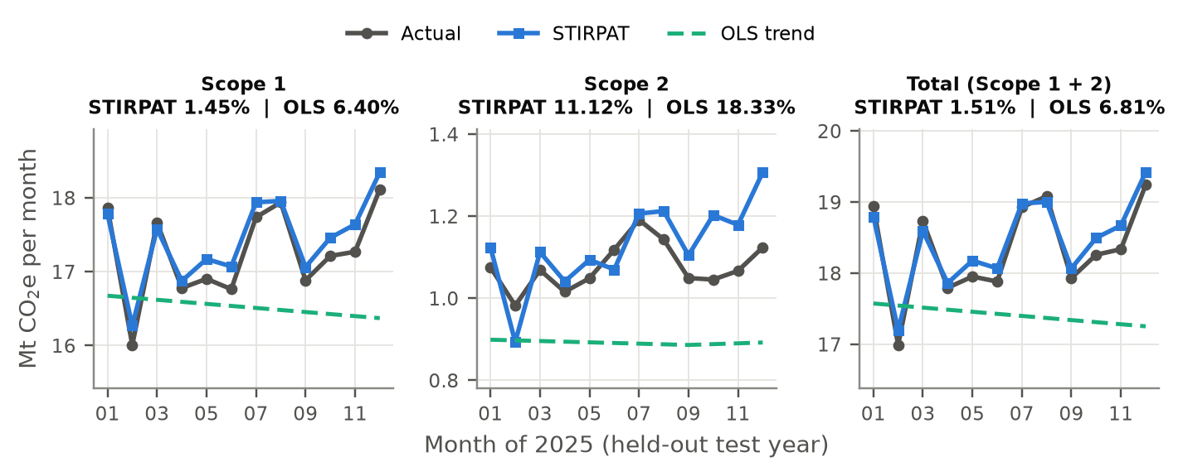
Figure 4.7: Actual, STIRPAT and OLS trend monthly emissions in the test year 2025 (all five companies; titles give the test WAPE)
The Scope 1 model and the total model are highly accurate for the unseen year, with a WAPE of 1.45% and 1.51% and R2 of more than 0.999. For the total model the company errors range from 1.07% (Equinor) to 2.51% (ConocoPhillips). The Scope 2 model is less accurate since the WAPE is 11.12% and the MAPE is 39.29% due to the fact that the absolute error in this model is large in relation to the small size of the scope 2 value in 2025 – this is the drawback of MAPE as pointed out by Hewamalage et al. [75] – which is why it is reported here as the main measure.
STIRPAT showed over three-quarters decrease in the WAPE of the OLS trend in Scope 1 and total and around 40% decrease in Scope 2. The trend line does not capture the seasonal component, and projecting its downward path to 2025 underestimates each month of 2025 as can be seen in Figure 4.7. A seasonal naive forecast was also calculated by repeating the value of the same month in the year 2024, and this also performed better than STIRPAT with WAPE values of 4.26%, 12.30% and 3.69% respectively. The comparison is skewed in favor of STIRPAT in one aspect: the test year in STIRPAT took into account the actual production, revenue and energy data for 2025, while both the baselines were done based on past emissions. The benefit it provides is therefore a measure of the drivers' ability to account for emissions and the accuracy of the drivers' forecast will also be affected by the accuracy of the drivers' forecast.

4.3.2 Interpretation of the Elasticities
The Scope 1 elasticities can be readily understood in physical terms. A 1% rise in production is responsible for a 0.86% rise in Scope 1 emissions and a 1% rise in energy intensity is accompanied by an almost negligible change in revenue (−0.05%). Direct emissions are therefore more closely coupled with physical activity and energy use, rather than oil/gas prices, that caused the big ups and downs in revenue that occurred between 2021 and 2023. This is similar to Kong et al. [35] who applied the STIRPAT model for Shandong and found the highest elasticities for energy structure and energy consumption intensity.
The Scope 2 elasticities are much larger, but should not be interpreted independently as the company trend terms in the Scope 2 model are correlated with the drivers, and partly offset these. The fitted trends are −28.0% per year for BP, +13.0% for Chevron, +18.0% for ExxonMobil, −0.8% for ConocoPhillips and +0.8% for Equinor, and only BP's matches a real change, its fall from 2.4 Mt in 2021 to 0.7 Mt in 2025. The AI advisor is not allowed to display these trend words as growth rates.

4.3.3 Six-Month Forecast
Forecast of total emissions January to June 2027 is presented in Figure 4.8. The model is predicting 108.91 Mt CO2e (6 months), which is 1.1% higher than the 107.73 Mt for January to 6 June 2026. There is the typical seasonal surge in January and March. Scope 1 is forecast at 102.35 Mt (+1.1%) and Scope 2 at 7.03 Mt (+8.7%). The forecast for Scope 1 and Scope 2 do not sum to the total forecast due to the models being fitted independently.
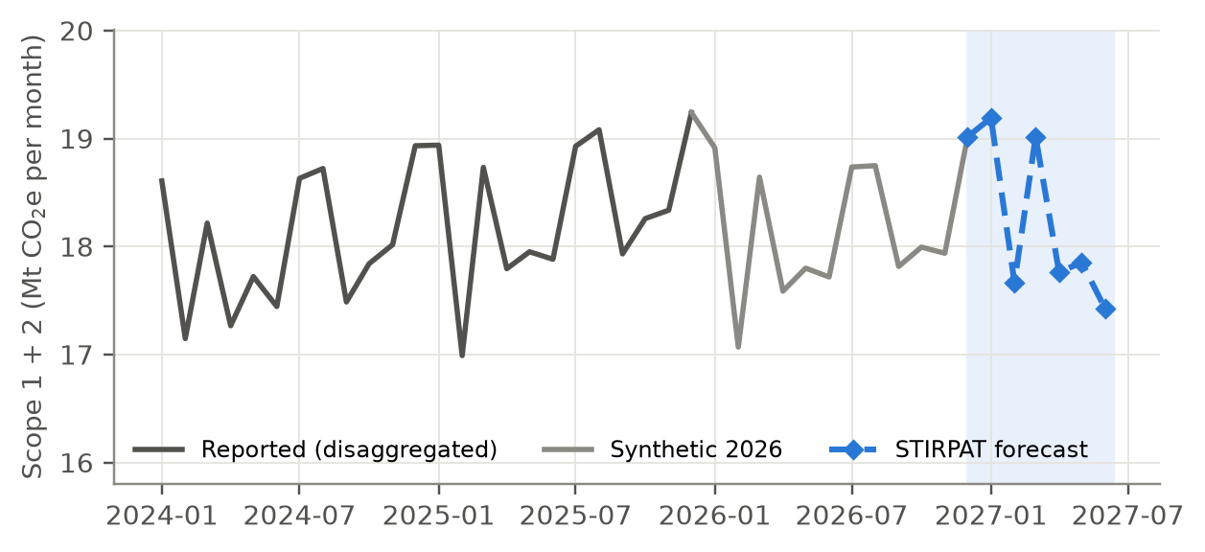
Figure 4.8: STIRPAT forecast of total emissions, January–June 2027
These results are intended for interpretation with caution. The model's monthly co-movement was built into the data as part of the disaggregation from annual totals of the monthly data (Section 3.4.1) in order to account for a portion of the monthly co-movement. The high accuracy thus indicates that the model reproduces the annual relationships and the seasonal pattern well but not necessarily that it is able to predict the true measured monthly emissions to within 1.5%. The forecast also relies on the synthetic 2026 drivers. Both of these are revealed on the dashboard and to the AI adviser.

4.4 Unit Testing
The entire set of 77 unit tests were passed in 3.4 seconds (Table 4.3). The tests include the arithmetic of emissions and tax, negative or non-finite quantities, the permission matrix and company filtering, the averaging of levers, the PDF statement totals, the anomaly rule, CSV formula neutralisation, fitting the STIRPAT model without the synthetic months, and submission, approval, rejection, replacement and withdrawal of the database.
Table 4.3: Unit test results by module
Test module | Main behaviour tested | Tests passed
test_core | Emission and tax calculation, SEDG factors, input checks | 7 / 7
test_auth | Login, case-insensitive usernames, permissions, row filtering | 4 / 4
test_ai_helper | Request content, rate-limit retry, safe failure message | 3 / 3
test_simulation | Lever mapping and averaging, full reduction, scope totals | 9 / 9
test_report | Statement totals, quarters, amount in words, missing data | 7 / 7
test_analytics | Totals, filters, search, anomaly rule, CSV safety, STIRPAT, chatbot context | 29 / 29
test_data_manager | Seeding, submission, approval, rejection, duplicates, undo, rollback, workbook | 18 / 18
Total |  | 77 / 77

4.5 User Acceptance Testing

4.5.1 Respondent Profile
Twenty people agreed to participate and answered the questionnaire. Their profile is in Figure 4.9. There were six computer science / IT students, four from petroleum engineering, four from chemical engineering and four from business management, and two other students from other disciplines. 13 used the three roles: all the twenty used the user role, seventeen the government role and fourteen the IT administrator role. The respondents are not specialists as the average of their familiarity with Scope 1 accounting was 3.05 on a scale of 1 to 5 and the average of their familiarity with Scope 2 accounting was 3.05 on a scale of 1 to 5 and the average of their familiarity with Malaysia's carbon tax was 2.80 on a scale of 1 to 5. 17 dashboards or analytics tools were used at least once a month.
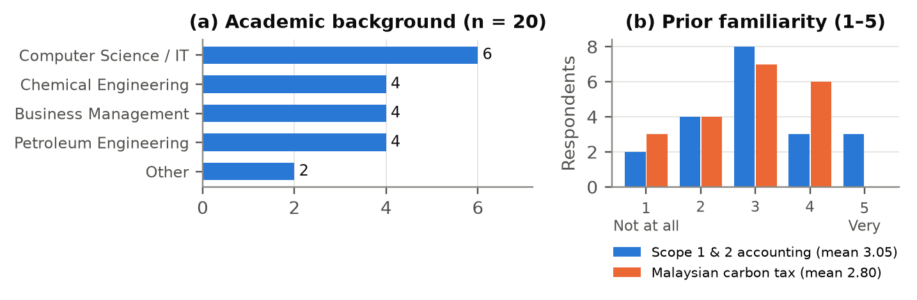
Figure 4.9: Respondent profile: (a) academic background; (b) prior familiarity

4.5.2 Test Case Outcomes and Defects
A total of 1120 test case judgements were made by the 20 respondents. Of these, 1,015 (90.6%) were Pass, 28 (2.5%) were Fail and 77 (6.9%) were Not tested, so 97.3% of the executed tests passed. The results of the tests by module are represented in figure 4.10 and the result of each test case is given in appendix C. There were no failures reported for the authentication and access or for the What-If Simulator. The Fail judgements are clustered in 2 Sustainability cases accounting for 20 of the 28 Fail judgements. All of the cases, which were rated as Fail, are summarized in Table 4.4, along with their current status at the time of this writing.
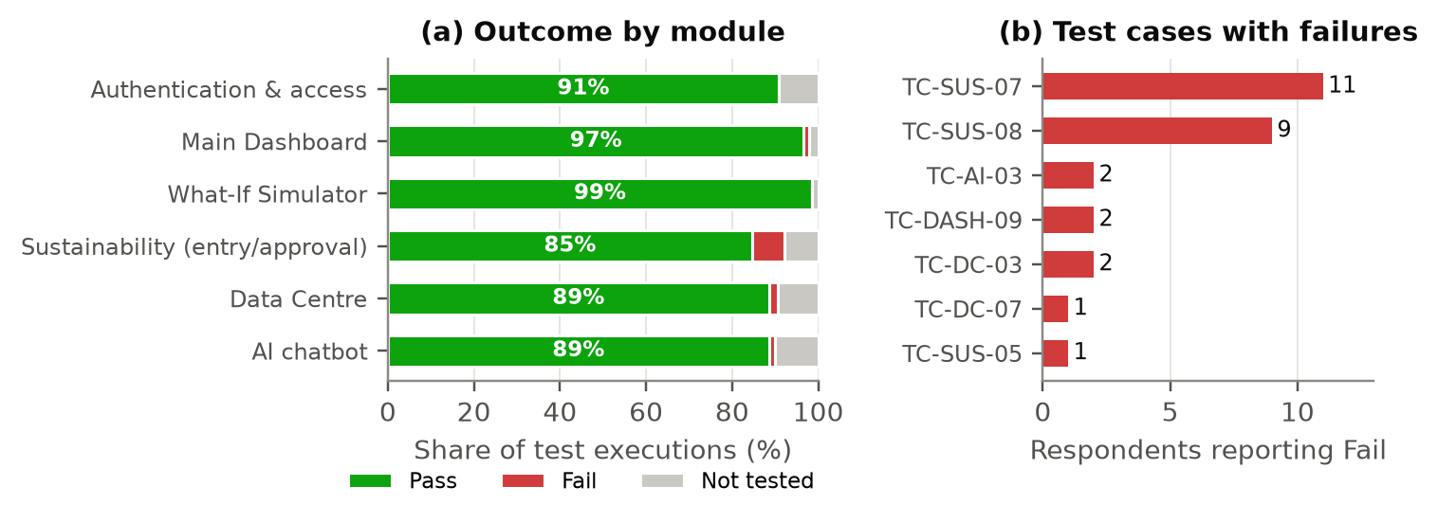
Figure 4.10: User acceptance test outcomes: (a) by module; (b) test cases reported as failed
Table 4.4: Defects reported in user acceptance testing
Test case | Fails | Reported problem | Cause | Status
TC-SUS-07 | 11 | A power consumption entry was sent to the approval queue as a duplicate instead of being recorded. | The workbook already seeds each company's total energy for every month up to December 2026. | Open
TC-SUS-08 | 9 | Undo withdrew the entry but showed no confirmation, and the next row was selected. | The message was lost in the page rerun and the table selection was kept. | Fixed after testing; to be re-tested
TC-DASH-09 | 2 | A negative tax rate showed a red outline with no explanation. | The input enforces a minimum of zero but shows no message. | Open
TC-DC-03 | 2 | Data Centre filters narrowed the table but the options appeared unticked. | Checkbox state is not redrawn inside the closed pop-over. | Open
TC-AI-03 | 2 | Forecast answers were long and did not state clearly whether emissions would rise or fall. | The answer-length rule was not followed for forecast questions. | Open
TC-SUS-05 | 1 | A quantity ten times the usual value was not flagged. | No score is computed for a source with fewer than five approved records; passed for 19 respondents. | To be investigated
TC-DC-07 | 1 | The no-data warning could not be triggered. | Every company has records for every period, so the case cannot occur with this data. | Covered by unit test

4.5.3 System Usability Scale
The mean SUS score was 77.4 (SD 9.1; median 78.8; range 57.5 to 92.5), and seventeen of the twenty respondents scored 68 or above (Figure 4.11). The mean is more than the average of 68 [84] and greater than the proposed average of 68 to 72 by Bangor et al. [85] which is the range of the adjective rating from “Good” to “Excellent”. The means of the items were positive for all of them (ranging from 4.00 for learning the system quickly to 4.15 for wanting to use it frequently) and negative for all of them (ranging from 1.75 for inconsistency to 2.00 for needing to learn a lot first), indicating that respondents were satisfied with the consistency and ease with which they learned the platform. The highest scores were recorded by business management (mean 84.4) and chemical engineering (81.9) while the lowest were recorded by computer science and IT respondents (mean 73.3) and the two respondents from other fields (mean 71.3) although in every case they are above 68; the differences are indicative only with two to six respondents in each group.
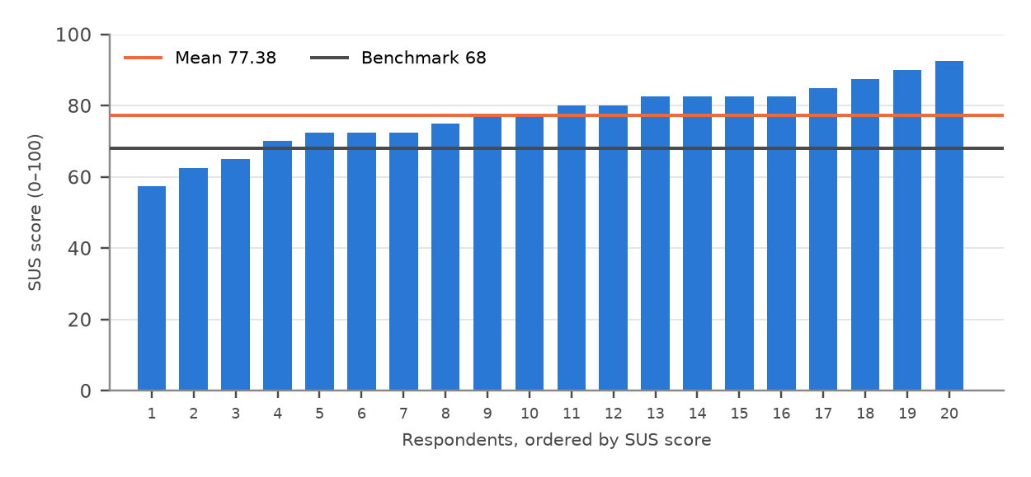
Figure 4.11: SUS score of each respondent with the mean and the benchmark of 68

4.5.4 Feature-Specific Evaluation
The ten feature-specific statements were answered with agreement, and this is revealed in Figure 4.12. Agreement was lower than on the SUS items, indicating that general ease of use was more highly rated than the individual features. The platform would assist an organisation in preparing for Malaysia's carbon tax (mean 4.05, 80% agreed) and would provide more effective monitoring of emissions than spreadsheets and manual reporting (3.85, 80%) had the highest level of agreement. The dashboard charts (3.90, 70%) and the What-If Simulator (3.85, 70%) were likewise rated very good. The two most frequently reported defects are found in data entry and handling flagged entries (3.15, 40%) and trust in the emission and tax figures (3.25, 40%). Overall satisfaction was rated at an average of 3.85 out of 5: 13 (65%) were satisfied or very satisfied five were neutral, two somewhat dissatisfied.
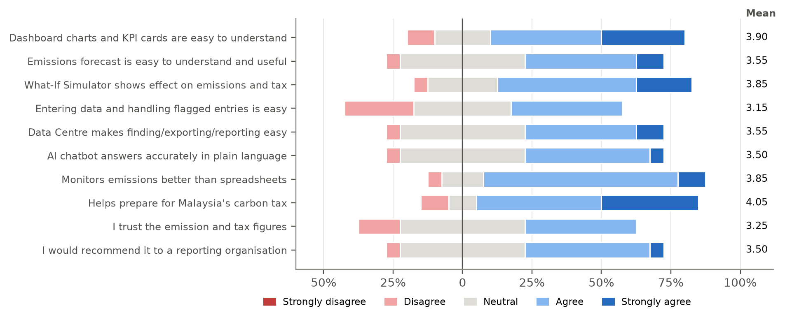
Figure 4.12: Agreement with the feature-specific statements (n = 20)

4.5.5 Qualitative Feedback
The responses to the open questions are grouped into categories in Table 4.5. The most frequently mentioned most useful features were the What-If Simulator (shown to be the most useful feature by far as respondents found that it displayed the tax saving of each action), and the AI chatbot, which was valued by respondents who had little carbon knowledge for its understandable explanations. The most frequent confusions were getting taken to the previous page rather than the dashboard upon logging out and in with another account (five) and different between the Sustainability page and the Data Centre (five). The most desired features were monthly data from Excel upload and company users to download their own carbon tax statement (three times).
Table 4.5: Summary of open-ended feedback (number of respondents)
Question | Main answers
Most useful feature | What-If Simulator (6); AI chatbot (4); STIRPAT forecast (2); company heatmap (2); Data Centre search and filters (2); approval queue (1); activity log (1); CSV export (1); dashboard charts (1)
Confusion or errors | Sustainability page versus Data Centre unclear (5); last page opened after re-login instead of dashboard (5); negative tax rate shows red box without a message (4); chatbot answers too long (2); Data Centre filters look unticked (2); meaning of “synthetic” 2026 data (1); no problems (6)
Most wanted improvement | Upload monthly data from Excel (3); company users download their own tax statement (3); password change or reset (2); fix filter checkboxes (2); faster loading (2); Bahasa Malaysia option (2); stronger colours for critical values (2); mobile layout (1); emission targets or benchmarks (1); tooltips for Scope 1, Scope 2 and STIRPAT (1); email alerts for flagged entries (1)

4.6 Findings and Discussion

4.6.1 Achievement of the Objectives
Table 4.6: End of FYP II Status of each objective. As FYP I was ending only the first objective had been completed, the database, STIRPAT model, and the AI advisor were still underway.
Table 4.6: Achievement of the project objectives
Objective | Status | Evidence
1. Platform automating Scope 1 and 2 ingestion, calculation and carbon tax, with role-based access | Achieved | All twelve functional requirements implemented; emission and tax arithmetic verified by unit tests; no failures in 218 executed authentication and access tests by respondents.
2. Auditable data-lineage ledger with anomaly screening and approval | Achieved | SQLite ledger keeps submitter, approver and status of every entry; z-score and duplicate rules; activity log.
3. STIRPAT forecasting, what-if simulator and AI advisor chat | Achieved | Test WAPE of 1.45%, 11.12% and 1.51% against 6.40%, 18.33% and 6.81% for the OLS trend; no failures in 138 executed simulator tests; 124 of 126 executed chatbot tests passed.
4. Unit testing and user acceptance evaluation | Achieved | 77 of 77 unit tests passed; 20 respondents; 97.3% of executed test cases passed; mean SUS 77.4.

Each output is traceable to a published emission factor and a provided formula, which is a solution to the issue of opacity which hampers trust in carbon accounting tools. The second and third objectives, which were only partially achieved at the end of FYP I, were achieved by implementing a transactional database with an activity log, as well as adopting a statistical anomaly as opposed to a fixed-ratio one and the adoption of STIRPAT in place of the OLS trend.

4.6.2 Usefulness, Usability and Trust
Overall, the platform was easy to use and some of the individual workflows were not so easy to use. The mean for the SUS is also above average at 77.4, but the statement regarding the entering of data and flagged entries received the lowest agreement (3.15): half of the respondents said that this was a defect of the workflow. There is no better way to enhance the experience than to fix TC-SUS-07 and confirm the fix of TC-SUS-08. The moderate trust in the figures (3.25) is fair, because the monthly values are disaggregated and the 2026 values synthetic; real monthly data from companies and more visible data notes would increase the trust in the figures.

4.6.3 Effect of Emission Factor Choice
The comparison in Section 2.1 has a direct financial impact. The SEDG factor adopted by SPK (0.774) leads to 774 t CO2e per 1GWh of electricity used in Peninsular grid; the MGTC factor (0.740) leads to 740 t and the Maybank factor (0.78) leads to 780 t. The difference between the SEDG and MGTC factors is 34 t per gigawatt-hour (MYR 510) at MYR 15 per tonne. A national MRV system will therefore require one official set of factors and SPK's factors will be stored in a single documented module so that they can be updated as one is published.

CHAPTER 5
CONCLUSION AND RECOMMENDATIONS

5.1 Conclusion
The aim of this project was to bridge the gap between Malaysia's pending carbon tax and disclosure obligations, and carbon accounting that is manual, error-prone, and is not easily accessible for SMEs. Scope 1 and Scope 2 activity data are recorded by SPK, converted into CO2e using the Malaysian SEDG factors and each submission is screened and all activity data, approvals and withdrawals are maintained in an auditable ledger. It displays emissions and carbon tax footprints for companies, predicts emissions using a STIRPAT model, models emissions reduction opportunities and answers questions using a grounded AI advisor, and is available separately for company, government and IT users.
The STIRPAT model outperformed the OLS trend of the FYP I prototype with its WAPE values of 1.45% (for Scope 1), 11.12% (for Scope 2), and 1.51% (for total emissions) for the held-out year, whereas the OLS trend of the FYP I prototype yielded 6.40%, 18.33% and 6.81%, respectively. All 77 unit tests were successfully completed. 97.3% of respondents successfully executed 20 of the test cases, and had a mean SUS score of 77.4, with 80% saying that the platform would assist an organisation prepare for the carbon tax. All four objectives were thus realised. Therefore, a connected platform for carbon accounting that could be forecasted can be considered feasible and useful, and the data entry process and confidence in the data are key areas for improvement.

5.2 Limitations
- The forecast accuracy is based on disaggregated monthly data, a synthetic 2026 and the drivers of the test year, which is an overestimate for the true forecast accuracy for the actual monthly data.
- Only five large international oil and gas companies are modeled, none of which is Malaysian and Scope 2 is not the same for all companies.
- It was not a practising government officer or company employee who did the acceptance test; 20 students were used instead; and the order of the features being tried was not controlled for the acceptance test.
- It's using demonstration accounts stored in the code and local running with SQLite instead of a multi-user, hosted service.
- The AI advisor has a reliance on another API and the quality of the answers which it provides, which has been verified during tests but not assessed systematically.

5.3 Recommendations and Future Work
The following work is recommended, in order of priority:
- Enhance data entry and self-service: allow companies to upload a month's worth of activity data from an excel or csv template with the same validation rules applied, download their own carbon tax statement and get email notifications when this statement contains flagged entries.
- Enhance security, storing hashed passwords in a data base, implement a password change and reset, and provide single sign on and multi-factor authentication before any real deployment.
- Improve clarity of guidance: provide an interface in the local language, provide tooltips on Scope 1, Scope 2 and STIRPAT, provide clearer names for pages and better guidance on critical values.
- Enhance the data and models: incorporate monthly data for measurement, report market-based Scope 2 as well as location-based Scope 2, include Scope 3, compare STIRPAT with machine learning and time-series models with projected drivers.
- Start the platform and synchronize it with the final policy: install and run the platform on a server database (e.g. PostgreSQL) for simultaneous access by users, update tax calculation and emission factors when the final policy and official country factors are published.
- Test the AI advisor: systematically compare the accuracy of the answers given by the AI advisor with the data in the page and introduce "grounded source" for adding Malaysian regulations.

REFERENCES
[1] P. Forster et al., "The Earth's energy budget, climate feedbacks, and climate sensitivity," in Climate Change 2021: The Physical Science Basis. Contribution of Working Group I to the Sixth Assessment Report of the Intergovernmental Panel on Climate Change, V. Masson-Delmotte et al., Eds. Cambridge, U.K.: Cambridge Univ. Press, 2021, pp. 923–1054, doi: 10.1017/9781009157896.009.
[2] World Resources Institute and World Business Council for Sustainable Development, The Greenhouse Gas Protocol: A Corporate Accounting and Reporting Standard, rev. ed. Washington, DC, USA: WRI and WBCSD, 2004.
[3] KPMG Malaysia, "2026 Budget – Indirect tax perspective," KPMG Tax Services Sdn. Bhd., Kuala Lumpur, Malaysia, Oct. 2025. [Online]. Available: https://assets.kpmg.com/content/dam/kpmgsites/my/pdf/2025/10/budget2026-tl-indirect-tax-perspective.pdf.coredownload.inline.pdf
[4] P. Nair and L. Lei, "Malaysia unveils 2026 budget, to implement carbon tax," Argus Media, Oct. 13, 2025. [Online]. Available: https://www.argusmedia.com/en/news-and-insights/latest-market-news/2741520-malaysia-unveils-2026-budget-to-implement-carbon-tax
[5] The Star, "Carbon tax rate of RM15 a tonne being considered," The Star, Nov. 6, 2025. [Online]. Available: https://www.thestar.com.my/business/business-news/2025/11/06/carbon-tax-rate-of-rm15-a-tonne-being-considered
[6] Bernama, "National Climate Change Bill unveils MRV system, basis for carbon price implementation," Bernama, Mar. 13, 2026. [Online]. Available: https://bernama.com/en/news.php?id=2534105
[7] Bernama, "National Climate Change Bill to institutionalise mandatory carbon accounting – Arthur," Bernama, Oct. 8, 2026. [Online]. Available: https://bernama.com/en/region/news.php?id=2617024
[8] A. Lai, "Carbon tax delayed due to Middle East uncertainties, says Arthur," The Star, Jun. 18, 2026. [Online]. Available: https://www.thestar.com.my/news/nation/2026/06/18/carbon-tax-delayed-due-to-middle-east-uncertainties-says-arthur
[9] Bernama, "Carbon tax deferment gives NRES time to finalise regulatory, policy framework – Arthur," Bernama, Oct. 5, 2026. [Online]. Available: https://bernama.com/en/general/news.php?id=2615811
[10] Free Malaysia Today, "Malaysia launches national carbon market policy," Free Malaysia Today, Apr. 21, 2026. [Online]. Available: https://freemalaysiatoday.com/category/nation/2026/04/21/malaysia-launches-national-carbon-market-policy
[11] S. Ho, "Malaysia launches its first carbon market policy, puts carbon tax on hold," Eco-Business, Apr. 22, 2026. [Online]. Available: https://www.eco-business.com/news/malaysia-launches-its-first-carbon-market-policy-puts-carbon-tax-on-hold/
[12] The Star, "National carbon tax policy in final phase, says MoF," The Star, Jun. 24, 2026. [Online]. Available: https://www.thestar.com.my/business/business-news/2026/06/24/national-carbon-tax-policy-in-final-phase-says-mof
[13] Securities Commission Malaysia, "National Sustainability Reporting Framework to enhance sustainability disclosures," Press release, Sep. 24, 2024.
[14] P. Kong, "Malaysia's carbon tax: From policy signal to portfolio risk," Kenanga Investment Bank, Kuala Lumpur, Malaysia, ESG Note, Mar. 11, 2026.
[15] S. Yong, "How can Malaysia design an effective carbon tax that drives sustainability without burdening businesses?" EY, Oct. 3, 2025. [Online]. Available: https://www.ey.com/en_my/insights/tax/malaysia-budget/carbon-tax-and-carbon-pricing-developments-ahead-of-budget-2026
[16] Suruhanjaya Tenaga (Energy Commission Malaysia), "Grid emission factor (GEF) in Malaysia," Nov. 25, 2024. [Online]. Available: https://myenergystats.st.gov.my/documents/d/guest/grid-emission-factor-gef-in-malaysia
[17] R. A. Ben Saleh, N. Faccilongo, and R. L. Rana, "The role of renewable energy production on greenhouse gas emission reduction in international petroleum companies under energy transition policy," Discover Sustainability, vol. 6, Art. no. 979, 2025, doi: 10.1007/s43621-025-01920-4.
[18] International Energy Agency, "Global methane tracker 2025," IEA, Paris, France, 2025. [Online]. Available: https://www.iea.org/reports/global-methane-tracker-2025
[19] S. Dietz, D. Gardiner, V. Jahn, and J. Noels, "How ambitious are oil and gas companies' climate goals?" Science, vol. 374, no. 6566, pp. 405–408, 2021, doi: 10.1126/science.abh0687.
[20] M. Li, G. Trencher, and J. Asuka, "The clean energy claims of BP, Chevron, ExxonMobil and Shell: A mismatch between discourse, actions and investments," PLOS ONE, vol. 17, no. 2, Art. no. e0263596, 2022, doi: 10.1371/journal.pone.0263596.
[21] Hedgehog, "Overcoming data collection challenges in carbon accounting for SMEs," Jun. 9, 2025. [Online]. Available: https://www.hhc.earth/knowledge-base/articles/carbon-data-collection-challenges-sme
[22] Market.us, "Carbon accounting software market size, share, growth analysis," Rep. ID 179566, Feb. 2026. [Online]. Available: https://market.us/report/carbon-accounting-software-market/
[23] M.-F. Körner, M. Schober, T. Ströher, and J. Strüker, "Digital carbon accounting for accelerating decarbonization: Characteristics of IS-enabled system architectures," in Proc. Americas Conf. Inf. Syst. (AMCIS), 2023, Paper 2. [Online]. Available: https://aisel.aisnet.org/amcis2023/sig_green/sig_green/2
[24] L. J. McDonald et al., "Towards a unified carbon accounting landscape," Philos. Trans. Roy. Soc. A, vol. 382, Art. no. 20230260, 2024, doi: 10.1098/rsta.2023.0260.
[25] Capital Markets Malaysia, "SEDG greenhouse gas emissions (GHG) calculator: User guide for small and medium enterprises (SMEs) in Malaysia," Kuala Lumpur, Malaysia, 2025. [Online]. Available: https://www.capitalmarketsmalaysia.com/sedg-ghg-calculator/
[26] Malaysian Green Technology and Climate Change Corporation, "SME carbon footprint calculator," 2026. Accessed: Nov. 11, 2026. [Online]. Available: https://lcosbasic.mgtc.gov.my/
[27] Maybank, "Carbon footprint calculator and ESG readiness test," myimpact SME Hub, n.d. Accessed: Nov. 11, 2026. [Online]. Available: https://www.maybank2u.com.my/maybank2u/malaysia/en/myimpactsme/sustainability/esg-tools.page
[28] J. Marlowe and A. Clarke, "Carbon accounting: A systematic literature review and directions for future research," Green Finance, vol. 4, no. 1, pp. 71–87, 2022, doi: 10.3934/GF.2022004.
[29] bp p.l.c., "ESG datasheet 2025," London, U.K., 2026.
[30] Equinor ASA, "Climate – Sustainability data hub," 2026. Accessed: Oct. 6, 2026. [Online]. Available: https://sustainability.equinor.com/climate
[31] N. Sanatkumar and A. L. Berka-Harnmeijer, "Walking the tightrope: Can integrated decision support transform business sustainability?" J. Cleaner Prod., vol. 445, Art. no. 141366, 2024, doi: 10.1016/j.jclepro.2024.141366.
[32] L. Huang et al., "A survey on hallucination in large language models: Principles, taxonomy, challenges, and open questions," ACM Trans. Inf. Syst., vol. 43, no. 2, Art. no. 42, 2025, doi: 10.1145/3703155.
[33] S. A. Vaghefi et al., "ChatClimate: Grounding conversational AI in climate science," Commun. Earth Environ., vol. 4, Art. no. 480, 2023, doi: 10.1038/s43247-023-01084-x.
[34] L. Klaaßen and C. Stoll, "Harmonizing corporate carbon footprints," Nature Commun., vol. 12, Art. no. 6149, 2021, doi: 10.1038/s41467-021-26349-x.
[35] D. Kong, Z. Dai, J. Tang, and H. Zhang, "Forecasting urban carbon emissions using an Adaboost-STIRPAT model," Frontiers Environ. Sci., vol. 11, Art. no. 1284028, 2023, doi: 10.3389/fenvs.2023.1284028.
[36] C. Rao, Q. Huang, L. Chen, M. Goh, and Z. Hu, "Forecasting the carbon emissions in Hubei Province under the background of carbon neutrality: A novel STIRPAT extended model with ridge regression and scenario analysis," Environ. Sci. Pollut. Res., vol. 30, pp. 57460–57480, 2023, doi: 10.1007/s11356-023-26599-w.
[37] N. Schneider, "Unveiling the anthropogenic dynamics of environmental change with the stochastic IRPAT model: A review of baselines and extensions," Environ. Impact Assess. Rev., vol. 96, Art. no. 106854, 2022, doi: 10.1016/j.eiar.2022.106854.
[38] T. Bernoville, "What are scopes 1, 2 and 3 of carbon emissions?" Plan A, May 30, 2025. [Online]. Available: https://plana.earth/academy/what-are-scope-1-2-3-emissions
[39] S. Stachelscheid and A. Dutzi, "Almost 10 years of dual reporting of Scope 2: Chaos or comparability?" Carbon Manage., vol. 16, no. 1, Art. no. 2459920, 2025, doi: 10.1080/17583004.2025.2459920.
[40] GHG Protocol, "Upcoming Scope 2 public consultation: Overview of revisions," World Resources Institute and World Business Council for Sustainable Development, 2025. [Online]. Available: https://ghgprotocol.org/index%2ephp/blog/upcoming-scope-2-public-consultation-overview-revisions
[41] R. He, L. Luo, A. Shamsuddin, and Q. Tang, "Corporate carbon accounting: A literature review of carbon accounting research from the Kyoto Protocol to the Paris Agreement," Accounting Finance, vol. 62, no. 1, pp. 261–298, 2022, doi: 10.1111/acfi.12789.
[42] World Bank, State and Trends of Carbon Pricing 2025. Washington, DC, USA: World Bank, 2025, doi: 10.1596/978-1-4648-2255-1.
[43] J. F. Green, "Does carbon pricing reduce emissions? A review of ex-post analyses," Environ. Res. Lett., vol. 16, no. 4, Art. no. 043004, 2021, doi: 10.1088/1748-9326/abdae9.
[44] N. Döbbeling-Hildebrandt et al., "Systematic review and meta-analysis of ex-post evaluations on the effectiveness of carbon pricing," Nature Commun., vol. 15, Art. no. 4147, 2024, doi: 10.1038/s41467-024-48512-w.
[45] Free Malaysia Today, "Malaysia needs a credible carbon pricing framework," Free Malaysia Today, May 11, 2026. [Online]. Available: https://www.freemalaysiatoday.com/category/opinion/2026/05/11/malaysia-needs-a-credible-carbon-pricing-framework
[46] Market Reports World, "Carbon accounting software market size & share [2034]," 2026. [Online]. Available: https://www.marketreportsworld.com/market-reports/carbon-accounting-software-market-14722050
[47] Intel Market Research, "Carbon accounting software platforms market forecast 2026–2034," Apr. 17, 2026. [Online]. Available: https://www.intelmarketresearch.com/carbon-accounting-software-platforms-market-40906
[48] R. D. Rajendra, "Conceptual design of a green technology module for accounting and sustainable financial reporting: An exploratory literature-based study," J. Accounting Finance, vol. 9, no. 2, pp. 96–112, 2025, doi: 10.25124/jaf.v9i2.9607.
[49] C. B. Bhattacharya and M. Zaman, "The what, why and how of ESG dashboards," NIM Marketing Intell. Rev., vol. 15, no. 1, pp. 32–39, 2023, doi: 10.2478/nimmir-2023-0005.
[50] B. Zhu et al., "CarbonMonitor-Power near-real-time monitoring of global power generation on hourly to daily scales," Sci. Data, vol. 10, Art. no. 217, 2023, doi: 10.1038/s41597-023-02094-2.
[51] Eurostat, "Eurostat's estimates of quarterly greenhouse gas emissions accounts: Methodological note," European Commission, Luxembourg, 2026.
[52] bp p.l.c., "bp annual report and Form 20-F 2025," London, U.K., 2026.
[53] Chevron Corporation, "Performance data 2025," 2026. [Dataset].
[54] ConocoPhillips, "AXPC ESG metrics template," 2026. Accessed: Oct. 6, 2026. [Online]. Available: https://www.conocophillips.com/sustainability/performance-metrics/our-performance/axpc-esg-metrics-template/
[55] ConocoPhillips, "Performance by year: 2025 performance metrics," 2026.
[56] Exxon Mobil Corporation, "2025 annual report," 2026.
[57] Exxon Mobil Corporation, "Advancing climate solutions 2026 report," 2026.
[58] Oil and Gas Climate Initiative, "OGCI performance data," in Progress Report 2025, ch. 4, Aug. 29, 2025. Accessed: Nov. 11, 2026. [Online]. Available: https://www.ogci.com/progress-report/staying-the-course/ogci-performance-data/
[59] A. Blázquez-García, A. Conde, U. Mori, and J. A. Lozano, "A review on outlier/anomaly detection in time series data," ACM Comput. Surv., vol. 54, no. 3, Art. no. 56, 2021, doi: 10.1145/3444690.
[60] S. Schmidl, P. Wenig, and T. Papenbrock, "Anomaly detection in time series: A comprehensive evaluation," Proc. VLDB Endowment, vol. 15, no. 9, pp. 1779–1797, 2022, doi: 10.14778/3538598.3538602.
[61] A. Zhang, S. Deng, D. Cui, Y. Yuan, and G. Wang, "An experimental evaluation of anomaly detection in time series," Proc. VLDB Endowment, vol. 17, no. 3, pp. 483–496, 2023, doi: 10.14778/3632093.3632110.
[62] T. Dietz and E. A. Rosa, "Rethinking the environmental impacts of population, affluence and technology," Hum. Ecol. Rev., vol. 1, no. 2, pp. 277–300, 1994.
[63] T. Dietz and E. A. Rosa, "Effects of population and affluence on CO₂ emissions," Proc. Nat. Acad. Sci. USA, vol. 94, no. 1, pp. 175–179, 1997, doi: 10.1073/pnas.94.1.175.
[64] R. York, E. A. Rosa, and T. Dietz, "STIRPAT, IPAT and ImPACT: Analytic tools for unpacking the driving forces of environmental impacts," Ecol. Econ., vol. 46, no. 3, pp. 351–365, 2003, doi: 10.1016/S0921-8009(03)00188-5.
[65] Y. Hwang, J.-S. Um, and S. Schlüter, "Evaluating the mutual relationship between IPAT/Kaya identity index and ODIAC-based GOSAT fossil-fuel CO₂ flux: Potential and constraints in utilizing decomposed variables," Int. J. Environ. Res. Public Health, vol. 17, no. 16, Art. no. 5976, 2020, doi: 10.3390/ijerph17165976.
[66] A. E. Hoerl and R. W. Kennard, "Ridge regression: Biased estimation for nonorthogonal problems," Technometrics, vol. 12, no. 1, pp. 55–67, 1970, doi: 10.1080/00401706.1970.10488634.
[67] A. Cooray and I. Özmen, "Institutions and carbon emissions: An investigation employing STIRPAT and machine learning methods," Empirical Econ., vol. 67, pp. 1015–1044, 2024, doi: 10.1007/s00181-024-02579-y.
[68] W. Liu, Z. Luo, and D. Xiao, "Age structure and carbon emission with climate-extended STIRPAT model: A cross-country analysis," Frontiers Environ. Sci., vol. 9, Art. no. 719168, 2022, doi: 10.3389/fenvs.2021.719168.
[69] Y. Jin, A. Sharifi, Z. Li, S. Chen, S. Zeng, and S. Zhao, "Carbon emission prediction models: A review," Sci. Total Environ., vol. 927, Art. no. 172319, 2024, doi: 10.1016/j.scitotenv.2024.172319.
[70] L. H. Kaack, P. L. Donti, E. Strubell, G. Kamiya, F. Creutzig, and D. Rolnick, "Aligning artificial intelligence with climate change mitigation," Nature Climate Change, vol. 12, no. 6, pp. 518–527, 2022, doi: 10.1038/s41558-022-01377-7.
[71] D. Rolnick et al., "Tackling climate change with machine learning," ACM Comput. Surv., vol. 55, no. 2, Art. no. 42, 2022, doi: 10.1145/3485128.
[72] S. Makridakis, E. Spiliotis, and V. Assimakopoulos, "M5 accuracy competition: Results, findings, and conclusions," Int. J. Forecasting, vol. 38, no. 4, pp. 1346–1364, 2022, doi: 10.1016/j.ijforecast.2021.11.013.
[73] R. J. Hyndman and G. Athanasopoulos, Forecasting: Principles and Practice, 3rd ed. Melbourne, Australia: OTexts, 2021. [Online]. Available: https://otexts.com/fpp3/
[74] F. Petropoulos et al., "Forecasting: Theory and practice," Int. J. Forecasting, vol. 38, no. 3, pp. 705–871, 2022, doi: 10.1016/j.ijforecast.2021.11.001.
[75] H. Hewamalage, K. Ackermann, and C. Bergmeir, "Forecast evaluation for data scientists: Common pitfalls and best practices," Data Mining Knowl. Discovery, vol. 37, pp. 788–832, 2023, doi: 10.1007/s10618-022-00894-5.
[76] F. T. Denton, "Adjustment of monthly or quarterly series to annual totals: An approach based on quadratic minimization," J. Amer. Statist. Assoc., vol. 66, no. 333, pp. 99–102, 1971, doi: 10.1080/01621459.1971.10482227.
[77] L. Mosley, I. A. Eckley, and A. Gibberd, "Sparse temporal disaggregation," J. Roy. Statist. Soc. A, vol. 185, no. 4, pp. 2203–2233, 2022, doi: 10.1111/rssa.12952.
[78] L. Mosley, K. Salehzadeh Nobari, G. Brandi, and A. Gibberd, "Disaggregating time-series with many indicators: An overview of the DisaggregateTS package," R J., vol. 16, no. 4, pp. 62–73, 2024.
[79] N. Webersinke, M. Kraus, J. A. Bingler, and M. Leippold, "ClimateBERT: A pretrained language model for climate-related text," 2022, arXiv:2110.12010, doi: 10.48550/arXiv.2110.12010.
[80] M. Kraus et al., "Enhancing large language models with climate resources," 2023, arXiv:2304.00116, doi: 10.48550/arXiv.2304.00116.
[81] K. Schwaber and J. Sutherland, "The Scrum guide," 2020. [Online]. Available: https://scrumguides.org/
[82] National Climate Change Secretariat Singapore, "Carbon tax," Jul. 9, 2026. Accessed: Nov. 11, 2026. [Online]. Available: https://www.nccs.gov.sg/singapores-climate-action/mitigation-efforts/carbontax/
[83] J. Brooke, "SUS: A 'quick and dirty' usability scale," in Usability Evaluation in Industry, P. W. Jordan, B. Thomas, B. A. Weerdmeester, and I. L. McClelland, Eds. London, U.K.: Taylor & Francis, 1996, pp. 189–194.
[84] J. Sauro and J. R. Lewis, Quantifying the User Experience: Practical Statistics for User Research, 2nd ed. Cambridge, MA, USA: Morgan Kaufmann, 2016.
[85] A. Bangor, P. Kortum, and J. Miller, "Determining what individual SUS scores mean: Adding an adjective rating scale," J. Usability Stud., vol. 4, no. 3, pp. 114–123, 2009.

APPENDICES

Appendix A: Project Gantt Chart (FYP II)
Week numbers follow the FYP II semester; the milestones are those suggested in Appendix 2-2 of the FYP Guidelines, and the sprint periods follow the dates of the project's Git commits.
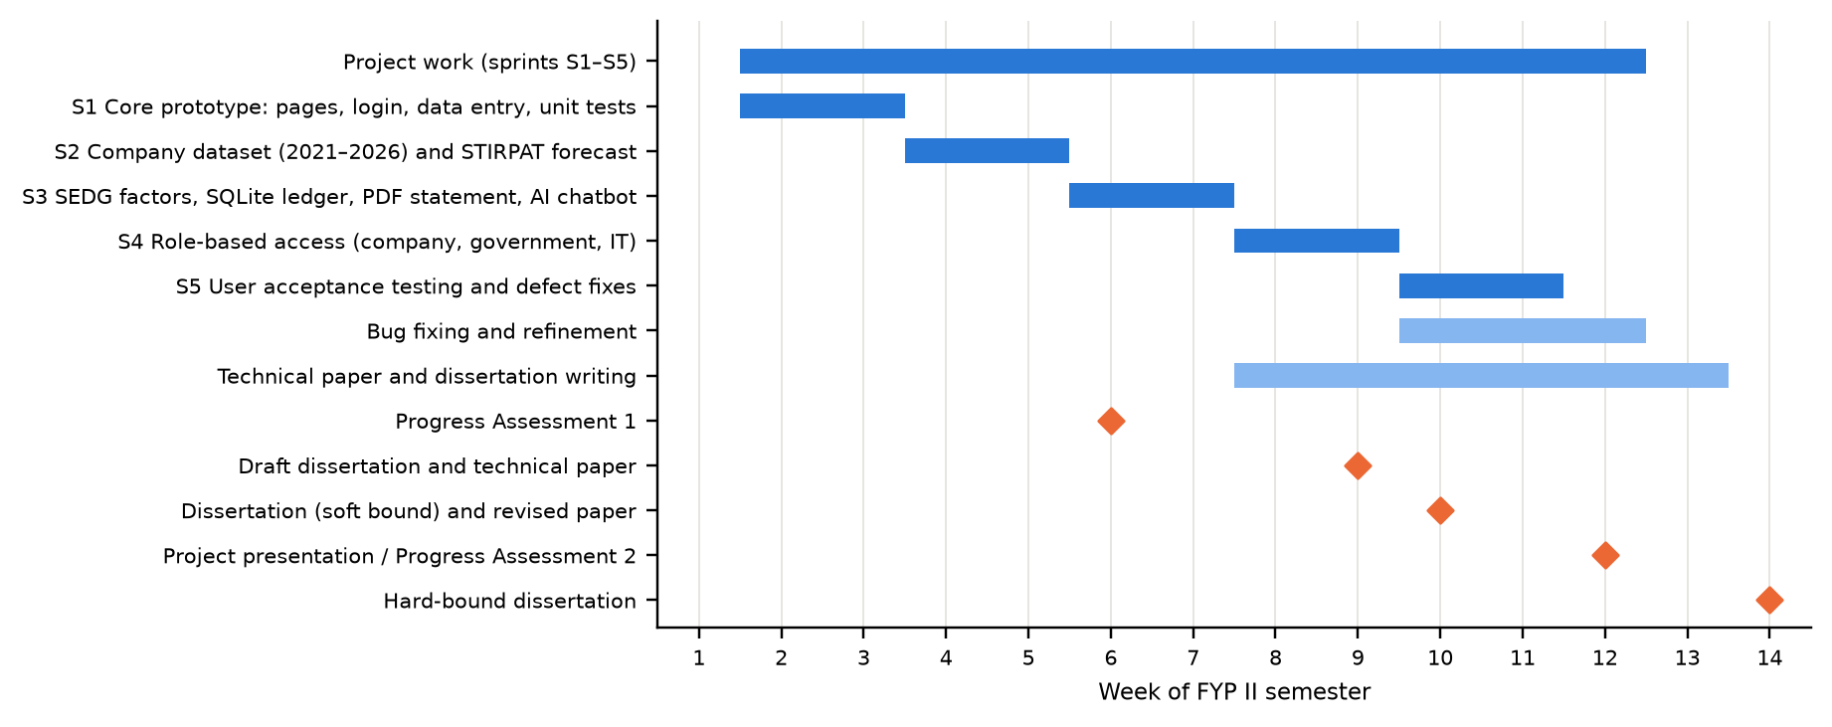
Figure A.1: Gantt chart of FYP II activities and milestones

Appendix B: Additional System Interface Screenshots
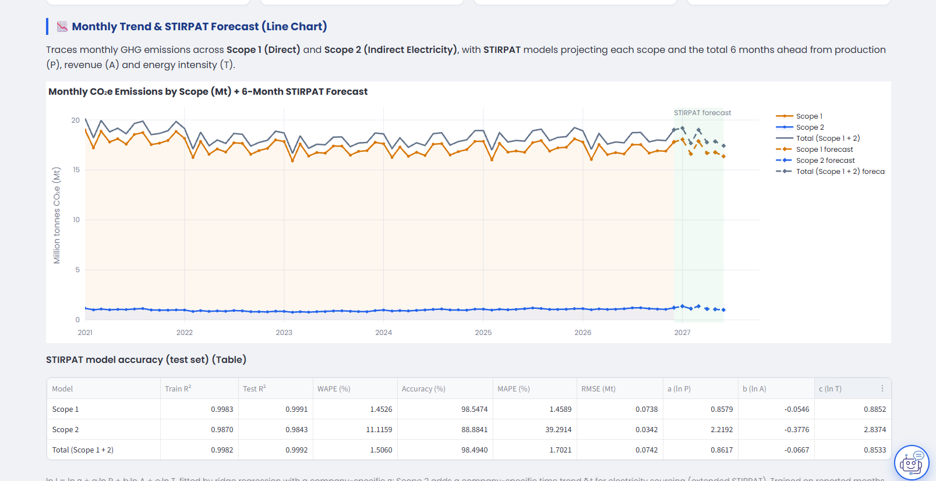
Figure B.1: Monthly trend with STIRPAT forecast and the model accuracy table (Main Dashboard)
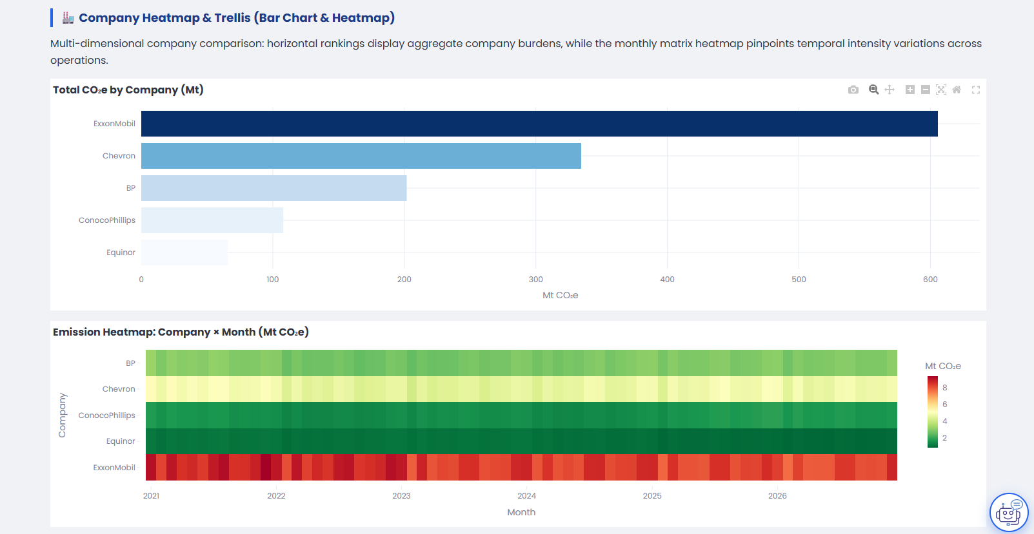
Figure B.2: Company bar chart and company × month heatmap (Main Dashboard)
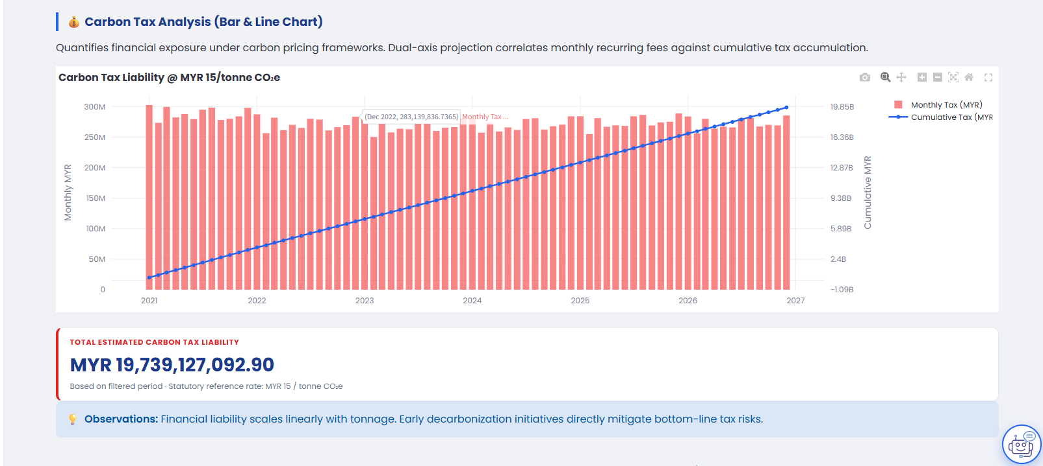
Figure B.3: Carbon tax analysis chart and total liability (Main Dashboard)
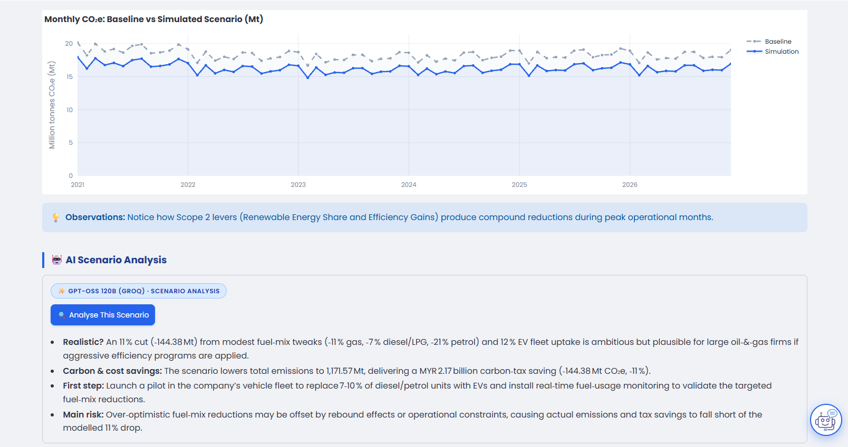
Figure B.4: AI scenario analysis in the What-If Simulator
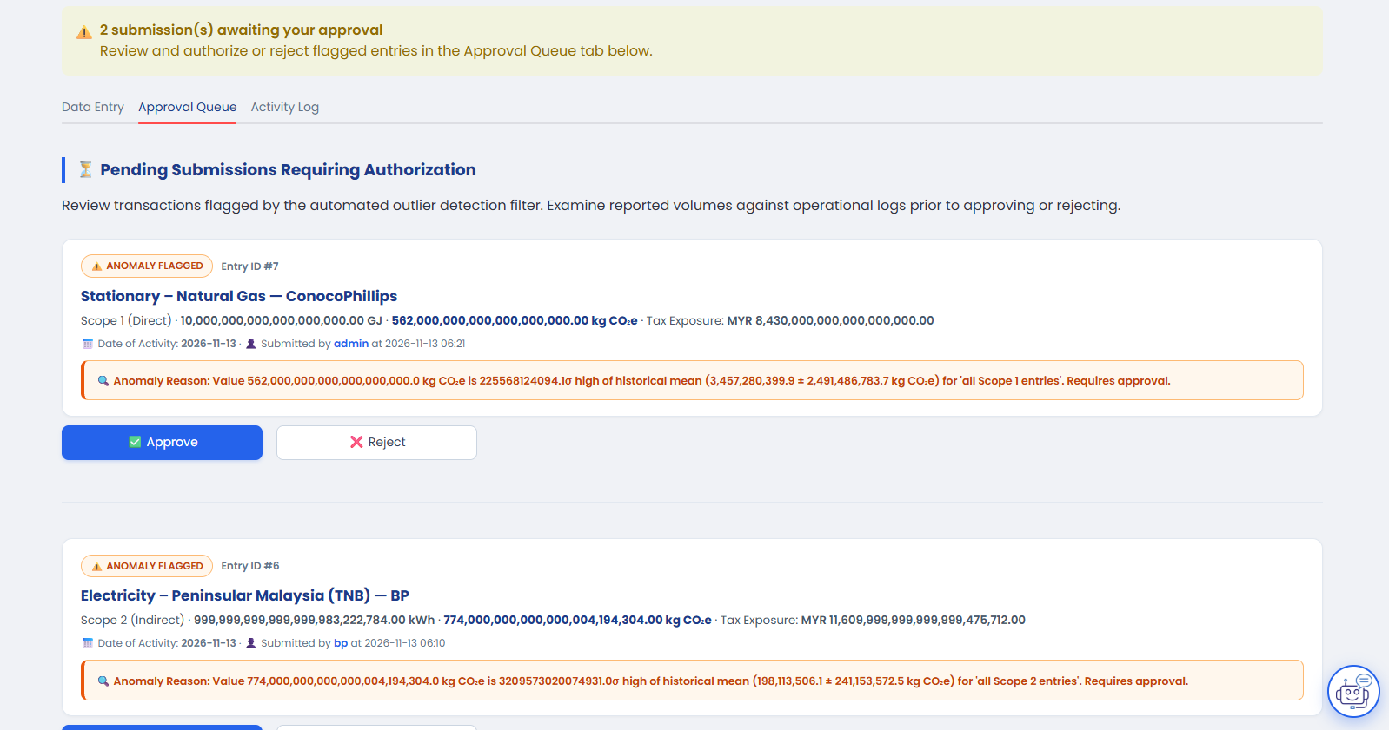
Figure B.5: Approval queue with flagged entries (company user)
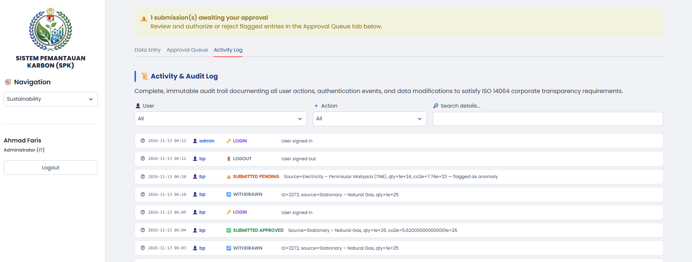
Figure B.6: Activity and audit log (IT administrator)
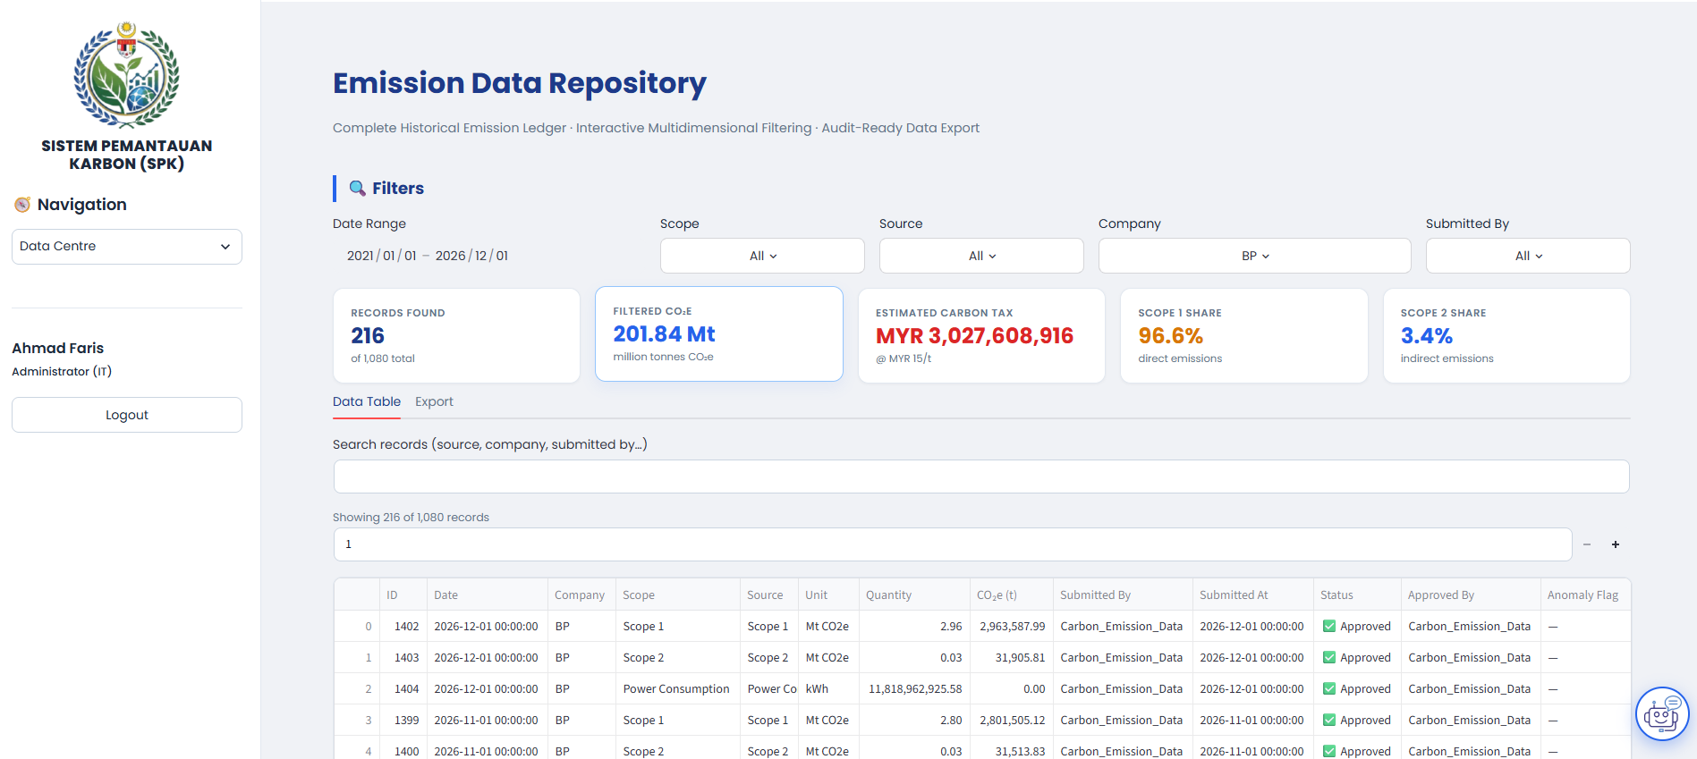
Figure B.7: Data Centre with filters, summary cards and the record table
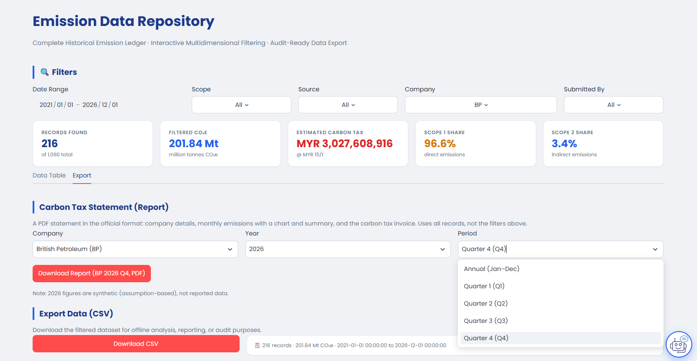
Figure B.8: Carbon tax statement and CSV export options (Data Centre, government officer)
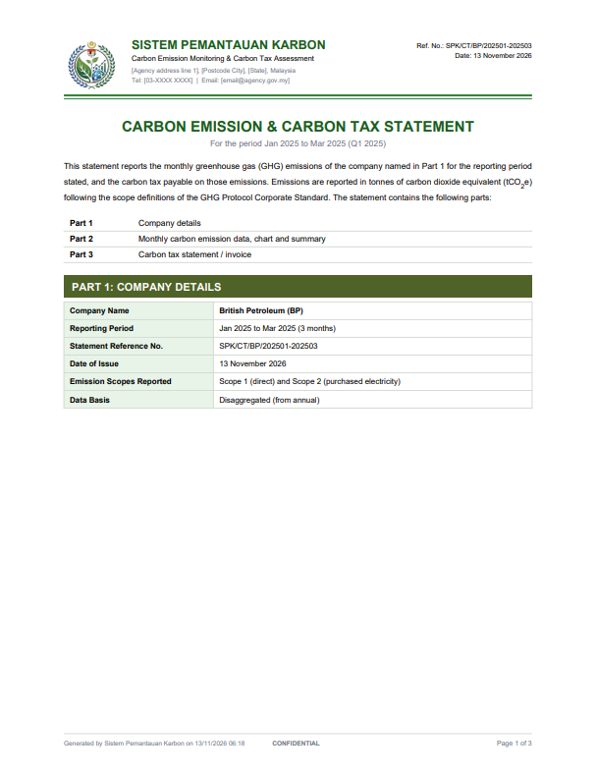
Figure B.9(a): Page 1 – Part 1: Company details
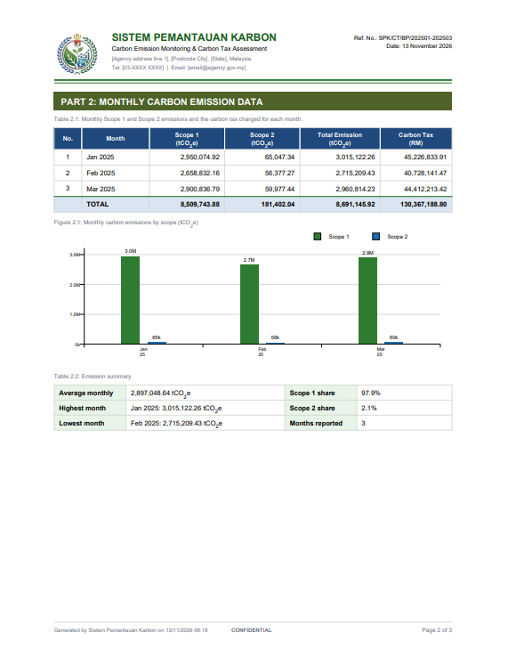
Figure B.9(b): Page 2 – Part 2: Monthly carbon emission data

Figure B.9(c): Page 3 – Part 3: Carbon tax statement / invoice
Figure B.9: Pages of the generated PDF carbon tax statement (bp, Q1 2025)

Appendix C: User Acceptance Testing Questionnaire and Test Case Outcomes
The questionnaire was distributed online (Microsoft Forms). Respondents tested the system with the demonstration accounts before answering. It contained the following sections.
Section 1: Consent and profile
- I have read the study information and agree to take part. My answers are anonymous and will be used only for this final year project. (I agree)
- What best describes your background? (Computer Science / IT Student; Petroleum Engineering Student; Chemical Engineering Student; Business Management Student; Other)
- Which login roles did you use during testing? (Select all that apply) (select all that apply: Administrator (IT); Government Officer; Company User)
- How familiar are you with carbon emissions accounting (Scope 1 and Scope 2)? (1 – Not at all familiar to 5 – Very familiar)
- How familiar are you with Malaysia's proposed carbon tax? (1 – Not at all familiar to 5 – Very familiar)
- How often do you use data dashboards or analytics tools? (Daily; Weekly; Monthly; Rarely; Never)
Section 2: Test cases. Each test case below was marked Pass, Fail or Not tested, followed by the question “For each test case you marked Fail, give the test case ID and describe what happened.” The table gives the number of respondents (n = 20) who chose each outcome.
Table C.1: Test cases in the questionnaire and respondent outcomes
ID | Test case | Pass | Fail | Not tested
TC-AUTH-01 | Valid login | 14 | 0 | 6
TC-AUTH-02 | Wrong password refused | 20 | 0 | 0
TC-AUTH-03 | Empty fields refused | 20 | 0 | 0
TC-AUTH-04 | Username not case-sensitive | 20 | 0 | 0
TC-AUTH-05 | Logout clears the session | 14 | 0 | 6
TC-AUTH-06 | Page blocked after logout | 19 | 0 | 1
TC-AUTH-07 | Company sees only its own data | 20 | 0 | 0
TC-AUTH-08 | Company entry locked to own company | 19 | 0 | 1
TC-AUTH-09 | Government cannot enter data | 16 | 0 | 4
TC-AUTH-10 | Government approval queue is view-only | 17 | 0 | 3
TC-AUTH-11 | Activity log restricted to IT | 20 | 0 | 0
TC-AUTH-12 | Company cannot issue tax reports | 19 | 0 | 1
TC-DASH-01 | Page loads | 18 | 0 | 2
TC-DASH-02 | Year filter | 20 | 0 | 0
TC-DASH-03 | Company filter | 19 | 0 | 1
TC-DASH-04 | Scope filter | 20 | 0 | 0
TC-DASH-05 | Empty filter message | 20 | 0 | 0
TC-DASH-06 | Forecast shown | 19 | 0 | 1
TC-DASH-07 | Forecast accuracy shown | 20 | 0 | 0
TC-DASH-08 | Carbon tax default (MYR 15) | 20 | 0 | 0
TC-DASH-09 | Change tax rate | 18 | 2 | 0
TC-SIM-01 | Baseline | 20 | 0 | 0
TC-SIM-02 | Scope 1 lever | 20 | 0 | 0
TC-SIM-03 | Scope 2 lever | 20 | 0 | 0
TC-SIM-04 | Combined levers | 20 | 0 | 0
TC-SIM-05 | Slider limit | 20 | 0 | 0
TC-SIM-06 | AI scenario analysis | 18 | 0 | 2
TC-SIM-07 | Reset | 20 | 0 | 0
TC-SUS-01 | CO2e preview | 20 | 0 | 0
TC-SUS-02 | Valid submission | 20 | 0 | 0
TC-SUS-03 | Zero quantity rejected | 20 | 0 | 0
TC-SUS-04 | Future date blocked | 20 | 0 | 0
TC-SUS-05 | Anomaly flag | 19 | 1 | 0
TC-SUS-06 | Duplicate flag | 20 | 0 | 0
TC-SUS-07 | Power consumption entry | 8 | 11 | 1
TC-SUS-08 | Undo own entry | 11 | 9 | 0
TC-SUS-09 | Pending banner (Company) | 20 | 0 | 0
TC-SUS-10 | Approve (Company) | 20 | 0 | 0
TC-SUS-11 | Reject (Company) | 19 | 0 | 1
TC-SUS-12 | Activity log entries (Admin) | 14 | 0 | 6
TC-SUS-13 | Log filter and export (Admin) | 13 | 0 | 7
TC-SUS-14 | Log cannot be deleted (Admin) | 13 | 0 | 7
TC-DC-01 | Table and paging | 20 | 0 | 0
TC-DC-02 | Search | 19 | 0 | 1
TC-DC-03 | Filters | 18 | 2 | 0
TC-DC-04 | Empty filter message | 20 | 0 | 0
TC-DC-05 | CSV export | 19 | 0 | 1
TC-DC-06 | PDF report (Government/Admin) | 17 | 0 | 3
TC-DC-07 | No data / synthetic note (Government/Admin) | 11 | 1 | 8
TC-AI-01 | Open chat | 20 | 0 | 0
TC-AI-02 | Data question | 16 | 0 | 4
TC-AI-03 | Forecast question | 17 | 2 | 1
TC-AI-04 | Off-topic question | 20 | 0 | 0
TC-AI-05 | History across pages | 20 | 0 | 0
TC-AI-06 | Service unavailable | 12 | 0 | 8
TC-AI-07 | Chatbot keeps other companies' data private | 19 | 0 | 1

Section 3: System Usability Scale (1 = strongly disagree, 5 = strongly agree)
Table C.2: SUS items and mean response of the 20 respondents
No. | Statement | Mean
1 | I think that I would like to use this system frequently. | 4.15
2 | I found the system unnecessarily complex. | 1.85
3 | I thought the system was easy to use. | 4.10
4 | I think that I would need the support of a technical person to be able to use this system. | 1.90
5 | I found the various functions in this system were well integrated. | 4.10
6 | I thought there was too much inconsistency in this system. | 1.75
7 | I would imagine that most people would learn to use this system very quickly. | 4.00
8 | I found the system very cumbersome to use. | 1.95
9 | I felt very confident using the system. | 4.05
10 | I needed to learn a lot of things before I could get going with this system. | 2.00

Section 4: Feature-specific statements (1 = strongly disagree, 5 = strongly agree)
- The Main Dashboard charts and KPI cards are easy to understand.
- The emissions forecast is easy to understand and useful for planning.
- The What-If Simulator clearly shows how actions would reduce emissions and carbon tax.
- Entering data and handling flagged entries (approve, reject, undo) is straightforward.
- The Data Centre makes it easy to find, export and report data.
- The AI chatbot gave accurate answers in plain language.
- The dashboard would monitor carbon emissions more effectively than spreadsheets or manual reports.
- The dashboard would help an organisation prepare for Malaysia's carbon tax.
- I trust the emission and tax figures shown in the system.
- I would recommend this system to an organisation that must report its emissions.
Section 5: Overall evaluation
- Overall, how satisfied are you with the system? (1 – Very dissatisfied to 5 – Very satisfied)
- Which feature did you find most useful, and why?
- Did anything confuse you, or did you find any errors? Please describe what happened.
- What one change would most improve the system?

Appendix D: Emission Factors Used in SPK
Source: SEDG GHG Emissions Calculator User Guide [25], section 2.4, using GHG Protocol cross-sector factors with IPCC AR6 GWPs for Scope 1 and the Energy Commission grid emission factors (2022) for Scope 2. Factors are stored in data/emission_factors.py in kg CO₂e per unit.
Table D.1: Scope 1 and Scope 2 emission factors
Scope | Emission source | Unit | kg CO₂e per unit
1 | Stationary – Natural Gas | GJ | 56.2
1 | Stationary – LPG | GJ | 63.2
1 | Stationary – Coal | kg | 1.82
1 | Stationary – Residual Fuel Oil | L | 3.04
1 | Stationary – Petrol | L | 2.32
1 | Stationary – Diesel | L | 2.95
1 | Stationary – Diesel B5 | L | 2.80
1 | Stationary – Diesel B7 | L | 2.74
1 | Stationary – Diesel B10 | L | 2.65
1 | Stationary – Diesel B20 | L | 2.36
1 | Stationary – Biodiesel B100 | kg | 0.67
1 | Mobile – Petrol | L | 2.288
1 | Mobile – Diesel | L | 2.909
1 | Mobile – Diesel B7 | L | 2.705
1 | Mobile – Diesel B10 | L | 2.618
1 | Mobile – Diesel B20 | L | 2.327
1 | Mobile – Biodiesel B100 | L | 0.001
1 | Mobile – LPG | L | 1.473
1 | Mobile – CNG | L | 1.885
2 | Electricity – Peninsular Malaysia (TNB) | kWh | 0.774
2 | Electricity – Sabah (SESB) | kWh | 0.525
2 | Electricity – Sarawak (Sarawak Energy) | kWh | 0.199
2 | Electricity – Kulim Hi-Tech Park (NUR) | kWh | 0.540

