Name___________________________________ Student ID__________________________

1) According to Robert Fogel, economic growth ________ health, and health ________ economic growth.
A) worsens; improves
B) improves; improves
C) worsens; worsens
D) does not impact; does not impact
E) improves; worsens

2) Actual real GDP will be above potential GDP if
A) firms are producing above capacity.
B) the current price level is lower than the price level in the base year.
C) firms are producing at capacity.
D) inflation is rising.
E) firms are producing below capacity.

3) What is one difference between stocks and bonds?
A) Bonds earn a higher rate of return than stocks.
B) Stocks represent partial ownership in a firm, while bonds do not.
C) Stocks represent a guarantee of future payment, while bonds do not.
D) Stocks earn a higher rate of return than bonds.
E) Bonds are purchased at a bank, while stocks are purchased through the federal government.

4) Inflation is measured
A) as the percentage change in real GDP.
B) using the level of real GDP.
C) as the percentage change in the consumer price index.
D) using the level of the consumer price index.
E) as the change in the value of the Canadian dollar.

5) Since 1980,
A) the average length of a recession has fallen to zero.
B) the average length of expansions in Canada has remained about the same.
C) the average length of expansions in Canada has become shorter.
D) the average length of expansions in Canada has become longer.
E) economic expansions in Canada have been so short that expansions barely exist.

6) Inflation tends to ________ during the expansion phase of the business cycle and ________ during the recession phase of the business cycle.
A) increase; increase further
B) decrease; increase
C) decrease; decrease further
D) decrease; remain constant
E) increase; decrease

7) If the federal government regulated airline ticket prices to prevent them from falling during a recession, there would be a ________ of airline tickets which would likely ________ the airline profits.
A) shortage; not change
B) shortage; increase
C) surplus; increase
D) shortage; reduce
E) surplus; reduce

8) Because ________ in the government budget deficit increase the real interest rate, budget deficits can ________.
A) increases; decrease firm investment
B) increases; increase firm investment
C) decreases; decrease capital stock
D) increases; increase capital stock
E) decreases; increase firm investment

9) If real GDP in a small country in 2019 is $8 billion and real GDP in the same country in 2020 is $8.3 billion, the growth rate of real GDP between 2019 and 2020 is
A) -3.0%. B) 3.0%. C) -3.6%. D) 3.6%. E) 3.75%.

10) If labour productivity growth slows down in a country, this means that the growth rate in ________ has declined.
A) the quantity of goods or services that can be produced by one hour of work
B) real interest rates
C) nominal GDP
D) labour force participation
E) the working-age population

11) The sustainability of India's economic growth is particularly threatened by
A) a lack of telecommunications companies.
B) the lack of "tech" sector.
C) a lack of access to international markets in goods and services.
D) a weak public education system.
E) poor access to international capital markets.

12) Which of the following explains why the unemployment rate tends to rise as a recession ends?
A) The birth rate tends to rise during recessions.
B) Discouraged workers begin to search for jobs.
C) The federal government uses a different definition of "unemployed" during recession.
D) Firms reducing hiring as recessions come to an end.
E) Employment insurance tends to be more generous during recessions.

13) The demand for loanable funds is downward sloping because the ________ the interest rate, the ________ the number of profitable investment projects a firm can undertake, and the ________ the quantity demanded of loanable funds.
A) greater; greater; lower
B) lower; smaller; lower
C) greater; smaller; lower
D) lower; smaller; greater
E) lower; greater; greater

14) If GDP is currently $1.7 trillion and is growing at a rate of 2.3% per year, how long will it take GDP to reach $3.4 trillion?
A) about 7 years
B) about 15 years
C) about 17 years
D) about 25 years
E) about 30 years

15) As the economy nears the end of a recession, which of the following do we typically see?
A) decreasing participation in the labour force
B) increased spending on capital goods by firms
C) further decreases in consumer spending
D) increasing interest rates
E) all of the above

Figure 6.6

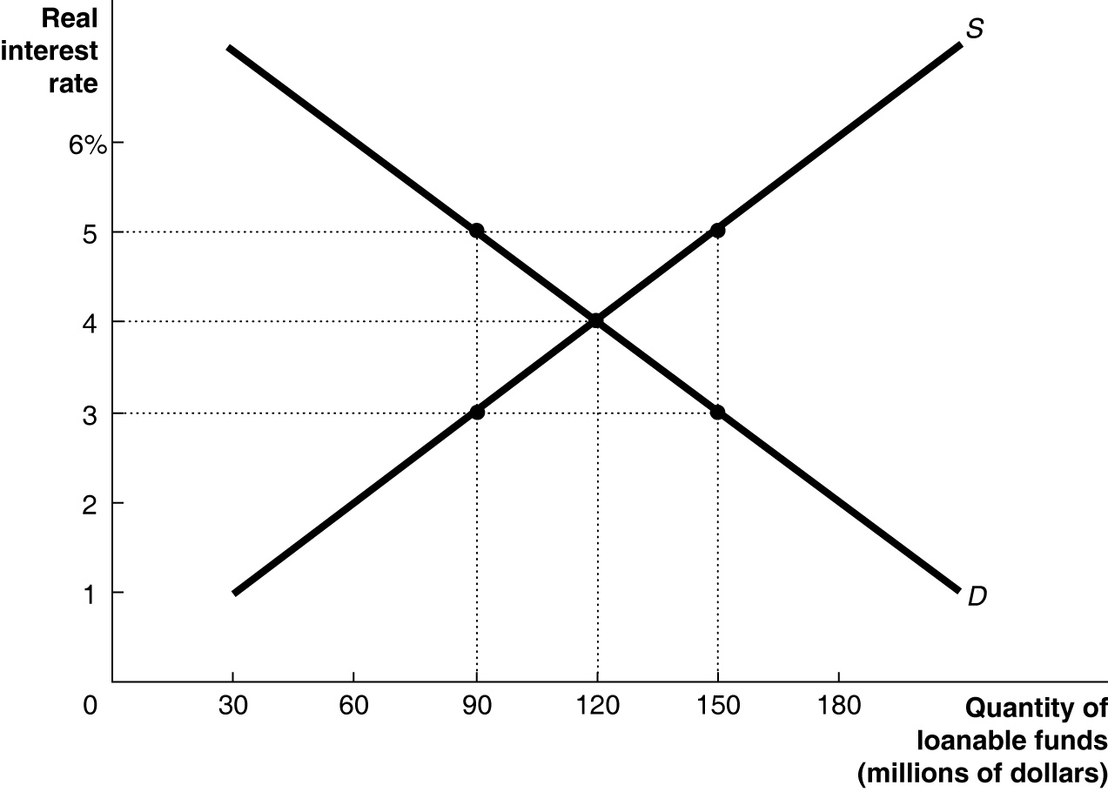

16) Refer to Figure 6.6. The loanable funds market is in equilibrium, as shown in the figure above. As a result of an increase in the government budget deficit, the ________ for loanable funds will ________, thereby ________ the equilibrium real interest rate and ________ the equilibrium quantity of loanable funds.
A) demand; fall; decreasing; decreasing
B) demand; rise; increasing; decreasing
C) supply; rise; decreasing; increasing
D) supply; fall; increasing; decreasing
E) demand; rise; increasing; increasing

17) How will an increase in the government budget surplus as a result of lower government spending (with no change in net taxes) affect private saving in the economy?
A) Private saving will increase by less than the amount of decrease in public savings.
B) Private saving will decrease by less than the amount of increase in the budget surplus.
C) Private saving will decrease by the amount of increase in the budget surplus.
D) Private saving will be unaffected by the increase in the budget surplus.
E) Private saving will increase by the amount of increase in the budget surplus.

18) ________ spending follows a smooth trend whereas, ________ spending is more volatile and subject to fluctuations.
A) Government; consumer
B) Investment; government
C) Consumer; investment
D) Consumer; government
E) Investment; consumer

19) All of the following are components of aggregate expenditure except
A) consumption spending.
B) government spending.
C) planned investment spending.
D) actual investment spending.
E) net export spending.

20) Which of the following is a true statement about the multiplier?
A) The multiplier is a value between zero and one.
B) The multiplier only applies to government spending.
C) The multiplier effect does not occur when autonomous expenditure decreases.
D) The smaller the MPC, the larger the multiplier.
E) The multiplier rises as the MPC rises.

21) Given the equations for C, I, G, and NX below, what is the marginal propensity to save?

C = 1,000 + 0.8Y
I = 1,500
G = 1,250
NX = 100

A) 0.1 B) 0.2 C) 0.8 D) 1.8 E) 10

22) Consumption is $5 million, planned investment spending is $8 million, government purchases are $10 million, and net exports are equal to $2 million. If GDP during the same time period is equal to $23 million, what unplanned changes in inventories occurred?
A) There was an unplanned decrease in inventories equal to $19 million.
B) There was an unplanned increase in inventories equal to $2 million.
C) There was an unplanned decrease in inventories equal to $2 million.
D) There was an unplanned decrease in inventories equal to $3 million.
E) There was no unplanned change in inventories.

23) Which of the following leads to a decrease in real GDP?
A) an increase in the inflation rate in other countries, relative to inflation in Canada
B) an increase in government spending
C) an increase in imports
D) households having increasingly optimistic expectations about future income
E) an increase in interest rates

24) If firms sell exactly what they expected to sell, all of the following will be true except
A) aggregate expenditure will be equal to GDP.
B) inventories will not change, and GDP and employment will remain stable.
C) unplanned investment will be zero.
D) there is no unplanned change in inventories.
E) aggregate expenditure will be greater than GDP.

25) Consumption spending is $16 billion, planned investment spending is $4 billion, unplanned investment spending is $2 billion, government purchases are $6 billion, and net export spending is $1 billion. What is aggregate expenditure?
A) $22 billion B) $26 billion C) $23 billion D) $27 billion E) $29 billion

26) If economists forecast a decrease in aggregate expenditure, which of the following is likely to occur?
A) GDP will rise.
B) Wages will rise.
C) Unemployment will fall.
D) Inventories will fall.
E) GDP will fall.

27) Canadian net export spending rises when
A) the growth rate of Canadian GDP is faster than the growth rate of GDP in other countries.
B) the value of the Canadian dollar increases relative to other currencies.
C) the Canadian economy become more open to international trade.
D) the inflation rate is higher in Canada relative to other countries.
E) the price level in Canada rises relative to the price level in other countries.

28) If the consumption function is defined as C = 5,500 + 0.9Y, what is the marginal propensity to consume?
A) 0.1 B) 0.9 C) 5.5 D) 6.1 E) $5,500

29) If the consumption function is defined as C = 7,250 + 0.8Y, what is the autonomous level of consumption expenditure?
A) $1,425 B) $5,800 C) $7,250 D) $9,062.50 E) $9,700

30) If the marginal propensity to save is 0.1, then a $10 million decrease in disposable income will
A) increase consumption by $1 million.
B) increase consumption by $9 million.
C) leave consumption unchanged.
D) decrease consumption by $9 million.
E) decrease consumption by $1 million.

31) Autonomous expenditure times the multiplier equals
A) planned autonomous investment.
B) government budget deficit.
C) autonomous consumption.
D) autonomous saving.
E) equilibrium GDP.

32) If an increase in autonomous consumption spending of $25 million results in a $100 million increase in equilibrium real GDP, then
A) the MPC is 0.25.
B) the MPC is 0.75.
C) the MPC is 0.8.
D) the MPC is 0.9.
E) the MPC is 2.5.

Figure 8.4

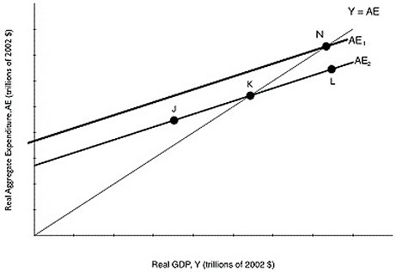

33) Refer to Figure 8.4. Suppose that the level of GDP associated with point K is potential GDP. If the Canadian economy is currently at point N,
A) the economy is in an expansion.
B) the level of unemployment is above the natural rate.
C) firms are operating below capacity.
D) the economy is at full employment.
E) the economy is in a recession.

34) Canadian National Railways (CN) plays such a large role in moving goods around the country that there is usually a close relationship between fluctuations in CN's business and fluctuations in GDP. When CN sees an increase in demand for its services, we can likely expect
A) an increase in unemployment.
B) a decrease in the price level.
C) a decrease in GDP.
D) a drop in the exchange rate.
E) an increase in GDP.

35) The basic aggregate demand and aggregate supply curve model helps explain
A) which workers will lose their jobs during a recession.
B) output fluctuations in an individual market.
C) long-term growth.
D) short-term fluctuations in real GDP and the price level.
E) price fluctuations in an individual market.

36) An economy is likely to recover from a recession quickly (without government intervention) when
A) it is caused by a negative supply shock and wages are fixed.
B) it is caused by a leftward shift in aggregate demand and wages are fixed.
C) it is caused by a leftward shift in aggregate demand and wages are flexible.
D) it is caused by a financial crisis.
E) it is caused by a leftward shift in aggregate supply and output prices are fixed.

37) Which of the following models focuses on how productivity shocks explain fluctuations in real GDP?
A) the monetarist model
B) the Austrian model
C) the real business cycle model
D) the new classical model
E) the new Keynesian model

38) If potential GDP is equal to $600 billion, what does the long-run aggregate supply curve look like?
A) It is a horizontal line at $600 billion of GDP.
B) It is a vertical line at a level of GDP below $600 billion.
C) It is a positively sloped line beginning at the origin and passing through a GDP of $600 billion.
D) It is a vertical line at a level of GDP above $600 billion.
E) It is a vertical line at $600 billion of GDP.

39) The aggregate demand curve shows the relationship between the ________ and ________.
A) inflation rate; quantity of real GDP demanded
B) real interest rate; quantity of real GDP supplied
C) price level; quantity of real GDP demanded
D) nominal interest rate; quantity of real GDP demanded
E) inflation rate; unemployment

40) The short-run aggregate supply curve has a(n)
A) indeterminate slope.
B) slope equal to zero.
C) negative slope.
D) positive slope.
E) slope equal to infinity.

41) The long-run aggregate supply curve shows the relationship between
A) the quantity of real GDP supplied and the quantity of nominal GDP supplied.
B) the real interest rate and the nominal interest rate.
C) the supply of labour and the price level.
D) short-run aggregate supply and short-run aggregate demand.
E) the price level and quantity of real GDP supplied.

42) The invention of the cotton gin ushered in the Industrial Revolution and began a long period of technological innovation. What did this technological change do the short-run supply curve?
A) It shifted the short-run aggregate supply curve to the left.
B) It shifted the short-run aggregate supply curve to the right.
C) It moved the economy up along a stationary short-run aggregate supply curve.
D) It moved the economy down along a stationary short-run aggregate supply curve.
E) It gave the short-run aggregate supply curve a negative slope.

Figure 9.5

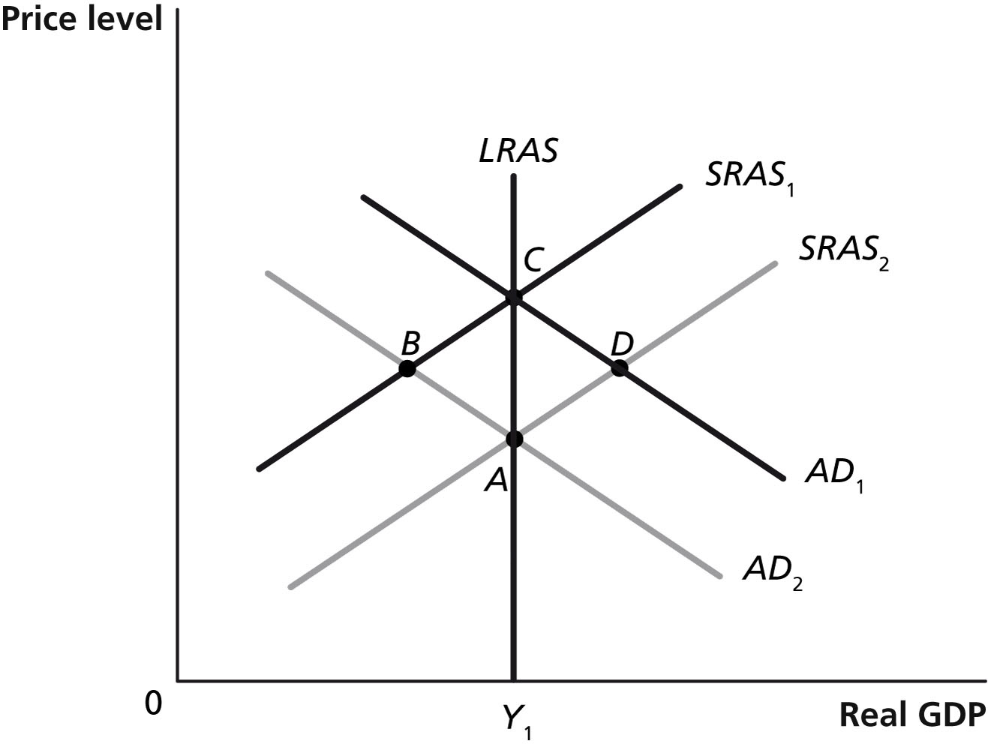

43) Refer to Figure 9.5. Which of the points in the above graph are possible short-run equilibria?
A) A and B
B) A and C
C) A and D
D) B and C
E) A, B, C, and D

44) A falling price level will
A) decrease the quantity of real GDP demanded.
B) increase aggregate demand.
C) increase the quantity of real GDP demanded.
D) decrease aggregate demand.
E) have no impact on the quantity of real GDP demanded.

45) Which of the following will shift the aggregate demand curve to the left, ceteris paribus?
A) an increase in net exports
B) an increase in disposable income
C) an increase in expected profits for firms
D) an increase in interest rates
E) an increase in the price level

46) Which of the following would cause the short-run aggregate supply curve to shift to the right?
A) an increase in the price level
B) an increase in the price of natural resources
C) a technological advance
D) a decrease in inflation expectations
E) an increase in interest rates

47) During 2008-2009, falling oil prices
A) shifted the Canadian long-run aggregate supply curve to the right.
B) shifted the Canadian aggregate supply curve to the left.
C) shifted the Canadian aggregate demand curve to the right.
D) shifted the Canadian short-run aggregate supply curve dramatically to the right.
E) shifted the Canadian aggregate demand curve to the left.

48) Proponents of the ________ model argue that the short-run supply curve is vertical.
A) new classical
B) new Keynesian
C) Austrian
D) real business cycle
E) monetarist

49) Ceteris paribus, in the long run, a negative supply shock causes
A) equilibrium real GDP to fall.
B) higher labour force participation.
C) the price level to rise initially, and then return to its lower level.
D) the long-run aggregate supply curve to shift to the left.
E) unemployment to fall below its short-run level.

50) Economists and industry analysts pay close attention to the volume of rail cargo shipments because changes in rail shipments have historically been good indicators of
A) past decreases in marginal tax rates.
B) future oil prices.
C) future exchange rate changes.
D) potential GDP.
E) future economic activity.

Figure 9.5

51) Refer to Figure 9.5. Which of the points in the above graph are possible short-run equilibria but not long-run equilibria? Assume that Y1 represents potential GDP.
A) A and B B) A and C C) B and C D) C and D E) B and D

52) In an open economy, the relationship between GDP (Y) and expenditures is Y = C + I + G.
A) True
B) False

53) The commonly accepted definition of a recession is at least two consecutive quarters of falling real GDP.
A) True
B) False

54) The formula for the multiplier is (1 - MPC).
A) True
B) False

55) A decrease in the price level in Canada will shift the aggregate expenditure line downward.
A) True
B) False

1) B
2) A
3) B
4) C
5) D
6) E
7) E
8) A
9) E
10) A
11) D
12) B
13) E
14) E
15) B
16) D
17) B
18) C
19) D
20) E
21) B
22) C
23) E
24) E
25) D
26) E
27) A
28) B
29) C
30) D
31) E
32) B
33) A
34) E
35) D
36) C
37) C
38) E
39) C
40) D
41) E
42) B
43) E
44) C
45) D
46) C
47) E
48) D
49) C
50) E
51) E
52) B
53) A
54) B
55) B

