LEBANESE INTERNATIONAL UNIVERSITY / CSCI426
WeScore

Phase 1 — Complete Code & GitHub Guide
Every project file explained • Methods linked to Dr. Messelmani’s lectures • GitHub & GitHub Pages deployment

PROJECT | DETAILS
Course | CSCI426 — Advanced Web Programming
Instructor | Dr. Kawthar Messelmani
Stage | Project Phase 1 — approved football website concept
Stack | ReactJS + React Router + JavaScript + CSS
Data | Fictional frontend sample data; no backend
Academic year | Fall 2026–2027

Prepared as a code-and-method explanation for the accompanying original React source files. The deployed GitHub URL and final student information must be provided by the submitting student.

1. What you are submitting
WeScore is an approved football-themed, frontend-only academic project. Its purpose is to let a user browse sample football fixtures, explore teams and standings, search/filter/sort data, and save selected fixtures or teams in the same browser. This guide accompanies the complete working React source project in the ZIP.
Requirement from Phase 1 | Implementation
React frontend + functional application | Seven React routes, reusable components, interactive pages
At least five pages | Home, About, Features, Contact, Matches, Teams, Standings
At least one dynamic page | Matches, Teams and Standings all render and process arrays
Responsive desktop/mobile | Media queries, flexible columns, mobile Navbar
Git + GitHub | Git commands, commit history & remote repository setup
Deploy frontend | gh-pages workflow matching the lecture
README and screenshots | README.md with captured desktop/mobile UI
PDF report | Separate WeScore_Phase1_Project_Report.pdf in docs/

Important limitations: all teams, match dates and results are fictional, not live scores. Contact form submissions are displayed locally in an alert; no email is sent and no server stores messages.

2. Folder structure and the role of every file
WeScore/
package.json dependencies and npm scripts
public/index.html HTML document containing the root div
src/index.js React starting point
src/App.js BrowserRouter and seven routes
src/components/NavBar.js links and responsive mobile menu
src/components/Footer.js site footer and links
src/components/MatchCard.js reusable card controlled by props
src/pages/Home.js homepage and featured fixture cards
src/pages/Matches.js dynamic search/filter/sort/saved matches
src/pages/Teams.js dynamic search and saved teams
src/pages/Standings.js sorted team table
src/pages/Features.js list of features built with map()
src/pages/About.js project purpose and description
src/pages/Contact.js functional validated contact form
src/data/MatchesList.js twelve fictional match objects
src/data/TeamsList.js eight fictional team objects
src/styles/Global.css page design, components, breakpoints
src/styles/NavBar.css Navbar and mobile-menu styling
src/styles/Footer.css Footer styling
docs/screenshots/ real locally rendered interface images
README.md GitHub repository overview
GITHUB_SETUP.md exact GitHub publishing instructions
docs/ Word guide + Phase 1 PDF report
Files and folder names are case-sensitive on many web hosts. For example, NavBar.js must match the exact import in App.js. The course code is deliberately split into components, pages, data and styles, like the instructor’s Bootstrap campus project.

3. Startup files: index.html, index.js, App.js

3.1 public/index.html
The HTML page supplies <div id="root"></div>. React mounts the application into that container. The viewport meta tag tells mobile browsers to use the device width. The <title> controls the browser tab.
<div id="root"></div>

3.2 src/index.js
import React from 'react';
import ReactDOM from 'react-dom/client';
import App from './App';
import './styles/Global.css';
const root = ReactDOM.createRoot(document.getElementById('root'));
root.render(<App />);
The import statements load React, the DOM renderer, App and shared CSS. createRoot selects the HTML root and render displays the App component. This matches Create React App conventions.

3.3 src/App.js: React Router
import { BrowserRouter as Router, Routes, Route } from 'react-router-dom';
<Router basename={process.env.PUBLIC_URL}>
<NavBar />
<main>
<Routes>
<Route path="/" element={<Home />} />
<Route path="/matches" element={<Matches />} />
<Route path="/teams" element={<Teams />} />
<Route path="/standings" element={<Standings />} />
<Route path="/features" element={<Features />} />
<Route path="/about" element={<About />} />
<Route path="/contact" element={<Contact />} />
</Routes>
</main>
<Footer />
</Router>
Term | Meaning
BrowserRouter as Router | Provides navigation without a full-page reload
Routes | Holds the set of Route definitions
Route path | The part of the URL that must match
Route element | Which React component to display
Link to | Clicking a link navigates to the matching Route
basename={process.env.PUBLIC_URL} | Configuration supporting the /WeScore subpath after adding homepage for GitHub Pages
main | Contains the changing page; Navbar/Footer remain visible

The homepage uses / and the other pages use explicit paths. The final catch-all route displays the homepage for unrecognized paths inside the running SPA. For GitHub Pages, direct refreshing a nested path can still show a hosting-level 404; see Section 12.

4. Reusable components

4.1 src/components/NavBar.js
const [openLinks, setOpenLinks] = useState(false);
const toggleNavbar = () => setOpenLinks(!openLinks);
<h1 className="brand-name">WeScore</h1>
<Link to="/matches">Matches</Link>
<button onClick={toggleNavbar}>{openLinks ? 'Close' : 'Menu'}</button>
<div className="mobile-links" id={openLinks ? 'open' : 'close'}> ... </div>
useState remembers if the mobile menu is open. The click event toggles the Boolean; the ternary operator changes the menu label and id, which CSS uses to show/hide links. Link comes from React Router. The brand is deliberately a non-clickable h1 text heading, not an image or a Link. These techniques follow the Week 3/4 Router, Navbar and Hooks examples.

4.2 src/components/Footer.js
Footer renders a fixed site-wide brand description, the React Router links and a course-demo disclaimer. App places Footer below Routes, so it persists when page content changes. Styling comes from Footer.css. JSX uses <footer>, <h2>, <p> and <Link>.

4.3 src/components/MatchCard.js: props and callbacks
function MatchCard({ match, isSaved, onSave }) {
return (
<div className="match-card">
<h3>{match.home}</h3>
<strong>{match.status === 'Completed'
? `${match.homeScore} : ${match.awayScore}` : 'VS'}</strong>
<h3>{match.away}</h3>
{onSave && <button onClick={() => onSave(match.id)}>
{isSaved ? 'Saved' : 'Favourite'}
</button>}
</div>
);
}
The full component also shows match status, date, time, venue and short team codes. props pass information from the parent (Matches) into a child (MatchCard). Clicking the child button calls the parent callback onSave with match.id. A ternary condition displays a final score or VS. The JSX conditional && hides the Save button when the parent does not provide onSave, such as on Home. This is parent-child communication taught in Week 5.

5. Sample data files

5.1 src/data/MatchesList.js
export const MatchesList = [
{ id: 1, home: 'Northbridge FC', away: 'Harbor City',
date: '2026-11-02', time: '19:00', status: 'Completed',
homeScore: 2, awayScore: 1 },
// ... additional fictional fixtures
];
The actual file defines twelve complete match objects with id, home/away teams, codes, dates, times, status, competition, venue, and scores. An array of objects is the same data structure used by the teacher’s CampusesList example and React Lists lecture. The source file contains the full fields shown in the interface.

5.2 src/data/TeamsList.js
export const TeamsList = [
{ id: 1, name: 'Northbridge FC', code: 'NBF',
played: 10, won: 7, drawn: 2, lost: 1,
points: 23, goalsFor: 22, goalsAgainst: 9 }
// ... additional fictional club records
];
Eight club records supply the team directory and league table. The same data is reused in multiple pages rather than duplicated. Team IDs act as stable React keys and as values saved in localStorage.

6. Dynamic Matches page: step by step
This is the main assessed dynamic page. It combines methods from React Forms, Week 5 JSON search, Week 6 arrays and the LocalStorage/Favourite Items exercises.

6.1 Store what the user selects using useState
const [search, setSearch] = useState('');
const [status, setStatus] = useState('All');
const [order, setOrder] = useState('Soonest first');
const [savedOnly, setSavedOnly] = useState(false);
Every pair contains the current state value and a setter function. Updating any value causes React to display updated results.

6.2 Load saved fixtures on the first render
const [favourites, setFavourites] = useState(() => {
try {
const saved = localStorage.getItem('wescore-favourites');
return saved ? JSON.parse(saved) : [];
} catch {
return [];
}
});
localStorage returns a string, so JSON.parse converts it back to an array. If nothing was saved, use an empty list. try/catch prevents damaged JSON from breaking the page. This follows the instructor’s Favourites Items App example.

6.3 Add/remove a favourite
const toggleFavourite = (id) => {
const updated = favourites.includes(id)
? favourites.filter(item => item !== id)
: [...favourites, id];
setFavourites(updated);
localStorage.setItem('wescore-favourites', JSON.stringify(updated));
};
includes checks whether an ID exists. filter removes it if already saved. Spread syntax creates a new array and adds the ID otherwise. setFavourites updates the visible React page; localStorage.setItem persists a JSON string so favourites remain after refresh.

6.4 Search, filter and sort
const filteredMatches = MatchesList.filter(match => {
const matchesSearch = match.home.toLowerCase().includes(search.toLowerCase()) ||
match.away.toLowerCase().includes(search.toLowerCase()) ||
match.competition.toLowerCase().includes(search.toLowerCase());
const matchesStatus = status === 'All' || match.status === status;
const matchesSaved = !savedOnly || favourites.includes(match.id);
return matchesSearch && matchesStatus && matchesSaved;
});
const displayedMatches = [...filteredMatches].sort((a, b) =>
order === 'Soonest first'
? a.date.localeCompare(b.date)
: b.date.localeCompare(a.date)
);
filter keeps only matching records. toLowerCase and includes perform a case-insensitive text search. Each Boolean filter must be true for an item to remain. Sorting uses a copy made with spread syntax, then localeCompare on ISO-formatted date strings to order correctly. These are directly aligned with the list, filter and sort examples.

6.5 Form controls and rendered list
<input value={search} onChange={e => setSearch(e.target.value)} />
<select value={status} onChange={e => setStatus(e.target.value)}>
<option>All</option><option>Upcoming</option><option>Completed</option>
</select>
<div className="card-grid two">
{displayedMatches.map(match => <MatchCard key={match.id}
match={match} isSaved={favourites.includes(match.id)}
onSave={toggleFavourite} />)}
</div>
Controlled inputs use value and onChange. map creates one component per match, key identifies each element, and props deliver match data and callbacks to MatchCard. A separate no-results conditional displays helpful text if no records match.

7. Teams and Standings pages

7.1 src/pages/Teams.js
const filteredTeams = TeamsList.filter(team => {
const matchesSearch = team.name.toLowerCase().includes(search.toLowerCase()) ||
team.city.toLowerCase().includes(search.toLowerCase());
const matchesSaved = !savedOnly || savedTeams.includes(team.id);
return matchesSearch && matchesSaved;
});
// Same localStorage/add-remove technique as Matches, with a different key:
localStorage.setItem('wescore-favourite-teams', JSON.stringify(updated));
Teams searches by team name/city, renders cards with map, and can save favourite club IDs. A different storage key prevents team favourites from overwriting match favourites. The UI shows wins, games played and points.

7.2 src/pages/Standings.js
const sortedTeams = [...TeamsList].sort((a, b) => b.points - a.points);
<tbody>
{sortedTeams.map((team, index) => (
<tr key={team.id}>
<td>{index + 1}</td>
<td>{team.name}</td>
<td>{team.points}</td>
</tr>
))}
</tbody>
The array copy prevents editing the original TeamsList. b.points - a.points sorts descending, showing the club with the highest points first. map produces the table body and index + 1 displays each position. The actual file includes played, won, drawn, lost, goals for and goals against columns.

8. Home, About and Features pages
Page | How it works | Main method
Home.js | Uses MatchesList.filter to choose featured upcoming matches, displays MatchCard children and Link buttons. | filter, map, Link, props
About.js | Describes the app, its Phase 1 purpose and fictional sample-data policy. | JSX, Link, CSS
Features.js | Maps a local array of six feature objects to separate feature cards with links. | map, key, Link

const features = [
{ no: '01', title: 'Match explorer', path: '/matches' },
{ no: '02', title: 'Team directory', path: '/teams' }
];
{features.map(feature => <div key={feature.no}>
<h3>{feature.title}</h3>
<Link to={feature.path}>Open feature</Link>
</div>)}
Repeated UI elements use an array plus .map() rather than copying separate markup for every item, following both the React Lists and React with Bootstrap example.

9. Contact page: controlled React form
const [values, setValues] = useState({ fname: '', email: '', message: '' });
const handleChange = (e) => {
const name = e.target.name;
const value = e.target.value;
setValues({ ...values, [name]: value });
};
const handleSubmit = (e) => {
e.preventDefault();
if (!values.fname.trim() || !values.email.trim() || !values.message.trim()) {
alert('Please complete all required fields.');
return;
}
alert('Demo form submitted successfully!\n' +
JSON.stringify(values, null, 2) + '\nThis form does not send an email.');
};
<form onSubmit={handleSubmit}>
<input id="fname" name="fname" value={values.fname}
required onChange={handleChange} />
</form>
useState stores the name, email and message in a single object. e.target.name finds which field was changed, and [name]: value updates that key. Spread {...values} keeps the remaining keys. preventDefault stops a form submission from refreshing the page. trim checks that required fields are not only spaces. JSON.stringify converts the object to a human-readable message in an alert. The email input also uses type="email" for basic browser validation.
The implementation intentionally uses a demonstration alert rather than pretending to send real messages: Phase 1 specifies a functional frontend but does not require a backend or database. This follows the Week 5 Forms lecture, Forms.jsx and the Bootstrap Contact example.

10. CSS files and responsive design
CSS file | Purpose | Lecture connection
Global.css | Global type, background, page sections, hero, cards, pitch graphic, forms, tables, mobile breakpoints | CSS styling; Flexbox, responsive design and media queries
NavBar.css | Desktop links, hidden mobile links, mobile Menu button, open/close state | Week 2 Navbar and Week 4 mobile-menu exercise
Footer.css | Footer text, Link layout, desktop and small-screen spacing | Week 2 Footer CSS and Bootstrap sample

/* Example of a media query: changes layout on narrow screens */
@media only screen and (max-width: 620px) {
.card-grid.three { grid-template-columns: 1fr; }
.matches-toolbar { grid-template-columns: 1fr; }
}
/* Mobile menu is controlled by the JSX id="open" or id="close" */
#open { display: flex; }
#close { display: none; }
CSS controls appearance only: fonts, colours, spacing, grid/flex layouts, borders and responsive changes. React controls which data is displayed and whether the menu is open. Green and lime are our original project palette. The source uses CSS grid for flexible sections alongside taught Flexbox and breakpoint techniques; no outside UI framework or prebuilt theme is imported.

11. npm package and installation
cd WeScore
npm install
npm start
# When you want a production bundle:
npm run build
package.json lists React, react-dom, react-router-dom, react-scripts and gh-pages. npm install creates the machine-specific node_modules folder. It is not included in the ZIP because it is very large and automatically generated. npm start runs the local development server; npm run build creates the production build folder. If using CRAO in class, ensure dependencies were already installed before going offline.
Package | Why it is needed
react | Components, JSX and React Hooks
react-dom | Render the components in the browser
react-router-dom | BrowserRouter, Routes, Route and Link
react-scripts | Create React App start and build commands
gh-pages | Publishes the build output to a GitHub Pages branch

12. Connect WeScore to GitHub: exact steps

12.1 Create a repository
- Sign in at github.com and create an empty repository called WeScore. Avoid creating another README on GitHub, because this project already includes one.
- Extract the ZIP, open the WeScore folder in VS Code and open Terminal. Use your own real GitHub username in the remote URL.
git init
git add .
git commit -m "Initial WeScore Phase 1 frontend"
git branch -M main
git remote add origin https://github.com/YOUR-USERNAME/WeScore.git
git push -u origin main
git init initializes a local Git repository; git add stages files; git commit records the snapshot; branch -M main names the main branch; git remote add origin connects your local repo to the remote repository URL; git push uploads commits to GitHub. This follows the doctor’s React Project Deployment to GitHub Pages lecture. GitHub may request credential-manager login or a personal access token.

12.2 Ensure the required Git history is visible
git status
git log --oneline
# After making a REAL improvement:
git add .
git commit -m "Improve matches filtering and team favourites"
git push
The project rubric requires commit history. Create genuine commits as you make and check edits, not invented historical commits. Screenshots of the GitHub repository and actual commit history can be added to your report after publishing.

12.3 Publish with GitHub Pages
- Open package.json, and add a top-level homepage field using your actual username and repo name. Do not leave the example placeholder.
"homepage": "https://YOUR-USERNAME.github.io/WeScore"
- Keep these existing scripts in package.json (already supplied):
"predeploy": "npm run build",
"deploy": "gh-pages -d build"
- Run npm install if needed, then npm run deploy. It builds and publishes into the gh-pages branch.
npm install
npm run deploy
- Open the repository Settings > Pages. Choose Deploy from branch, branch gh-pages, folder /(root), then Save.
- Open https://YOUR-USERNAME.github.io/WeScore/ and test the links. Submit the GitHub repository link and Phase 1 PDF report as required.

12.4 React Router and GitHub Pages limitation
WeScore uses BrowserRouter because it is the router taught in the lectures. After clicking links from the homepage, routing works in the React application. GitHub Pages is a static host; refreshing a direct nested URL such as /WeScore/matches may return a hosting-level 404. Our README and GITHUB_SETUP.md mention this. Do not silently replace BrowserRouter with another routing method without the instructor’s approval.

12.5 Update your deployed project
git add .
git commit -m "Update homepage and screenshots"
git push
npm run deploy
No GitHub authentication, remote repository or public live website is included in this ZIP. Connection and publication require your GitHub account and the exact repository URL.

13. Common errors and solutions
Error | Cause / fix
Cannot find module react-router-dom | Run npm install in WeScore. Verify package.json is in current folder.
Module not found for component | Check exact capitalization and relative import paths.
npm start fails | Check Node.js/npm installation; run npm install and inspect terminal output.
Blank after GitHub deploy | Check homepage and repository spelling; rebuild and redeploy.
GitHub 404 after refresh | BrowserRouter static-host limitation: open the website homepage and use navigation.
Saved items vanish | Browser storage is per browser/origin; private mode and clearing localStorage reset it.
Contact form not emailing | Expected in Phase 1: it shows an alert only, not a backend submission.
Broken layouts on phone | Use viewport meta, responsive CSS, test 390px/mobile menu.

14. Lecturer methods: quick reference
Method / syntax | Purpose in WeScore | Lecture source
Components, props, import/export | Building pages and cards, passing data | Weeks 1–3 and Bootstrap project
BrowserRouter, Link, Routes, Route | Frontend navigation between pages | Week 3 React Router
useState, onClick, onChange | User input, filter values, mobile menu | Week 4 Hooks, Week 5 Forms
map and key | Generate match cards, team cards and rows | Week 5 and Lecture 6-1
filter, includes, toLowerCase | Search matches and clubs | JSON.jsx and Lecture 6-1
sort and localeCompare | Sort by match date or team points | Week 5/6 list lectures
JSON.parse/stringify | Convert saved arrays to/from strings | Week 5 JSON and favourites lecture
localStorage.getItem/setItem | Remember user favourites after refresh | React LocalStorage / Favourite Items
preventDefault, required, alert | Demo form submission | Lecture 5 React forms
CSS, Flexbox, media queries | Responsive desktop/mobile interface | Week 2 and Bootstrap lecture
Git, gh-pages | Version control and publishing | GitHub Pages deployment PDF

15. Visual examples and review checklist
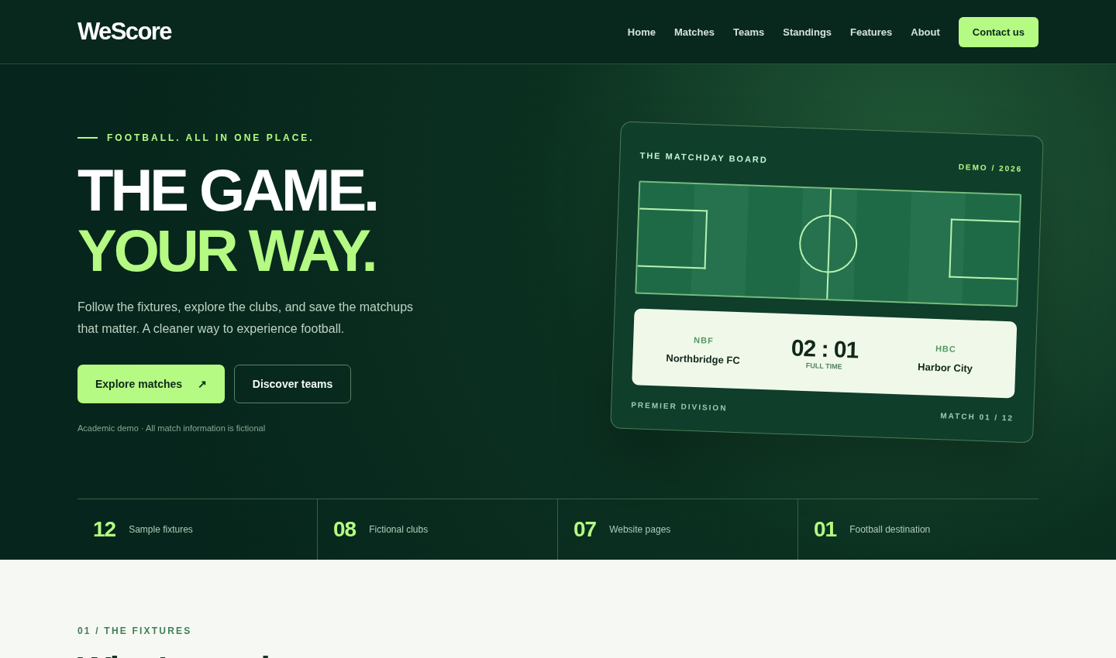
Homepage: matchday design, demo notice, persistent Navbar
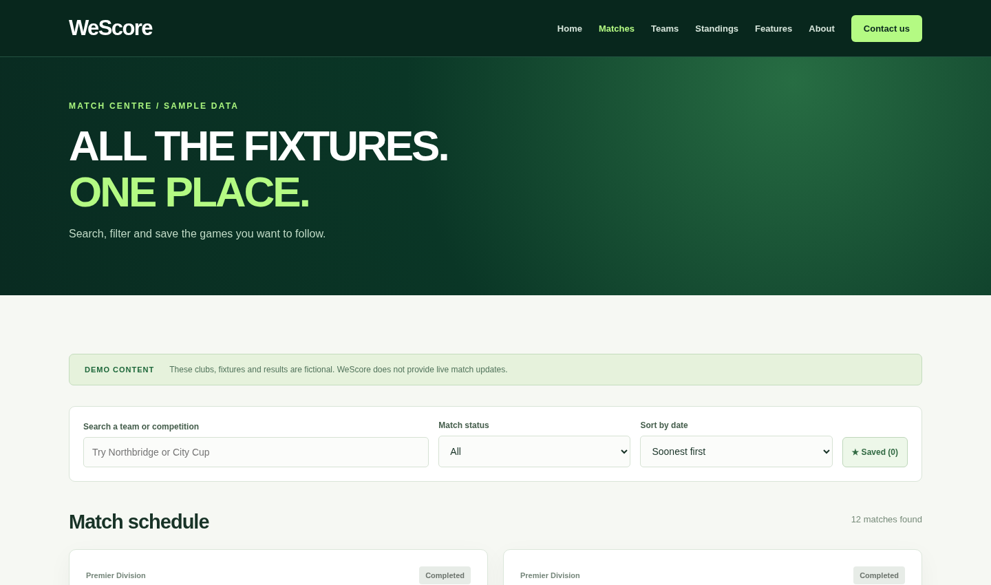
Matches: visible search/filter controls and match cards
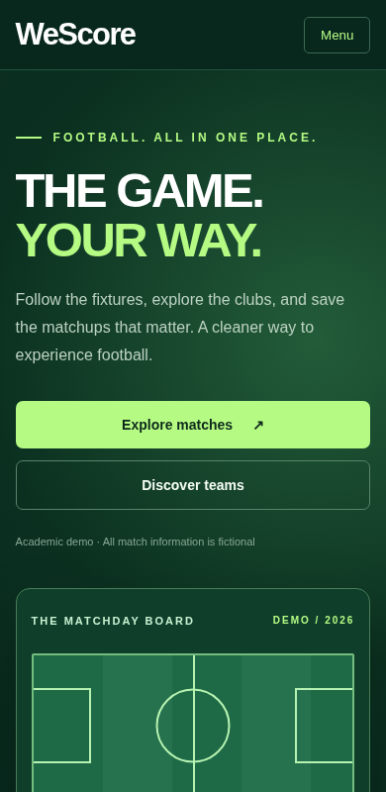
Mobile homepage: responsive layout and compact navigation
- Open all seven routes: Home, Matches, Teams, Standings, Features, About, Contact.
- Search Matches by team and City Cup; change completed/upcoming filter and date sort.
- Save a match and a team; reload the page and confirm saved selections remain.
- Use the contact form with empty values and valid inputs; verify demo alert.
- Test the mobile Menu button and all routes on a narrow browser window.
- Run npm run build successfully; do not upload node_modules to GitHub.
- Create GitHub repository, push original source, and show genuine commit history.
- Edit package.json homepage and deploy on GitHub Pages using npm run deploy.
- Check README screenshots and update the PDF report with actual deployed links.

Source documents consulted
CSCI426_Project_Phase1_Fall2026-20267.doc; React-with-Bootstrap-FullProject.pdf; CSCI426 Weeks 1–5 slides; Lecture 6-1.pdf; React Router and React Forms lecture PDFs; JSON and React LocalStorage/Favourite Items examples; React Project Deployment to GitHub Pages.pdf; provided Forms.jsx and MyList.jsx examples. This guide discusses methods shown in these lectures but implements an original WeScore site.

