OTC Derivatives Margining
Monte Carlo Simulation Analysis
Margin Design, Fire-Sale Externalities, Systemic Risk and Policy Evaluation
Frankfurt School of Finance & Management
Master of Finance — Risk Management
Supervisor: Prof. F. Sannino

1. Introduction and Model Setup
This report analyses the design of initial and variation margin in OTC derivative contracts using a Monte Carlo simulation framework. We model a one-year bilateral contract between counterparty A (the potentially distressed party) and counterparty B (the protected party). The contract mark-to-market value is V(t) = Q(St - K), where St follows an arithmetic random walk driven by daily Gaussian increments. The framework examines how margin design, settlement frequency, and collateral eligibility interact to determine credit losses, liquidity defaults, and systemic risk amplification.

Three model cases of increasing complexity are analysed. Case 1 assumes A has unlimited cash, so default is purely exogenous (driven by a Poisson process calibrated to PD = 15% per annum). Case 2 - Fires sale model introduces a limited cash buffer L0 and an illiquid asset pool A0, allowing A to also default due to insufficient liquidity to meet variation margin calls. When cash is exhausted, A must fire-sell illiquid assets at a fixed discount h=0.25. Case 3 – Systemic model extends Case 2 with a shared market price impact: cumulative fire sales across all investors raise the per-unit discount ht dynamically through a feedback parameter gamma, creating a systemic doom loop. The theoretical initial margin formula applied throughout is IM = k × Q × σ × √(MPOR/252) × z₉₉, where z₉₉ = 2.3263. This is the closed-form 99% VaR under normality, consistent with empirical simulation.

1.1 Base Parameters
Table 1 lists all base parameters used across simulations. Policy sweeps vary one parameter at a time while holding all others fixed. Case 3 procyclicality uses sigma normal=15 for IM calibration and sigma stress=40 for path generation after day 126, creating a structural gap between the margin buffer and actual market moves.

Parameter | Value | Description
Q (position size) | 1,000 | Number of contract units
S0 = K | 100 | At-the-money start, V0 = 0
sigma (base) - Unlimited and Fire - Sale | 30 | Annual volatility in price units
sigma normal (C3) | 15 | Calm-market calibration for procyclical case
sigma stress (C3) | 40 | Stress-period volatility after day 126
PD annual | 15% | Annual probability of exogenous default
MPOR | 10 days | Margin period of risk
IM multiplier k | 1.0 | Scales the 99% VaR initial margin
L0 (initial cash) | 5,000 | Free cash available to A (Cases 2 & 3)
A0 (illiquid assets) | 50,000 | Illiquid asset pool available for fire sales
h (fire-sale discount) | 0.25 | Fixed discount (Case 2); base discount (Case 3)
gamma (market impact) | 1.17e-8 | Price impact coefficient for cumulative selling (C3)
Steps | 252 | Trading days per year
Table 1 — Base simulation parameters used across all cases and policy sweeps.

1.2 Simulated MTM Paths

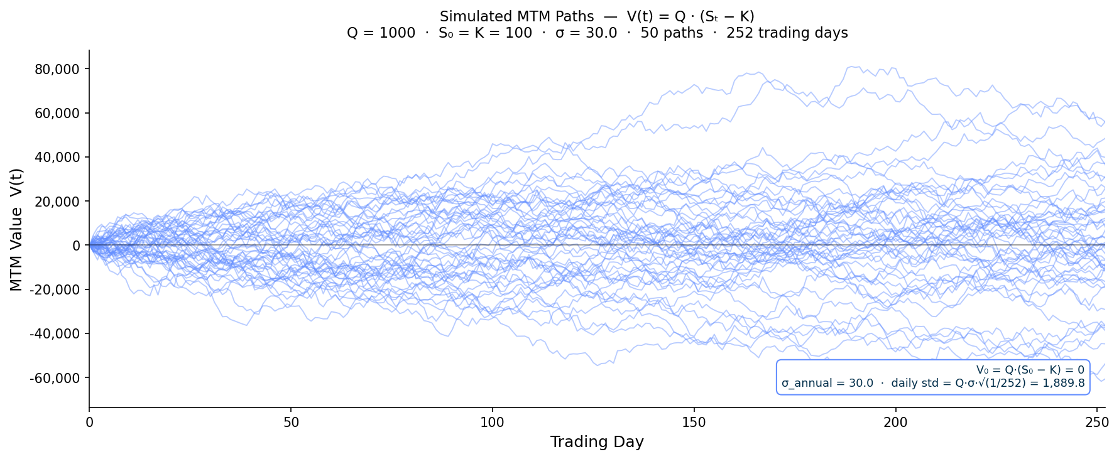
Figure 1 — 50 simulated MTM paths V(t) = Q(St - K) over 252 trading days. sigma = 30, Q = 1,000, S0 = K = 100.

2. Baseline Results
Figure 2 presents the conditional loss distributions to counterparty B across all three cases for both daily and weekly variation margin. The conditional distribution shows only paths on which B incurred a strictly positive loss, isolating loss severity conditional on default. Case 1 produces a tight distribution near zero with unlimited cash, B is protected by IM alone and tail losses are rare. Case 2 broadens the distribution significantly as fire sales generate larger and more correlated close-out exposures. Case 3 dramatically fattens the right tail: the doom loop causes defaults to cluster during stress exactly when B's close-out exposure is largest, producing extreme losses that dwarf the Case 2 distribution. Weekly VM consistently shifts the distribution rightward relative to daily VM in Cases 2 and 3, reflecting the staleness of collateral at the time of default.

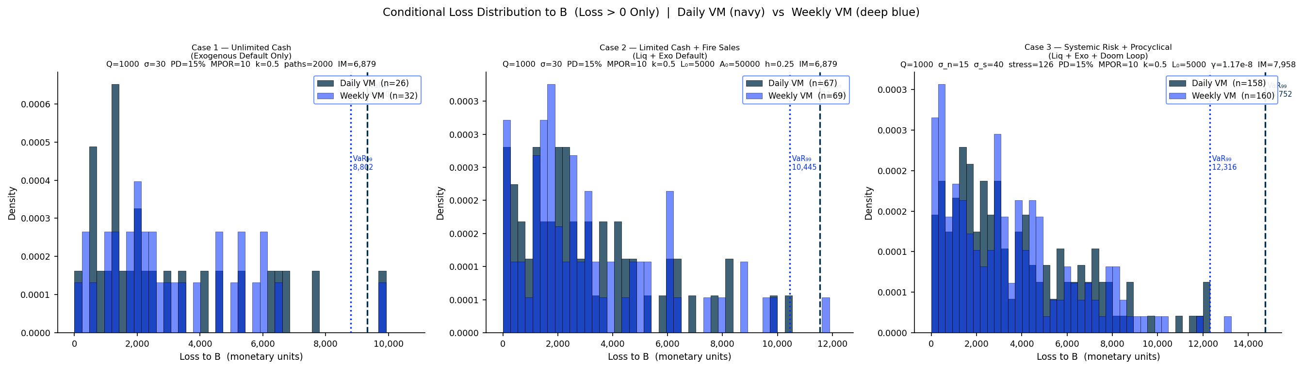
Figure 2 — Conditional loss distribution to B (loss > 0 only) for Cases 1, 2, 3. Navy = daily VM, deep blue = weekly VM. Dashed lines mark VaR99.
Figure 3 decomposes the total default rate into its exogenous and liquidity components for the Fire Sale Model (Case 2) and the Systemic Model (Case 3, no procyclicality) and separately reports total fire sale event counts. The exogenous default rate is approximately 14% in both cases, confirming it is driven solely by the Poisson process and is invariant to the liquidity channel. The liquidity default rate is dramatically higher in Case 3 at 59% versus 20% in Case 2 the doom loop amplifies every marginal fire sale through rising ht. Counterintuitively, Case 2 records more total fire sale events than Case 3: each event in Case 3 is more destructive due to the higher dynamic ht, requiring fewer but larger episodes to exhaust A's assets entirely.

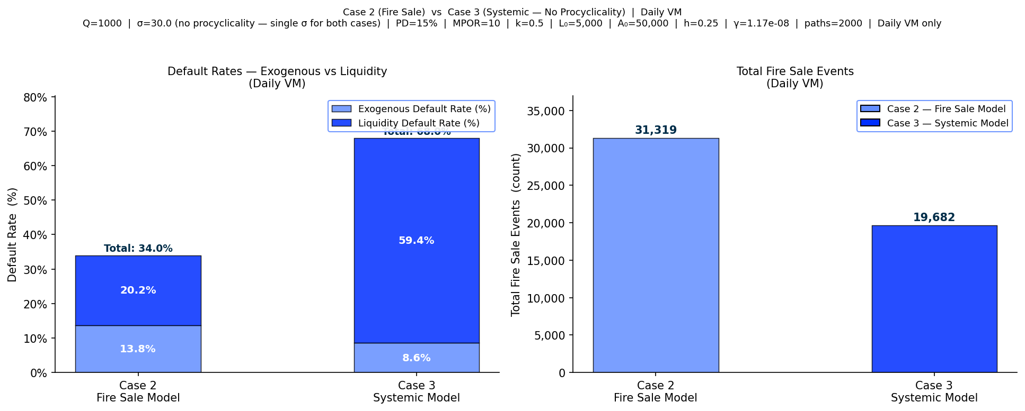
Figure 3 — Left: default rate decomposition (exogenous dark, liquidity light) for Fire Sale Model vs Systemic Model. Right: total fire sale event count. Daily VM.

3. Policy Analysis

3.1 Policy A — Initial Margin Multiplier
Figure 4 sweeps the IM multiplier k from 0.25 to 3.0 across all six variants. The expected loss panel (left) confirms that higher k monotonically reduces B's average loss for Cases 2 and 3, as the larger IM buffer absorbs more of the close-out exposure. However, the VaR99 panel (centre) reveals a critical non-monotonicity: beyond k = 1.0 to 1.5, the 99th percentile of B's loss distribution begins rising again. The mechanism is direct IM is posted from A's initial cash L0, so a higher k at inception reduces the free cash available for subsequent VM calls. When stress arrives, a more cash-constrained A is more likely to exhaust liquidity, triggering fire sales that amplify losses precisely when B's close-out exposure is at its peak. This is the fundamental paradox of the model: the policy instrument designed to protect B eventually destabilises A in a way that harms B. The liquidity default rate panel (right) confirms that higher k raises the liquidity default rate in Cases 2 and 3, with Case 3 showing a sharper response due to doom loop amplification.

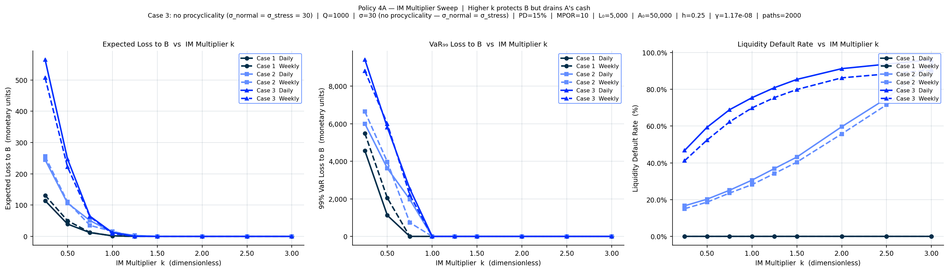
Figure 4 — Policy A: IM multiplier sweeps across all six variants. Left: expected loss. Centre: VaR99 (note non-monotonicity in Cases 2 and 3). Right: liquidity default rate.

3.2 Policy B — Variation Margin Frequency
Figure 5 analyses VM settlement frequency. The left panel shows that weekly calls are approximately 2.2 times larger than daily calls in mean size (3,366 vs 1,509 monetary units) since MTM changes accumulate over five days between settlements. The right panel sweeps frequency from daily to monthly: Case 1 remains flat confirming exogenous defaults are unaffected by settlement timing, while Cases 2 and 3 show a modest increasing trend as larger infrequent calls are harder for cash-constrained investors to absorb. The effect is second-order relative to the IM multiplier sweep, suggesting that settlement frequency is a supporting rather than primary policy lever. Case 3 sits consistently above Case 2 across all frequencies due to systemic amplification.

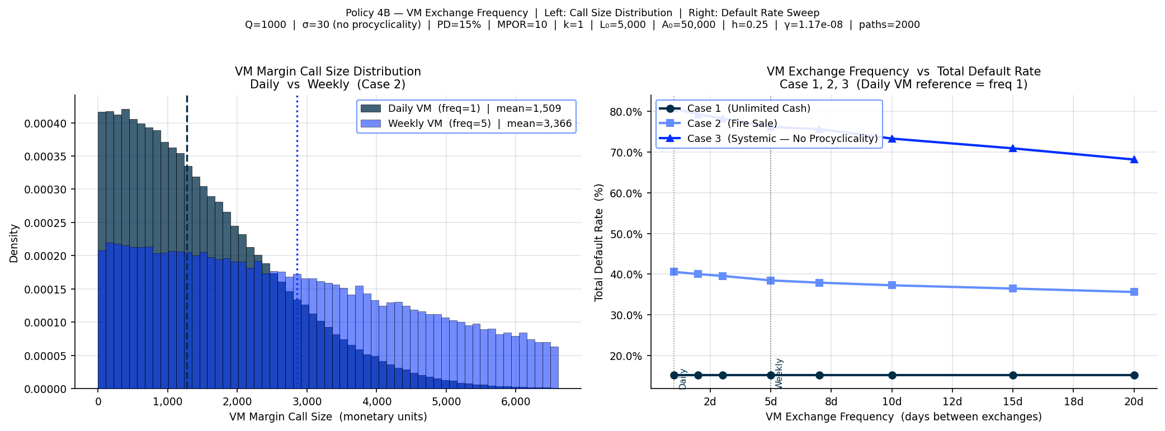
Figure 5 — Policy B: VM exchange frequency. Left: call size distribution for daily vs weekly (Case 2). Right: total default rate vs VM frequency for Cases 1, 2, 3.

3.3 Policy C — Margin Period of Risk
Figure 6 analyses the MPOR across its two roles in the model: it scales the IM through the square-root formula and sets the close-out horizon. Panel 1 (left) shows that both B's Expected Loss and VaR99 rise with MPOR for all cases, with the gap between Case 1 and Cases 2 and 3 widening substantially at longer horizons. Stale VM exposure compounds existing liquidity stress a wider close-out window allows MTM to drift further against B during the default resolution period. Panel 2 (right) isolates the liquidity default channel: Case 3 starts at 45% even at MPOR = 1 and reaches 85% at MPOR = 20, far above Case 2 which rises from 18% to 41%. The divergence between cases widens with MPOR, confirming that reducing the close-out horizon achievable through more efficient post-trade infrastructure delivers a disproportionately large reduction in systemic liquidity default risk.

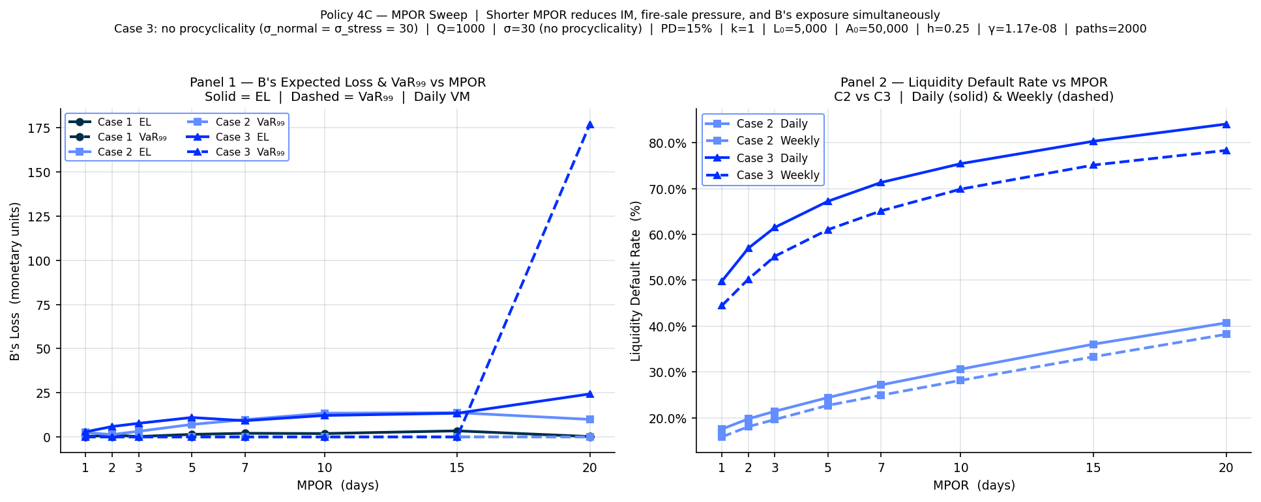
Figure 6 — Policy C: MPOR sweep. Left: B's Expected Loss and VaR99 vs MPOR for Cases 1, 2, 3 (solid = EL, dashed = VaR99). Right: liquidity default rate for Cases 2 and 3 (daily and weekly VM).

3.4 Policy D — Asset Collateral Eligibility
Figure 7 evaluates the policy of allowing A to post illiquid asset units directly as margin collateral, eliminating forced fire sales. The left panel confirms the key benefit: the liquidity default rate collapses from approximately 31% to 13% under asset collateral (daily VM), while the exogenous default rate remains unchanged at 14%. The right panel reveals the cost. Under the Fire Sale Model, B's recovery at close-out clusters tightly around the fixed IM value cash collateral is stable and predictable. Under Asset Collateral, B seizes illiquid asset units whose market value at close-out is uncertain (driven by the asset price GBM path) and is further reduced by the liquidation discount h. The recovery distribution spreads widely and becomes volatile, introducing significant uncertainty into B's own risk management. The policy transfers risk from A to B rather than eliminating it, which has important implications for B's capital requirements and loss provisioning.

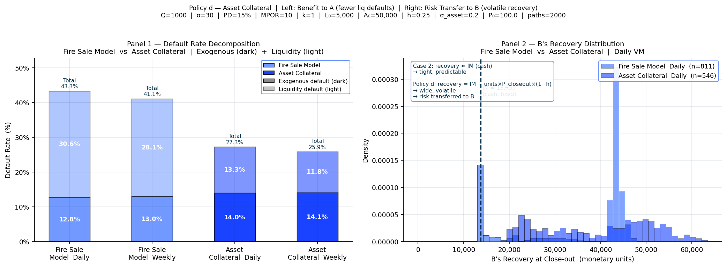
Figure 7 — Policy D: asset collateral. Left: default decomposition showing liquidity defaults collapse under asset collateral. Right: B's recovery distribution — tight for Fire Sale Model, wide for Asset Collateral.

4.1 Procyclicality Risk
A central concern in margin design is procyclicality the phenomenon whereby margin requirements increase during market downturns, exactly when liquidity is most scarce. In the model, procyclicality is captured through the volatility regime switch at day 126. Under the Systemic Model with Procyclicality, the IM is set at inception using the calm-market sigma normal = 15, while actual price moves after day 126 are generated by sigma stress = 40. This creates a structural gap between the margin buffer calibrated at inception and the market stress that materialises. Because the IM is fixed at inception using the theoretical formula, it does not spike when stress arrives instead, the procyclicality manifests as a sudden and severe insufficiency of the existing buffer. Larger post-stress price moves generate larger VM calls that A's depleted cash cannot meet, forcing fire sales that push ht higher faster, triggering more defaults, further depressing asset prices in a self-reinforcing spiral.

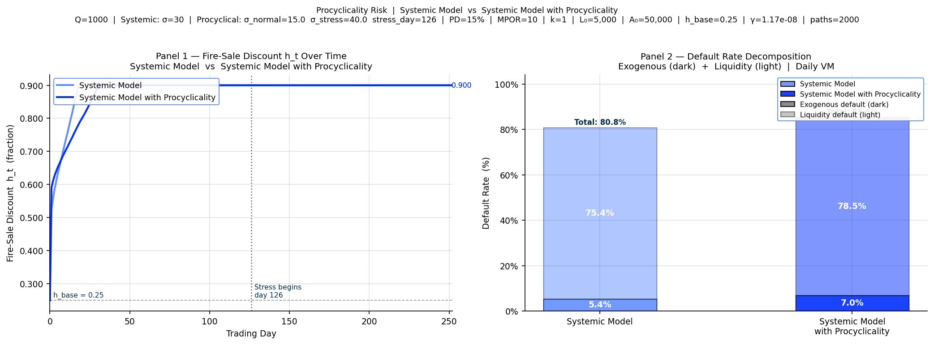
Figure 8 — Procyclicality risk. Left: htover 252 days for Systemic Model (mid-blue) vs Systemic Model with Procyclicality (deep blue) — procyclical case diverges after day 126. Right: default rate decomposition confirming higher liquidity defaults under procyclicality.

Figure 8 confirms this mechanism directly. The ht path under the Systemic Model with Procyclicality diverges after day 126, rising faster and reaching higher levels as sigma stress-driven price moves generate larger VM shortfalls and larger fire sales. The default rate decomposition shows the outcome: the liquidity default rate increases from 75% to 79%, while the exogenous rate is unchanged. The additional defaults are entirely attributable to the volatility regime switch. This finding has direct regulatory relevance: BCBS-IOSCO margining standards require stressed VaR calibration using historical crisis data precisely to prevent IM being systematically underestimated during tranquil periods. The model quantifies the cost of failing to apply this requirement.

4.2 Extra: Anti-Procyclical IM Calibration
The two figures illustrate the fundamental trade-off of anti-procyclical margin calibration. Under the Procyclical model, IM is set at inception using σ_normal = 15, producing IM = 6,951. When volatility switches to σ_stress = 40 at day 126, the buffer is structurally insufficient VM calls exceed A's cash reserves, triggering fire sales and a liquidity default rate of 66.5%. Counterparty B incurs losses in 2.5% of paths with EL = 51 and VaR₉₉ = 1,996. Under Anti-Procyclical calibration, IM rises to 11,585 using σ_stress at inception reducing B's loss incidence by 90% and collapsing EL to near zero. The cost is A's liquidity default rate rising from 66.5% to 71.1% as the larger upfront IM depletes free cash earlier. APC is therefore a direct risk transfer from B to A. This aligns with CPMI-IOSCO PFMI (2012), which mandates collateral haircuts "calibrated to include periods of stressed market conditions" — our model quantifies precisely what that compliance costs in liquidity terms.
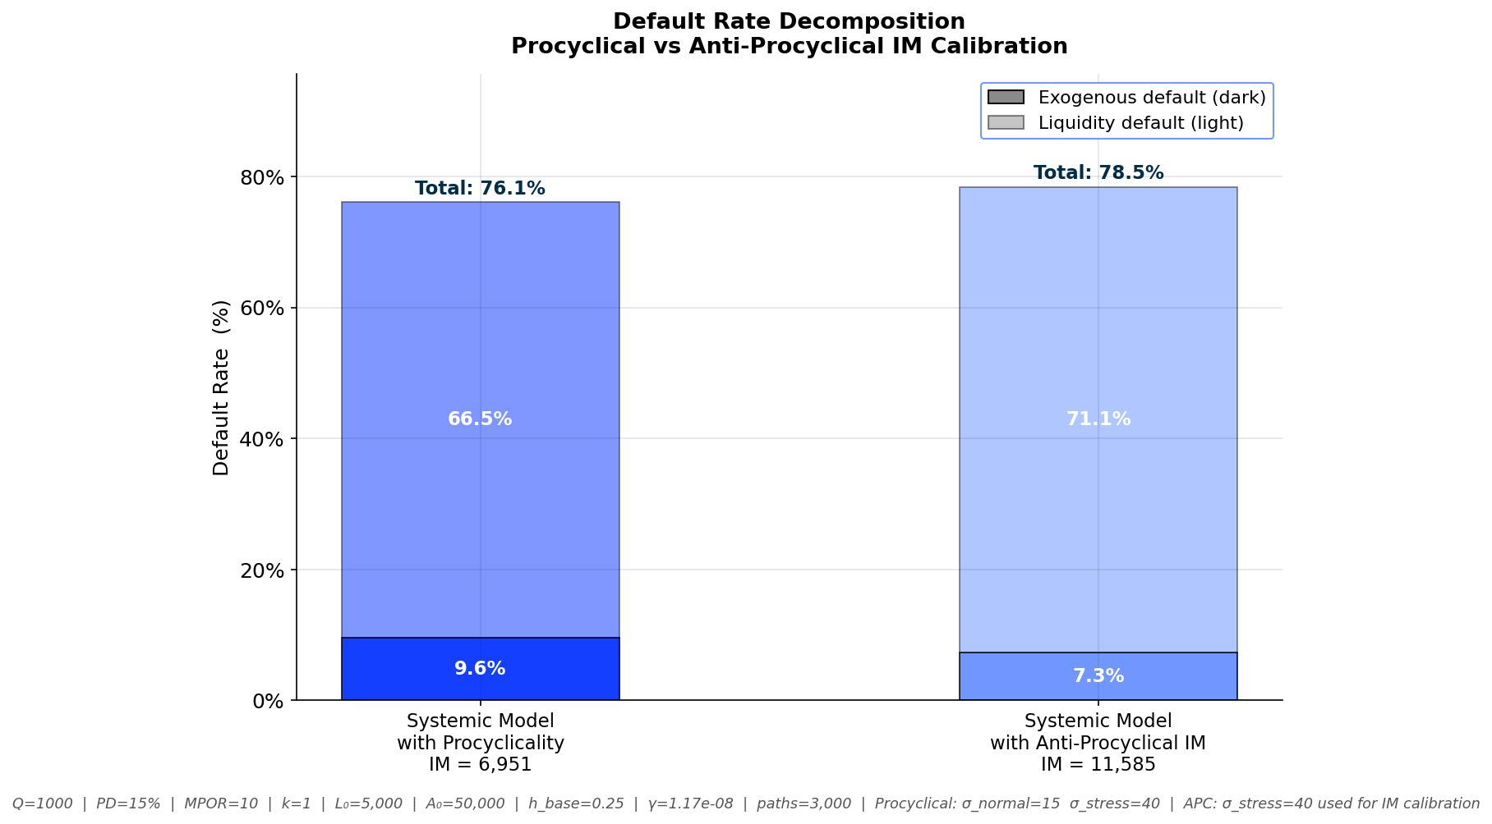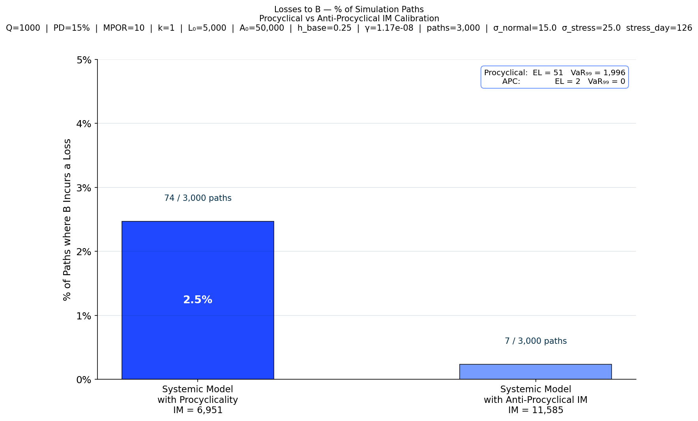

5. Conclusion
This analysis demonstrates that margin design in OTC derivatives involves fundamental trade-offs that no single policy instrument can resolve. A higher IM multiplier initially protects B but eventually destabilises A by depleting its liquidity buffer the non-monotonicity in the VaR99 of Policy A is the clearest illustration of this core paradox. More frequent VM settlement reduces individual call size but has only a second-order effect on default rates. Shorter MPOR delivers disproportionately large systemic benefits, particularly under shared market impact, making post-trade infrastructure efficiency a first-order policy tool. Asset collateral eliminates A's fire-sale risk but transfers volatile, uncertain risk to B in a form that complicates B's own capital planning. Procyclicality amplifies all these effects by timing peak margin stress to coincide with peak market stress.

The central lesson from the model is that systemic risk in margining cannot be addressed by protecting individual counterparties in isolation. Policies that reduce fire sale pressure shorter MPOR, through the cycle margin calibration using stressed volatility, and adequate initial cash buffers deliver the largest aggregate reductions in liquidity default rates because they dampen the feedback loop between margin stress, forced selling, and rising market impact. Effective regulation must therefore account for the systemic externalities of individually rational margin decisions, recognising that what protects one counterparty may destabilise the system.

