Rental Resource Management System (RRMS)
Design Documentation
Java 17 | Spring Boot | Spring Data JPA / Hibernate | MySQL | Maven | Java Swing

1. Problem Statement and Project Purpose
Managing rental resources, customer details and rental transactions with paper registers or spreadsheets is slow and error-prone. Records can be duplicated, lost or entered inconsistently, it is difficult to know which resource was rented by which customer and when it was returned, and invalid data such as incorrect phone numbers or negative prices goes unchecked.
The Rental Resource Management System (RRMS) addresses these problems by storing resources, customers and rentals in a central MySQL database. A Spring Boot REST back end applies input validation and handles add, view, update and delete operations, and a Java Swing desktop interface lets the user perform these operations without using the database directly.

2. Layered Architecture
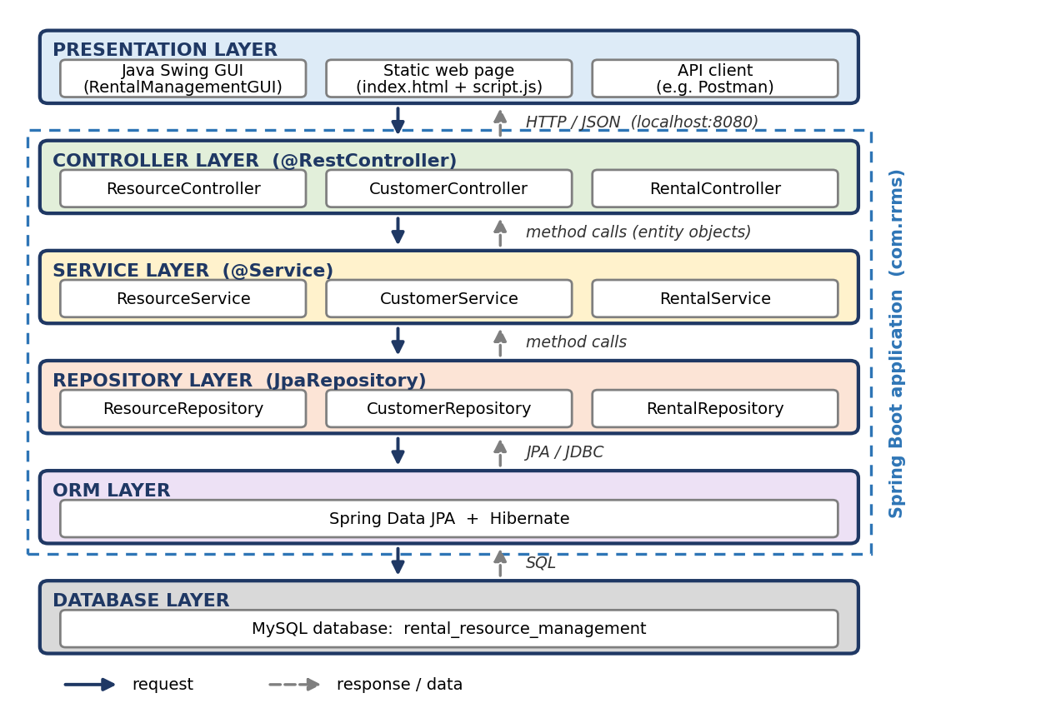
Figure 1: Layered architecture of RRMS
Layer | Purpose (as implemented)
Presentation | User interaction. The Swing GUI (RentalManagementGUI) sends HTTP requests to http://localhost:8080 using Java's HttpClient. The static web page and API clients such as Postman use the same REST API.
Controller | ResourceController, CustomerController and RentalController (@RestController) receive requests, validate the request body (@Valid) and return responses.
Service | ResourceService, CustomerService and RentalService hold the application logic, e.g. checking that a record exists before updating or deleting it.
Repository | ResourceRepository, CustomerRepository and RentalRepository extend JpaRepository and provide database access.
ORM / Database | Spring Data JPA with Hibernate maps the entities to tables in the MySQL database rental_resource_management.

3. Entity Description and ER Diagram
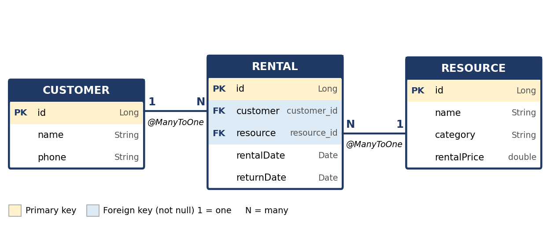
Figure 2: ER diagram of RRMS (attribute names as in the entity classes, package com.rrms.model)
Entity | Attributes | Key and validation
Customer | id, name, phone | PK: id (auto-generated). name is required; phone is required and must contain 10 digits.
Resource | id, name, category, rentalPrice | PK: id (auto-generated). name and category are required; rentalPrice cannot be negative.
Rental | id, customer, resource, rentalDate, returnDate | PK: id (auto-generated). FK customer_id and FK resource_id (both not null). rentalDate is required; returnDate is optional (DATE type).
Relationships. Rental is the linking entity. It holds a @ManyToOne reference to Customer through the foreign key customer_id, and a @ManyToOne reference to Resource through the foreign key resource_id. Therefore:
- Customer to Rental is one-to-many: one customer can have many rentals, and each rental belongs to exactly one customer.
- Resource to Rental is one-to-many: one resource can appear in many rentals, and each rental is for exactly one resource.
- Customer and Resource are therefore related indirectly (many-to-many) through Rental.
The relationships are unidirectional: Customer and Resource do not hold references back to Rental.

