SMART STUDY PLANNER
- Overview
The Smart Study Planner is a console-based Python programme that lets a student log, review and analyses study sessions across different subjects over a semester. It uses a menu-driven interface built around a main() loop, and it persists data to a plain text file (study_log.txt) so that sessions logged in one run are still available the next time the programme is started.

- Programme Structure
The solution is organized into small, single-purpose functions rather than one long block of code, as summarized below:
Function | Purpose
main() | Displays the menu in a loop, routes the user's choice to the correct function, and rejects invalid input without crashing.
add_session() | Collects subject, topic, date/day label and duration from the user; re-prompts until the duration entered is a valid positive number; stores the entry as a dictionary in the session’s list.
classify_session(duration) | Returns 'Short' (<30 min), 'Medium' (30-90 min) or 'Long' (>90 min) using conditionals. Called automatically by every function that displays a session.
view_sessions() | Prints every logged session as a formatted table (subject, topic, date, duration, classification).
search_by_subject(subject) | Performs a case-insensitive match on subject name, lists matching sessions and the total time spent, or shows a clear message if none are found.
study_statistics() | Calculates total hours overall, total hours per subject, the weakest subject (least total time) and the single longest session.
save_sessions() | Writes every session to study_log.txt (pipe-delimited) when the user chooses to exit.
load_sessions() | Reads study_log.txt at startup and rebuilds the session’s list; does nothing (instead of crashing) if the file does not yet exist.

- How the Requirements Were Met

- Menu-driven interface
Main () prints a numbered menu (Add a session, View all sessions, Search by subject, View statistics, Save & exit) inside a while True loop. Any input that is not 1-5 falls through to an 'Invalid choice' message and the menu simply reappears, so the programme never crashes on bad input.
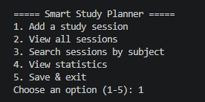
- add_session()
Subject, topic, date/day label and duration are collected with input(). The duration is parsed inside a validation loop: non-numeric text raises a caught ValueError and re-prompts, and any value that is zero or negative also triggers a re-prompt, so only a valid positive number is ever stored.
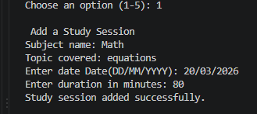
- classify_session(duration)
A single function applies the Short/Medium/Long rule with simple if/elif/else conditionals. Because view_sessions(), search_by_subject() and study_statistics() all call this same function, the classification logic exists in exactly one place.
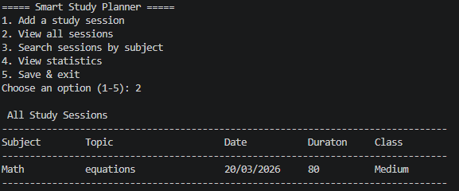
- view_sessions()
Iterates over the sessions list and prints an aligned table (using Python's string formatting) with subject, topic, date, duration and classification for every entry.
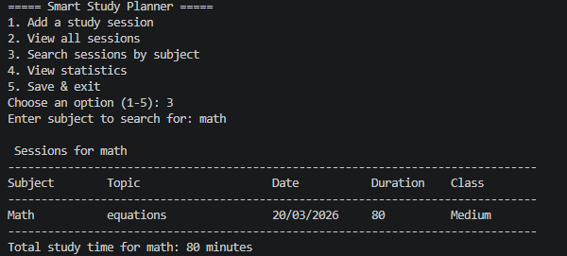
- search_by_subject(subject)
Filters the sessions list using subject.lower() comparisons so matching ignores case, prints the matching rows and their combined total time, and prints a clear 'No sessions found' message when the filter returns nothing.
- study_statistics()
Computes the overall total, a per-subject total using a dictionary, the subject with the smallest total (identified with min() and a key function) as the weakest area, and the single longest session using max().
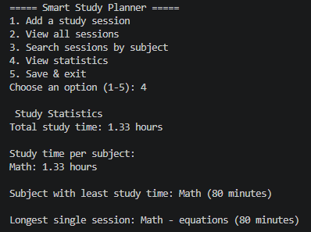
- save_sessions() and load_sessions()
save_sessions() writes one pipe-delimited line per session to study_log.txt when the user selects 'Save & exit'. load_sessions() is called once at startup; it checks oj.path.exists() first, so a missing file on the very first run is handled gracefully instead of causing a crash, and any malformed line encountered while parsing is skipped rather than raising an error.
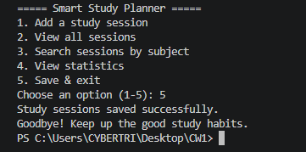
- Code quality and structure
The programme is split into well-named functions, each with a docstring, inline comments explain non-obvious logic (e.g. the validation loops and the min()/max() statistics), and the entry point is guarded with if __name__ == "__main__": so the module can also be imported without side effects.
- Testing Performed
- Added multiple sessions across different subjects and confirmed correct Short/Medium/Long classification.
- Entered negative numbers and non-numeric text for duration and confirmed the programme kept re-prompting instead of crashing.
- Searched for a subject that exists (case-insensitive) and one that does not, confirming both the results table and the 'no sessions found' message.
- Verified study_statistics() correctly identified the weakest subject and the longest session.
- Exited and restarted the programme to confirm sessions saved to study_log.txt were automatically reloaded.
- Deleted study_log.txt and started the programme to confirm it starts cleanly with no sessions rather than crashing.
- Entered an invalid menu option (e.g. 9) and confirmed the menu simply reappeared with an error message.

