SOFTWARE DESIGN DOCUMENT

presence.if.its.ac.id

intended for:
Teknik Informatika ITS

Prepared by:
Muhammad Rifatullah 5114100118
Aditya Ikhsan 5114100186

Jurusan Teknik Informatika - Institut Teknologi Sepuluh Nopember

Kampus ITS Keputih Sukolilo Surabaya

 | Jurusan  Teknik Informatika ITS | Nomor Dokumen |  | Halaman
 | Jurusan  Teknik Informatika ITS | DPPL-XXX |  | hlm / # hlm
 | Jurusan  Teknik Informatika ITS | Revisi | - | Tgl release
DAFTAR PERUBAHAN
Revisi | Deskripsi
A
B
C
D
E
F
G

INDEX  TGL | - | A | B | C | D | E | F | G
Ditulis oleh
Diperiksa oleh
Disetujui oleh

Daftar Halaman Perubahan
Halaman | Revisi | Halaman | Revisi

Daftar Isi
Daftar Isi 4
1. Pendahuluan 5
1.1 Tujuan Penulisan Dokumen 5
1.2 Lingkup Masalah 5
1.3 Definisi dan Istilah 5
1.4 Aturan Penamaan dan Penomoran 5
1.5 Referensi 5
1.6 Ikhtisar Dokumen 5
2 Deskripsi Perancangan Global (Arsitektural) 6
2.1 Diagram Kasus Penggunaan (Use Case) 6
2.2 Rancangan Lingkungan Implementasi 6
2.3 Deskripsi Persistensi Objek (Basis Data) 6
2.3.1 Physical Data Model 6
2.4 Dekomposisi Sistem 6
2.4.1 Subsistem 1: <Nama Subsistem> 6
2.4.2 Subsistem 2: <nama Subsistem> 6
2.5 Arsitektur Sistem 6
2.5.1 Diagram Komponen 6
2.5.2 Diagram Deployment 6
3 Deskripsi Perancangan Rinci 6
3.1 Deskripsi Antarmuka/Layar 6
3.2 Deskripsi Rinci Kelas-kelas 6
3.3 Dekomposisi Fisik Modul 7
3.4 Matriks Kerunutan 7

1. Foreword

Document Objective
This document contains Software Requirement Specification for student presence system. The purpose of writing this document is to give detailed explanation about the software that is going to be built.
This document is going to be used as a foundation when developing the software and as an evaluation medium during the development process. Through this document, the development process is expected to be in order and detailed so that no ambiguity will arise for the developers of this software.

Problem Scope
The student presence system in Informatics Department is a web based information system. This system is capable of doing the following stuff:
- Store presence information in Informatics Department
- Input media for verifying student presence in Informatics Department
This system is expected to make student easier to see their own presence history and make presence more original and validated.

Definition and Term
Here are the following definition list and important terms that is used in this document:
- SRS : Software Requirements Specification, atau
SKPL : Spesifikasi Kebutuhan Perangkat Lunak
Dokumen hasil analisis yang berisi spesifikasi kebutuhan perangkat lunak.
- IEEE : Institute of Electrical and Electronics Engineering
Standar internasional untuk pengembangan dan perancangan produk.
- ANSI : American National Standard Institute
Lembaga Standardisasi Amerika.
- TBD : To Be Defined
- LAN : Local Area Network
- SIBES : Sistem Informasi Beasiswa

Naming and Numbering Rule
This document uses a variation of naming and numbering for specific section. The naming and numbering is based on the table below

Hal/Bagian | Aturan Penomoran/Penamaan
Functional Requirement | SKPL-FXX : Menunjukkan kebutuhan fungsional ke-XX
Non Functional Requirement | SKPL-NFXX : Menunjukkan kebutuhan non fungsional ke-XX
Functional Requirement Summary | SKPL-Fxxxdimana xxx adalah tiga digit bilangan bulat dimulai dari 000
Non Functional Requirement Summary | SKPL-NFxxxdimana xxx adalah tiga digit bilangan bulat dimulai dari 000
Table 1-1 Naming and Numbering Rule

Reference
The following documents are used as a reference for this SRS
- Software Requirement Spesification Document (SRS) – IEEE 1999 by Karl E. Wiegers.
- Panduan Penggunaan dan Pengisian Spesifikasi Perangkat Lunak (SKPL), Jurusan Teknik Informatika, Institut Teknologi Sepuluh November.
- Panduan Penggunaan dan Pengisian Spesifikasi Perangkat Lunak (SKPL), Jurusan Teknik Informatika, Institut Teknologi Bandung.

Document Summary

Dokumen ini secara garis besar terdiri dari tiga bab dengan perincian sebagai berikut:
- Chapter 1 Foreword, discuss about the introduction of this SRS document. The content of the foreword are document objective, problem scope, definition and term, naming and numbering rule, reference and document summary
- Chapter 2 Software General Description. Discuss about the definition of the software and also the assumption and dependencies that is used in the making of this software
- Chapter 3 Functional Description. Discuss about the specific requirements of this software including user interface, functional requirement, non functional requirement, software attribute, performance requir

Deskripsi Perancangan Global (Arsitektural)

Deskripsi Umum Sistem
Berikan gambaran umum system berupa fungsionalitas serta latar belakang pengembangan.
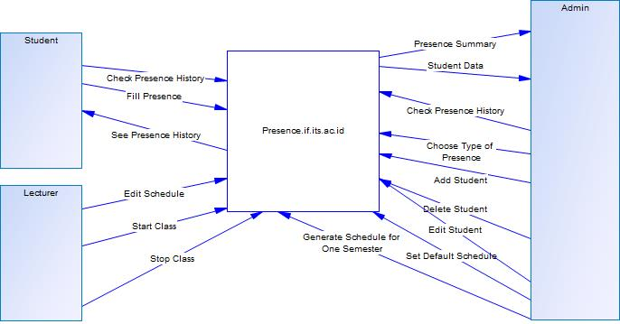

Matriks Kebutuhan
Menyediakan matriks yang menelusuri komponen sistem yang berasa dari SKPL. Menggunakan format tabular berisi daftar fungsionalitas dari SKPL dengan pengkodean seperti yang terdapat di SKPL
SKPL-Id | Keterangan
SKPL-F000 | See summary of presence in each class
SKPL-F001 | See presence history of every student
SKPL-F002 | See presence data of the student
SKPL-F003 | Add new user
SKPL-F004 | Edit user
SKPL-F005 | Delete user
SKPL-F006 | Set presence type
SKPL-F007 | Fill presence by scanning KTM
SKPL-F008 | Start Class
SKPL-F009 | Stop Class
SKPL-F010 | Edit Schedule
SKPL-F011 | Set Default Schedule
SKPL-F012 | Generate schedule for one semester
SKPL-F013 | Choose Type of Presence

Rancangan Lingkungan Implementasi

-Sistem Operasi:
Sistem Informasi yang digunakan

-Bahasa Pemrograman:
PHP (Framework Laravel (MVC))

-Desain:
HTML, CSS, Javascript

-DBMS:
PostgreSQL

Arsitektur Sistem

Perancangan Arsitektur
Pada bagian ini dijelaskan struktur modular sistemdan hubungan antar modul yang membangun sistem. Bagian ini merupakan level tingkat tinggi mengenai bagian-bagian system

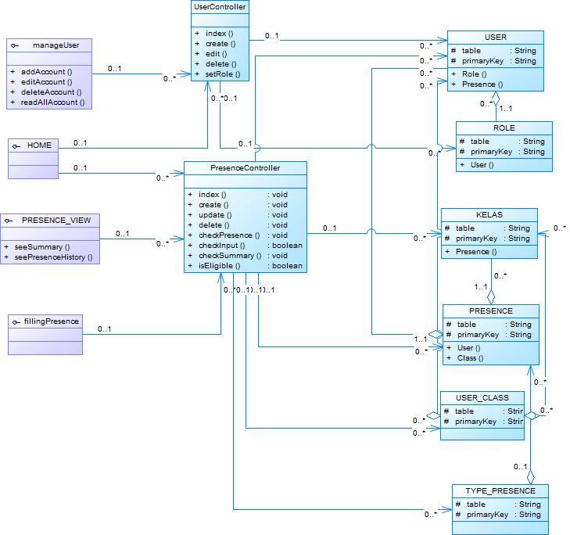

Dekomposisi Sistem
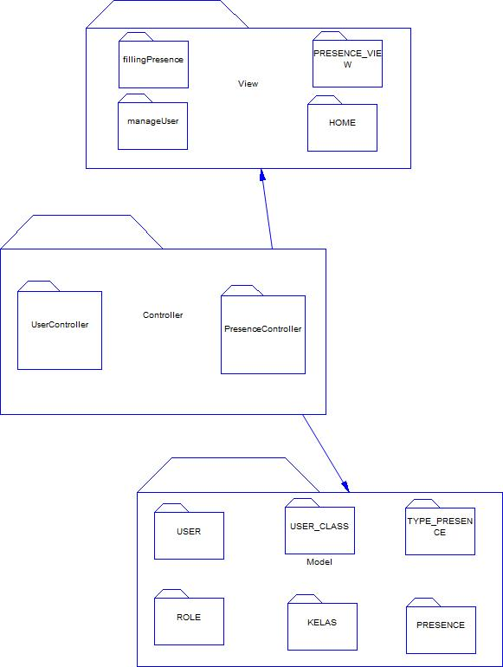

Subsistem 1: <Nama Subsistem>

Subsistem 2: <nama Subsistem>

Subsistem 3: <nama Subsistem>

Diagram Komponen
Berisi diagram komponen

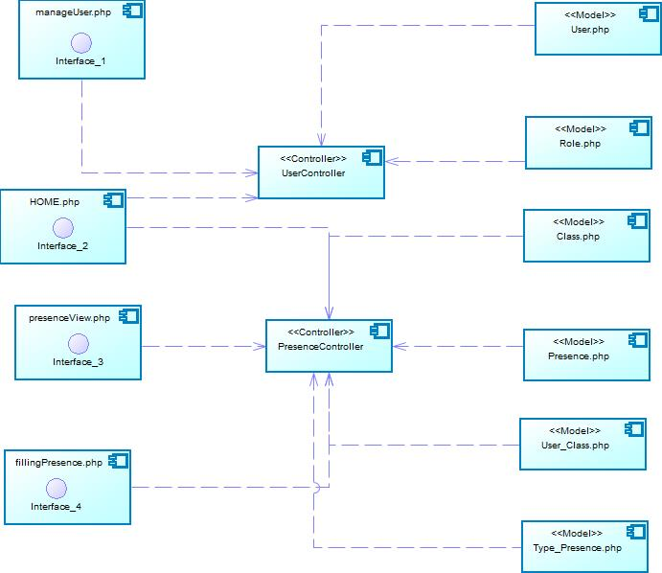

Diagram Deployment

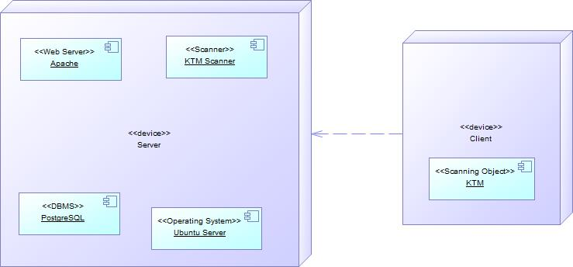

Perancangan Data

Physical Data Model
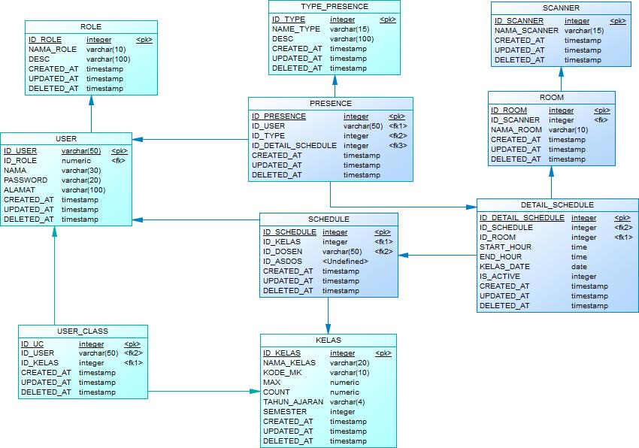

Kamus Data
Berisi daftar entitas system yang disusun secara alphabet beserta dengan tipe data dan deskripsinya

Deskripsi Perancangan Rinci

Deskripsi Antarmuka/Layar
Berisi rancangan antarmuka seluruh sistem

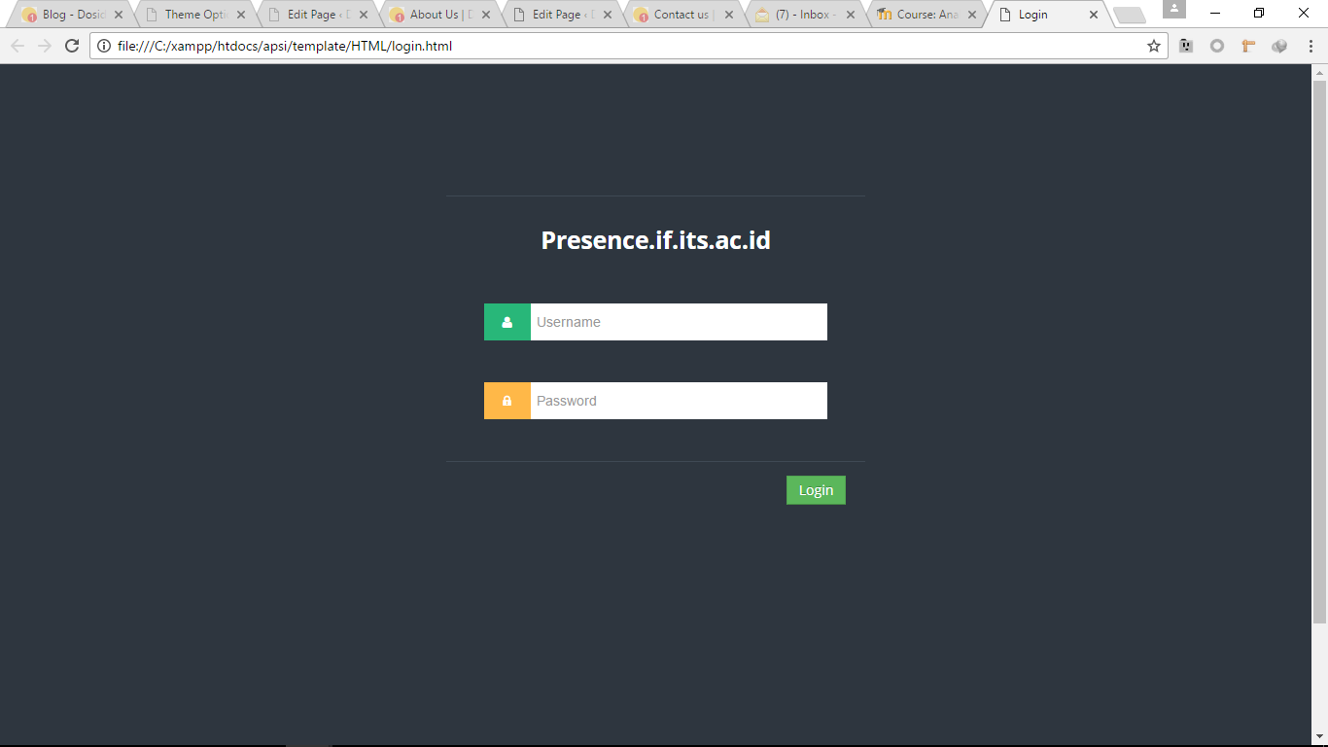

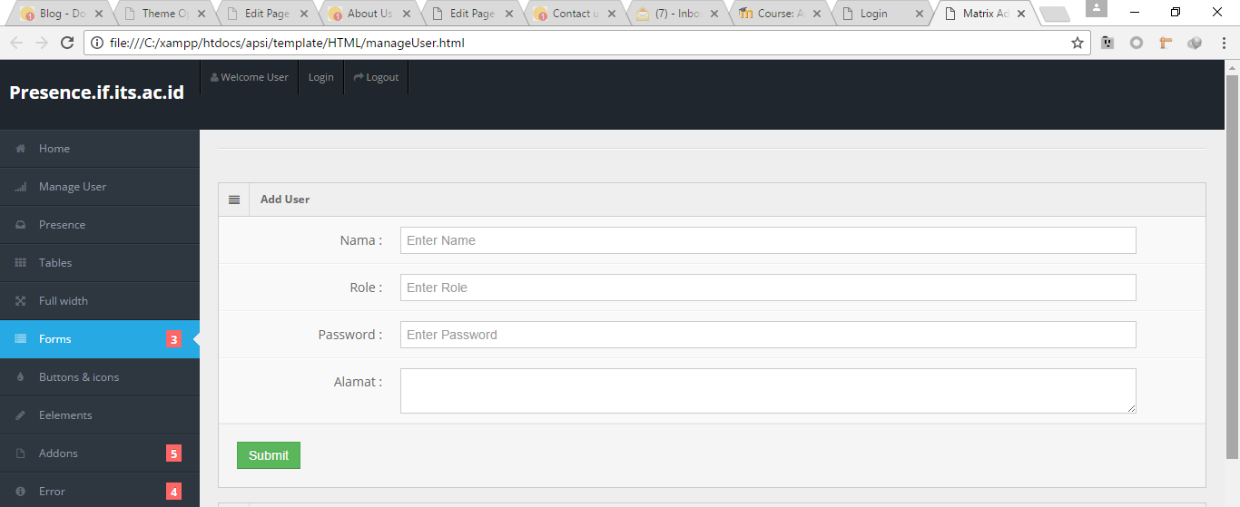

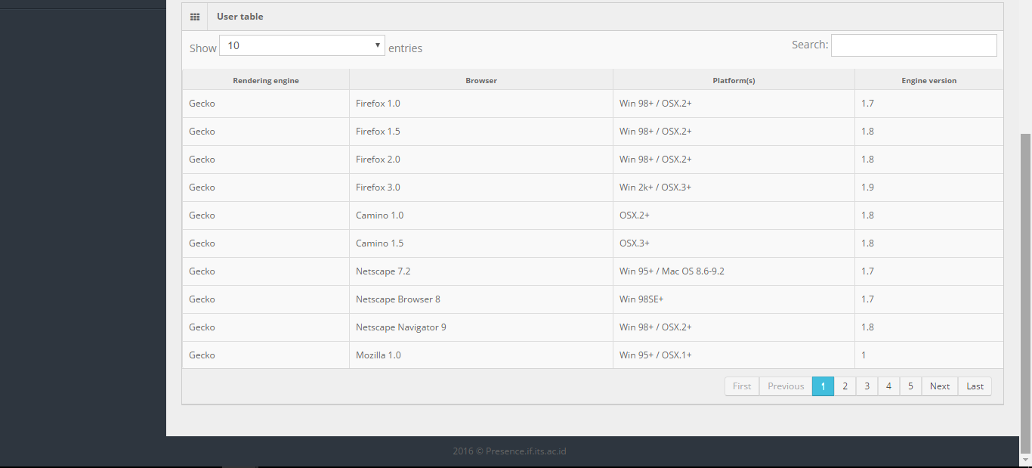

Dekomposisi Fisik Modul

Nama Direktori | Nama File (dan ekstensinya) | Keterangan

Appendix
[Optional]

