SOFTWARE DESIGN DOCUMENT

presence.if.its.ac.id

intended for:
Teknik Informatika ITS

Prepared by:
Muhammad Rifatullah 5114100118
Aditya Ikhsan 5114100186

Jurusan Teknik Informatika - Institut Teknologi Sepuluh Nopember

Kampus ITS Keputih Sukolilo Surabaya

 | Jurusan  Teknik Informatika ITS | Nomor Dokumen |  | Halaman
 | Jurusan  Teknik Informatika ITS | DPPL-XXX |  | hlm / # hlm
 | Jurusan  Teknik Informatika ITS | Revisi | - | Tgl release
DAFTAR PERUBAHAN
Revisi | Deskripsi
A
B
C
D
E
F
G

INDEX  TGL | - | A | B | C | D | E | F | G
Ditulis oleh
Diperiksa oleh
Disetujui oleh

Daftar Halaman Perubahan
Halaman | Revisi | Halaman | Revisi

Table of Contents
Table of Contents 4
1. Foreword 6
1.1 Document Objective 6
1.2 Problem Scope 6
1.3 Definition and Term 6
1.4 Naming and Numbering Rule 6
1.5 Reference 7
1.6 Document Summary 7
2 Global Planning Description 7
2.1 General System Description 8
2.2 Requirement Matrix 8
2.3 Environment Design Implementation 8
3 System Architecture 9
3.1 Architecture Design 9
3.1.1 Subsistem 1: <View> 12
3.1.2 Subsistem 2: <Controller> 12
3.1.3 Subsistem 3: <Model> 12
4 Component Diagram 13
5 Deployment Diagram 14
6 Data Design 14
6.1 Physical Data Model 14
6.2 Data Dictionary 15
7 Detailed Design Description 16
7.1 Interface Description 16
7.1.1 Interface <User Login> 16
7.1.1.1 Interface Specification 16
7.1.1.2 Interface Element Specification 17
7.1.1.3 Interface Object Design 17
7.1.2 Interface <scannerview> 17
7.1.2.1 Interface Specification 18
7.1.2.2 Interface Element Specification 19
7.1.2.3 Interface Object Design 19
7.1.3 Interface <manageUser> 19
7.1.3.1 Interface Specification 20
7.1.3.2 Interface Element Specification 20
7.1.3.3 Interface Object Design 20
7.1.4 Interface <schedule> 20
7.1.4.1 Interface Specification 20
7.1.4.2 Interface Element Specification 21
7.1.4.3 Interface Object Design 21
7.1.5 Interface <Input presence> 21
7.1.5.1 Interface Specification 22
7.1.5.2 Interface Element Specification 22
7.1.5.3 Interface Object Design 22
7.1.6 Interface <Edit Schedule> 22
7.1.6.1 Interface Specification 23
7.1.6.2 Interface Element Design 23
7.1.6.3 Interface Object Design 23
7.1.7 Interface <Add User> 23
7.1.7.1 Interface Specification 24
7.1.7.2 Interface Element Design 24
7.1.7.3 Interface Object Design 24
7.1.8 Interface <Edit User> 24
7.1.8.1 Interface Specification 25
7.1.8.2 Interface Element Design 25
7.1.8.3 Interface Object Design 25
7.1.9 Interface <Detail Schedule> 25
7.1.9.1 Interface Specification 26
7.1.9.2 Interface Element Design 26
7.1.9.3 Interface Object Design 26
7.1.10 Interface <Presence History> 26
7.1.10.1 Interface Specification 27
7.1.10.2 Interface Element Specification 27
7.1.10.3 Interface Object Design 27
7.2 Physical Module Decomposition 27

1. Foreword

Document Objective
This document contains Software Design Document for student presence system. The purpose of writing this document is to give detailed explanation about the software that is going to be built.
This document is going to be used as a foundation when developing the software and as an evaluation medium during the development process. Through this document, the development process is expected to be in order and detailed so that no ambiguity will arise for the developers of this software.

Problem Scope
The student presence system in Informatics Department is a web based information system. This system is capable of doing the following stuff:
- Store presence information in Informatics Department
- Input media for verifying student presence in Informatics Department
This system is expected to make student easier to see their own presence history and make presence more original and validated.

Definition and Term
Here are the following definition list and important terms that is used in this document:
- SRS : Software Requirements Specification, atau
SKPL : Spesifikasi Kebutuhan Perangkat Lunak
Dokumen hasil analisis yang berisi spesifikasi kebutuhan perangkat lunak.
- IEEE : Institute of Electrical and Electronics Engineering
Standar internasional untuk pengembangan dan perancangan produk.
- ANSI : American National Standard Institute
Lembaga Standardisasi Amerika.
- TBD : To Be Defined
- LAN : Local Area Network
- SIBES : Sistem Informasi Beasiswa

Naming and Numbering Rule
This document uses a variation of naming and numbering for specific section. The naming and numbering is based on the table below

Hal/Bagian | Aturan Penomoran/Penamaan
Functional Requirement | SKPL-FXX : Menunjukkan kebutuhan fungsional ke-XX
Non Functional Requirement | SKPL-NFXX : Menunjukkan kebutuhan non fungsional ke-XX
Functional Requirement Summary | SKPL-Fxxxdimana xxx adalah tiga digit bilangan bulat dimulai dari 000
Non Functional Requirement Summary | SKPL-NFxxxdimana xxx adalah tiga digit bilangan bulat dimulai dari 000
Table 1-1 Naming and Numbering Rule

Reference
The following documents are used as a reference for this SRS
- Software Requirement Spesification Document (SRS) – IEEE 1999 by Karl E. Wiegers.
- Panduan Penggunaan dan Pengisian Spesifikasi Perangkat Lunak (SKPL), Jurusan Teknik Informatika, Institut Teknologi Sepuluh November.
- Panduan Penggunaan dan Pengisian Spesifikasi Perangkat Lunak (SKPL), Jurusan Teknik Informatika, Institut Teknologi Bandung.

Document Summary

Dokumen ini secara garis besar terdiri dari tiga bab dengan perincian sebagai berikut:
- Chapter 1 Foreword, discuss about the introduction of this SRS document. The content of the foreword are document objective, problem scope, definition and term, naming and numbering rule, reference and document summary
- Chapter 2 Software General Description. Discuss about the definition of the software and also the assumption and dependencies that is used in the making of this software
- Chapter 3 Functional Description. Discuss about the specific requirements of this software including user interface, functional requirement, non functional requirement, software attribute, performance requir

Global Planning Description

General System Description
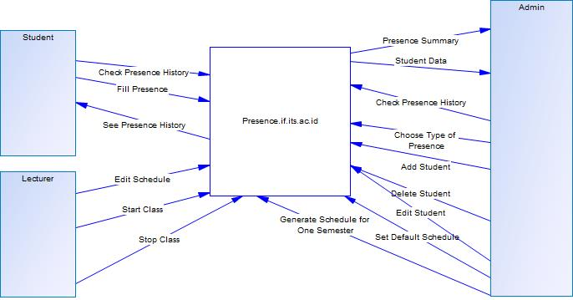

Requirement Matrix

SKPL-Id | Keterangan
SKPL-F000 | See summary of presence in each class
SKPL-F001 | See presence history of every student
SKPL-F002 | See presence data of the student
SKPL-F003 | Add new user
SKPL-F004 | Edit user
SKPL-F005 | Delete user
SKPL-F006 | Set presence type
SKPL-F007 | Fill presence by scanning KTM
SKPL-F008 | Start Class
SKPL-F009 | Stop Class
SKPL-F010 | Edit Schedule
SKPL-F011 | Set Default Schedule
SKPL-F012 | Generate schedule for one semester
SKPL-F013 | Choose Type of Presence

Environment Design Implementation

-Sistem Operasi:
Sistem Informasi yang digunakan

-Bahasa Pemrograman:
PHP (Framework Laravel (MVC))

-Desain:
HTML, CSS, Javascript

-DBMS:
PostgreSQL

System Architecture

Architecture Design
Pada bagian ini dijelaskan struktur modular sistemdan hubungan antar modul yang membangun sistem. Bagian ini merupakan level tingkat tinggi mengenai bagian-bagian system

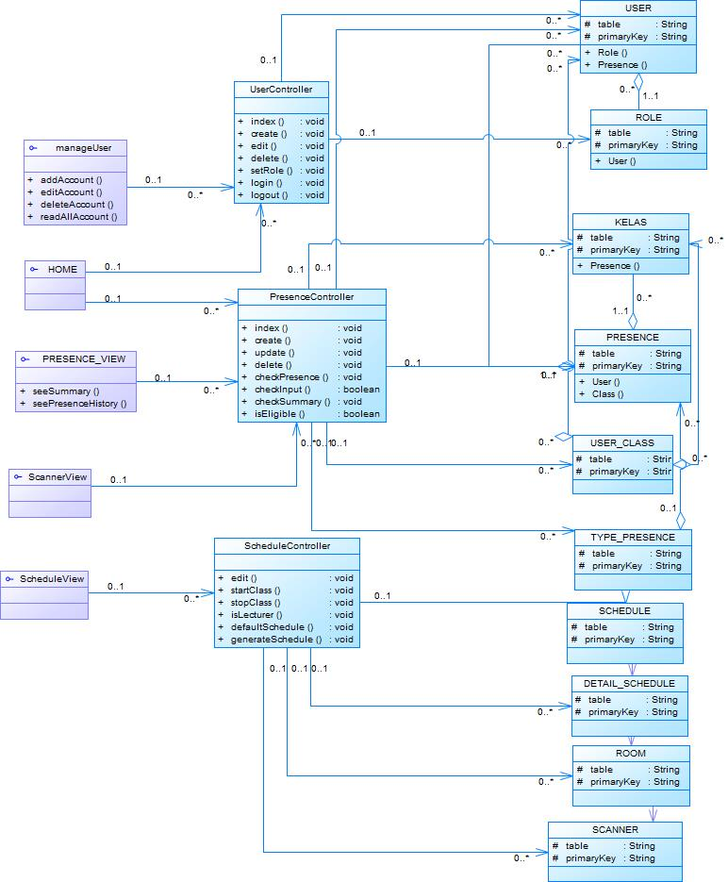 Dekomposisi Sistem
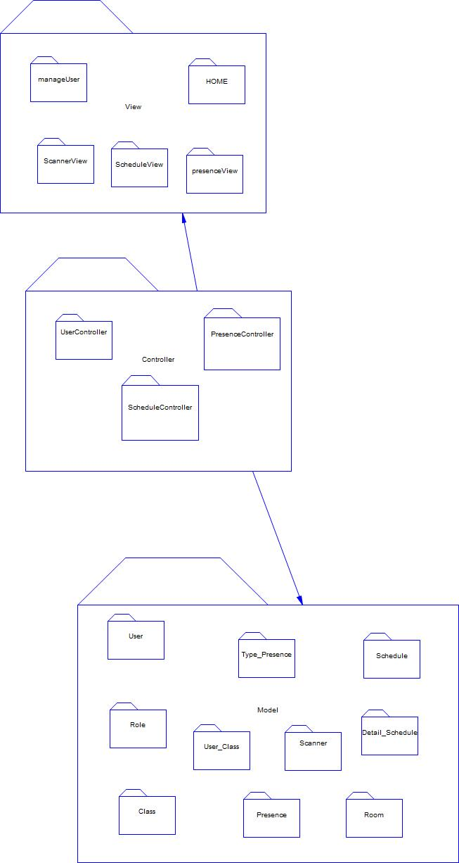

Subsistem 1: <View>

Subsistem 2: <Controller>

Subsistem 3: <Model>

Component Diagram

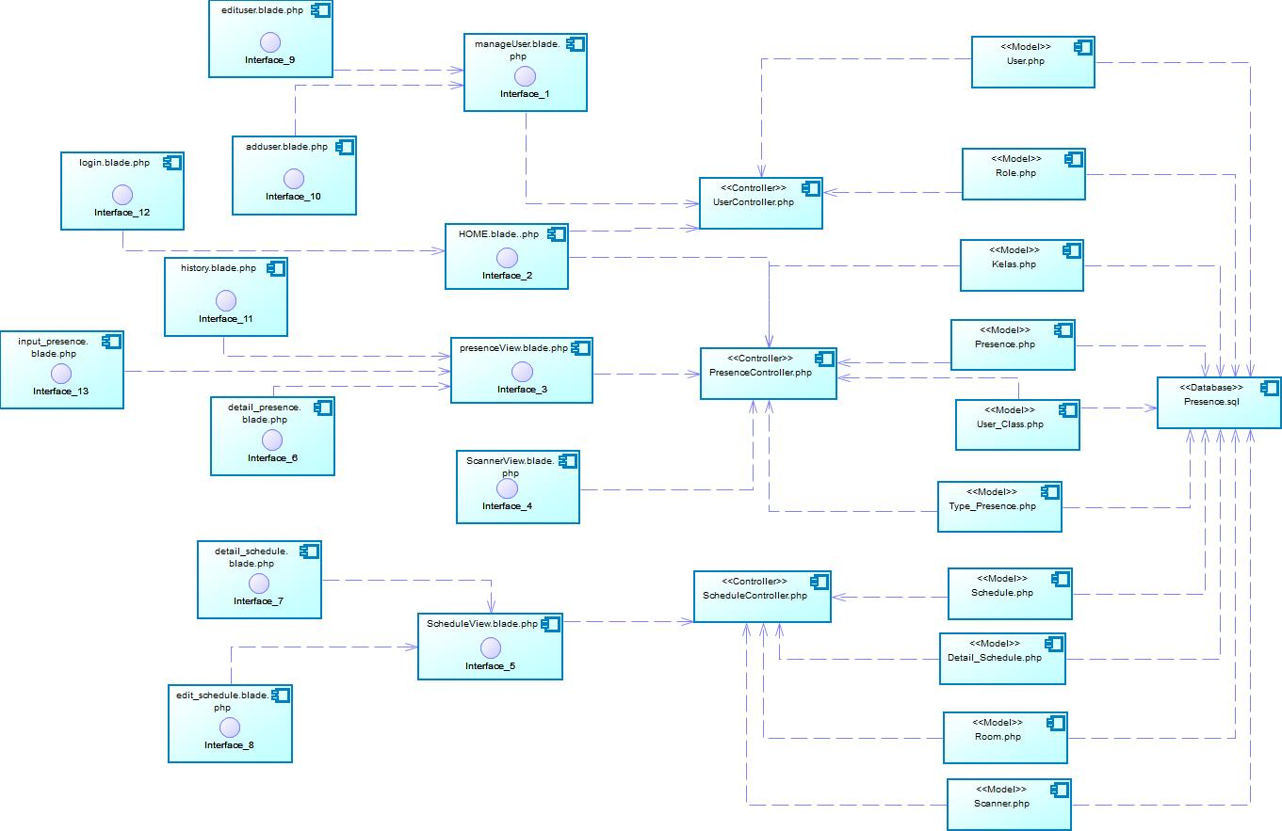

Deployment Diagram

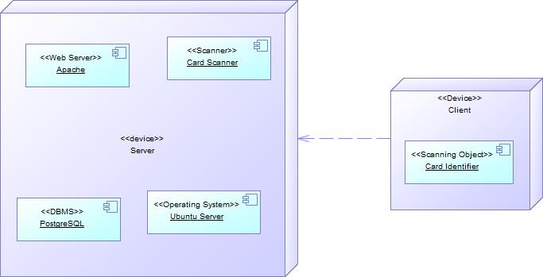

Data Design

Physical Data Model
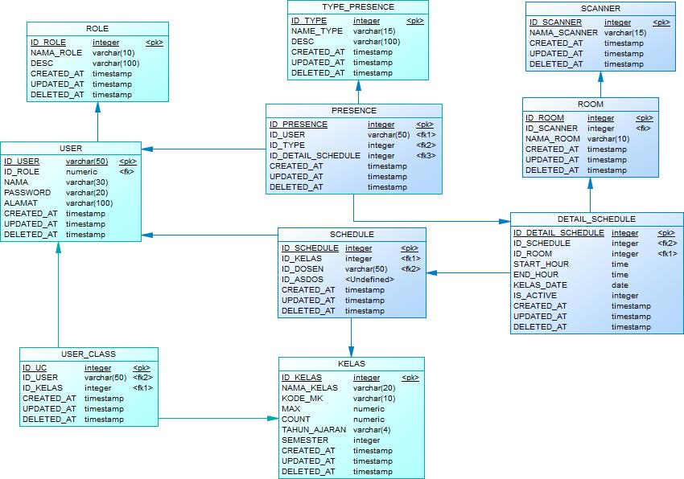

Data Dictionary

Table | Field | Type | Null | Default
Role | ID_ROLE | Integer | No | Autoincrement
 | NAMA_ROLE | Varchar(10) | No | Null
 | DESC | Varchar(100) | No | Null
 | CREATED_AT | Timestamp | No | Null
 | UPDATED_AT | Timestamp | No | Null
 | DELETED_AT | Timestamp | No | Null
USER | ID_USER | Varchar(50) | No | Null
 | NAMA | Varchar(30) | No | Null
 | PASSWORD | Varchar(20) | No | Null
 | ALAMAT | Varchar(100) | No | Null
 | CREATED_AT | Timestamp | No | Null
 | UPDATED_AT | Timestamp | No | Null
 | DELETED_AT | Timestamp | No | Null
USER_CLASS | ID_UC | Integer | No | Autoincrement
 | CREATED_AT | Timestamp | No | Null
 | UPDATED_AT | Timestamp | No | Null
 | DELETED_AT | Timestamp | No | Null
TYPE_PRESENCE | ID_TYPE | Integer | No | Autoincrement
 | NAME_TYPE | Varchar(15) | No | Null
 | DESC | Varchar(100) | No | Null
 | CREATED_AT | Timestamp | No | Null
 | UPDATED_AT | Timestamp | No | Null
 | DELETED_AT | Timestamp | No | Null
PRESENCE | ID_PRESENCE | Integer | No | Autoincrement
 | CREATED_AT | Timestamp | No | Null
 | UPDATED_AT | Timestamp | No | Null
 | DELETED_AT | Timestamp | No | Null
SCHEDULE | ID_SCHEDULE | Integer | No | Autoincrement
 | CREATED_AT | Timestamp | No | Null
 | UPDATED_AT | Timestamp | No | Null
 | DELETED_AT | Timestamp | No | Null
KELAS | ID_KELAS | Integer | No | Autoincrement
 | NAMA_KELAS | Varchar(20) | No | Null
 | KODE_MK | Varchar(10) | No | Null
 | MAX | Numeric | No | Null
 | COUNT | Numeric | No | Null
 | TAHUN_AJARAN | Varchar(4) | No | Null
 | SEMESTER | Integer | No | Null
 | CREATED_AT | Timestamp | No | Null
 | UPDATED_AT | Timestamp | No | Null
 | DELETED_AT | Timestamp | No | Null
ROOM | ID_ROOM | Integer | No | Autoincrement
 | NAMA_ROOM | Varchar(10) | No | Null
 | CREATED_AT | Timestamp | No | Null
 | UPDATED_AT | Timestamp | No | Null
 | DELETED_AT | Timestamp | No | Null
SCANNER | ID_SCANNER | Integer | No | Autoincrement
 | NAMA_SCANNER | Varchar(15) | No | Null
 | CREATED_AT | Timestamp | No | Null
 | UPDATED_AT | Timestamp | No | Null
 | DELETED_AT | Timestamp | No | Null
DETAIL_SCHEDULE | ID_DETAIL_SCHEDULE | Integer | No | Autoincrement
 | START_HOUR | Timestamp | No | Null
 | END_HOUR | Timestamp | No | Null
 | KELAS_DATE | Date | No | Null
 | IS_ACTIVE | Integer | No | Null
 | CREATED_AT | Timestamp | No | Null
 | UPDATED_AT | Timestamp | No | Null
 | DELETED_AT | Timestamp | No | Null

Detailed Design Description

Interface Description

Interface <User Login>
Name: User login page
Description: This interface display the form with two field for user to input their username and password to log into the system

Interface Specification

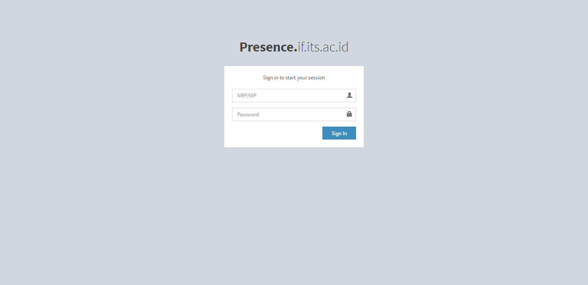

Interface Element Specification
Object | Type | Description
Username | Text | Field for user’s username input
Password | Text | Field for user’s password input
Login | Button | Button to submit form

Interface Object Design
Interface Design: This interface use gray background with white text field. There is a blue button for submitting the form.

Interface <scannerview>
Name: Scanner view page
Description: This interface represents the card scanner machine in each class. As the machine itself is not available yet, we choose to represent it in the webpage. There are four tab which are Student, Lecturer, Start Class and Stop Class. Student is used to input presence. While lecturer is used to input lecturer presence. Start and stop class is used by lecturer to enable student to input presence in the class and disable student to input presence.

Interface Specification
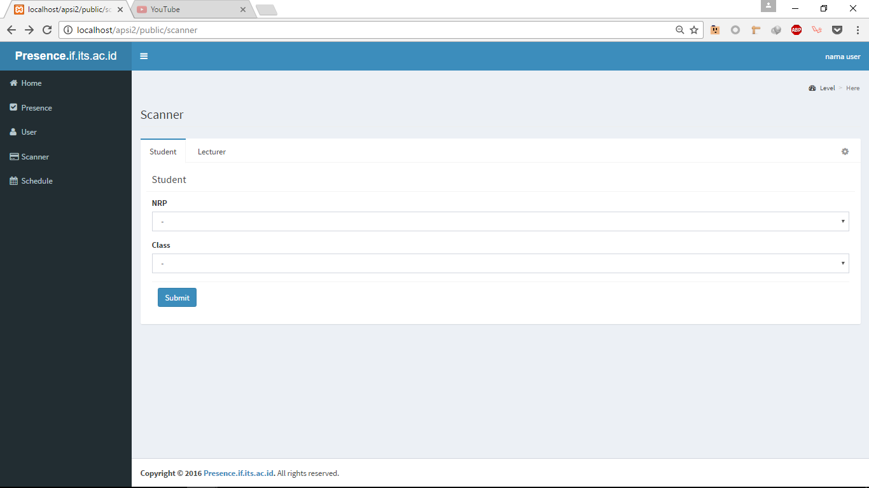

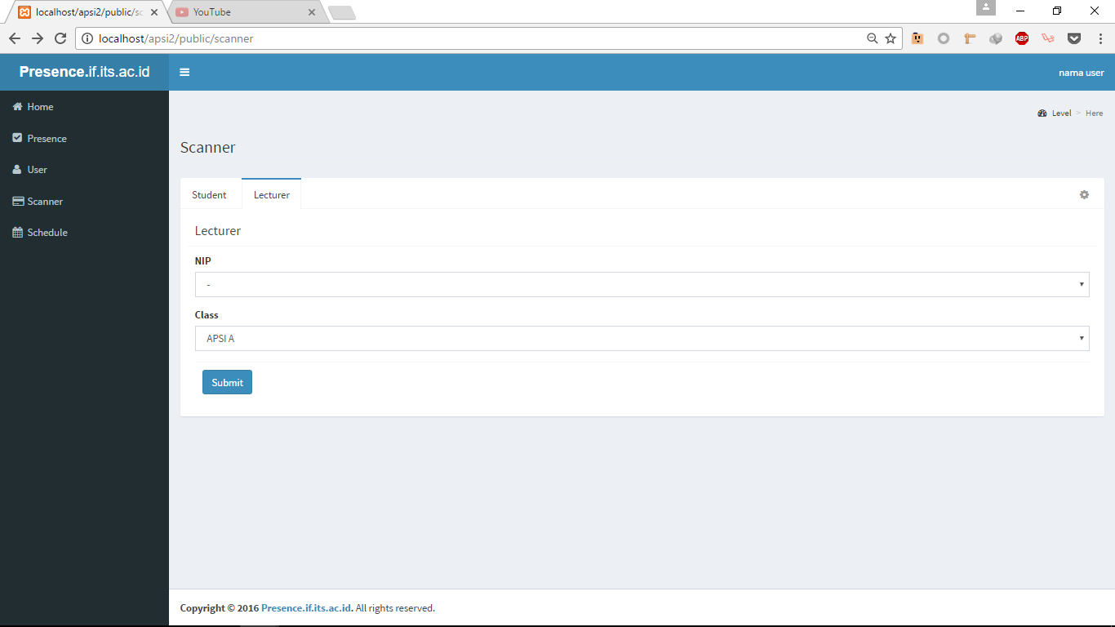

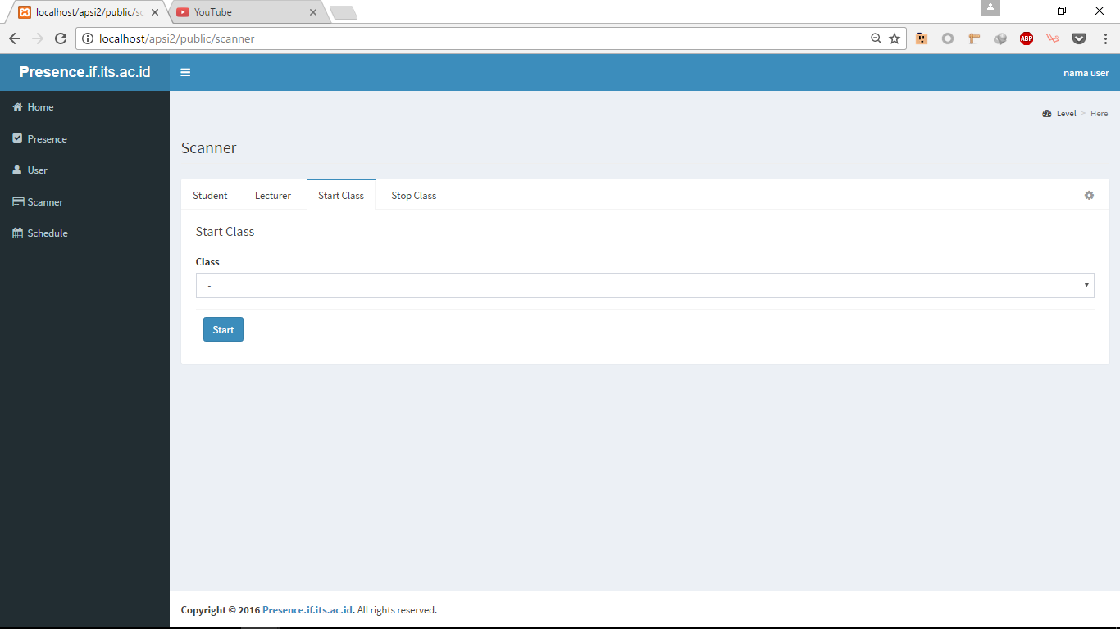

Interface Element Specification

Object | Type | Description
NRP | Dropdown | Dropdown for NRP Input
Class | Dropdown | Dropdown for class Input
Login | Button | Button to submit form

Interface Object Design

Interface Design: This interface use gray background with white text field. There is a blue button for submitting the form. There is a navigation bar on the left of the screen.

Interface <manageUser>
Name: User page
Description: This interface display a table containing user data. There are delete and edit button for each record on the table. There is also an add user button for adding user.

Interface Specification
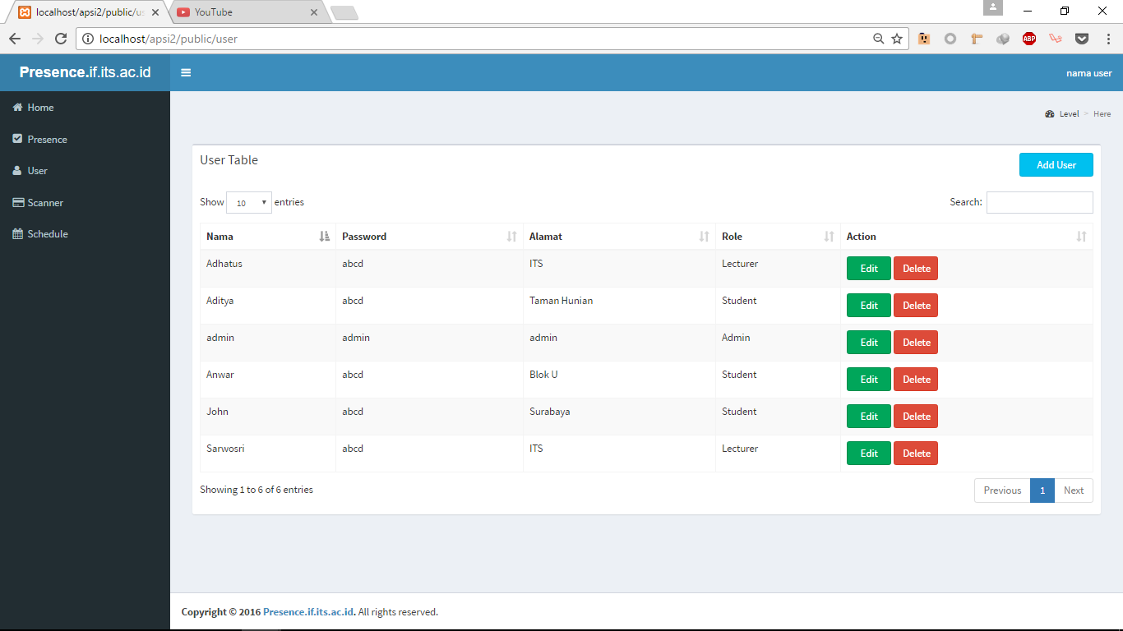

Interface Element Specification
Object | Type | Description
User Table | Table | Table for displaying user data
Add User | Button | Button for adding user
Edit | Button | Button for editing user
Delete | Button | Button for deleting user

Interface Object Design

Interface Design: This interface use gray background with white table field. There are a blue button for adding new user, red button for deleting user and green button for updating user. There is a navigation bar on the left of the screen.

Interface <schedule>
Name: Schedule
Description: This interface display a table containing schedule data. There are generate button to generate schedule for the rest of the semester and detail button to see more information about the class.

Interface Specification

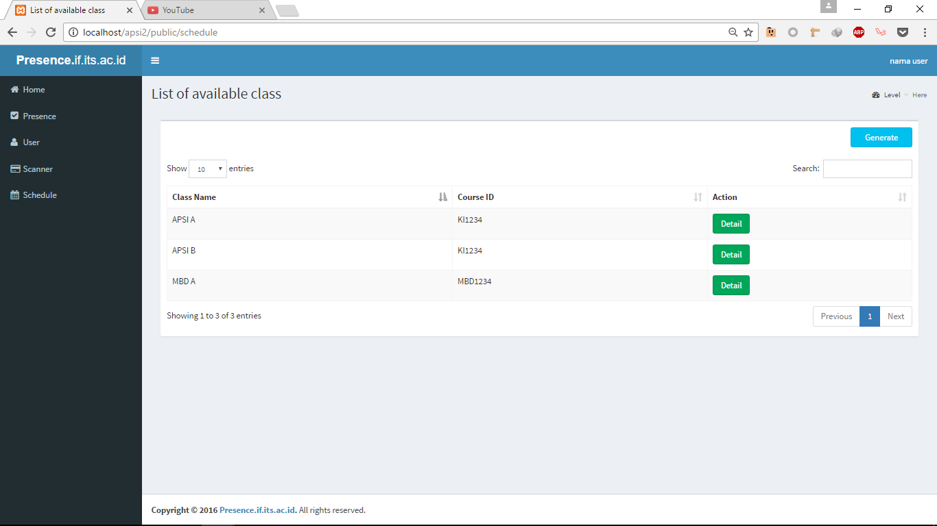

Interface Element Specification
Object | Type | Description
User Table | Table | Table for displaying schedule
Generate | Button | Button for generating schedule for one semester
Detail | Button | Button for viewing schedule detail

Interface Object Design
Interface Design: This interface use gray background with white table field. There are a blue button for generating schedule and green button for seeing schedule detail. There is a navigation bar on the left of the screen.

Interface <Input presence>
Name: Input Presence
Description: This interface display a form for inputing presence only for admin. This page is intended for student who is absent with a reason or no reason at all.

Interface Specification
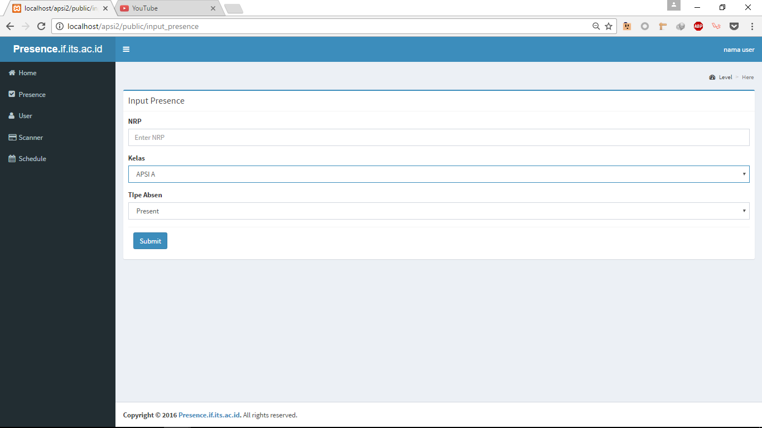

Interface Element Specification
Object | Type | Description
NRP | Text | Field for entering students NRP
Kelas | Dropdown | Dropdown for choosing class that is available based on the schedule
Tipe Absen | Dropdown | Dropdown for choosing the type of presence
Submit | Button | Button for submitting presence record

Interface Object Design
Interface Design: This interface use gray background with white table field. There are a blue button for submitting presence record. There is a navigation bar on the left of the screen.

Interface <Edit Schedule>
Name: Edit Schedule
Description: This interface display a form for inputing schedule in case the lecturer wants to rearrange or replace their teaching schedule

Interface Specification
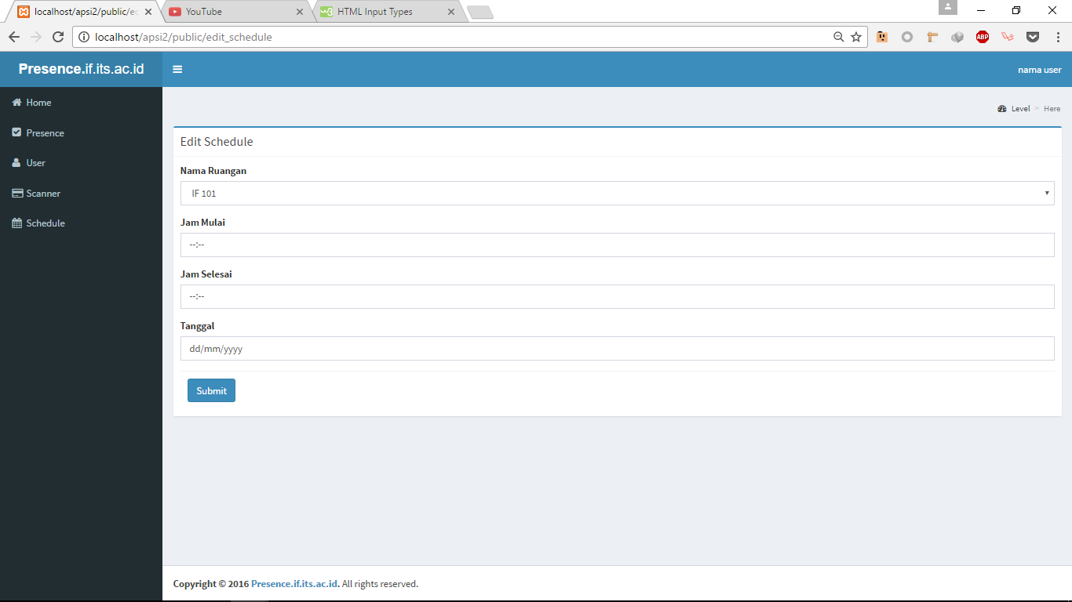

Interface Element Design
Object | Type | Description
Nama Ruangan | Dropdown | Dropdown field to choose available room
Jam Mulai | Time | Time field to choose start time
Jam Selesai | Time | Time field to choose stop time
Tanggal | Date | Date field to choose class date
Submit | Button | Button for submitting schedule

Interface Object Design
Interface Design: This interface use gray background with white table field. There are a blue button for submitting updated schedule. There is a navigation bar on the left of the screen.

Interface <Add User>
Name: Add User
Description: This interface display a form for admin to edit user data

Interface Specification
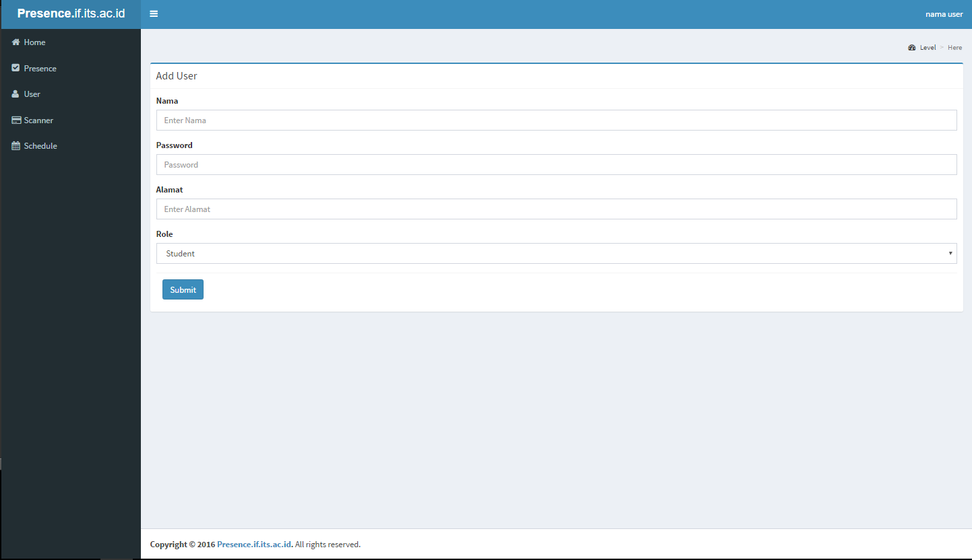

Interface Element Design
Object | Type | Description
Nama | Text | Text field to input users name
Password | Password | Password field to input password
Alamat | Text | Text field to input users address
Role | Dropdown | Dropdown field to choose user role
Submit | Button | Button for submitting user data

Interface Object Design
Interface Design: This interface use gray background with white table field. There are a blue button for submitting user data. There is a navigation bar on the left of the screen.

Interface <Edit User>
Name: Add User
Description: This interface display a form for admin to edit user data

Interface Specification
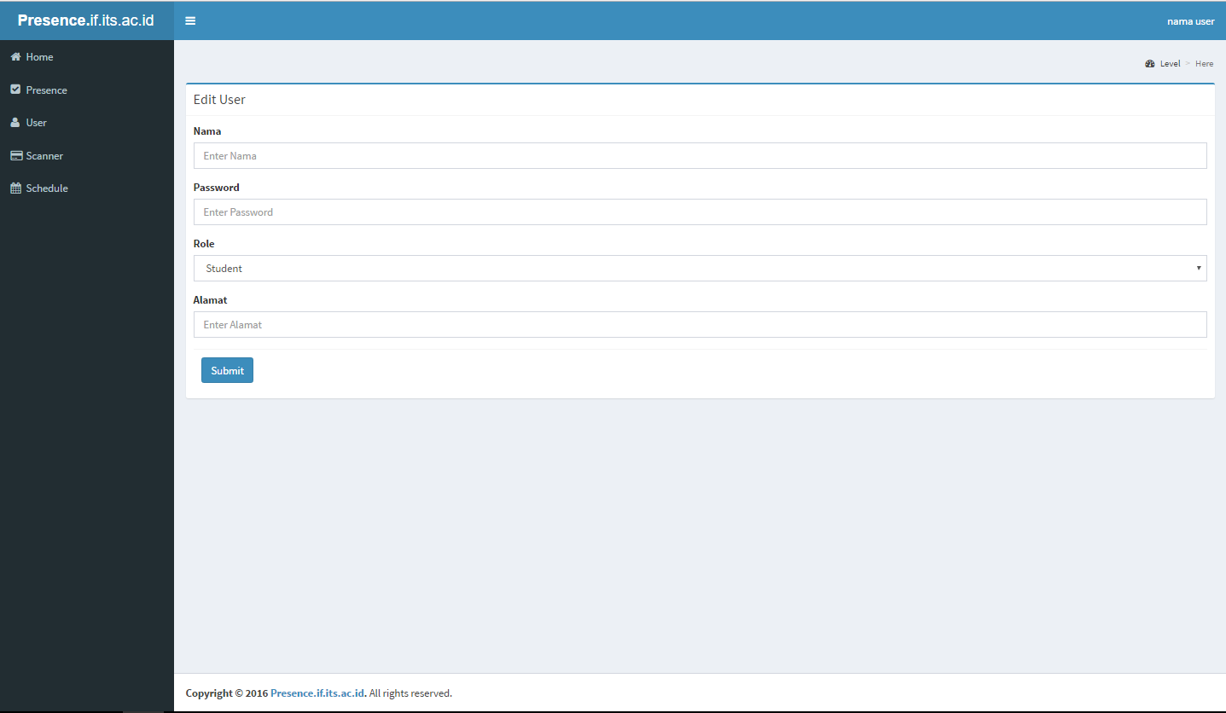

Interface Element Design
Object | Type | Description
Nama | Text | Text field to input users name
Password | Password | Password field to input password
Alamat | Text | Text field to input users address
Role | Dropdown | Dropdown field to choose user role
Submit | Button | Button for submitting user data

Interface Object Design
Interface Design: This interface use gray background with white table field. There are a blue button for submitting user data. There is a navigation bar on the left of the screen.

Interface <Detail Schedule>
Name: Detail Schedule
Description: This interface display a table that shows the schedule detail of a class

Interface Specification
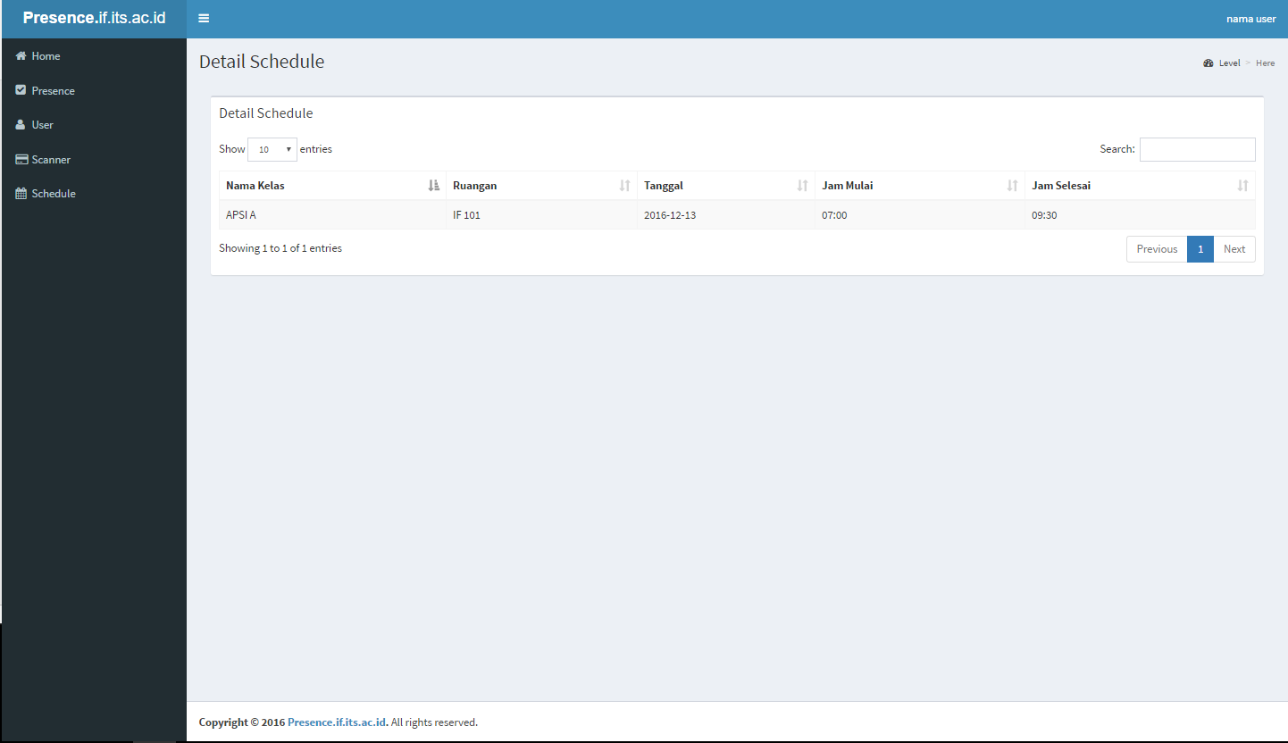

Interface Element Design
Object | Type | Description
Table | Text | Display schedule detail

Interface Object Design
Interface Design: This interface use gray background with white table field. There is a navigation bar on the left of the screen.

Interface <Presence History>

Name: Presence History
Description: This interface display a table that shows the presence history of a specific student

Interface Specification
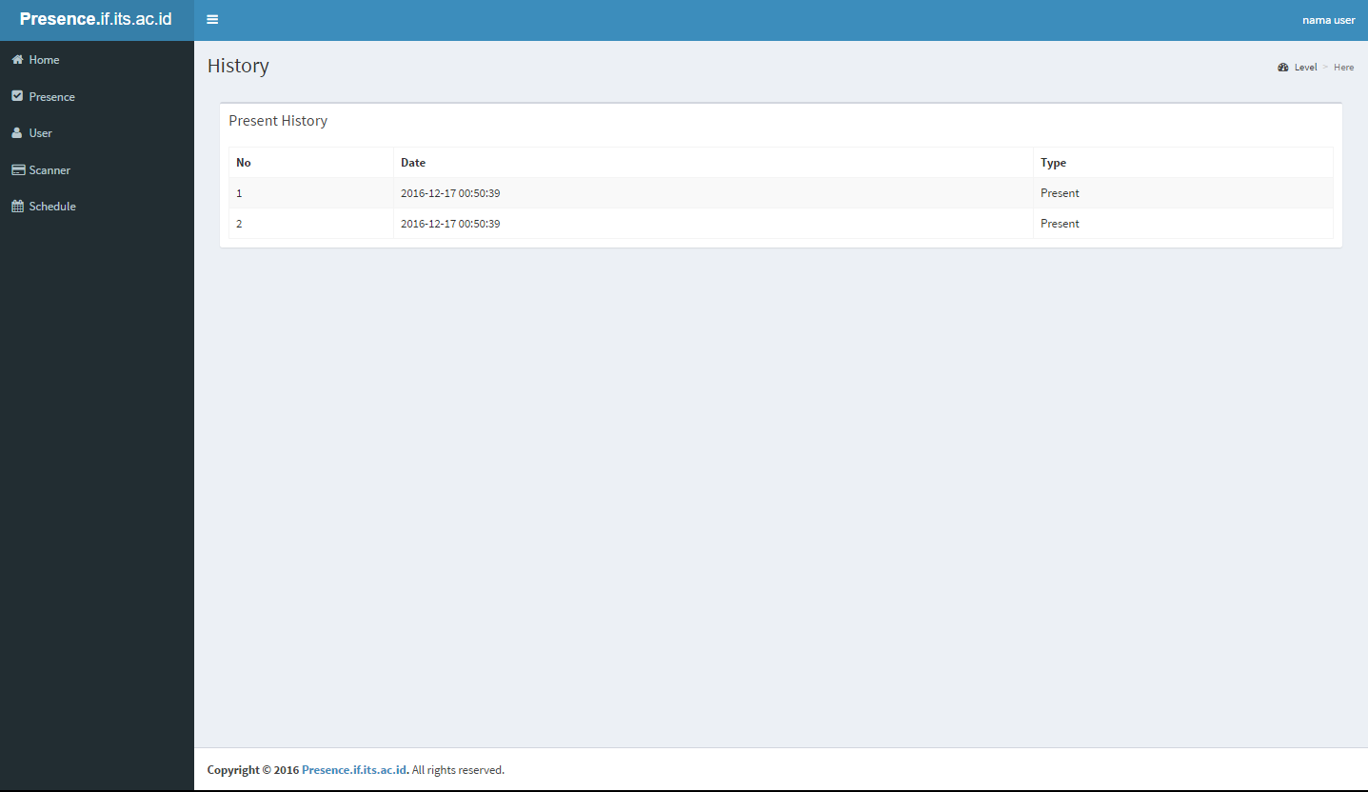

Interface Element Specification
Object | Type | Description
Table | Text | Display presence history

Interface Object Design
Interface Design: This interface use gray background with white table field. There is a navigation bar on the left of the screen.

Interface <Every Student Presence History>
Name: Every Student Presence History
Description: This interface display a table that shows all the student presence history from a specific class. This interface can only be accessed by admin

Interface Specification
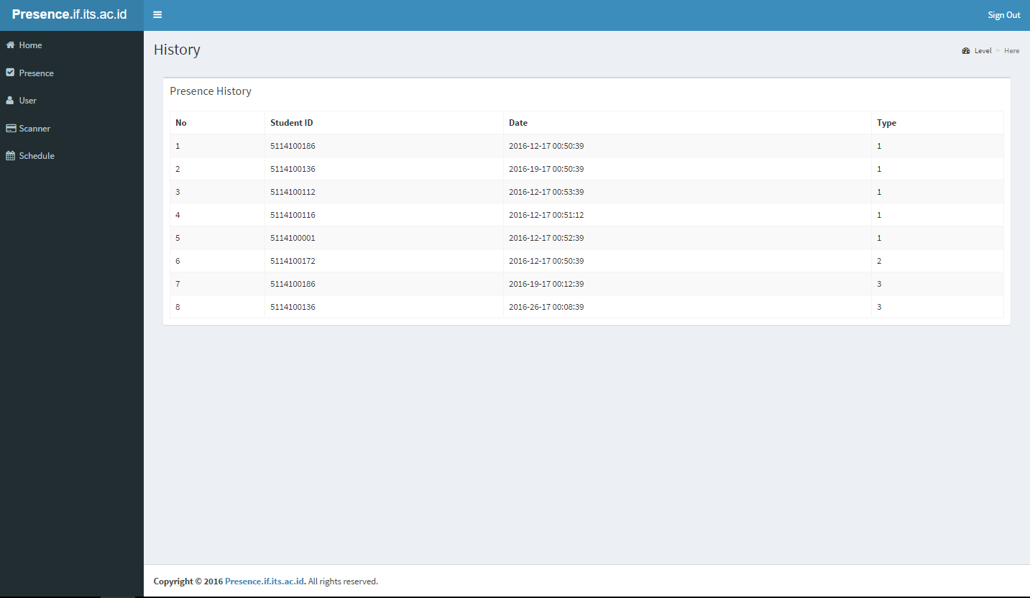

Interface Element Specification
Object | Type | Description
Table | Text | Display presence history

Interface Object Design
Interface Design: This interface use gray background with white table field. There is a navigation bar on the left of the screen.

Interface <Summary of Presence in each class>
Name: Summary of presence in each class
Description: This interface display a table that shows the presence summary of each class available.

Interface Specification
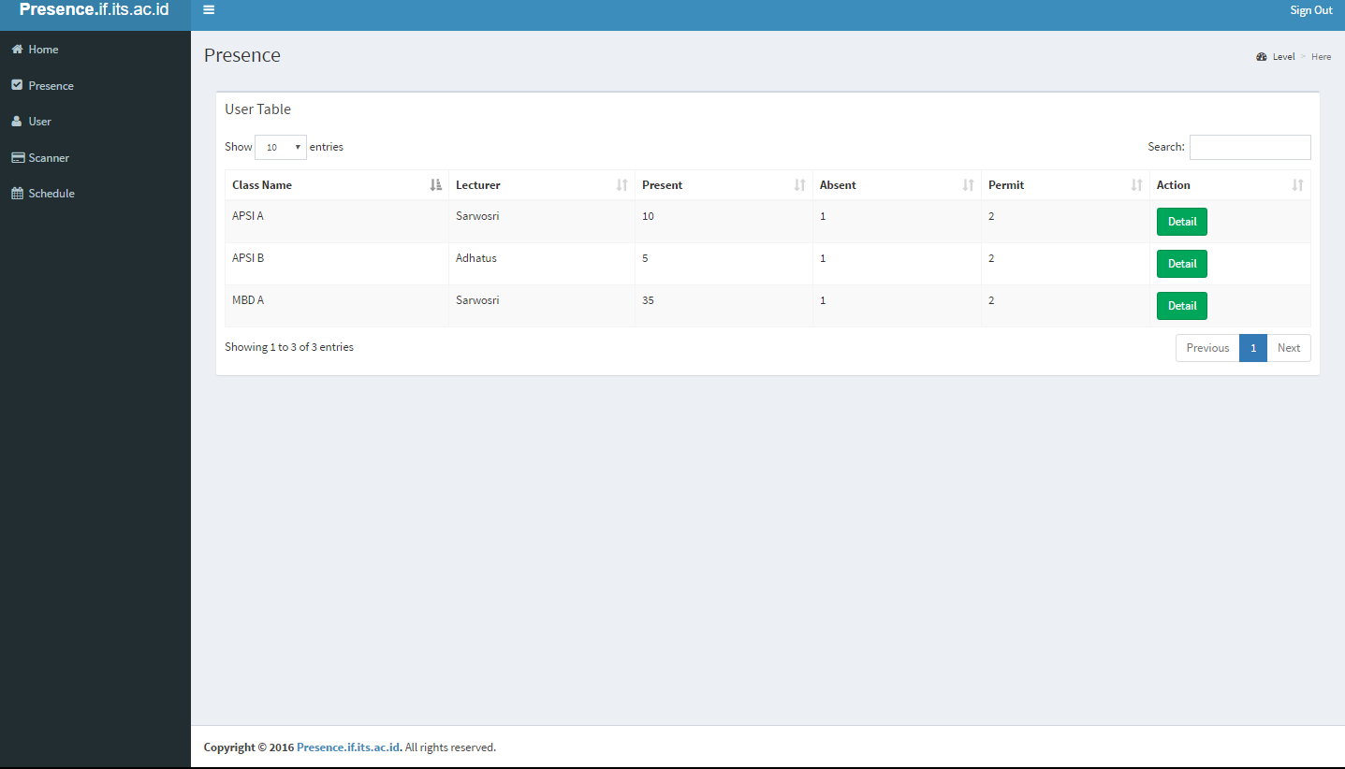

Interface Element Specification
Object | Type | Description
Table | Text | Display presence history
Detail | Button | Link to display detailed presence from each student enrolled in the class

Interface Object Design
Interface Design: This interface use gray background with white table field. There is a navigation bar on the left of the screen.

Interface <Home>
Name: Home
Description: This interface display two information about current date and current lecturing week.

Interface Specification
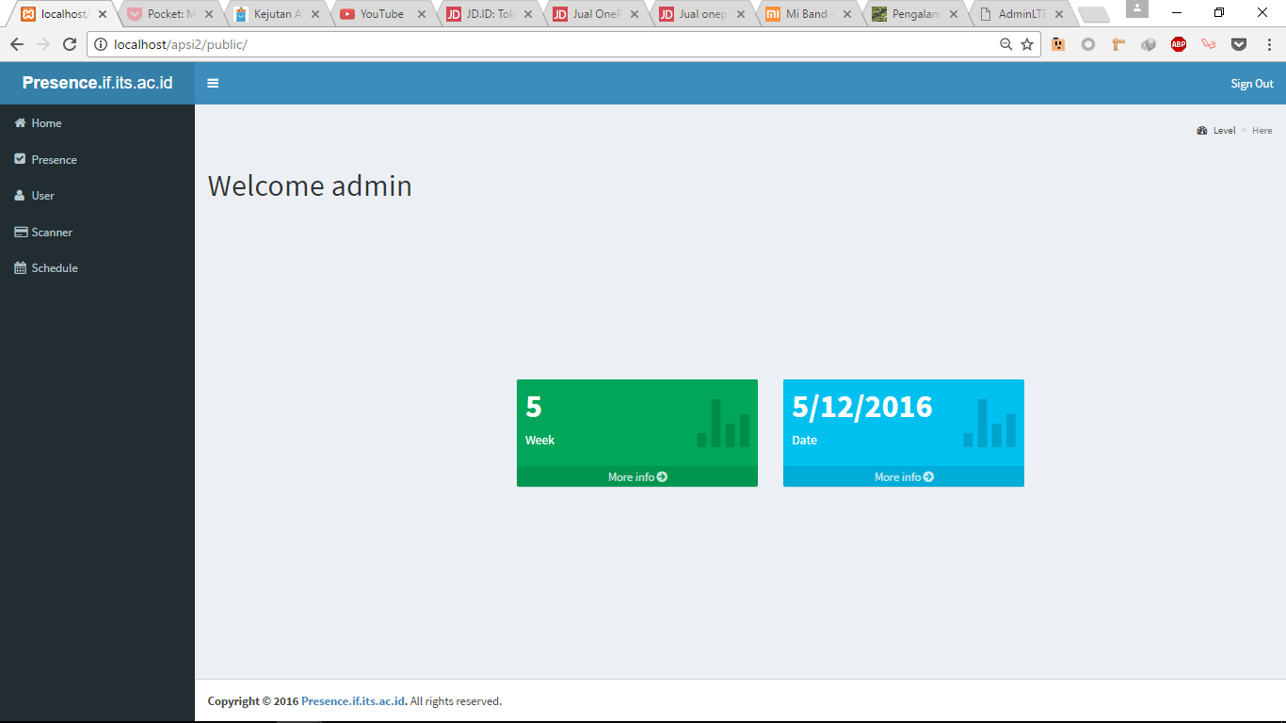

Interface Element Specification
Object | Type | Description
Box | Text | Display current week
Box | Text | Display current date

Interface Object Design
Interface Design: This interface use gray background two boxes. There is a navigation bar on the left of the screen.

Physical Module Decomposition

Directory Name | File Name | Description
/app/Http/Controllers | PresenceController.php | File controller for presence
/app/Http/Controllers | ScheduleController.php | File controller for schedule
/app/Http/Controllers | UserController.php | File controller for user
/resources/views | edituser.blade.php | View for editing user
/resources/views | manageUser.blade.php | View for managing user
/resources/views | adduser.blade.php | View for adding user
/resources/views | login.blade.php | View for login user
/resources/views | home.blade.php | View for home page
/resources/views | history.blade.php | View for history
/resources/views | Input_presence.blade.php | View for inputting presence
/resources/views | presenceView.blade.php | View for seeing student presence
/resources/views | Detail_presence.blade.php | View for seeing presence detail
/resources/views | scannerView.blade.php | View for representing card scanner
/resources/views | Detail_schedule.blade.php | View for seeing schedule detail
/resources/views | ScheduleView.blade.php | View for seeing schedule
/resources/views | Edit_schedule.blade.php | View for editing schedule
/app | User.php | Model file for User table
/app | Role.php | Model file for Role table
/app | Kelas.php | Model file for Kelas table
/app | Presence.php | Model file for Presence table
/app | User_Class.php | Model file for User Class table
/app | Type_Presence.php | Model file for Type Presence table
/app | Schedule.php | Model file for Schedule table
/app | Detail_Schedule.php | Model file for Detai Schedule table
/app | Room.php | Model file for Room table
/app | Scanner.php | Model file for Scanner table

