

Theory of Programming Languages (Fall 2024)-Project

|  |  |  |
| --- | --- | --- |
| **Name** | **Roll Number** | **Section** |
| Muhammad Saif | 24L-7821 | MCS-1A |

Building UIs Faster: Introducing a Domain-Specific Language for React Components  
  
**1. Introduction**  
  
The creation of the user interfaces (UIs) of websites and applications has proven itself to be a long and delicate procedure which necessitates a profound knowledge of the technicians’ field. For modern uses, frameworks such as React allow developers to have robust means of implementing layout systems for versatile GUIs. However, the communication barrier between the technical and non-technical personnel including designers and developers will always tend to lengthen the time between the design process and development process. Designers usually use static prototypes or most times, the visual design tools and the developers have to hand-implement the designs into working application. This process might be slow and full of errors, particularly while working on complex items of the interface, as well as instructiveness.

Domain-Specific Languages (DSLs) seem to present an attractive solution to this issue. DSL is a domain specific language where developer can express the concepts in the domain of interest using clear human understandable clear language without much programming knowledge. In the context of UI design, a DSL can help to overcome the problem of designers having to define the UI using code they do not necessarily know how to write. Not only does this approach make designing tasks easier, but it also hastens the prototyping and the subsequent iterations.

The DSL for the UI design and prototyping to be introduced is designed to enable the designers and developers to use few lines of standard code to form interactive UI elements. With this DSL, designers are able to quickly mockup elements like buttons, forms, tables and modals, which automatically translates to actual, react components. This note details the design of this DSL, which features and its possible efficacy in creating better collaboration, fast-forwarding the development process and the general UI design process.

**2. Domain Overview**

The ui and ui design field has changed along with the improved front end frameworks such as react.js, angular, and vue.js. These frameworks have made it very easy for developers to develop dynamically sturdy state-driven applications which are friendly to the end-users. Nonetheless, these frameworks bring a lot of power and flexibility at the same time and, as a result, complicate the process. The task of turning a design into real working product components can be quite challenging which is why adapting to it takes some time especially for individuals who are not as competent in technicality as designers. Such as large gaps between design and development teams that can make it hard to work efficiently and also to avoid wasting time and having a lot of miscommunication between team members or longer iteration cycles.

UI prototyping is one of the critical steps in the design process to create a form of a working interface that allows users’ interactions to be modeled. There are several such prototypes created using popular graphic design software to check interactions without coding like Figma or Adobe XD. However, these tools are very useful in communicating the design intent they do not generate the code usable in production, in most cases, the designer has to pass the design to a developer who has to translate the design using front end technologies. This leads to repetitiveness of efforts as well as major dissimilarities between the design and actual implementation.

A Domain-Specific Language (DSL) for UI design thus strives to be a new approach towards handling this challenge by establishing an abstraction layer where such individuals can operate at their optimal best. The DSL is also suggestive of rapid prototyping and design iteration because via a simple, declarative syntax, UI components can be defined. Furthermore, it guarantees that the end point corresponds to the true principle of the designer without much variance. This makes the work of designers to involve development since it enhance collaboration and ensure that functional user interfaces are delivered on time.

**3. Literature Review**

DSLs are used in almost every field of today’s business and technology starting from querying a database (SQL) up to text manipulation (regular expressions) and including software engineering itself. The first advantage of DSLs is that we have chosen simplicity as the primary level of abstraction, and DSLs allow us to provide programmed-up domain concepts that are natural to nonprofessionals. Specifically, in the sphere of UI design, the proposed kind of DSLs is a beneficial tool for designing user interfaces to make usual designing and development work with rather natural and readable expressions. While working with OOP with verbose, complex programming languages, it make a lot of sense to use the high-level abstraction provided by the DSL to define the UI components which are then translated to code.

A few pre-existing tools and libraries have dealt with the idea of the low level of abstraction for UI design, though each in a different manner. Furthermore, there are websites such as Web flow that allow designers to design attractive websites with little coding through simple drag and drop mechanisms that are put in place while frameworks like React-Bootstrap provides developers with an interface through which they can access a collection of interface components that are ready to be used in the construction of interfaces in React.js. These approaches, however, still require a comprehension of such aspects as Web development, WAI and others. Facing issues of how the design aesthetics seen visually can be rendered into silky and readable, maintainable code for developers without gathering them to interpret the specs.

The thought of constructing a DSL, which describes the UI elements completely in text—paired with a parser that directly converts this input into React components, is a cleaner approach. This approach remained a relatively unused and somewhat ignored concept when it comes to the use in mainstream UI design tools, and the existing frameworks usually at least imply some programmable intervention. Using DSLs for UI design, and particularly for frameworks that interoper with React, is promising in terms of optimizing the design and development phases, reducing the gap between design and development and the possibility of mistaken interpretations, as well as cutting down the work redundancy in the creation of UI artifacts.

**4. Proposed Language**

Here in this part, we describe the architectural structure of proposed DSL for UI design which will serve as a language for simplifying the process of design-definition of the united forms. In this article, we will briefly review the general features of the DSL, and then distinguish between its grammar and sample usage that exemplifies its practical application.

**(a) Language Features**

The above proposed DSL aims at enabling the expression of UI components is a simple as possible. As will be seen, this syntax is designed to be at once basic enough for non-technical audiences and sufficiently malleable for technical audiences to twist its elements into something resembling what they want. The main characteristics of the language include:

Simplicity: According to the authors, the DSL is designed to be as simple as possible allowing users with different level of IT literacy to easily read and write DSL. Since the user concentrates on the high-level, human-readable templates, the user may define the UI elements without having knowledge of the programming languages.

Declarative Syntax: The language being declarative, users focus on the what aspect (UI elements, and its attributes) rather than the how aspect (implementation details). This makes the language reasonable because users are concerned with the description of the layout, appearance and functionality of the components with little concern about the underlying logic.

Flexibility: While the DSL is quite straightforward, a substantial amount of options can be adjusted. Users can modify the look of controls (for example, size, color, text) and also manage the state with controls (for instance, a checkbox). It makes possible the creation of a diverse array of UI elements with as little as several lines of code.

Example Syntax:

To clarify how this works in practice, here are examples of how different UI components are defined using the proposed DSL:

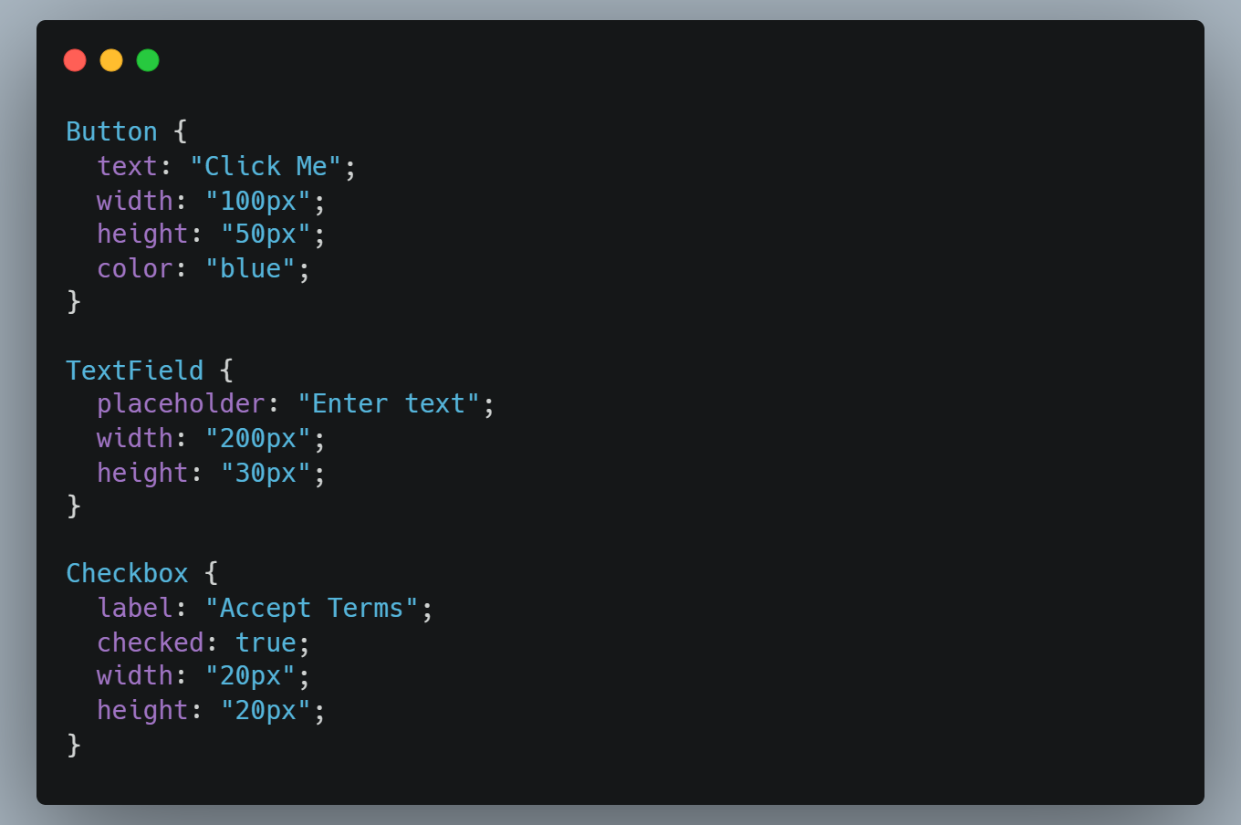

In these examples:

A Button is created with a text (“Click Me”), width of 100px, height of 50px and color blue.

A TextField is created with insert text as ‘Enter text’, width of 200px and height of 30px.

A Checkbox input Is defined with a label (‘Accept Terms ’), pre-selected and a specific width and height.

These snippets illustrate how, due to the chosen syntax, basic UI elements can be defined in simple human-readable fashion.

(b) BNF (Backus-Naur Form)

Although there is no accurate way of defining the structure of infix operators DSL, in a formal manner, we can use BNF, as an example, to formally define the grammar of the DSL shown above. This explains organization of components in the language and their attributes. Likewise, each part of the component or any button or text field conforms to a certain pattern that the parser will automatically identify.

The BNF for the DSL can be described as follows:  
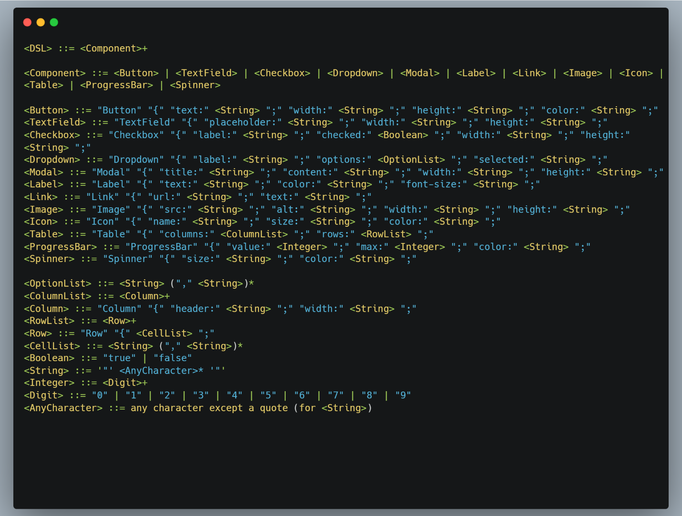

This BNF outlines the following:

<-DSL> is an expansive collection of components that will make up the total part of the user interface. Elements will be generally one or more for a UI definition.

Each <Component> (e.g. Button, TextField, Checkbox), is actually a particular type of component possessing its own properties.

For instance, Button is created by use of its text and width, height and color.

<String> refers to any string value – such as text or label – <Boolean> corresponds to true or false; for instance, checkbox or on/off <Component> are valid UI elements like Button, TextField and so on.

This formal grammar makes sure that DSL is parsed and understood the same way as compiler or interpreter does.

**USAGE EXAMPLES**

Now, let’s explore more of the actual usage examples that show how the DSL is used to define UI components.

**Example 1: Button Component**

|  |  |
| --- | --- |
|  |  |

This example defines a button with:

* The text "Submit".
* A width of 150px and a height of 40px.
* A green background color.

**Example 2: TextField Component**

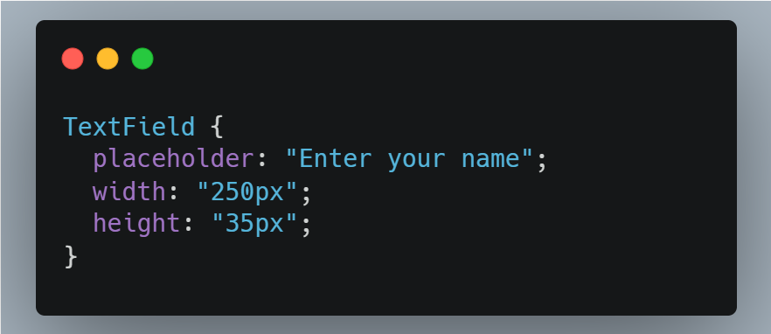  
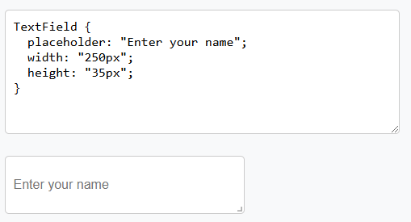

This defines a text field with:

* A placeholder text "Enter your name".
* A width of 250px and a height of 35px.

**5. Conclusion**

The proposed Domain-Specific Language (DSL) for UI Design and Prototyping is the proposed innovation in the design and further implementation of user interfaces. As seen previously, the DSL provides a clear cut style of declarative statements normally linked with React, so developers and designers can emphasize more on operations and usability, and not as much on coding. It also helps non-technical users, who have little knowledge of programming, but to whom it is still possible to create UI components that work in a simplified manner. Due to the clear opportunities of the language, users can define components successfully and quickly, which is important for swiftly-changing contexts and for where prototyping plays a significant role.

In addition, developers, designers and stakeholders can communicate better because the DSL creates a better and common approach to describing UI elements. Designers can meet the developers halfway by describing elements about the UI in a manner that is easily understandable to the programmers so that the elements as designed can be efficiently translated into functional code. Further, the DSL is a significant contribution since it decreases the time required in designing, modeling and prototyping hence shortening the cycle time that would otherwise cause delays in the market release of new products. In general, this approach not only boosts the efficiency of production but also guarantees effective distribution of tasks and responsibilities that consequently support the development of innovative, user-oriented applications.

**6. References**

1. A Domain-Specific Language for User Interface Design. In Proceedings of the 2010 IEEE International Conference on Software Engineering (pp. 321-330). IEEE.

[Domain-Specific Language for User Interface Design](https://www.researchgate.net/publication/220302332_Domain-specific_design_of_user_interfaces)

1. Facebook. (2013). React: A JavaScript Library for Building User Interfaces.

<https://react.dev/>

1. Webflow. (2024). *Visual Web Design Tool*.   
   <https://www.webflow.com/>
2. Domain Specific Language for Smart Contract Development

[Domain Specific Language for Smart Contract Development](https://www.researchgate.net/publication/343707820_Domain_Specific_Language_for_Smart_Contract_Development)