AWE in the Context of Disaster Relief Situations
Tamana Muhseny, Eva Espindola, Gideon Seyoum

Abstract— This work presents Airborne Wind Energy (AWE) in the context of disaster relief situations. Developing and managing microgrids using AWE in such areas allow communities to maintain independent grids when natural disasters disconnect them from the main grid. The lack of energy during a natural disaster negatively impacts society's access to basic services such as water, gas, communication, and the Internet. This requires a strong management system to prevent infrastructure collapse. A crucial first step in developing microgrids is understanding the specific communities these implementations will serve. This involves analyzing factors that may influence implementation, including political and environmental considerations that determine the project's appropriate scale and scope. The results envisioned from this analysis give a robust understanding of how to improve disaster preparedness using microgrids. While focused on coastal regions, this approach can be adapted to off-coast communities, offering a sustainable solution for energy access in disaster prone areas in a general sense.
Keywords—AWE, microgrids, interpolation, DRE

Introduction
Natural disasters often cause widespread damage to critical infrastructure, leaving communities without essential services such as electricity, water, communication, and internet access. The importance of energy resilience in disaster-prone areas has been widely recognized, with research emphasizing the role of decentralized energy solutions, particularly microgrids, in maintaining power supply during and after disasters [1], [2]. Microgrids allow for localized energy generation and distribution, reducing dependence on centralized grids, which are highly vulnerable to extreme weather events [3].
Among various renewable energy sources, Airborne Wind Energy (AWE) has emerged as a promising technology for disaster relief applications. Unlike traditional wind turbines, AWE systems operate at higher altitudes where wind speeds are stronger and more consistent, making them a viable option for power generation in post-disaster environments [4], [5]. Studies have shown that AWE can be deployed rapidly, making it particularly suitable for emergency scenarios where time-sensitive energy solutions are required [6], [7]. However, integrating AWE into microgrids presents challenges related to system stability, energy intermittency, and operational constraints, particularly in real-time disaster conditions [8].
Previous studies have explored hybrid microgrid designs that combine renewable energy with conventional backup power sources such as diesel generators to enhance system reliability [9]. Research indicates that hybrid microgrids can ensure continuous power availability, with diesel generators compensating for renewable energy fluctuations [10]. The proposed study builds upon this foundation by designing an AWE + diesel microgrid model tailored for disaster relief efforts in Guayama, Puerto Rico. This model will assess the feasibility of using AWE as the primary energy source while leveraging diesel power for system stabilization during energy drops and startup sequences.
Real-world wind data analysis has been used to validate the performance of wind-based energy systems in disaster-stricken areas [4]. In this study, NASA Power Data Access Viewer (DAV) will be utilized to obtain post-Hurricane Maria wind data for Guayama, PR, providing insights into the power and energy potential of an AWE-based system in a real-world disaster scenario [11].
This research contributes to existing literature by offering a comprehensive analysis of AWE-powered microgrids in disaster relief settings, focusing on system performance, load capacity, and post-disaster energy resilience. By leveraging MATLAB simulations and established linear interpolation equation, this study aims to provide quantitative assessments of AWE’s role in sustainable disaster recovery efforts.

Methodology
Recent advancement in microgrids combined with Airborne Wind Energy (AWE) have created a new power system design. These advancements allow for a more resilient power system that does not solely rely on fuel-based sources but readily available renewable energy. This paper proposes a robust understanding of how to improve disaster preparedness by designing an AWE + diesel hybrid microgrid model tested for power potential with generated wind data and real-life wind data post disaster.
The proposed approach capitalizes on the inherent resilience and deployability of Airborne Wind Energy (AWE) systems in comparison to wind-diesel microgrids which rely on stationary wind turbines. Current wind-diesel generation microgrid systems primarily rely on wind turbines rather than AWE, making them vulnerable to disasters. In contrast, AWE can be deployed after disasters and remain unaffected by such events. This feature enables a more robust electricity generation solution in disaster relief situations, complementing other renewable technologies such as solar panels.
The microgrid system is designed to provide energy to a coastal hospital that is in a disaster-prone area to run at full capacity, ensuring access to essential services including water, gas, communications, and internet for the community. This is possible through the integration of microgrid system powered by AWE and supported by diesel generators. Consequently, this enables reliable and scalable energy solutions in disaster-stricken areas.

Guayama, Puerto Rico
Guayama, Puerto Rico is one of many coastal towns that are affected by hurricanes, like hurricane Maria on September 20, 2017. Even 5 years after Maria there were still many homes covered with blue tarp to cover the damages, even now, Puerto Rico hasn’t recovered [12]. Guayama has one main hospital, Hospital General Menonita de Guayama. The hospital’s estimated energy demand is based on industry benchmarks, which indicate that medical facilities require approximately 31 kWh per square foot annually [13]. Given an estimated facility size of 280,000 ft², the hospital’s annual average load demand is 1MWh.

Makani AWE
The Makani M600 airborne wind turbine is selected as the primary renewable energy source due to its high-altitude wind access and continuous energy harvesting capabilities [14]. The Makani is a fly-gen AWE system with crosswind trajectories, which fly onboard turbine-generator units that are connected to an airframe along figure-eight or circular crosswind trajectories defined by the tether length. Electricity is generated onboard the kite. The onboard-generated electrical power is transmitted to the ground station through a conductor in the tether. The system is designed to achieve high relative velocity on the flying wind turbines [15]. The system operates at altitudes between 200m and 600m, enabling greater wind speed capture compared to conventional ground-based turbines. The Makani system has a rated power output of 600 kW (0.6 MW) under optimal wind conditions. Based on the estimated loads for the hospital, 4 Makani AWE systems and a 1.5 MW diesel generator as back up are needed Fig. 1.
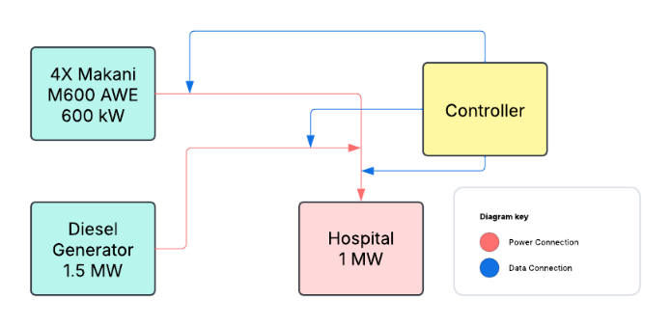
- Design for AWE-Diesel Microgrid
The first step in this methodology involves defining system parameters for both AWE generation and diesel generation. To estimate real-world power generation, the crosswind kite power linear interpolation equation is used [16]:
$P=2*\left(P_{rated}\right)*\frac{V_{wind}-V_{cut_{in}}}{V_{rated}-V_{cutin}}$ (2)
where P is the power output (W), P_{rated} is the AWE power, V_{wind} is the wind speed, V_{cutin} is the minimum wind speed for the kite to operate and V_{rated} is the optimal wind speed for the AWE. This formula approximates power performance.

Diesel
Since AWE power fluctuates with wind speed, a 1.5 MW diesel generator is included to provide startup power and compensate for energy gaps during low-wind periods. The microgrid is programmed to prioritize AWE-generated electricity, then the diesel generator, ensuring fuel efficiency and emissions reduction [14]. The proposed solution can act as a primary energy source to a diesel generator. To analyze effectiveness a MATLAB simulation is developed that accommodates a hybrid of AWE-diesel generation.

Matlab
Next, real time wind data from Guayama, Puerto Rico after hurricane Maria through the next 11 months is found using NASA Power DAV. Because DAV only offers wind data up to 50 meters, the data needs to be extrapolated to 200 meters using the wind shear equation [17]:
$V={(\frac{h}{h_{0}})}^{α}*V_{0}$ (1)
where h₀ is the height at the known speed, h is the height at the unknown speed, α is the shear power exponent and V₀ is the known speed at the known height. The shear exponent chosen was 0.3 to meet the wind conditions in coastal Puerto Rico.
To evaluate the systems reliability the data is then put into an hourly power simulation in MATLAB. The model incorporates AWE power generation equations based on the real wind data and diesel generator activation thresholds to maintain system stability. An 11-month simulation in hours is performed to analyze long-term resilience under varying wind conditions.
This methodology provides a structured approach to evaluating an AWE + diesel microgrid for post-disaster hospital power supply. By integrating high-altitude wind energy and fuel-efficient diesel backup, this system aims to enhance energy resilience in hurricane-prone regions. The next section will present simulation results, demonstrating the power potential, reliability, and stability of the proposed microgrid solution.

Results
In this section, the performance of the proposed Airborne Wind Energy (AWE) + diesel hybrid system is analyzed for a hospital microgrid during disaster relief conditions. The simulation is designed to evaluate power potential, reliability, and stability of a Makani M600 AWE system with diesel as back up. To create a steady state power balance, an hourly power simulation is conducted using real-world wind data to emulate dynamic wind speeds. The Makani M600 AWE system operates between 200 meters and 600 meters and can generate up to 600 kilowatts of electricity [1]. For this reason, the wind turbines are simulated to operate at 200 meters and a constant production of 600 kilowatts of electricity.

The simulation additionally includes a 1.5-megawatt diesel generator as a backup power source. The model is implemented in MATLAB where the power output of the AWE system is calculated using linear interpolation to calculate the power generation below the cut-off speed and above the cut-in speed of the AWE system [2]. An hourly power simulation is conducted for an 11-month period using historical wind patterns after Hurricane Maria on September 20, 2017, to August 20,2018, in Guayama, Puerto Rico from the NASA Power Project’s Data Access Viewer (DAV), which ensures a realistic post disaster representation. The system is tested in MATLAB, divided into three main investigations.

Wind Speed Adjustment Analysis
First, an analysis of the wind speed adjusted to a different elevation is done using the wind shear equation. From the data, one can assume that as the wind shear equation indicates the higher the elevation the higher the wind speed and power output will be.
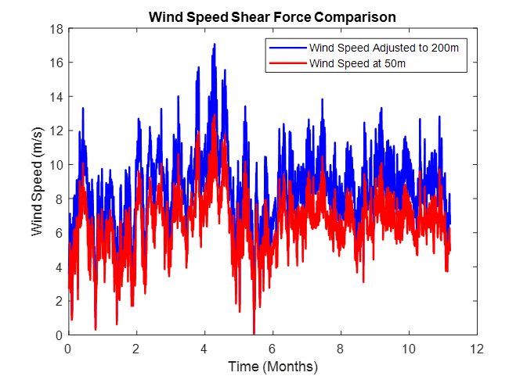
- Wind Speed from Shear Force Comparison Design

Fig. 2 details the initial wind speed data extrapolated using the wind shear equation. One can assume that the data shows that the increase in elevation correlates to a slight increase in wind speed of roughly 2 m/s per time interval.

Steady-State Power Balance Analysis
Secondly, a steady state model to evaluate the ability of the hybrid system to meet the hospitals continuous average 1-megawatt demand. This analysis analyzes whether the Makani M600 AWE system, in combination with a 1.5 MW diesel generator, could maintain a continuous power balance. This evaluation included hourly wind variations and analyzing the output using the linear interpolation equation over the course of the entire period. The separate power output datasets were then analyzed over a 11-month period. This period was chosen as it mimics the actual build time for the power grid to be restored post Hurricane Maria.
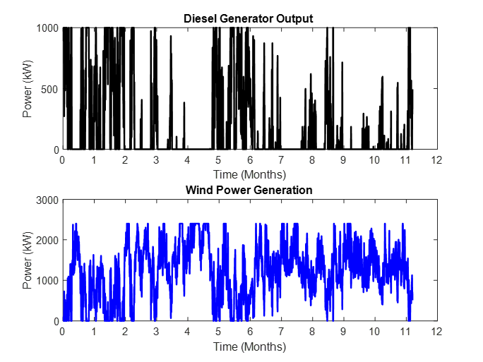
- 11-Month Power and Diesel Generation
Fig. 3 shows the inverse relationship between the wind and diesel generation inputs to meet the power load necessity of the hospital.

Energy Demand and Generation Comparison
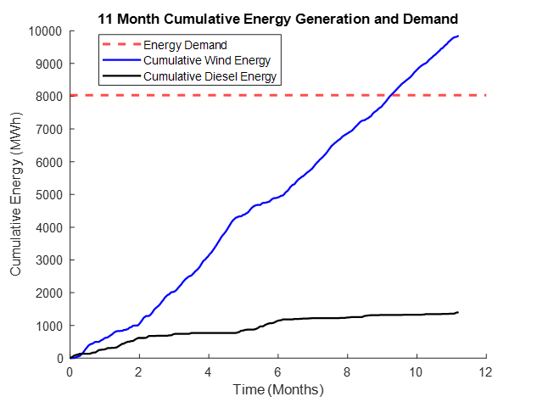
- 11-Month Energy Demand and Generation Comparison
Fig. 4 details the energy demand of the hospital over the course of the total 11-month period in comparison to the cumulative load. The total hospital energy demand is determined by the equation. Where energy (E) is the total demand of power (P) which is 1 MW and time (T) is 11 months (8760 hours). This results in a total energy demand of 8760 MWh. From the figure, one can assume that the energy threshold is met by wind generation with relatively minimal contribution from the diesel generator.
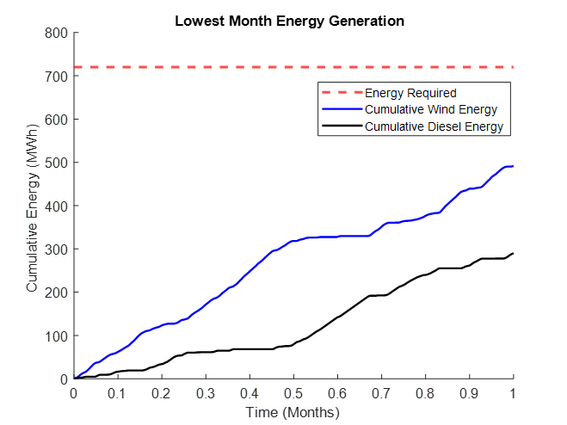
- Lowest Month Energy Demand and Generation Comparison

When analyzing Fig. 5 one can see that the energy (E) is the total demand of power (P) which is 1 MW and time (T) is 1 month (720 hours). This results in a total energy demand of 720 MWh. The wind energy generation over the course of this month falls below the threshold of energy demand. In response to this, cumulative diesel energy is required to compensate for the deficit.
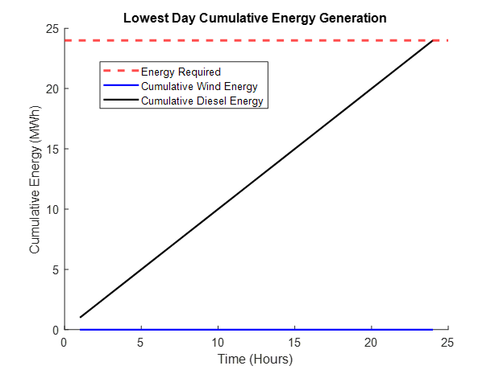
- September 30, 2017, Lowest Day of Wind Energy Generation
When analyzing Fig. 6 one can see that the energy demand across a single day has been calculated to be 24 MWh. One can see that the cumulative wind energy has a production of 0 MWh.

Quarterly Power and Energy Analysis
A Quarterly analysis of the cumulative energy and power demand of the hospital was calculated in comparison with the load to compare the systems performance across the different subperiods of the total simulation. The subperiods were determined to be 2.75 months as that is exactly one fourth of the total simulation period. Additionally, the load was determined by the energy equation

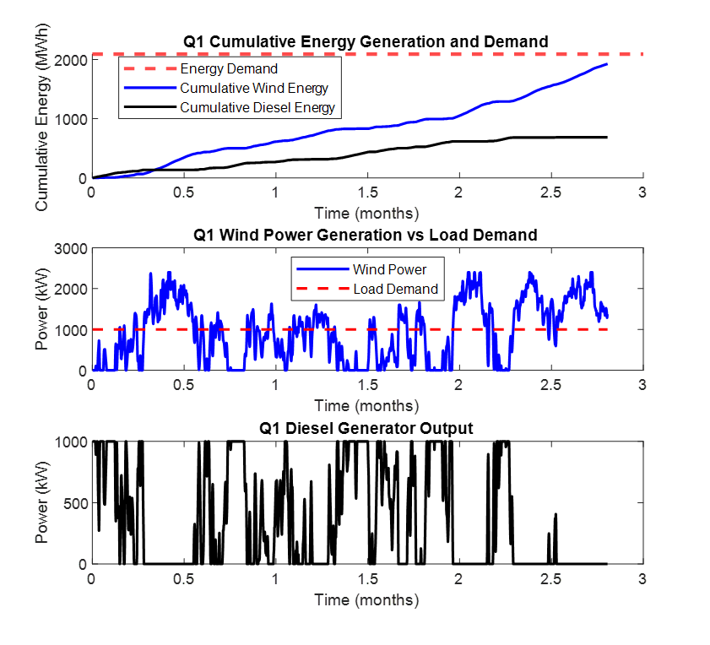
- Quarter 1 Power and Energy Analysis

The first subplot of Fig. 7 details the systems’ performance across Quarter 1 with the energy demand failing to be met by the turbines alone. However, the combination of cumulative wind energy and diesel energy has supplied the energy needed. The second and third subplot details the wind power generation and the load demand. In it one can deduce that the diesel generator requires frequent utilization to offset the low wind power.

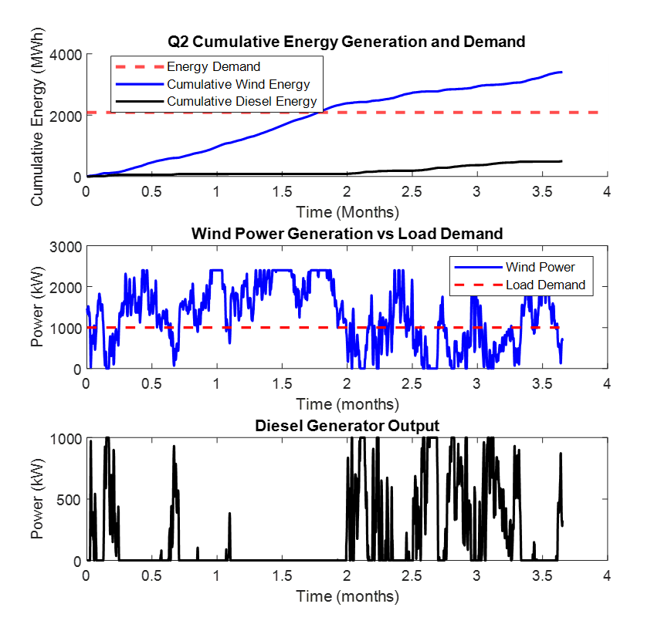
- Quarter 2 Power and Energy Analysis
The first subplot of Fig. 8 details the systems’ performance across Quarter 2 where the energy demand is successfully met by the turbines alone. One can assume that the increased energy generation of the wind turbines resulted in a decreased necessity for diesel energy generation. Additionally, the obtained results from the second and third subplot show little to no power generation across the second month for the diesel generator.
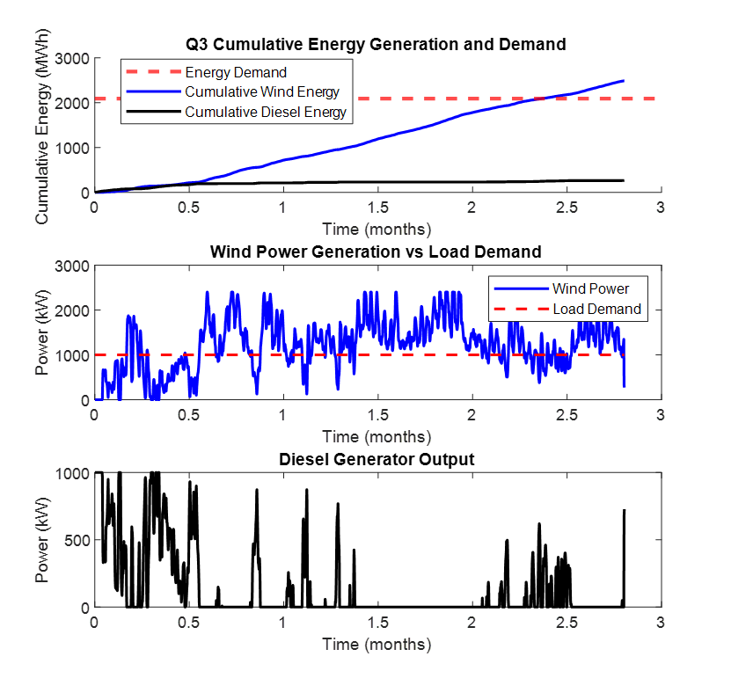
- Quarter 3 Power and Energy Analysis

The first subplot of Fig. 9 details the systems’ performance across Quarter 3 where the energy demand is successfully met by the turbines alone. The increased energy generation of wind turbines resulted in a decreased necessity of diesel energy generation. The second subplot of Figure 9 indicates that the wind power generation is consistently above the load demand except for the last week of the first month of the quarter. Furthermore, one can assume that the diesel generation of the third subplot underwent little to no power generation across the latter half of the second month due to the high wind power.

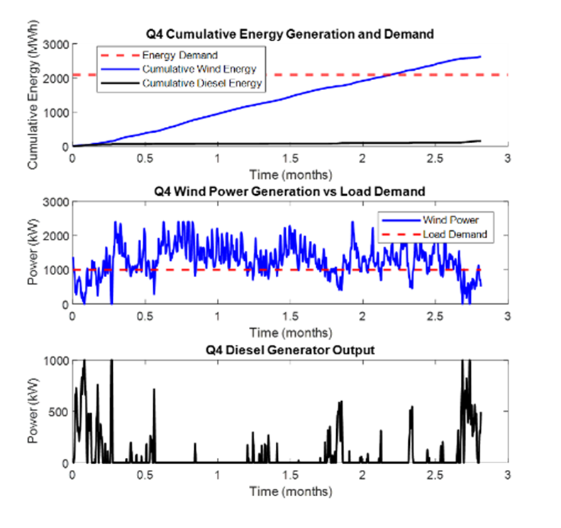
- Quarter 4 Power and Energy Analysis
The first subplot of Fig. 10 details the systems’ performance across Quarter 4 where the energy demand is successfully met by the turbines alone. From this, one can deduce that the increased energy supply has resulted in a decreased necessity for diesel energy generation. The second subplot details a consistent, increased power generation of the wind turbines. Additionally, this had led too little to no power generation across the latter half of the second month.

Conclusion
This paper presents a novel approach to addressing community power needs in disaster preparedness scenarios, with a focus on coastal regions. The proposed method enhances existing literature by providing a comprehensive analysis of AWE-powered microgrids, emphasizing system performance, load capacity, and post-disaster energy resilience. This study leverages MATLAB simulations and established crosswind kite power equations to evaluate the system’s effectiveness. Guayama, Puerto Rico, and the Makani M600 airborne turbine were used as case studies to highlight the inherent resilience and deploy-ability of Airborne Wind Energy (AWE) systems. This comparison underscores the advantages of AWE over wind-diesel microgrids, which depend on stationary wind turbines.

Obtained results are divided into three main analyses, Wind Speed Adjustment, Steady-State Wind and Diesel Power Balance, and Wind-Diesel Energy Generation and Hospital Demand Comparison. The Guayama Real Wind Speed analysis (Figure 2) examines wind patterns in Guayama, Puerto Rico, over a three-month period from late September to late December (09/22/2017 – 12/22/2017) to assess the potential for wind power generation. The Wind Power Generation vs. Load Demand analysis (Figure 3) utilizes real wind speed data from Guayama to simulate the power output of the AWE system. This analysis assesses whether the AWE system can generate sufficient power to meet the region’s load demand. The Diesel Generator Output data (Figure 4) evaluates the power generation capacity of an individual diesel generator to determine its contribution to meeting the load demand.

References
- B. Naughton, “Deployable Wind-Hybrid Power Systems for Defense and Disaster Response Applications,” National Technology & Engineering Solutions of Sandia, LLC., Albuquerque, New Mexico, 2021.
- B. Naughton et al., “Design Guidelines for Deployable Wind Turbines for Defense and Disaster Response Missions,” Journal of Physics Conference Series, vol. 2265, no. 4, pp. 1–10, May 2022, doi: https://doi.org/10.1088/1742-6596/2265/4/042074.
- J. Granholm, A. Nouri, and E. Noll, “Challenges and Opportunities for Airborne Wind Energy in the United States,” United States Department of Energy by National Technology & Engineering Solutions , pp. 7-20, United States Department of Energy Washington, DC 20585, Nov. 2021.
- J. Marqusee, S. Ericson, and D. Jenket, “Impact of emergency diesel generator reliability on microgrids and building-tied systems,” Applied Energy, vol. 285, no. 0306-2619, pp. 1, Mar. 2021, doi: https://doi.org/10.1016/j.apenergy.2021.116437.
- K. Vimalakanthan, M. Caboni, J. G. Schepers, E. Pechenik, and P. Williams, “Aerodynamic analysis of Ampyx’s airborne wind energy system,” Journal of Physics: Conference Series, vol. 1037, no. 6, p. 062008, Jun. 2018, doi: https://doi.org/10.1088/1742-6596/1037/6/062008.
- E. Lunney, M. Ban, N. Duic, and A. Foley, “A state-of-the-art review and feasibility analysis of high altitude wind power in Northern Ireland,” Renewable and Sustainable Energy Reviews, vol. 68, no. 1364-0321, pp. 899–911, Feb. 2017, doi: https://doi.org/10.1016/j.rser.2016.08.014.
- M. Ippolito and E. Saraceno, “KiteGen Research High Altitude Wind Generation Tropospheric Wind Exploitation Under Structural and Technological Constraints,” KiteGen, vol. 2.2, pp. 1–11, Jan. 2019, doi: https://doi.org/10.13140/RG.2.2.12701.97766.
- A. Cherubini, A. Papini, R. Vertechy, and M. Fontana, “Airborne Wind Energy Systems: A review of the technologies,” Renewable and Sustainable Energy Reviews, vol. 51, no. 1364- 0321, pp. 1461–1476, Nov. 2015, doi: https://doi.org/10.1016/j.rser.2015.07.053.
- M. Gadwantikar, N. Sumanth Reddy, M. Mahesh, K. Shiva Nagendra, and D. Tharun, “AIRBORNE WIND ENERGY,” International Research Journal of Modernization in Engineering Technology and Science , vol. 5, no. 4, pp. pp.1-6, Apr. 2023, doi: https://doi.org/10.56726/IRJMETS37176.
- C. Vermillion et al., “Electricity in the air: Insights from two decades of advanced control research and experimental flight testing of airborne wind energy systems,” Annual Reviews in Control, vol. 52, no. 1367–5788, pp. 330–357, 2021, doi: https://doi.org/10.1016/j.arcontrol.2021.03.002.
- P. Stackhouse, “NASA POWER | Docs | Tutorials | DAV - NASA POWER | Docs,” Nasa.gov, 2022. https://power.larc.nasa.gov/docs/tutorials/data-access-viewer/user-guide/ (accessed Feb. 24, 2025).
- A. Maxouris and R. Tinoco, "Puerto Rico faces crisis in wake of Hurricane Fiona with power outages and water service disruptions," CNN, Sep. 24, 2022. [Online]. Available: https://www.cnn.com/2022/09/24/us/puerto-rico-hurricane-fiona-aftermath/index.html. (Accessed: Feb. 23, 2025).
- Hardy Diesel, "Electrical formulas for generator set sizing," Hardy Diesel Generators, [Online]. Available: https://hardydiesel.com/resources/electrical-formulas-for-generator-set-sizing/. (Accessed: Feb. 23, 2025).
- P. Echeverri, T. Fricke, G. Homsy, and N. Tucker, “The Energy Kite Selected Results From the Design, Development and Testing of Makani’s Airborne Wind Turbines Part I,” Makani Technologies LLC, Sep. 2020. Accessed: Feb. 24, 2025. [Online]. Available: https://storage.googleapis.com/x-prod.appspot.com/files/Makani_TheEnergyKiteReport_Part1.pdf
- M. Rossol, S. M. Fawke, and A. Lopez, "The National Solar Radiation Database (NSRDB): A Brief Overview," National Renewable Energy Laboratory (NREL), Tech. Rep. NREL/TP-5D00-79992, Jan. 2021. [Online]. Available: https://www.nrel.gov/docs/fy21osti/79992.pdf. (Accessed: Feb. 23, 2025).
- J. P. Birky, M. A. Boyd, and R. R. Keller, Electrification of Medium- and Heavy-Duty Diesel Vehicles: Impacts on Emissions and Infrastructure Requirements, Natl. Renew. Energy Lab. (NREL), Golden, CO, USA, Tech. Rep. NREL/TP-5400-78412, Mar. 2021. [Online]. Available: https://www.nrel.gov/docs/fy21osti/78412.pdf.
- The Engineering ToolBox, "Wind turbine power calculator," The Engineering ToolBox, [Online]. Available: https://www.engineeringtoolbox.com/wind-turbine-power-calculator-d_319.html. (Accessed: Feb. 23, 2025)

