WITH year_bounds AS (
SELECT
DATE_TRUNC('year', CURRENT_DATE)::date AS year_start,
(DATE_TRUNC('year', CURRENT_DATE) + INTERVAL '1 year')::date AS next_year_start
),

recovered_rows AS (
SELECT DISTINCT ON (dc.reference_no_claim)
dc.reference_no_claim,
dc.return_date AS closing_date
FROM public.device_claims dc
CROSS JOIN year_bounds yb
WHERE dc.claim_status = 10
AND dc.reference_no_claim IS NOT NULL
AND dc.return_date IS NOT NULL
AND dc.return_date::date >= yb.year_start
AND dc.return_date::date < yb.next_year_start
ORDER BY
dc.reference_no_claim,
dc.return_date DESC NULLS LAST,
dc.id DESC
)

SELECT COUNT(*) AS recovered_count
FROM recovered_rows;

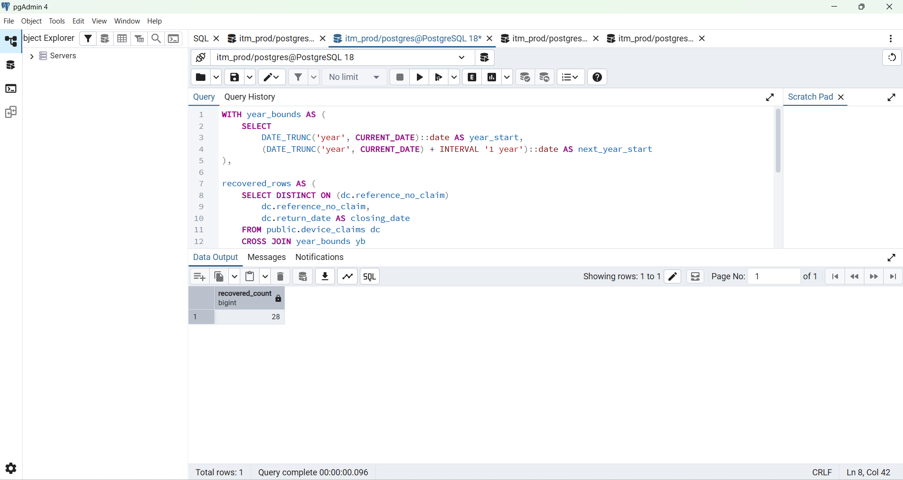

SELECT
dc.reference_no_claim,
MAX(dc.return_date) AS closing_date
FROM public.device_claims dc
WHERE dc.claim_status = 10
AND dc.return_date IS NOT NULL
AND dc.return_date::date >= DATE_TRUNC('year', CURRENT_DATE)::date
AND dc.return_date::date < (DATE_TRUNC('year', CURRENT_DATE) + INTERVAL '1 year')::date
GROUP BY dc.reference_no_claim
ORDER BY closing_date DESC;

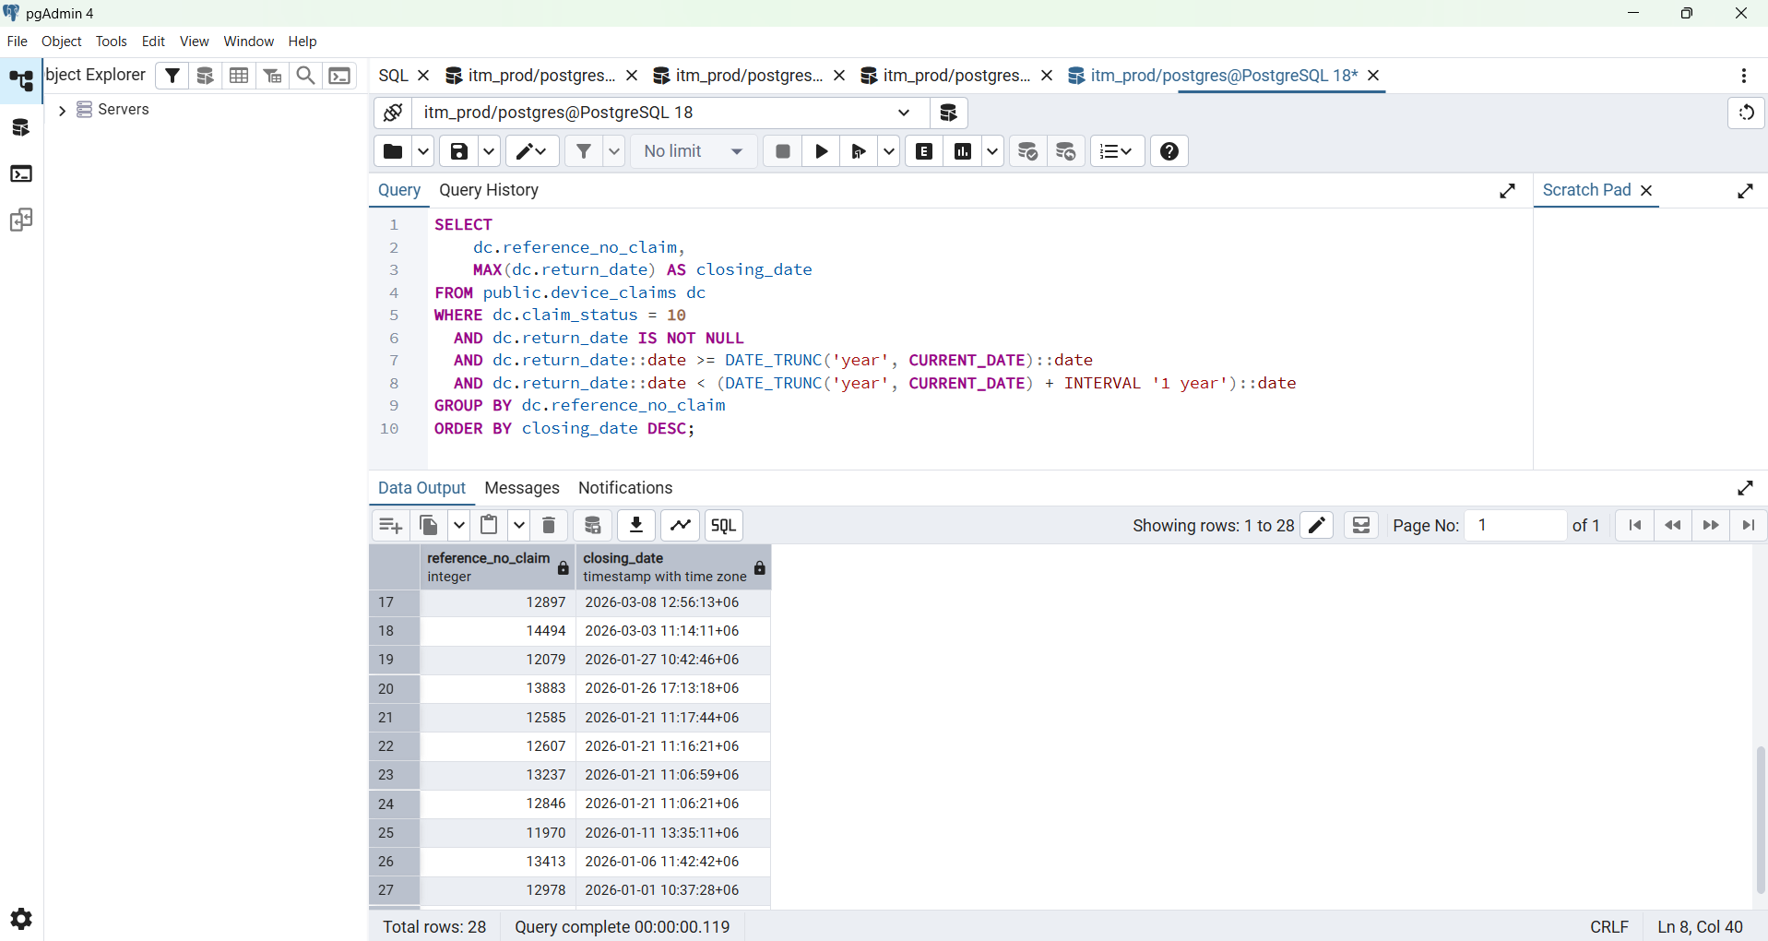

SELECT
h.claim_reference_no,
MAX(h.created_at) AS closing_date
FROM public.device_claim_histories h
WHERE h.current_status = 10
AND h.created_at >= DATE_TRUNC('year', CURRENT_DATE)
AND h.created_at < DATE_TRUNC('year', CURRENT_DATE) + INTERVAL '1 year'
GROUP BY h.claim_reference_no
ORDER BY closing_date DESC;

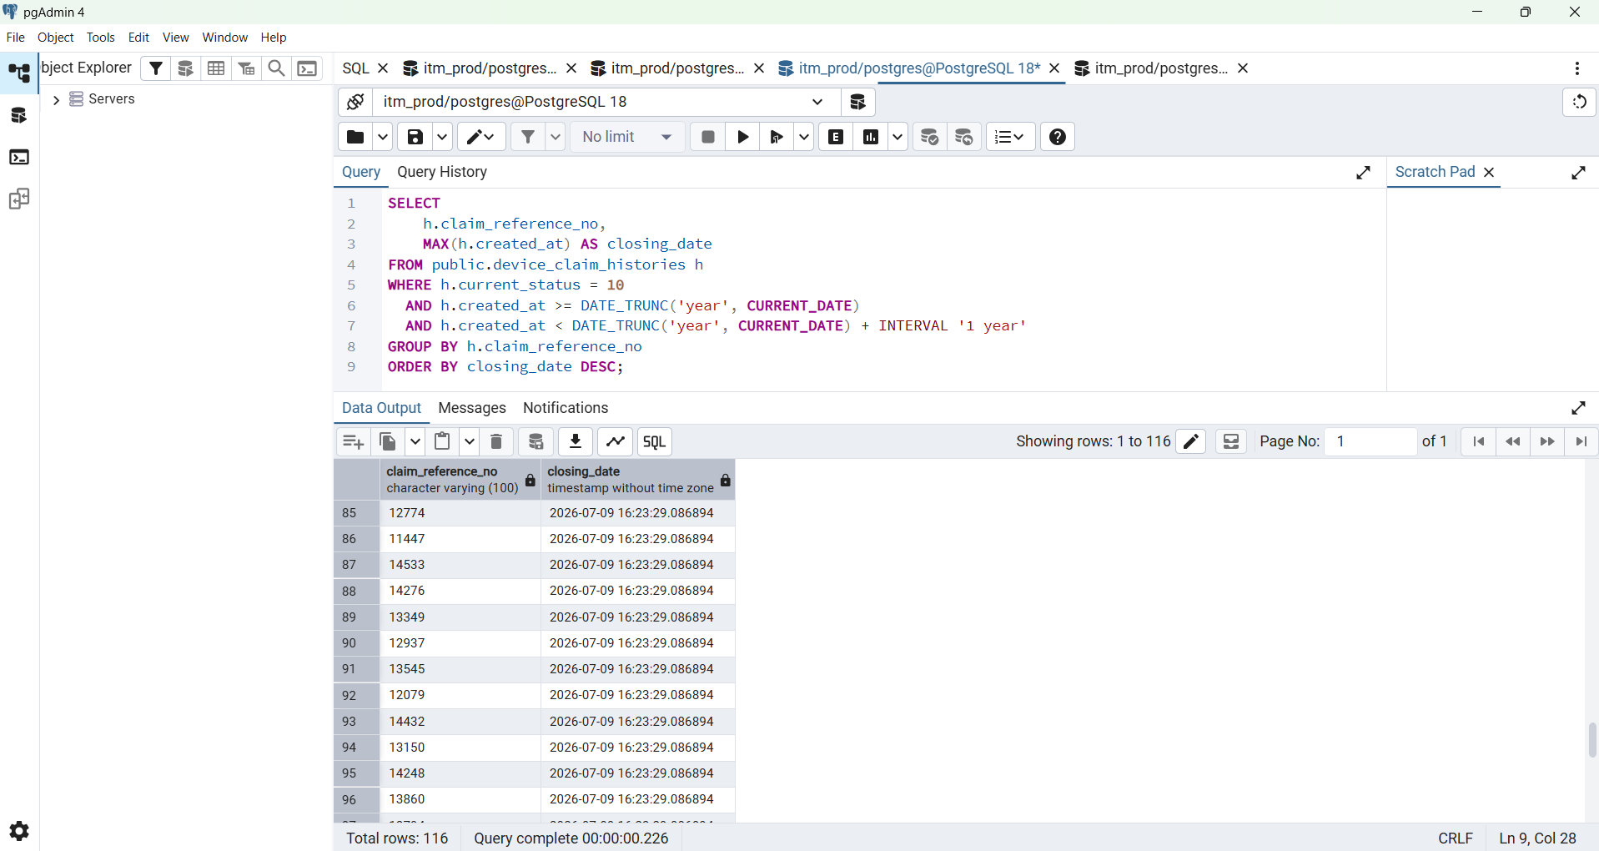

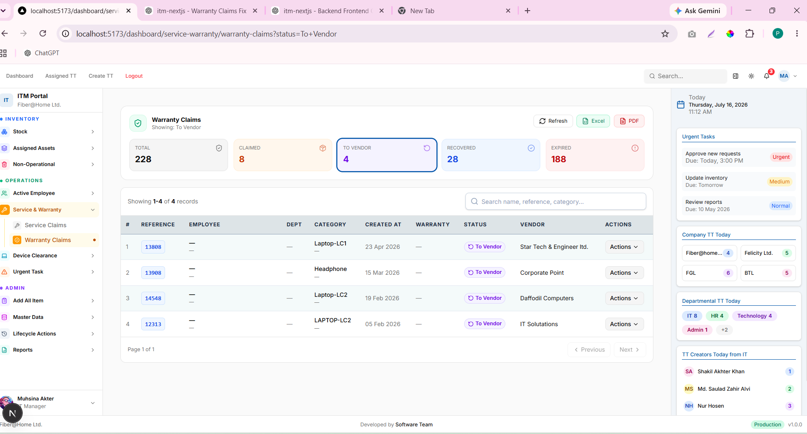

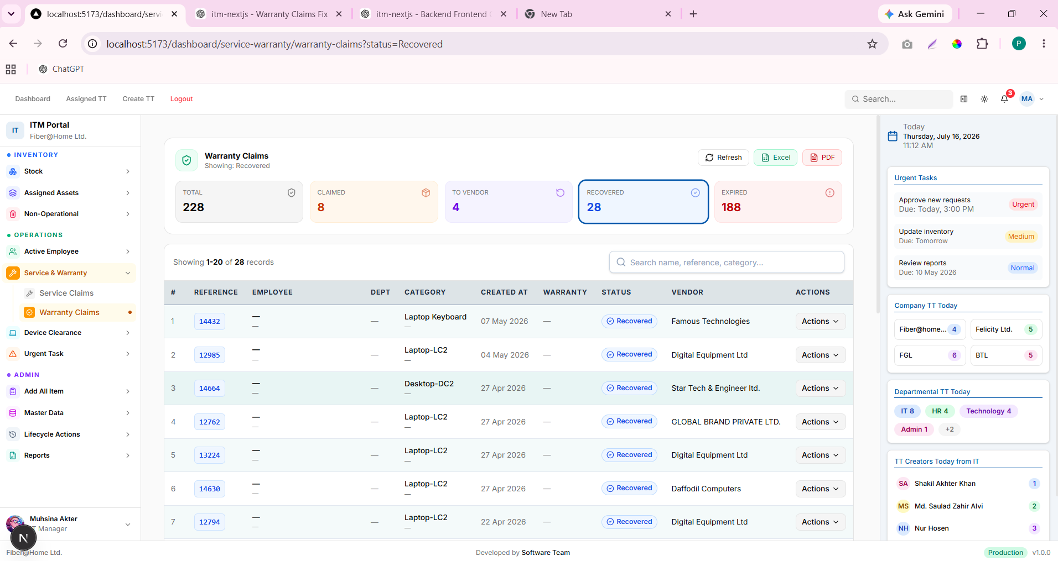

Implemented PostgreSQL database integration, executed the data migration, and validated application connectivity.
Here, each word describes a different part of the work:
- Implemented = Developed/integrated the solution.
- Executed = Performed the migration/deployment/testing.
- Validated = Verified that everything worked correctly.

