https://chatgpt.com/c/6aa2469a-b218-83ee-a063-cf066ce977cc

date : September 10, 2026
Itm.root
f@hrt1@itm_new

-------------------------------------------------------------------------------------
shakil.khan
munmunj1

nur.hosen
Nh.121212

limon.miah
-------------------------------------------------------------------------------------------------------------------------------

https://chatgpt.com/c/6aa2469a-b218-83ee-a063-cf066ce977cc\

Date : 10th September, 2026

select * from inventory_categories order by id desc

These two files itm/frontend/components/tt-columns.tsx
frontend/components/TTTable.tsx are involved in itm/backend/internal/handler/handlers.go

select id, employee_id, status, created_at, closed_at, closed_by, closing_description from trouble_tickets where id ='29578'

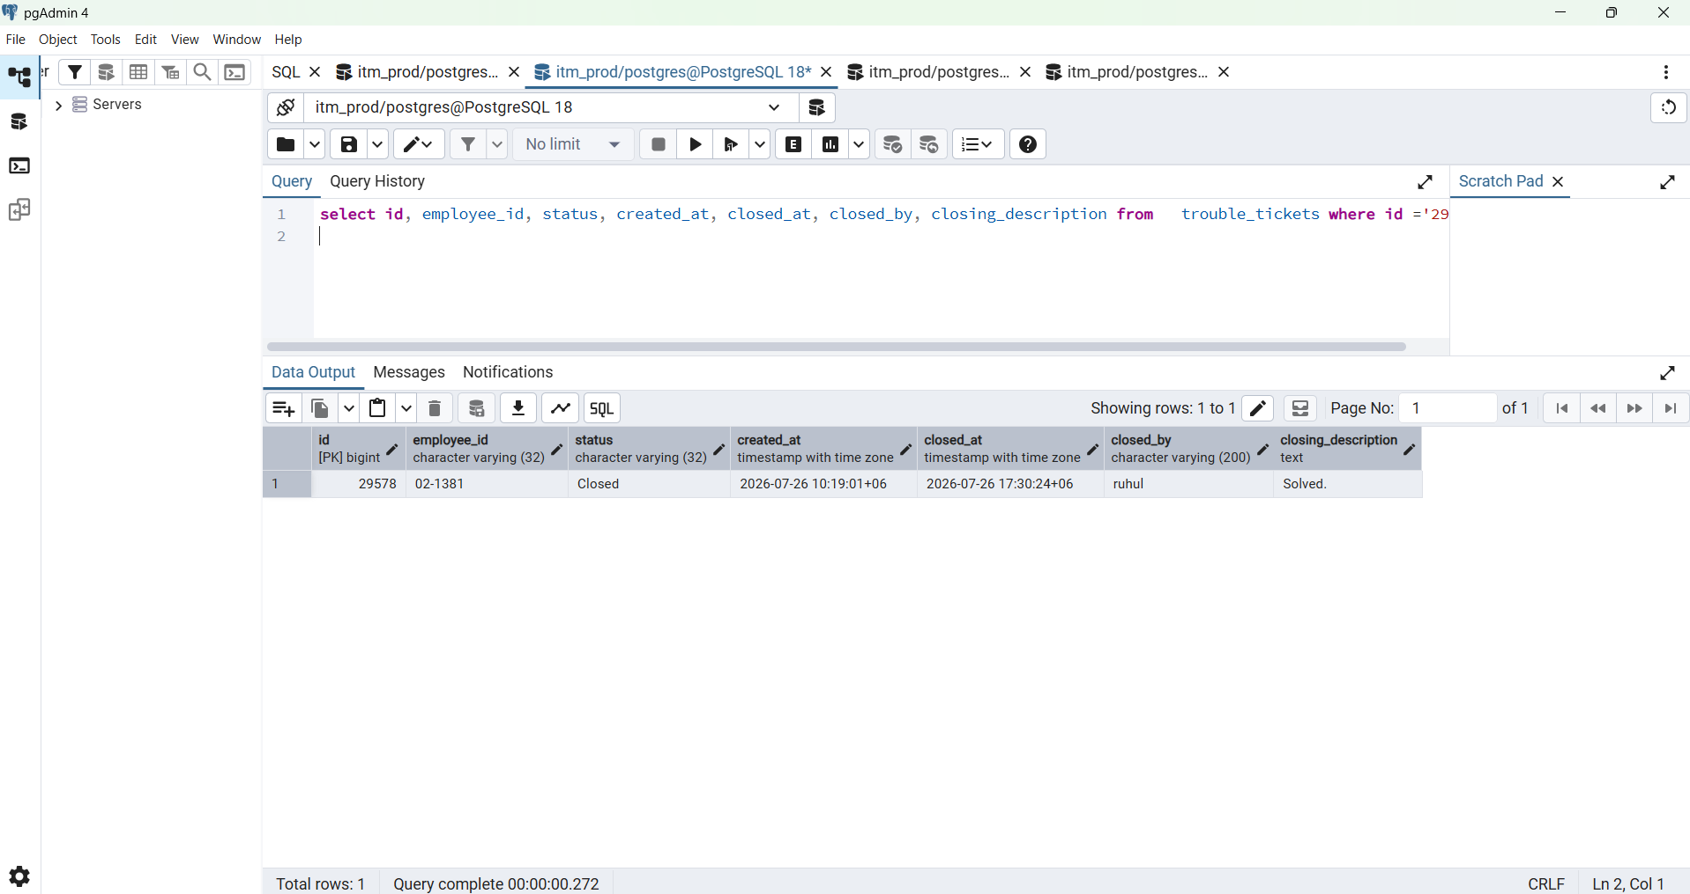

Yes, you can run this in pgAdmin, but first confirm the actual table and column names match exactly:
public.auth_permissions(code, name, active)
public.auth_role_permissions(role_id, permission_id)
public.auth_roles(id, code, name, active)
If those are correct, this SQL is valid for PostgreSQL.

BEGIN;

INSERT INTO public.auth_permissions (
code,
name,
active
)
VALUES (
'TT_Close',
'Close Trouble Ticket',
TRUE
)
ON CONFLICT (code)
DO UPDATE SET
name = EXCLUDED.name,
active = TRUE;

INSERT INTO public.auth_role_permissions (
role_id,
permission_id
)
SELECT
r.id,
p.id
FROM public.auth_roles AS r
CROSS JOIN public.auth_permissions AS p
WHERE r.code IN (
'ROOT',
'IT_ADMIN',
'IT_PERSONNEL'
)
AND r.active = TRUE
AND p.code = 'TT_Close'
AND p.active = TRUE
ON CONFLICT DO NOTHING;

-- Safety:
-- GENERAL_USER must not have TT_Close directly.
DELETE FROM public.auth_role_permissions AS rp
USING public.auth_roles AS r,
public.auth_permissions AS p
WHERE rp.role_id = r.id
AND rp.permission_id = p.id
AND r.code = 'GENERAL_USER'
AND p.code = 'TT_Close';

COMMIT;

-- Verification
SELECT
r.id AS role_id,
r.code AS role_code,
r.name AS role_name,
p.code AS permission_code
FROM public.auth_role_permissions AS rp
JOIN public.auth_roles AS r
ON r.id = rp.role_id
JOIN public.auth_permissions AS p
ON p.id = rp.permission_id
WHERE p.code = 'TT_Close'
ORDER BY r.id;

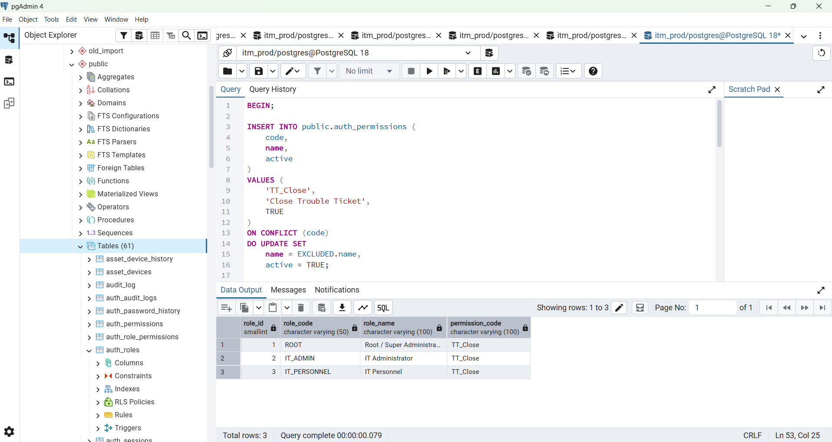

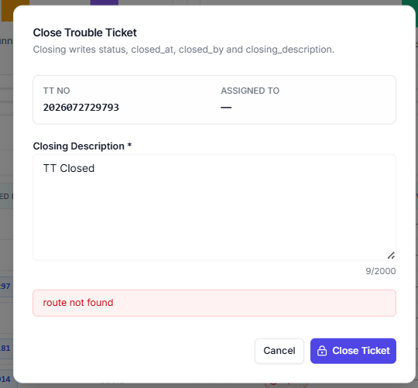

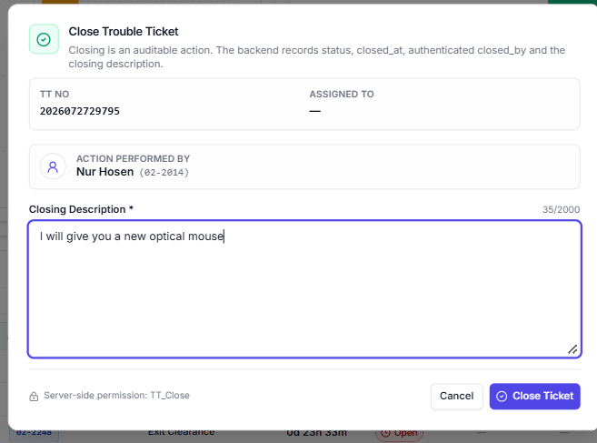

Error for TT Closing:

http://localhost:5173/dashboard?scope=closed_today

Build Error
Export columns doesn't exist in target module
./app/dashboard/trouble-tickets/page.tsx (29:1)
Export columns doesn't exist in target module
27 |
28 |
> 29 | import {
| ^^^^^^^^
> 30 | columns,
| ^^^^^^^^^^^^
> 31 | toSection,
| ^^^^^^^^^^^^
> 32 | } from "@/components/tt-columns";
| ^^^^^^^^^^^^^^^^^^^^^^^^^^^^^^^^^^
33 |
34 |
35 | import {

The export columns was not found in module [project]/components/tt-columns.tsx [app-client] (ecmascript).
Did you mean to import toSection?
All exports of the module are statically known (It doesn't have dynamic exports). So it's known statically that the requested export doesn't exist.

Import traces:
Client Component Browser:
./app/dashboard/trouble-tickets/page.tsx [Client Component Browser]
./app/dashboard/trouble-tickets/page.tsx [Server Component]

Client Component SSR:
./app/dashboard/trouble-tickets/page.tsx [Client Component SSR]
./app/dashboard/trouble-tickets/page.tsx [Server Component]

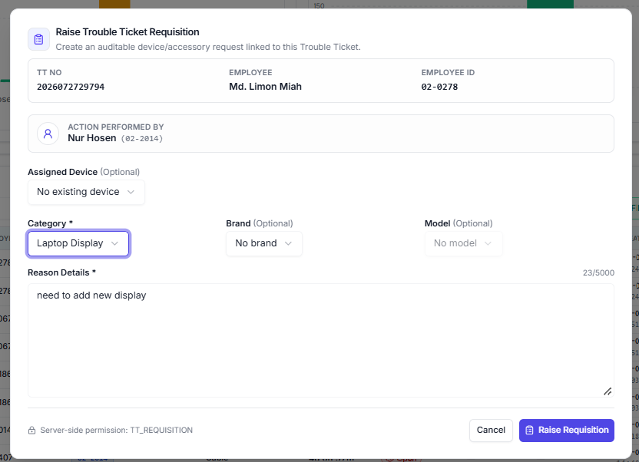

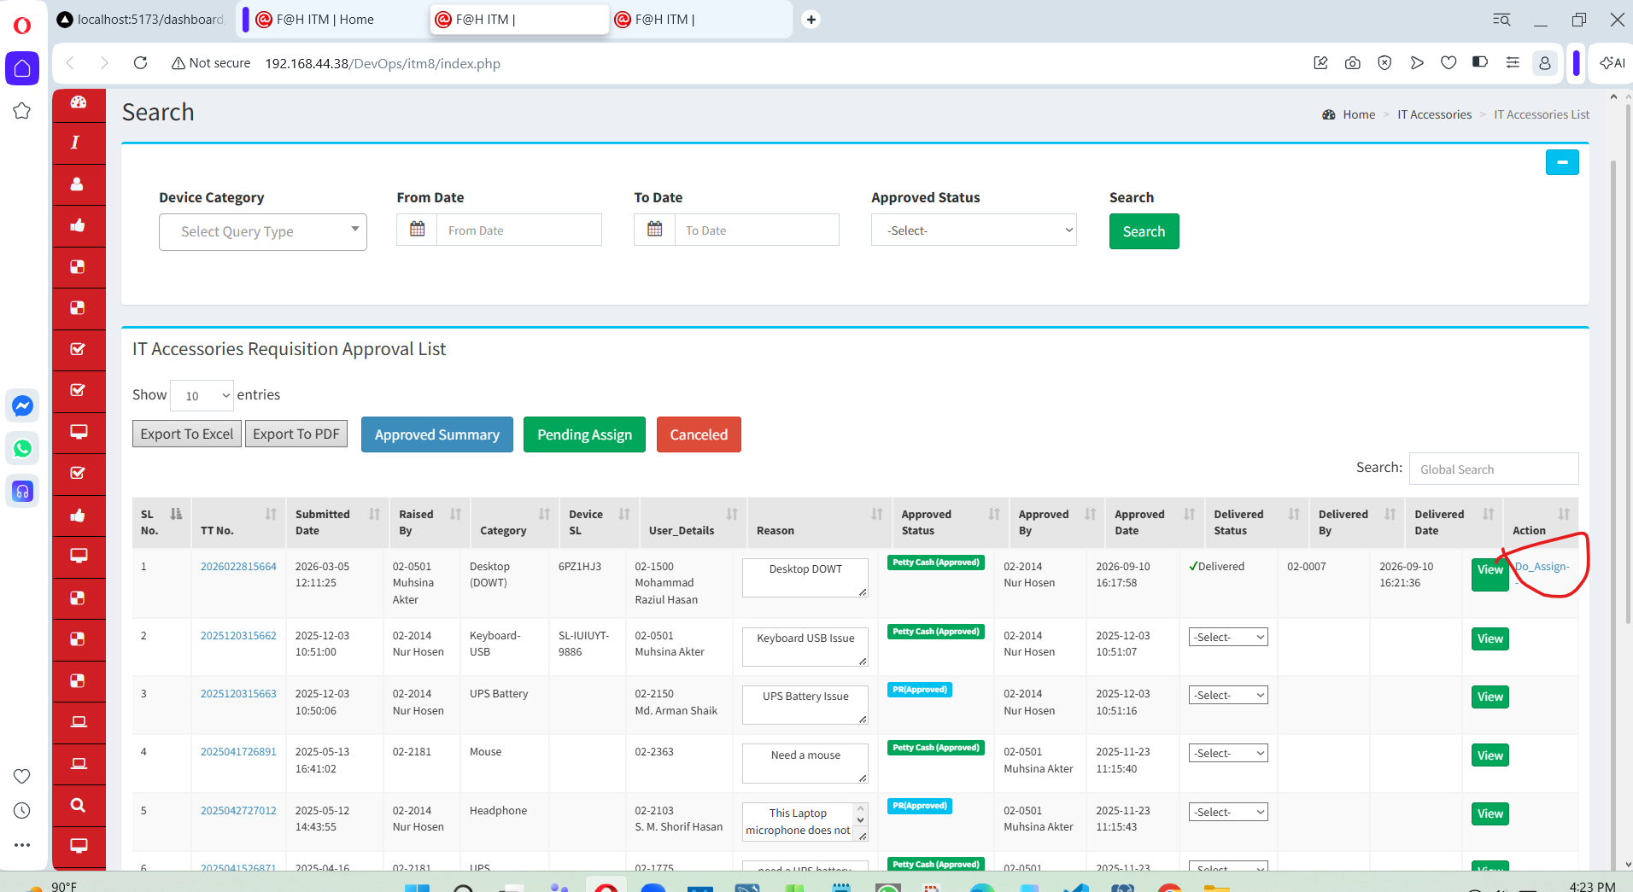

After assigned it will be delivered to employees and the below form is device assigned form is my assigned form and status will be delivered after assigned the device
