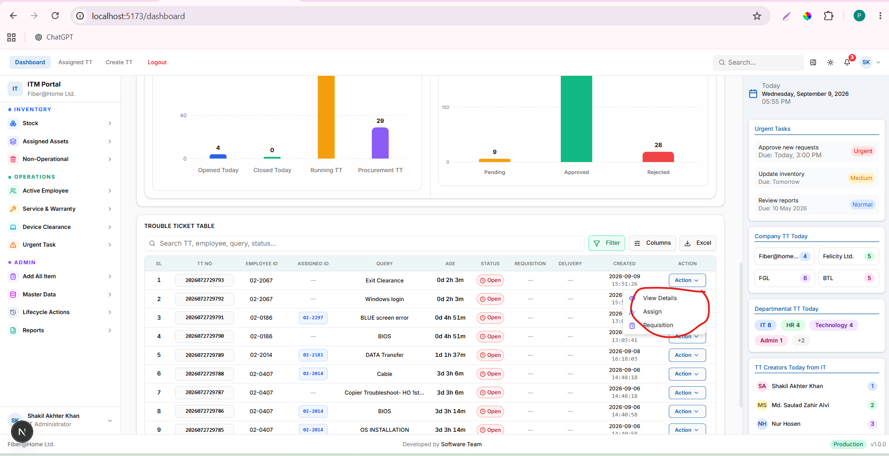

select id, employee_id, status, created_at, closed_at, closed_by, closing_description from trouble_tickets where id ='29578'

