SELECT
asset_status,
CASE asset_status
WHEN 0 THEN 'Available'
WHEN 1 THEN 'Assigned'
WHEN 2 THEN 'Damaged'
WHEN 3 THEN 'Transferred'
WHEN 4 THEN 'Returned'
WHEN 5 THEN 'Lost'
WHEN 7 THEN 'Ownership Transfer'
WHEN 8 THEN 'Claim Raised'
WHEN 15 THEN 'Service Request'
ELSE 'Unknown'
END AS status_name,
COUNT(*) AS total_devices
FROM public.asset_devices
GROUP BY asset_status
ORDER BY asset_status;

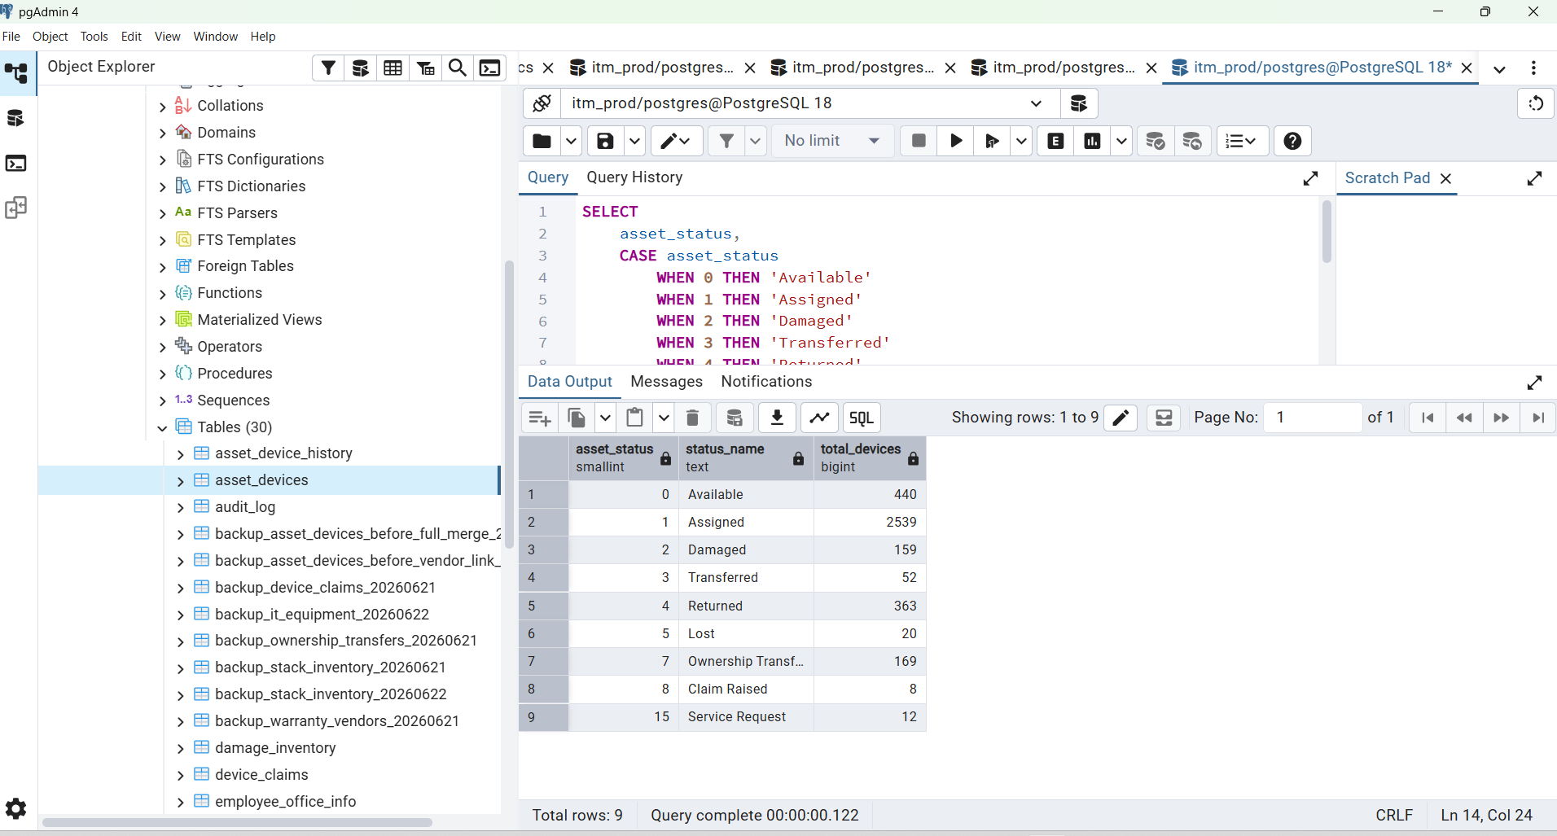
SELECT
COUNT(*) FILTER (WHERE asset_status = 0) AS available,
COUNT(*) FILTER (WHERE asset_status = 2) AS damaged,
COUNT(*) FILTER (WHERE asset_status = 5) AS lost,
COUNT(*) FILTER (WHERE asset_status = 7) AS ownership_transfer
FROM public.asset_devices;
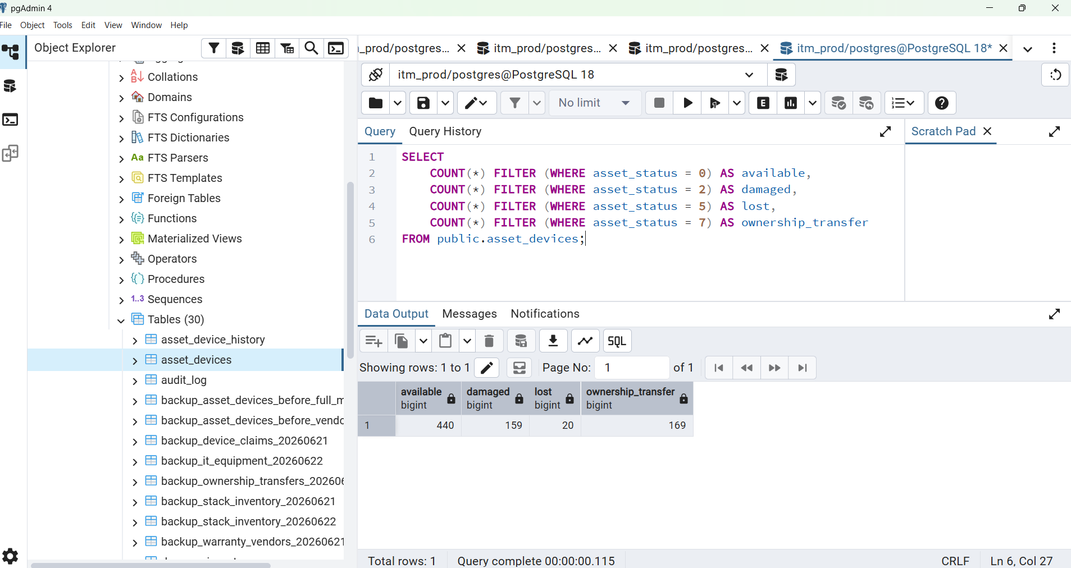
SELECT
asset_status,
COUNT(*) AS total
FROM public.asset_devices
GROUP BY asset_status
ORDER BY asset_status;

Expected important counts from your current registry should be around:
Ownership Transfer = 169
Damaged = 440
Lost = 20
Non-Operational Assets: 629
Ownership: 169
Damaged: 440
Lost: 20

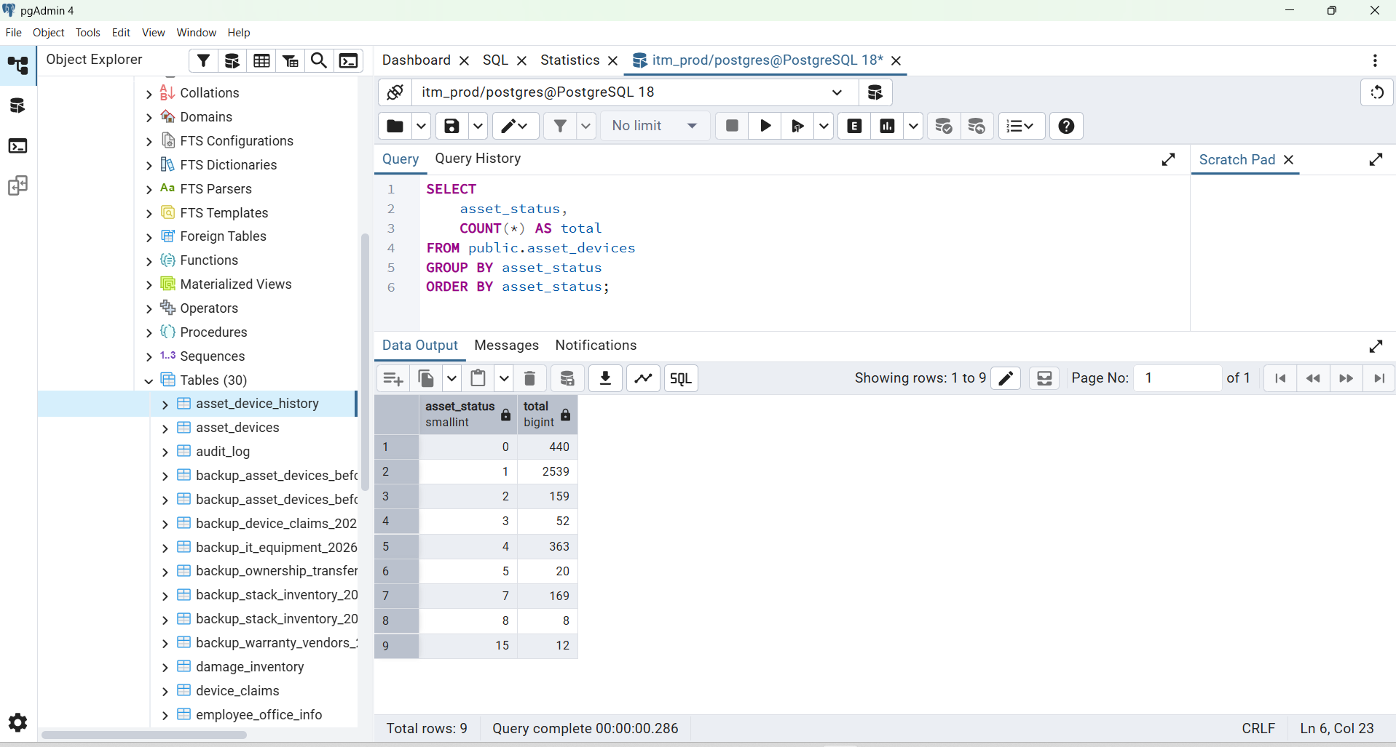

SELECT
id,
device_serial,
emp_id,
emp_name,
category,
model,
asset_status
FROM public.asset_devices
WHERE asset_status IN (
5,
6,
7
)
ORDER BY id DESC
LIMIT 30;

SELECT
device_status,
status,
COUNT(*) AS total_records
FROM public.damage_inventory
GROUP BY device_status, status
ORDER BY device_status, status;

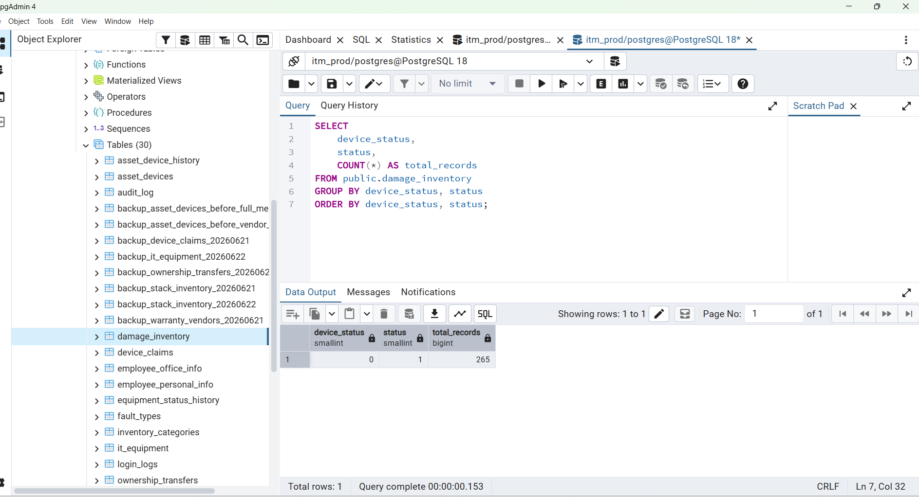

Ownership 169
Damaged 159
Lost 20

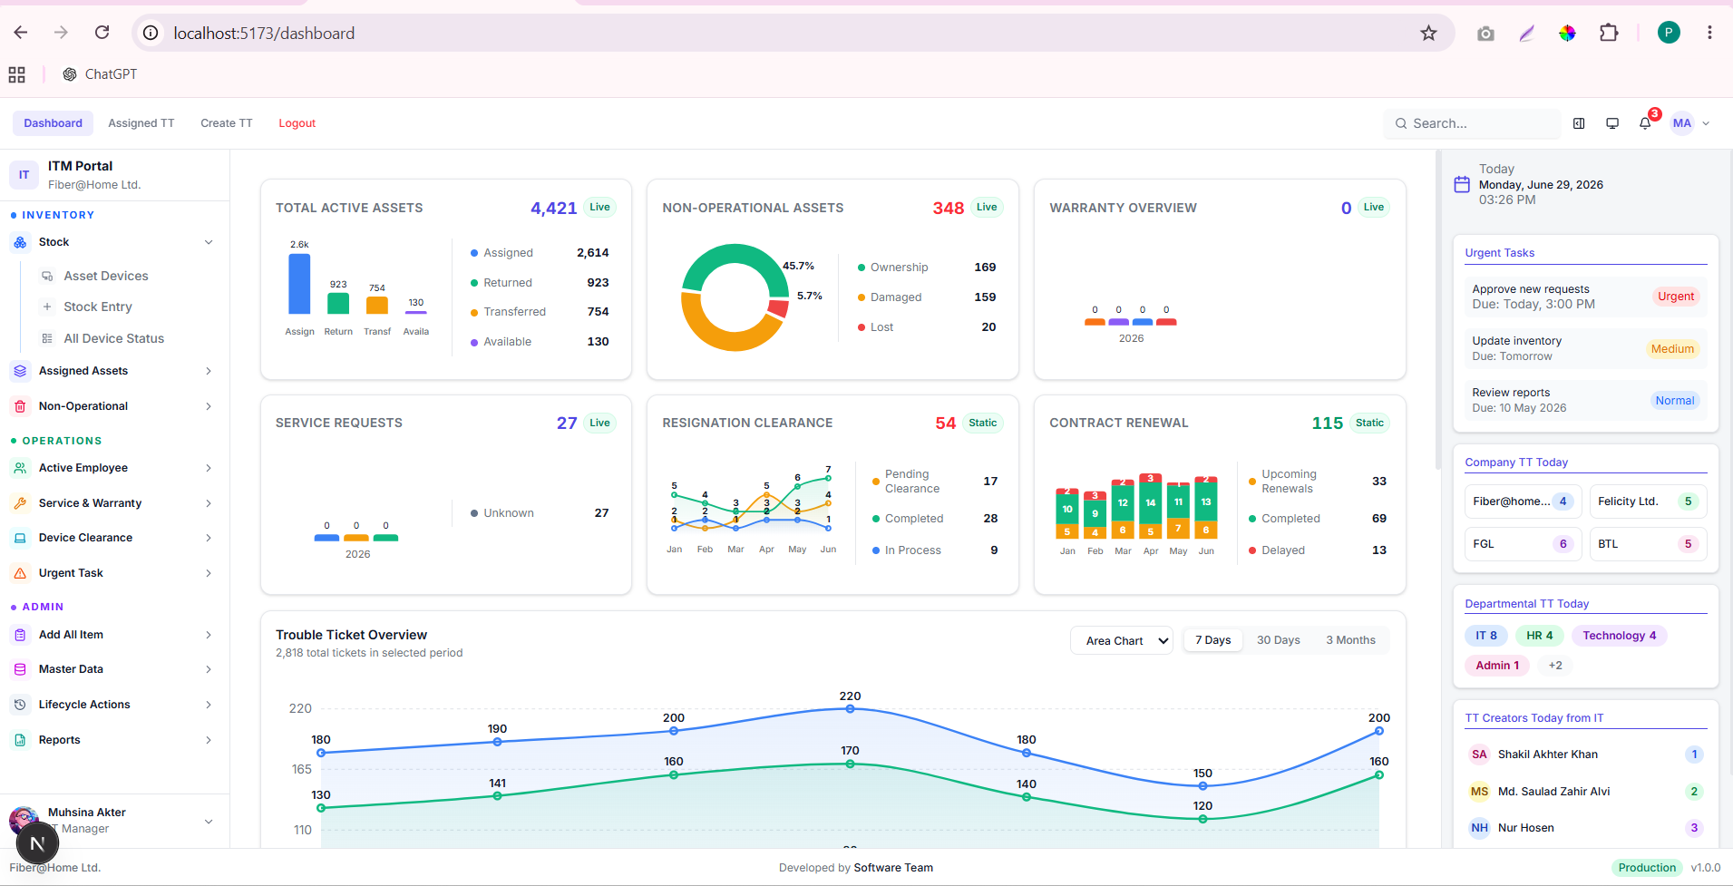

Step 2 — Check duplicate serial numbers in damage data
SELECT
BTRIM(device_sl_no) AS device_sl_no,
COUNT(*) AS total
FROM public.damage_inventory
WHERE device_status = 0
AND status = 1
AND NULLIF(BTRIM(device_sl_no), '') IS NOT NULL
GROUP BY BTRIM(device_sl_no)
HAVING COUNT(*) > 1
ORDER BY total DESC, device_sl_no;
Ideally this returns zero rows.

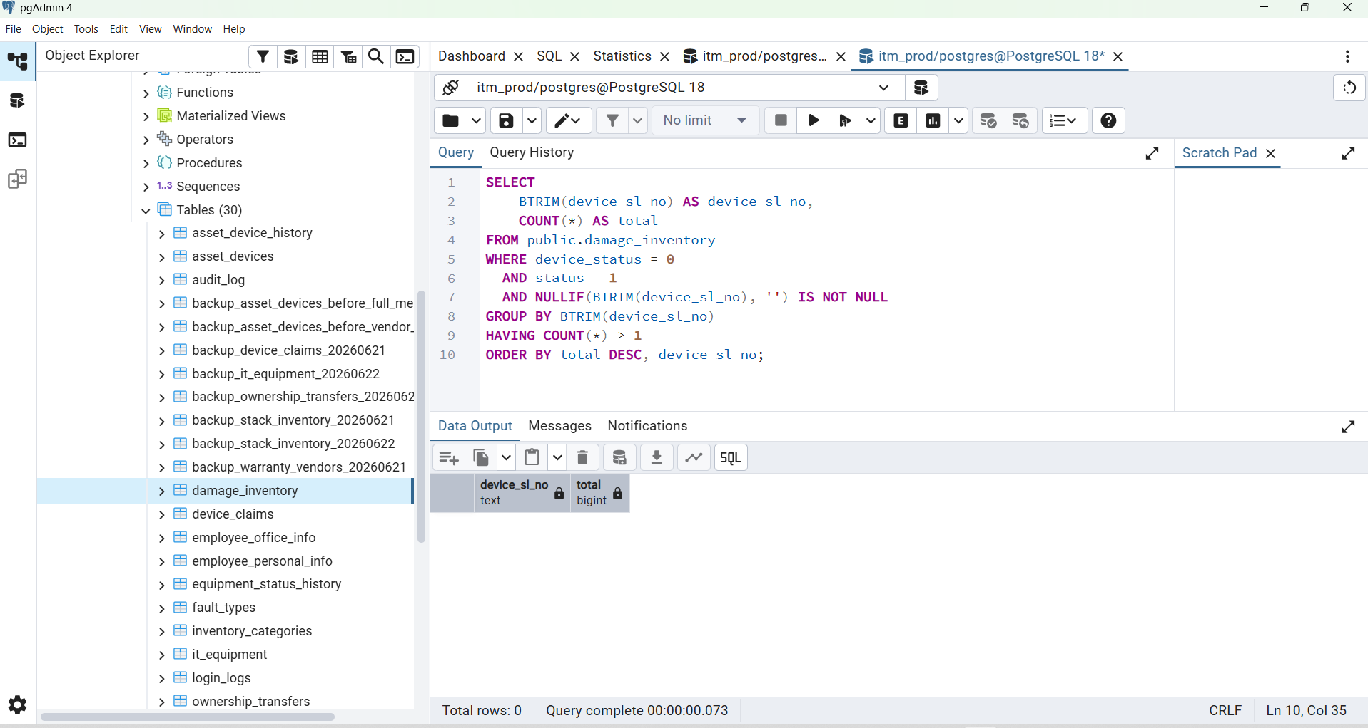

Step 3 — Check duplicate serial numbers in main table
SELECT
BTRIM(device_serial) AS device_serial,
COUNT(*) AS total
FROM public.asset_devices
WHERE NULLIF(BTRIM(device_serial), '') IS NOT NULL
GROUP BY BTRIM(device_serial)
HAVING COUNT(*) > 1
ORDER BY total DESC, device_serial;
Ideally this also returns zero rows.

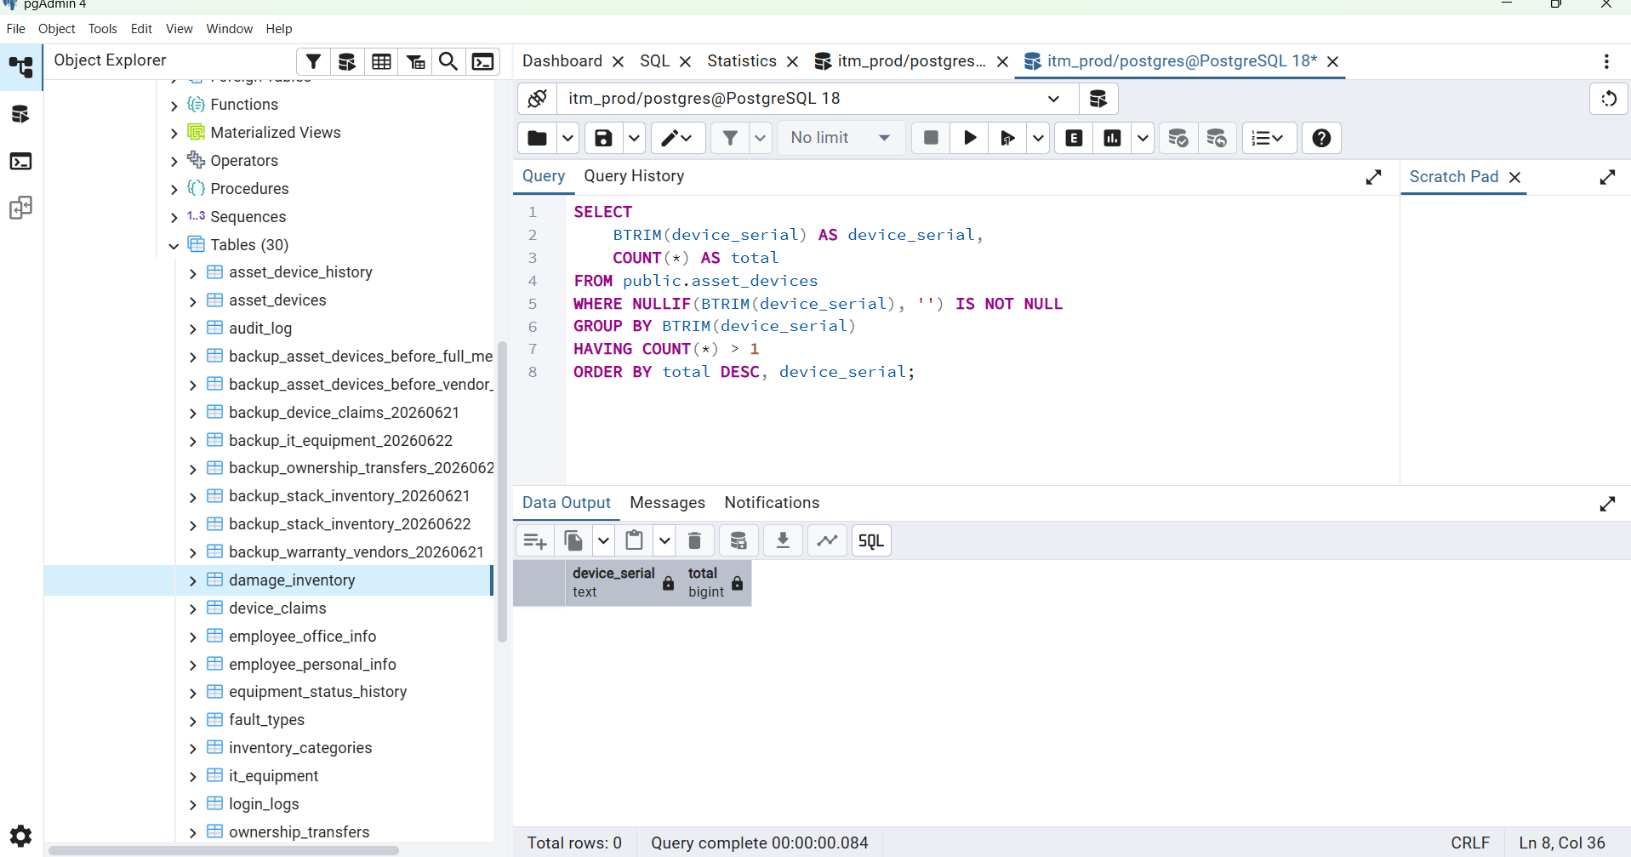

SELECT
CASE
WHEN ad.id IS NULL THEN 'INSERT_NEW_DEVICE'
ELSE 'UPDATE_EXISTING_DEVICE'
END AS migration_action,
di.id AS damage_inventory_id,
di.device_sl_no,
di.device_category,
di.model,
di.device_status,
di.status,
di.remarks,
ad.id AS asset_device_id,
ad.device_serial,
ad.asset_status AS current_asset_status
FROM public.damage_inventory di
LEFT JOIN public.asset_devices ad
ON BTRIM(ad.device_serial) = BTRIM(di.device_sl_no)
WHERE di.device_status = 0
AND di.status = 1
AND NULLIF(BTRIM(di.device_sl_no), '') IS NOT NULL
ORDER BY migration_action, di.device_sl_no;

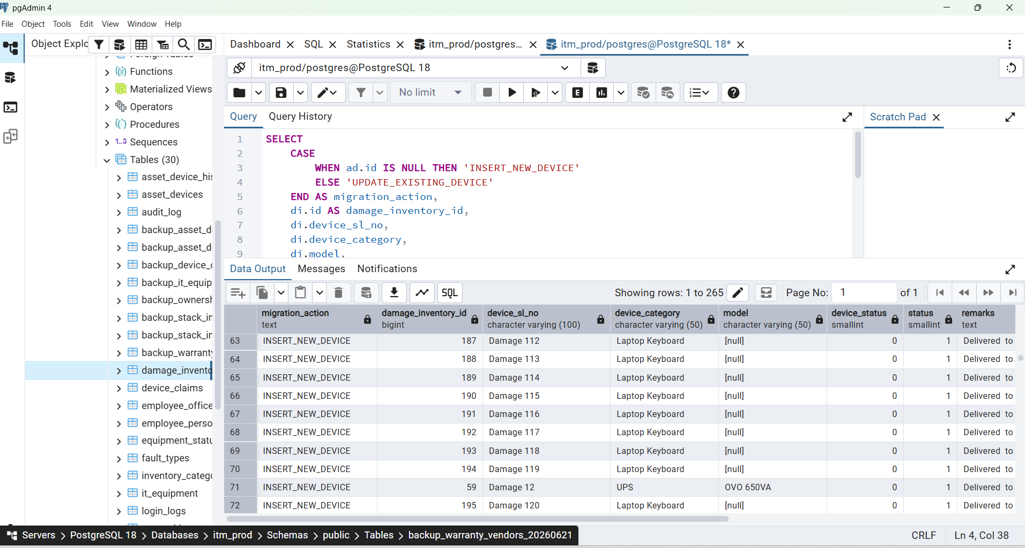

SELECT
COUNT(*) AS total_valid_damage_records,
COUNT(ad.id) AS existing_devices_to_update,
COUNT(*) - COUNT(ad.id) AS missing_devices_to_insert
FROM public.damage_inventory di
LEFT JOIN public.asset_devices ad
ON BTRIM(ad.device_serial) = BTRIM(di.device_sl_no)
WHERE di.device_status = 0
AND di.status = 1
AND NULLIF(BTRIM(di.device_sl_no), '') IS NOT NULL;

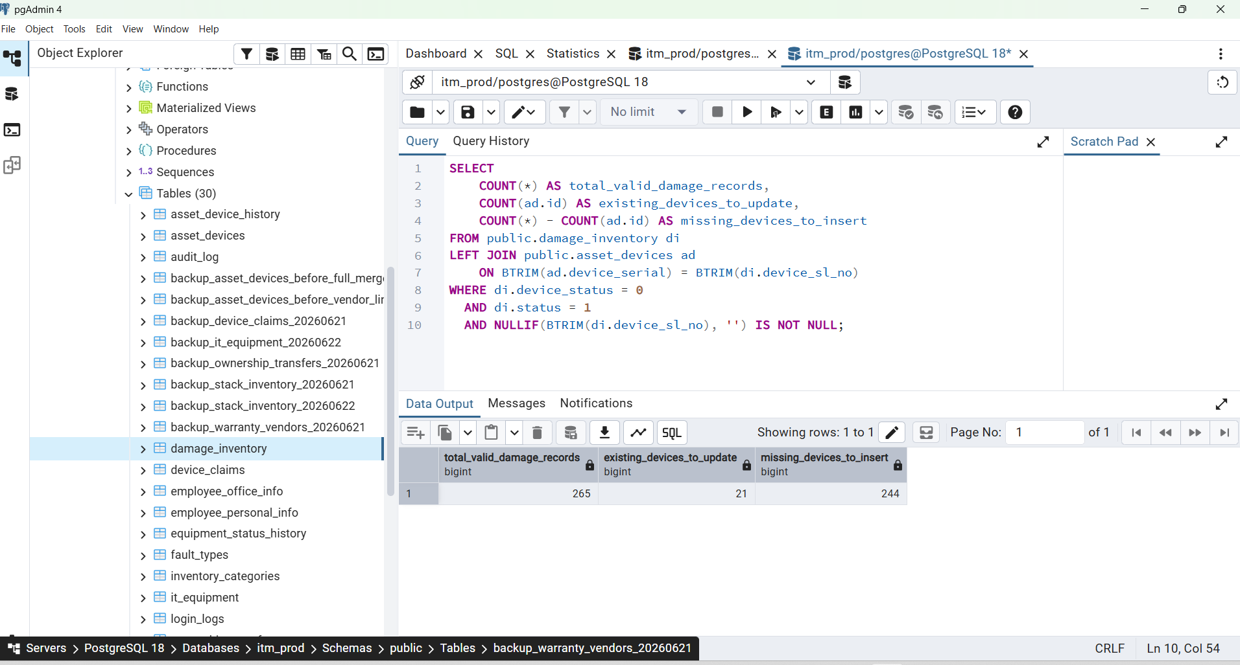

SELECT
ad.id,
ad.device_serial,
ad.asset_status AS old_asset_status,
2 AS new_asset_status,
di.id AS damage_inventory_id,
di.device_category,
di.model,
di.remarks,
di.created_at
FROM public.damage_inventory di
JOIN public.asset_devices ad
ON BTRIM(ad.device_serial) = BTRIM(di.device_sl_no)
WHERE di.device_status = 0
AND di.status = 1
AND NULLIF(BTRIM(di.device_sl_no), '') IS NOT NULL
ORDER BY ad.device_serial;

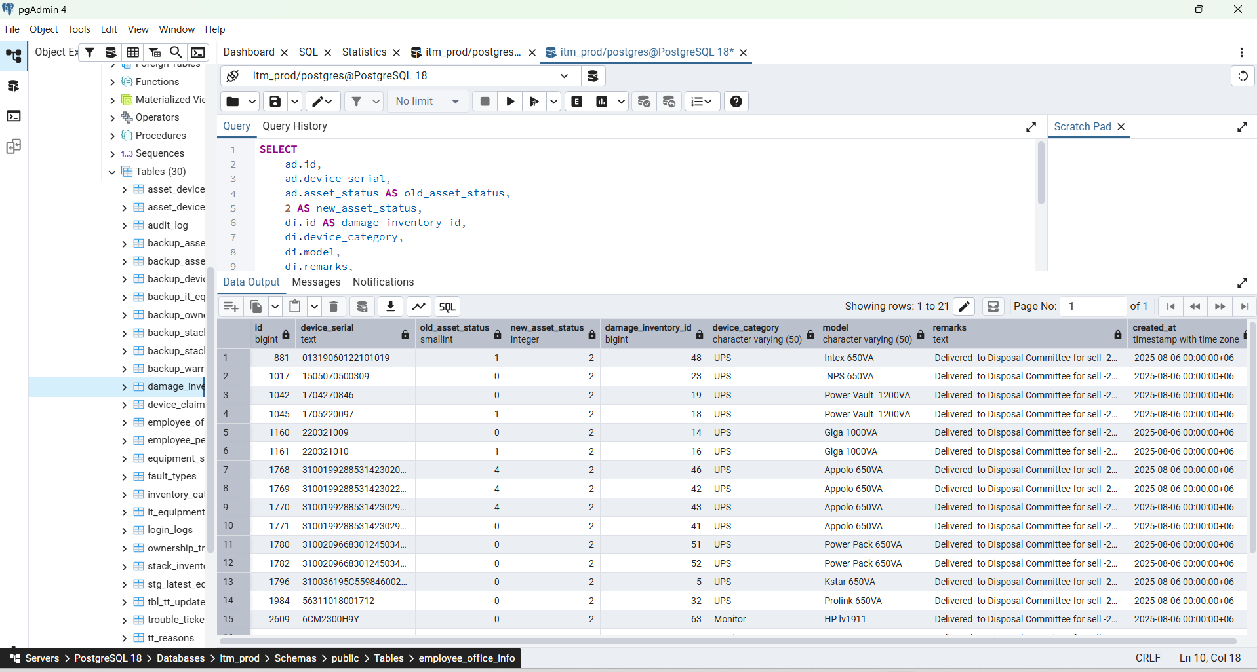

SELECT
column_name,
data_type,
is_nullable,
column_default
FROM information_schema.columns
WHERE table_schema = 'public'
AND table_name = 'asset_devices'
ORDER BY ordinal_position;

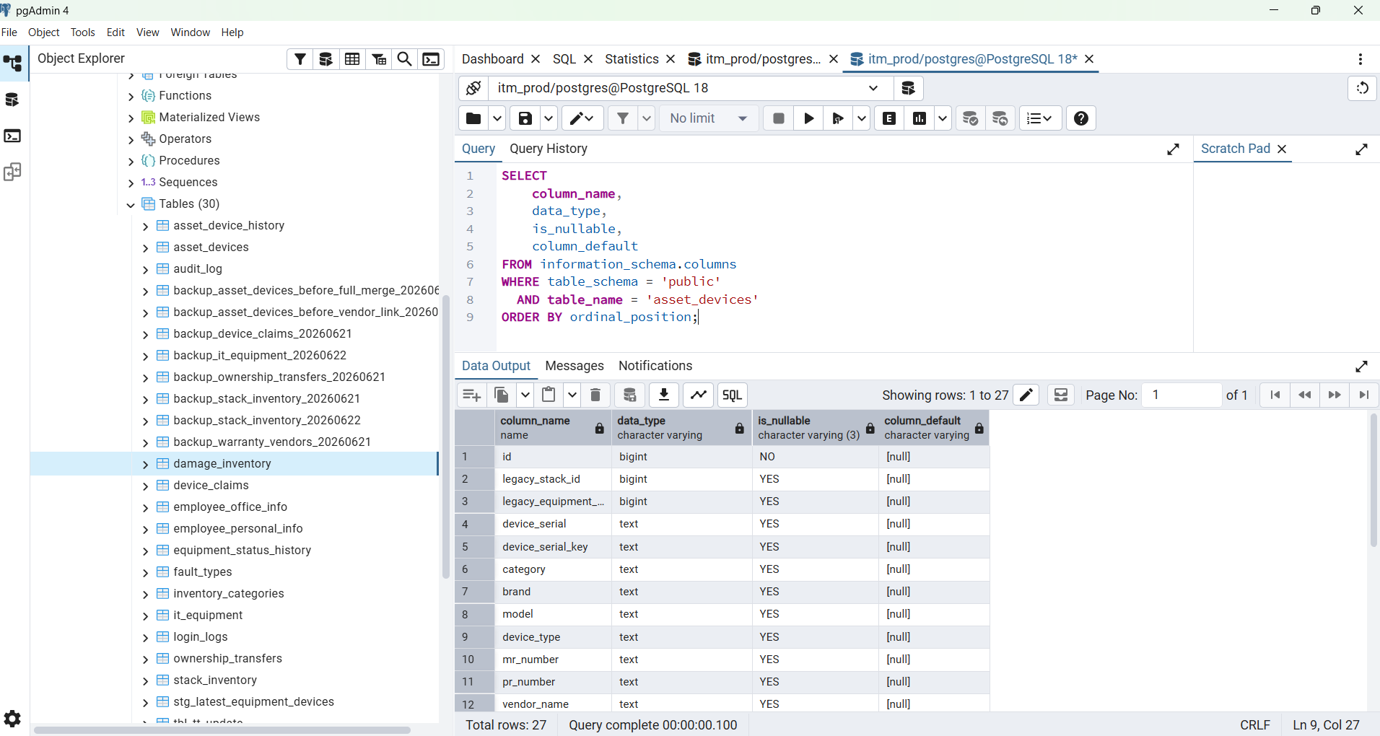

SELECT
COUNT(*) AS total_damage_records,
COUNT(ad.id) AS matched_in_asset_devices,
COUNT(*) - COUNT(ad.id) AS not_found_in_asset_devices
FROM public.damage_inventory di
LEFT JOIN public.asset_devices ad
ON BTRIM(ad.device_serial) = BTRIM(di.device_sl_no)
WHERE di.device_status = 0
AND di.status = 1
AND NULLIF(BTRIM(di.device_sl_no), '') IS NOT NULL;

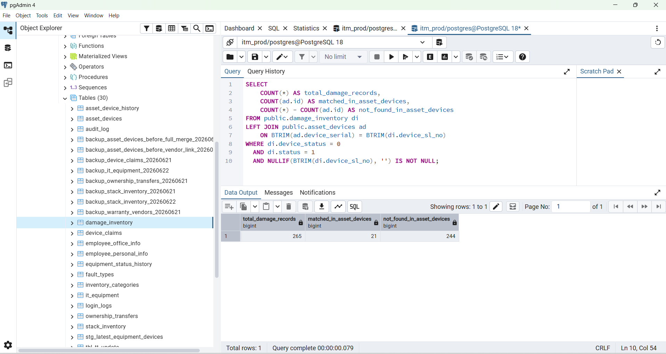

ALTER TABLE public.asset_devices
ADD COLUMN IF NOT EXISTS damage_inventory_id BIGINT,
ADD COLUMN IF NOT EXISTS damage_remarks TEXT,
ADD COLUMN IF NOT EXISTS damaged_at TIMESTAMPTZ;

Output:

NOTICE: column "damage_inventory_id" of relation "asset_devices" already exists, skipping
NOTICE: column "damage_remarks" of relation "asset_devices" already exists, skipping
NOTICE: column "damaged_at" of relation "asset_devices" already exists, skipping
ALTER TABLE

Query returned successfully in 57 msec.

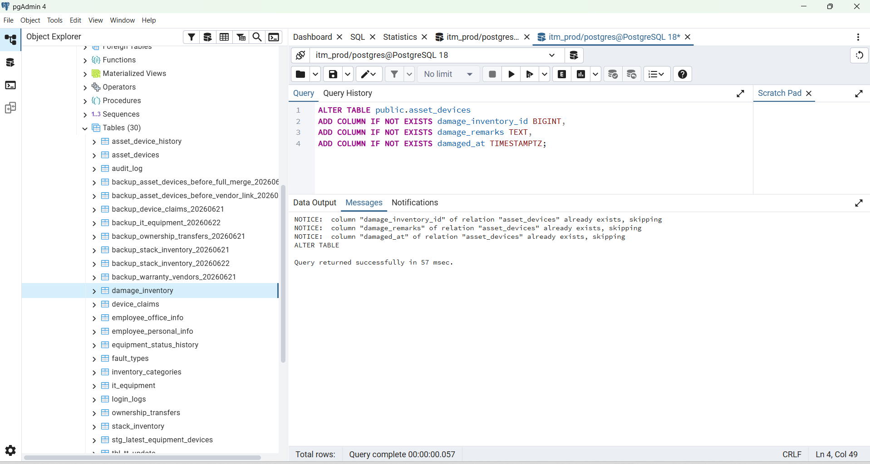

CREATE UNIQUE INDEX IF NOT EXISTS uq_asset_devices_damage_inventory_id
ON public.asset_devices (damage_inventory_id)
WHERE damage_inventory_id IS NOT NULL;

Output :
NOTICE: relation "uq_asset_devices_damage_inventory_id" already exists, skipping
CREATE INDEX

Query returned successfully in 44 msec.

Step 4 — Test update without saving
This marks matching devices as Damaged, but ROLLBACK means nothing is saved yet:
BEGIN;
UPDATE public.asset_devices ad
SET
asset_status = 2,
damage_inventory_id = di.id,
damage_remarks = COALESCE(
NULLIF(BTRIM(di.remarks), ''),
ad.damage_remarks
),
damaged_at = COALESCE(di.created_at, ad.damaged_at),
updated_at = NOW()
FROM public.damage_inventory di
WHERE BTRIM(ad.device_serial) = BTRIM(di.device_sl_no)
AND di.device_status = 0
AND di.status = 1
AND NULLIF(BTRIM(di.device_sl_no), '') IS NOT NULL;
SELECT
COUNT(*) AS damaged_devices_after_test
FROM public.asset_devices
WHERE asset_status = 2;
ROLLBACK;
This should show the expected damaged count before saving.

SELECT
column_name,
data_type,
is_nullable,
column_default
FROM information_schema.columns
WHERE table_schema = 'public'
AND table_name = 'asset_devices'
AND is_nullable = 'NO'
ORDER BY ordinal_position;

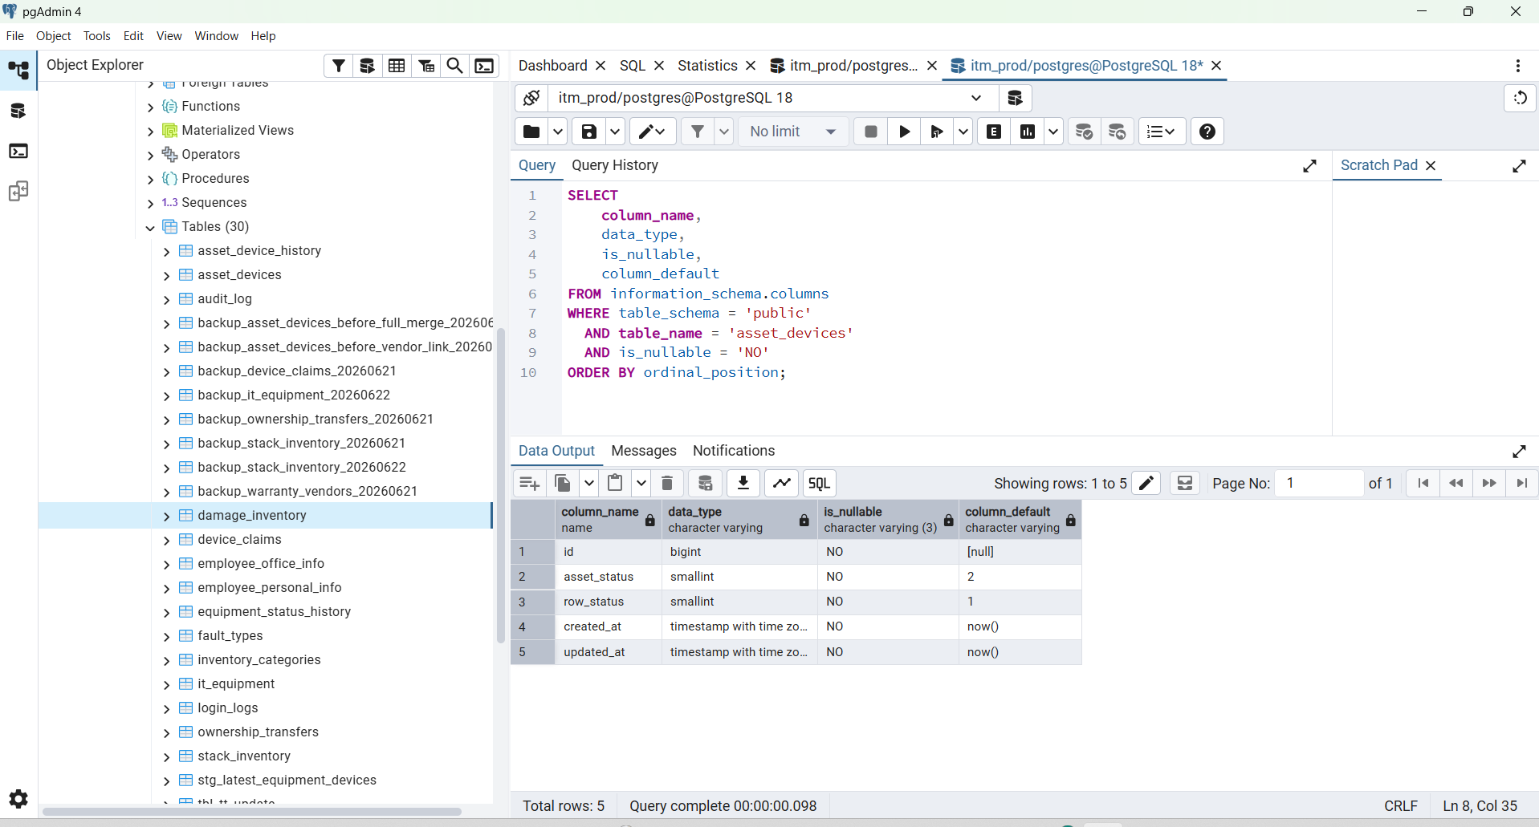

SELECT
COUNT(*) AS total_damage_records,
COUNT(ad.id) AS already_exists_in_asset_devices,
COUNT(*) - COUNT(ad.id) AS missing_from_asset_devices
FROM public.damage_inventory di
LEFT JOIN public.asset_devices ad
ON BTRIM(ad.device_serial) = BTRIM(di.device_sl_no)
WHERE di.device_status = 0
AND di.status = 1
AND NULLIF(BTRIM(di.device_sl_no), '') IS NOT NULL;

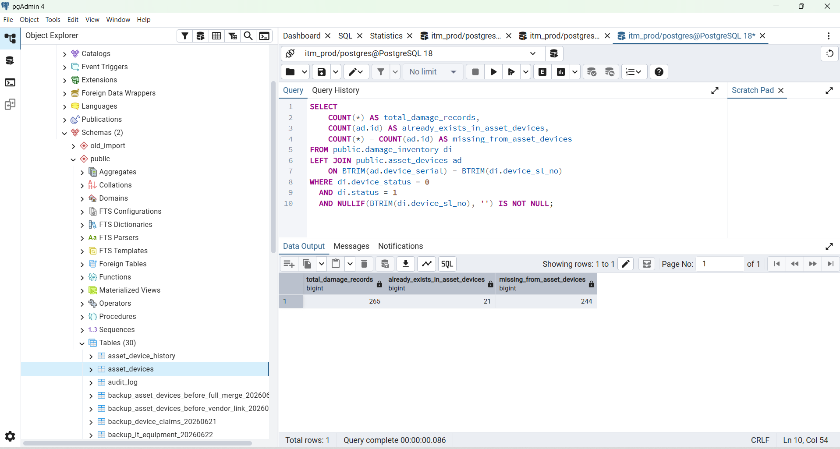

SELECT
di.id AS damage_inventory_id,
di.device_sl_no AS device_serial,
di.device_category AS category,
di.model,
di.department,
di.function_name,
di.remarks,
di.created_at
FROM public.damage_inventory di
LEFT JOIN public.asset_devices ad
ON BTRIM(ad.device_serial) = BTRIM(di.device_sl_no)
WHERE di.device_status = 0
AND di.status = 1
AND NULLIF(BTRIM(di.device_sl_no), '') IS NOT NULL
AND ad.id IS NULL
ORDER BY di.device_sl_no
LIMIT 100;

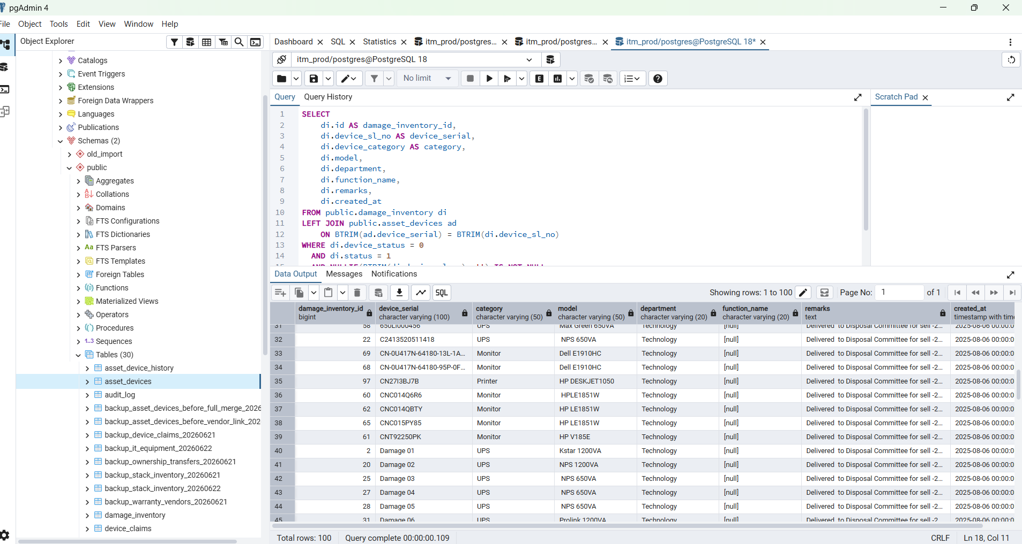

SELECT
COUNT(*) AS total_valid_damage_records,
COUNT(ad.id) AS already_exists_in_asset_devices,
COUNT(*) - COUNT(ad.id) AS missing_from_asset_devices
FROM public.damage_inventory di
LEFT JOIN public.asset_devices ad
ON BTRIM(ad.device_serial) = BTRIM(di.device_sl_no)
WHERE di.device_status = 0
AND di.status = 1
AND NULLIF(BTRIM(di.device_sl_no), '') IS NOT NULL;

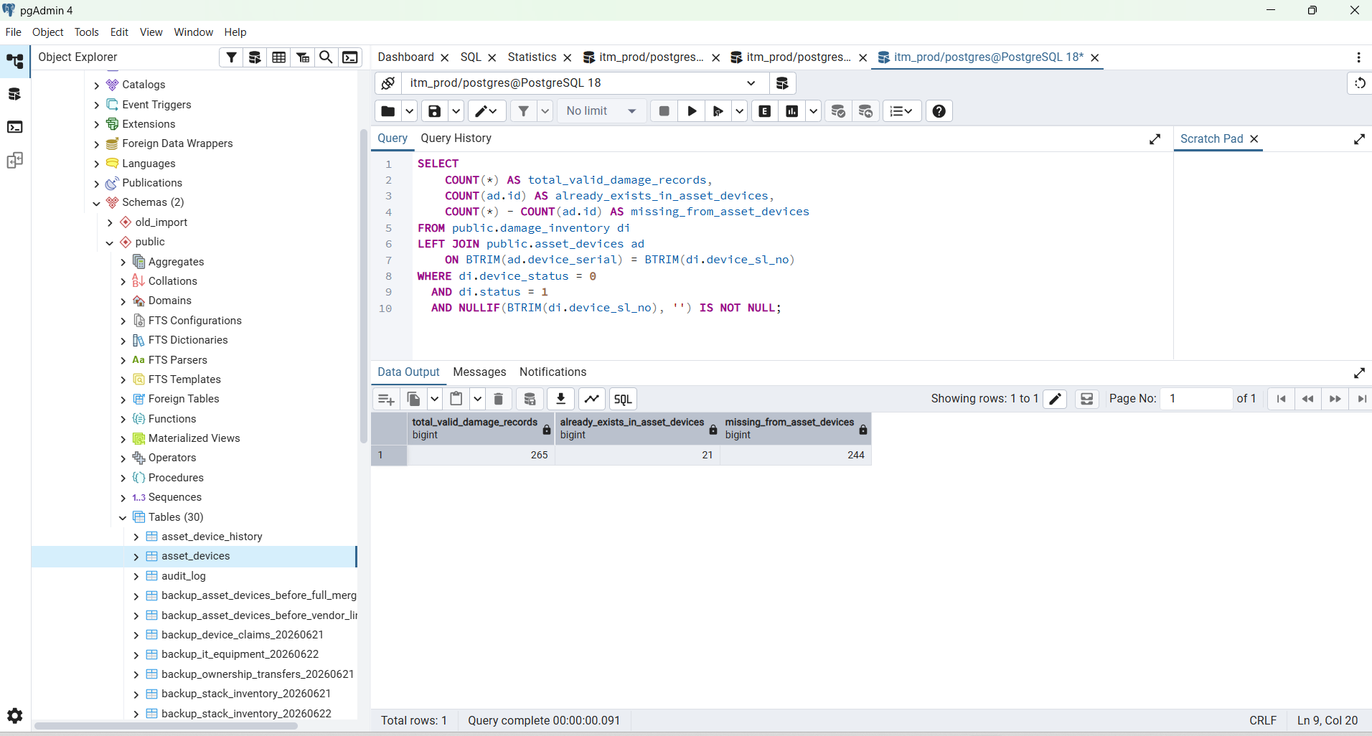

BEGIN;

-- A. Mark matching main-table devices as Damaged
UPDATE public.asset_devices ad
SET
asset_status = 2,
updated_at = NOW()
FROM public.damage_inventory di
WHERE BTRIM(ad.device_serial) = BTRIM(di.device_sl_no)
AND di.device_status = 0
AND di.status = 1
AND NULLIF(BTRIM(di.device_sl_no), '') IS NOT NULL;

-- B. Insert only damage devices that do not exist in main table
INSERT INTO public.asset_devices (
id,
device_serial,
category,
model,
asset_status,
row_status,
created_at,
updated_at
)
SELECT
nextval('public.asset_devices_id_seq'),
BTRIM(di.device_sl_no),
NULLIF(BTRIM(di.device_category), ''),
NULLIF(BTRIM(di.model), ''),
2,
1,
COALESCE(di.created_at, NOW()),
NOW()
FROM public.damage_inventory di
LEFT JOIN public.asset_devices ad
ON BTRIM(ad.device_serial) = BTRIM(di.device_sl_no)
WHERE di.device_status = 0
AND di.status = 1
AND NULLIF(BTRIM(di.device_sl_no), '') IS NOT NULL
AND ad.id IS NULL;

-- C. Verify the temporary result
SELECT
COUNT(*) FILTER (WHERE asset_status = 2) AS damaged,
COUNT(*) FILTER (WHERE asset_status = 5) AS lost,
COUNT(*) FILTER (WHERE asset_status = 7) AS ownership,
COUNT(*) FILTER (
WHERE asset_status IN (2, 5, 7)
) AS total_non_operational
FROM public.asset_devices;

ROLLBACK;

Output

ERROR: duplicate key value violates unique constraint "uq_asset_devices_serial_key"
Key (device_serial_key)=(C2413520511418) already exists.

SQL state: 23505
Detail: Key (device_serial_key)=(C2413520511418) already exists.

SELECT
id,
device_serial,
device_serial_key,
asset_status,
category,
model
FROM public.asset_devices
WHERE device_serial_key = 'C2413520511418';

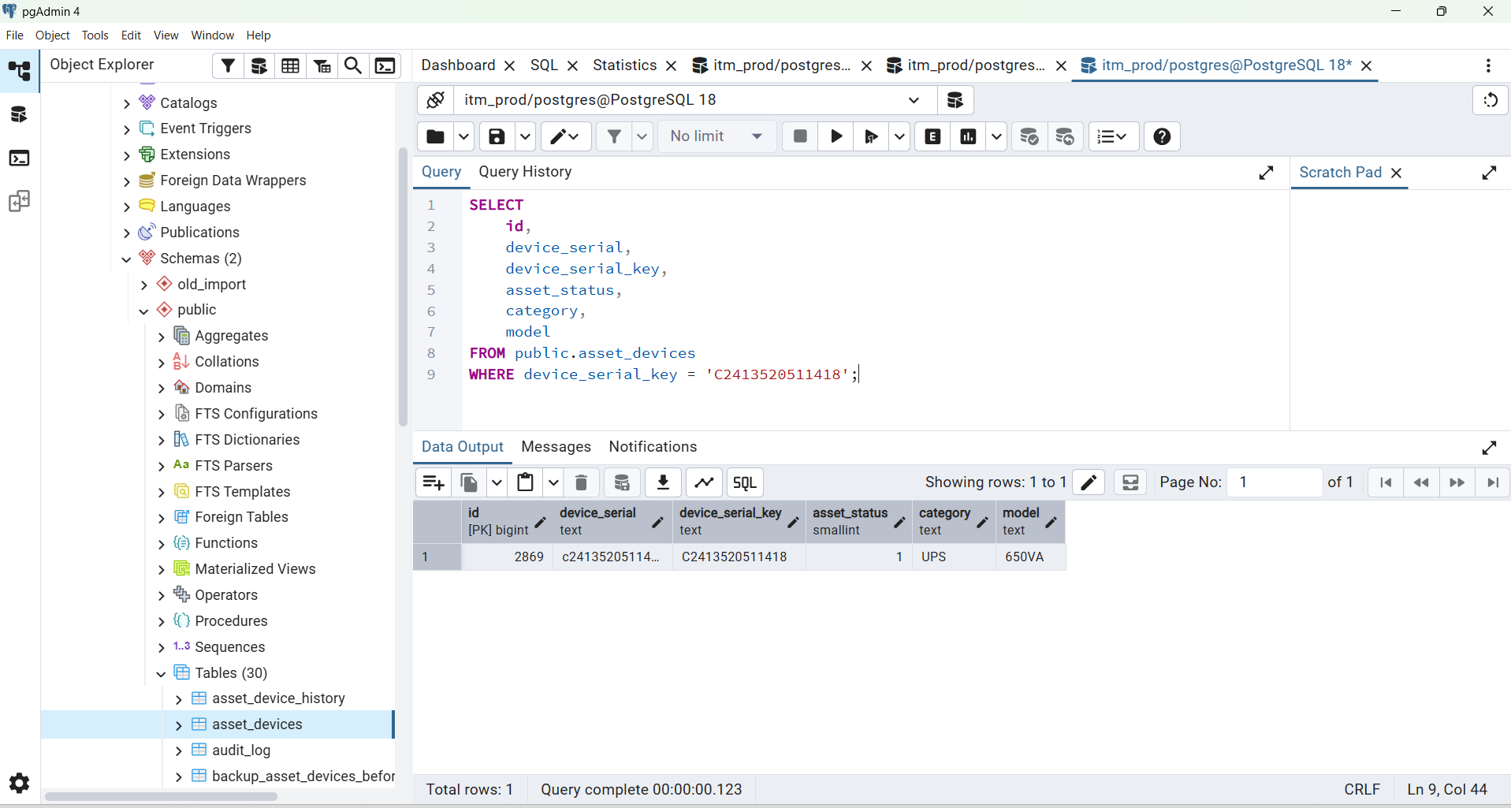

SELECT
COUNT(*) FILTER (WHERE asset_status = 2) AS damaged,
COUNT(*) FILTER (WHERE asset_status = 5) AS lost,
COUNT(*) FILTER (WHERE asset_status = 7) AS ownership,
COUNT(*) FILTER (
WHERE asset_status IN (2, 5, 7)
) AS total_non_operational
FROM public.asset_devices;

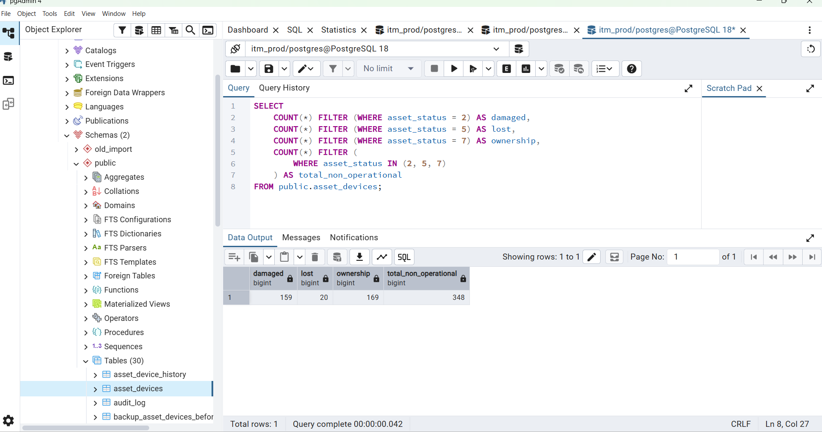

WITH damage_source AS (
SELECT DISTINCT ON (normalized_serial_key)
normalized_serial_key
FROM (
SELECT
UPPER(
REGEXP_REPLACE(
BTRIM(di.device_sl_no),
'[^A-Za-z0-9]+',
'',
'g'
)
) AS normalized_serial_key,
di.created_at,
di.id
FROM public.damage_inventory di
WHERE di.device_status = 0
AND di.status = 1
AND NULLIF(BTRIM(di.device_sl_no), '') IS NOT NULL
) source_rows
ORDER BY normalized_serial_key, created_at DESC NULLS LAST, id DESC
),
main_damaged AS (
SELECT COUNT(*) AS total
FROM public.asset_devices
WHERE asset_status = 2
),
damage_inventory_summary AS (
SELECT
COUNT(*) AS total_damage_inventory,
COUNT(ad.id) AS already_in_main_table,
COUNT(*) - COUNT(ad.id) AS not_in_main_table
FROM damage_source ds
LEFT JOIN public.asset_devices ad
ON ad.device_serial_key = ds.normalized_serial_key
)
SELECT
md.total AS main_table_damaged,
dis.total_damage_inventory AS damage_inventory_damaged,
dis.already_in_main_table AS duplicate_in_both_tables,
dis.not_in_main_table AS damage_inventory_only,
md.total + dis.not_in_main_table AS total_damaged_without_duplicate
FROM main_damaged md
CROSS JOIN damage_inventory_summary dis;

Total Damaged Devices

WITH raw_damage_source AS (
SELECT
di.id,
di.created_at,
UPPER(
REGEXP_REPLACE(
BTRIM(di.device_sl_no),
'[^A-Za-z0-9]+',
'',
'g'
)
) AS normalized_serial_key
FROM public.damage_inventory di
WHERE di.device_status = 0
AND di.status = 1
AND NULLIF(BTRIM(di.device_sl_no), '') IS NOT NULL
),

damage_source AS (
SELECT DISTINCT ON (normalized_serial_key)
normalized_serial_key
FROM raw_damage_source
ORDER BY
normalized_serial_key,
created_at DESC NULLS LAST,
id DESC
),

main_summary AS (
SELECT
COUNT(*) FILTER (
WHERE asset_status = 7
) AS ownership,

COUNT(*) FILTER (
WHERE asset_status = 2
) AS main_table_damaged,

COUNT(*) FILTER (
WHERE asset_status = 5
) AS lost
FROM public.asset_devices
),

damage_inventory_summary AS (
SELECT
COUNT(*) AS damage_inventory_damaged,
COUNT(ad.id) AS duplicate_in_both_tables,
COUNT(*) - COUNT(ad.id) AS damage_inventory_only
FROM damage_source ds
LEFT JOIN public.asset_devices ad
ON ad.device_serial_key = ds.normalized_serial_key
)

SELECT
ms.ownership,
(
ms.main_table_damaged +
dis.damage_inventory_only
) AS damaged,
ms.lost,
ms.main_table_damaged,
dis.damage_inventory_damaged,
dis.duplicate_in_both_tables,
dis.damage_inventory_only
FROM main_summary ms
CROSS JOIN damage_inventory_summary dis;

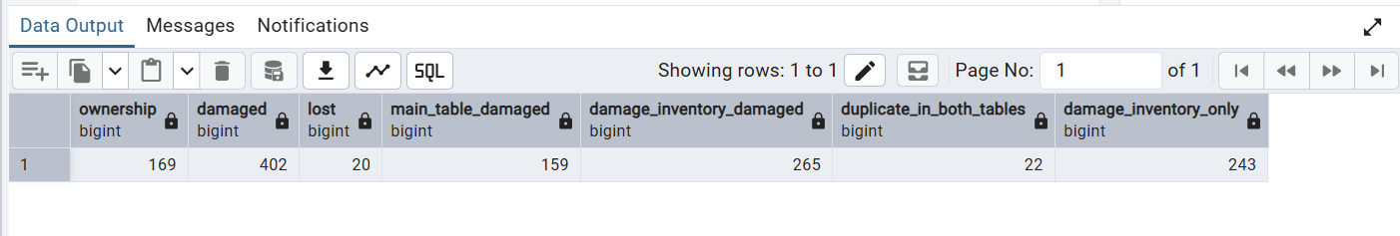

ownership 169
damaged 402
lost 20
main_table_damaged 159
damage_inventory_damaged 265
duplicate_in_both_tables 22
damage_inventory_only 243

