https://chatgpt.com/g/g-p-6a5378cdfc588191b929a3b5ca9c1c9a/c/6a58a9b1-fa0c-83ee-8051-ffd332cceb1f

select * from device_claims where claim_status=15

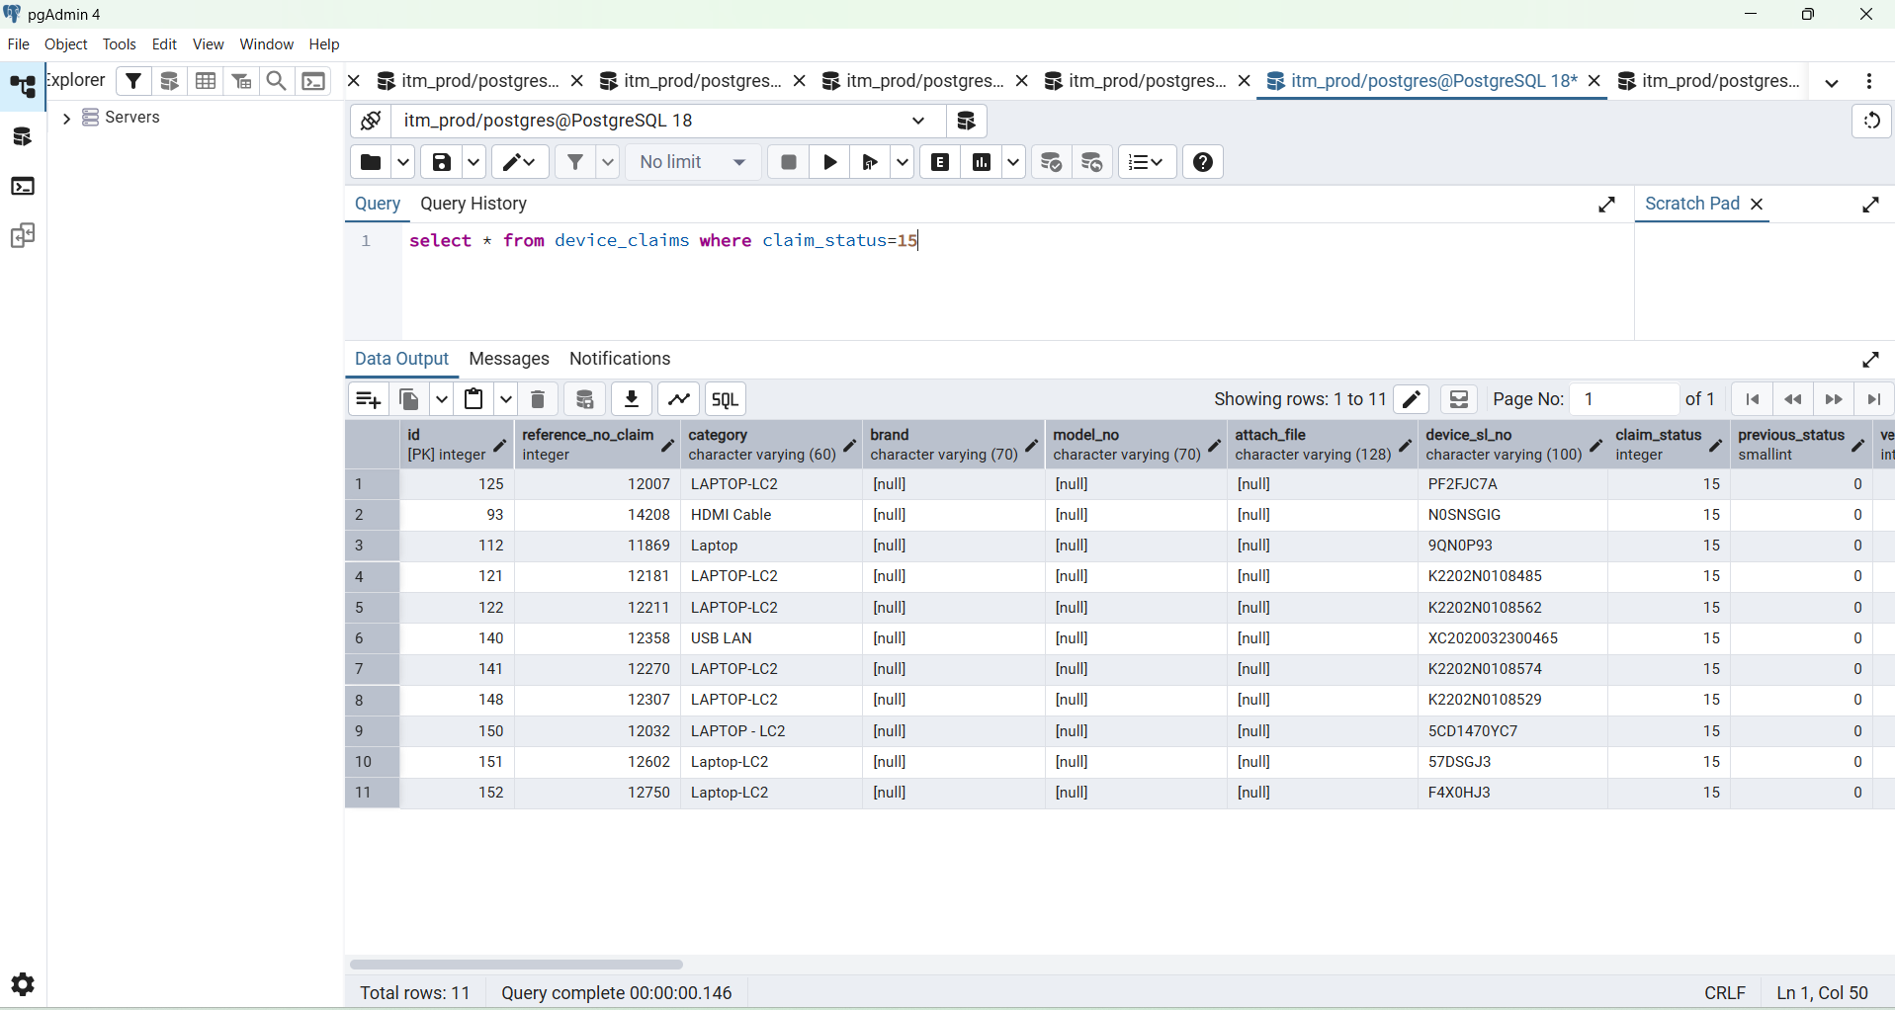

SELECT
id,
device_serial,
emp_id,
emp_name,
department,
designation,
asset_status
FROM public.asset_devices
WHERE asset_status = 15
AND row_status = 1
ORDER BY id DESC;

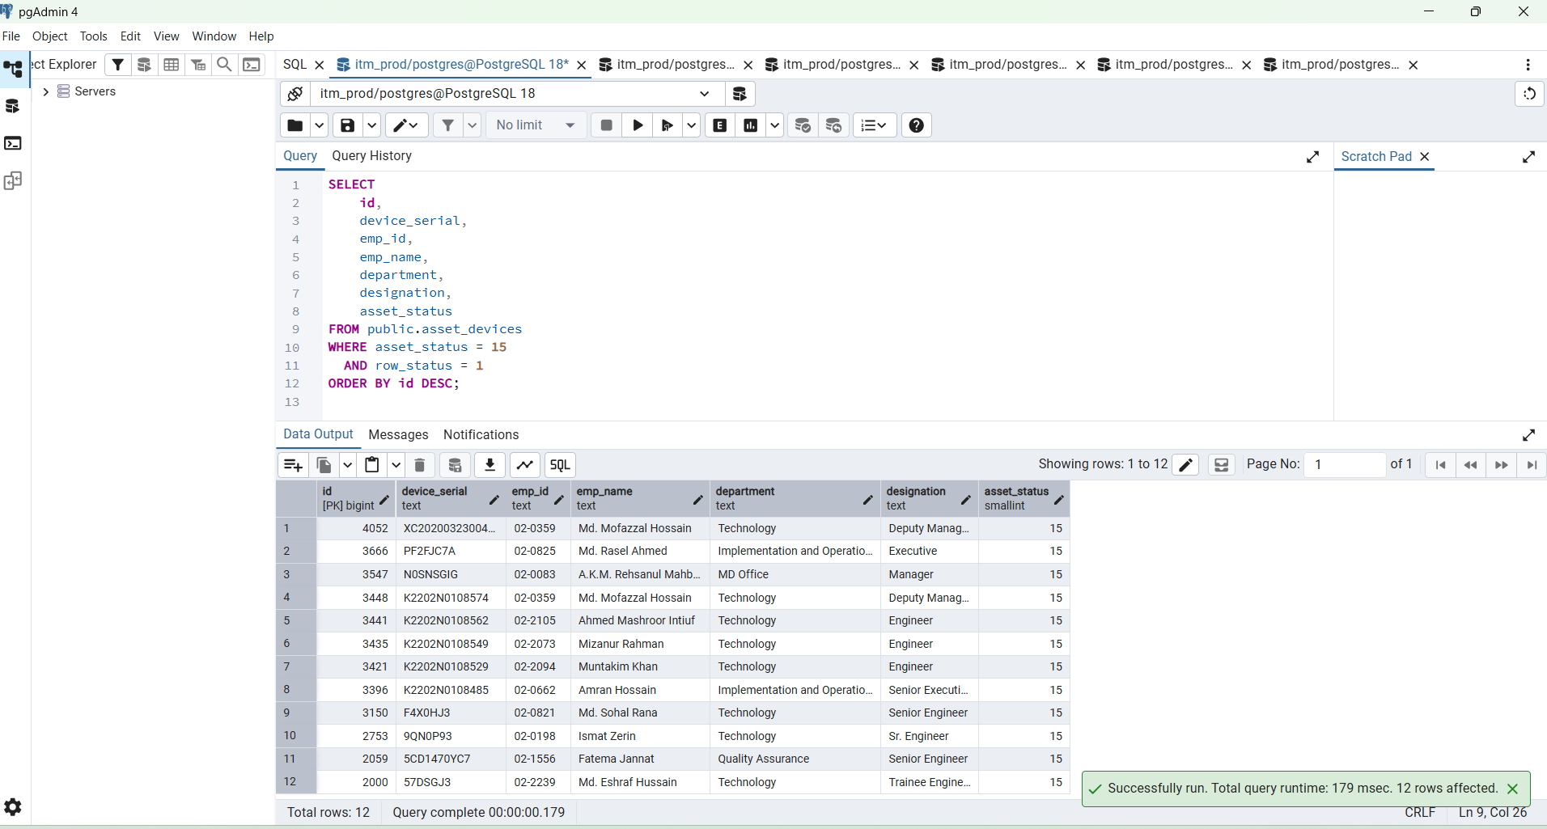

Date : 2026-07-19

SELECT
claim_status,
COUNT(*) AS total
FROM itm.tbl_device_claim
GROUP BY claim_status
ORDER BY claim_status;
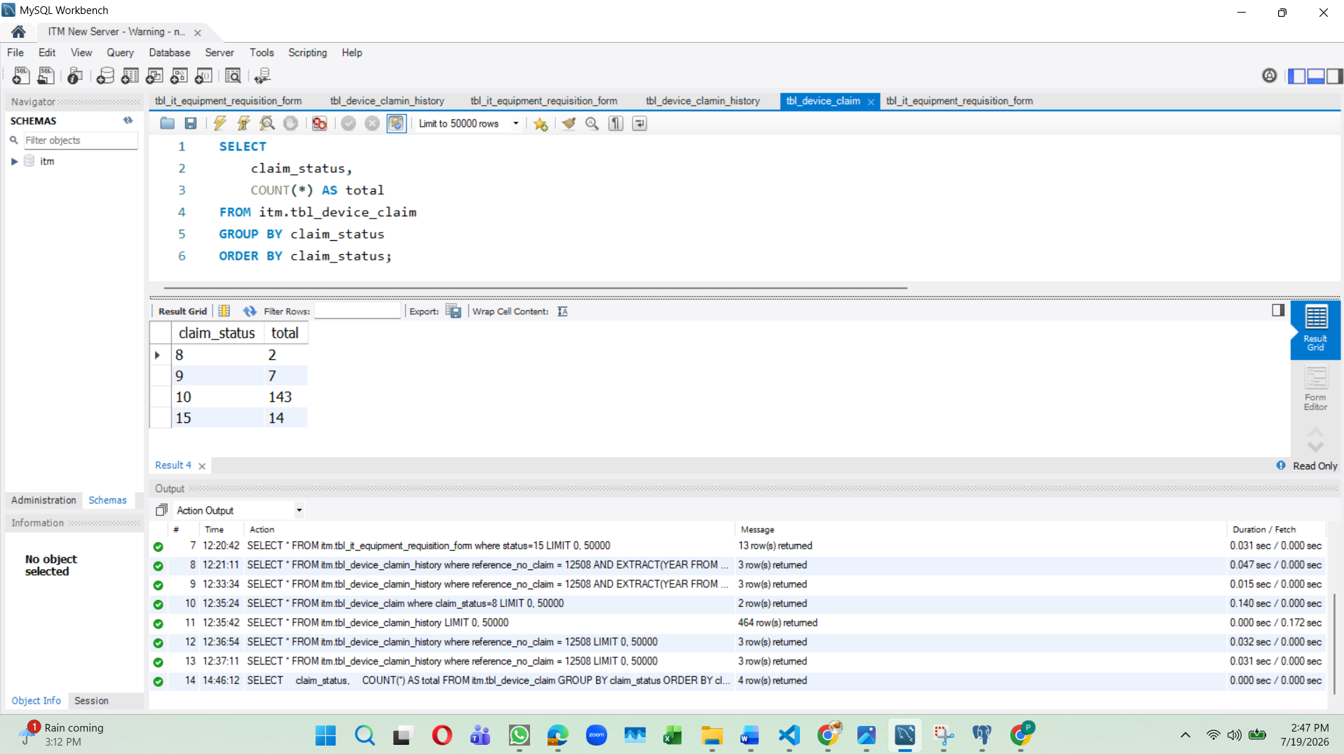

SELECT
previos_status,
current_status,
COUNT(*) AS total
FROM itm.tbl_device_clamin_history
GROUP BY previos_status, current_status
ORDER BY previos_status, current_status;

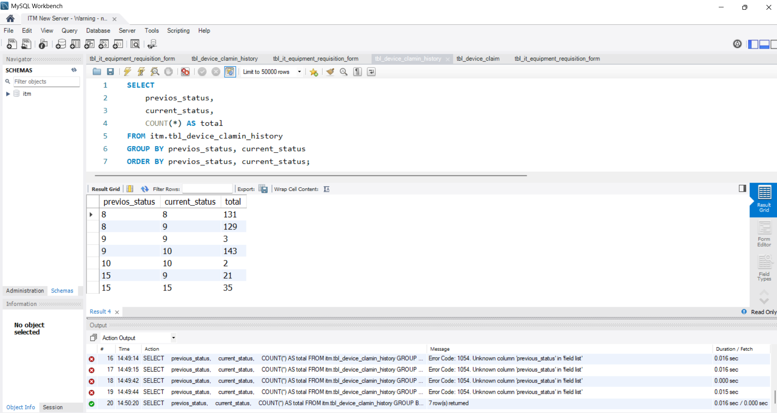

device_claim_histories

SELECT
to_regclass('public.tbl_device_claim') AS public_claim,
to_regclass('public.tbl_device_clamin_history') AS public_history,
to_regclass('old_import.tbl_device_claim') AS old_import_claim,
to_regclass('old_import.tbl_device_clamin_history') AS old_import_history;

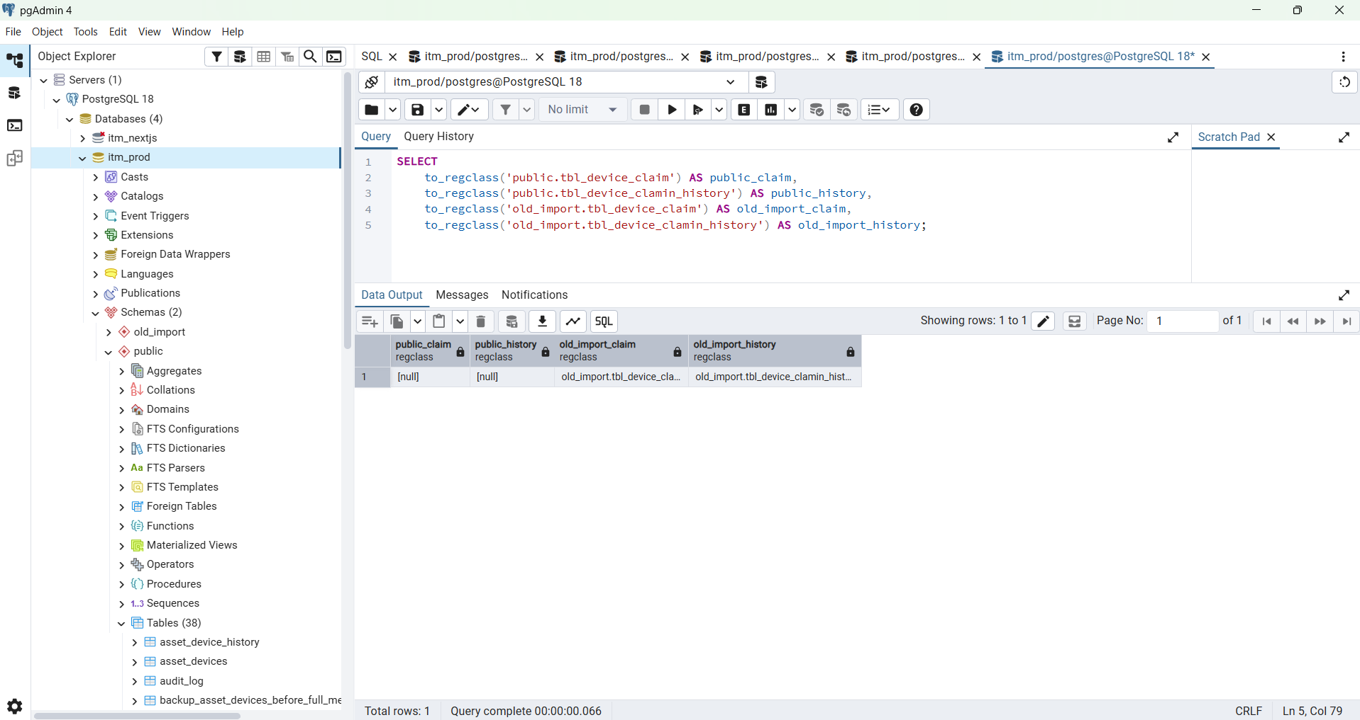

SELECT
table_schema,
table_name
FROM information_schema.tables
WHERE table_name ILIKE '%device%claim%'
OR table_name ILIKE '%device%clamin%'
ORDER BY table_schema, table_name;

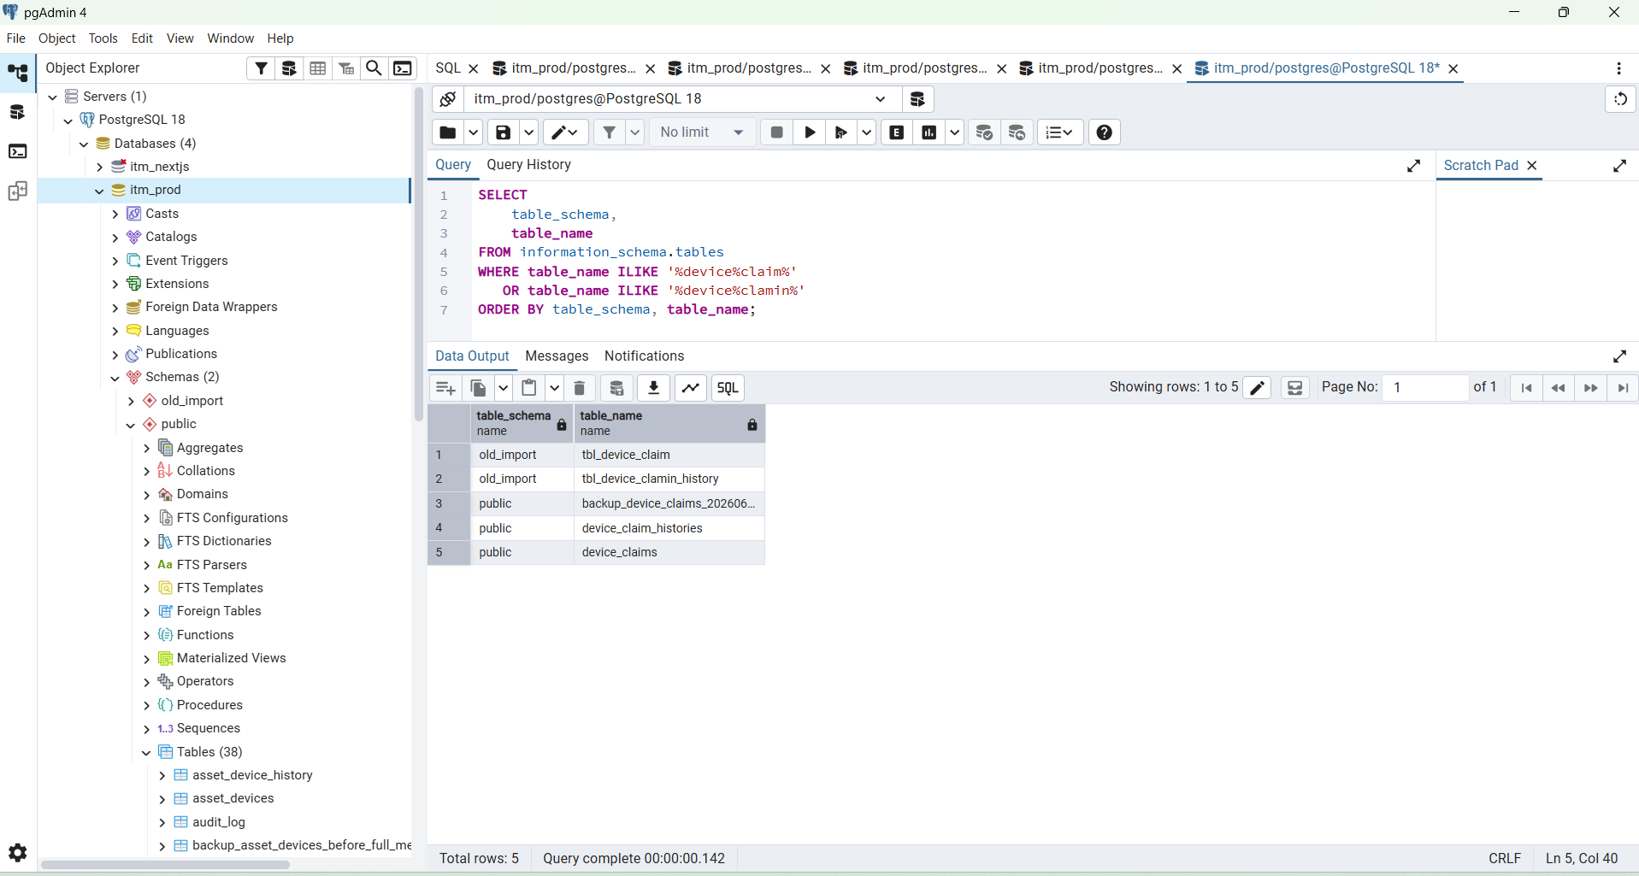

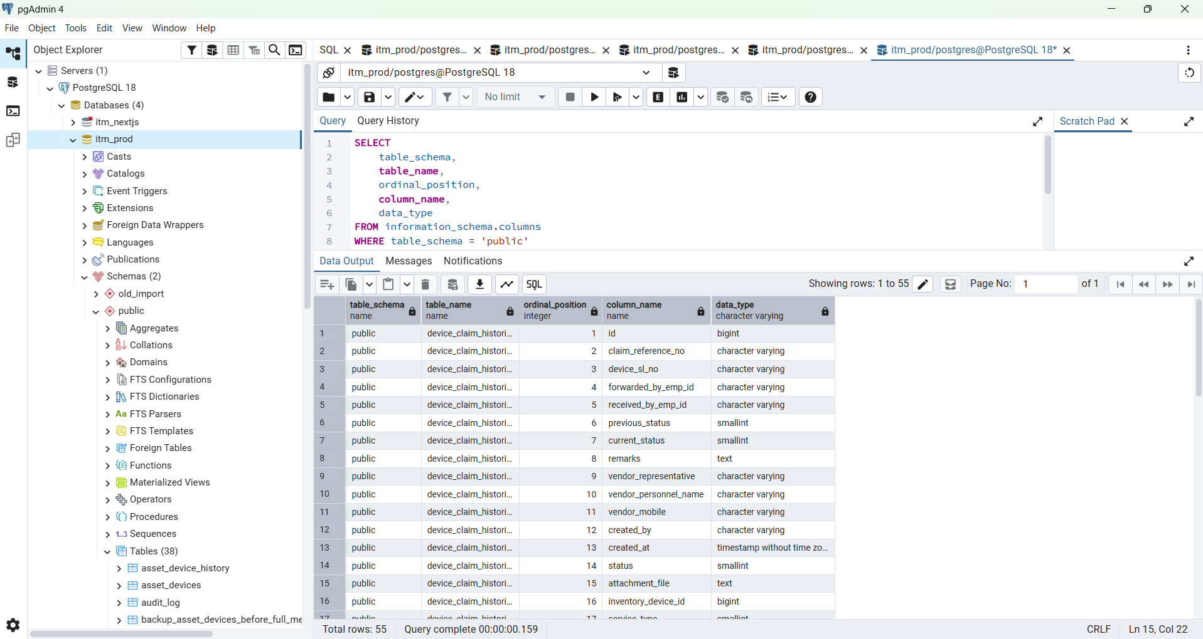

service_type =2 is User Device
service_type = 1

SELECT
table_schema,
table_name,
ordinal_position,
column_name,
data_type
FROM information_schema.columns
WHERE table_schema = 'public'
AND table_name IN (
'device_claims',
'device_claim_histories'
)
ORDER BY
table_name,
ordinal_position;

SELECT
column_name,
data_type
FROM information_schema.columns
WHERE table_schema = 'public'
AND table_name = 'device_claims'
AND (
column_name ILIKE '%reference%'
OR column_name ILIKE '%status%'
OR column_name ILIKE '%service%'
OR column_name ILIKE '%created%'
)
ORDER BY ordinal_position;

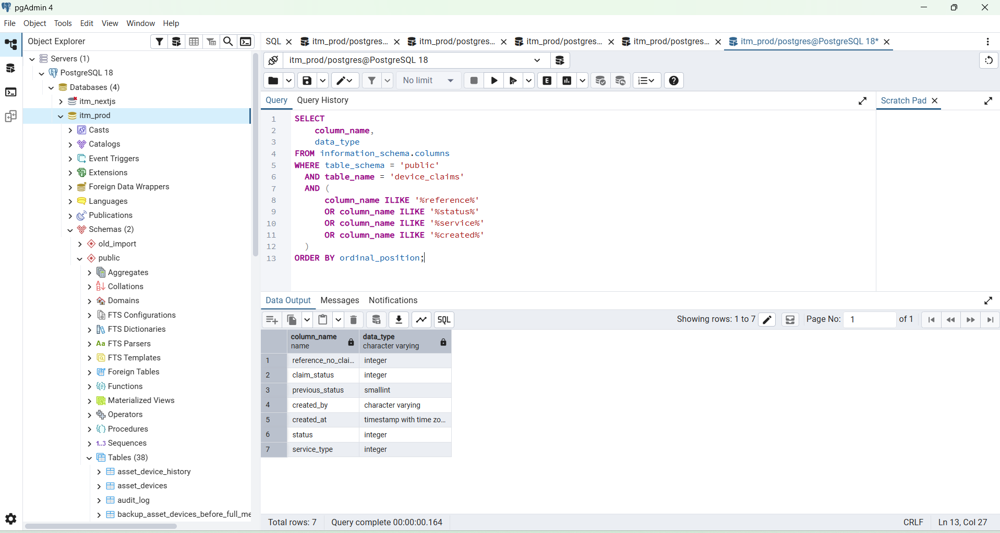

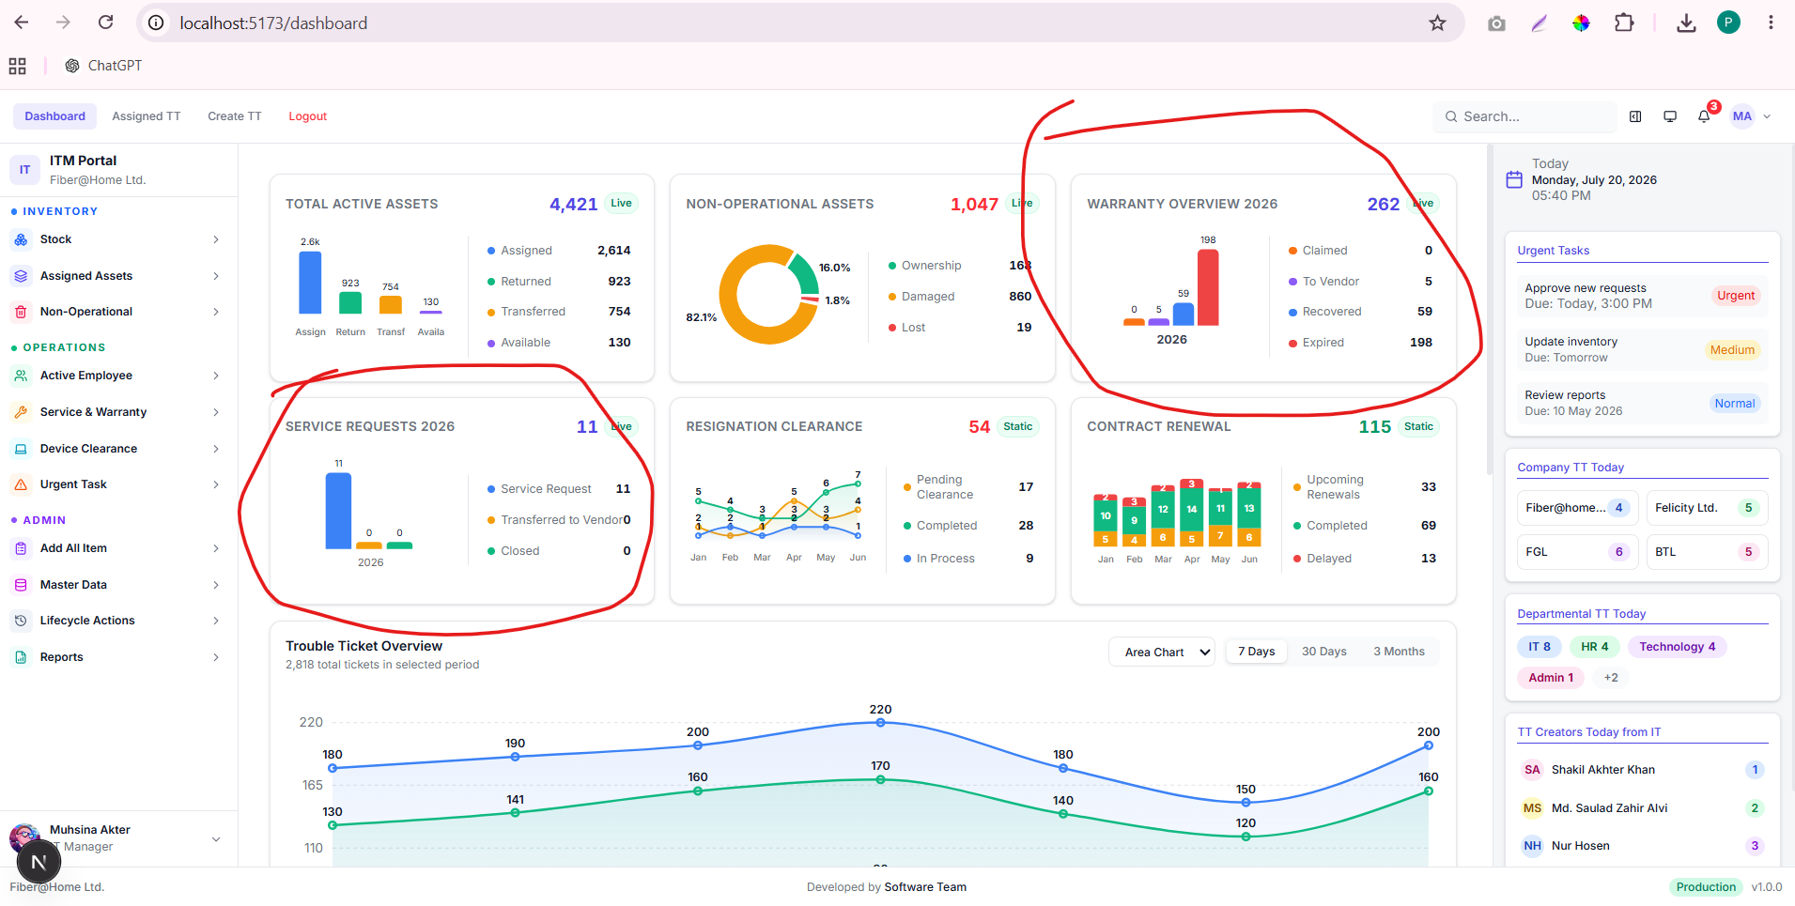

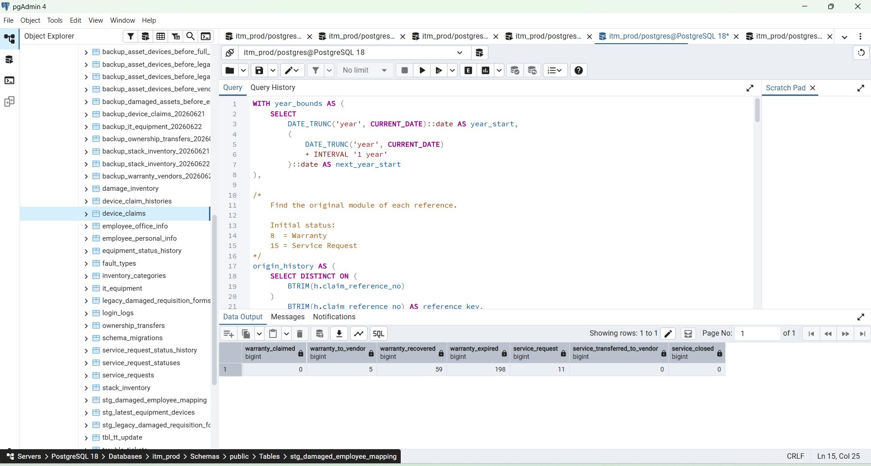

WITH year_bounds AS (
SELECT
DATE_TRUNC('year', CURRENT_DATE)::date AS year_start,
(
DATE_TRUNC('year', CURRENT_DATE)
+ INTERVAL '1 year'
)::date AS next_year_start
),

/*
Find the original module of each reference.

Initial status:
8 = Warranty
15 = Service Request
*/
origin_history AS (
SELECT DISTINCT ON (
BTRIM(h.claim_reference_no)
)
BTRIM(h.claim_reference_no) AS reference_key,

CASE
WHEN h.previous_status IN (8, 15)
THEN h.previous_status

WHEN h.current_status IN (8, 15)
THEN h.current_status

ELSE NULL
END AS origin_status,

h.created_at AS opened_at

FROM public.device_claim_histories h

WHERE h.claim_reference_no IS NOT NULL
AND (
h.previous_status IN (8, 15)
OR h.current_status IN (8, 15)
)
AND COALESCE(h.status, 1) = 1

ORDER BY
BTRIM(h.claim_reference_no),
h.created_at ASC NULLS LAST,
h.id ASC
),

/*
Get one latest/current row for every claim reference.
*/
latest_claims AS (
SELECT DISTINCT ON (
BTRIM(dc.reference_no_claim::text)
)
BTRIM(dc.reference_no_claim::text) AS reference_key,
dc.claim_status,
dc.created_at

FROM public.device_claims dc

WHERE dc.reference_no_claim IS NOT NULL
AND dc.claim_status IN (8, 9, 10, 15)

ORDER BY
BTRIM(dc.reference_no_claim::text),
dc.created_at DESC NULLS LAST,
dc.id DESC
),

classified_claims AS (
SELECT
latest.reference_key,
latest.claim_status,

COALESCE(
origin.origin_status,

CASE
WHEN latest.claim_status IN (8, 15)
THEN latest.claim_status
ELSE NULL
END
) AS origin_status,

COALESCE(
origin.opened_at,
latest.created_at
) AS opened_at

FROM latest_claims latest

LEFT JOIN origin_history origin
ON origin.reference_key =
latest.reference_key
),

expired_summary AS (
SELECT
COUNT(*)::BIGINT AS expired

FROM public.asset_devices ad
CROSS JOIN year_bounds bounds

WHERE ad.row_status = 1
AND ad.warranty_date IS NOT NULL
AND ad.warranty_date::date >= bounds.year_start
AND ad.warranty_date::date < bounds.next_year_start
AND ad.warranty_date::date < CURRENT_DATE
)

SELECT
/*
Warranty Overview
*/
COUNT(classified.reference_key) FILTER (
WHERE classified.origin_status = 8
AND classified.claim_status = 8
)::BIGINT AS warranty_claimed,

COUNT(classified.reference_key) FILTER (
WHERE classified.origin_status = 8
AND classified.claim_status = 9
)::BIGINT AS warranty_to_vendor,

COUNT(classified.reference_key) FILTER (
WHERE classified.origin_status = 8
AND classified.claim_status = 10
)::BIGINT AS warranty_recovered,

expired.expired AS warranty_expired,

/*
Service Requests
*/
COUNT(classified.reference_key) FILTER (
WHERE classified.origin_status = 15
AND classified.claim_status = 15
)::BIGINT AS service_request,

COUNT(classified.reference_key) FILTER (
WHERE classified.origin_status = 15
AND classified.claim_status = 9
)::BIGINT AS service_transferred_to_vendor,

COUNT(classified.reference_key) FILTER (
WHERE classified.origin_status = 15
AND classified.claim_status = 10
)::BIGINT AS service_closed

FROM year_bounds bounds

CROSS JOIN expired_summary expired

LEFT JOIN classified_claims classified
ON classified.opened_at::date >= bounds.year_start
AND classified.opened_at::date < bounds.next_year_start

GROUP BY expired.expired;

Update in PostgreSQL
Use a development/test database, not production. On a test database, change one record and commit:

BEGIN;

UPDATE public.device_claims
SET claim_status = 9
WHERE id = 12307
AND claim_status = 15;
COMMIT;

BEGIN;

UPDATE public.device_claims
SET claim_status = 9
WHERE id = 8 and reference_no_claim='12307
AND claim_status = 15;
COMMIT;

Then restore immediately:

BEGIN;
UPDATE public.device_claims
SET claim_status = 15
WHERE id = 12307
AND claim_status = 9;
COMMIT;

SELECT
id,
device_serial,
emp_id,
emp_name,
department,
designation,
asset_status
FROM public.asset_devices
WHERE asset_status = 8
AND row_status = 1
ORDER BY id DESC;

WITH year_bounds AS (
SELECT
DATE_TRUNC('year', CURRENT_DATE)::date AS year_start,
(
DATE_TRUNC('year', CURRENT_DATE)
+ INTERVAL '1 year'
)::date AS next_year_start
),

/*
Find the original module of each reference.

Initial status:
8 = Warranty
15 = Service Request
*/
origin_history AS (
SELECT DISTINCT ON (
BTRIM(h.claim_reference_no)
)
BTRIM(h.claim_reference_no) AS reference_key,

CASE
WHEN h.previous_status IN (8, 15)
THEN h.previous_status

WHEN h.current_status IN (8, 15)
THEN h.current_status

ELSE NULL
END AS origin_status,

h.created_at AS opened_at

FROM public.device_claim_histories h

WHERE h.claim_reference_no IS NOT NULL
AND (
h.previous_status IN (8, 15)
OR h.current_status IN (8, 15)
)
AND COALESCE(h.status, 1) = 1

ORDER BY
BTRIM(h.claim_reference_no),
h.created_at ASC NULLS LAST,
h.id ASC
),

/*
Get one latest/current row for every claim reference.
*/
latest_claims AS (
SELECT DISTINCT ON (
BTRIM(dc.reference_no_claim::text)
)
BTRIM(dc.reference_no_claim::text) AS reference_key,
dc.claim_status,
dc.created_at

FROM public.device_claims dc

WHERE dc.reference_no_claim IS NOT NULL
AND dc.claim_status IN (8, 9, 10, 15)

ORDER BY
BTRIM(dc.reference_no_claim::text),
dc.created_at DESC NULLS LAST,
dc.id DESC
),

classified_claims AS (
SELECT
latest.reference_key,
latest.claim_status,

COALESCE(
origin.origin_status,

CASE
WHEN latest.claim_status IN (8, 15)
THEN latest.claim_status
ELSE NULL
END
) AS origin_status,

COALESCE(
origin.opened_at,
latest.created_at
) AS opened_at

FROM latest_claims latest

LEFT JOIN origin_history origin
ON origin.reference_key =
latest.reference_key
),

expired_summary AS (
SELECT
COUNT(*)::BIGINT AS expired

FROM public.asset_devices ad
CROSS JOIN year_bounds bounds

WHERE ad.row_status = 1
AND ad.warranty_date IS NOT NULL
AND ad.warranty_date::date >= bounds.year_start
AND ad.warranty_date::date < bounds.next_year_start
AND ad.warranty_date::date < CURRENT_DATE
)

SELECT
/*
Warranty Overview
*/
COUNT(classified.reference_key) FILTER (
WHERE classified.origin_status = 8
AND classified.claim_status = 8
)::BIGINT AS warranty_claimed,

COUNT(classified.reference_key) FILTER (
WHERE classified.origin_status = 8
AND classified.claim_status = 9
)::BIGINT AS warranty_to_vendor,

COUNT(classified.reference_key) FILTER (
WHERE classified.origin_status = 8
AND classified.claim_status = 10
)::BIGINT AS warranty_recovered,

expired.expired AS warranty_expired,

/*
Service Requests
*/
COUNT(classified.reference_key) FILTER (
WHERE classified.origin_status = 15
AND classified.claim_status = 15
)::BIGINT AS service_request,

COUNT(classified.reference_key) FILTER (
WHERE classified.origin_status = 15
AND classified.claim_status = 9
)::BIGINT AS service_transferred_to_vendor,

COUNT(classified.reference_key) FILTER (
WHERE classified.origin_status = 15
AND classified.claim_status = 10
)::BIGINT AS service_closed

FROM year_bounds bounds

CROSS JOIN expired_summary expired

LEFT JOIN classified_claims classified
ON classified.opened_at::date >= bounds.year_start
AND classified.opened_at::date < bounds.next_year_start

GROUP BY expired.expired;

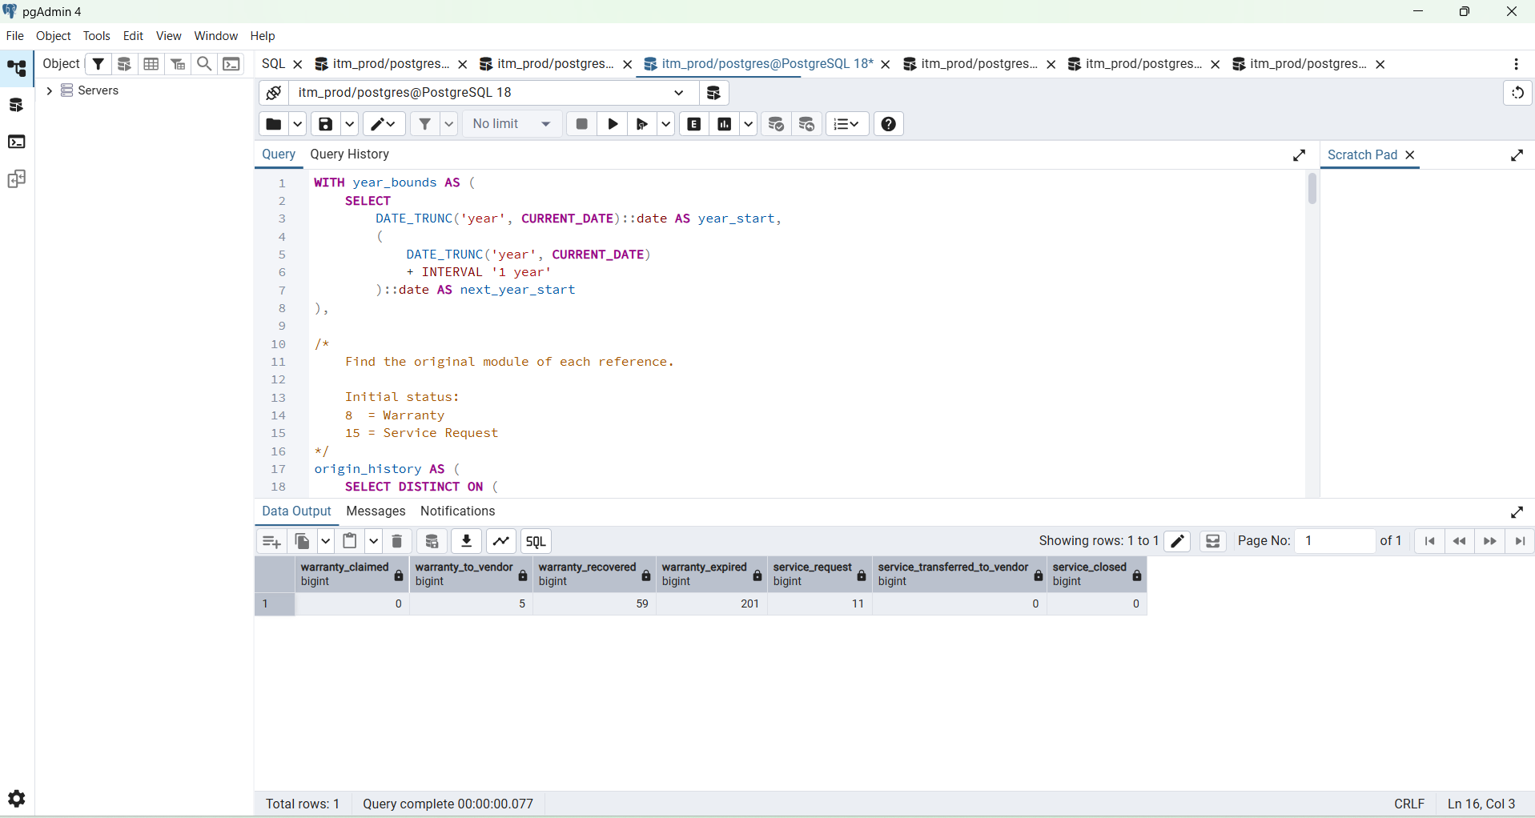

Correct Query
-----------------------------------------------------------------------------------------

WITH year_bounds AS (
SELECT
DATE_TRUNC('year', CURRENT_DATE)::date AS year_start,
(
DATE_TRUNC('year', CURRENT_DATE)
+ INTERVAL '1 year'
)::date AS next_year_start
),

/*
Find the original module of each reference.

Initial status:
8 = Warranty
15 = Service Request
*/
origin_history AS (
SELECT DISTINCT ON (
BTRIM(h.claim_reference_no)
)
BTRIM(h.claim_reference_no) AS reference_key,

CASE
WHEN h.previous_status IN (8, 15)
THEN h.previous_status

WHEN h.current_status IN (8, 15)
THEN h.current_status

ELSE NULL
END AS origin_status,

h.created_at AS opened_at

FROM public.device_claim_histories h

WHERE h.claim_reference_no IS NOT NULL
AND (
h.previous_status IN (8, 15)
OR h.current_status IN (8, 15)
)
AND COALESCE(h.status, 1) = 1

ORDER BY
BTRIM(h.claim_reference_no),
h.created_at ASC NULLS LAST,
h.id ASC
),

/*
Get one latest/current row for every claim reference.
*/
latest_claims AS (
SELECT DISTINCT ON (
BTRIM(dc.reference_no_claim::text)
)
BTRIM(dc.reference_no_claim::text) AS reference_key,
dc.claim_status,
dc.created_at

FROM public.device_claims dc

WHERE dc.reference_no_claim IS NOT NULL
AND dc.claim_status IN (8, 9, 10, 15)

ORDER BY
BTRIM(dc.reference_no_claim::text),
dc.created_at DESC NULLS LAST,
dc.id DESC
),

classified_claims AS (
SELECT
latest.reference_key,
latest.claim_status,

COALESCE(
origin.origin_status,

CASE
WHEN latest.claim_status IN (8, 15)
THEN latest.claim_status
ELSE NULL
END
) AS origin_status,

COALESCE(
origin.opened_at,
latest.created_at
) AS opened_at

FROM latest_claims latest

LEFT JOIN origin_history origin
ON origin.reference_key =
latest.reference_key
),

expired_summary AS (
SELECT
COUNT(*)::BIGINT AS expired

FROM public.asset_devices ad
CROSS JOIN year_bounds bounds

WHERE ad.row_status = 1
AND ad.warranty_date IS NOT NULL
AND ad.warranty_date::date >= bounds.year_start
AND ad.warranty_date::date < bounds.next_year_start
AND ad.warranty_date::date < CURRENT_DATE
)

SELECT
/*
Warranty Overview
*/
COUNT(classified.reference_key) FILTER (
WHERE classified.origin_status = 8
AND classified.claim_status = 8
)::BIGINT AS warranty_claimed,

COUNT(classified.reference_key) FILTER (
WHERE classified.origin_status = 8
AND classified.claim_status = 9
)::BIGINT AS warranty_to_vendor,

COUNT(classified.reference_key) FILTER (
WHERE classified.origin_status = 8
AND classified.claim_status = 10
)::BIGINT AS warranty_recovered,

expired.expired AS warranty_expired,

/*
Service Requests
*/
COUNT(classified.reference_key) FILTER (
WHERE classified.origin_status = 15
AND classified.claim_status = 15
)::BIGINT AS service_request,

COUNT(classified.reference_key) FILTER (
WHERE classified.origin_status = 15
AND classified.claim_status = 9
)::BIGINT AS service_transferred_to_vendor,

COUNT(classified.reference_key) FILTER (
WHERE classified.origin_status = 15
AND classified.claim_status = 10
)::BIGINT AS service_closed

FROM year_bounds bounds

CROSS JOIN expired_summary expired

LEFT JOIN classified_claims classified
ON classified.opened_at::date >= bounds.year_start
AND classified.opened_at::date < bounds.next_year_start

GROUP BY expired.expired;

--------------------------------------------------------------------------------------------------------------------------

