https://chatgpt.com/g/g-p-6a5378cdfc588191b929a3b5ca9c1c9a/c/6a6aea6e-6794-83e8-a9d3-22852803845a

date : August 11, 2026

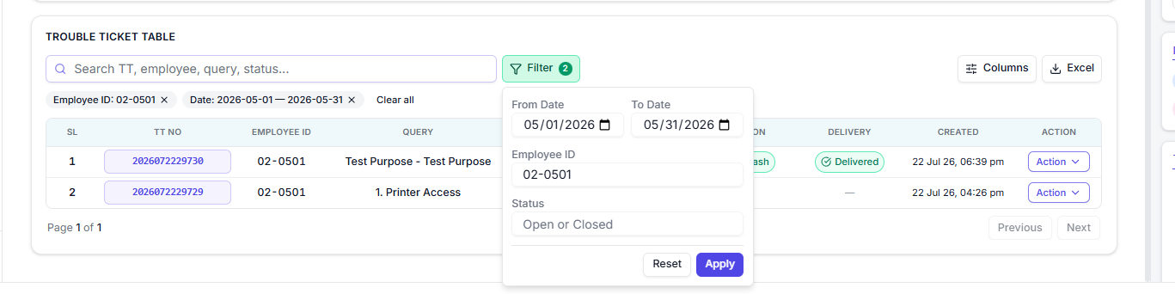

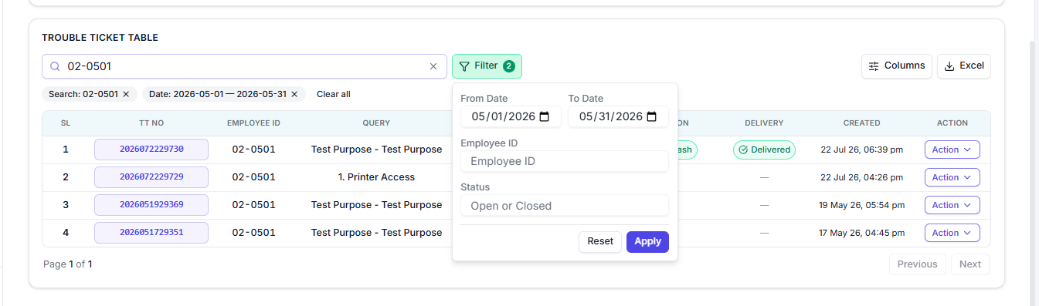

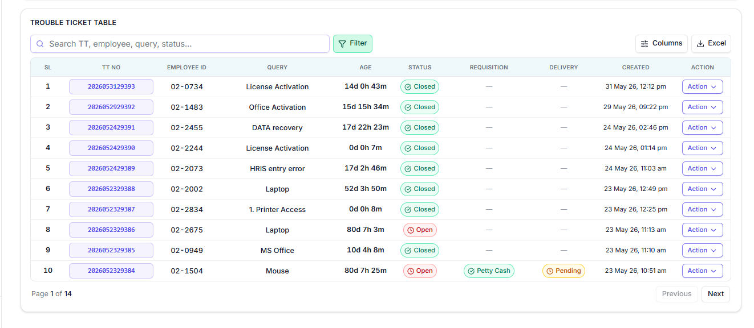

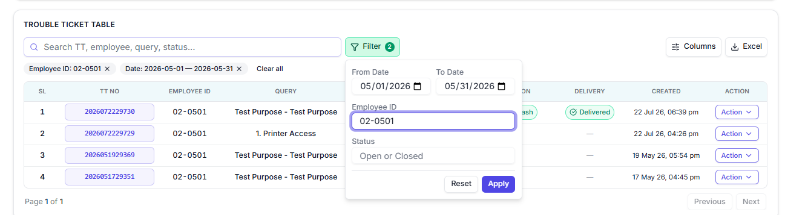

-------------------------------------------------------------------------------------------------------------------------------

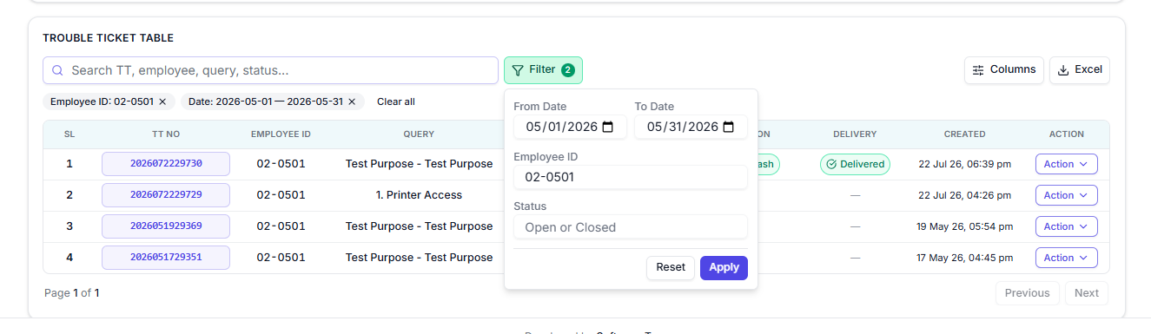
This is result
