-------------------------------------------------------------------------------------------------
Username : itm.root
Password : f@hrt1@itm_new
------------------------------------------------------------------------------------------------------
username : admin
Password : Admin@1234
-------------------------------------------------------------------------------------------------------
Username : test.itpersonnel
Password : f@hrt1@itm_itprs
-------------------------------------------------------------------------------------------------------
Username : test.general
Password : f@hrt1@itm_guser
-------------------------------------------------------------------------------------------------------

SELECT
u.id,
u.employee_id,
u.username,
u.user_type,
u.active,
u.account_status,
r.code AS role_code,
r.name AS role_name
FROM public.users AS u

LEFT JOIN public.auth_user_roles AS ur
ON ur.user_id = u.id
AND ur.active = TRUE

LEFT JOIN public.auth_roles AS r
ON r.id = ur.role_id

WHERE u.deleted_at IS NULL
ORDER BY
u.user_type,
u.id;

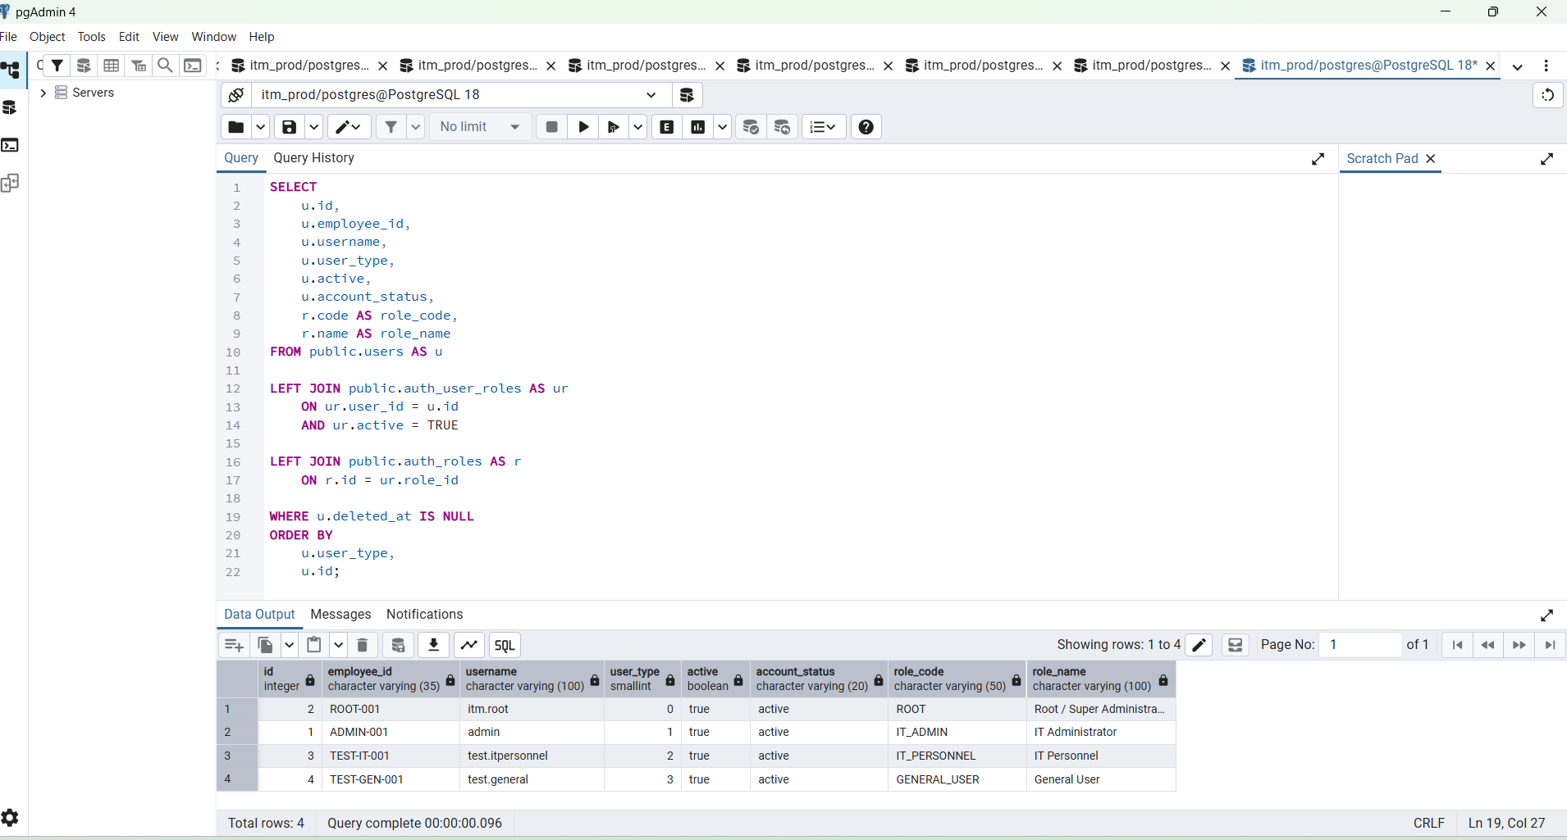

"id","employee_id","username","user_type","active","account_status","role_code","role_name"

2 "ROOT-001" "itm.root" 0 true "active" "ROOT" "Root / Super Administrator"
1 "ADMIN-001" "admin" 1 true "active" "IT_ADMIN" "IT Administrator"
3 "TEST-IT-001" "test.itpersonnel" 2 true "active" "IT_PERSONNEL" "IT Personnel"
4 "TEST-GEN-001" "test.general" 3 true "active" "GENERAL_USER" "General User"

"id","employee_id","username","user_type","active","account_status","role_code","role_name"
2,"ROOT-001","itm.root",0,True,"active","ROOT","Root / Super Administrator"
1,"ADMIN-001","admin",1,True,"active","IT_ADMIN","IT Administrator"
3,"TEST-IT-001","test.itpersonnel",2,True,"active","IT_PERSONNEL","IT Personnel"
4,"TEST-GEN-001","test.general",3,True,"active","GENERAL_USER","General User"

