https://chatgpt.com/g/g-p-6a5378cdfc588191b929a3b5ca9c1c9a/c/6a6aea6e-6794-83e8-a9d3-22852803845a

Date : 13 August 2026

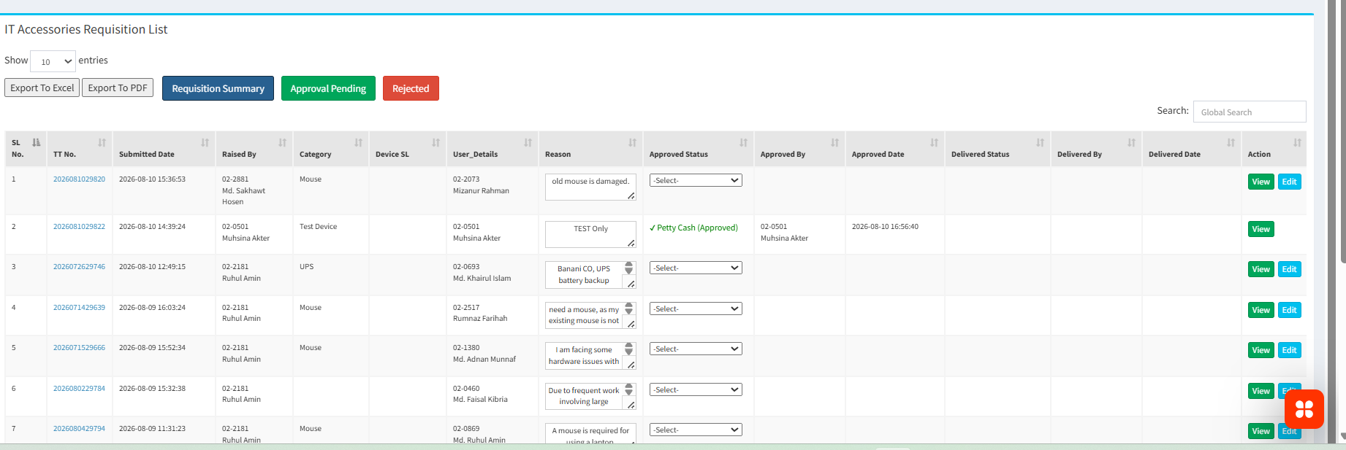

SELECT
COUNT(*) FILTER (
WHERE COALESCE(approved_val, 0) = 0
)::int AS approval_pending,

COUNT(
DISTINCT NULLIF(
BTRIM(category),
''
)
) FILTER (
WHERE COALESCE(approved_val, 0) = 0
)::int AS pending_categories,

COUNT(*) FILTER (
WHERE approved_val = 2
)::int AS rejected,

COUNT(*) FILTER (
WHERE approved_val IN (1, 3)
)::int AS approved

FROM public.tt_reasons

WHERE COALESCE(status, 1) = 1;

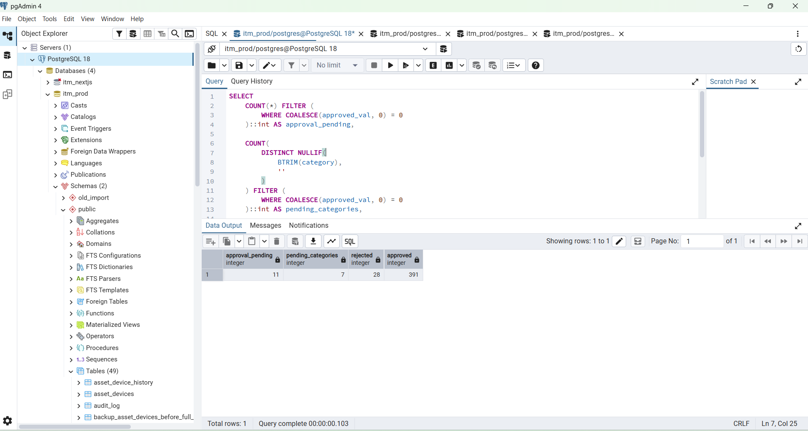

PowerShell

PS C:\WINDOWS\system32> cd D:\ITM-Data\itm\backend
PS D:\ITM-Data\itm\backend> gofmt -w internal/handler/handlers.go
PS D:\ITM-Data\itm\backend> go test ./...
? itm-api/cmd/migrate_passwords [no test files]
? itm-api/cmd/server [no test files]
? itm-api/internal/config [no test files]
? itm-api/internal/db [no test files]
? itm-api/internal/handler [no test files]
? itm-api/internal/middleware [no test files]
? itm-api/pkg/response [no test files]
PS D:\ITM-Data\itm\backend> go run ./cmd/server

Method : GET

http://127.0.0.1:8080/api/v1/dashboard/trouble-tickets?scope=all&page=1&limit=1000&status=all&from_date=2026-06-01&to_date=2026-06-30

Step 2 — Test Requisition Dashboard Summary
In Postman:
GET http://localhost:8080/api/v1/dashboard/requisition-dashboard-summary
Expected structure:
{
"success": true,
"data": {
"pending_categories": 0,
"approval_pending": 0,
"rejected": 0,
"approved": 0,
"total_active": 0
}
}
Your actual numbers will be different.
This endpoint feeds:
Requisition Summary
Approval Pending
Rejected

1. Define the three meanings
I recommend these exact rules:
Requisition Summary
= pending requests grouped by Device Category

Approval Pending
= approved_val IS NULL OR approved_val = 0

Rejected
= approved_val = 2

Approved Petty Cash
= approved_val = 1

Approved PR
= approved_val = 3

GET : Method
http://127.0.0.1:8080/api/v1/dashboard/requisition-dashboard-summary

{
"data": {
"pending_categories": 7,
"approval_pending": 11,
"rejected": 28,
"approved": 391,
"total_active": 430
},
"success": true
}

Great — this result is consistent:
- 11 + 28 + 391 = 430
- pending_categories = 7 means those 11 pending requests are spread across 7 categories.
So the dashboard summary API is working correctly.
Next Step — Test Requisition Summary
In Postman, run:
GET http://127.0.0.1:8080/api/v1/dashboard/requisition-summary
Expected structure:
{
"data": [
{
"category": "Mouse",
"pending_count": 3
},
{
"category": "RAM-Laptop",
"pending_count": 2
}
],
"success": true
}
The total of all pending_count values should equal:
11
because your dashboard summary already returned:
"approval_pending": 11
Then test Approval Pending list
GET http://127.0.0.1:8080/api/v1/dashboard/requisitions?view=pending&page=1&limit=10
Check that:
total = 11
and each returned row has:
approved_val = 0
approval_status = "Approval Pending"
Then test Rejected list
GET http://127.0.0.1:8080/api/v1/dashboard/requisitions?view=rejected&page=1&limit=10
Check that:
total = 28
and rows show:
approved_val = 2
approval_status = "Rejected"
Then test Approved list
GET http://127.0.0.1:8080/api/v1/dashboard/requisitions?view=approved&page=1&limit=10
Check that:
total = 391
and approval statuses should be either:
Petty Cash (Approved)
or:
PR (Approved)
Once these three API results match:
Pending = 11
Rejected = 28
Approved = 391
Total = 430
the backend requisition module is fully verified.
After that, next file
We move to:
frontend/lib/api.ts
and add the requisition interfaces plus these API methods:
requisitionDashboardSummary()
requisitionSummary()
requisitions()
Send me the result of:
GET http://127.0.0.1:8080/api/v1/dashboard/requisition-summary
and I’ll give you the exact next frontend/lib/api.ts update.
Method : GET
http://127.0.0.1:8080/api/v1/dashboard/requisition-summary

{
"data": [
{
"category": "Mouse",
"pending_count": 3
},
{
"category": "RAM-Laptop",
"pending_count": 3
},
{
"category": "Laptop Bag",
"pending_count": 1
},
{
"category": "Laptop Display",
"pending_count": 1
},
{
"category": "Laptop Keyboard",
"pending_count": 1
},
{
"category": "Speaker",
"pending_count": 1
},
{
"category": "WI-FI Card/Receiver",
"pending_count": 1
}
],
"success": true
}

Method : GET

http://127.0.0.1:8080/api/v1/dashboard/requisitions?view=pending&page=1&limit=10

output

{
"data": [
{
"id": 428,
"tt_no": "2026072129717",
"category": "Mouse",
"employee_id": "02-0283",
"employee_name": "Md. Zahurul Alam",
"reason_details": "I am requesting a mouse, as I currently do not have one to perform my work.",
"created_by": "02-2181",
"created_by_name": "Ruhul Amin",
"created_at": "2026-07-21 17:12:06+06",
"device_sl_no": "",
"approved_val": 0,
"approval_status": "Approval Pending",
"approved_by": "",
"approved_by_name": "",
"approved_date": "",
"delivered_val": 0,
"delivery_status": "Pending",
"delivered_by": "",
"delivered_by_name": "",
"delivered_date": "",
"device_assigned_val": 0,
"device_assigned_by": "",
"device_assigned_date": ""
},
{
"id": 427,
"tt_no": "2026071629674",
"category": "Laptop Bag",
"employee_id": "02-1991",
"employee_name": "Rasif-Ur-Rahman",
"reason_details": "Did not receive the laptop bag yet. After 05 years of Service in FHL, did not receive any Laptop Bag Yet.",
"created_by": "02-2181",
"created_by_name": "Ruhul Amin",
"created_at": "2026-07-20 10:34:47+06",
"device_sl_no": "",
"approved_val": 0,
"approval_status": "Approval Pending",
"approved_by": "",
"approved_by_name": "",
"approved_date": "",
"delivered_val": 0,
"delivery_status": "Pending",
"delivered_by": "",
"delivered_by_name": "",
"delivered_date": "",
"device_assigned_val": 0,
"device_assigned_by": "",
"device_assigned_date": ""
},
{
"id": 386,
"tt_no": "2026051229322",
"category": "WI-FI Card/Receiver",
"employee_id": "02-2175",
"employee_name": "Md. Riyadh Sarker",
"reason_details": "Several times, the laptop`s Wi-Fi driver is not working, but after using a LAN cable, I can do office work. Need a new Wi-Fi card for an MSI Laptop.",
"created_by": "02-2181",
"created_by_name": "Ruhul Amin",
"created_at": "2026-05-13 10:35:02+06",
"device_sl_no": "",
"approved_val": 0,
"approval_status": "Approval Pending",
"approved_by": "",
"approved_by_name": "",
"approved_date": "",
"delivered_val": 0,
"delivery_status": "Pending",
"delivered_by": "",
"delivered_by_name": "",
"delivered_date": "",
"device_assigned_val": 0,
"device_assigned_by": "",
"device_assigned_date": ""
},
{
"id": 385,
"tt_no": "2026050429272",
"category": "Laptop Keyboard",
"employee_id": "02-2635",
"employee_name": "Syed Aftab Uddin",
"reason_details": "Laptop Keybord Issue.",
"created_by": "02-2181",
"created_by_name": "Ruhul Amin",
"created_at": "2026-05-10 16:41:26+06",
"device_sl_no": "",
"approved_val": 0,
"approval_status": "Approval Pending",
"approved_by": "",
"approved_by_name": "",
"approved_date": "",
"delivered_val": 0,
"delivery_status": "Pending",
"delivered_by": "",
"delivered_by_name": "",
"delivered_date": "",
"device_assigned_val": 0,
"device_assigned_by": "",
"device_assigned_date": ""
},
{
"id": 384,
"tt_no": "2026050629284",
"category": "Speaker",
"employee_id": "02-1644",
"employee_name": "Ariful Anwar",
"reason_details": "The laptop speaker is not working.",
"created_by": "02-2181",
"created_by_name": "Ruhul Amin",
"created_at": "2026-05-10 10:28:26+06",
"device_sl_no": "",
"approved_val": 0,
"approval_status": "Approval Pending",
"approved_by": "",
"approved_by_name": "",
"approved_date": "",
"delivered_val": 0,
"delivery_status": "Pending",
"delivered_by": "",
"delivered_by_name": "",
"delivered_date": "",
"device_assigned_val": 0,
"device_assigned_by": "",
"device_assigned_date": ""
},
{
"id": 382,
"tt_no": "2026050529280",
"category": "Mouse",
"employee_id": "02-2582",
"employee_name": "Md. Sadik Hossain Chowdhury",
"reason_details": "The old mouse has a scroll issue.",
"created_by": "02-2181",
"created_by_name": "Ruhul Amin",
"created_at": "2026-05-10 10:23:14+06",
"device_sl_no": "",
"approved_val": 0,
"approval_status": "Approval Pending",
"approved_by": "",
"approved_by_name": "",
"approved_date": "",
"delivered_val": 0,
"delivery_status": "Pending",
"delivered_by": "",
"delivered_by_name": "",
"delivered_date": "",
"device_assigned_val": 0,
"device_assigned_by": "",
"device_assigned_date": ""
},
{
"id": 381,
"tt_no": "2026050729291",
"category": "Mouse",
"employee_id": "02-1272",
"employee_name": "Nazmul Huda",
"reason_details": "The old mouse is damaged, so a new mouse is needed",
"created_by": "02-2181",
"created_by_name": "Ruhul Amin",
"created_at": "2026-05-07 12:23:21+06",
"device_sl_no": "",
"approved_val": 0,
"approval_status": "Approval Pending",
"approved_by": "",
"approved_by_name": "",
"approved_date": "",
"delivered_val": 0,
"delivery_status": "Pending",
"delivered_by": "",
"delivered_by_name": "",
"delivered_date": "",
"device_assigned_val": 0,
"device_assigned_by": "",
"device_assigned_date": ""
},
{
"id": 300,
"tt_no": "2026010428570",
"category": "Laptop Display",
"employee_id": "02-1556",
"employee_name": "Fatema Jannat",
"reason_details": "I have checked the issue. The primary display is discolored, and some keyboard buttons are not working properly. One key is physically damaged (lifted). The keyboard and display need to be replaced.",
"created_by": "02-2181",
"created_by_name": "Ruhul Amin",
"created_at": "2026-01-27 11:23:43+06",
"device_sl_no": "",
"approved_val": 0,
"approval_status": "Approval Pending",
"approved_by": "",
"approved_by_name": "",
"approved_date": "",
"delivered_val": 0,
"delivery_status": "Pending",
"delivered_by": "",
"delivered_by_name": "",
"delivered_date": "",
"device_assigned_val": 0,
"device_assigned_by": "",
"device_assigned_date": ""
},
{
"id": 298,
"tt_no": "2026012128687",
"category": "RAM-Laptop",
"employee_id": "02-0470",
"employee_name": "Md. Rasheduzzaman",
"reason_details": "Additional RAM required. Sometime it works slow when work with several excel files, Tally & others.\r\n\r\nTroubleshoot has been done but ram usage got high whenever multiple tasks running. So additional 3200 bus 8gb ram needed.",
"created_by": "02-2297",
"created_by_name": "Sakib Mashrafi Apu",
"created_at": "2026-01-26 17:05:26+06",
"device_sl_no": "H32FN93",
"approved_val": 0,
"approval_status": "Approval Pending",
"approved_by": "",
"approved_by_name": "",
"approved_date": "",
"delivered_val": 0,
"delivery_status": "Pending",
"delivered_by": "",
"delivered_by_name": "",
"delivered_date": "",
"device_assigned_val": 0,
"device_assigned_by": "",
"device_assigned_date": ""
},
{
"id": 297,
"tt_no": "2026012028678",
"category": "RAM-Laptop",
"employee_id": "02-2148",
"employee_name": "Rasel Ahmed",
"reason_details": "I have checked the userâ€™s laptop. In normal conditions, RAM usage is above 70%.\r\nWhen using the laptop with normal files and a few tabs open, RAM usage increases to 80â€“100%.",
"created_by": "02-2181",
"created_by_name": "Ruhul Amin",
"created_at": "2026-01-26 12:46:22+06",
"device_sl_no": "",
"approved_val": 0,
"approval_status": "Approval Pending",
"approved_by": "",
"approved_by_name": "",
"approved_date": "",
"delivered_val": 0,
"delivery_status": "Pending",
"delivered_by": "",
"delivered_by_name": "",
"delivered_date": "",
"device_assigned_val": 0,
"device_assigned_by": "",
"device_assigned_date": ""
}
],
"page": 1,
"page_size": 10,
"success": true,
"total": 11
}

Postman:
Method: GET
http://127.0.0.1:8080/api/v1/dashboard/requisitions?view=rejected&page=1&limit=10

{
"data": [
{
"id": 403,
"tt_no": "2026051929367",
"category": "Mouse",
"employee_id": "02-2093",
"employee_name": "Md. Taskin Ahsan",
"reason_details": "<p>Due to my mouse faulty i need a mouseÃ‚ </p>",
"created_by": "02-2181",
"created_by_name": "Ruhul Amin",
"created_at": "2026-06-16 11:10:50+06",
"device_sl_no": "n0sn5602",
"approved_val": 2,
"approval_status": "Rejected",
"approved_by": "02-2014",
"approved_by_name": "Nur Hosen",
"approved_date": "2026-06-22 10:29:45+06",
"delivered_val": 0,
"delivery_status": "Pending",
"delivered_by": "",
"delivered_by_name": "",
"delivered_date": "",
"device_assigned_val": 0,
"device_assigned_by": "",
"device_assigned_date": ""
},
{
"id": 360,
"tt_no": "2026030528957",
"category": "RAM-Laptop",
"employee_id": "02-2093",
"employee_name": "Md. Taskin Ahsan",
"reason_details": "He is working at various system at a time. so the memory occupied, & performance go down. need to extend another 8 GB RAM=3200 bus ",
"created_by": "02-2248",
"created_by_name": "S.M. Ariful",
"created_at": "2026-04-20 16:17:01+06",
"device_sl_no": "5CG1514QX6",
"approved_val": 2,
"approval_status": "Rejected",
"approved_by": "02-2014",
"approved_by_name": "Nur Hosen",
"approved_date": "2026-06-22 10:29:48+06",
"delivered_val": 0,
"delivery_status": "Pending",
"delivered_by": "",
"delivered_by_name": "",
"delivered_date": "",
"device_assigned_val": 0,
"device_assigned_by": "",
"device_assigned_date": ""
},
{
"id": 326,
"tt_no": "2026022528918",
"category": "Mouse",
"employee_id": "02-1285",
"employee_name": "Md. Hasan Ali",
"reason_details": "Dear Concern,\r\n\r\nNeed my previous mouse replace due to this mouse not working smoothly.Â \r\n\r\nDetails Below that:Â \r\n\r\n**Category :** Mouse\r\n\r\n**Brand :** LOGITECH\r\n\r\n**Device Serial No. :** 2306LV006958\r\n\r\n**Model No. :** M190",
"created_by": "02-1285",
"created_by_name": "Md. Hasan Ali",
"created_at": "2026-03-04 14:01:15+06",
"device_sl_no": "2306LV006958",
"approved_val": 2,
"approval_status": "Rejected",
"approved_by": "02-2014",
"approved_by_name": "Nur Hosen",
"approved_date": "2026-04-01 13:17:10+06",
"delivered_val": 0,
"delivery_status": "Pending",
"delivered_by": "",
"delivered_by_name": "",
"delivered_date": "",
"device_assigned_val": 0,
"device_assigned_by": "",
"device_assigned_date": ""
},
{
"id": 290,
"tt_no": "2026012028681",
"category": "U green",
"employee_id": "02-2588",
"employee_name": "Md. Shah Miraj ",
"reason_details": "Dear Nur Bhai,\r\n\r\nAn external HDMI cable needed for Shah Miraz Sir for his monitor to laptop display connection as he got new laptop but the existing cable is not HDMI. So its urgent to purchase a HDMI cable (UGREEN 3 meter or 2 Meter). ",
"created_by": "02-2297",
"created_by_name": "Sakib Mashrafi Apu",
"created_at": "2026-01-20 12:05:37+06",
"device_sl_no": "5CD9383KJ9",
"approved_val": 2,
"approval_status": "Rejected",
"approved_by": "02-2014",
"approved_by_name": "Nur Hosen",
"approved_date": "2026-01-21 13:28:37+06",
"delivered_val": 0,
"delivery_status": "Pending",
"delivered_by": "",
"delivered_by_name": "",
"delivered_date": "",
"device_assigned_val": 0,
"device_assigned_by": "",
"device_assigned_date": ""
},
{
"id": 286,
"tt_no": "2026011228626",
"category": "RAM-Laptop",
"employee_id": "02-2104",
"employee_name": "Md. Rafat Sarker",
"reason_details": "User is facing difficulty for ram issues. Ram usage percentage got high whenever multiple tasks are ongoing. Several troubleshoot has been taken to resolve but the result remain same. So it is very urgent to add a 8 GB 3200 bus RAM .",
"created_by": "02-2297",
"created_by_name": "Sakib Mashrafi Apu",
"created_at": "2026-01-13 16:39:21+06",
"device_sl_no": "K2202N0108537",
"approved_val": 2,
"approval_status": "Rejected",
"approved_by": "02-2014",
"approved_by_name": "Nur Hosen",
"approved_date": "2026-01-20 12:58:53+06",
"delivered_val": 0,
"delivery_status": "Pending",
"delivered_by": "",
"delivered_by_name": "",
"delivered_date": "",
"device_assigned_val": 0,
"device_assigned_by": "",
"device_assigned_date": ""
},
{
"id": 279,
"tt_no": "2025121428459",
"category": "Speaker",
"employee_id": "02-1160",
"employee_name": "Md. Rashedul Hasan",
"reason_details": "I have checked the issue and found that the speaker is damaged. A new speaker is required. Please send the laptop to NMC IT for speaker replacement.",
"created_by": "02-2181",
"created_by_name": "Ruhul Amin",
"created_at": "2025-12-24 10:50:38+06",
"device_sl_no": "K2202N0108528",
"approved_val": 2,
"approval_status": "Rejected",
"approved_by": "02-2014",
"approved_by_name": "Nur Hosen",
"approved_date": "2026-01-04 10:11:08+06",
"delivered_val": 0,
"delivery_status": "Pending",
"delivered_by": "",
"delivered_by_name": "",
"delivered_date": "",
"device_assigned_val": 0,
"device_assigned_by": "",
"device_assigned_date": ""
},
{
"id": 277,
"tt_no": "2025121528473",
"category": "RAM-Laptop",
"employee_id": "02-2279",
"employee_name": "Ripon Biswas",
"reason_details": "The RAM usage is at 8GB, with utilization reaching 90â€“95%. An additional RAM upgrade is required.",
"created_by": "02-2181",
"created_by_name": "Ruhul Amin",
"created_at": "2025-12-23 16:48:28+06",
"device_sl_no": "7ZD19T3",
"approved_val": 2,
"approval_status": "Rejected",
"approved_by": "02-2014",
"approved_by_name": "Nur Hosen",
"approved_date": "2025-12-24 11:09:12+06",
"delivered_val": 0,
"delivery_status": "Pending",
"delivered_by": "",
"delivered_by_name": "",
"delivered_date": "",
"device_assigned_val": 0,
"device_assigned_by": "",
"device_assigned_date": ""
},
{
"id": 276,
"tt_no": "2025121828490",
"category": "Laptop Battery",
"employee_id": "02-1521",
"employee_name": "Md. Arifuzzaman Sardar",
"reason_details": "The laptop battery health is very poor. need a new battery.\r\n",
"created_by": "02-2181",
"created_by_name": "Ruhul Amin",
"created_at": "2025-12-23 16:45:06+06",
"device_sl_no": "16HJ303",
"approved_val": 2,
"approval_status": "Rejected",
"approved_by": "02-2014",
"approved_by_name": "Nur Hosen",
"approved_date": "2025-12-24 11:10:11+06",
"delivered_val": 0,
"delivery_status": "Pending",
"delivered_by": "",
"delivered_by_name": "",
"delivered_date": "",
"device_assigned_val": 0,
"device_assigned_by": "",
"device_assigned_date": ""
},
{
"id": 274,
"tt_no": "2025120228404",
"category": "RAM-Laptop",
"employee_id": "02-2210",
"employee_name": "Md. Shakhawat Hossain",
"reason_details": "The RAM usage is at 8GB, with utilization reaching 80â€“90%. An additional RAM upgrade is required.",
"created_by": "02-2181",
"created_by_name": "Ruhul Amin",
"created_at": "2025-12-23 16:26:30+06",
"device_sl_no": "3SHSGJ3",
"approved_val": 2,
"approval_status": "Rejected",
"approved_by": "02-2014",
"approved_by_name": "Nur Hosen",
"approved_date": "2025-12-24 11:12:14+06",
"delivered_val": 0,
"delivery_status": "Pending",
"delivered_by": "",
"delivered_by_name": "",
"delivered_date": "",
"device_assigned_val": 0,
"device_assigned_by": "",
"device_assigned_date": ""
},
{
"id": 260,
"tt_no": "2025120828426",
"category": "Laptop Display",
"employee_id": "02-2035",
"employee_name": "Khaled Bin Waleed",
"reason_details": "The laptop display is damaged, and the warranty has already expired. We urgently need to replace the display to ensure uninterrupted official work.",
"created_by": "02-2181",
"created_by_name": "Ruhul Amin",
"created_at": "2025-12-08 10:49:18+06",
"device_sl_no": "CNN0P93",
"approved_val": 2,
"approval_status": "Rejected",
"approved_by": "02-2014",
"approved_by_name": "Nur Hosen",
"approved_date": "2025-12-08 14:29:54+06",
"delivered_val": 0,
"delivery_status": "Pending",
"delivered_by": "",
"delivered_by_name": "",
"delivered_date": "",
"device_assigned_val": 0,
"device_assigned_by": "",
"device_assigned_date": ""
}
],
"page": 1,
"page_size": 10,
"success": true,
"total": 28
}

