Date : 27 August 2026

https://chatgpt.com/g/g-p-6a5378cdfc588191b929a3b5ca9c1c9a/c/6a8a7c40-36f4-83e8-8a59-4ba8633d33b6

Which one should you use?
Based on your current code:
Requirement | Correct API
Get currently logged-in user | authApi.me()
Get employee/user list for dropdown | reportApi.users()
Get employees | employeeApi.list()
Get employee by ID | employeeApi.get(empId)

Your browser is calling:
fetch("/api/auth/me")
and:
fetch("/api/trouble-tickets/faults")

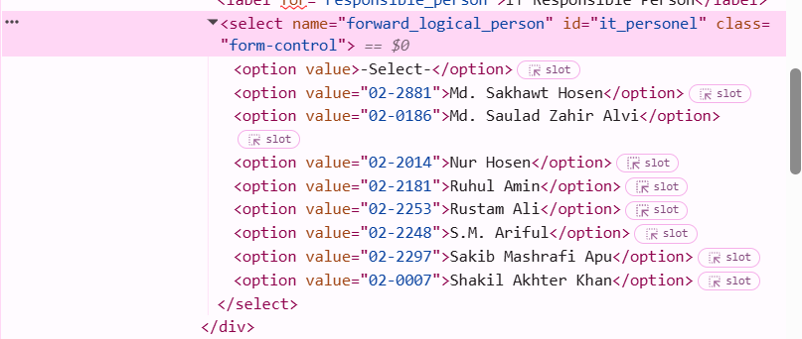

SELECT

tu.tt_no,

tu.user AS updated_by_id,

u.full_name AS updated_by_name,

tu.logical_team,

tu.logical_team_person AS assigned_id,

assigned.full_name AS assigned_name,

tu.department,

tt.status,

tt.created_at

FROM tt_updates tu

LEFT JOIN users u
ON u.employee_id = tu.user

LEFT JOIN users assigned
ON assigned.employee_id = tu.logical_team_person

LEFT JOIN trouble_tickets tt
ON tt.tt_no = tu.tt_no

WHERE tu.tt_no = '2026072629741'

ORDER BY tt.created_at ASC;

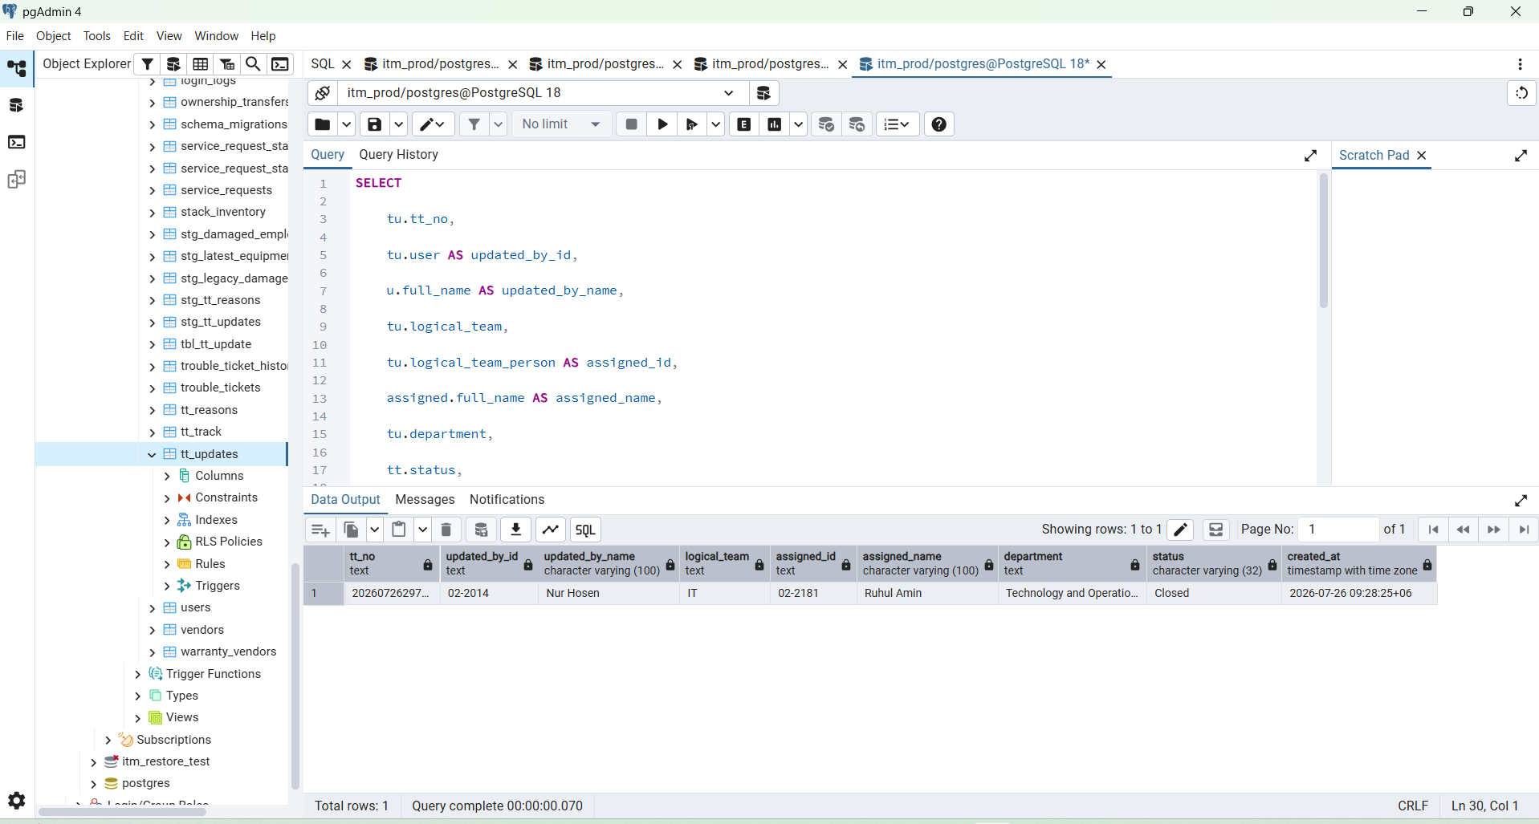

tt_no | updated_by_id | updated_by_name | team | assigned_id | assigned_name | status
2026072629741 | 02-2014 | Nur Hosen | IT | 02-2181 | Ruhul Amin | Closed

http://localhost:8080/api/v1/admin/role-access/overview

http://localhost:8080/api/v1/tickets/2026072629741/updates

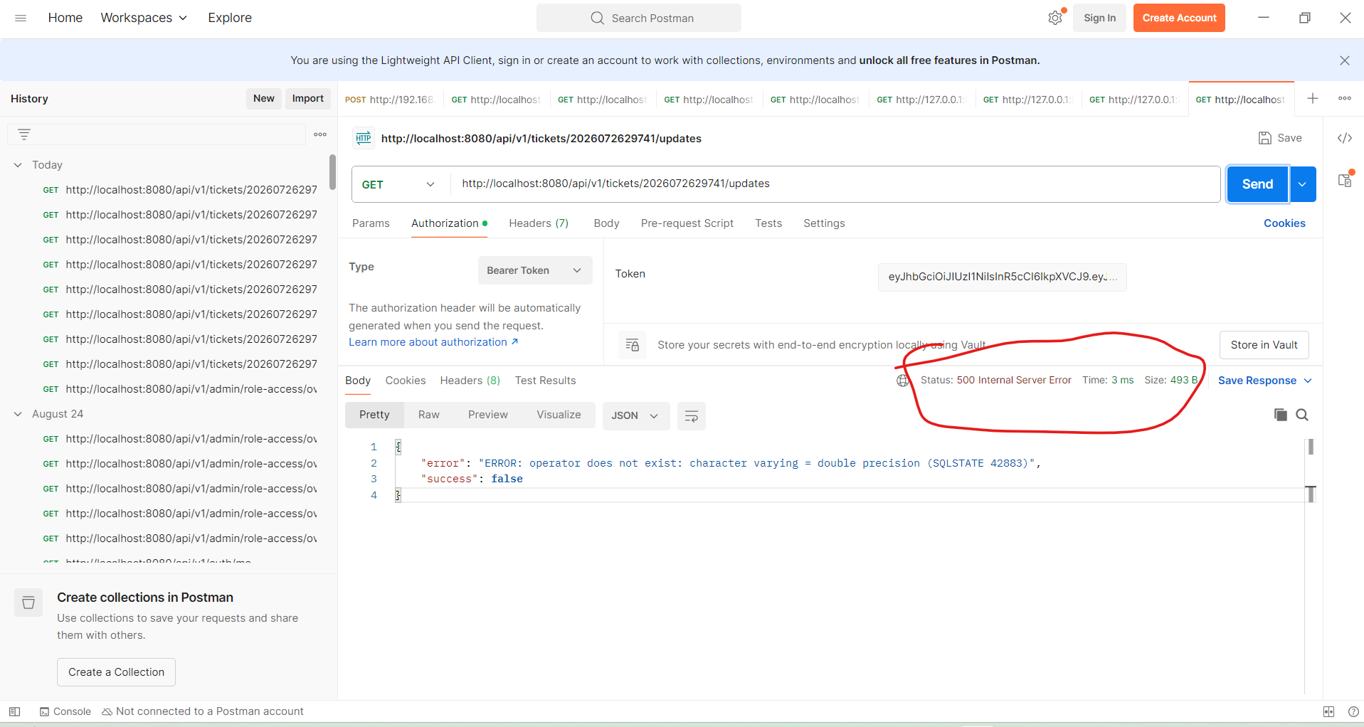

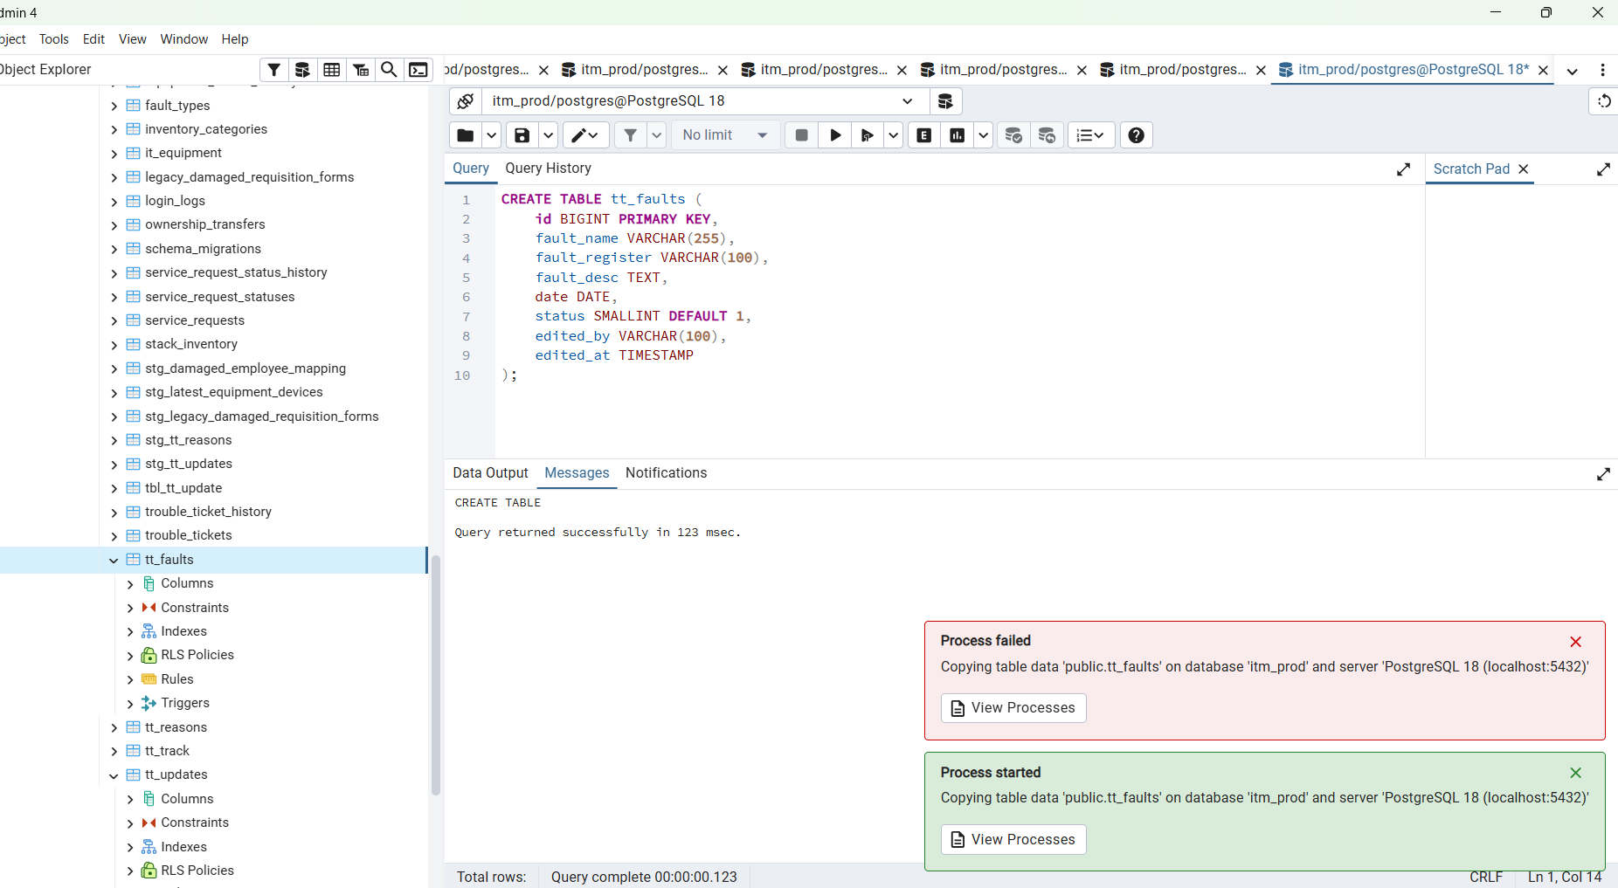

& "D:\Program Files\PostgreSQL\18\bin\psql.exe" -U postgres -d itm_prod -c "\copy public.tt_faults(id, fault_name, fault_register, fault_desc, date, status, edited_by, edited_at) FROM 'C:/Users/HP/Desktop/touble_ticket_final/tbl_fault_type1.csv' WITH (FORMAT csv, HEADER true, DELIMITER ',', NULL '');"

