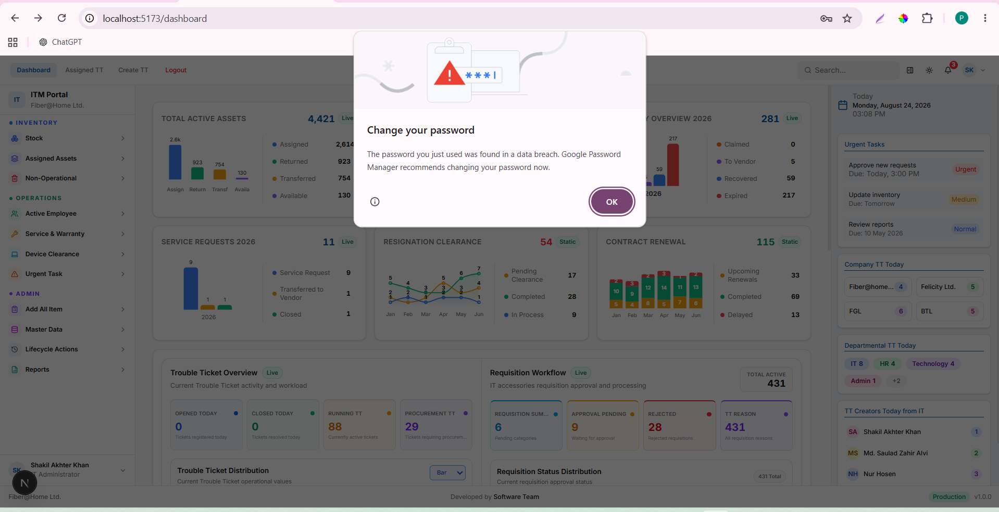

SELECT
u.id,
u.username,
u.employee_id,
u.user_type,
r.id AS role_id,
r.code AS role_code,
r.name AS role_name,
ur.active AS role_assignment_active
FROM public.users u

JOIN public.auth_user_roles ur
ON ur.user_id = u.id
AND ur.active = TRUE
AND (
ur.expires_at IS NULL
OR ur.expires_at > CURRENT_TIMESTAMP
)

JOIN public.auth_roles r
ON r.id = ur.role_id
AND r.active = TRUE
AND r.legacy_user_type = u.user_type

WHERE u.username = 'muhsina.akter';

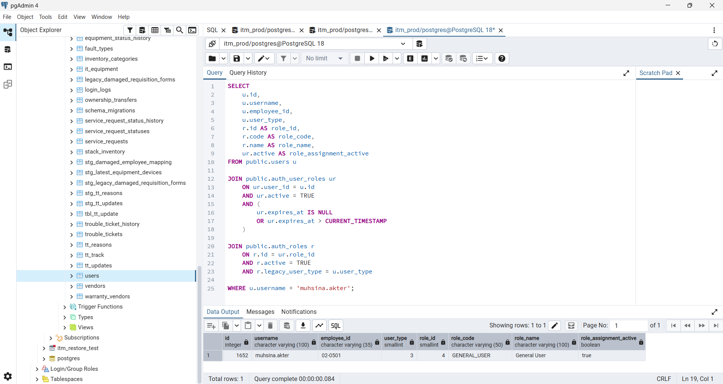

After changing the below status
