https://chatgpt.com/g/g-p-6aa643e2dadc8191aa94244a899b7ea1/c/6aa64409-3abc-83e8-8ad3-11f5965f2aa3

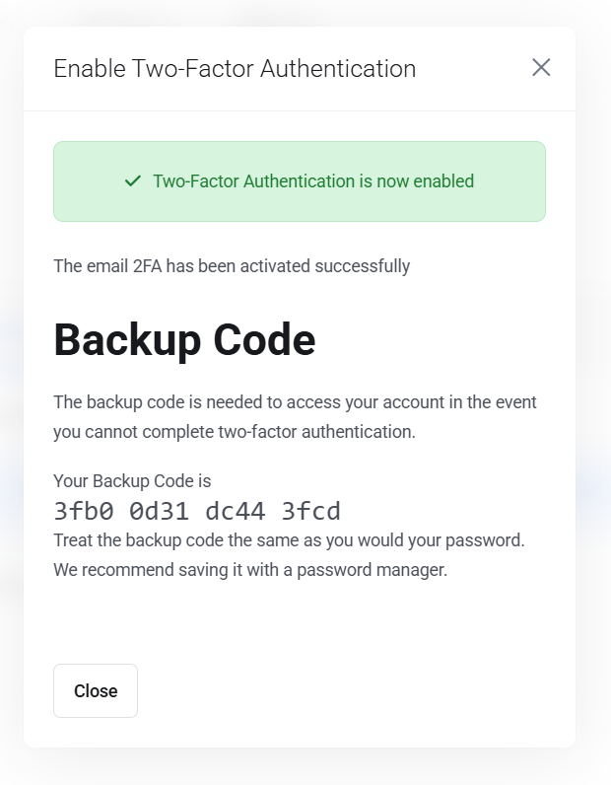

https://chatgpt.com/g/g-p-6aa643e2dadc8191aa94244a899b7ea1-itm/c/6aa64409-3abc-83e8-8ad3-11f5965f2aa3

https://chatgpt.com/g/g-p-6aa643e2dadc8191aa94244a899b7ea1-itm/c/6aa64409-3abc-83e8-8ad3-11f5965f2aa3

user_images/1401616150.jpg in postgresql

Done. I packaged the complete folder structure using the exact paths you asked for:
itm-device-clearance-complete-folder/
├── README.txt
├── install.sh
├── frontend/
│ ├── .env.local.example
│ └── app/
│ ├── api/
│ │ └── hris-image/
│ │ └── route.ts
│ └── dashboard/
│ └── device-clearance/
│ └── create/
│ └── page.tsx
└── itm/
└── backend/
└── internal/
└── handler/
└── handlers.go
The backend file is your full handlers.go, with employee search/get/IT-person endpoints updated so the picture field is returned consistently. Your current code already joins office and personal employee tables in some places; the updated endpoints make that consistent for the clearance screen.
The frontend create/page.tsx includes employee search with image, selected employee photo, assigned devices, clearance checklist, assigned IT-person search, and the HRIS image proxy. You do not need to create a local employee-photo directory.
Download the complete folder ZIP
After extracting, configure the HRIS_IMAGE_* values from frontend/.env.local.example, then restart your frontend and backend.

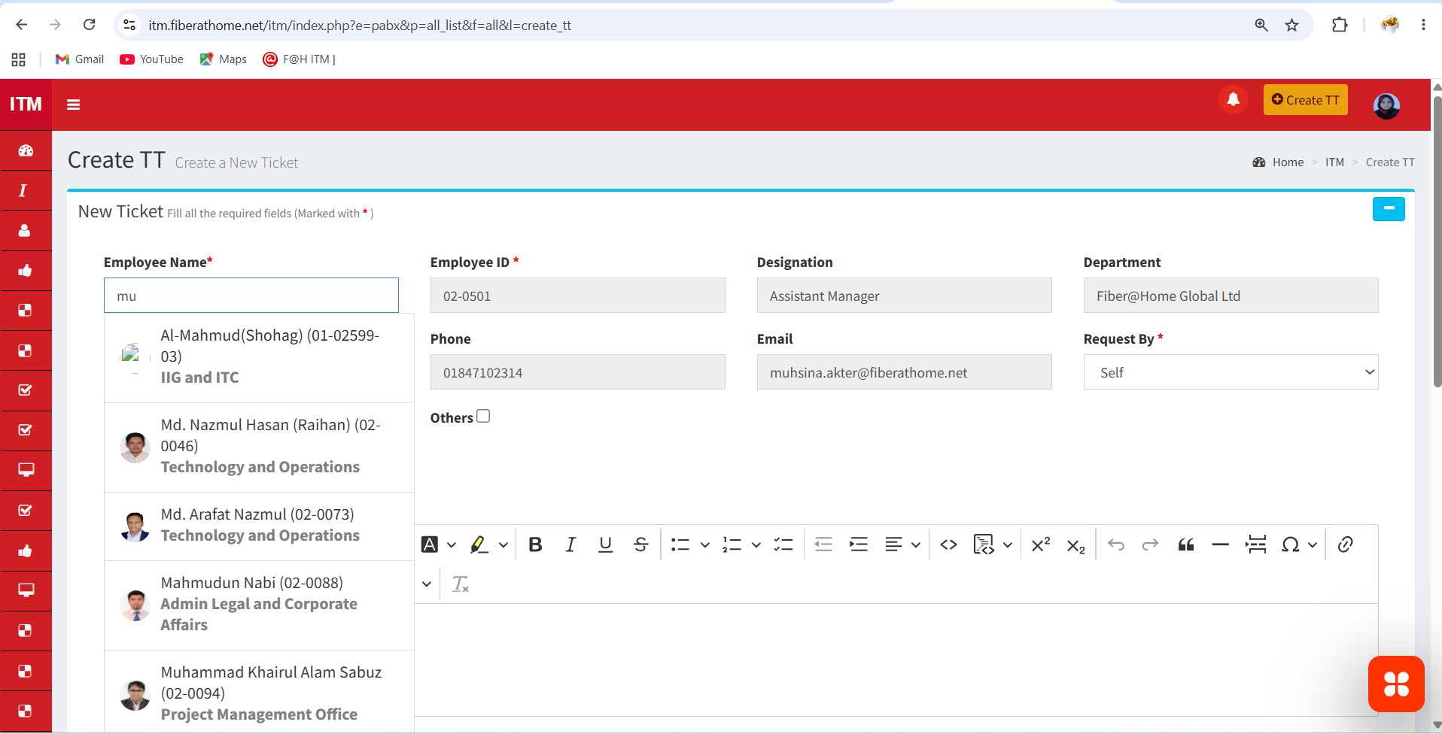

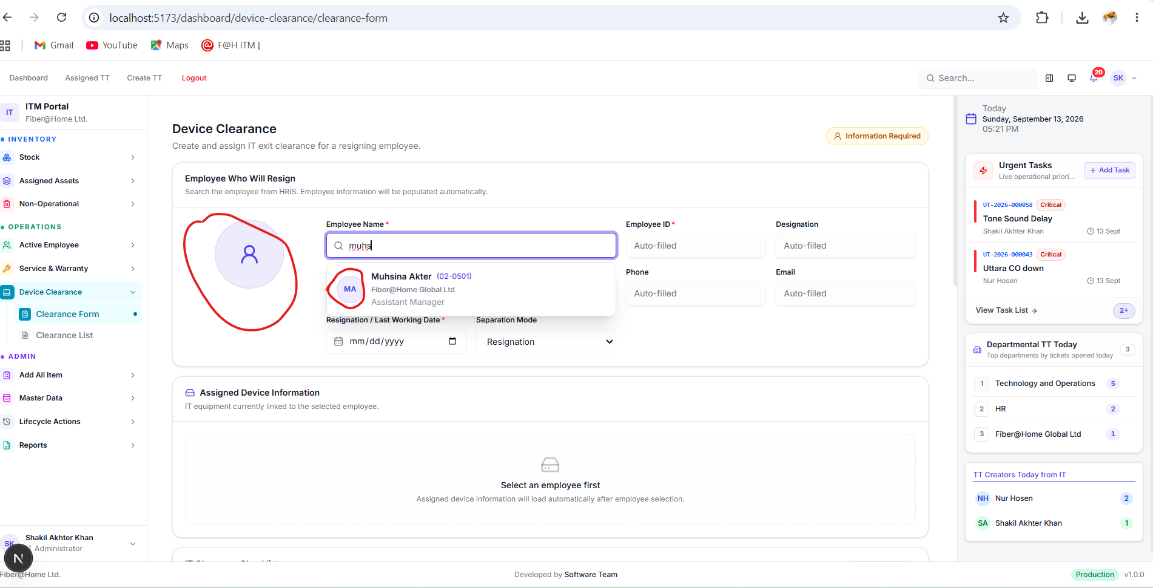

-- Check the HRIS picture path stored in PostgreSQL.

SELECT
o.employee_id,
o.employee_name,
o.designation,
o.department_name,
p.picture,
CASE
WHEN COALESCE(BTRIM(p.picture), '') = ''
THEN ''
WHEN p.picture ~* '^https?://'
THEN p.picture
ELSE
'https://hris.fiberathome.net/hris/admin/' ||
LTRIM(BTRIM(p.picture), '/')
END AS employee_image_url
FROM public.employee_office_info o
LEFT JOIN public.employee_personal_info p
ON BTRIM(p.employee_id) = BTRIM(o.employee_id)
WHERE o.employee_id = '02-0501';

-- Find employees that have no picture path.

SELECT
o.employee_id,
o.employee_name
FROM public.employee_office_info o
LEFT JOIN public.employee_personal_info p
ON BTRIM(p.employee_id) = BTRIM(o.employee_id)
WHERE COALESCE(BTRIM(p.picture), '') = ''
ORDER BY o.employee_name;

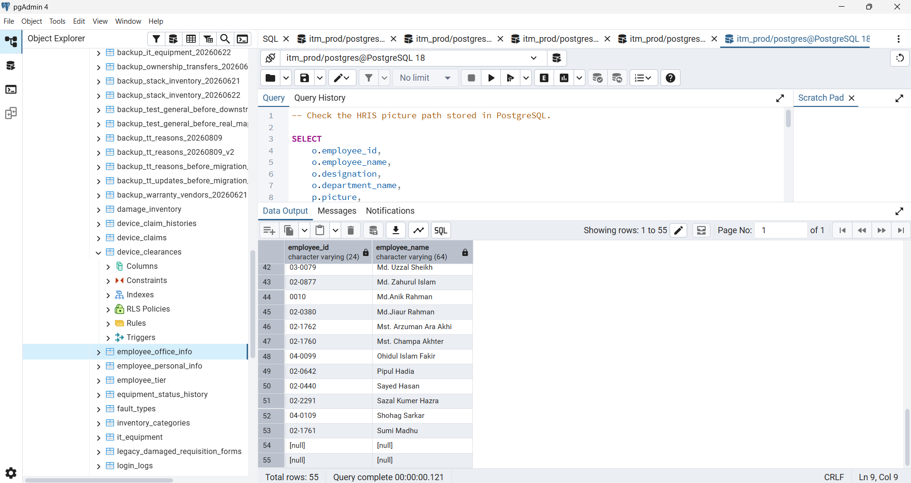

https://chatgpt.com/g/g-p-6aa643e2dadc8191aa94244a899b7ea1/c/6aa64409-3abc-83e8-8ad3-11f5965f2aa3

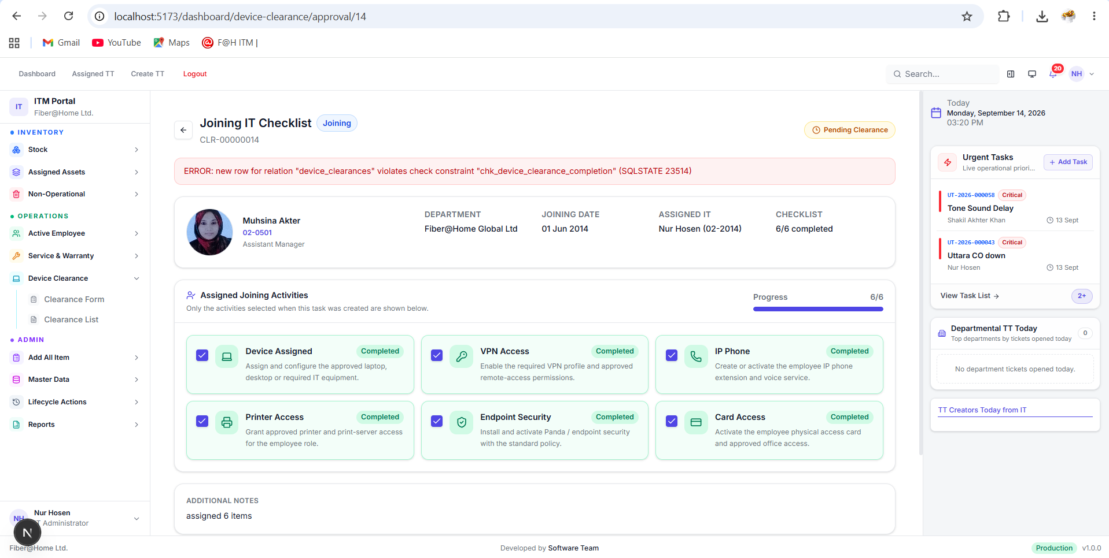

localhost:5173/dashboard/operations/create_tt

