SELECT
id,
code,
name,
legacy_user_type,
hierarchy_level,
active
FROM public.auth_roles
WHERE code = 'ROOT';

Output:
-----------------------------------------
code ROOT
legacy_user_type 0
hierarchy_level 100
active true

SELECT
p.code
FROM public.auth_role_permissions rp
JOIN public.auth_roles r
ON r.id = rp.role_id
JOIN public.auth_permissions p
ON p.id = rp.permission_id
WHERE r.code = 'ROOT'
ORDER BY p.code;
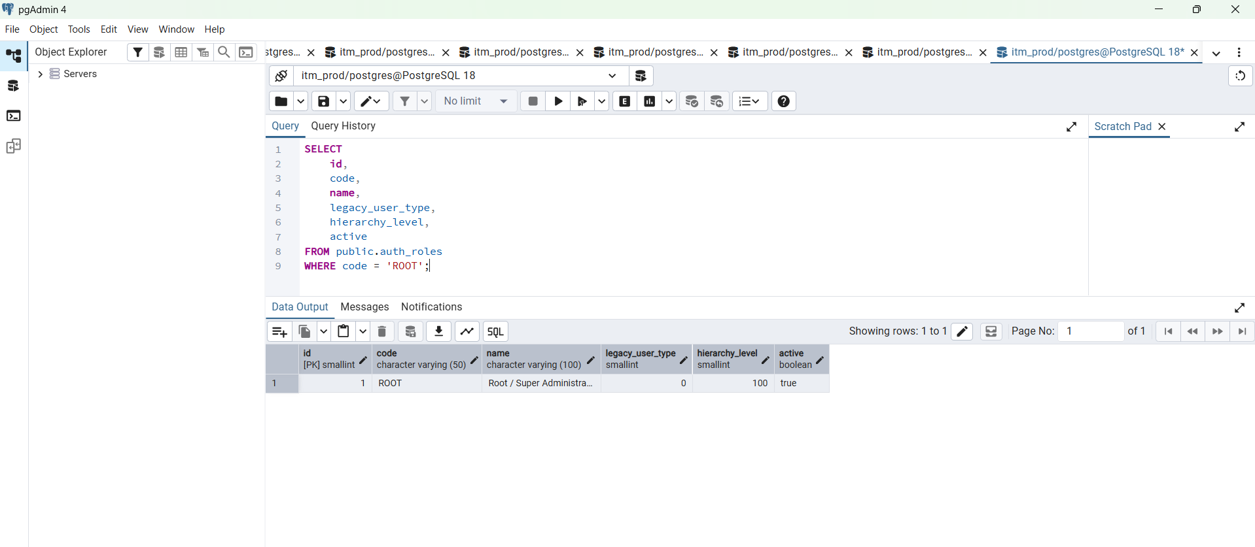

SELECT
p.code
FROM public.auth_role_permissions rp
JOIN public.auth_roles r
ON r.id = rp.role_id
JOIN public.auth_permissions p
ON p.id = rp.permission_id
WHERE r.code = 'ROOT'
ORDER BY p.code;

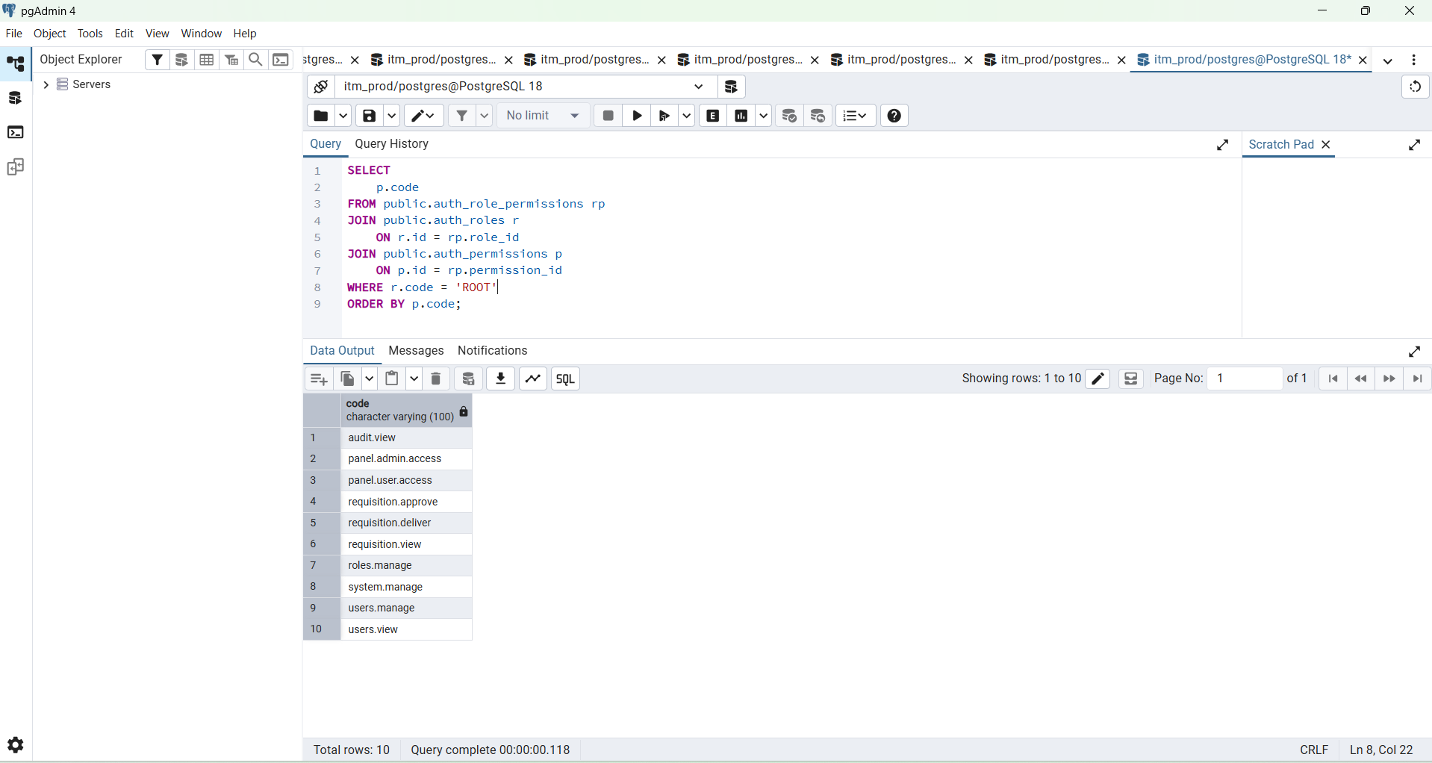

PS D:\ITM-Data\itm\backend> go run ./cmd/hash_password
Enter password: Admin@1234
2026/08/17 11:45:04 password must be at least 12 characters
exit status 1
PS D:\ITM-Data\itm\backend> go run ./cmd/hash_password
Enter password:

----------------------------------------------------------------------------------------------------------
Set Login Password

PS D:\ITM-Data\itm\backend> go run ./cmd/hash_password
Enter password: Admin@1234
2026/08/17 11:45:04 password must be at least 12 characters
exit status 1
PS D:\ITM-Data\itm\backend> go run ./cmd/hash_password
Enter password: Admin@1234
2026/08/17 11:47:16 password must be at least 12 characters
exit status 1
PS D:\ITM-Data\itm\backend> go run ./cmd/hash_password
Enter password: f@hrt1@itm_new

$2a$10$Z.pdR11CzVeq3Cayodjy1eHzhsJqk3ujzvEp82Nr8mZh.f0gEzdb6
PS D:\ITM-Data\itm\backend>

-----------------------------------------------------------------------------------------------------

SELECT
id,
employee_id,
username,
user_type,
active,
account_status
FROM public.users
WHERE
LOWER(username) = 'itm.root'
OR employee_id = 'ROOT-001';

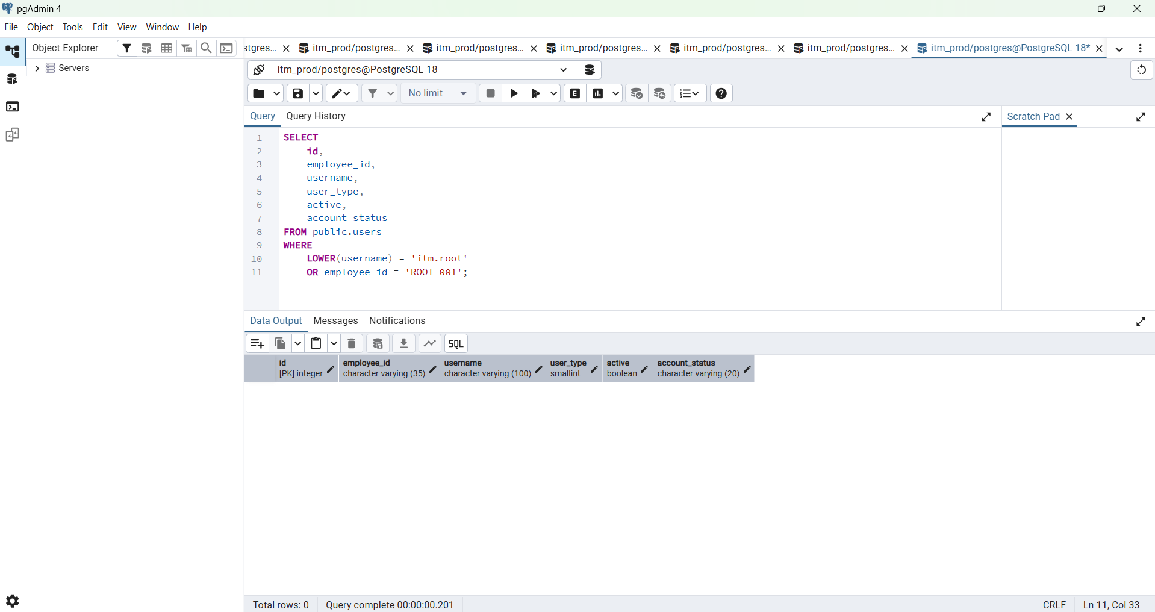

BEGIN;

INSERT INTO public.users (
employee_id,
username,
full_name,
email,
password_hash,
user_type,
active,
account_status,
must_change_password,
failed_login_attempts
)
VALUES (
'ROOT-001',
'itm.root',
'ITM Root Administrator',
'root@itm.local',
'PASTE_BCRYPT_HASH_HERE',
0,
TRUE,
'active',
TRUE,
0
);

INSERT INTO public.auth_user_roles (
user_id,
role_id,
active
)
SELECT
u.id,
r.id,
TRUE
FROM public.users u
JOIN public.auth_roles r
ON r.code = 'ROOT'
WHERE u.username = 'itm.root';

COMMIT;

-----------------------------------------------------------------------------------

BEGIN;

INSERT INTO public.users (
employee_id,
username,
full_name,
email,
password_hash,
user_type,
active,
account_status,
must_change_password,
failed_login_attempts
)
VALUES (
'ROOT-001',
'itm.root',
'ITM Root Administrator',
'root@itm.local',
'$2a$10$Z.pdR11CzVeq3Cayodjy1eHzhsJqk3ujzvEp82Nr8mZh.f0gEzdb6',
0,
TRUE,
'active',
TRUE,
0
);

INSERT INTO public.auth_user_roles (
user_id,
role_id,
active
)
SELECT
u.id,
r.id,
TRUE
FROM public.users u
JOIN public.auth_roles r
ON r.code = 'ROOT'
WHERE u.username = 'itm.root';

COMMIT;

SELECT
u.id,
u.employee_id,
u.username,
u.full_name,
u.user_type,
u.active,
u.account_status,
u.must_change_password,
r.code AS role_code,
r.name AS role_name
FROM public.users u

JOIN public.auth_user_roles ur
ON ur.user_id = u.id
AND ur.active = TRUE

JOIN public.auth_roles r
ON r.id = ur.role_id

WHERE u.username = 'itm.root';

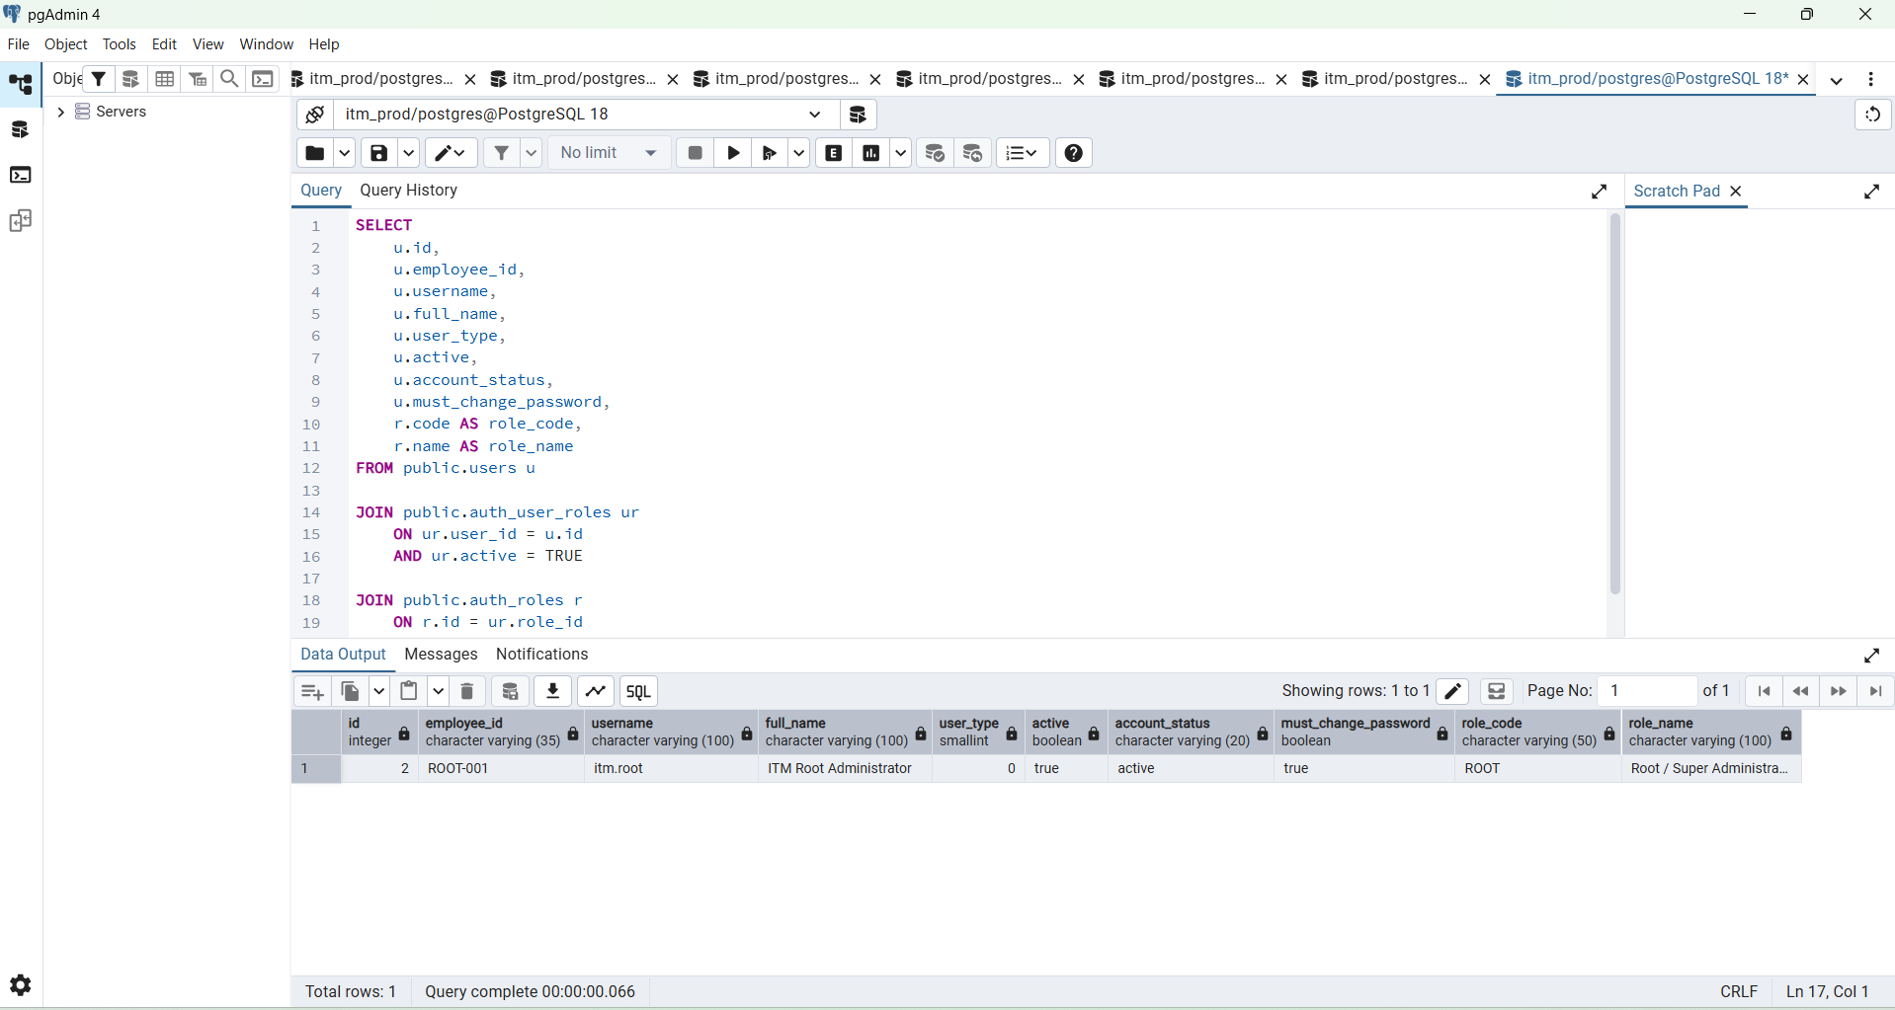

5. Verify ROOT mapping
Run:
SELECT
u.id,
u.employee_id,
u.username,
u.full_name,
u.user_type,
u.active,
u.account_status,
u.must_change_password,
r.code AS role_code,
r.name AS role_name
FROM public.users u

JOIN public.auth_user_roles ur
ON ur.user_id = u.id
AND ur.active = TRUE

JOIN public.auth_roles r
ON r.id = ur.role_id

WHERE u.username = 'itm.root';

Expected:
employee_id ROOT-001
username itm.root
user_type 0
active true
account_status active
must_change_password true
role_code ROOT

