Recommended professional flow
Use this architecture:
Employee
↓
Individual ITM account
↓
users.employee_id
↓
Login
↓
JWT:
user_id
employee_id
username
user_type
↓
Auth Middleware
↓
Gin context:
employee_id
↓
Approval
approved_by = logged-in employee_id
approved_date = server time
↓
Delivery
delivered_by = logged-in employee_id
delivered_date = server time
The frontend should never send approved_by or delivered_by.

Step 1 — Keep admin as system admin
Do not change:
admin → ADMIN-001
into an employee account.
Keep it for system administration.
Instead, create personal ITM login accounts for employees.
For example:
username employee_id user_type
------------------------------------------------
muhsina.akter 02-0501 1
nur.hosen 02-2014 1
...

Then:
Muhsina login
↓
JWT employee_id = 02-0501
↓
Approve
↓
approved_by = 02-0501
That gives you a proper audit trail.

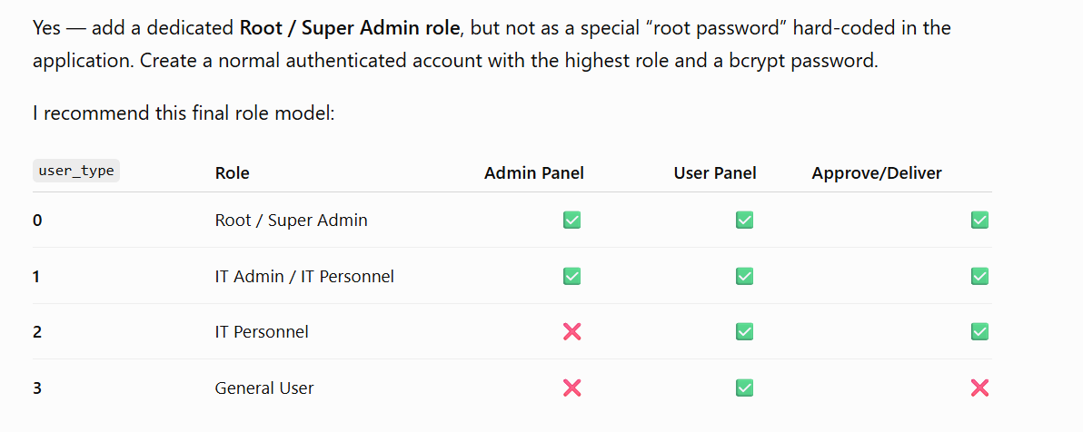

Yes — add a dedicated Root / Super Admin role, but not as a special “root password” hard-coded in the application. Create a normal authenticated account with the highest role and a bcrypt password.
I recommend this final role model:
user_type | Role | Admin Panel | User Panel | Approve/Deliver
0 | Root / Super Admin | ✅ | ✅ | ✅
1 | IT Admin / IT Personnel | ✅ | ✅ | ✅
2 | IT Personnel | ❌ | ✅ | ✅
3 | General User | ❌ | ✅ | ❌
Your existing legacy tbl_user_info.status can continue mapping 1 → 1, 2 → 2, 3 → 3. Role 0 is new and only belongs to the new ITM application.

1. Professional database architecture
Use:
users
│
├── auth_user_roles
│ └── auth_roles
│ └── auth_role_permissions
│ └── auth_permissions
│
├── auth_sessions
├── auth_password_history
└── auth_audit_logs
The important distinction is:
ROLE
ROOT / IT_ADMIN / IT_PERSONNEL / GENERAL_USER

ACCOUNT STATUS
active / suspended / locked / disabled
Do not use one status field for both concepts.

2. Create the migration
Create:
backend/migrations/20260816_001_auth_security.sql

NOTICE: column "created_at" of relation "users" already exists, skipping
NOTICE: column "updated_at" of relation "users" already exists, skipping
NOTICE: trigger "trg_users_updated_at" for relation "public.users" does not exist, skipping
NOTICE: trigger "trg_auth_roles_updated_at" for relation "public.auth_roles" does not exist, skipping
COMMIT

Query returned successfully in 353 msec.

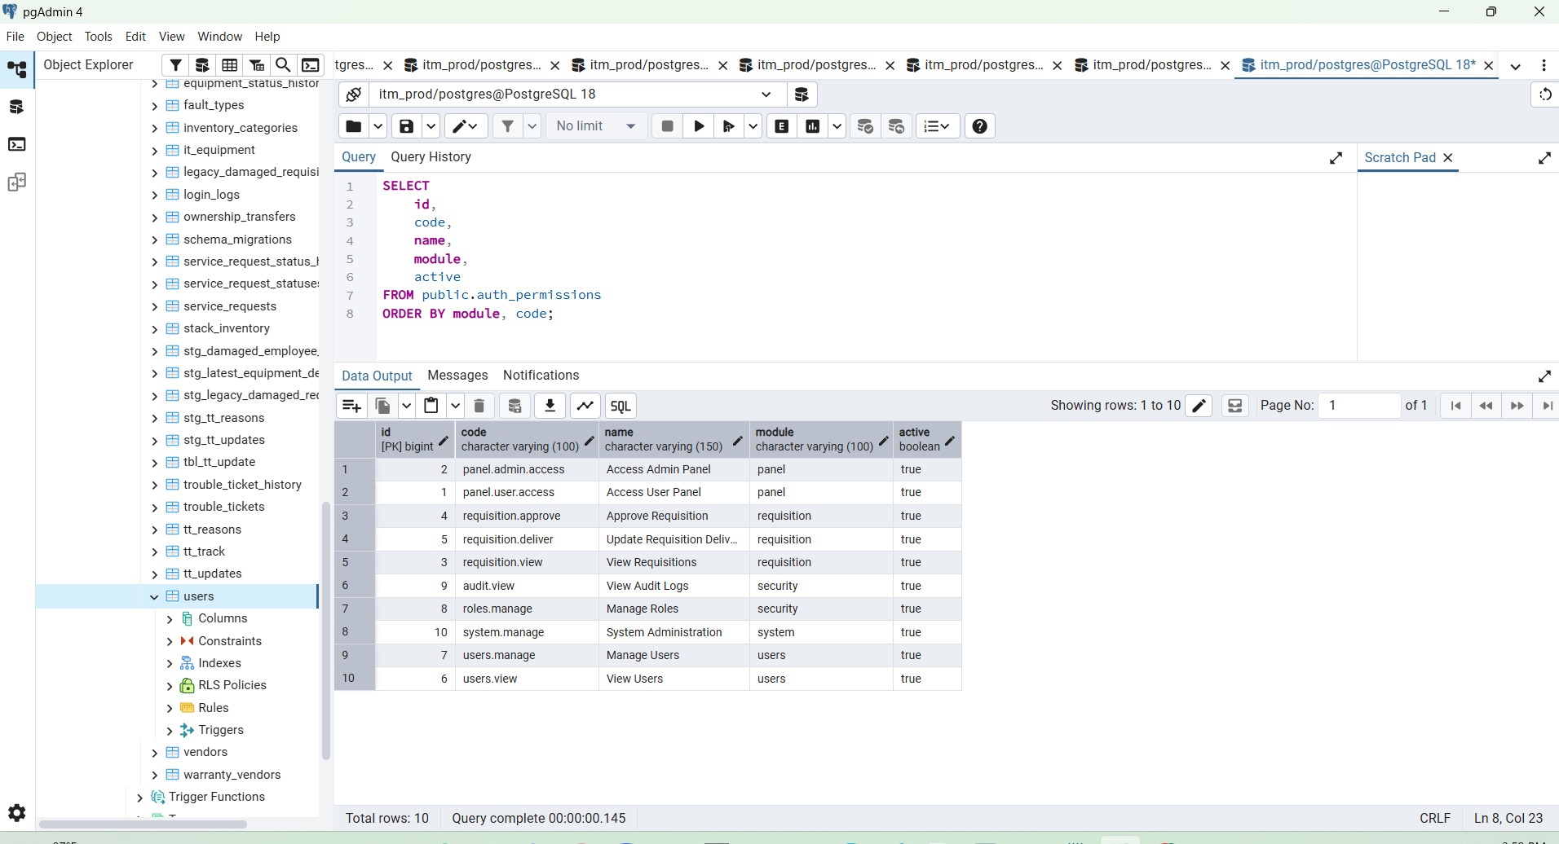

Next Step 3 — Verify permissions
Run:
SELECT
id,
code,
name,
module,
active
FROM public.auth_permissions
ORDER BY module, code;
You should see permissions such as:
panel.admin.access
panel.user.access

requisition.view
requisition.approve
requisition.deliver

users.view
users.manage

roles.manage
audit.view
system.manage
Next Step 4 — Verify role permissions
Run:
SELECT
r.code AS role,
p.code AS permission
FROM public.auth_role_permissions rp
JOIN public.auth_roles r
ON r.id = rp.role_id
JOIN public.auth_permissions p
ON p.id = rp.permission_id
ORDER BY
r.hierarchy_level DESC,
p.code;
You should see roughly:
ROOT
all permissions

IT_ADMIN
panel.admin.access
panel.user.access
requisition.view
requisition.approve
requisition.deliver
users.view
users.manage
audit.view

IT_PERSONNEL
panel.user.access
requisition.view
requisition.approve
requisition.deliver

GENERAL_USER
panel.user.access
requisition.view
Next Step 5 — Verify your current admin mapping
Run:
SELECT
u.id,
u.employee_id,
u.username,
u.full_name,
u.user_type,
r.code AS role_code,
r.name AS role_name
FROM public.users u
LEFT JOIN public.auth_user_roles ur
ON ur.user_id = u.id
AND ur.active = TRUE
LEFT JOIN public.auth_roles r
ON r.id = ur.role_id
WHERE LOWER(u.username) = 'admin';
With your current account, I expect:
employee_id = ADMIN-001
username = admin
user_type = 1
role_code = IT_ADMIN
That is correct for the existing system account.
Next Step 6 — Verify all current users and roles
Run:
SELECT
u.id,
u.employee_id,
u.username,
u.full_name,
u.user_type,
u.account_status,
u.active,
r.code AS role
FROM public.users u
LEFT JOIN public.auth_user_roles ur
ON ur.user_id = u.id
AND ur.active = TRUE
LEFT JOIN public.auth_roles r
ON r.id = ur.role_id
WHERE u.deleted_at IS NULL
ORDER BY u.id;
This will tell us whether every existing account was mapped correctly.
Next Step 7 — Check the user_type values before validating constraint
Run:
SELECT
user_type,
COUNT(*) AS total
FROM public.users
GROUP BY user_type
ORDER BY user_type;
Every value should be only:
0
1
2
3
If that is true, then run:
ALTER TABLE public.users
VALIDATE CONSTRAINT users_user_type_check;
You should get:
ALTER TABLE
Do not create Root yet
Before inserting the Root account, I recommend we first complete the backend authentication layer properly:
Database security structure ✅ Done

Next:
1. Rewrite auth.go
2. Update JWT middleware
3. Add permission middleware
4. Verify employee_id from JWT
5. Create Root account securely
6. Create individual IT Personnel accounts
7. Connect requisition Approval
8. Connect requisition Delivery
9. Write auth_audit_logs
Send me the result of these two queries next
First:
SELECT
id,
code,
name,
legacy_user_type,
hierarchy_level
FROM public.auth_roles
ORDER BY hierarchy_level DESC;
Second:
SELECT
u.id,
u.employee_id,
u.username,
u.full_name,
u.user_type,
r.code AS role
FROM public.users u
LEFT JOIN public.auth_user_roles ur
ON ur.user_id = u.id
AND ur.active = TRUE
LEFT JOIN public.auth_roles r
ON r.id = ur.role_id
ORDER BY u.id;
Once those results are correct, the next step will be backend/internal/handler/auth.go, and I’ll rewrite the complete file for the new professional role/permission architecture.

Create only:
1 Root
1 IT Admin
1 IT Personnel
1 General User

Step 4 — Do not import all Excel rows yet
Before importing 2,676 rows, first test with only a few accounts.
From your uploaded sheet, there are IT Personnel examples with:
user_type = 2
work_area = IT
and General User examples with:
user_type = 3
Create only:
1 Root
1 IT Admin
1 IT Personnel
1 General User
first.
Then verify all four access levels before mass migration.
Our test matrix should be:
Account | Type | Admin Panel | User Panel | Approve | Deliver
Root | 0 | ✅ | ✅ | ✅ | ✅
IT Admin | 1 | ✅ | ✅ | ✅ | ✅
IT Personnel | 2 | ❌ | ✅ | ✅ | ✅
General User | 3 | ❌ | ✅ | ❌ | ❌

Yes. The safest way is to implement this in phases and not touch Approval/Delivery until authentication identity and permissions are proven working.
Your target architecture is:
ROOT user_type = 0
IT_ADMIN user_type = 1
IT_PERSONNEL user_type = 2
GENERAL_USER user_type = 3
with authentication driven by:
users
↓
auth_user_roles
↓
auth_roles
↓
auth_role_permissions
↓
auth_permissions
and the logged-in employee identity coming from JWT → Gin context.

SELECT
id,
code,
name,
legacy_user_type,
hierarchy_level,
active
FROM public.auth_roles
ORDER BY hierarchy_level DESC;

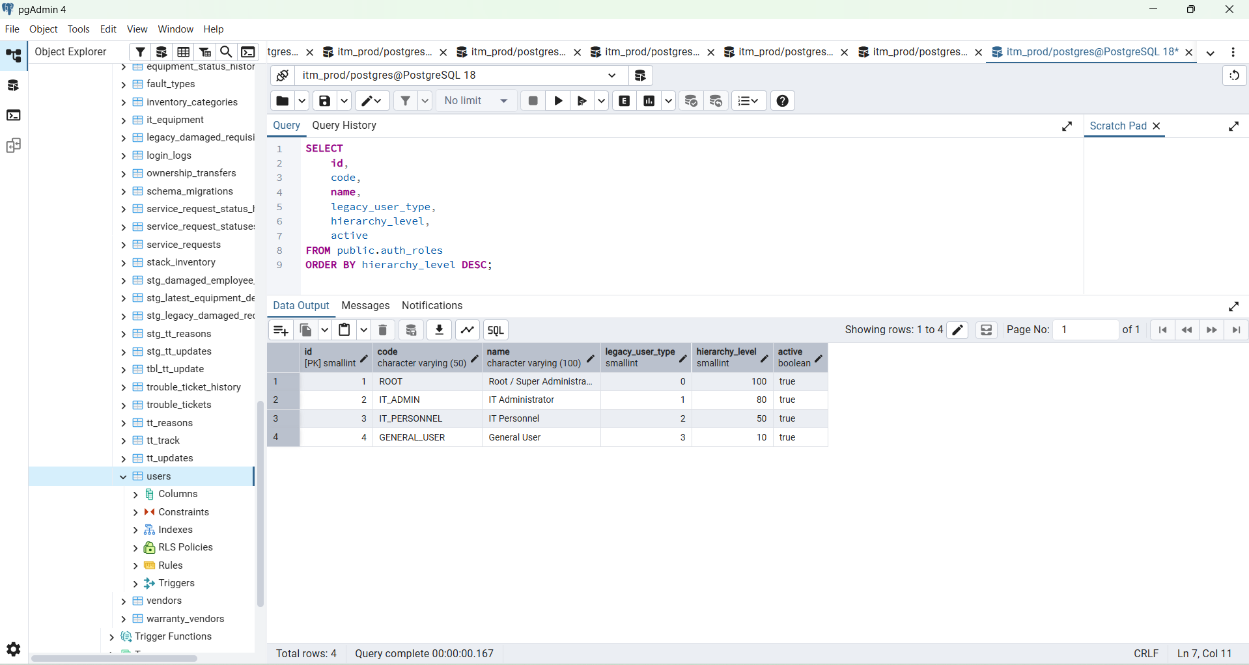
https://chatgpt.com/g/g-p-6a5378cdfc588191b929a3b5ca9c1c9a/c/6a6aea6e-6794-83e8-a9d3-22852803845a

Step 1 — Verify the new security tables

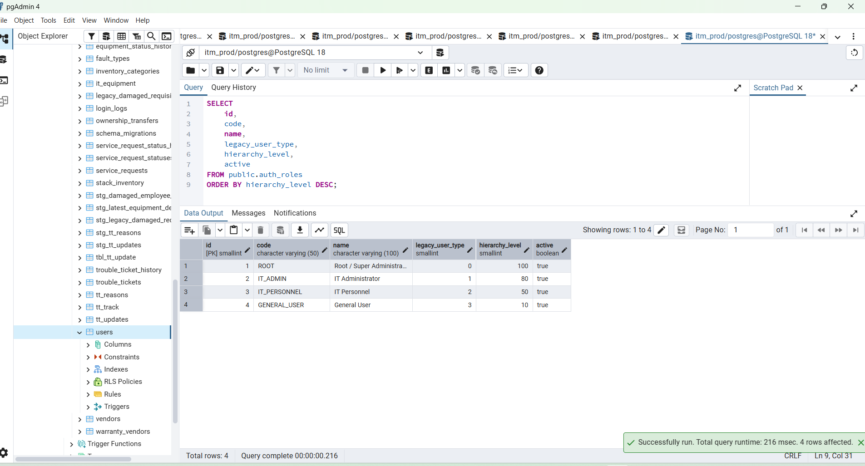

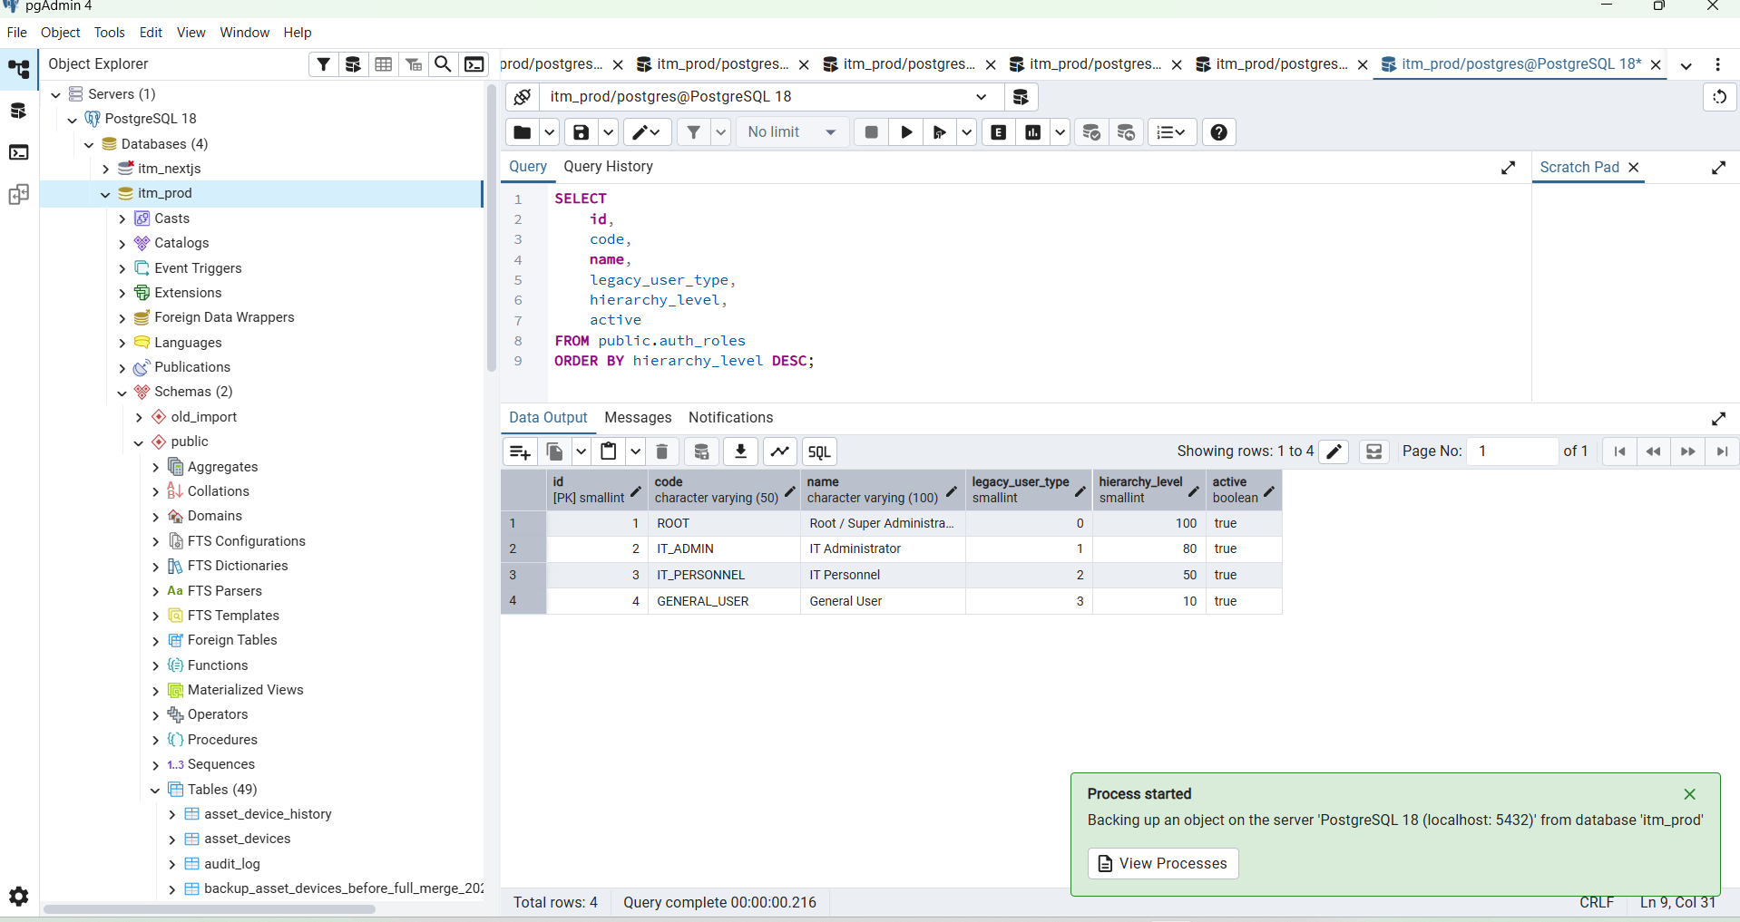

Yes. You already have the correct place for JWT authentication: backend/internal/middleware/middleware.go. We should upgrade it first and leave handler/auth.go and main.go unchanged for this step.

Yes. You already have the correct place for JWT authentication: backend/internal/middleware/middleware.go. We should upgrade it first and leave handler/auth.go and main.go unchanged for this step.
This is the safest order:
STEP 1 middleware/middleware.go ← NOW
STEP 2 handler/auth.go
STEP 3 middleware/permission.go
STEP 4 /auth/me + main.go
STEP 5 Root account
STEP 6 Test roles
STEP 7 Approval/Delivery
The important part is that Step 1 will remain compatible with your existing admin login. Your existing tokens use "role" for UserType, so we will keep that claim unchanged and add role_code separately.
Step 1 — Back up the current middleware file
From:
cd D:\ITM-Data\itm\backend
run:
Copy-Item `
".\internal\middleware\middleware.go" `
".\internal\middleware\middleware.go.before-professional-auth"
Then confirm:
Get-Item ".\internal\middleware\middleware.go.before-professional-auth"

Step 2 — Replace the complete middleware file
Replace the entire:
backend/internal/middleware/middleware.go
with this:
package middleware

import (
"net/http"
"strings"
"sync"
"time"

"github.com/gin-gonic/gin"
"github.com/golang-jwt/jwt/v5"
"golang.org/x/time/rate"
)

/* ============================================================
AUTHENTICATION CONTEXT KEYS
============================================================ */

const (
ContextUserID = "user_id"
ContextEmployeeID = "employee_id"
ContextUsername = "username"
ContextUserType = "user_type"
ContextRoleCode = "role_code"
)

/* ============================================================
USER TYPE / ROLE CONSTANTS

0 = Root / Super Administrator
1 = IT Administrator
2 = IT Personnel
3 = General User
============================================================ */

const (
UserTypeRoot = 0
UserTypeITAdmin = 1
UserTypeITPersonnel = 2
UserTypeGeneral = 3
)

/* ============================================================
JWT CLAIMS

IMPORTANT:
UserType keeps json:"role" for backward compatibility with
the JWT tokens already generated by the current application.

RoleCode is new and will be populated after handler/auth.go
is upgraded in the next step.
============================================================ */

type Claims struct {
UserID int `json:"uid"`
EmployeeID string `json:"emp"`
Username string `json:"uname"`
UserType int `json:"role"`
RoleCode string `json:"role_code,omitempty"`

jwt.RegisteredClaims
}

/* ============================================================
AUTH MIDDLEWARE
============================================================ */

func Auth(secret string) gin.HandlerFunc {
secret = strings.TrimSpace(secret)

return func(c *gin.Context) {
if secret == "" {
c.AbortWithStatusJSON(
http.StatusInternalServerError,
gin.H{
"success": false,
"error": "authentication configuration error",
},
)
return
}

authHeader := strings.TrimSpace(
Step 3 — Format it
Run:
cd D:\ITM-Data\itm\backend

gofmt -w .\internal\middleware\middleware.go
Then:
go test ./...
If you have packages without tests, that's okay. What matters is that there are no compilation errors.
If there is an error, don't change anything else. Send me the exact output.

Step 4 — Start the backend
Use your normal method.
If you use air:
air
or:
go run ./cmd/server
We are not changing main.go yet.
Your current line remains correct:
p.Use(middleware.Auth(cfg.JWTSecret))

Step 5 — Test current demo login
Use the existing demo admin account.
Request:
POST /api/v1/auth/login
Content-Type: application/json
Body:
{
"username": "admin",
"password": "YOUR_CURRENT_DEMO_PASSWORD"
}
We want the current login to continue returning:
{
"success": true,
"data": {
"token": "...",
"expires_in": 28800,
"user_id": 1,
"employee_id": "ADMIN-001",
"username": "admin",
"full_name": "System Administrator",
"user_type": 1
}
}
role_code will not exist yet. That's expected because we haven't updated handler/auth.go.

Step 6 — Test a protected API
Copy the returned token.
Call one of your existing protected endpoints:
GET /api/v1/dashboard/requisition-dashboard-summary
Authorization: Bearer YOUR_TOKEN
It should return:
200 OK
That proves:
login
↓
JWT created
↓
middleware.Auth
↓
JWT validated
↓
protected API works

Step 7 — Test missing token
Call the same endpoint without Authorization.
Expected:
401 Unauthorized
with:
{
"success": false,
"error": "missing or invalid authorization token"
}

Step 8 — Test invalid token
Use:
Authorization: Bearer abc123
Expected:
401 Unauthorized
with:
{
"success": false,
"error": "invalid or expired token"
}
That confirms invalid JWTs cannot enter protected routes.

What changed in this step
Previously your middleware accepted any HMAC JWT algorithm:
if _, ok := t.Method.(*jwt.SigningMethodHMAC); !ok
That means HS256/384/512 were all potentially accepted.
Now it accepts only:
HS256
which matches your token creation:
jwt.SigningMethodHS256
We also now validate:
✓ signature
✓ HS256 algorithm
✓ expiration
✓ issued-at
✓ user identity
✓ role range
and provide authoritative context values:
user_id
employee_id
username
user_type
role_code
role_code is empty for current legacy tokens, which is intentional during this transition.
Do NOT update these yet
For this step, leave these exactly as they are:
backend/internal/handler/auth.go ← don't modify yet
backend/cmd/server/main.go ← don't modify yet
requisition workflow ← don't modify yet
frontend ← don't modify yet
And don't disable:
admin / ADMIN-001
yet.
After this test passes
Then we go to Step 2:
backend/internal/handler/auth.go
That is a more important change. We will make login query:
users
+
auth_user_roles
+
auth_roles
instead of trusting only:
users.user_type
and the new JWT will become:
uid = users.id
emp = employee_id
uname = username
role = 0/1/2/3
role_code = ROOT / IT_ADMIN / IT_PERSONNEL / GENERAL_USER
We'll also fix the unsafe current Refresh() behavior because this line:
jwt.WithoutClaimsValidation()
should not remain in the professional authentication implementation.
So complete Steps 1–8 above first. If go test ./..., login, and protected API all succeed, send me the results and we'll replace the complete backend/internal/handler/auth.go next.

