Role | Type | Admin | User | Approve | Deliver
ROOT | 0 | ✅ | ✅ | ✅ | ✅
IT_ADMIN | 1 | ✅ | ✅ | ✅ | ✅
IT_PERSONNEL | 2 | ❌ | ✅ | ✅ | ✅
GENERAL_USER | 3 | ❌ | ✅ | ❌ | ❌

Windows PowerShell
Copyright (C) Microsoft Corporation. All rights reserved.

PS C:\WINDOWS\system32> cd D:
PS D:\> cd ITM-Data
PS D:\ITM-Data> cd itm
PS D:\ITM-Data\itm> cd backend
PS D:\ITM-Data\itm\backend> go run ./cmd/hash_password
Enter password: f@hrt1@itm_itprs

$2a$10$zVCr89B5mk0DEdQgBgjFjOrmb/NaNKYGPRS0v5900QtqQZhqfLhsK
PS D:\ITM-Data\itm\backend> go run ./cmd/hash_password
Enter password: f@hrt1@itm_guser

$2a$10$gZzjpUY5Kw0XHY9S3EXlweXeJydRk6Fl1NqTBgpABA52BTrXPqt7y
PS D:\ITM-Data\itm\backend>

- Root password
SELECT
id,
user_id,
employee_id_snapshot,
username_snapshot,
action,
module,
success,
created_at
FROM public.auth_audit_logs
WHERE username_snapshot = 'itm.root'
ORDER BY id DESC
LIMIT 10;

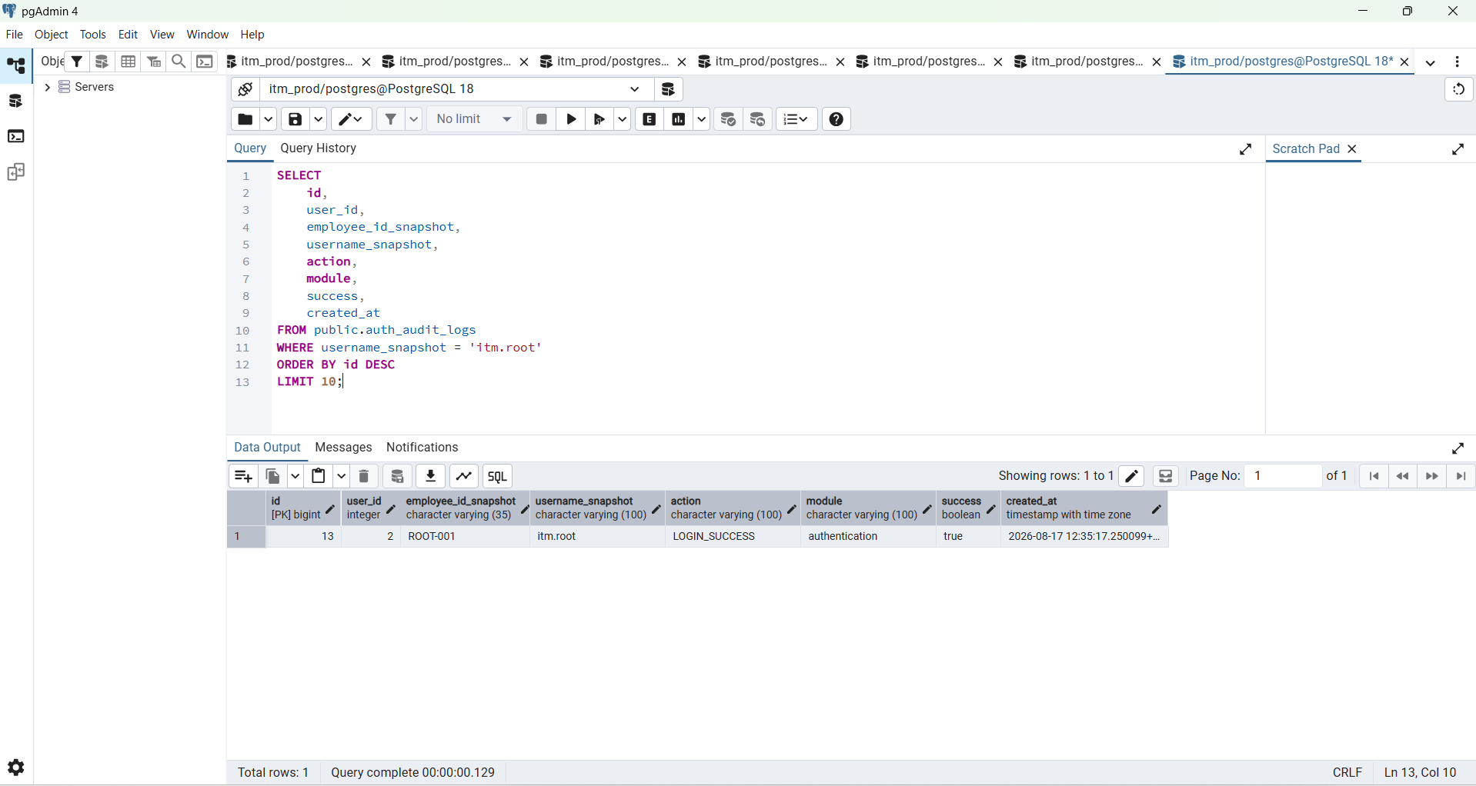

- IT Personnel
IT Personnel test account : f@hrt1@itm_itprs
Enter password: f@hrt1@itm_itprs
$2a$10$zVCr89B5mk0DEdQgBgjFjOrmb/NaNKYGPRS0v5900QtqQZhqfLhsK
PS D:\ITM-Data\itm\backend>

BEGIN;

INSERT INTO public.users (
employee_id,
username,
full_name,
email,
password_hash,
user_type,
active,
account_status,
must_change_password,
failed_login_attempts
)
VALUES (
'TEST-IT-001',
'test.itpersonnel',
'Test IT Personnel',
'test.itpersonnel@itm.local',
'$2a$10$zVCr89B5mk0DEdQgBgjFjOrmb/NaNKYGPRS0v5900QtqQZhqfLhsK',
2,
TRUE,
'active',
TRUE,
0
);

INSERT INTO public.auth_user_roles (
user_id,
role_id,
active
)
SELECT
u.id,
r.id,
TRUE
FROM public.users u
JOIN public.auth_roles r
ON r.code = 'IT_PERSONNEL'
WHERE u.username = 'test.itpersonnel';

COMMIT;

BEGIN;

INSERT INTO public.users (
employee_id,
username,
full_name,
email,
password_hash,
user_type,
active,
account_status,
must_change_password,
failed_login_attempts
)
VALUES (
'TEST-IT-001',
'test.itpersonnel',
'Test IT Personnel',
'test.itpersonnel@itm.local',
'$2a$10$zVCr89B5mk0DEdQgBgjFjOrmb/NaNKYGPRS0v5900QtqQZhqfLhsK',
2,
TRUE,
'active',
TRUE,
0
);

INSERT INTO public.auth_user_roles (
user_id,
role_id,
active
)
SELECT
u.id,
r.id,
TRUE
FROM public.users u
JOIN public.auth_roles r
ON r.code = 'IT_PERSONNEL'
WHERE u.username = 'test.itpersonnel';

COMMIT;

SELECT
u.id,
u.employee_id,
u.username,
u.user_type,
r.code AS role_code
FROM public.users u
JOIN public.auth_user_roles ur
ON ur.user_id = u.id
AND ur.active = TRUE
JOIN public.auth_roles r
ON r.id = ur.role_id
WHERE u.username = 'test.itpersonnel';

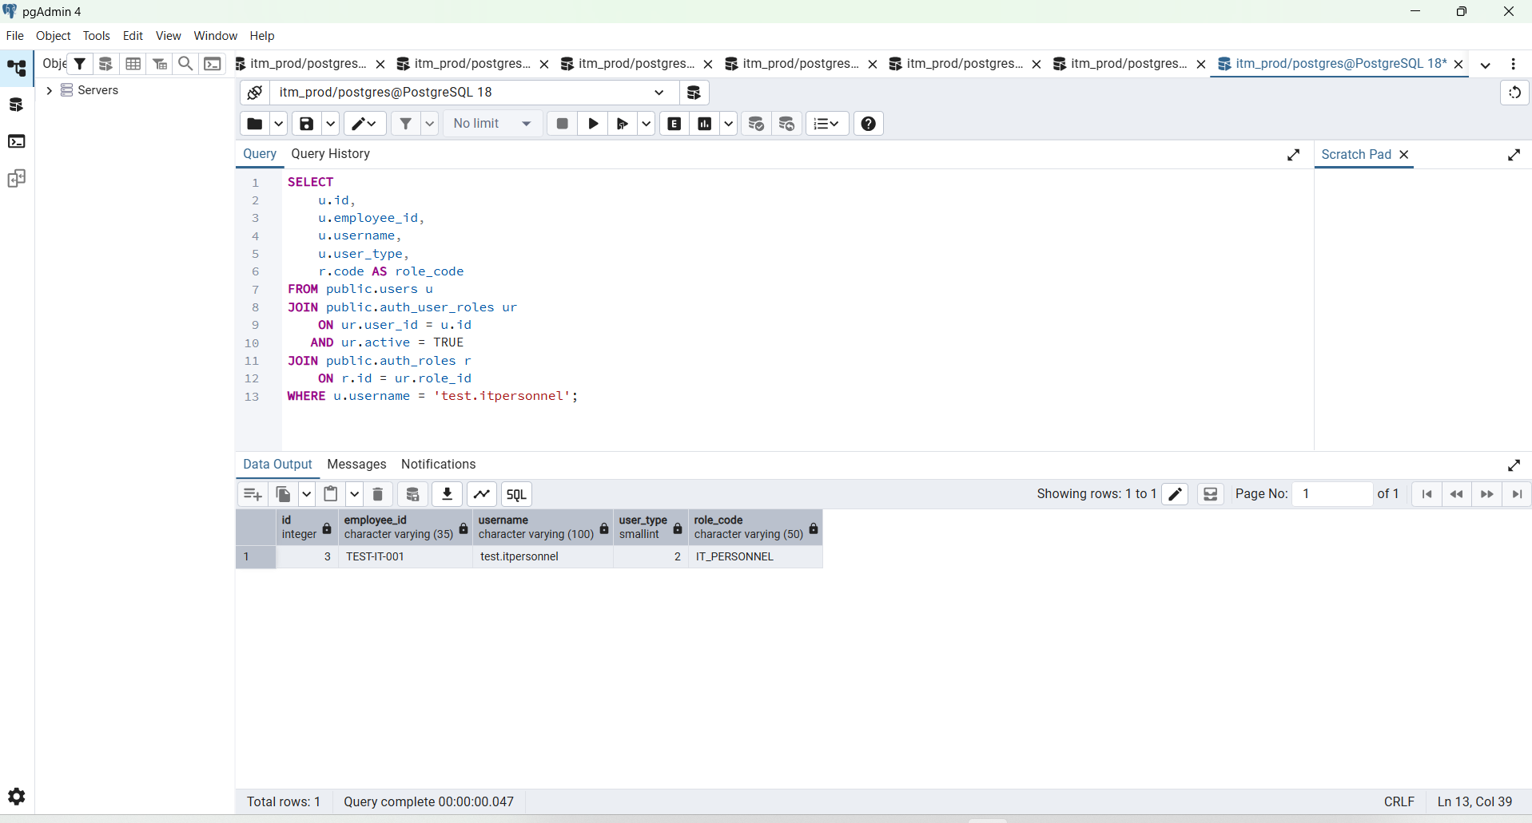

Expected:
employee_id TEST-IT-001
user_type 2
role_code IT_PERSONNEL

Step 2 — Create a General User test account
Generate another bcrypt hash:
go run ./cmd/hash_password

BEGIN;

INSERT INTO public.users (
employee_id,
username,
full_name,
email,
password_hash,
user_type,
active,
account_status,
must_change_password,
failed_login_attempts
)
VALUES (
'TEST-GEN-001',
'test.general',
'Test General User',
'test.general@itm.local',
'$2a$10$gZzjpUY5Kw0XHY9S3EXlweXeJydRk6Fl1NqTBgpABA52BTrXPqt7y',
3,
TRUE,
'active',
TRUE,
0
);

INSERT INTO public.auth_user_roles (
user_id,
role_id,
active
)
SELECT
u.id,
r.id,
TRUE
FROM public.users u
JOIN public.auth_roles r
ON r.code = 'GENERAL_USER'
WHERE u.username = 'test.general';

COMMIT;

SELECT
u.id,
u.employee_id,
u.username,
u.user_type,
r.code AS role_code
FROM public.users u
JOIN public.auth_user_roles ur
ON ur.user_id = u.id
AND ur.active = TRUE
JOIN public.auth_roles r
ON r.id = ur.role_id
WHERE u.username = 'test.general';

Expected:
employee_id TEST-GEN-001
user_type 3
role_code GENERAL_USER

SELECT
u.id,
u.employee_id,
u.username,
u.user_type,
u.account_status,
u.active,
r.code AS role_code,
r.name AS role_name
FROM public.users u
JOIN public.auth_user_roles ur
ON ur.user_id = u.id
AND ur.active = TRUE
JOIN public.auth_roles r
ON r.id = ur.role_id
WHERE u.username IN (
'itm.root',
'admin',
'test.itpersonnel',
'test.general'
)
ORDER BY u.user_type;

We want:
0 itm.root ROOT
1 admin IT_ADMIN
2 test.itpersonnel IT_PERSONNEL
3 test.general GENERAL_USER

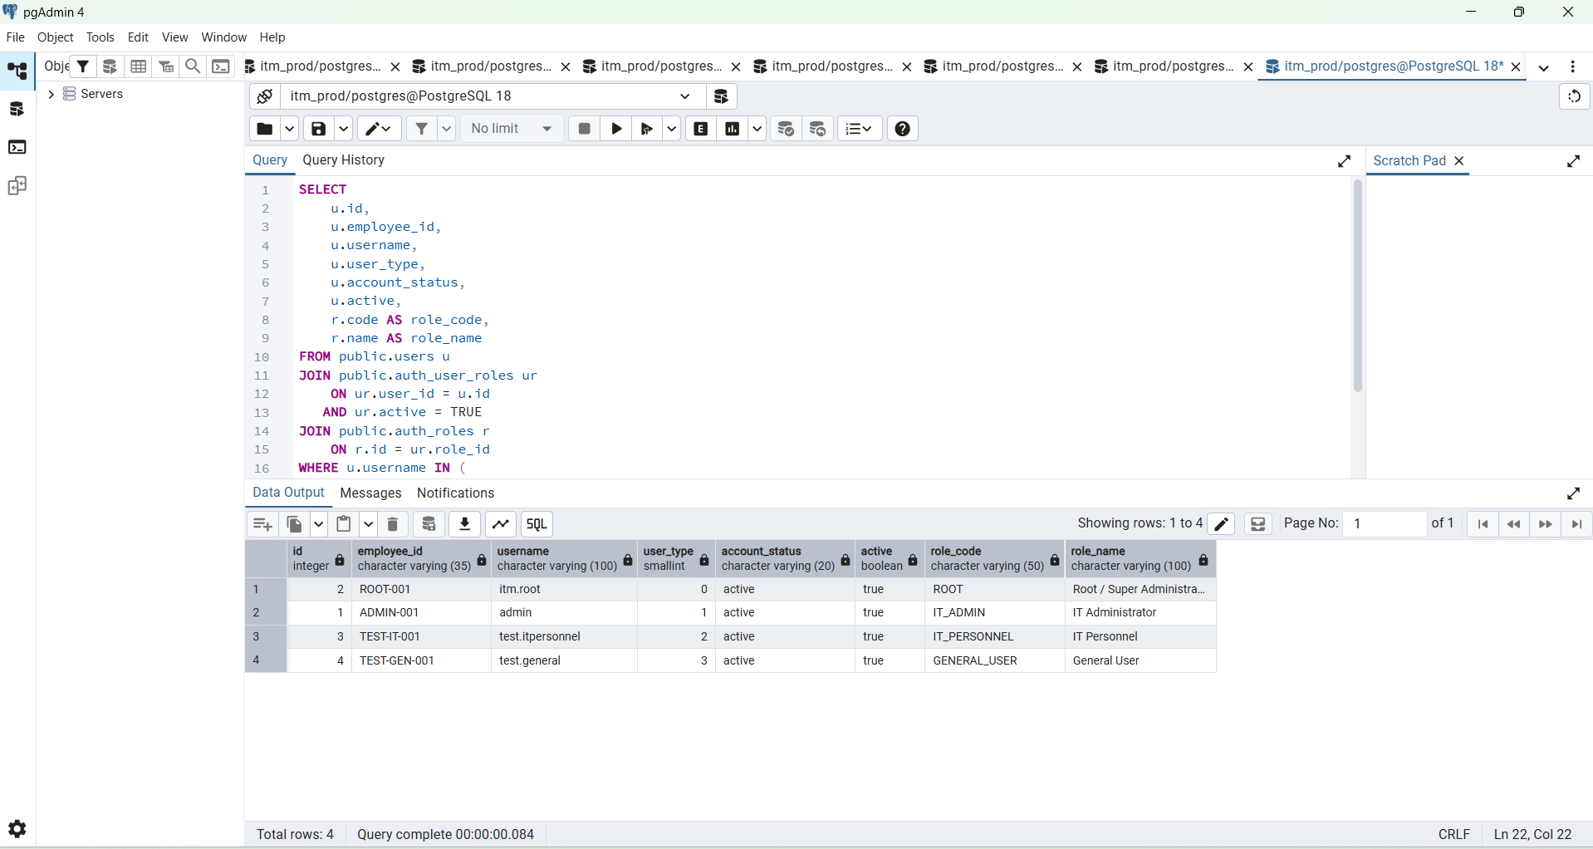

Step 5 — Login as General User
-----------------------------------------------------------------------------
$body = @{
username = " test.general"
password = $password
} | ConvertTo-Json

$itLogin = Invoke-RestMethod `
-Uri "$base/auth/login" `
-Method POST `
-ContentType "application/json" `
-Body $body
--------------------------------------------------------------
Then:
$itToken = $itLogin.data.token

$itMe = Invoke-RestMethod `
-Uri "$base/auth/me" `
-Method GET `
-Headers @{
Authorization = "Bearer $itToken"
}

$itMe | ConvertTo-Json -Depth 10

But before inserting them, I need to confirm:
1. DashboardHandler has h.db
2. exact Register() signature
3. whether middleware is already imported
Then we can make the change without guessing.
The final route behavior will become:
PATCH /requisitions/:id/approval
↓
JWT authentication
↓
requisition.approve permission
↓
UpdateRequisitionApproval
and:
PATCH /requisitions/:id/delivery
↓
JWT authentication
↓
requisition.deliver permission
↓
UpdateRequisitionDelivery
Result:
Role | Approval | Delivery
ROOT | ✅ | ✅
IT_ADMIN | ✅ | ✅
IT_PERSONNEL | ✅ | ✅
GENERAL_USER | ❌ 403 | ❌ 403
For now, do not edit handlers.go yet.
Run those three commands and send me the output. Then I’ll give you the exact complete updated DashboardHandler.Register() function and any required import change.

SELECT
column_name,
data_type,
character_maximum_length
FROM information_schema.columns
WHERE table_schema = 'public'
AND table_name = 'tt_reasons'
AND column_name IN (
'employee_id',
'created_by',
'approved_by',
'edited_by',
'delivered_by',
'dev_assinged_by'
)
ORDER BY column_name;\

SELECT
column_name,
data_type,
character_maximum_length
FROM information_schema.columns
WHERE table_schema = 'public'
AND table_name = 'tt_reasons'
AND column_name IN (
'employee_id',
'created_by',
'approved_by',
'edited_by',
'delivered_by',
'dev_assinged_by'
)
ORDER BY column_name;

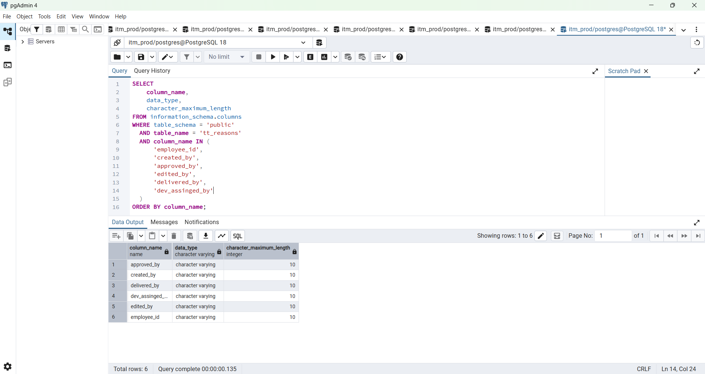

SELECT
column_name,
data_type,
character_maximum_length
FROM information_schema.columns
WHERE table_schema = 'public'
AND table_name = 'tt_reasons'
AND column_name IN (
'employee_id',
'created_by',
'approved_by',
'edited_by',
'delivered_by',
'dev_assinged_by'
)
ORDER BY column_name;
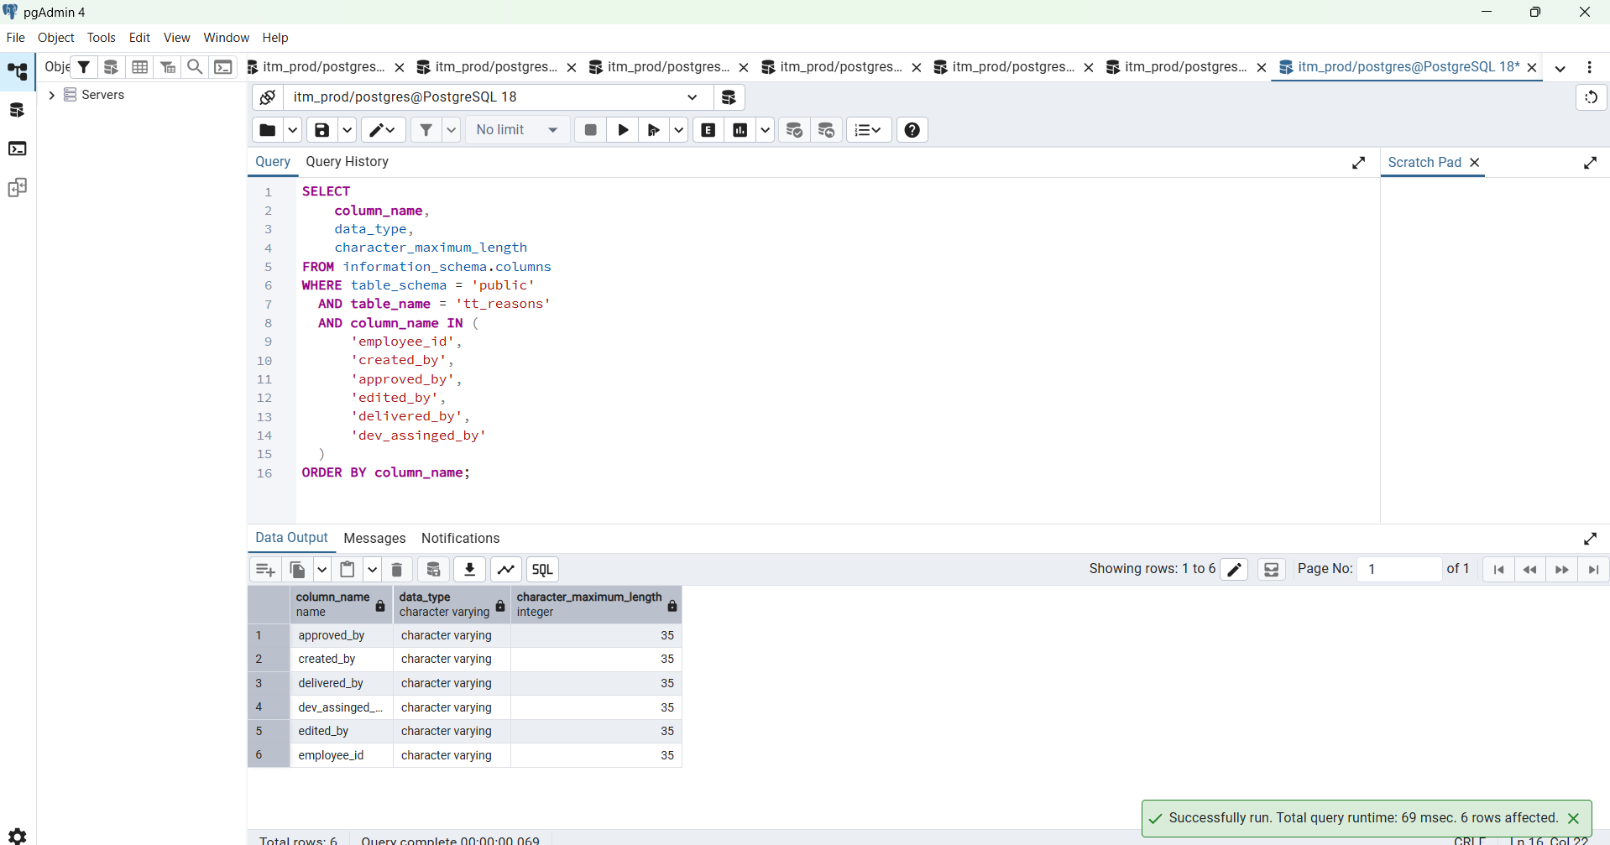

SELECT
id,
tt_no,
approved_val,
delivered_val
FROM public.tt_reasons
WHERE
COALESCE(status, 1) = 1
AND approved_val IN (1, 2, 3)
ORDER BY id DESC
LIMIT 1;

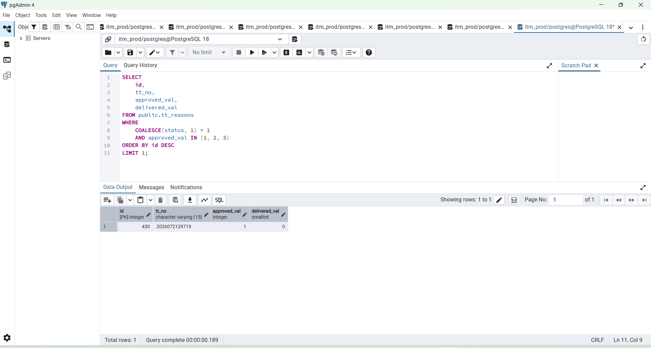

SELECT
id,
tt_no,
approved_val,
approved_by,
approved_date,
delivered_val,
delivered_by,
delivered_date
FROM public.tt_reasons
WHERE id = 430;

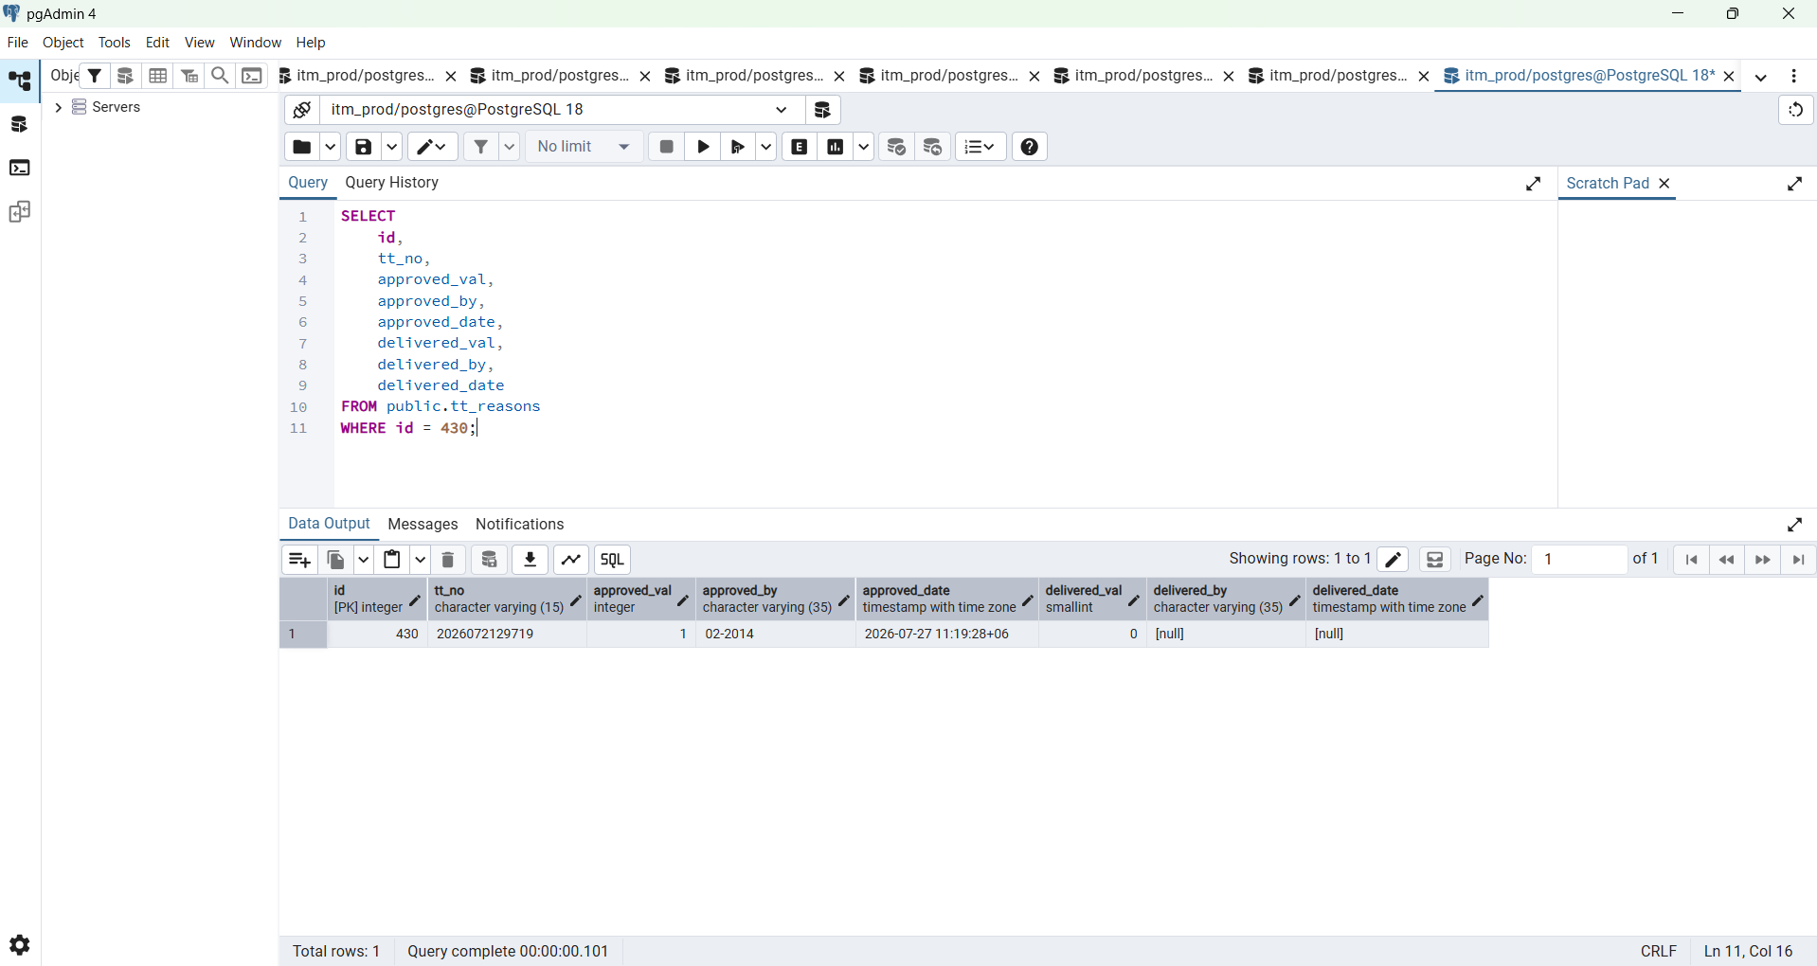

SELECT
id,
tt_no,
approved_val,
delivered_val
FROM public.tt_reasons
WHERE
COALESCE(status, 1) = 1
AND COALESCE(approved_val, 0) = 0
ORDER BY id DESC
LIMIT 1;

SELECT
id,
tt_no,
approved_val,
approved_by,
approved_date,
delivered_val,
delivered_by,
delivered_date
FROM public.tt_reasons
WHERE id = 386;

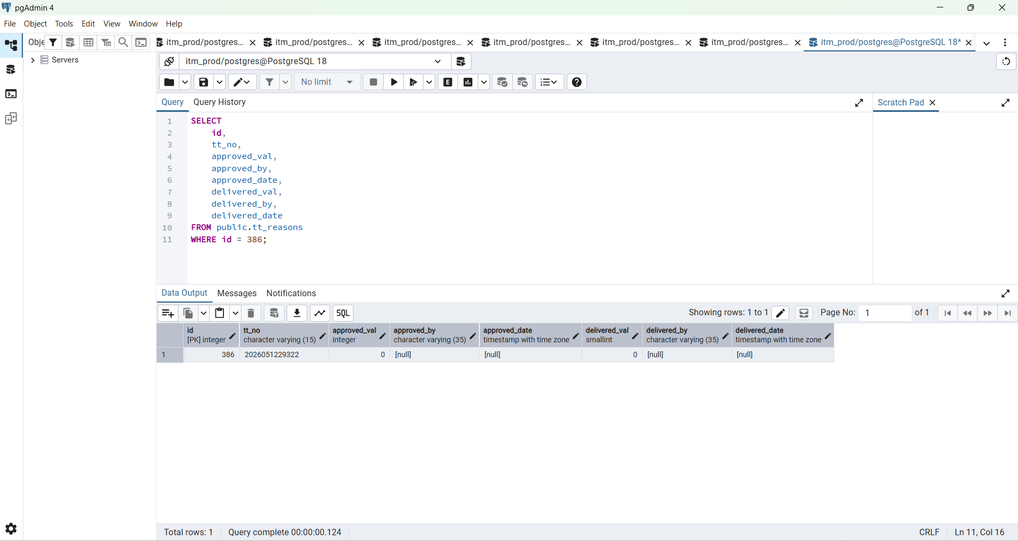

SELECT
id,
tt_no,
approved_val,
approved_by,
approved_date,
delivered_val,
delivered_by,
delivered_date
FROM public.tt_reasons
WHERE id = 430;

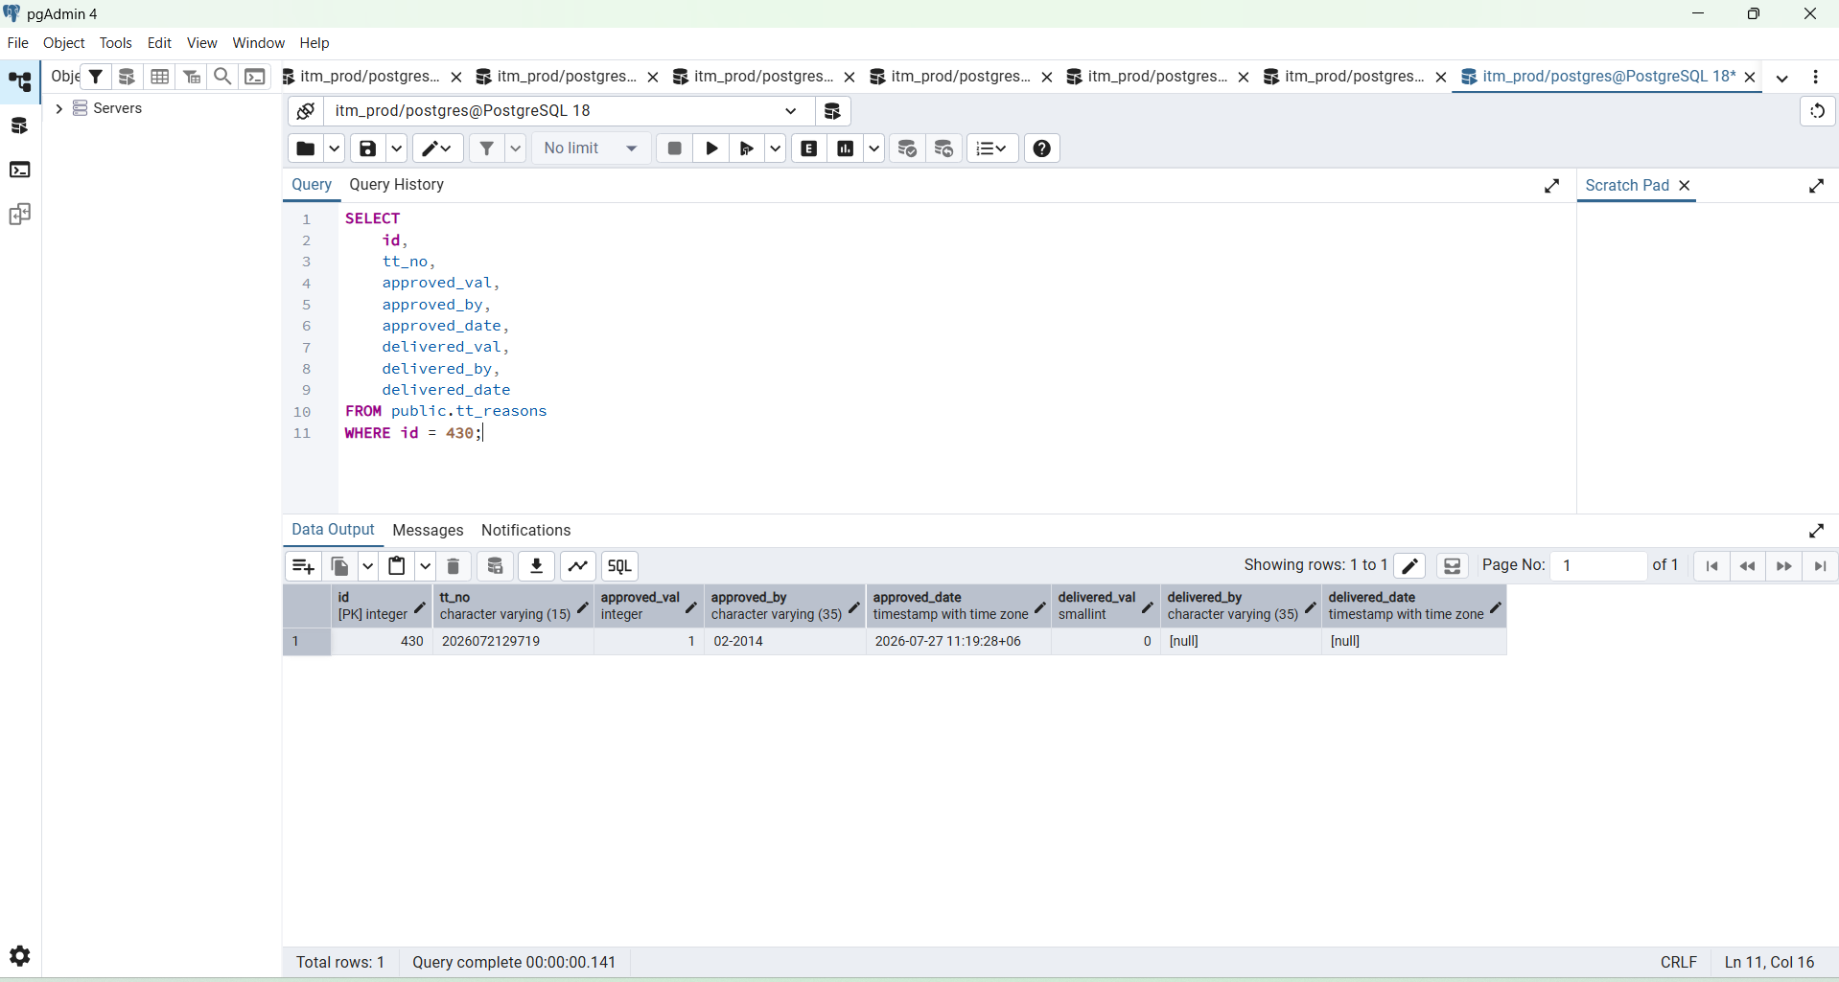

SELECT
column_name,
data_type,
is_nullable,
column_default
FROM information_schema.columns
WHERE table_schema = 'public'
AND table_name = 'tt_reasons'
ORDER BY ordinal_position;

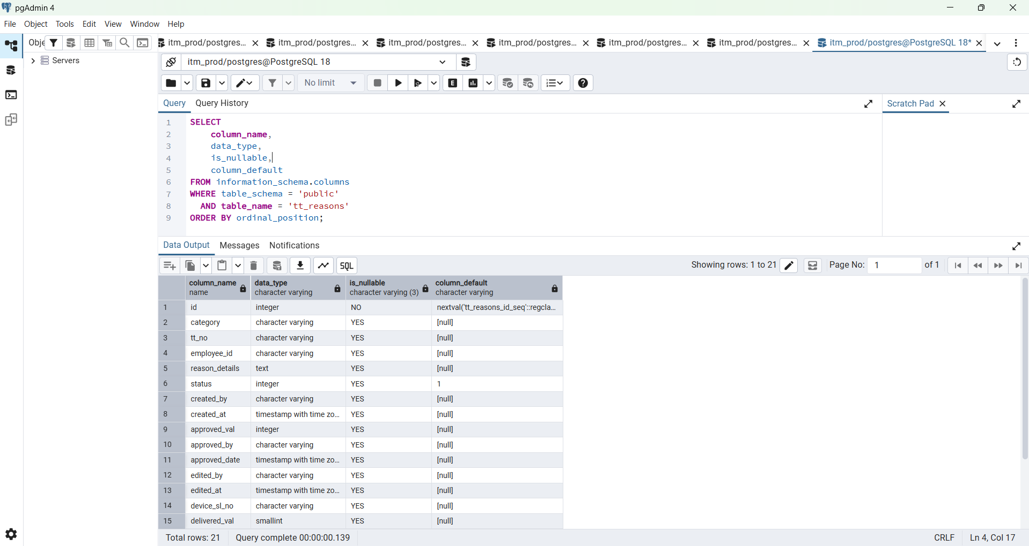

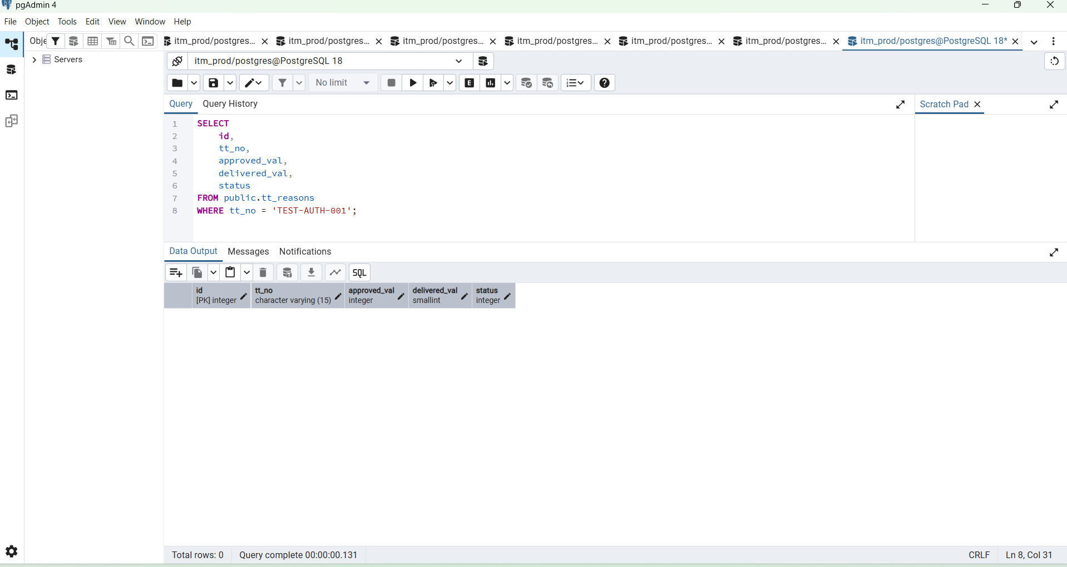

INSERT INTO public.tt_reasons (
tt_no,
category,
employee_id,
reason_details,
status,
created_by,
created_at,
approved_val,
delivered_val
)
VALUES (
'TEST-AUTH-001',
'AUTH TEST',
'TEST-IT-001',
'Authentication approval and delivery workflow test',
1,
'TEST-IT-001',
CURRENT_TIMESTAMP AT TIME ZONE 'Asia/Dhaka',
0,
0
)
RETURNING
id,
tt_no,
category,
employee_id,
approved_val,
delivered_val,
status;

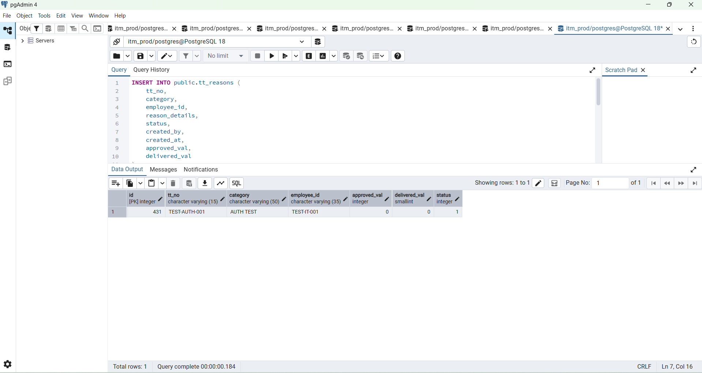

PS D:\ITM-Data\itm\backend>
PS D:\ITM-Data\itm\backend> $approval | ConvertTo-Json -Depth 10
{
"data": {
"id": 431,
"approved_val": 1,
"approval_status": "Petty Cash (Approved)",
"approved_by": "TEST-IT-001",
"approved_date": "2026-08-17 18:40:20.728665+06"
},
"success": true
}
PS D:\ITM-Data\itm\backend>

We will expect:
approved_val = 1
approval_status = Petty Cash (Approved)
approved_by = TEST-IT-001
approved_date = populated

PS D:\ITM-Data\itm\backend>
PS D:\ITM-Data\itm\backend> $testID = 431
PS D:\ITM-Data\itm\backend> $approval = Invoke-RestMethod `
>> -Uri "$base/dashboard/requisitions/$testID/approval" `
>> -Method PATCH `
>> -Headers @{
>> Authorization = "Bearer $itToken"
>> } `
>> -ContentType "application/json" `
>> -Body '{"approved_val":1}'
PS D:\ITM-Data\itm\backend>
PS D:\ITM-Data\itm\backend> $approval | ConvertTo-Json -Depth 10
{
"data": {
"id": 431,
"approved_val": 1,
"approval_status": "Petty Cash (Approved)",
"approved_by": "TEST-IT-001",
"approved_date": "2026-08-17 18:40:20.728665+06"
},
"success": true
}
PS D:\ITM-Data\itm\backend>

Tomorrow start from here

Perfect — the real Approval test passed successfully. ✅
Your backend correctly recorded:
Requisition ID : 431
Approval : Petty Cash (Approved)
approved_by : TEST-IT-001
approved_date : 2026-08-17 18:40:20.728665+06

