Date : 18 August 2026
https://chatgpt.com/g/g-p-6a5378cdfc588191b929a3b5ca9c1c9a/c/6a6aea6e-6794-83e8-a9d3-22852803845a

SELECT
id,
tt_no,

approved_val,
approved_by,
approved_date,

delivered_val,
delivered_by,
delivered_date,

edited_by,
edited_at
FROM public.tt_reasons
WHERE id = 430;

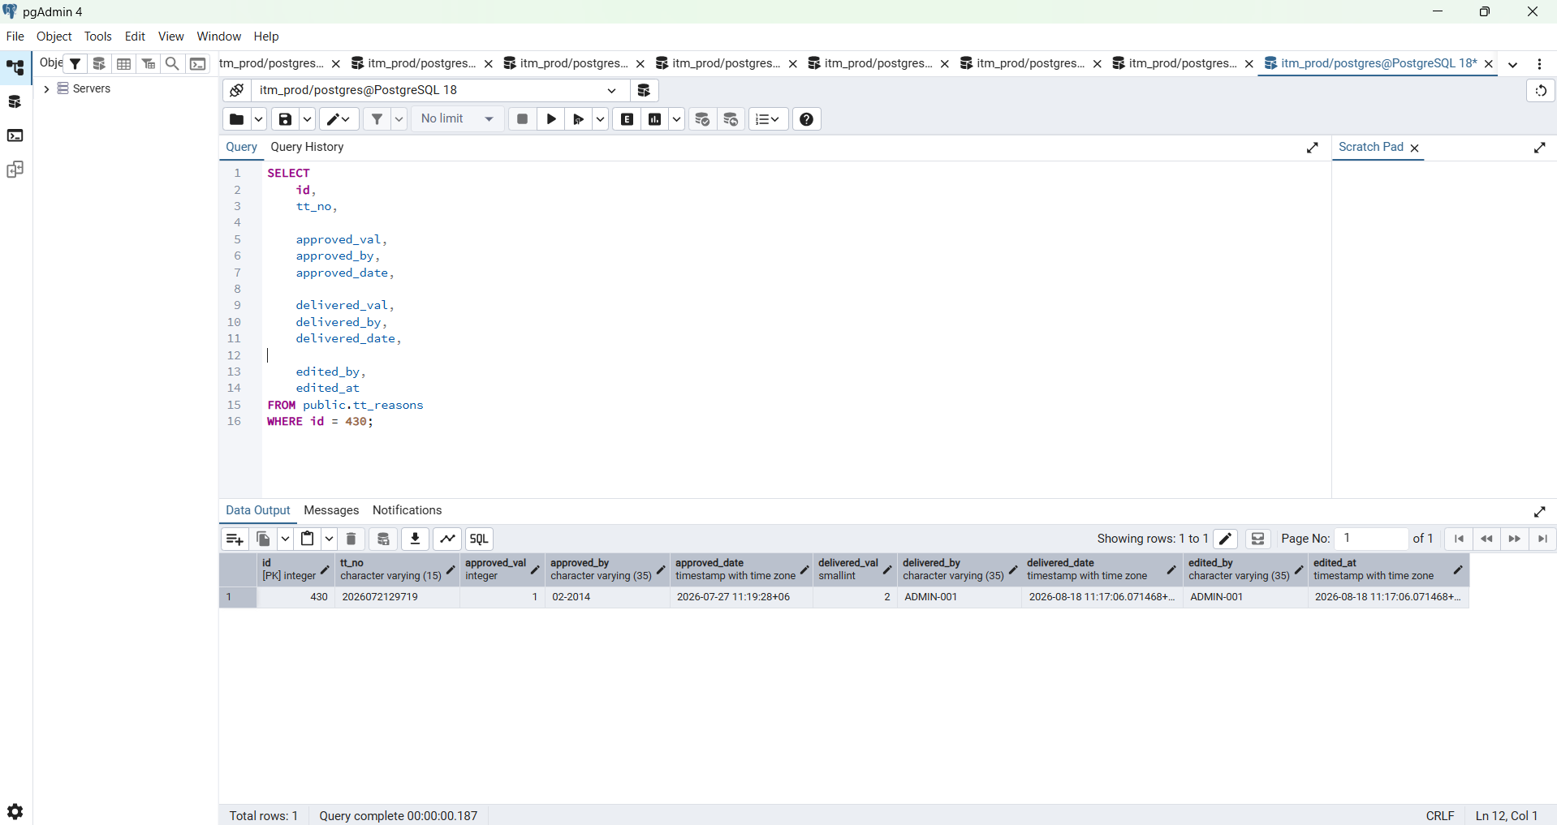

SELECT
id,
user_id,
employee_id_snapshot,
username_snapshot,
action,
module,
entity_type,
entity_id,
success,
metadata,
ip_address,
created_at
FROM public.auth_audit_logs
WHERE
entity_type = 'tt_reason'
AND entity_id = '430'
ORDER BY id DESC;

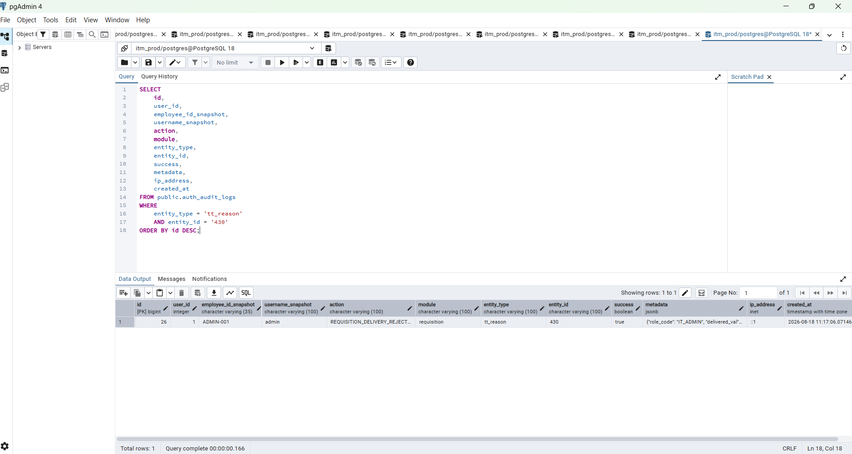

SELECT
u.id,
u.employee_id,
u.username,
u.user_type,
u.active,
u.account_status,
r.code AS role_code,
r.name AS role_name
FROM public.users AS u

LEFT JOIN public.auth_user_roles AS ur
ON ur.user_id = u.id
AND ur.active = TRUE

LEFT JOIN public.auth_roles AS r
ON r.id = ur.role_id

WHERE u.deleted_at IS NULL
ORDER BY
u.user_type,
u.id;

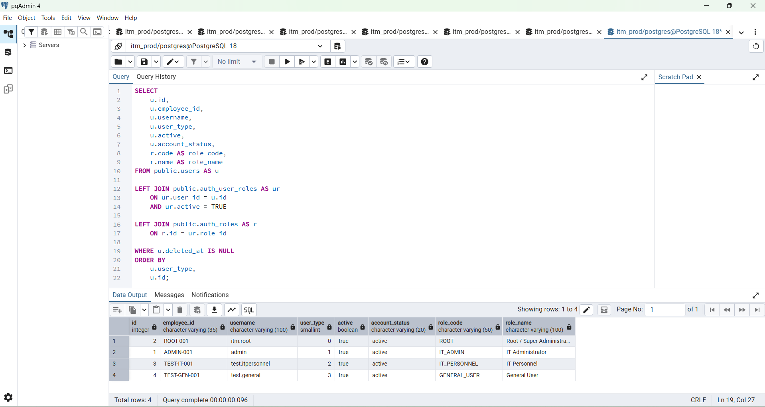

Step 1 — first verify all current login accounts
Run this in pgAdmin:
SELECT
u.id,
u.employee_id,
u.username,
u.user_type,
u.active,
u.account_status,
r.code AS role_code,
r.name AS role_name
FROM public.users AS u

LEFT JOIN public.auth_user_roles AS ur
ON ur.user_id = u.id
AND ur.active = TRUE

LEFT JOIN public.auth_roles AS r
ON r.id = ur.role_id

WHERE u.deleted_at IS NULL
ORDER BY
u.user_type,
u.id;
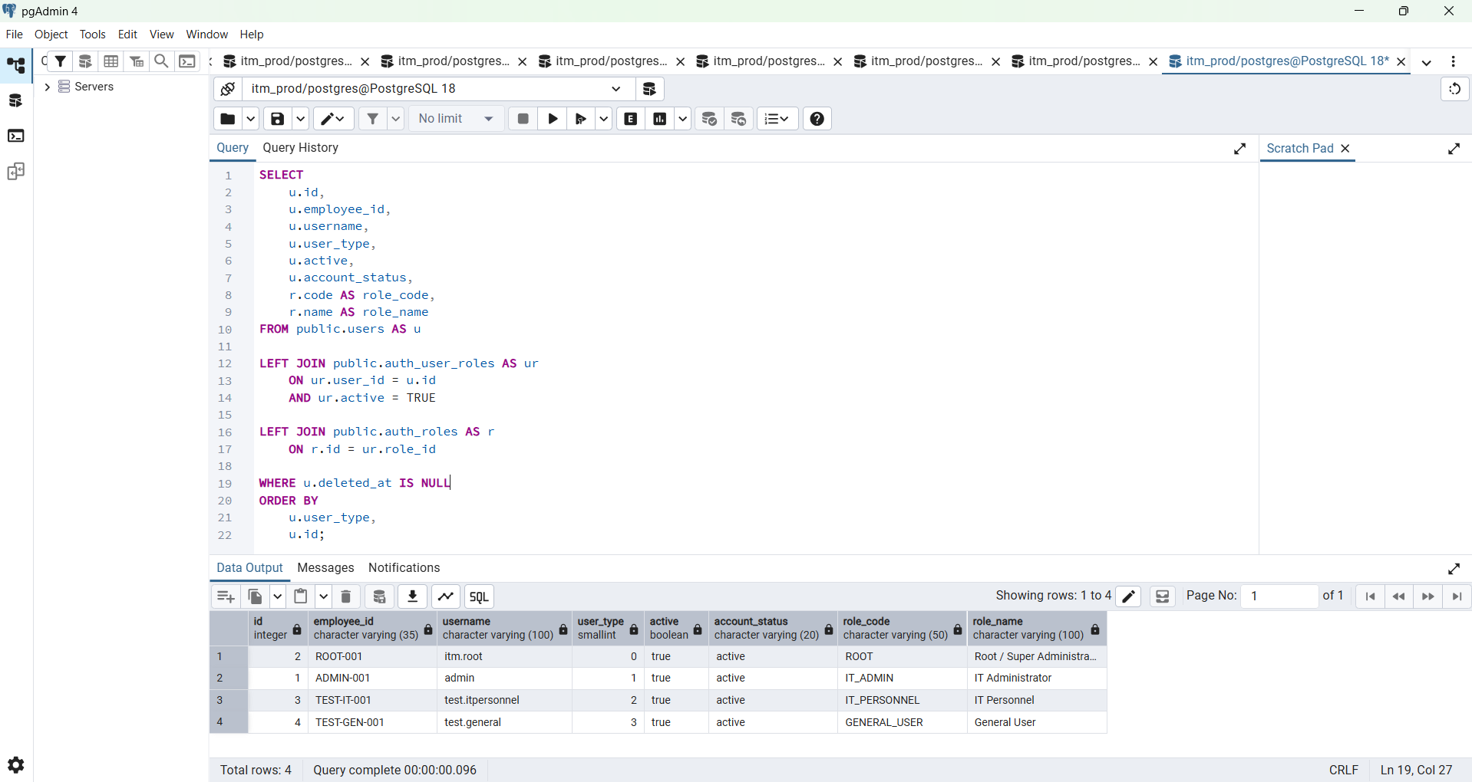

The target UI behavior is:
Role | Admin Panel | User Panel | Approve | Deliver
ROOT | ✅ | ✅ | ✅ | ✅
IT_ADMIN | ✅ | ✅ | ✅ | ✅
IT_PERSONNEL | ❌ | ✅ | ✅ | ✅
GENERAL_USER | ❌ | ✅ | ❌ | ❌
The frontend should use the permissions returned by:

Perfect — your authentication database is now in the correct state. You have all four role levels active and correctly mapped:
0 ROOT-001 itm.root ROOT
1 ADMIN-001 admin IT_ADMIN
2 TEST-IT-001 test.itpersonnel IT_PERSONNEL
3 TEST-GEN-001 test.general GENERAL_USER
The backend permission/workflow testing is complete enough to move forward.
Next phase: Frontend permission integration
Do not delete or disable any of these four accounts yet. We need them for frontend testing.
The target UI behavior is:
Role | Admin Panel | User Panel | Approve | Deliver
ROOT | ✅ | ✅ | ✅ | ✅
IT_ADMIN | ✅ | ✅ | ✅ | ✅
IT_PERSONNEL | ❌ | ✅ | ✅ | ✅
GENERAL_USER | ❌ | ✅ | ❌ | ❌
The frontend should use the permissions returned by:
GET /api/v1/auth/me
rather than hard-coded user_type checks.
Step 1 — Locate the frontend authentication files
From project root:
cd D:\ITM-Data\itm
First confirm api.ts:
Get-Item ".\frontend\lib\api.ts"
Then find where token/user/login information is currently handled:
Get-ChildItem `
".\frontend" `
-Recurse `
-Include *.tsx,*.ts |
Select-String `
-Pattern 'itm_token|itm_user|user_type|auth/login'
Step 2 — Find your sidebar/navigation
Run:
Get-ChildItem `
".\frontend" `
-Recurse `
-Include *.tsx,*.ts |
Select-String `
-Pattern 'Admin Panel|User Panel|Sidebar|sidebar|navigation|navItems'
Step 3 — Find the Requisition page
Run:
Get-ChildItem `
".\frontend" `
-Recurse `
-Include *.tsx,*.ts |
Select-String `
-Pattern 'updateRequisitionApproval|updateRequisitionDelivery|approved_val|delivered_val'
This should identify your requisition page and API functions.
Step 4 — Send me these files
Please send the current:
frontend/lib/api.ts
plus whichever files the searches identify for:
Sidebar / navigation
Auth state / login handling
Requisition page
Most likely they will be something like:
frontend/components/app-sidebar.tsx
frontend/app/dashboard/layout.tsx
frontend/app/login/page.tsx
frontend/app/dashboard/requisitions/page.tsx
but use your actual paths.
What we'll implement next
We will do it safely in this order:
1. Add /auth/me to frontend/lib/api.ts
2. Add AuthMe + permission TypeScript types
3. Load /auth/me after login
4. Restore /auth/me when page refreshes
5. Create hasPermission()
6. ROOT / IT_ADMIN → Admin Panel visible
7. IT_PERSONNEL / GENERAL_USER → Admin Panel hidden
8. Approval dropdown → requisition.approve
9. Delivery dropdown → requisition.deliver
10. Handle backend 403 cleanly
11. Test all four accounts
One important rule stays permanent:
Frontend permission check = UI convenience
Backend RequirePermission = actual security
So even if somebody manipulates the browser and displays an Approval button, GENERAL_USER will still receive the 403 you already verified.
Run the three PowerShell searches above and send me the results/files. Then we'll start with the complete updated frontend/lib/api.ts first.

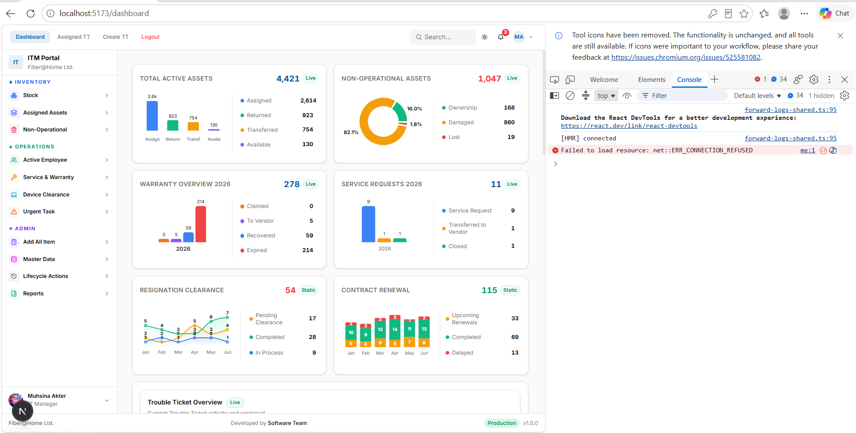

Good — this stage is now working properly. Your current frontend has the important foundation in place:
- login saves the JWT and then loads /auth/me with the full permission profile;
- dashboard refresh validates the session through /auth/me;
- logout clears itm_token and itm_user before going to /auth, which is why it is smooth now;
- api.ts already has hasPermission(), canAccessAdminPanel(), canApproveRequisition(), and canDeliverRequisition().
The Gin 200 responses you posted also look normal.
Next step — make the Sidebar permission-aware
This is the correct next stage.
Target behavior:
Role | Inventory / Operations | Admin section
ROOT | ✅ | ✅
IT_ADMIN | ✅ | ✅
IT_PERSONNEL | ✅ | ❌
GENERAL_USER | ✅ | ❌
The decision should be based on:
panel.user.access
panel.admin.access
not on:
user_type === 1
Step 1 — Verify the logged-in permission profile once
After logging in, open browser DevTools → Console and run:
JSON.parse(
localStorage.getItem("itm_user")
)
For test.itpersonnel, it should contain:
role_code: IT_PERSONNEL

permissions:
panel.user.access
requisition.view
requisition.approve
requisition.deliver
For test.general:
role_code: GENERAL_USER

permissions:
panel.user.access
requisition.view
If this is already correct, continue.

Step 2 — Back up the current Sidebar
Run:
cd D:\ITM-Data\itm

Copy-Item `
".\frontend\components\ui\sidebar.tsx" `
".\frontend\components\ui\sidebar.tsx.before-permission-filter"
Your current sidebar clearly has an Admin group containing items such as Add All Item, Master Data, Lifecycle Actions, and Reports.

Step 3 — Send me the current Sidebar file
Run:
Get-Content `
".\frontend\components\ui\sidebar.tsx"
Paste/upload the complete result.
I don't want to give you a replacement based on the older June copy because your current sidebar is much larger and may have changed.
Once you send the current file, I will give you the complete updated frontend/components/ui/sidebar.tsx, not partial snippets.
We will implement it so it reads:
const currentUser = getUser();
as properly typed AuthMeData, then:
const canUseUserPanel =
canAccessUserPanel(currentUser);

const canUseAdminPanel =
canAccessAdminPanel(currentUser);
and filter menu groups professionally.
Conceptually:
const visibleMenuGroups =
menuGroups.filter((group) => {
if (group.label === "Admin") {
return canUseAdminPanel;
}

return canUseUserPanel;
});
So:
ROOT
├─ INVENTORY ✅
├─ OPERATIONS ✅
└─ ADMIN ✅

IT_ADMIN
├─ INVENTORY ✅
├─ OPERATIONS ✅
└─ ADMIN ✅

IT_PERSONNEL
├─ INVENTORY ✅
├─ OPERATIONS ✅
└─ ADMIN hidden

GENERAL_USER
├─ INVENTORY ✅
├─ OPERATIONS ✅
└─ ADMIN hidden
One additional improvement we should make there
The current sidebar appears to contain hard-coded user information at the bottom. We'll replace that with the authenticated /auth/me information too:
full_name
employee_id
role_name
So instead of a fixed user such as:
Muhsina Akter
Manager
the sidebar will automatically display the actual logged-in account.
After Sidebar permission testing, the next file will be:
frontend/app/dashboard/requisitions/page.tsx
where we'll hide Approval/Delivery controls according to:
requisition.approve
requisition.deliver
while keeping the backend 403 checks permanently.
So now send the complete current:
frontend/components/ui/sidebar.tsx
and I'll give you the safe full replacement.

