Date : 16-08-2026

https://chatgpt.com/g/g-p-6a5378cdfc588191b929a3b5ca9c1c9a/c/6a6aea6e-6794-83e8-a9d3-22852803845a

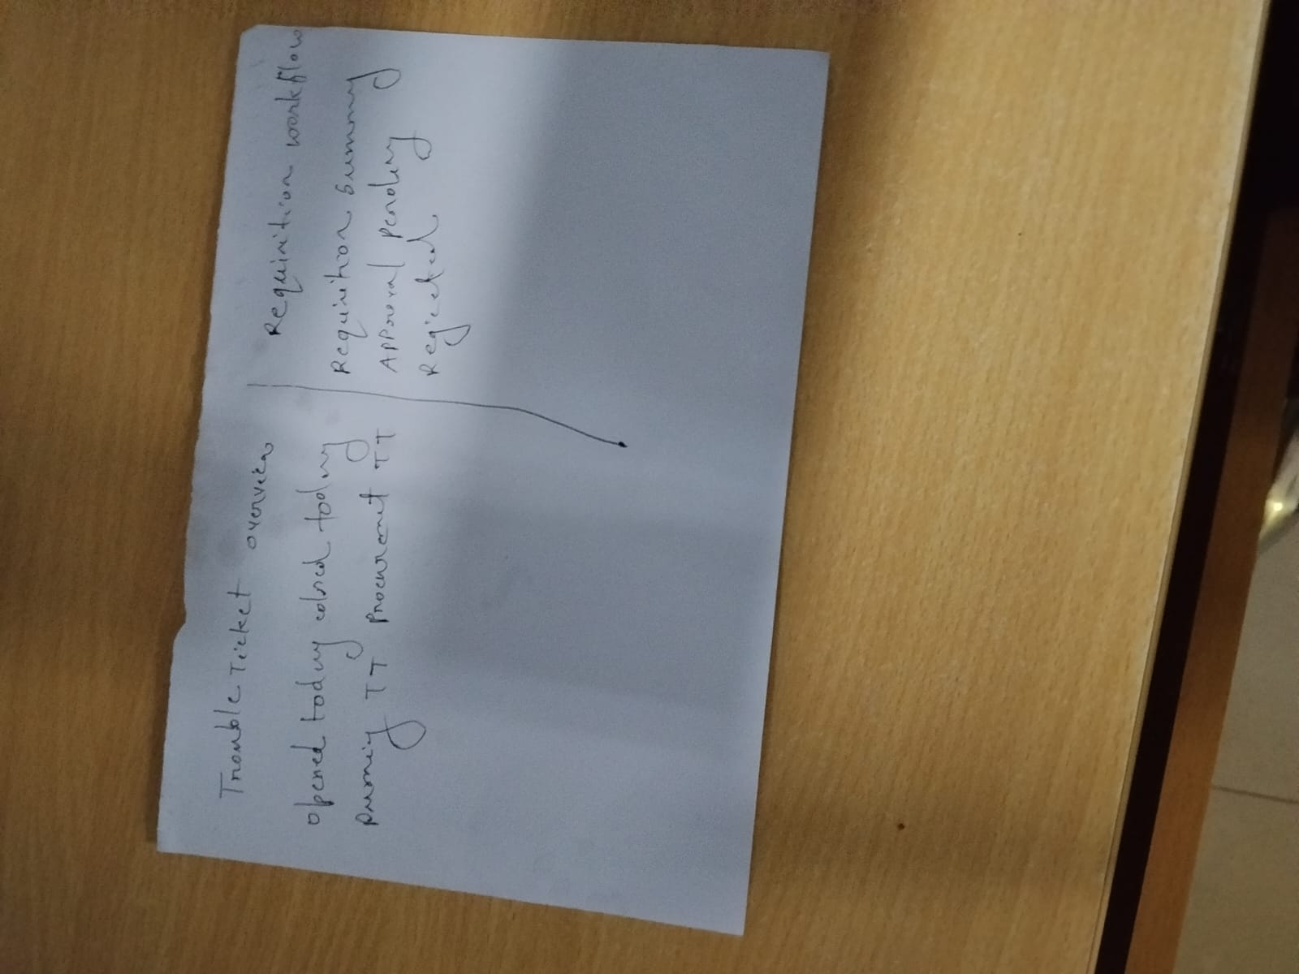

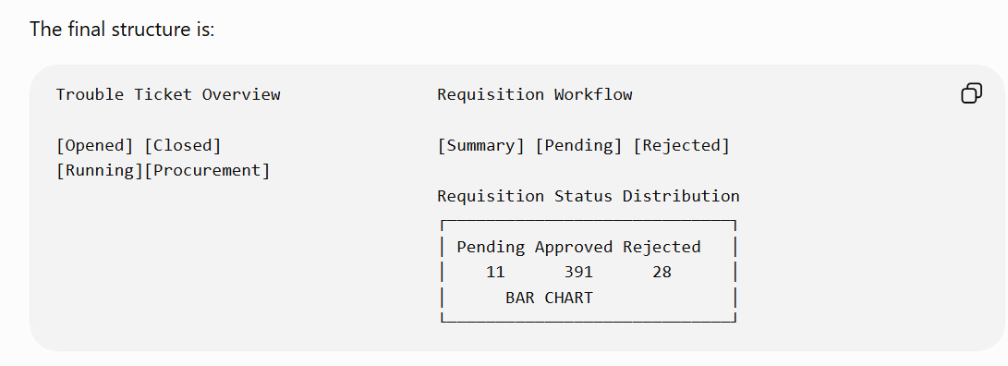

Your handler package already imports pgx, strconv, strings, Gin, and the response package, so these workflow handlers fit the existing file structure.

Yes — before we continue with Approval/Delivery, we should make the logged-in employee ID authoritative. That is the right foundation.
I inspected your uploaded tbl_user_info Excel. It contains the important mapping fields:
id
user_name
employee_id
user_type
full_name
status
active
...
For the account shown in your UI, the sheet maps Muhsina Akter → employee_id 02-0501. We should use that employee ID automatically when approval/delivery is performed. We should never send approved_by from the dropdown/frontend, because a user could modify it manually.
Your frontend API also already expects employee_id in the login response and sends the JWT token with every API request.
The correct flow is:
Login
↓
tbl_user_info
↓
get employee_id
↓
JWT contains employee_id
↓
Auth middleware reads JWT
↓
c.Set("employee_id", employee_id)
↓
Approval PATCH
↓
approved_by = logged-in employee_id
approved_date = current time
↓
Delivery PATCH
↓
delivered_by = logged-in employee_id
delivered_date = current time
Step 1 — First verify the logged-in user in the browser
Don't change Approval code yet.
Login normally, then open Chrome:
F12
→ Console
Run:
JSON.parse(localStorage.getItem("itm_user"))
You should get something similar to:
{
user_id: 776,
employee_id: "02-0501",
username: "muhsina.akter",
full_name: "Muhsina Akter",
user_type: 1
}
Your current frontend already has:
export function getUser(): Record<string, any> | null {
if (typeof window === "undefined") return null;

try {
return JSON.parse(
localStorage.getItem("itm_user") ?? "null"
);
} catch {
return null;
}
}
and your login API type already contains:
employee_id: string;
so that part of the architecture is already prepared.
Do this test first.
If Console shows:
employee_id: "02-0501"
then Step 1 is complete.

Step 2 — Verify the backend login source
The backend Login query must return the employee ID from your user table.
Assuming your imported PostgreSQL table is:
public.tbl_user_info
run:
SELECT
id,
user_name,
employee_id,
user_type,
full_name,
status,
active
FROM public.tbl_user_info
WHERE user_name = 'muhsina.akter';
Expected structure:
id 776
user_name muhsina.akter
employee_id 02-0501
user_type 1
full_name Muhsina Akter
status 1
active Yes
This matches the row in the Excel you uploaded.
We don't need the Excel during runtime. It is only useful for confirming the legacy user mapping.

Step 3 — Login response must include employee_id
In your backend Login handler, the logged-in user struct should contain at least:
type LoginUser struct {
ID int64
Username string
EmployeeID string
FullName string
UserType int
}
Your login SQL should retrieve:
SELECT
id,
user_name,
employee_id,
full_name,
user_type
FROM public.tbl_user_info
WHERE user_name = $1
After authentication, response data should include:
response.OK(c, gin.H{
"token": token,
"expires_in": expiresIn,
"user_id": user.ID,
"employee_id": user.EmployeeID,
"username": user.Username,
"full_name": user.FullName,
"user_type": user.UserType,
})
This is consistent with what your frontend authApi.login() already expects.

Step 4 — Most important: put employee ID inside JWT
Do not depend only on:
localStorage itm_user
for Approval.
LocalStorage is useful for UI display, but it must not decide who approved something.
Your JWT should contain:
type Claims struct {
UserID int64 `json:"user_id"`
EmployeeID string `json:"employee_id"`
Username string `json:"username"`
UserType int `json:"user_type"`

jwt.RegisteredClaims
}
When generating the token:
claims := Claims{
UserID: user.ID,
EmployeeID: user.EmployeeID,
Username: user.Username,
UserType: user.UserType,

RegisteredClaims: jwt.RegisteredClaims{
ExpiresAt: jwt.NewNumericDate(
time.Now().Add(
24 * time.Hour,
),
),
},
}
This is the key security piece.

Step 5 — Auth middleware must put employee ID into Gin Context
After JWT validation, your middleware should do:
c.Set(
"user_id",
claims.UserID,
)

c.Set(
"employee_id",
claims.EmployeeID,
)

c.Set(
"username",
claims.Username,
)

c.Set(
"user_type",
claims.UserType,
)

c.Next()
Then any protected handler can safely use:
employeeID :=
strings.TrimSpace(
c.GetString(
"employee_id",
),
)
That's what we want for Approval.

Step 6 — Add a temporary debug endpoint before Approval
Before changing any requisition, I strongly recommend verifying the context.
Inside DashboardHandler.Register() temporarily add:
g.GET(
"/current-user",
h.CurrentUser,
)
Then add:
func (
h *DashboardHandler,
) CurrentUser(
c *gin.Context,
) {
response.OK(
c,
gin.H{
"user_id":
c.GetString(
"user_id",
),

"employee_id":
c.GetString(
"employee_id",
),

"username":
c.GetString(
"username",
),
},
)
}
Depending on how user_id is currently stored in your middleware, it might be an integer rather than a string, so we can adjust that once we see your current middleware.
Then restart the backend and call:
GET http://127.0.0.1:8080/api/v1/dashboard/current-user
using the logged-in Bearer token.
We want:
{
"success": true,
"data": {
"employee_id": "02-0501",
"username": "muhsina.akter"
}
}
Do not move to Approval until this works.

Step 7 — Approval will then use only that employee ID
After Step 6 succeeds, your approval handler becomes safe:
employeeID :=
strings.TrimSpace(
c.GetString(
"employee_id",
),
)

if employeeID == "" {
response.BadRequest(
c,
"logged-in employee ID not found",
)

return
}
Then:
UPDATE public.tt_reasons

SET
approved_val = $1,
approved_by = $2,
approved_date =
CURRENT_TIMESTAMP
AT TIME ZONE 'Asia/Dhaka'

WHERE id = $3
Arguments:
req.ApprovedVal,
employeeID,
requisitionID,
So if Muhsina is logged in and chooses:
Petty Cash (Approved)
the database automatically becomes:
approved_val 1
approved_by 02-0501
approved_date 2026-08-16 ...
The frontend does not send 02-0501.

Step 8 — Delivery uses exactly the same logged-in identity
Later, when the approved requisition is delivered:
UPDATE public.tt_reasons

SET
delivered_val = $1,
delivered_by = $2,
delivered_date =
CURRENT_TIMESTAMP
AT TIME ZONE 'Asia/Dhaka'

WHERE id = $3
Again:
employeeID :=
c.GetString(
"employee_id",
)
Therefore the person who delivers may be different from the person who approved:
Approved By
02-0501
Muhsina Akter

Delivered By
02-2014
Nur Hosen
That is exactly what you want for proper audit history.

Do this now — only Step 1
For now, don't modify the approval handler yet.
Open browser Console and run:
JSON.parse(localStorage.getItem("itm_user"))
Also run:
localStorage.getItem("itm_token")
Don't send me the full token. Just tell me whether itm_user shows:
employee_id
username
full_name
user_type
and paste that itm_user object with any sensitive information removed if necessary.
Once we confirm employee_id is already present there, the next step will be the backend JWT + middleware, and I'll give you the exact full file/function changes for that step.

currently I am using this user name and password for system login

this is my auth.go page
now I am using username: admin and password is Admin@1234
// backend/internal/handler/auth.go
package handler
import (
"context"
"log"
"net/http"
"time"
"itm-api/internal/config"
"itm-api/internal/middleware"
"itm-api/pkg/response"
"github.com/gin-gonic/gin"
"github.com/golang-jwt/jwt/v5"
"github.com/jackc/pgx/v5/pgxpool"
"golang.org/x/crypto/bcrypt"
)
type AuthHandler struct {
db *pgxpool.Pool
cfg *config.Config
}
func NewAuthHandler(db *pgxpool.Pool, cfg *config.Config) *AuthHandler {
return &AuthHandler{db: db, cfg: cfg}
}
func (h *AuthHandler) Login(c *gin.Context) {
var req struct {
Username string `json:"username" binding:"required"`
Password string `json:"password" binding:"required"`
}
if err := c.ShouldBindJSON(&req); err != nil {
log.Println("LOGIN DEBUG bind error:", err)
response.BadRequest(c, "username and password required")
return
}
ctx, cancel := context.WithTimeout(c.Request.Context(), 5*time.Second)
defer cancel()
var id int
var empID, username, fullName, hash string
var userType int
var active bool
err := h.db.QueryRow(ctx,
`SELECT id, employee_id, username, full_name, password_hash, user_type, active
FROM users
WHERE LOWER(username) = LOWER($1) OR LOWER(email) = LOWER($1)
LIMIT 1`, req.Username).
Scan(&id, &empID, &username, &fullName, &hash, &userType, &active)
if err != nil {
log.Println("LOGIN DEBUG query/scan error:", err)
response.BadRequest(c, "invalid credentials")
return
}
// print debug info
// log.Println("LOGIN DEBUG id:", id)
// log.Println("LOGIN DEBUG username:", username)
// log.Println("LOGIN DEBUG active:", active)
// log.Println("LOGIN DEBUG userType:", userType)
// log.Println("LOGIN DEBUG hash length:", len(hash))
// log.Println("LOGIN DEBUG hash:", hash)
// log.Println("LOGIN DEBUG password:", req.Password)
if !active {
c.JSON(http.StatusForbidden, gin.H{"success": false, "error": "account inactive"})
return
}
bcryptErr := bcrypt.CompareHashAndPassword([]byte(hash), []byte(req.Password))
log.Println("LOGIN DEBUG bcrypt error:", bcryptErr)
if bcryptErr != nil {
response.BadRequest(c, "invalid credentials")
return
}
token, err := h.makeToken(id, empID, username, userType, 8*time.Hour)
if err != nil {
response.ServerError(c, err)
return
}
_, _ = h.db.Exec(ctx,
`INSERT INTO login_logs (user_id, ip_address) VALUES ($1, $2::inet)`,
empID,
c.ClientIP(),
)
response.OK(c, gin.H{
"token": token,
"expires_in": 28800,
"user_id": id,
"employee_id": empID,
"username": username,
"full_name": fullName,
"user_type": userType,
})
}
func (h *AuthHandler) Refresh(c *gin.Context) {
h2 := c.GetHeader("Authorization")
if len(h2) < 8 {
response.BadRequest(c, "missing token")
return
}
claims := &middleware.Claims{}
p := jwt.NewParser(jwt.WithoutClaimsValidation())
if _, err := p.ParseWithClaims(h2[7:], claims, func(t *jwt.Token) (any, error) {
return []byte(h.cfg.JWTSecret), nil
}); err != nil {
response.BadRequest(c, "invalid token")
return
}
tok, err := h.makeToken(
claims.UserID,
claims.EmployeeID,
claims.Username,
claims.UserType,
8*time.Hour,
)
if err != nil {
response.ServerError(c, err)
return
}
response.OK(c, gin.H{"token": tok, "expires_in": 28800})
}
func (h *AuthHandler) makeToken(uid int, empID, username string, role int, dur time.Duration) (string, error) {
claims := &middleware.Claims{
UserID: uid,
EmployeeID: empID,
Username: username,
UserType: role,
RegisteredClaims: jwt.RegisteredClaims{
ExpiresAt: jwt.NewNumericDate(time.Now().Add(dur)),
IssuedAt: jwt.NewNumericDate(time.Now()),
},
}
return jwt.NewWithClaims(jwt.SigningMethodHS256, claims).SignedString([]byte(h.cfg.JWTSecret))
}

