এটি guaranteed duplicate serial-এর rows দেখাবে।

WITH first_duplicate AS (
SELECT
UPPER(
REGEXP_REPLACE(
device_s_or_n,
'[^A-Za-z0-9]',
'',
'g'
)
) AS serial_key
FROM public.it_equipment
WHERE COALESCE(active, 0) > 0
AND NULLIF(BTRIM(device_s_or_n), '') IS NOT NULL
GROUP BY
UPPER(
REGEXP_REPLACE(
device_s_or_n,
'[^A-Za-z0-9]',
'',
'g'
)
)
HAVING COUNT(*) > 1
ORDER BY COUNT(*) DESC, serial_key
LIMIT 1
)
SELECT
e.id,
e.device_s_or_n,

UPPER(
REGEXP_REPLACE(
e.device_s_or_n,
'[^A-Za-z0-9]',
'',
'g'
)
) AS normalized_serial,

e.status,
e.previous_status,
e.return_status,
e.transfer_status,

e.emp_id,
e.emp_name,
e.department,

e.date AS created_date,
e.assign_date,
e.transfer_date_time,
e.return_date,
e.return_input_date,
e.update_date,
e.delete_date_time,

e.mr_number,
e.pr_number,
e.vendor,
e.active
FROM public.it_equipment e
JOIN first_duplicate d
ON UPPER(
REGEXP_REPLACE(
e.device_s_or_n,
'[^A-Za-z0-9]',
'',
'g'
)
) = d.serial_key
ORDER BY
COALESCE(
e.update_date,
e.return_input_date,
e.transfer_date_time,
e.assign_date,
e.date,
e.delete_date_time
) DESC NULLS LAST,
e.id DESC;

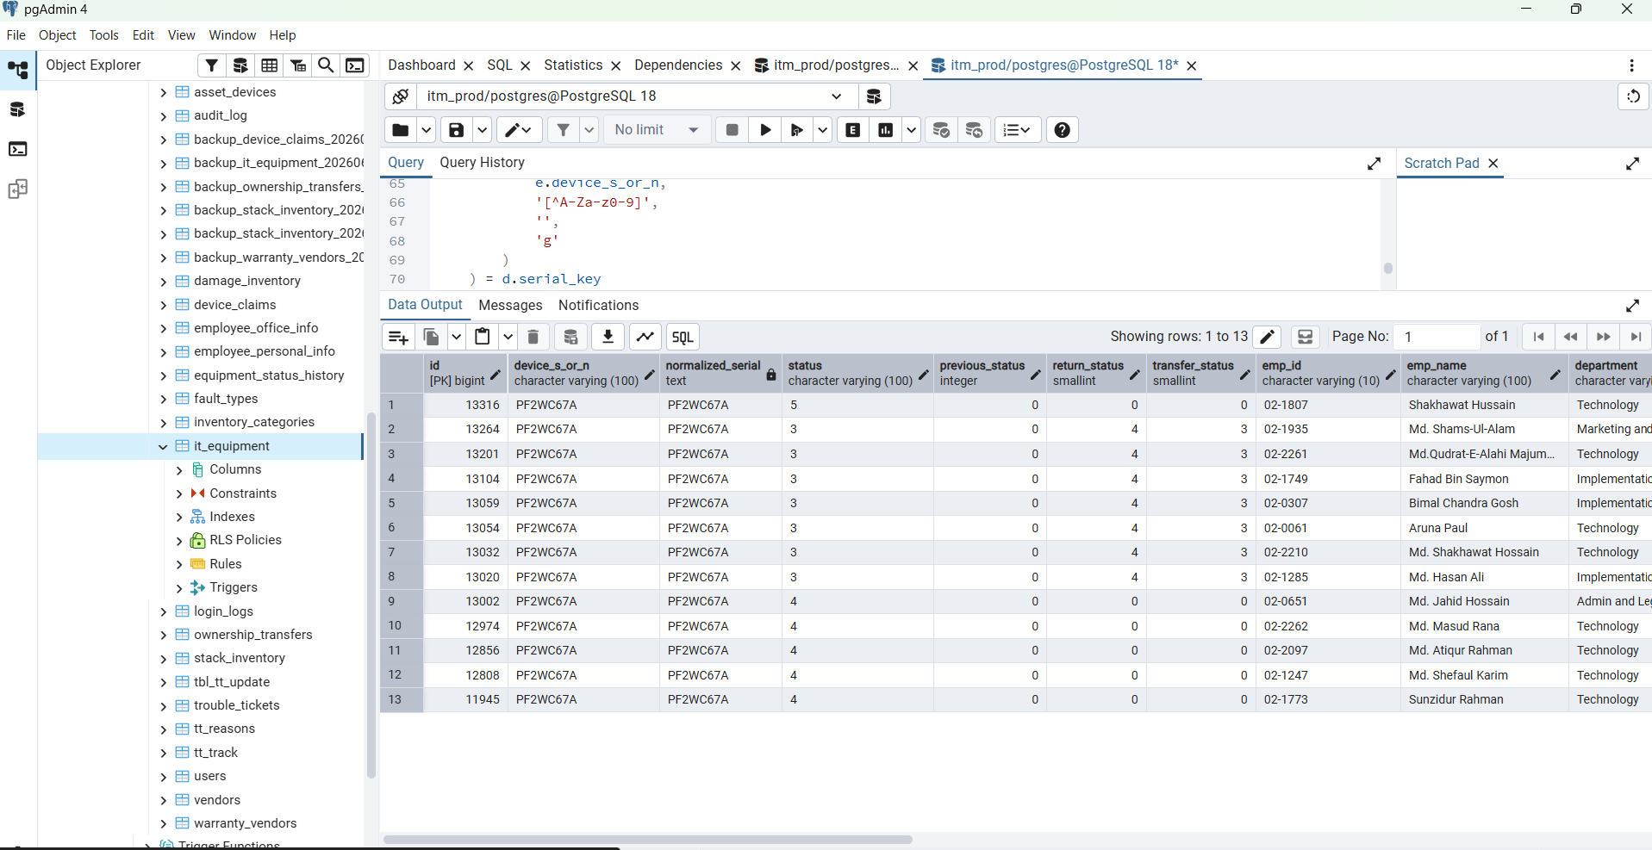

WITH ranked_equipment AS (
SELECT
e.id,
e.device_s_or_n,

UPPER(
REGEXP_REPLACE(
e.device_s_or_n,
'[^A-Za-z0-9]',
'',
'g'
)
) AS serial_key,

ROW_NUMBER() OVER (
PARTITION BY UPPER(
REGEXP_REPLACE(
e.device_s_or_n,
'[^A-Za-z0-9]',
'',
'g'
)
)
ORDER BY
COALESCE(
e.update_date,
e.return_input_date,
e.transfer_date_time,
e.assign_date,
e.date,
e.delete_date_time
) DESC NULLS LAST,
e.id DESC
) AS row_rank
FROM public.it_equipment e
WHERE COALESCE(e.active, 0) > 0
AND NULLIF(BTRIM(e.device_s_or_n), '') IS NOT NULL
)
SELECT
COUNT(*) AS total_active_rows,
COUNT(*) FILTER (WHERE row_rank = 1) AS unique_current_devices,
COUNT(*) FILTER (WHERE row_rank > 1) AS duplicate_or_history_rows
FROM ranked_equipment;

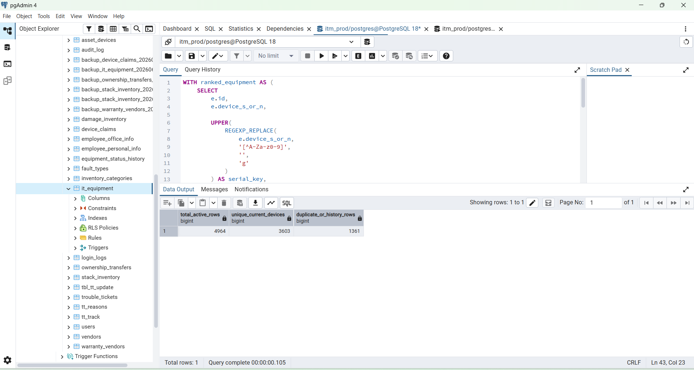

Perfect BOSS — now the real picture is clear:
Active rows in it_equipment = 4,964
Unique physical devices = 3,603
Duplicate/history rows = 1,361

So your old it_equipment table has 1,361 repeated historical records. For one-device-one-row design, asset_devices should use the 3,603 latest/current unique serials, not all 4,964 rows.
Before inserting anything, we need one last safe preview:
- How many unique devices exist in stack_inventory
- How many are already present in it_equipment
- How many final physical devices will exist after merging both tables
Run this query in pgAdmin:
WITH equipment_serials AS (
SELECT DISTINCT
UPPER(
REGEXP_REPLACE(
device_s_or_n,
'[^A-Za-z0-9]',
'',
'g'
)
) AS serial_key
FROM public.it_equipment
WHERE COALESCE(active, 0) > 0
AND NULLIF(BTRIM(device_s_or_n), '') IS NOT NULL
),
stack_serials AS (
SELECT DISTINCT
UPPER(
REGEXP_REPLACE(
serial_no,
'[^A-Za-z0-9]',
'',
'g'
)
) AS serial_key
FROM public.stack_inventory
WHERE COALESCE(status, 1) = 1
AND NULLIF(BTRIM(serial_no), '') IS NOT NULL
)
SELECT
(SELECT COUNT(*) FROM equipment_serials) AS unique_equipment_devices,
(SELECT COUNT(*) FROM stack_serials) AS unique_stack_devices,
(
SELECT COUNT(*)
FROM stack_serials s
JOIN equipment_serials e
ON e.serial_key = s.serial_key
) AS same_device_in_both_tables,
(
SELECT COUNT(*)
FROM stack_serials s
LEFT JOIN equipment_serials e
ON e.serial_key = s.serial_key
WHERE e.serial_key IS NULL
) AS stack_only_devices,
(
SELECT COUNT(*)
FROM (
SELECT serial_key FROM equipment_serials
UNION
SELECT serial_key FROM stack_serials
) final_devices
) AS expected_final_unique_devices;
Expected meaning:
unique_equipment_devices = 3,603
unique_stack_devices = ?
same_device_in_both_tables= ?
stack_only_devices = ?
expected_final_unique_devices = final asset_devices count
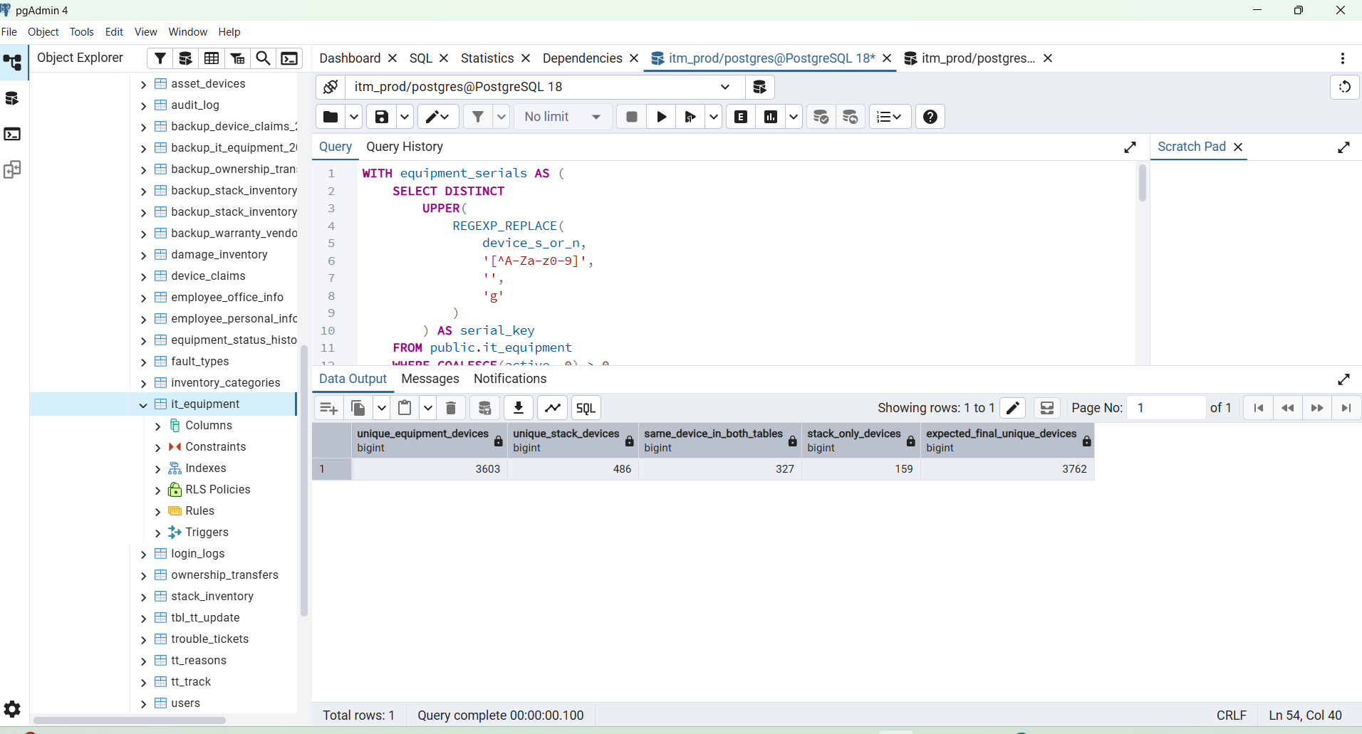

Important:
Dashboard count 4,421 = lifecycle rows/status count
asset_devices count = physical unique device count
These will not necessarily be the same, because the dashboard includes historical assigned/returned/transferred records, while asset_devices should contain only one current row per physical serial.
After you send this result, I will give you the exact safe SQL to:
- update existing asset_devices rows,
- insert the remaining unique equipment devices,
- keep duplicate rows as history,
- avoid changing your current dashboard count.

BOSS, next step is final merge preview. This query does not change any data. It tells us how many unique physical devices will exist after combining it_equipment and stack_inventory.
Run this in pgAdmin:

WITH equipment_serials AS (
SELECT DISTINCT
UPPER(
REGEXP_REPLACE(
device_s_or_n,
'[^A-Za-z0-9]',
'',
'g'
)
) AS serial_key
FROM public.it_equipment
WHERE COALESCE(active, 0) > 0
AND NULLIF(BTRIM(device_s_or_n), '') IS NOT NULL
),

stack_serials AS (
SELECT DISTINCT
UPPER(
REGEXP_REPLACE(
serial_no,
'[^A-Za-z0-9]',
'',
'g'
)
) AS serial_key
FROM public.stack_inventory
WHERE COALESCE(status, 1) = 1
AND NULLIF(BTRIM(serial_no), '') IS NOT NULL
)

SELECT
(SELECT COUNT(*) FROM equipment_serials) AS unique_equipment_devices,

(SELECT COUNT(*) FROM stack_serials) AS unique_stack_devices,

(
SELECT COUNT(*)
FROM stack_serials s
JOIN equipment_serials e
ON e.serial_key = s.serial_key
) AS same_device_in_both_tables,

(
SELECT COUNT(*)
FROM stack_serials s
LEFT JOIN equipment_serials e
ON e.serial_key = s.serial_key
WHERE e.serial_key IS NULL
) AS stack_only_devices,

(
SELECT COUNT(*)
FROM equipment_serials e
LEFT JOIN stack_serials s
ON s.serial_key = e.serial_key
WHERE s.serial_key IS NULL
) AS equipment_only_devices,

(
SELECT COUNT(*)
FROM (
SELECT serial_key FROM equipment_serials
UNION
SELECT serial_key FROM stack_serials
) final_devices
) AS expected_final_unique_devices;

We will now safely add the missing equipment-only devices without changing the dashboard.

Step 1 — Backup current asset_devices
Run this first:
CREATE TABLE IF NOT EXISTS public.backup_asset_devices_before_full_merge_20260622 AS
SELECT *
FROM public.asset_devices;
Check backup:
SELECT
COUNT(*) AS asset_devices_now,
(
SELECT COUNT(*)
FROM public.backup_asset_devices_before_full_merge_20260622
) AS backup_rows
FROM public.asset_devices;
Both should currently show:
486

Step 2 — Create latest/current one-row-per-serial staging table
This table will hold only the latest record for each physical device serial.
DROP TABLE IF EXISTS public.stg_latest_equipment_devices;
CREATE TABLE public.stg_latest_equipment_devices AS
WITH ranked_equipment AS (
SELECT
e.*,
UPPER(
REGEXP_REPLACE(
e.device_s_or_n,
'[^A-Za-z0-9]',
'',
'g'
)
) AS serial_key,
ROW_NUMBER() OVER (
PARTITION BY UPPER(
REGEXP_REPLACE(
e.device_s_or_n,
'[^A-Za-z0-9]',
'',
'g'
)
)
ORDER BY
COALESCE(
e.update_date,
e.return_input_date,
e.transfer_date_time,
e.assign_date,
e.date,
e.delete_date_time
) DESC NULLS LAST,
e.id DESC
) AS row_rank
FROM public.it_equipment e
WHERE COALESCE(e.active, 0) > 0
AND NULLIF(BTRIM(e.device_s_or_n), '') IS NOT NULL
)
SELECT *
FROM ranked_equipment
WHERE row_rank = 1;
Verify:
SELECT COUNT(*) AS latest_unique_equipment_devices
FROM public.stg_latest_equipment_devices;
Expected:
3,603

Step 3 — Preview status count from latest device rows
This does not modify anything:
SELECT
CASE
WHEN status = '0' THEN 'Damaged'
WHEN status = '1' THEN 'Assigned'
WHEN status = '3' THEN 'Transferred'
WHEN status = '4' THEN 'Returned'
WHEN status = '5' THEN 'Lost'
WHEN status = '7' THEN 'Ownership Transfer'
WHEN status = '8' THEN 'Claim Raised'
WHEN status = '15' THEN 'Service Request'
WHEN LOWER(COALESCE(status, '')) = 'assigned' THEN 'Assigned'
WHEN LOWER(COALESCE(status, '')) = 'returned' THEN 'Returned'
WHEN LOWER(COALESCE(status, '')) IN ('transfer', 'transferred') THEN 'Transferred'
ELSE 'Unknown'
END AS latest_status,
COUNT(*) AS total
FROM public.stg_latest_equipment_devices
GROUP BY latest_status
ORDER BY total DESC;
This count will be lower than dashboard, and that is correct.
Dashboard = all lifecycle/history rows
asset_devices = one current row per physical device

Step 4 — Update existing stack device rows from latest equipment data
This updates the 327 serials found in both tables.
UPDATE public.asset_devices ad
SET
legacy_equipment_id = e.id,
category = COALESCE(NULLIF(BTRIM(e.category), ''), ad.category),
brand = COALESCE(NULLIF(BTRIM(e.brand), ''), ad.brand),
model = COALESCE(NULLIF(BTRIM(e.model_no), ''), ad.model),
device_type = COALESCE(e.device_type::text, ad.device_type),
mr_number = COALESCE(NULLIF(BTRIM(e.mr_number), ''), ad.mr_number),
pr_number = COALESCE(NULLIF(BTRIM(e.pr_number), ''), ad.pr_number),
vendor_name = COALESCE(NULLIF(BTRIM(e.vendor), ''), ad.vendor_name),
warranty_date = COALESCE(e.device_warranty_date, ad.warranty_date),
emp_id = NULLIF(BTRIM(e.emp_id), ''),
emp_name = NULLIF(BTRIM(e.emp_name), ''),
department = NULLIF(BTRIM(e.department), ''),
designation = NULLIF(BTRIM(e.designation), ''),
assigned_date = e.assign_date,
asset_status = CASE
WHEN e.status = '0'
OR LOWER(COALESCE(e.status, '')) = 'damaged'
THEN 0
WHEN e.status = '1'
OR LOWER(COALESCE(e.status, '')) = 'assigned'
THEN 1
WHEN e.status = '3'
OR LOWER(COALESCE(e.status, '')) IN ('transfer', 'transferred')
THEN 3
WHEN e.status = '4'
OR LOWER(COALESCE(e.status, '')) = 'returned'
THEN 4
WHEN e.status = '5'
OR LOWER(COALESCE(e.status, '')) = 'lost'
THEN 5
WHEN e.status = '7'
OR LOWER(COALESCE(e.status, '')) IN ('ownership', 'owst')
THEN 7
WHEN e.status = '8'
OR LOWER(COALESCE(e.status, '')) IN ('claim raised', 'claimed')
THEN 8
WHEN e.status = '15'
OR LOWER(COALESCE(e.status, '')) IN ('request service', 'service request')
THEN 15
ELSE ad.asset_status
END,
updated_at = NOW()
FROM public.stg_latest_equipment_devices e
WHERE ad.device_serial_key = e.serial_key;
Check affected merged rows:
SELECT COUNT(*) AS merged_stack_and_equipment_rows
FROM public.asset_devices
WHERE legacy_stack_id IS NOT NULL
AND legacy_equipment_id IS NOT NULL;
Expected:
327

Step 5 — Insert the remaining equipment-only devices
This inserts the missing unique physical devices from it_equipment.
INSERT INTO public.asset_devices (
legacy_equipment_id,
device_serial,
category,
brand,
model,
device_type,
mr_number,
pr_number,
vendor_name,
warranty_date,
asset_status,
row_status,
emp_id,
emp_name,
department,
designation,
assigned_date,
created_at,
updated_at
)
SELECT
e.id,
NULLIF(BTRIM(e.device_s_or_n), ''),
NULLIF(BTRIM(e.category), ''),
NULLIF(BTRIM(e.brand), ''),
NULLIF(BTRIM(e.model_no), ''),
e.device_type::text,
NULLIF(BTRIM(e.mr_number), ''),
NULLIF(BTRIM(e.pr_number), ''),
NULLIF(BTRIM(e.vendor), ''),
e.device_warranty_date,
CASE
WHEN e.status = '0'
OR LOWER(COALESCE(e.status, '')) = 'damaged'
THEN 0
WHEN e.status = '1'
OR LOWER(COALESCE(e.status, '')) = 'assigned'
THEN 1
WHEN e.status = '3'
OR LOWER(COALESCE(e.status, '')) IN ('transfer', 'transferred')
THEN 3
WHEN e.status = '4'
OR LOWER(COALESCE(e.status, '')) = 'returned'
THEN 4
WHEN e.status = '5'
OR LOWER(COALESCE(e.status, '')) = 'lost'
THEN 5
WHEN e.status = '7'
OR LOWER(COALESCE(e.status, '')) IN ('ownership', 'owst')
THEN 7
WHEN e.status = '8'
OR LOWER(COALESCE(e.status, '')) IN ('claim raised', 'claimed')
THEN 8
WHEN e.status = '15'
OR LOWER(COALESCE(e.status, '')) IN ('request service', 'service request')
THEN 15
ELSE 1
END,
1,
NULLIF(BTRIM(e.emp_id), ''),
NULLIF(BTRIM(e.emp_name), ''),
NULLIF(BTRIM(e.department), ''),
NULLIF(BTRIM(e.designation), ''),
e.assign_date,
COALESCE(e.date, NOW()),
NOW()
FROM public.stg_latest_equipment_devices e
WHERE NOT EXISTS (
SELECT 1
FROM public.asset_devices ad
WHERE ad.device_serial_key = e.serial_key
);
This should insert:
3,276 rows
because:
3,603 unique equipment devices
- 327 already matched with stock
= 3,276 equipment-only devices

Step 6 — Final verification
Run:
SELECT
COUNT(*) AS final_asset_devices,
COUNT(*) FILTER (
WHERE legacy_stack_id IS NOT NULL
) AS from_stack,
COUNT(*) FILTER (
WHERE legacy_equipment_id IS NOT NULL
) AS from_equipment,
COUNT(*) FILTER (
WHERE legacy_stack_id IS NOT NULL
AND legacy_equipment_id IS NOT NULL
) AS merged_from_both_sources
FROM public.asset_devices;
Expected result:
final_asset_devices = 3,762
from_stack = 486
from_equipment = 3,603
merged_from_both_sources= 327
And verify no duplicate physical serials:
SELECT
device_serial_key,
COUNT(*) AS total
FROM public.asset_devices
WHERE device_serial_key <> ''
GROUP BY device_serial_key
HAVING COUNT(*) > 1;
Expected:
0 rows

Important
Do not change dashboard backend yet.
Keep dashboard using:
it_equipment + stack_inventory
because dashboard currently counts historical lifecycle rows:
Assigned 2,614
Returned 923
Transferred 754
Available 130
asset_devices will now represent only current unique physical devices:
3,762 physical devices
After Step 6 result is correct, the next task will be creating a separate asset_device_history table so the old 1,361 duplicate/history rows are preserved professionally.

Check backup:
SELECT
COUNT(*) AS asset_devices_now,
(
SELECT COUNT(*)
FROM public.backup_asset_devices_before_full_merge_20260622
) AS backup_rows
FROM public.asset_devices;
Both should currently show:
486

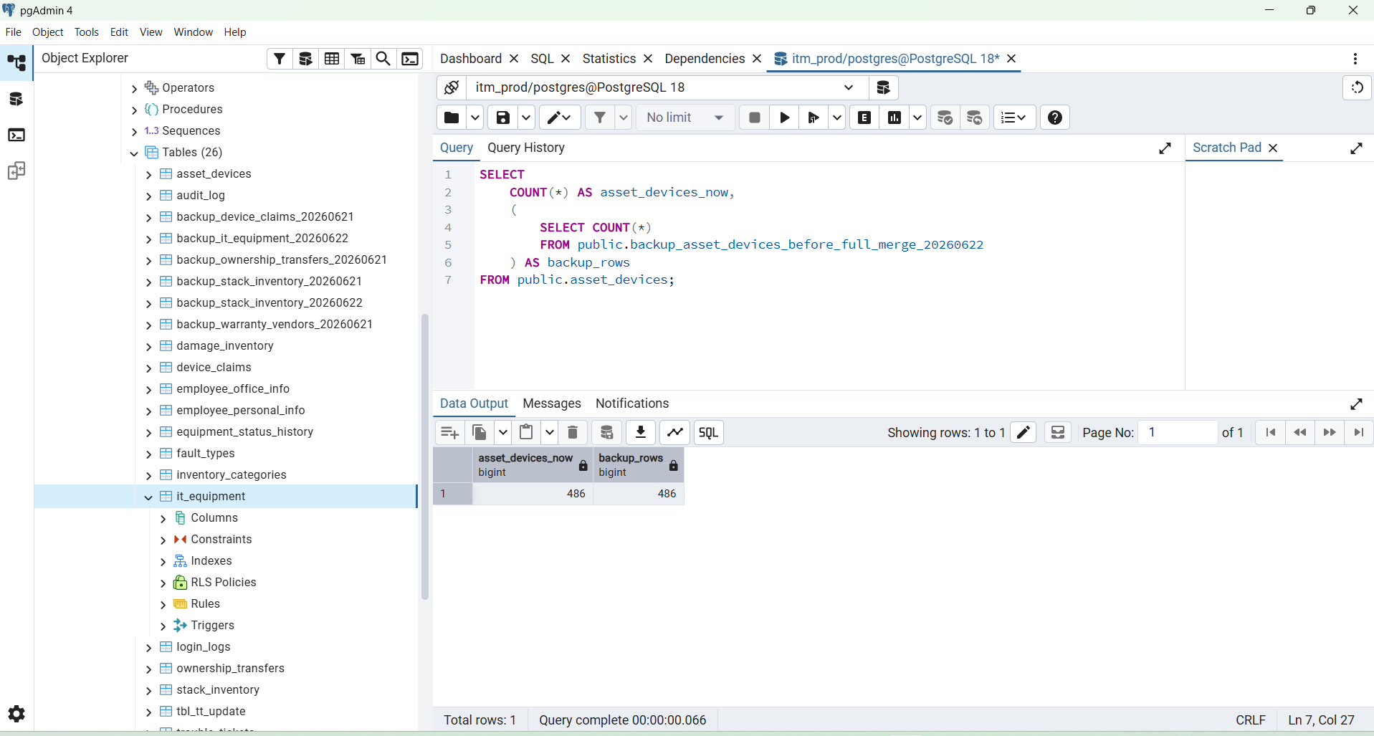

SELECT COUNT(*) AS latest_unique_equipment_devices
FROM public.stg_latest_equipment_devices;

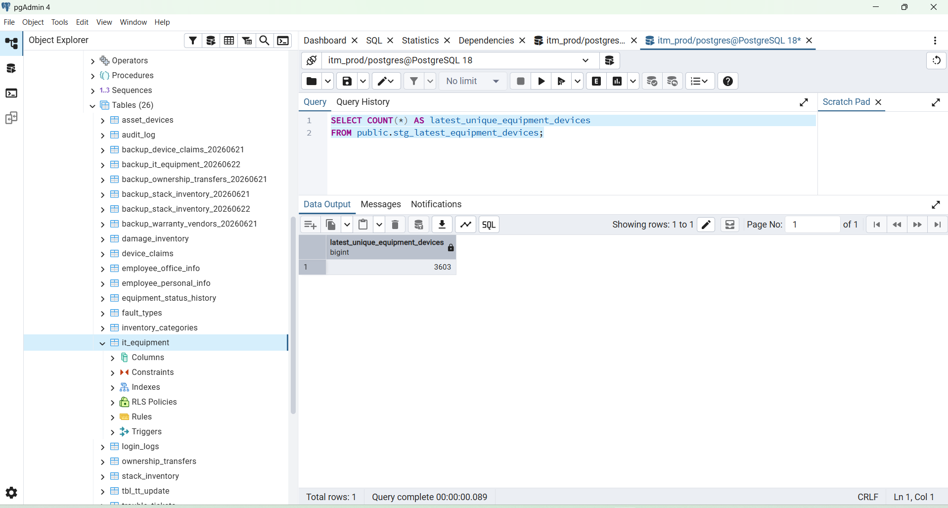

SELECT
CASE
WHEN status = '0' THEN 'Damaged'
WHEN status = '1' THEN 'Assigned'
WHEN status = '3' THEN 'Transferred'
WHEN status = '4' THEN 'Returned'
WHEN status = '5' THEN 'Lost'
WHEN status = '7' THEN 'Ownership Transfer'
WHEN status = '8' THEN 'Claim Raised'
WHEN status = '15' THEN 'Service Request'
WHEN LOWER(COALESCE(status, '')) = 'assigned' THEN 'Assigned'
WHEN LOWER(COALESCE(status, '')) = 'returned' THEN 'Returned'
WHEN LOWER(COALESCE(status, '')) IN ('transfer', 'transferred') THEN 'Transferred'
ELSE 'Unknown'
END AS latest_status,
COUNT(*) AS total
FROM public.stg_latest_equipment_devices
GROUP BY latest_status
ORDER BY total DESC;

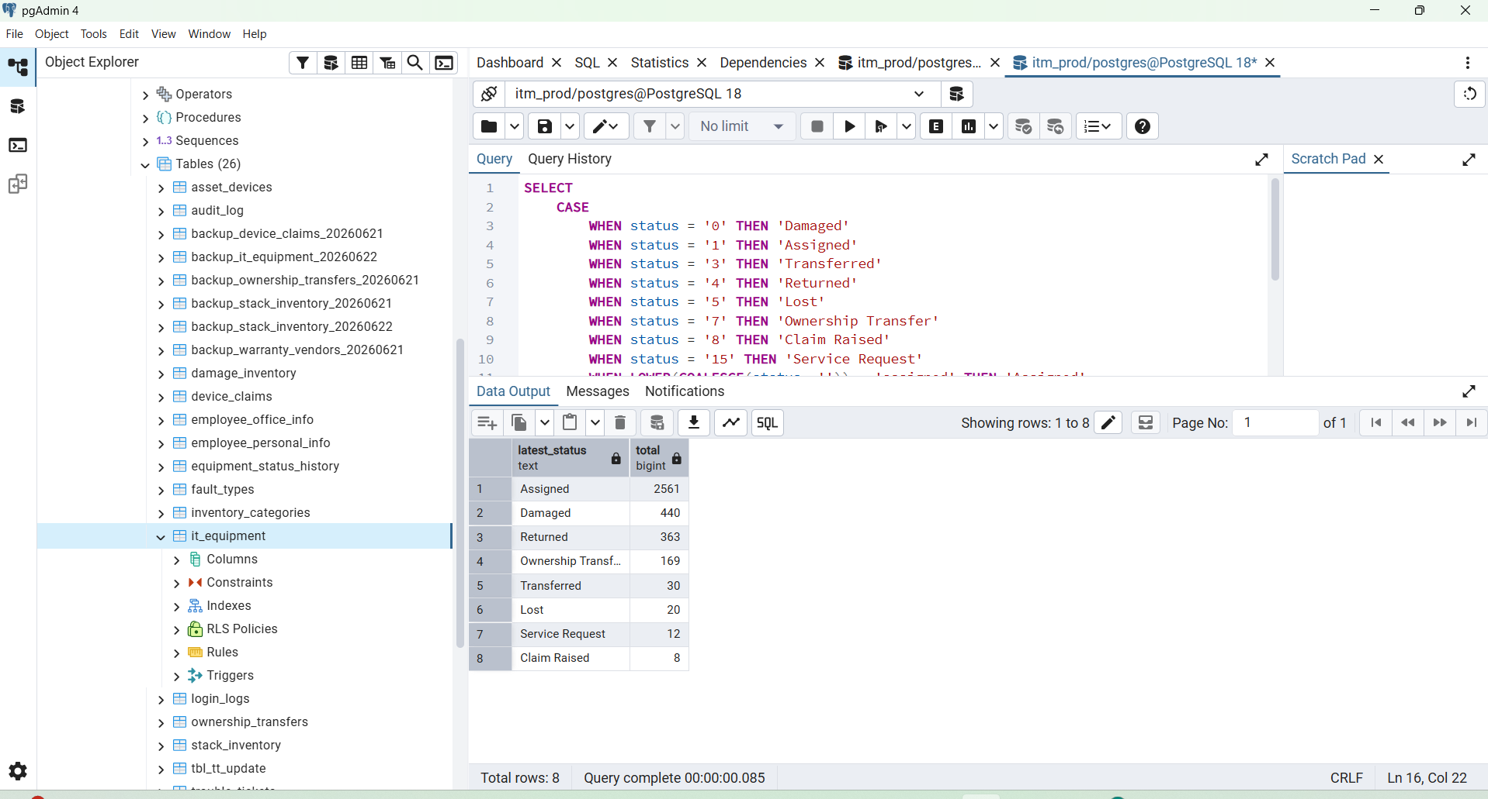

Check affected merged rows:
SELECT COUNT(*) AS merged_stack_and_equipment_rows
FROM public.asset_devices
WHERE legacy_stack_id IS NOT NULL
AND legacy_equipment_id IS NOT NULL;
Expected:
327

Perfect BOSS — now we have the final expected physical-device count:
Unique devices from it_equipment = 3,603
Unique devices from stack_inventory = 486
Same device in both tables = 327
Stack-only devices = 159
Expected final unique devices = 3,762
So after correct merging:
asset_devices total should become 3,762
Your current asset_devices is only 486, because it currently contains stack devices, and only 327 equipment records matched those stack rows.
We will now safely add the missing equipment-only devices without changing the dashboard.

Step 1 — Backup current asset_devices
Run this first:
CREATE TABLE IF NOT EXISTS public.backup_asset_devices_before_full_merge_20260622 AS
SELECT *
FROM public.asset_devices;
Check backup:
SELECT
COUNT(*) AS asset_devices_now,
(
SELECT COUNT(*)
FROM public.backup_asset_devices_before_full_merge_20260622
) AS backup_rows
FROM public.asset_devices;
Both should currently show:
486

Step 2 — Create latest/current one-row-per-serial staging table
This table will hold only the latest record for each physical device serial.
DROP TABLE IF EXISTS public.stg_latest_equipment_devices;
CREATE TABLE public.stg_latest_equipment_devices AS
WITH ranked_equipment AS (
SELECT
e.*,
UPPER(
REGEXP_REPLACE(
e.device_s_or_n,
'[^A-Za-z0-9]',
'',
'g'
)
) AS serial_key,
ROW_NUMBER() OVER (
PARTITION BY UPPER(
REGEXP_REPLACE(
e.device_s_or_n,
'[^A-Za-z0-9]',
'',
'g'
)
)
ORDER BY
COALESCE(
e.update_date,
e.return_input_date,
e.transfer_date_time,
e.assign_date,
e.date,
e.delete_date_time
) DESC NULLS LAST,
e.id DESC
) AS row_rank
FROM public.it_equipment e
WHERE COALESCE(e.active, 0) > 0
AND NULLIF(BTRIM(e.device_s_or_n), '') IS NOT NULL
)
SELECT *
FROM ranked_equipment
WHERE row_rank = 1;
Verify:
SELECT COUNT(*) AS latest_unique_equipment_devices
FROM public.stg_latest_equipment_devices;
Expected:
3,603

Step 3 — Preview status count from latest device rows
This does not modify anything:
SELECT
CASE
WHEN status = '0' THEN 'Damaged'
WHEN status = '1' THEN 'Assigned'
WHEN status = '3' THEN 'Transferred'
WHEN status = '4' THEN 'Returned'
WHEN status = '5' THEN 'Lost'
WHEN status = '7' THEN 'Ownership Transfer'
WHEN status = '8' THEN 'Claim Raised'
WHEN status = '15' THEN 'Service Request'
WHEN LOWER(COALESCE(status, '')) = 'assigned' THEN 'Assigned'
WHEN LOWER(COALESCE(status, '')) = 'returned' THEN 'Returned'
WHEN LOWER(COALESCE(status, '')) IN ('transfer', 'transferred') THEN 'Transferred'
ELSE 'Unknown'
END AS latest_status,
COUNT(*) AS total
FROM public.stg_latest_equipment_devices
GROUP BY latest_status
ORDER BY total DESC;
This count will be lower than dashboard, and that is correct.
Dashboard = all lifecycle/history rows
asset_devices = one current row per physical device

Step 4 — Update existing stack device rows from latest equipment data
This updates the 327 serials found in both tables.
UPDATE public.asset_devices ad
SET
legacy_equipment_id = e.id,
category = COALESCE(NULLIF(BTRIM(e.category), ''), ad.category),
brand = COALESCE(NULLIF(BTRIM(e.brand), ''), ad.brand),
model = COALESCE(NULLIF(BTRIM(e.model_no), ''), ad.model),
device_type = COALESCE(e.device_type::text, ad.device_type),
mr_number = COALESCE(NULLIF(BTRIM(e.mr_number), ''), ad.mr_number),
pr_number = COALESCE(NULLIF(BTRIM(e.pr_number), ''), ad.pr_number),
vendor_name = COALESCE(NULLIF(BTRIM(e.vendor), ''), ad.vendor_name),
warranty_date = COALESCE(e.device_warranty_date, ad.warranty_date),
emp_id = NULLIF(BTRIM(e.emp_id), ''),
emp_name = NULLIF(BTRIM(e.emp_name), ''),
department = NULLIF(BTRIM(e.department), ''),
designation = NULLIF(BTRIM(e.designation), ''),
assigned_date = e.assign_date,
asset_status = CASE
WHEN e.status = '0'
OR LOWER(COALESCE(e.status, '')) = 'damaged'
THEN 0
WHEN e.status = '1'
OR LOWER(COALESCE(e.status, '')) = 'assigned'
THEN 1
WHEN e.status = '3'
OR LOWER(COALESCE(e.status, '')) IN ('transfer', 'transferred')
THEN 3
WHEN e.status = '4'
OR LOWER(COALESCE(e.status, '')) = 'returned'
THEN 4
WHEN e.status = '5'
OR LOWER(COALESCE(e.status, '')) = 'lost'
THEN 5
WHEN e.status = '7'
OR LOWER(COALESCE(e.status, '')) IN ('ownership', 'owst')
THEN 7
WHEN e.status = '8'
OR LOWER(COALESCE(e.status, '')) IN ('claim raised', 'claimed')
THEN 8
WHEN e.status = '15'
OR LOWER(COALESCE(e.status, '')) IN ('request service', 'service request')
THEN 15
ELSE ad.asset_status
END,
updated_at = NOW()
FROM public.stg_latest_equipment_devices e
WHERE ad.device_serial_key = e.serial_key;
Check affected merged rows:
SELECT COUNT(*) AS merged_stack_and_equipment_rows
FROM public.asset_devices
WHERE legacy_stack_id IS NOT NULL
AND legacy_equipment_id IS NOT NULL;
Expected:
327

Step 5 — Insert the remaining equipment-only devices
This inserts the missing unique physical devices from it_equipment.
INSERT INTO public.asset_devices (
legacy_equipment_id,
device_serial,
category,
brand,
model,
device_type,
mr_number,
pr_number,
vendor_name,
warranty_date,
asset_status,
row_status,
emp_id,
emp_name,
department,
designation,
assigned_date,
created_at,
updated_at
)
SELECT
e.id,
NULLIF(BTRIM(e.device_s_or_n), ''),
NULLIF(BTRIM(e.category), ''),
NULLIF(BTRIM(e.brand), ''),
NULLIF(BTRIM(e.model_no), ''),
e.device_type::text,
NULLIF(BTRIM(e.mr_number), ''),
NULLIF(BTRIM(e.pr_number), ''),
NULLIF(BTRIM(e.vendor), ''),
e.device_warranty_date,
CASE
WHEN e.status = '0'
OR LOWER(COALESCE(e.status, '')) = 'damaged'
THEN 0
WHEN e.status = '1'
OR LOWER(COALESCE(e.status, '')) = 'assigned'
THEN 1
WHEN e.status = '3'
OR LOWER(COALESCE(e.status, '')) IN ('transfer', 'transferred')
THEN 3
WHEN e.status = '4'
OR LOWER(COALESCE(e.status, '')) = 'returned'
THEN 4
WHEN e.status = '5'
OR LOWER(COALESCE(e.status, '')) = 'lost'
THEN 5
WHEN e.status = '7'
OR LOWER(COALESCE(e.status, '')) IN ('ownership', 'owst')
THEN 7
WHEN e.status = '8'
OR LOWER(COALESCE(e.status, '')) IN ('claim raised', 'claimed')
THEN 8
WHEN e.status = '15'
OR LOWER(COALESCE(e.status, '')) IN ('request service', 'service request')
THEN 15
ELSE 1
END,
1,
NULLIF(BTRIM(e.emp_id), ''),
NULLIF(BTRIM(e.emp_name), ''),
NULLIF(BTRIM(e.department), ''),
NULLIF(BTRIM(e.designation), ''),
e.assign_date,
COALESCE(e.date, NOW()),
NOW()
FROM public.stg_latest_equipment_devices e
WHERE NOT EXISTS (
SELECT 1
FROM public.asset_devices ad
WHERE ad.device_serial_key = e.serial_key
);
This should insert:
3,276 rows
because:
3,603 unique equipment devices
- 327 already matched with stock
= 3,276 equipment-only devices

Step 6 — Final verification
Run:
SELECT
COUNT(*) AS final_asset_devices,
COUNT(*) FILTER (
WHERE legacy_stack_id IS NOT NULL
) AS from_stack,
COUNT(*) FILTER (
WHERE legacy_equipment_id IS NOT NULL
) AS from_equipment,
COUNT(*) FILTER (
WHERE legacy_stack_id IS NOT NULL
AND legacy_equipment_id IS NOT NULL
) AS merged_from_both_sources
FROM public.asset_devices;
Expected result:
final_asset_devices = 3,762
from_stack = 486
from_equipment = 3,603
merged_from_both_sources= 327
And verify no duplicate physical serials:
SELECT
device_serial_key,
COUNT(*) AS total
FROM public.asset_devices
WHERE device_serial_key <> ''
GROUP BY device_serial_key
HAVING COUNT(*) > 1;
Expected:
0 rows

Important
Do not change dashboard backend yet.
Keep dashboard using:
it_equipment + stack_inventory
because dashboard currently counts historical lifecycle rows:
Assigned 2,614
Returned 923
Transferred 754
Available 130
asset_devices will now represent only current unique physical devices:
3,762 physical devices
After Step 6 result is correct, the next task will be creating a separate asset_device_history table so the old 1,361 duplicate/history rows are preserved professionally.

current_unique_devices = 3,762
historical_records = 1,361
total_migrated_equipment_records = 5,123

SELECT
COUNT(*) AS history_rows,
COUNT(DISTINCT asset_device_id) AS devices_with_history,
COUNT(DISTINCT legacy_equipment_id) AS unique_old_equipment_rows
FROM public.asset_device_history;
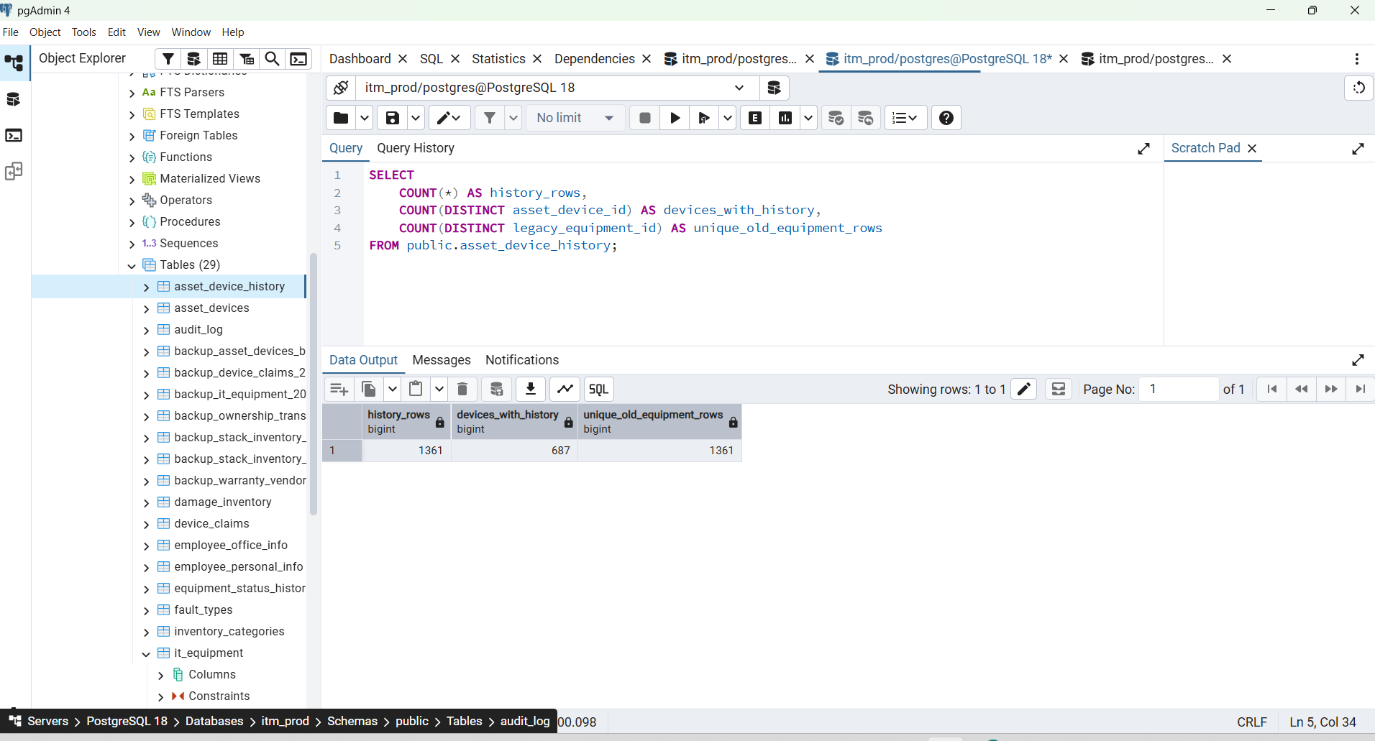

Expected:
history_rows = 1361
unique_old_equipment_rows = 1361
devices_with_history = some number less than 1361

SELECT
h.legacy_equipment_id,
h.device_serial,
h.raw_status,
h.emp_id,
h.emp_name,
h.assigned_date,

ad.id AS current_asset_id,
ad.asset_status AS current_asset_status,
ad.emp_id AS current_emp_id,
ad.emp_name AS current_emp_name
FROM public.asset_device_history h
JOIN public.asset_devices ad
ON ad.id = h.asset_device_id
ORDER BY h.id DESC
LIMIT 20;

After this, your database structure will be:
asset_devices
→ one current row for every physical device
→ 3,762 rows
asset_device_history
→ old duplicate / returned / reassigned lifecycle records
→ 1,361 rows
it_equipment
→ old original table kept safely for rollback and comparison
Do not delete it_equipment or change dashboard source yet

BOSS, ধরে নিচ্ছি history insert query run করেছেন এবং কোনো error আসেনি।
এখন verify করুন asset_device_history-তে expected 1,361 old duplicate/history rows গেছে কি না।
SELECT
COUNT(*) AS history_rows,
COUNT(DISTINCT asset_device_id) AS devices_with_history,
COUNT(DISTINCT legacy_equipment_id) AS unique_old_equipment_rows
FROM public.asset_device_history;

Expected:
history_rows = 1361
unique_old_equipment_rows = 1361
devices_with_history = 687 or less

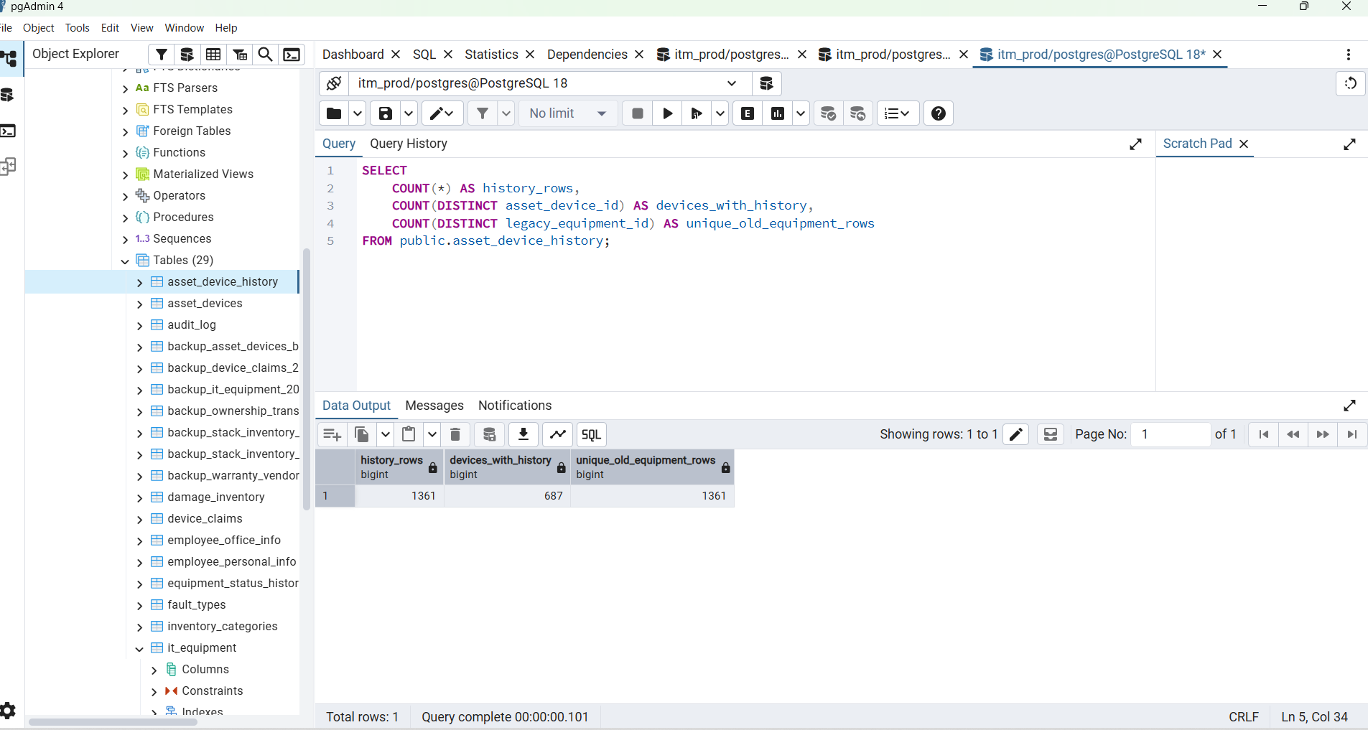

SELECT
asset_status,
CASE asset_status
WHEN 0 THEN 'Damaged'
WHEN 1 THEN 'Assigned'
WHEN 2 THEN 'Available'
WHEN 3 THEN 'Transferred'
WHEN 4 THEN 'Returned'
WHEN 5 THEN 'Lost'
WHEN 7 THEN 'Ownership Transfer'
WHEN 8 THEN 'Claim Raised'
WHEN 15 THEN 'Service Request'
ELSE 'Unknown'
END AS status_name,
COUNT(*) AS total
FROM public.asset_devices
GROUP BY asset_status
ORDER BY asset_status;

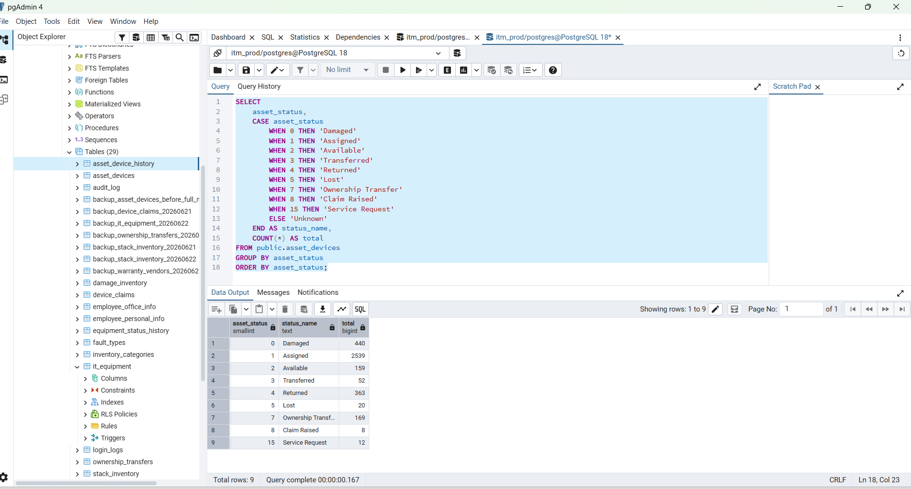

এখন database structure হবে:
asset_devices
→ 3,762 unique physical devices
→ one device = one row
asset_device_history
→ 1,361 old duplicate/history records
it_equipment
→ old production source, এখনো untouched
এই verification result ঠিক হলে পরের step হবে asset_devices-এ proper vendor_id, category_id, brand_id relation add করা, যাতে raw text/name না রেখে clean IDs দিয়ে backend চালানো যায়।

BOSS, this status summary is useful, but before going forward we need one reconciliation check.
From your screenshot, visible status total is:
Damaged 440
Assigned 2459
Available 159
Transferred 52
Returned 363
Lost 20
Ownership Transfer 169
Claim Raised 8
Service Request 12
-------------------------
Visible total 3682
But asset_devices total is:
3762
So there is a difference of:
3762 - 3682 = 80
Before adding more relations, find those 80 rows.
Step 1 — Find missing/unknown status rows
Run this in pgAdmin:
SELECT
COUNT(*) AS total_asset_devices,
COUNT(*) FILTER (
WHERE asset_status IS NULL
) AS null_asset_status,
COUNT(*) FILTER (
WHERE asset_status NOT IN (0, 1, 2, 3, 4, 5, 7, 8, 15)
) AS unsupported_asset_status,
COUNT(*) FILTER (
WHERE row_status IS NULL
) AS null_row_status,
COUNT(*) FILTER (
WHERE row_status <> 1
) AS non_active_row_status
FROM public.asset_devices;
Then run this:
SELECT
COALESCE(asset_status::text, '[NULL]') AS raw_asset_status,
COALESCE(row_status::text, '[NULL]') AS raw_row_status,
COUNT(*) AS total
FROM public.asset_devices
GROUP BY asset_status, row_status
ORDER BY asset_status NULLS LAST, row_status NULLS LAST;
This will tell us exactly which 80 rows are not appearing in your current dashboard-style status result.

Step 2 — Verify history migration
Now verify whether the old duplicate/history rows were inserted:
SELECT
COUNT(*) AS history_rows,
COUNT(DISTINCT legacy_equipment_id) AS unique_legacy_equipment_rows,
COUNT(DISTINCT asset_device_id) AS devices_with_history
FROM public.asset_device_history;
Expected:
history_rows = 1361
unique_legacy_equipment_rows = 1361

Why this step matters
Your final production structure should reconcile like this:
it_equipment active rows = 4964
latest unique equipment rows = 3603
old history rows = 1361
stack-only devices = 159
asset_devices = 3762
asset_device_history = 1361
Do not update dashboard backend yet. Your dashboard 2,614 remains based on old lifecycle rows, while asset_devices represents one current row per physical devic

SELECT
COUNT(*) AS total_asset_devices,

COUNT(*) FILTER (
WHERE asset_status IS NULL
) AS null_asset_status,

COUNT(*) FILTER (
WHERE asset_status NOT IN (0, 1, 2, 3, 4, 5, 7, 8, 15)
) AS unsupported_asset_status,

COUNT(*) FILTER (
WHERE row_status IS NULL
) AS null_row_status,

COUNT(*) FILTER (
WHERE row_status <> 1
) AS non_active_row_status
FROM public.asset_devices;

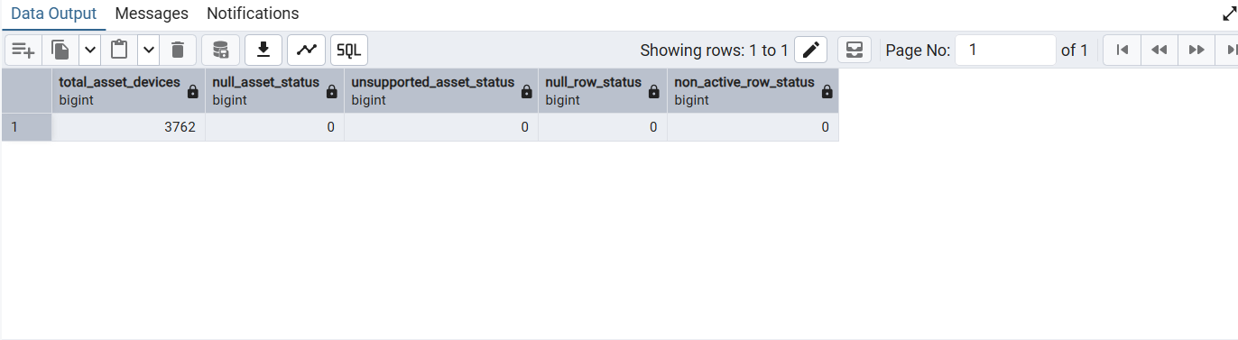

SELECT
COALESCE(asset_status::text, '[NULL]') AS raw_asset_status,
COALESCE(row_status::text, '[NULL]') AS raw_row_status,
COUNT(*) AS total
FROM public.asset_devices
GROUP BY asset_status, row_status
ORDER BY asset_status NULLS LAST, row_status NULLS LAST;

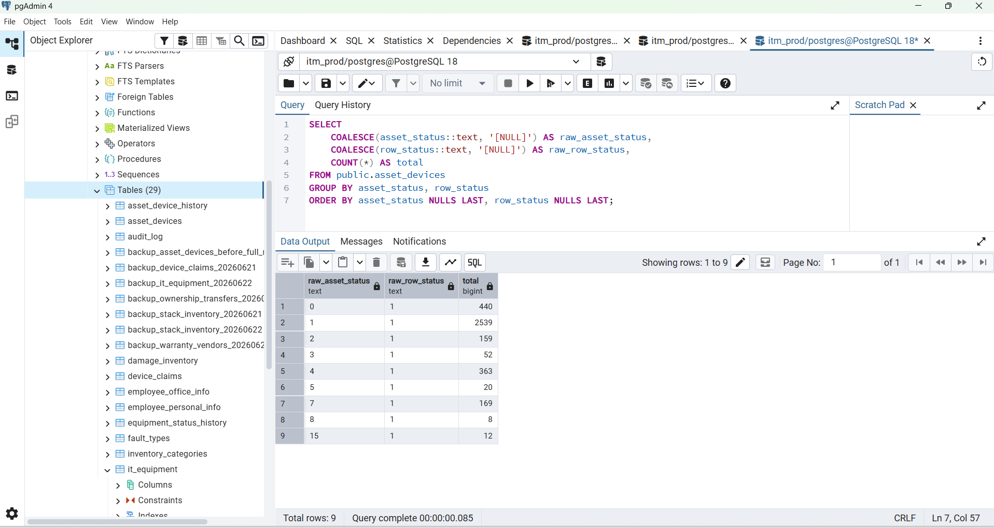

Perfect BOSS — everything is correct now. ✅
Your latest result shows:
total_asset_devices = 3,762
null_asset_status = 0
unsupported_asset_status = 0
null_row_status = 0
non_active_row_status = 0
And the status totals now reconcile exactly:
Damaged = 440
Assigned = 2,539
Available = 159
Transferred = 52
Returned = 363
Lost = 20
Ownership Transfer = 169
Claim Raised = 8
Service Request = 12
--------------------------------
Total = 3,762
So the previous apparent 80 difference was only because the Assigned value was read incorrectly from the screenshot. It is 2,539, not 2,459.

Next step — verify history migration
Run this:
SELECT
COUNT(*) AS history_rows,
COUNT(DISTINCT legacy_equipment_id) AS unique_legacy_equipment_rows,
COUNT(DISTINCT asset_device_id) AS devices_with_history
FROM public.asset_device_history;

Expected:
history_rows = 1,361
unique_legacy_equipment_rows = 1,361
devices_with_history = less than 1,361

Then inspect a few history records linked to their current device:
SELECT
h.id AS history_id,
h.legacy_equipment_id,
h.device_serial,
h.raw_status,
h.emp_id,
h.emp_name,
h.assigned_date,
ad.id AS current_asset_id,
ad.asset_status AS current_asset_status,
ad.emp_id AS current_emp_id,
ad.emp_name AS current_emp_name
FROM public.asset_device_history h
JOIN public.asset_devices ad
ON ad.id = h.asset_device_id
ORDER BY h.id DESC
LIMIT 20;
After this verification, your migration structure is clean:
asset_devices
→ 3,762 current physical devices
→ one serial = one row
asset_device_history
→ 1,361 old duplicate/history rows
it_equipment
→ original old table, keep as backup/live source for now
Do not change the dashboard source yet. Your current dashboard still correctly uses old lifecycle counts such as Assigned 2,614, Returned 923, and Transferred 754.

BOSS, এখন আগে confirm করি asset_device_history-তে data গেছে কি না।
Run this:
SELECT
COUNT(*) AS history_rows,
COUNT(DISTINCT legacy_equipment_id) AS unique_legacy_equipment_rows,
COUNT(DISTINCT asset_device_id) AS devices_with_history
FROM public.asset_device_history;
Expected:
history_rows = 1361
unique_legacy_equipment_rows = 1361

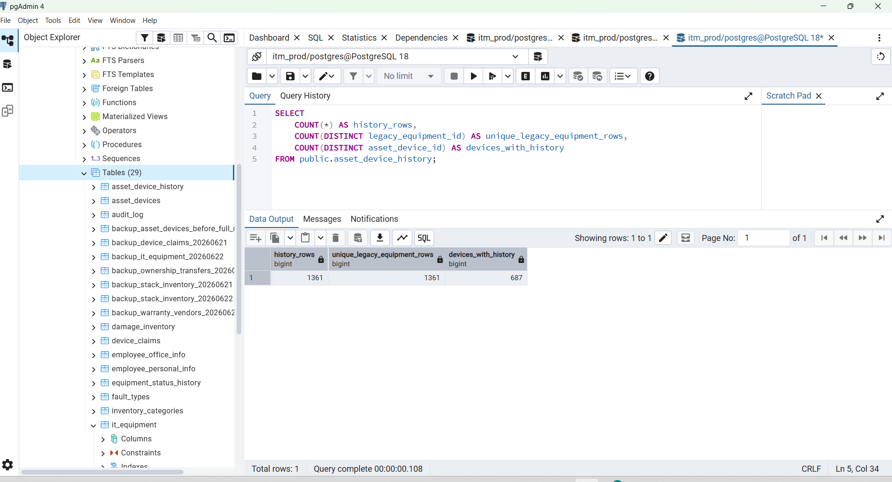

Result অনুযায়ী next action
history_rows = 1361
→ history migration complete
→ next step হবে backend/API new `asset_devices` table use করা
history_rows = 0
→ history table তৈরি হয়েছে, কিন্তু old duplicate rows এখনো copy হয়নি
→ তখন নিচের insert query run করতে হবে
যদি 0 আসে, এই query run করুন:
WITH ranked_equipment AS (
SELECT
e.*,
UPPER(
REGEXP_REPLACE(
e.device_s_or_n,
'[^A-Za-z0-9]',
'',
'g'
)
) AS serial_key,
ROW_NUMBER() OVER (
PARTITION BY UPPER(
REGEXP_REPLACE(
e.device_s_or_n,
'[^A-Za-z0-9]',
'',
'g'
)
)
ORDER BY
COALESCE(
e.update_date,
e.return_input_date,
e.transfer_date_time,
e.assign_date,
e.date,
e.delete_date_time
) DESC NULLS LAST,
e.id DESC
) AS row_rank
FROM public.it_equipment e
WHERE COALESCE(e.active, 0) > 0
AND NULLIF(BTRIM(e.device_s_or_n), '') IS NOT NULL
)
INSERT INTO public.asset_device_history (
asset_device_id,
legacy_equipment_id,
device_serial,
device_serial_key,
status_code,
raw_status,
previous_status,
return_status,
transfer_status,
emp_id,
emp_name,
department,
designation,
mr_number,
pr_number,
vendor,
assigned_date,
transferred_at,
returned_at,
return_input_at,
updated_at_source,
created_at_source,
deleted_at_source,
history_reason,
source_snapshot
)
SELECT
ad.id,
e.id,
e.device_s_or_n,
e.serial_key,
CASE
WHEN e.status = '0' OR LOWER(COALESCE(e.status, '')) = 'damaged' THEN 0
WHEN e.status = '1' OR LOWER(COALESCE(e.status, '')) = 'assigned' THEN 1
WHEN e.status = '3' OR LOWER(COALESCE(e.status, '')) IN ('transfer', 'transferred') THEN 3
WHEN e.status = '4' OR LOWER(COALESCE(e.status, '')) = 'returned' THEN 4
WHEN e.status = '5' OR LOWER(COALESCE(e.status, '')) = 'lost' THEN 5
WHEN e.status = '7' OR LOWER(COALESCE(e.status, '')) IN ('ownership', 'owst') THEN 7
WHEN e.status = '8' OR LOWER(COALESCE(e.status, '')) IN ('claimed', 'claim raised') THEN 8
WHEN e.status = '15' OR LOWER(COALESCE(e.status, '')) IN ('request service', 'service request') THEN 15
ELSE NULL
END,
e.status,
e.previous_status,
e.return_status,
e.transfer_status,
e.emp_id,
e.emp_name,
e.department,
e.designation,
e.mr_number,
e.pr_number,
e.vendor,
e.assign_date,
e.transfer_date_time,
e.return_date,
e.return_input_date,
e.update_date,
e.date,
e.delete_date_time,
'duplicate_or_previous_record',
to_jsonb(e) - 'row_rank' - 'serial_key'
FROM ranked_equipment e
JOIN public.asset_devices ad
ON ad.device_serial_key = e.serial_key
WHERE e.row_rank > 1
ON CONFLICT (legacy_equipment_id) DO NOTHING;
Then run the first count query again.
Your current clean structure is now:
asset_devices
→ 3,762 current physical devices
asset_device_history
→ 1,361 old assignment/return/transfer history rows
it_equipment
→ old source table, keep unchanged for now
Do not change dashboard backend yet.

না BOSS, এই query এখন আর run করবেন না।
কারণ আপনার result already দেখিয়েছে:
history_rows = 1361
unique_legacy_equipment_rows = 1361
devices_with_history = 687
মানে এই query আগে থেকেই successfully run হয়েছে এবং old duplicate/history records asset_device_history-তে চলে গেছে।
এই query আবার run করলে error হবে না, কারণ শেষে আছে:
ON CONFLICT (legacy_equipment_id) DO NOTHING;
কিন্তু নতুন কোনো data insertও হবে না। তাই unnecessary।
Current migration status
asset_devices
→ 3,762 unique current physical devices
asset_device_history
→ 1,361 previous/duplicate lifecycle records
it_equipment
→ old source table, untouched
Next forward step: connect vendor master with asset devices
এখন asset_devices.vendor_name text হিসেবে আছে। Professional way হলো:
asset_devices.vendor_id → vendors.id
আগে শুধু preview করুন, কোনো data change হবে না।
1. Asset table-এ vendor data কত আছে দেখুন
SELECT
COUNT(*) AS total_asset_devices,
COUNT(*) FILTER (
WHERE NULLIF(BTRIM(vendor_name), '') IS NOT NULL
) AS assets_with_vendor_name,
COUNT(DISTINCT LOWER(BTRIM(vendor_name))) FILTER (
WHERE NULLIF(BTRIM(vendor_name), '') IS NOT NULL
) AS unique_vendor_names,
COUNT(*) FILTER (
WHERE NULLIF(BTRIM(vendor_name), '') IS NULL
) AS assets_without_vendor_name
FROM public.asset_devices;
2. Unified vendors table structure দেখুন
SELECT
column_name,
data_type
FROM information_schema.columns
WHERE table_schema = 'public'
AND table_name = 'vendors'
ORDER BY ordinal_position;
এই দুই query-এর result send করুন। তারপর আমি exact safe SQL দেব:
1. asset_devices.vendor_id column add
2. vendors table-এ missing vendor names insert
3. existing vendor_name থেকে vendor_id auto-map
4. foreign key add
5. unmatched vendors verify
Dashboard এখনো change করবেন না।
---------------------------------------------------------------------------------------------------------------------
SELECT
column_name,
data_type
FROM information_schema.columns
WHERE table_schema = 'public'
AND table_name = 'vendors'
ORDER BY ordinal_position;

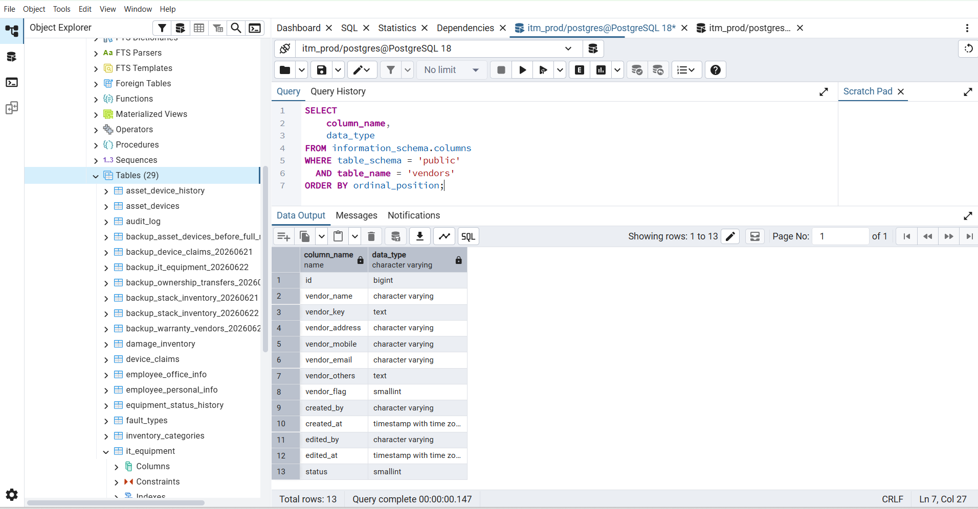

SELECT
COUNT(*) AS total_asset_devices,

COUNT(*) FILTER (
WHERE NULLIF(BTRIM(vendor_name), '') IS NOT NULL
) AS assets_with_vendor_name,

COUNT(DISTINCT LOWER(BTRIM(vendor_name))) FILTER (
WHERE NULLIF(BTRIM(vendor_name), '') IS NOT NULL
) AS unique_vendor_names,

COUNT(*) FILTER (
WHERE NULLIF(BTRIM(vendor_name), '') IS NULL
) AS assets_without_vendor_name
FROM public.asset_devices;

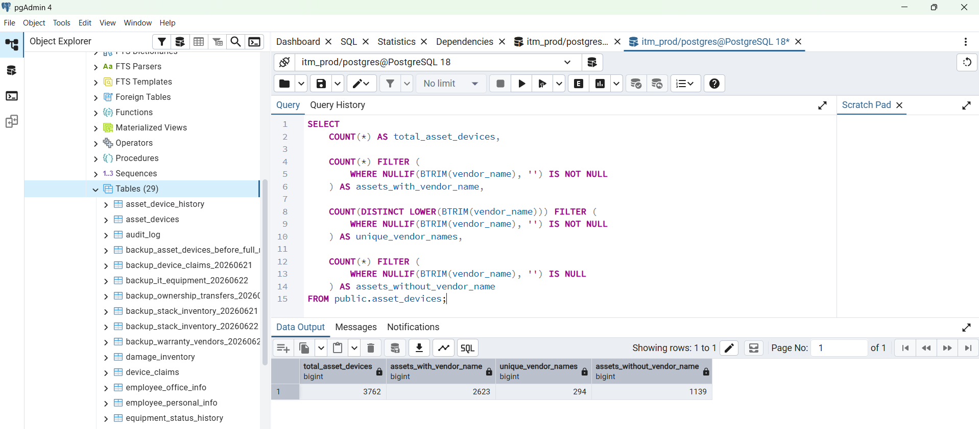

Perfect BOSS — your result is clear:
Total asset devices = 3,762
Assets with vendor name = 2,623
Unique vendor names = 294
Assets without vendor name = 1,139
And your vendors table already has the required columns:
id
vendor_name
vendor_key
vendor_address
vendor_mobile
vendor_email
vendor_others
vendor_flag
created_by
created_at
edited_by
edited_at
status
Now we safely connect:
asset_devices.vendor_id → vendors.id
The 1,139 assets without a vendor name will remain vendor_id = NULL. That is correct; do not create fake vendors for them.
Next step — create and map vendor relation
Run this whole SQL block in pgAdmin:
BEGIN;
-- Safety backup of current merged asset data.
CREATE TABLE IF NOT EXISTS public.backup_asset_devices_before_vendor_link_20260622 AS
SELECT *
FROM public.asset_devices;
-- Add vendor relation column.
ALTER TABLE public.asset_devices
ADD COLUMN IF NOT EXISTS vendor_id BIGINT;
-- Add every vendor name found in current assets to the one master vendors table.
-- Flag 4 means Purchase Vendor.
INSERT INTO public.vendors (
vendor_name,
vendor_flag,
created_at,
status
)
SELECT DISTINCT
BTRIM(ad.vendor_name),
4,
NOW(),
1
FROM public.asset_devices ad
WHERE NULLIF(BTRIM(ad.vendor_name), '') IS NOT NULL
ON CONFLICT (vendor_key)
DO UPDATE SET
vendor_flag = public.vendors.vendor_flag | EXCLUDED.vendor_flag;
-- Match each asset with its master vendor ID.
UPDATE public.asset_devices ad
SET vendor_id = v.id
FROM public.vendors v
WHERE ad.vendor_id IS NULL
AND NULLIF(BTRIM(ad.vendor_name), '') IS NOT NULL
AND v.vendor_key = LOWER(BTRIM(ad.vendor_name));
-- Create index for faster vendor-based reports.
CREATE INDEX IF NOT EXISTS idx_asset_devices_vendor_id
ON public.asset_devices(vendor_id);
-- Add the foreign key safely.
ALTER TABLE public.asset_devices
DROP CONSTRAINT IF EXISTS fk_asset_devices_vendor;
ALTER TABLE public.asset_devices
ADD CONSTRAINT fk_asset_devices_vendor
FOREIGN KEY (vendor_id)
REFERENCES public.vendors(id)
ON DELETE SET NULL
NOT VALID;
COMMIT;
What this does
Existing vendor in vendors
→ keeps same vendor row
→ adds Purchase flag using bitwise OR
New vendor from asset_devices.vendor_name
→ creates one vendor row
→ vendor_flag = 4
Asset with vendor_name
→ gets vendor_id
Asset without vendor_name
→ vendor_id stays NULL
For example:
Existing vendor_flag = 1 Warranty
Asset purchase flag = 4
1 | 4 = 5
Final vendor_flag = 5
Warranty + Purchase
Verify mapping after running the SQL
Run this:
SELECT
COUNT(*) AS total_assets,
COUNT(*) FILTER (
WHERE NULLIF(BTRIM(vendor_name), '') IS NOT NULL
) AS assets_with_vendor_name,
COUNT(*) FILTER (
WHERE vendor_id IS NOT NULL
) AS assets_linked_to_vendor,
COUNT(*) FILTER (
WHERE NULLIF(BTRIM(vendor_name), '') IS NOT NULL
AND vendor_id IS NULL
) AS vendor_name_but_not_linked,
COUNT(*) FILTER (
WHERE NULLIF(BTRIM(vendor_name), '') IS NULL
AND vendor_id IS NULL
) AS no_vendor_information
FROM public.asset_devices;
Expected:
total_assets = 3762
assets_with_vendor_name = 2623
assets_linked_to_vendor = 2623
vendor_name_but_not_linked = 0
no_vendor_information = 1139
Then inspect sample mapped data:
SELECT
ad.id AS asset_id,
ad.device_serial,
ad.vendor_name AS old_vendor_text,
ad.vendor_id,
v.vendor_name AS master_vendor_name,
v.vendor_flag,
CASE v.vendor_flag
WHEN 1 THEN 'Warranty'
WHEN 2 THEN 'Ownership'
WHEN 3 THEN 'Warranty + Ownership'
WHEN 4 THEN 'Purchase'
WHEN 5 THEN 'Warranty + Purchase'
WHEN 6 THEN 'Ownership + Purchase'
WHEN 7 THEN 'Warranty + Ownership + Purchase'
ELSE 'Unknown'
END AS vendor_category
FROM public.asset_devices ad
LEFT JOIN public.vendors v
ON v.id = ad.vendor_id
WHERE ad.vendor_id IS NOT NULL
ORDER BY ad.id DESC
LIMIT 30;
Do not remove asset_devices.vendor_name yet. Keep it temporarily as migration backup. The dashboard also remains unchanged.

SELECT
EXISTS (
SELECT 1
FROM information_schema.columns
WHERE table_schema = 'public'
AND table_name = 'asset_devices'
AND column_name = 'vendor_id'
) AS vendor_id_exists,

EXISTS (
SELECT 1
FROM information_schema.tables
WHERE table_schema = 'public'
AND table_name = 'backup_asset_devices_before_vendor_link_20260622'
) AS vendor_backup_exists;

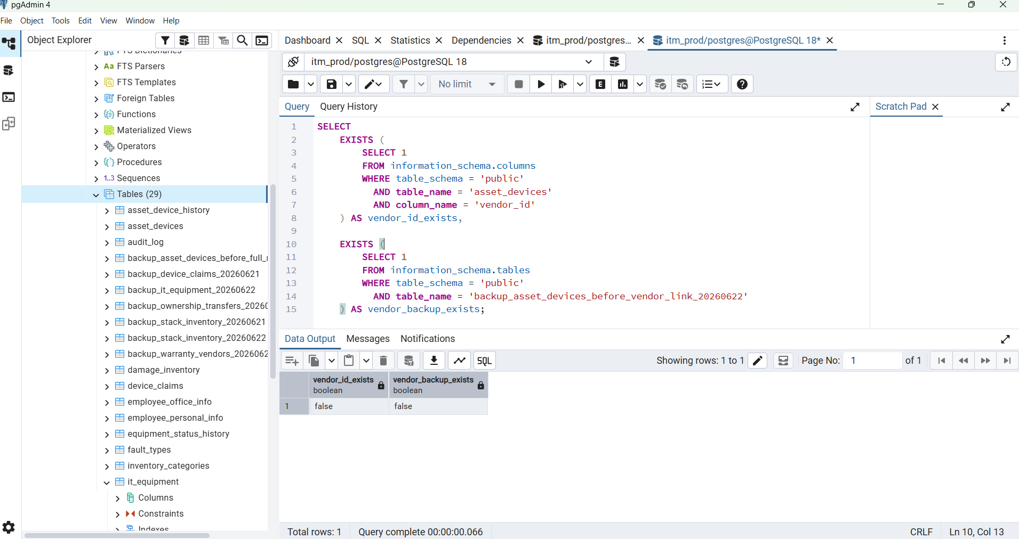

-----------------------------------------------------------------------------------------------------------------------

SELECT
indexname,
indexdef
FROM pg_indexes
WHERE schemaname = 'public'
AND tablename = 'vendors'
ORDER BY indexname;

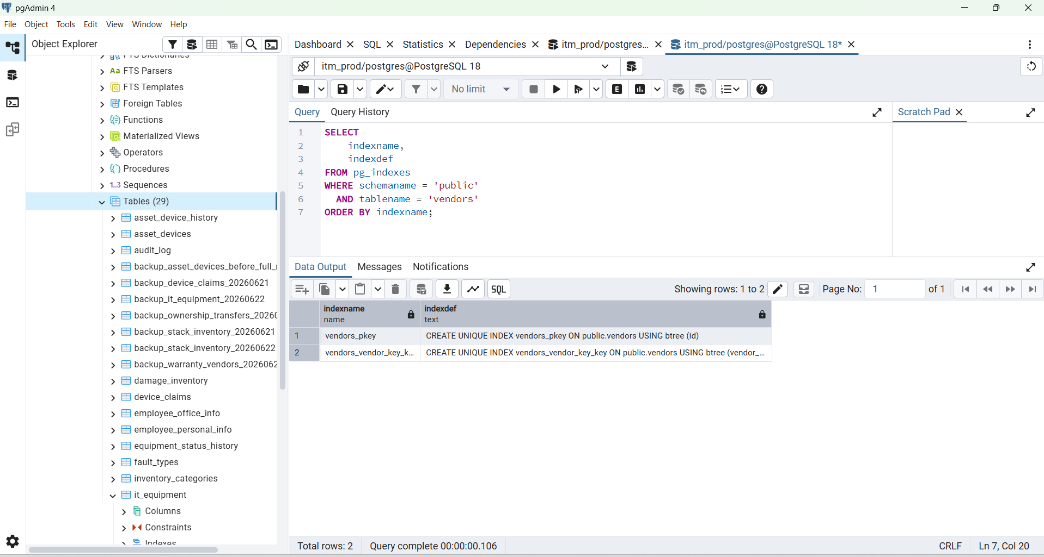

BOSS, this confirms vendors.vendor_key has a valid UNIQUE index. So the original failure was likely because asset_devices.vendor_name contains names with different spelling/case/extra spaces, for example:
UCC
ucc
Ucc
UCC
Your old query used SELECT DISTINCT vendor_name, which treats those as different rows, but they create the same normalized vendor_key. PostgreSQL then aborts when one insert tries to conflict with the same vendor twice.
Now use the safe normalized version below.
Step 1 — Backup and add vendor_id
Run this first:
CREATE TABLE IF NOT EXISTS public.backup_asset_devices_before_vendor_link_20260622 AS
SELECT *
FROM public.asset_devices;
ALTER TABLE public.asset_devices
ADD COLUMN IF NOT EXISTS vendor_id BIGINT;
Then verify:
SELECT
COUNT(*) AS backup_rows,
EXISTS (
SELECT 1
FROM information_schema.columns
WHERE table_schema = 'public'
AND table_name = 'asset_devices'
AND column_name = 'vendor_id'
) AS vendor_id_exists
FROM public.backup_asset_devices_before_vendor_link_20260622;
Expected:
backup_rows = 3762
vendor_id_exists = true
Step 2 — Insert/update vendors safely
This groups all vendor-name variations by normalized key first:
WITH source_vendors AS (
SELECT
LOWER(BTRIM(ad.vendor_name)) AS normalized_vendor_key,
MIN(BTRIM(ad.vendor_name)) AS clean_vendor_name
FROM public.asset_devices ad
WHERE NULLIF(BTRIM(ad.vendor_name), '') IS NOT NULL
GROUP BY LOWER(BTRIM(ad.vendor_name))
)
INSERT INTO public.vendors (
vendor_name,
vendor_flag,
created_at,
status
)
SELECT
clean_vendor_name,
4,
NOW(),
1
FROM source_vendors
ON CONFLICT (vendor_key)
DO UPDATE SET
vendor_flag = public.vendors.vendor_flag | EXCLUDED.vendor_flag;
4 means Purchase Vendor.
Step 3 — Map every asset to its vendor ID
UPDATE public.asset_devices ad
SET vendor_id = v.id
FROM public.vendors v
WHERE ad.vendor_id IS NULL
AND NULLIF(BTRIM(ad.vendor_name), '') IS NOT NULL
AND v.vendor_key = LOWER(BTRIM(ad.vendor_name));
Step 4 — Add index and foreign-key relation
CREATE INDEX IF NOT EXISTS idx_asset_devices_vendor_id
ON public.asset_devices(vendor_id);
ALTER TABLE public.asset_devices
DROP CONSTRAINT IF EXISTS fk_asset_devices_vendor;
ALTER TABLE public.asset_devices
ADD CONSTRAINT fk_asset_devices_vendor
FOREIGN KEY (vendor_id)
REFERENCES public.vendors(id)
ON DELETE SET NULL
NOT VALID;
Step 5 — Verify result
SELECT
COUNT(*) AS total_assets,
COUNT(*) FILTER (
WHERE NULLIF(BTRIM(vendor_name), '') IS NOT NULL
) AS assets_with_vendor_name,
COUNT(*) FILTER (
WHERE vendor_id IS NOT NULL
) AS assets_linked_to_vendor,
COUNT(*) FILTER (
WHERE NULLIF(BTRIM(vendor_name), '') IS NOT NULL
AND vendor_id IS NULL
) AS vendor_name_but_not_linked,
COUNT(*) FILTER (
WHERE NULLIF(BTRIM(vendor_name), '') IS NULL
AND vendor_id IS NULL
) AS assets_without_vendor_info
FROM public.asset_devices;

Expected:
total_assets = 3762
assets_with_vendor_name = 2623
assets_linked_to_vendor = 2623
vendor_name_but_not_linked = 0
assets_without_vendor_info = 1139

Keep asset_devices.vendor_name for now as backup text. The professional relation is now:
asset_devices.vendor_id → vendors.id

BOSS, now run Step 1 only. This will create backup and add vendor_id column. It will not change vendor data yet.
CREATE TABLE IF NOT EXISTS public.backup_asset_devices_before_vendor_link_20260622 AS
SELECT *
FROM public.asset_devices;
ALTER TABLE public.asset_devices
ADD COLUMN IF NOT EXISTS vendor_id BIGINT;
Then verify both are ready:
SELECT
(SELECT COUNT(*)
FROM public.backup_asset_devices_before_vendor_link_20260622
) AS backup_rows,
EXISTS (
SELECT 1
FROM information_schema.columns
WHERE table_schema = 'public'
AND table_name = 'asset_devices'
AND column_name = 'vendor_id'
) AS vendor_id_exists;
Expected:
backup_rows = 3762
vendor_id_exists = true
After this result, next step will safely insert the missing vendor names from asset_devices.vendor_name into vendors and map every asset to vendor_id.

next steps to forward.

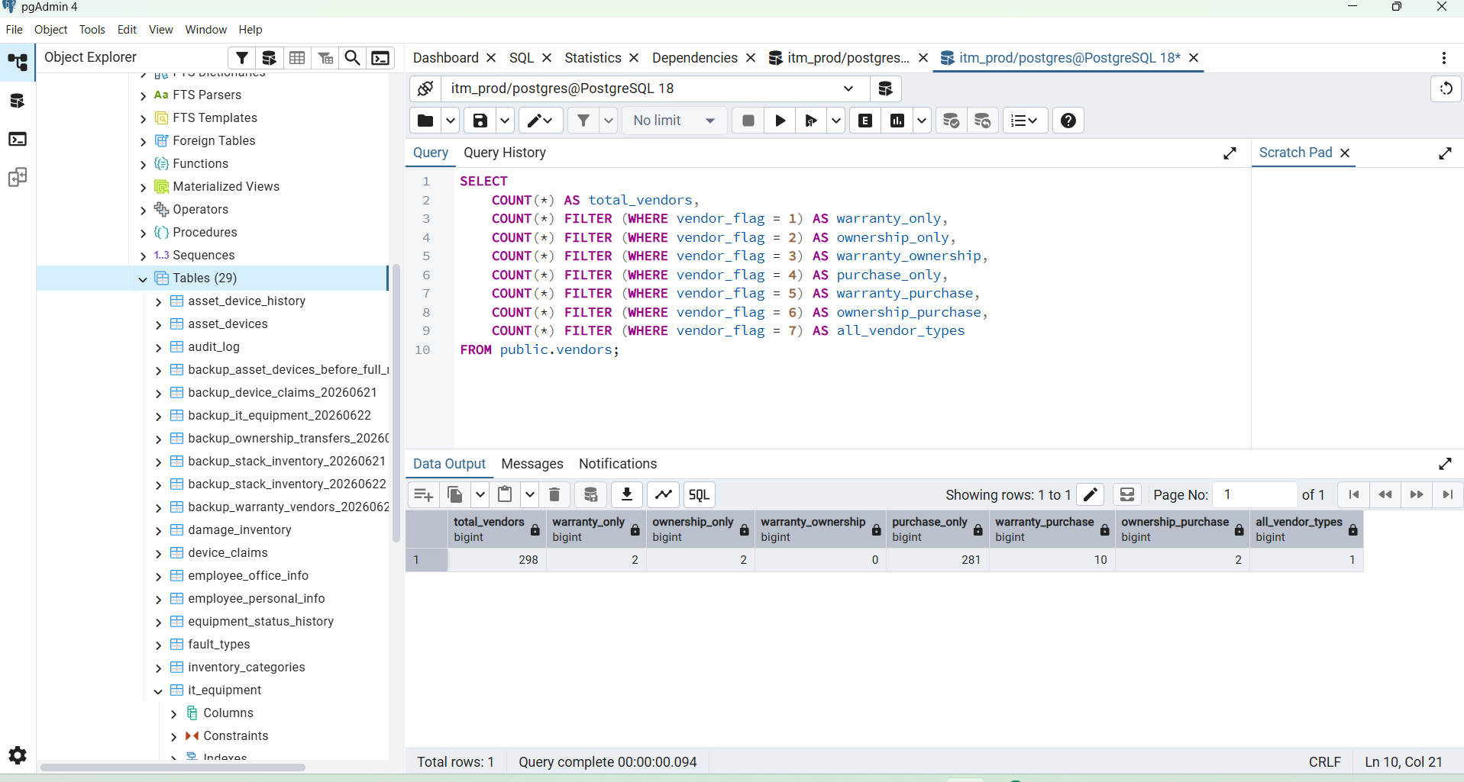

Perfect BOSS — vendor merge is successful.
Your result:
Total vendors = 298
Purchase only = 281
Warranty only = 2
Ownership only = 2
Warranty + Purchase = 10
Ownership + Purchase = 2
All vendor types = 1
This is correct. Now next step is to connect each device row with the correct vendor ID.
Step 3 — Map asset_devices.vendor_id
Run this:
UPDATE public.asset_devices ad
SET vendor_id = v.id
FROM public.vendors v
WHERE ad.vendor_id IS NULL
AND NULLIF(BTRIM(ad.vendor_name), '') IS NOT NULL
AND v.vendor_key = LOWER(BTRIM(ad.vendor_name));
This will connect:
asset_devices.vendor_name
↓
vendors.vendor_key
↓
asset_devices.vendor_id
Then verify mapping:
SELECT
COUNT(*) AS total_assets,
COUNT(*) FILTER (
WHERE NULLIF(BTRIM(vendor_name), '') IS NOT NULL
) AS assets_with_vendor_name,
COUNT(*) FILTER (
WHERE vendor_id IS NOT NULL
) AS assets_linked_to_vendor,
COUNT(*) FILTER (
WHERE NULLIF(BTRIM(vendor_name), '') IS NOT NULL
AND vendor_id IS NULL
) AS vendor_name_but_not_linked,
COUNT(*) FILTER (
WHERE NULLIF(BTRIM(vendor_name), '') IS NULL
AND vendor_id IS NULL
) AS assets_without_vendor_info
FROM public.asset_devices;
Expected:
total_assets = 3762
assets_with_vendor_name = 2623
assets_linked_to_vendor = 2623
vendor_name_but_not_linked = 0
assets_without_vendor_info = 1139
After that, inspect a few mapped rows:
SELECT
ad.id AS asset_id,
ad.device_serial,
ad.vendor_name AS old_vendor_text,
ad.vendor_id,
v.vendor_name AS master_vendor_name,
v.vendor_flag
FROM public.asset_devices ad
LEFT JOIN public.vendors v
ON v.id = ad.vendor_id
WHERE ad.vendor_id IS NOT NULL
ORDER BY ad.id DESC
LIMIT 30;
When the result is correct, next step will add the foreign-key constraint:
asset_devices.vendor_id → vendors.id

BOSS, UPDATE 0 is not an error.
It means there are no rows left matching this condition:
ad.vendor_id IS NULL
AND vendor_name is not empty
Most likely the earlier transaction had already completed the mapping part before it failed later, so vendor IDs are already assigned.
Now run this verification query:
SELECT
COUNT(*) AS total_assets,
COUNT(*) FILTER (
WHERE NULLIF(BTRIM(vendor_name), '') IS NOT NULL
) AS assets_with_vendor_name,
COUNT(*) FILTER (
WHERE vendor_id IS NOT NULL
) AS assets_linked_to_vendor,
COUNT(*) FILTER (
WHERE NULLIF(BTRIM(vendor_name), '') IS NOT NULL
AND vendor_id IS NULL
) AS vendor_name_but_not_linked,
COUNT(*) FILTER (
WHERE NULLIF(BTRIM(vendor_name), '') IS NULL
AND vendor_id IS NULL
) AS assets_without_vendor_info
FROM public.asset_devices;

Expected result:
total_assets = 3762
assets_with_vendor_name = 2623
assets_linked_to_vendor = 2623
vendor_name_but_not_linked = 0
assets_without_vendor_info = 1139

Then inspect some rows:
SELECT
ad.id AS asset_id,
ad.device_serial,
ad.vendor_name AS old_vendor_text,
ad.vendor_id,
v.vendor_name AS master_vendor_name,
v.vendor_flag
FROM public.asset_devices ad
LEFT JOIN public.vendors v
ON v.id = ad.vendor_id
WHERE ad.vendor_name IS NOT NULL
ORDER BY ad.id DESC
LIMIT 30;
When vendor_name_but_not_linked = 0, run the final relation step:
CREATE INDEX IF NOT EXISTS idx_asset_devices_vendor_id
ON public.asset_devices(vendor_id);
ALTER TABLE public.asset_devices
DROP CONSTRAINT IF EXISTS fk_asset_devices_vendor;
ALTER TABLE public.asset_devices
ADD CONSTRAINT fk_asset_devices_vendor
FOREIGN KEY (vendor_id)
REFERENCES public.vendors(id)
ON DELETE SET NULL
NOT VALID;
After that, asset_devices.vendor_id → vendors.id relation is safely complete.
Next step to forward
SELECT
COUNT(*) AS total_assets,

COUNT(*) FILTER (
WHERE NULLIF(BTRIM(vendor_name), '') IS NOT NULL
) AS assets_with_vendor_name,

COUNT(*) FILTER (
WHERE vendor_id IS NOT NULL
) AS assets_linked_to_vendor,

COUNT(*) FILTER (
WHERE NULLIF(BTRIM(vendor_name), '') IS NOT NULL
AND vendor_id IS NULL
) AS vendor_name_but_not_linked,

COUNT(*) FILTER (
WHERE NULLIF(BTRIM(vendor_name), '') IS NULL
AND vendor_id IS NULL
) AS assets_without_vendor_info
FROM public.asset_devices;

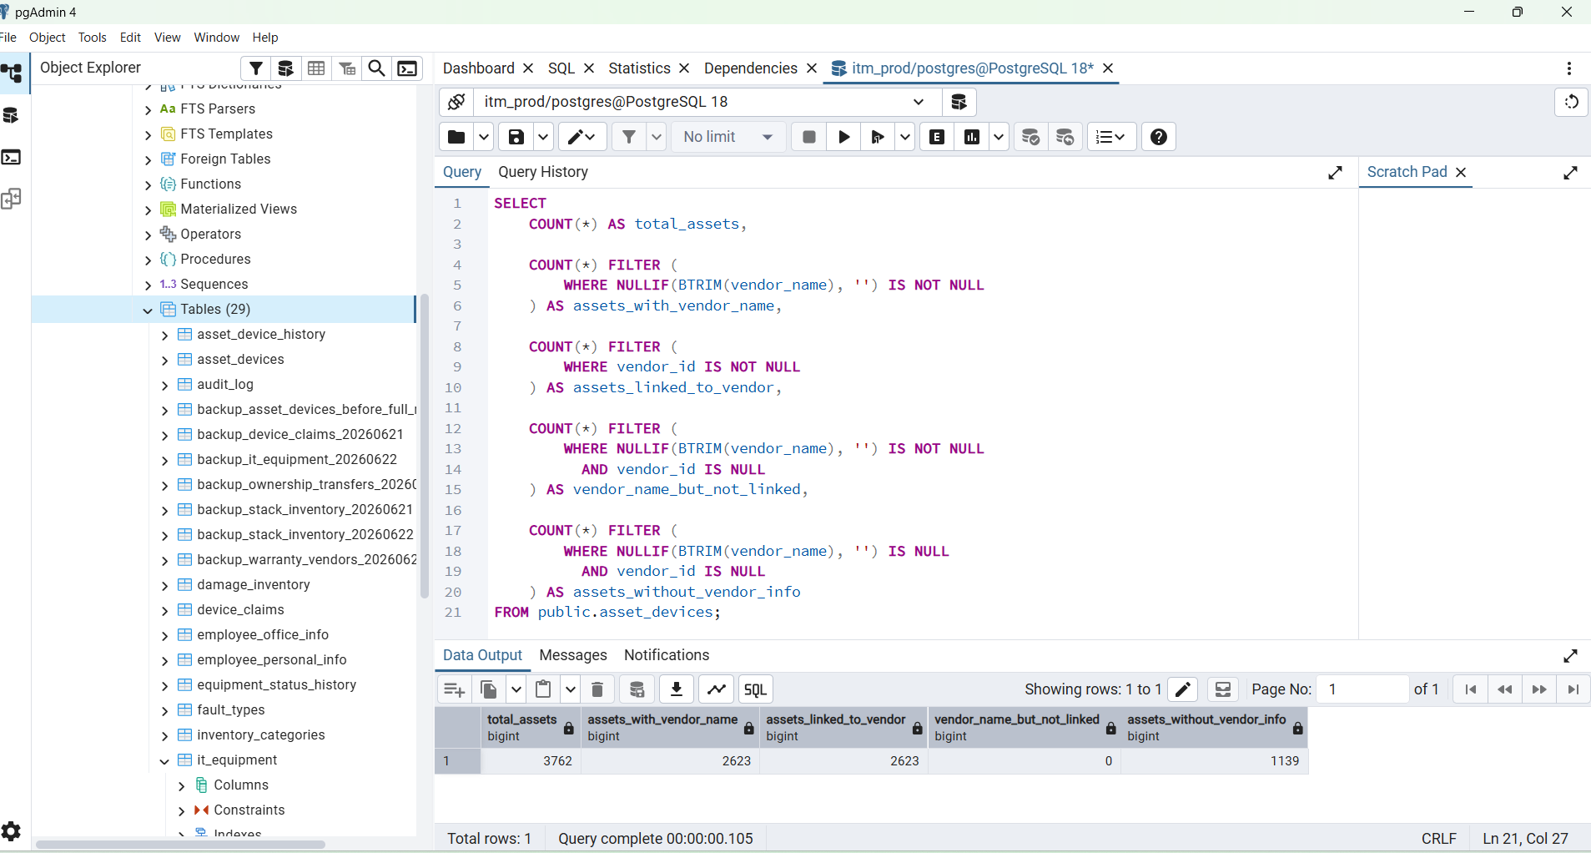

---------------------------------------------------------------------------------------------------------------
CREATE INDEX IF NOT EXISTS idx_asset_devices_vendor_id
ON public.asset_devices(vendor_id);

ALTER TABLE public.asset_devices
DROP CONSTRAINT IF EXISTS fk_asset_devices_vendor;

ALTER TABLE public.asset_devices
ADD CONSTRAINT fk_asset_devices_vendor
FOREIGN KEY (vendor_id)
REFERENCES public.vendors(id)
ON DELETE SET NULL
NOT VALID;

NOTICE: relation "idx_asset_devices_vendor_id" already exists, skipping
ALTER TABLE

Query returned successfully in 152 msec.

BOSS, UPDATE 0 means mapping was likely already completed earlier. Now verify first.
Run this:
SELECT
COUNT(*) AS total_assets,
COUNT(*) FILTER (
WHERE NULLIF(BTRIM(vendor_name), '') IS NOT NULL
) AS assets_with_vendor_name,
COUNT(*) FILTER (
WHERE vendor_id IS NOT NULL
) AS assets_linked_to_vendor,
COUNT(*) FILTER (
WHERE NULLIF(BTRIM(vendor_name), '') IS NOT NULL
AND vendor_id IS NULL
) AS vendor_name_but_not_linked,
COUNT(*) FILTER (
WHERE NULLIF(BTRIM(vendor_name), '') IS NULL
AND vendor_id IS NULL
) AS assets_without_vendor_info
FROM public.asset_devices;
Expected:
total_assets = 3762
assets_with_vendor_name = 2623
assets_linked_to_vendor = 2623
vendor_name_but_not_linked = 0
assets_without_vendor_info = 1139
If vendor_name_but_not_linked = 0, then run this final vendor relation SQL:
CREATE INDEX IF NOT EXISTS idx_asset_devices_vendor_id
ON public.asset_devices(vendor_id);
ALTER TABLE public.asset_devices
DROP CONSTRAINT IF EXISTS fk_asset_devices_vendor;
ALTER TABLE public.asset_devices
ADD CONSTRAINT fk_asset_devices_vendor
FOREIGN KEY (vendor_id)
REFERENCES public.vendors(id)
ON DELETE SET NULL
NOT VALID;
Then verify the foreign key exists:
SELECT
conname AS constraint_name,
pg_get_constraintdef(oid) AS constraint_definition
FROM pg_constraint
WHERE conrelid = 'public.asset_devices'::regclass
AND contype = 'f';
Expected relation:
fk_asset_devices_vendor
FOREIGN KEY (vendor_id) REFERENCES vendors(id) ON DELETE SET NULL
After this, your device-vendor relation is complete:
asset_devices.vendor_id → vendors.id
Keep asset_devices.vendor_name for now as a migration backup; do not drop it yet.

BOSS, এখন next step হলো vendor mapping verification। আগে নিশ্চিত হবো সব vendor_name-এর জন্য vendor_id বসেছে কি না।
Run this query:
SELECT
COUNT(*) AS total_assets,
COUNT(*) FILTER (
WHERE NULLIF(BTRIM(vendor_name), '') IS NOT NULL
) AS assets_with_vendor_name,
COUNT(*) FILTER (
WHERE vendor_id IS NOT NULL
) AS assets_linked_to_vendor,
COUNT(*) FILTER (
WHERE NULLIF(BTRIM(vendor_name), '') IS NOT NULL
AND vendor_id IS NULL
) AS vendor_name_but_not_linked,
COUNT(*) FILTER (
WHERE NULLIF(BTRIM(vendor_name), '') IS NULL
AND vendor_id IS NULL
) AS assets_without_vendor_info
FROM public.asset_devices;
Expected result:
total_assets = 3762
assets_with_vendor_name = 2623
assets_linked_to_vendor = 2623
vendor_name_but_not_linked = 0
assets_without_vendor_info = 1139
If vendor_name_but_not_linked = 0
Then run this final relation query:
CREATE INDEX IF NOT EXISTS idx_asset_devices_vendor_id
ON public.asset_devices(vendor_id);
ALTER TABLE public.asset_devices
DROP CONSTRAINT IF EXISTS fk_asset_devices_vendor;
ALTER TABLE public.asset_devices
ADD CONSTRAINT fk_asset_devices_vendor
FOREIGN KEY (vendor_id)
REFERENCES public.vendors(id)
ON DELETE SET NULL
NOT VALID;
Then verify foreign key:
SELECT
conname AS constraint_name,
pg_get_constraintdef(oid) AS constraint_definition
FROM pg_constraint
WHERE conrelid = 'public.asset_devices'::regclass
AND contype = 'f';
Expected:
fk_asset_devices_vendor
FOREIGN KEY (vendor_id) REFERENCES vendors(id) ON DELETE SET NULL
After this, your professional relation is complete:
asset_devices.vendor_id → vendors.id
Keep vendor_name column for now as old-data backup.
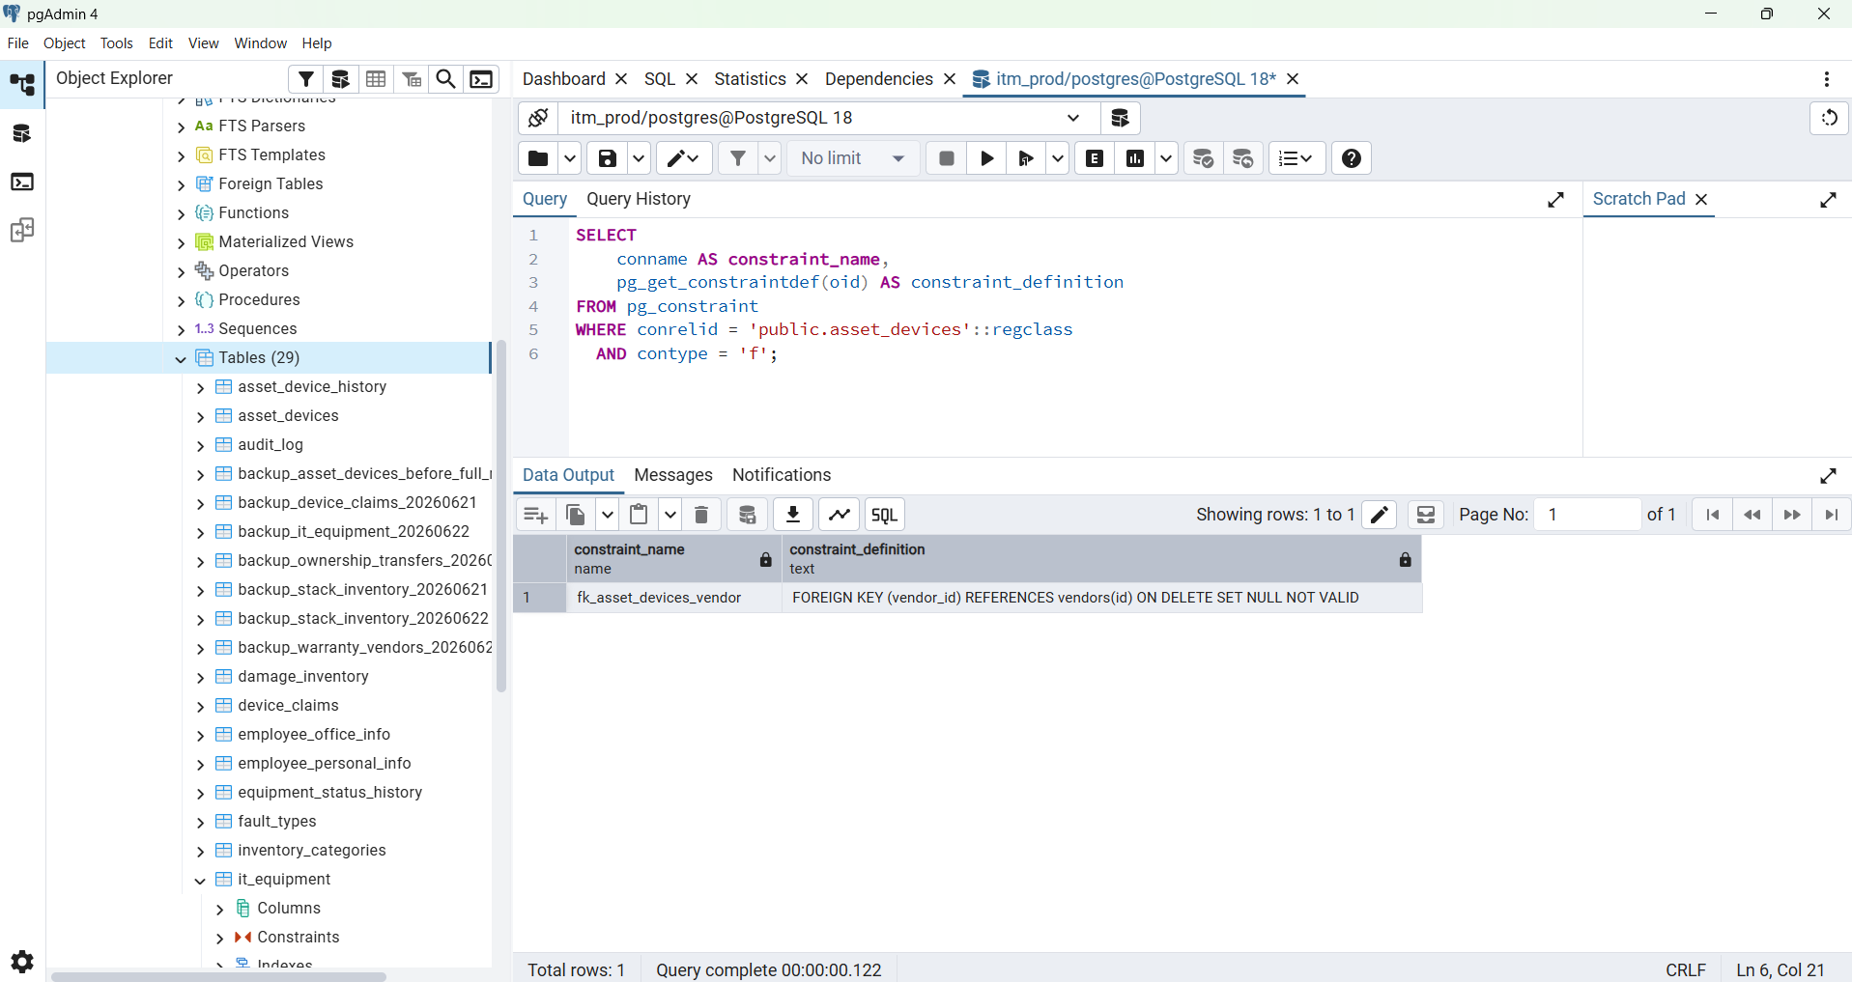

--------------------------------------------------------------------------------------------------------------------------------------------------------

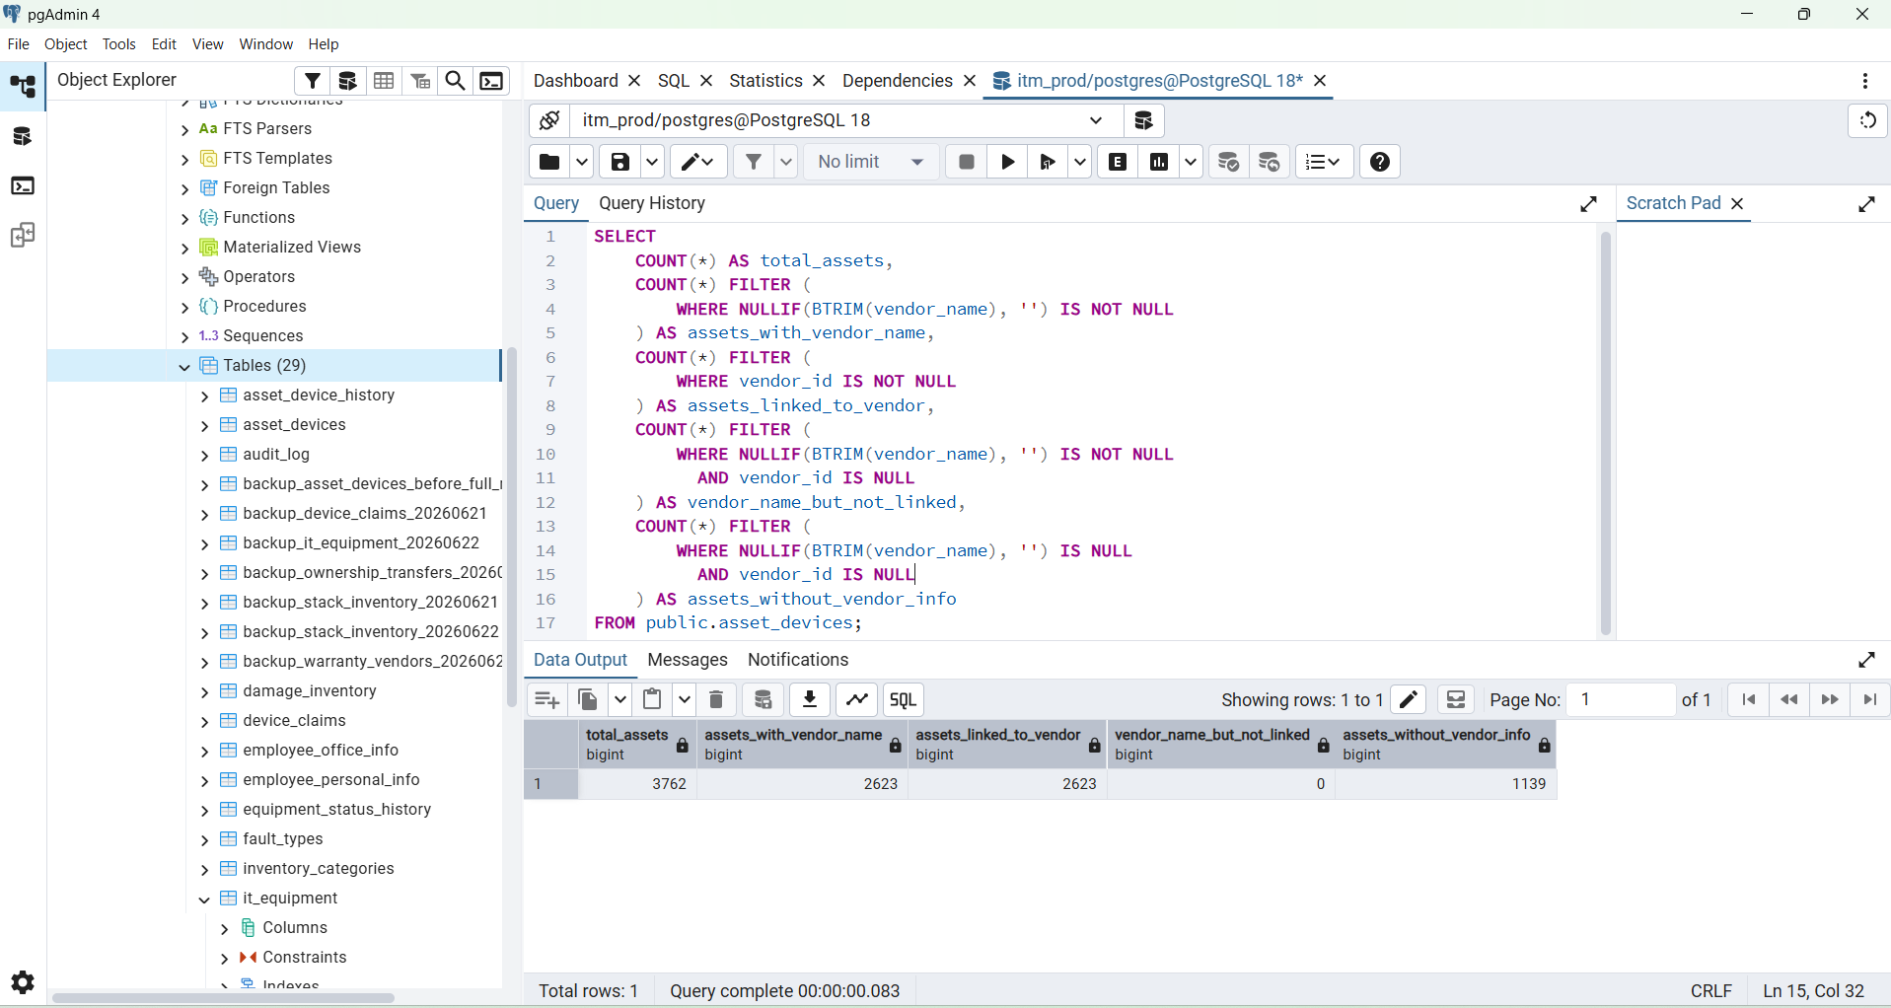

Next Step to Forward

BOSS, এখন final database validation করুন। Screenshot-এ foreign key আছে, কিন্তু এখনো NOT VALID দেখাচ্ছে। এটি validate করলে vendor migration officially complete হবে।
Run this:
ALTER TABLE public.asset_devices
VALIDATE CONSTRAINT fk_asset_devices_vendor;
Successful হলে pgAdmin দেখাবে:
ALTER TABLE
তারপর final check:
SELECT
COUNT(*) AS total_assets,
COUNT(*) FILTER (
WHERE NULLIF(BTRIM(vendor_name), '') IS NOT NULL
) AS assets_with_vendor_name,
COUNT(*) FILTER (
WHERE vendor_id IS NOT NULL
) AS assets_linked_to_vendor,
COUNT(*) FILTER (
WHERE NULLIF(BTRIM(vendor_name), '') IS NOT NULL
AND vendor_id IS NULL
) AS vendor_name_but_not_linked
FROM public.asset_devices;
Expected important result:
vendor_name_but_not_linked = 0
After that, database migration part is complete.
Then move to backend safely:
- Keep existing dashboard summary API unchanged.
- Do not replace Assigned 2614, Returned 923, Transferred 754, Available 130.
- Add a new endpoint for the new unique-device table, such as:
GET /api/v1/assets/devices?page=1&limit=50
This new endpoint will fetch from:
asset_devices
LEFT JOIN vendors
and return:
serial, category, brand, model, status,
employee, department, vendor, assigned_date
Use this query inside that new API:
SELECT
ad.id,
ad.device_serial,
ad.category,
ad.brand,
ad.model,
ad.device_type,
ad.asset_status,
ad.emp_id,
ad.emp_name,
ad.department,
ad.designation,
ad.assigned_date,
ad.vendor_id,
COALESCE(v.vendor_name, ad.vendor_name) AS vendor_name,
v.vendor_flag,
ad.created_at,
ad.updated_at
FROM public.asset_devices ad
LEFT JOIN public.vendors v
ON v.id = ad.vendor_id
ORDER BY ad.updated_at DESC, ad.id DESC
LIMIT $1 OFFSET $2;
Next development task: create the new backend Asset Devices List API without touching the old dashboard summary logic.

------------------------------------------------------------------------------------------------------------------------------------

ALTER TABLE public.asset_devices
VALIDATE CONSTRAINT fk_asset_devices_vendor;

ALTER TABLE
Query returned successfully in 80 msec.

SELECT
COUNT(*) AS total_assets,
COUNT(*) FILTER (
WHERE NULLIF(BTRIM(vendor_name), '') IS NOT NULL
) AS assets_with_vendor_name,
COUNT(*) FILTER (
WHERE vendor_id IS NOT NULL
) AS assets_linked_to_vendor,
COUNT(*) FILTER (
WHERE NULLIF(BTRIM(vendor_name), '') IS NOT NULL
AND vendor_id IS NULL
) AS vendor_name_but_not_linked
FROM public.asset_devices;

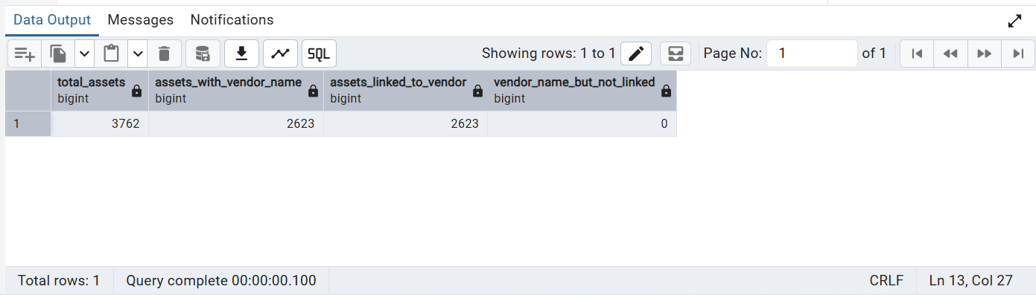

Last step

Next step to forward
Thought for a few seconds
BOSS, এখন final database validation করুন। Screenshot-এ foreign key আছে, কিন্তু এখনো NOT VALID দেখাচ্ছে। এটি validate করলে vendor migration officially complete হবে।
Run this:
ALTER TABLE public.asset_devices
VALIDATE CONSTRAINT fk_asset_devices_vendor;
Successful হলে pgAdmin দেখাবে:
ALTER TABLE
তারপর final check:
SELECT
COUNT(*) AS total_assets,
COUNT(*) FILTER (
WHERE NULLIF(BTRIM(vendor_name), '') IS NOT NULL
) AS assets_with_vendor_name,
COUNT(*) FILTER (
WHERE vendor_id IS NOT NULL
) AS assets_linked_to_vendor,
COUNT(*) FILTER (
WHERE NULLIF(BTRIM(vendor_name), '') IS NOT NULL
AND vendor_id IS NULL
) AS vendor_name_but_not_linked
FROM public.asset_devices;
Expected important result:
vendor_name_but_not_linked = 0
After that, database migration part is complete.
Then move to backend safely:
- Keep existing dashboard summary API unchanged.
- Do not replace Assigned 2614, Returned 923, Transferred 754, Available 130.
- Add a new endpoint for the new unique-device table, such as:
GET /api/v1/assets/devices?page=1&limit=50
This new endpoint will fetch from:
asset_devices
LEFT JOIN vendors
and return:
serial, category, brand, model, status,
employee, department, vendor, assigned_date
Use this query inside that new API:
SELECT
ad.id,
ad.device_serial,
ad.category,
ad.brand,
ad.model,
ad.device_type,
ad.asset_status,
ad.emp_id,
ad.emp_name,
ad.department,
ad.designation,
ad.assigned_date,
ad.vendor_id,
COALESCE(v.vendor_name, ad.vendor_name) AS vendor_name,
v.vendor_flag,
ad.created_at,
ad.updated_at
FROM public.asset_devices ad
LEFT JOIN public.vendors v
ON v.id = ad.vendor_id
ORDER BY ad.updated_at DESC, ad.id DESC
LIMIT $1 OFFSET $2;
Next development task: create the new backend Asset Devices List API without touching the old dashboard summary logic.

