https://chatgpt.com/c/6a29381f-0528-83a4-a117-fa1ece38f4ab

api.ts
→ BASE = http://localhost:8080/api/v1
→ Authorization: Bearer itm_token
→ /assets/ownership/summary
→ /assets/ownership

Perfect — তোমার api.ts-এ already central api.get() client আছে, and it uses:
const BASE =
process.env.NEXT_PUBLIC_API_URL ??
"http://localhost:8080/api/v1";

SUM(CASE WHEN owst_category = 1 THEN 1 ELSE 0 END) AS user_ownership,
SUM(CASE WHEN owst_category = 2 THEN 1 ELSE 0 END) AS vendor_ownership,
SUM(CASE WHEN owst_category IN (1, 2) THEN 1 ELSE 0 END) AS total_ownership
FROM itm.tbl_device_ownership_transfer_form;

user_ownership : 58
vendor_ownership : 119
total_ownership : 177

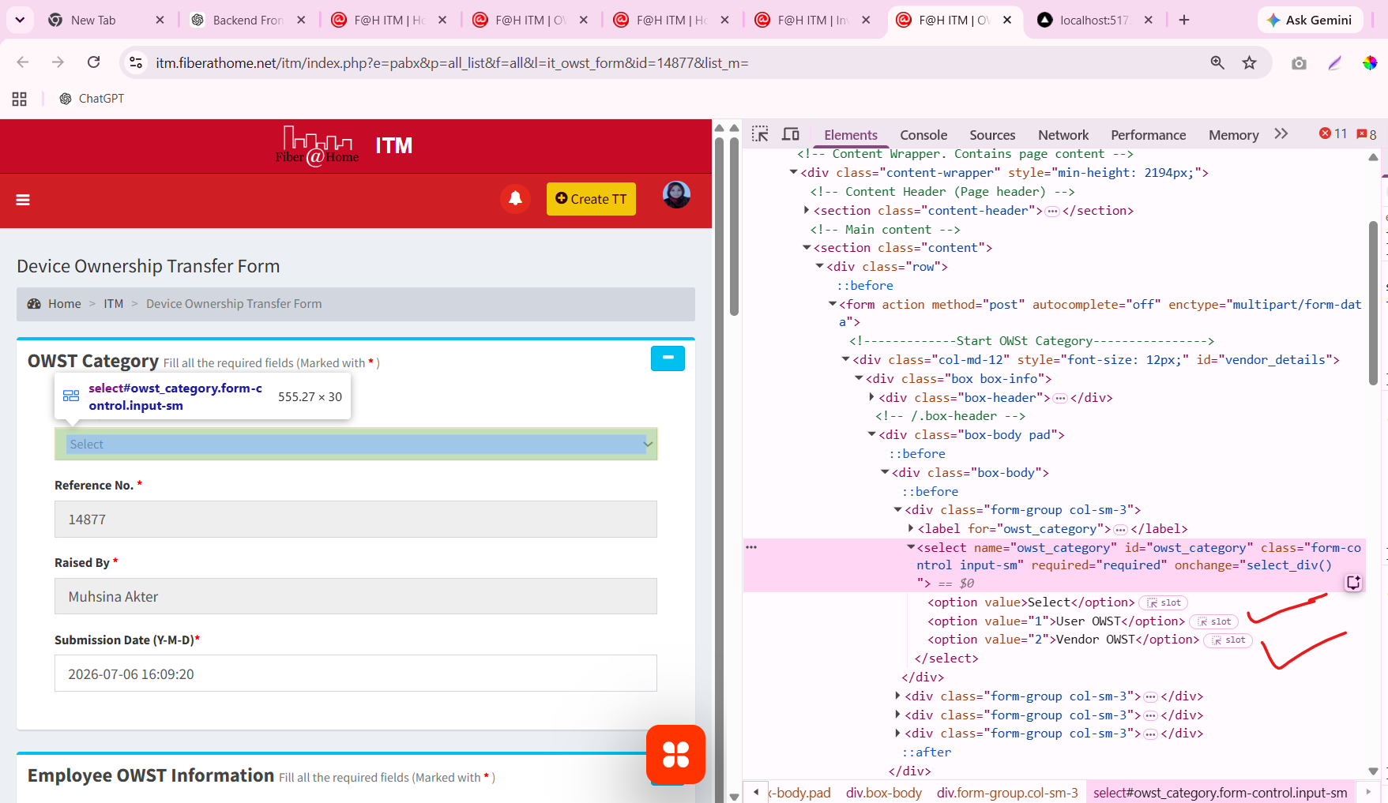

3. Get User / Vendor / Total counts in one PostgreSQL query

SELECT
COUNT(*) FILTER (WHERE owst_category = 1) AS user_ownership,
COUNT(*) FILTER (WHERE owst_category = 2) AS vendor_ownership,
COUNT(*) FILTER (WHERE owst_category IN (1, 2)) AS total_ownership
FROM public.ownership_transfers;

Expected structure:
user_ownership | vendor_ownership | total_ownership
----------------- |------------------ |----------------
58 | 119 | 177

4. Better grouped query for dashboard/API
This gives one row per ownership type:
SELECT
CASE owst_category
WHEN 1 THEN 'User Ownership'
WHEN 2 THEN 'Vendor Ownership'
END AS ownership_type,
COUNT(*) AS total
FROM public.ownership_transfers
WHERE owst_category IN (1, 2)
GROUP BY owst_category
ORDER BY owst_category;
Result:
User Ownership | 58
Vendor Ownership | 119

Important: Your current asset_devices query is a different source
This query:
SELECT
id,
device_serial,
emp_id,
emp_name,
department,
designation,
asset_status
FROM public.asset_devices
WHERE asset_status = 7
AND row_status = 1
ORDER BY id DESC;
returns the current asset registry ownership records, and your screenshot shows 168 rows.
But ownership_transfers is the actual ownership-transfer source table. Before changing the dashboard total from 168 to 177, check whether the same device appears in both places. Otherwise you may double-count ownership records.
Run this next:
SELECT
owst_category,
COUNT(*) AS total
FROM public.ownership_transfers
WHERE owst_category IN (1, 2)
GROUP BY owst_category
ORDER BY owst_category;

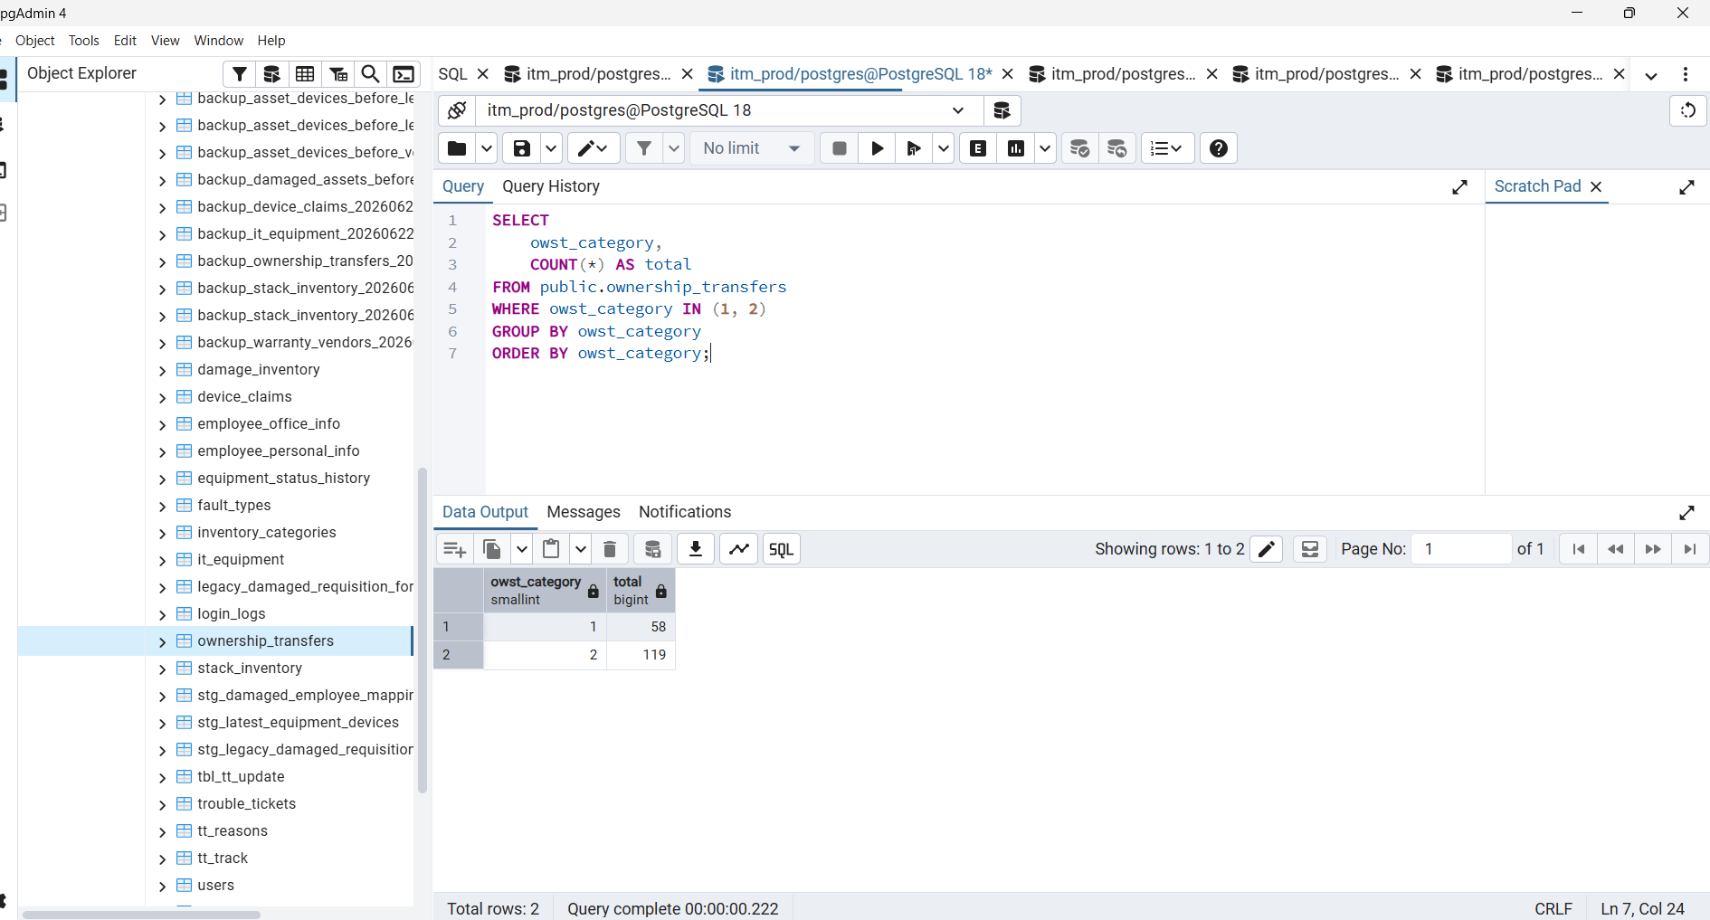

how to implement data in this page for ownership
Thought for 5s
We will implement it in 3 parts:
1. Backend API from public.ownership_transfers
2. frontend lib/api.ts method
3. Replace mock ownership[] data in ownership-assets page
Your uploaded asset_device.go already has the correct handler structure and pgxpool database access, so we can add the ownership API there or create a separate handler later.
Before writing the SQL fields, we need the real columns from your live ownership_transfers table. The page needs employee, serial, device, reference, date, and ownership category — but we must use your exact database field names.
Step 1 — Run this on the live database
SELECT
column_name,
data_type
FROM information_schema.columns
WHERE table_schema = 'public'
AND table_name = 'ownership_transfers'
ORDER BY ordinal_position;
Then run:
SELECT *
FROM public.ownership_transfers
WHERE owst_category IN (1, 2)
ORDER BY id DESC
LIMIT 5;
Send both screenshots/results.
After you send that, I will give you only the next copy-paste step:
backend/internal/handler/ownership_transfer.go
with:
GET /api/v1/ownership-transfers
GET /api/v1/ownership-transfers?category=1
GET /api/v1/ownership-transfers?category=2
GET /api/v1/ownership-transfers/summary
Then we will connect your current page and remove this mock block:
const ownership: Claim[] = [
...
];
The final page will load:
Total Ownership → 177
User Ownership → 58
Vendor Ownership → 119
from the live API, not hardcoded frontend data.

Perfect — তোমার api.ts-এ already central api.get() client আছে, and it uses:
const BASE =
process.env.NEXT_PUBLIC_API_URL ??
"http://localhost:8080/api/v1";
So ownership page-এ direct fetch() লাগবে না. We will use the same api.get() pattern that your dashboard and report APIs already use.
Step 1 — Add Ownership API in frontend/lib/api.ts
In api.ts, find this existing section:
export const assetDeviceApi = {
list: (params?: {
page?: number;
limit?: number;
category?: string;
status?: number;
vendor_id?: number;
search?: string;
}) => {
// ...
},
get: (id: number) =>
api.get<ApiOk<AssetDevice>>(`/assets/devices/${id}`),
history: (id: number) =>
api.get<ApiOk<AssetDeviceHistory[]>>(`/assets/devices/${id}/history`),
};
Immediately below it, paste this:
export interface OwnershipSummary {
user_ownership: number;
vendor_ownership: number;
total_ownership: number;
current_asset_count: number;
}
export interface OwnershipAsset {
id: number;
reference: string;
device_serial: string | null;
category: string | null;
brand: string | null;
model: string | null;
emp_id: string | null;
emp_name: string | null;
department: string | null;
designation: string | null;
assigned_date: string | null;
purchase_date: string | null;
warranty_date: string | null;
asset_status: number;
status_label: string;
created_at: string | null;
updated_at: string | null;
}
export const ownershipApi = {
summary: () =>
api.get<ApiOk<OwnershipSummary>>(
"/assets/ownership/summary"
),
list: () =>
api.get<ApiOk<OwnershipAsset[]>>(
"/assets/ownership"
),
};
Save api.ts.
This creates these frontend API methods:
ownershipApi.summary()
ownershipApi.list()
They will call:
http://localhost:8080/api/v1/assets/ownership/summary
http://localhost:8080/api/v1/assets/ownership
using your existing token and central API base configuration.
Next, we will update the ownership page imports and replace its direct fetch() calls with ownershipApi.summary() and ownershipApi.list().

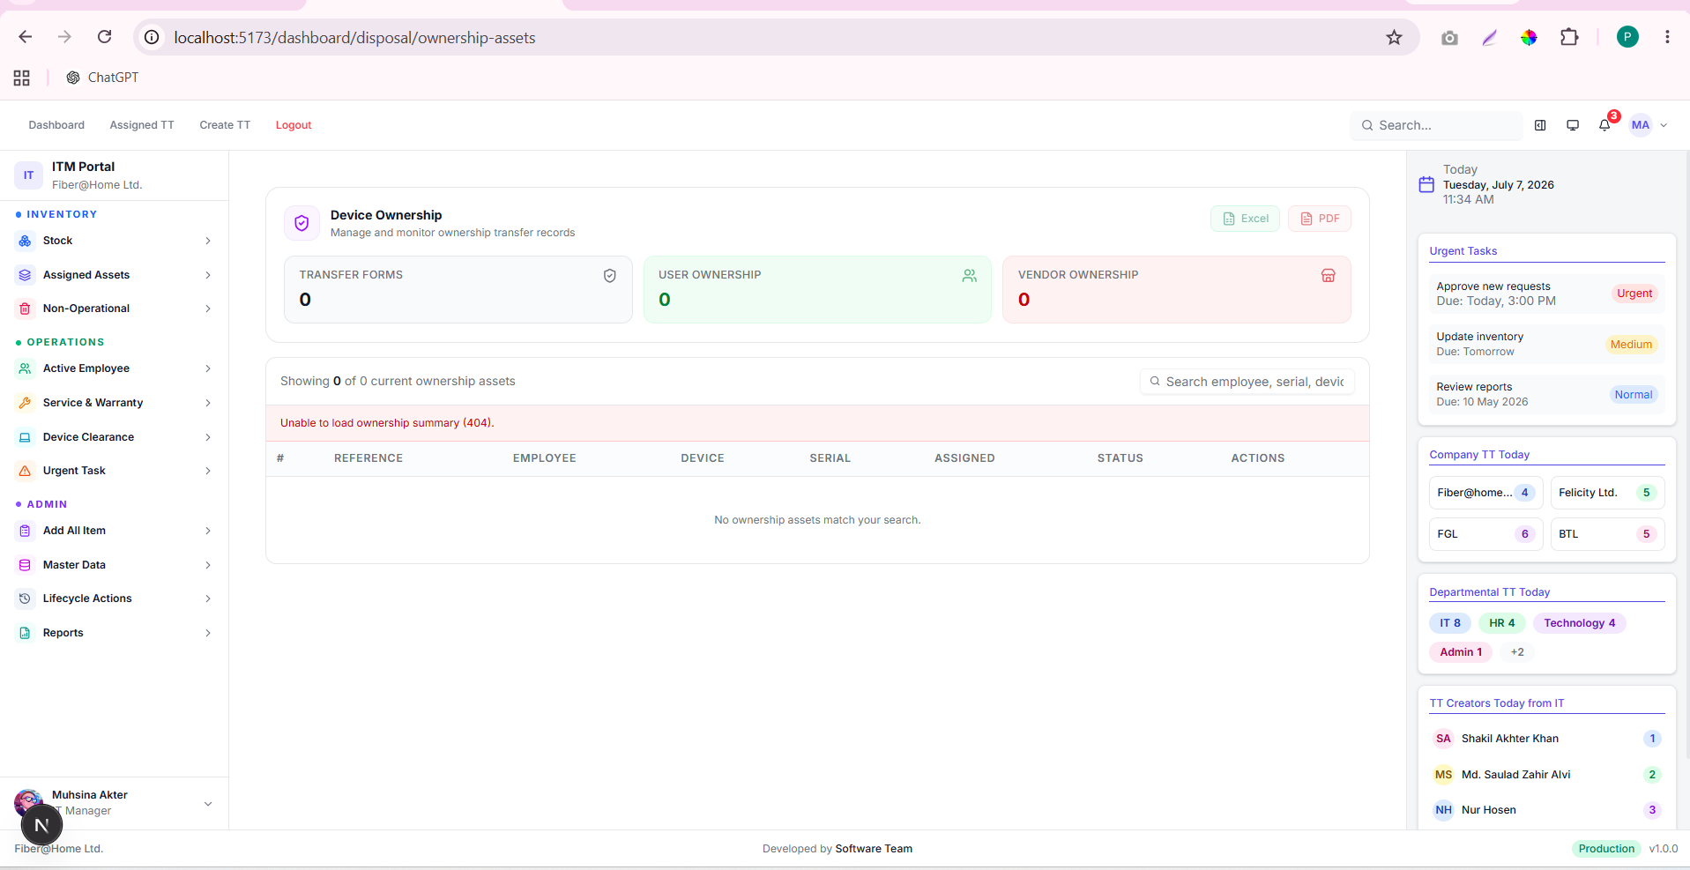

Because these now come from @/lib/api.

SELECT
COUNT(*) FILTER (WHERE owst_category = 1 AND status = 1) AS user_ownership,
COUNT(*) FILTER (WHERE owst_category = 2 AND status = 1) AS vendor_ownership,
COUNT(*) FILTER (WHERE owst_category IN (1, 2) AND status = 1) AS total_ownership
FROM public.ownership_transfers;

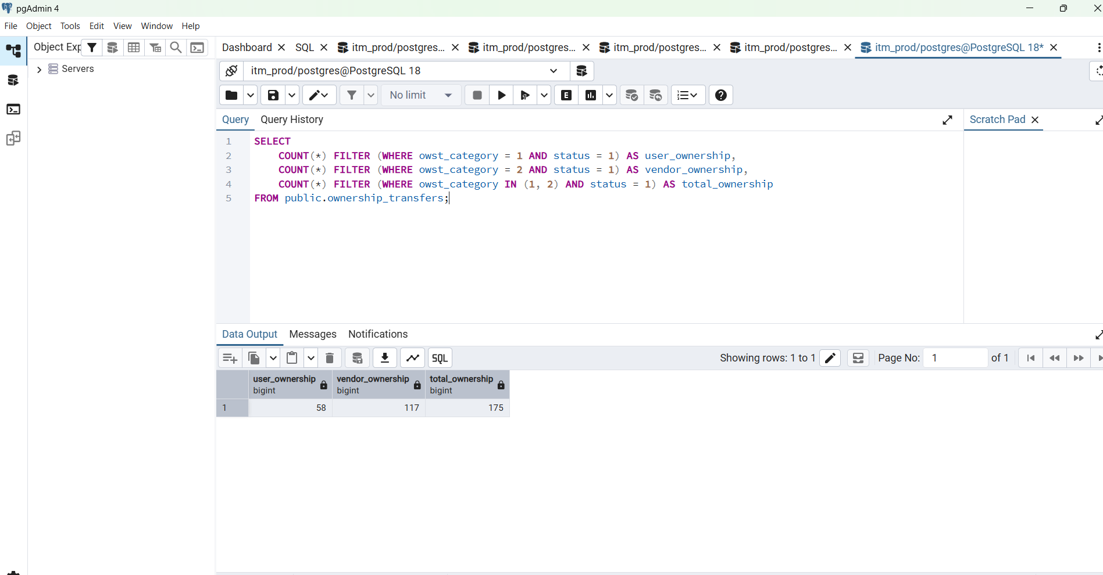

SELECT
column_name,
data_type
FROM information_schema.columns
WHERE table_schema = 'public'
AND table_name = 'ownership_transfers'
ORDER BY ordinal_position;

