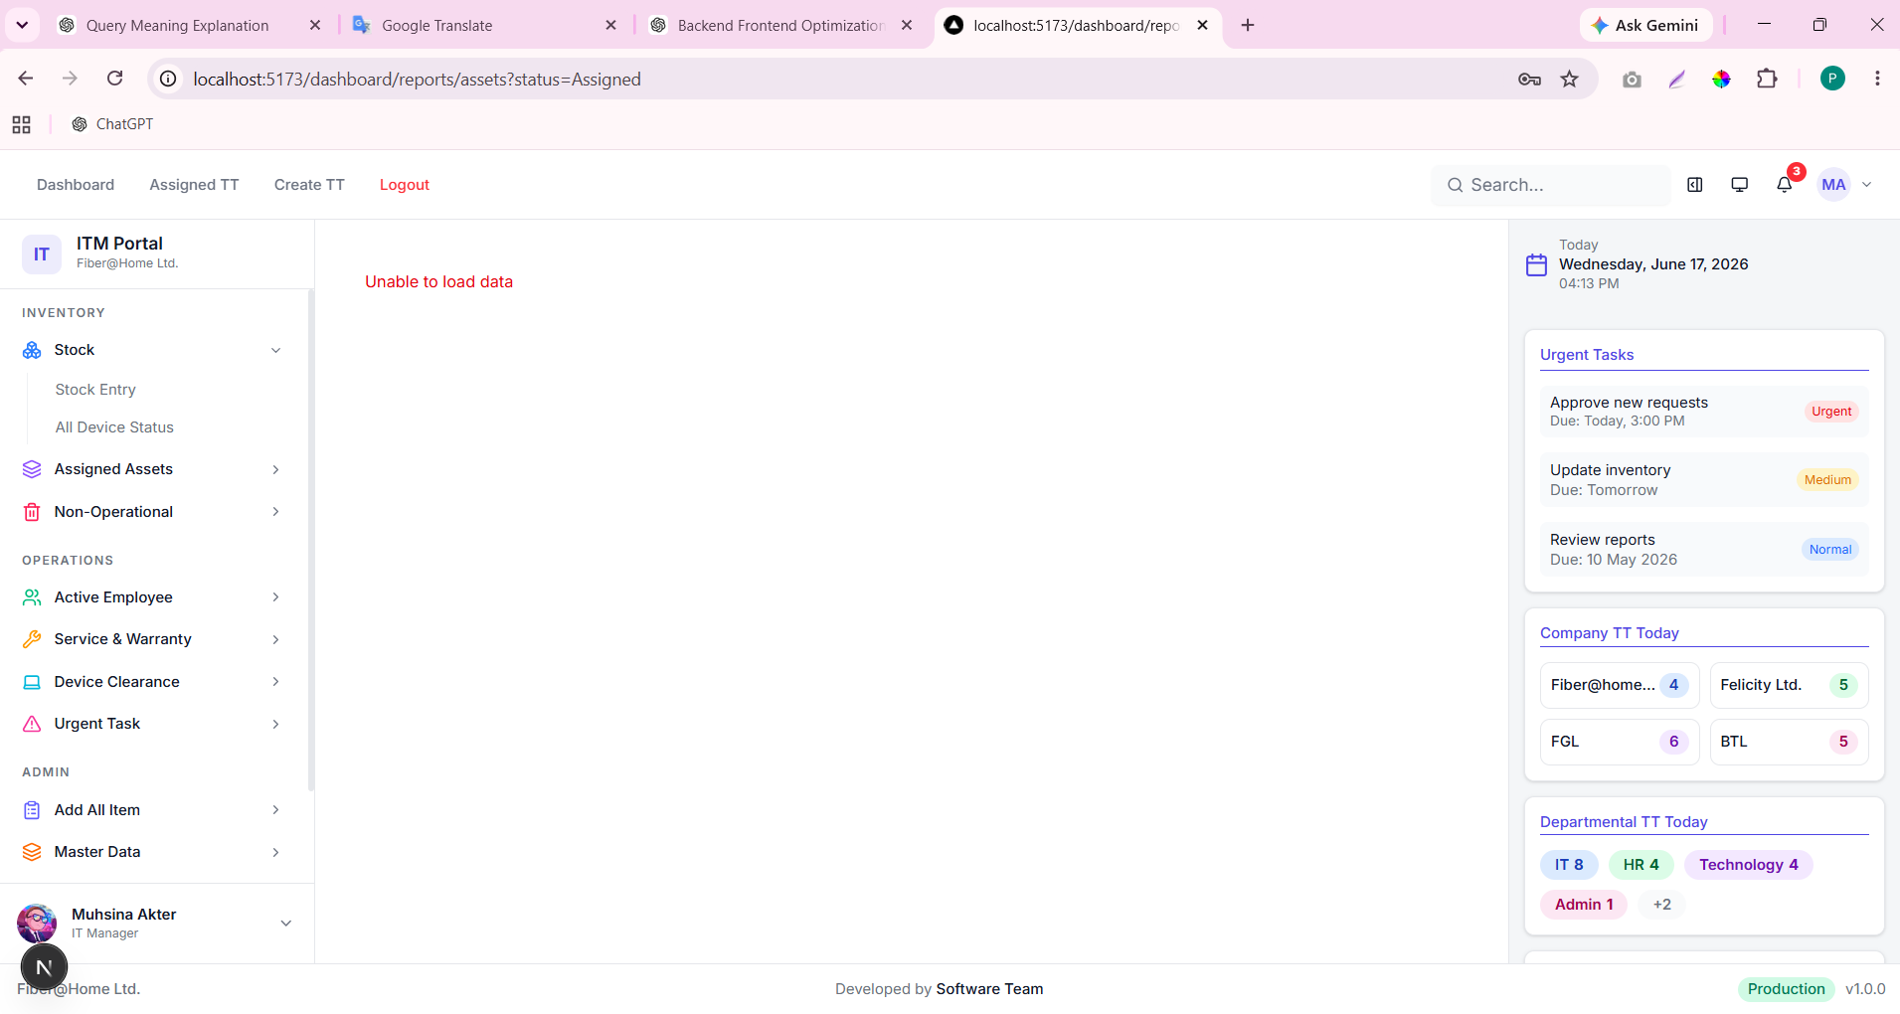

Now I want to show data in dashboard or entire system . or next step to forward. professional and industrial methods
Thought for 24s
BOSS, database import is done. Now the real professional next step is:
Database data → Backend API → Frontend service → Dashboard/pages
Right now your dashboard is still using static frontend values like 11797, 42, 28, and sections from tt-data. So even though database has data, dashboard will not automatically show it until we connect frontend with backend API. Your uploaded dashboard/page.tsx is still mostly static/hardcoded chart data.
Current issue
This screen:
Unable to load data
usually means one of these:
1. Frontend API call URL is wrong
2. Backend endpoint is missing
3. Backend query failed
4. Token/auth header missing
5. API response format does not match frontend expected format
So next step should be API-first, not UI-first.

Professional next step
Step 1: Verify backend can read imported data
Run these in pgAdmin:
SELECT COUNT(*) FROM public.it_equipment;
SELECT COUNT(*) FROM public.employee_office_info;
SELECT COUNT(*) FROM public.employee_personal_info;
SELECT COUNT(*) FROM public.device_claims;
SELECT COUNT(*) FROM public.damage_inventory;
SELECT COUNT(*) FROM public.ownership_transfers;
SELECT COUNT(*) FROM public.warranty_vendors;
SELECT COUNT(*) FROM public.tt_track;
If counts are showing, DB side is okay.

Step 2: Test backend API directly
Open browser/Postman/PowerShell and test current asset endpoint.
Example:
Invoke-RestMethod `
-Uri "http://localhost:8080/api/v1/reports/assets?status=Assigned&page=1&limit=20" `
-Method GET `
-Headers @{ Authorization = "Bearer YOUR_TOKEN_HERE" }
If this fails, frontend will also fail.

Recommended industrial API structure
Create one dashboard summary API:
GET /api/v1/dashboard/summary
Response should be like this:
{
"success": true,
"data": {
"active_assets": {
"total": 473,
"items": [
{ "label": "Assigned", "value": 300 },
{ "label": "Transferred", "value": 50 },
{ "label": "Returned", "value": 80 },
{ "label": "Available", "value": 43 }
]
},
"non_operational": {
"total": 265,
"items": [
{ "label": "Damaged", "value": 265 },
{ "label": "Lost", "value": 0 },
{ "label": "Ownership", "value": 185 }
]
},
"service_requests": {
"total": 152,
"items": [
{ "label": "Service Request", "value": 40 },
{ "label": "To Vendor", "value": 20 },
{ "label": "Closed", "value": 92 }
]
},
"warranty": {
"total": 13,
"items": [
{ "label": "Vendor", "value": 13 }
]
}
}
}
Then dashboard page will only consume this API.

Step 3: Use real SQL for dashboard summary
In backend dashboard service, use SQL like:
SELECT
COALESCE(status, 'Unknown') AS status,
COUNT(*) AS total
FROM public.it_equipment
WHERE COALESCE(active, 1) = 1
GROUP BY COALESCE(status, 'Unknown')
ORDER BY total DESC;
For category:
SELECT
COALESCE(category, 'Unknown') AS category,
COUNT(*) AS total
FROM public.it_equipment
WHERE COALESCE(active, 1) = 1
GROUP BY COALESCE(category, 'Unknown')
ORDER BY total DESC;
For service claims:
SELECT
COALESCE(status, 'Unknown') AS status,
COUNT(*) AS total
FROM public.device_claims
GROUP BY COALESCE(status, 'Unknown')
ORDER BY total DESC;
For damage:
SELECT COUNT(*) AS total
FROM public.damage_inventory;
For ownership transfer:
SELECT COUNT(*) AS total
FROM public.ownership_transfers;

Step 4: Frontend should remove static data
In frontend/app/dashboard/page.tsx, these should not stay static:
const activeAssetsData = [...]
const nonOpData = [...]
const warrantyDetails = [...]
const serviceData = [...]
const resignationAreaData = [...]
const renewalBarData = [...]
Instead use:
const [summary, setSummary] = useState<DashboardSummary | null>(null);
const [loading, setLoading] = useState(true);
const [error, setError] = useState("");
useEffect(() => {
async function loadDashboard() {
try {
setLoading(true);
setError("");
const data = await dashboardApi.summary();
setSummary(data);
} catch (err: any) {
setError(err?.message || "Unable to load dashboard data");
} finally {
setLoading(false);
}
}
loadDashboard();
}, []);
Then charts use:
summary.active_assets.items
summary.service_requests.items
summary.non_operational.items

Step 5: For full system pages
Every page should follow this structure:
Page
↓
Frontend service/api.ts
↓
Backend controller
↓
Backend service
↓
Repository
↓
PostgreSQL public table
For example:
/dashboard/reports/assets
Should call:
GET /api/v1/reports/assets?page=1&limit=20&status=Assigned&search=
Backend should query:
SELECT *
FROM public.it_equipment
WHERE active = 1
ORDER BY id DESC
LIMIT $1 OFFSET $2;
And count:
SELECT COUNT(*)
FROM public.it_equipment
WHERE active = 1;
Response:
{
"success": true,
"data": {
"items": [],
"page": 1,
"limit": 20,
"total": 473
}
}

Immediate next task
Before changing dashboard, first fix the page showing:
Unable to load data
Do this:
- Open browser DevTools.
- Go to Network tab.
- Reload /dashboard/reports/assets?status=Assigned.
- Click the failed API request.
- Send me:
  - Request URL
  - Status code
  - Response body
That will tell us exactly whether backend route is missing, query failing, or frontend API path wrong.
After that, we connect the real DB data to dashboard and all report pages cleanly.

Backend is now done. based on attached file need to forward step by step. to fetch and show data in dashboard with entire system
Thought for 6s
BOSS, backend done হলে এখন frontend side এ professional flow হবে:
Backend API
↓
frontend/lib/api.ts
↓
dashboard/page.tsx state/useEffect
↓
chart/table data mapping
↓
entire system pages
Your backend already has dashboard routes like /dashboard/stats, /dashboard/ticket-trend, and now you added /dashboard/summary. Your ReportHandler also has report routes like /reports/assigned, /reports/warranty, /reports/service, etc.
Your frontend dashboard currently still uses static arrays like activeAssetsData, warrantyDetails, serviceData, resignationAreaData, and renewalBarData, so these must be replaced by API data.

Step 1: Confirm frontend .env.local
File:
frontend/.env.local
Should be:
NEXT_PUBLIC_API_URL=http://localhost:8080/api/v1
API_URL=http://localhost:8080/api/v1
Then restart frontend after any env change:
cd D:\ITM-Data\itm\itm\frontend
npx next dev -p 5173

Step 2: Update frontend/lib/api.ts
Add this structure. If authApi already exists, keep it and only add getAuthHeaders, apiGet, dashboardApi, and reportsApi.
const API_BASE_URL = process.env.NEXT_PUBLIC_API_URL || "http://localhost:8080/api/v1";
function getAuthHeaders(): HeadersInit {
if (typeof window === "undefined") {
return {
"Content-Type": "application/json",
};
}
const token = localStorage.getItem("itm_token");
return {
"Content-Type": "application/json",
...(token ? { Authorization: `Bearer ${token}` } : {}),
};
}
async function apiGet<T>(path: string): Promise<T> {
const res = await fetch(`${API_BASE_URL}${path}`, {
method: "GET",
headers: getAuthHeaders(),
cache: "no-store",
});
const data = await res.json().catch(() => null);
if (!res.ok || data?.success === false) {
throw new Error(data?.error || data?.message || `Request failed: ${res.status}`);
}
return data?.data ?? data;
}
export type DashboardSummaryItem = {
label: string;
value: number;
};
export type DashboardSummaryGroup = {
total: number;
items: DashboardSummaryItem[];
};
export type DashboardSummary = {
active_assets: DashboardSummaryGroup;
non_operational: DashboardSummaryGroup;
service_requests: DashboardSummaryGroup;
warranty: DashboardSummaryGroup;
employees?: DashboardSummaryGroup;
stock?: DashboardSummaryGroup;
};
export const dashboardApi = {
summary() {
return apiGet<DashboardSummary>("/dashboard/summary");
},
stats() {
return apiGet("/dashboard/stats");
},
ticketTrend() {
return apiGet("/dashboard/ticket-trend");
},
};
export const reportsApi = {
assets(params = "") {
return apiGet(`/reports/assets${params}`);
},
assigned(params = "") {
return apiGet(`/reports/assigned${params}`);
},
warranty(params = "") {
return apiGet(`/reports/warranty${params}`);
},
service(params = "") {
return apiGet(`/reports/service${params}`);
},
users(params = "") {
return apiGet(`/reports/users${params}`);
},
disposal(params = "") {
return apiGet(`/reports/disposal${params}`);
},
stockStatus(params = "") {
return apiGet(`/reports/stock-status${params}`);
},
resignation(params = "") {
return apiGet(`/reports/resignation${params}`);
},
renewal(params = "") {
return apiGet(`/reports/renewal${params}`);
},
nonOperational(params = "") {
return apiGet(`/reports/non-operational${params}`);
},
};

Step 3: Test API from browser console
Login first, then browser console এ run করো:
localStorage.getItem("itm_token")
Token থাকলে:
fetch("http://localhost:8080/api/v1/dashboard/summary", {
headers: {
Authorization: `Bearer ${localStorage.getItem("itm_token")}`
}
}).then(r => r.json()).then(console.log)
If response আসে, frontend can fetch data.

Step 4: Update dashboard/page.tsx imports
Change:
import React from "react";
to:
import React, { useEffect, useMemo, useState } from "react";
Add API import:
import { dashboardApi, type DashboardSummary } from "@/lib/api";

Step 5: Remove hardcoded static dashboard source
In dashboard/page.tsx, do not use static data as final source:
const activeAssetsData = [...]
const nonOpData = [...]
const warrantyDetails = [...]
const serviceData = [...]
Instead inside DashboardPage() use API state.
Paste inside DashboardPage() after const router = useRouter();:
const [summary, setSummary] = useState<DashboardSummary | null>(null);
const [loading, setLoading] = useState(true);
const [error, setError] = useState("");
useEffect(() => {
let mounted = true;
async function loadDashboard() {
try {
setLoading(true);
setError("");
const data = await dashboardApi.summary();
if (mounted) {
setSummary(data);
}
} catch (err: any) {
if (mounted) {
setError(err?.message || "Unable to load dashboard data");
}
} finally {
if (mounted) {
setLoading(false);
}
}
}
loadDashboard();
return () => {
mounted = false;
};
}, []);
Then add:
if (loading) {
return (
<div className="p-4 text-sm text-muted-foreground">
Loading dashboard data...
</div>
);
}
if (error) {
return (
<div className="p-4 text-sm text-red-600">
{error}
</div>
);
}
if (!summary) {
return (
<div className="p-4 text-sm text-red-600">
No dashboard data found.
</div>
);
}

Step 6: Convert API summary to chart data
Inside DashboardPage() after loading checks, add these computed values:
const colorByLabel = (label: string) => {
const key = label.toLowerCase();
if (key.includes("assigned")) return "#3b82f6";
if (key.includes("transfer")) return "#f59e0b";
if (key.includes("return")) return "#10b981";
if (key.includes("available") || key.includes("stored")) return "#8b5cf6";
if (key.includes("damage")) return "#f59e0b";
if (key.includes("lost")) return "#ef4444";
if (key.includes("ownership")) return "#10b981";
if (key.includes("claim")) return "#f97316";
if (key.includes("vendor")) return "#8b5cf6";
if (key.includes("recover")) return "#3b82f6";
if (key.includes("closed")) return "#10b981";
if (key.includes("expired")) return "#ef4444";
return "#64748b";
};
const activeAssetsData = summary.active_assets.items.map((item) => ({
label: item.label,
shortLabel: item.label.length > 6 ? item.label.slice(0, 6) : item.label,
value: item.value,
color: colorByLabel(item.label),
}));
const nonOpData = summary.non_operational.items.map((item) => ({
label: item.label,
value: item.value,
color: colorByLabel(item.label),
}));
const warrantyDetails = summary.warranty.items.map((item) => ({
label: item.label,
value: item.value,
color: colorByLabel(item.label),
status: item.label,
}));
const serviceData = summary.service_requests.items.map((item) => ({
label: item.label,
value: item.value,
color: colorByLabel(item.label),
status: item.label,
}));
const getValue = (items: { label: string; value: number }[], keyword: string) =>
items.find((item) => item.label.toLowerCase().includes(keyword.toLowerCase()))?.value ?? 0;
const warrantyBarData = [
{
year: "2026",
claimed: getValue(summary.warranty.items, "claim"),
vendor: getValue(summary.warranty.items, "vendor"),
recovered: getValue(summary.warranty.items, "recover"),
expired: getValue(summary.warranty.items, "expired"),
},
];
const warrantyMaxValue = Math.max(
warrantyBarData[0].claimed,
warrantyBarData[0].vendor,
warrantyBarData[0].recovered,
warrantyBarData[0].expired,
1
);
const serviceBarData = [
{
name: "2026",
servicerequest: getValue(summary.service_requests.items, "service"),
transferred: getValue(summary.service_requests.items, "vendor"),
closed: getValue(summary.service_requests.items, "closed"),
},
];
const serviceMaxValue = Math.max(
serviceBarData[0].servicerequest,
serviceBarData[0].transferred,
serviceBarData[0].closed,
1
);
const totalAssets = summary.active_assets.total;
const totalNonOp = summary.non_operational.total;
const totalWarranty = summary.warranty.total;
const totalService = summary.service_requests.total;
For now keep resignationAreaData and renewalBarData static until backend gives monthly data. But later we should create:
GET /api/v1/dashboard/resignation-trend
GET /api/v1/dashboard/renewal-trend

Step 7: Fix assets report page
Your frontend URL:
/dashboard/reports/assets?status=Assigned
Should call backend:
/api/v1/reports/assets?status=Assigned
Find your assets page file, likely:
frontend/app/dashboard/reports/assets/page.tsx
In that page use:
"use client";
import { useEffect, useState } from "react";
import { reportsApi } from "@/lib/api";
export default function AssetsReportPage() {
const [items, setItems] = useState<any[]>([]);
const [loading, setLoading] = useState(true);
const [error, setError] = useState("");
useEffect(() => {
async function loadData() {
try {
setLoading(true);
setError("");
const data = await reportsApi.assets("");
setItems(Array.isArray(data) ? data : data.items ?? []);
} catch (err: any) {
setError(err?.message || "Unable to load data");
} finally {
setLoading(false);
}

