Data Importing

SELECT table_schema, table_name
FROM information_schema.tables
WHERE table_schema = 'old_import'
ORDER BY table_name;

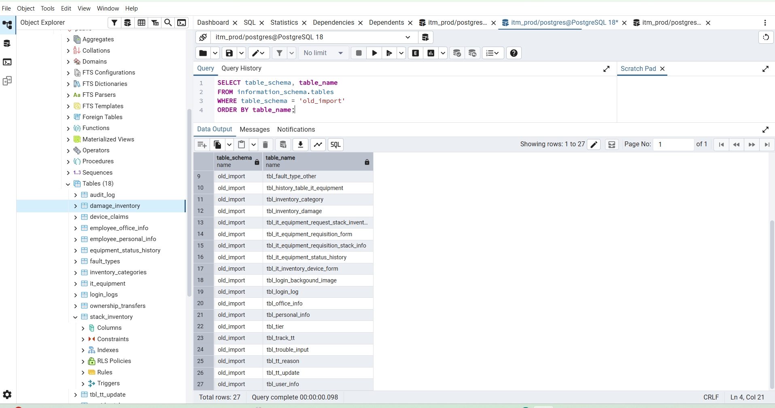

Total rows: 27
Query complete 00:00:00.098

Step 2: Count important old tables exactly
Run this:
SELECT 'tbl_personal_info' AS table_name, COUNT(*) FROM old_import.tbl_personal_info
UNION ALL SELECT 'tbl_office_info', COUNT(*) FROM old_import.tbl_office_info
UNION ALL SELECT 'tbl_it_equipment_requisition_form', COUNT(*) FROM old_import.tbl_it_equipment_requisition_form
UNION ALL SELECT 'tbl_it_equipment_requisition_stack_info', COUNT(*) FROM old_import.tbl_it_equipment_requisition_stack_info
UNION ALL SELECT 'tbl_it_equipment_request_stack_inventory', COUNT(*) FROM old_import.tbl_it_equipment_request_stack_inventory
UNION ALL SELECT 'tbl_it_equipment_status_history', COUNT(*) FROM old_import.tbl_it_equipment_status_history
UNION ALL SELECT 'tbl_trouble_input', COUNT(*) FROM old_import.tbl_trouble_input
UNION ALL SELECT 'tbl_track_tt', COUNT(*) FROM old_import.tbl_track_tt
UNION ALL SELECT 'tbl_device_claim', COUNT(*) FROM old_import.tbl_device_claim
UNION ALL SELECT 'tbl_inventory_damage', COUNT(*) FROM old_import.tbl_inventory_damage
UNION ALL SELECT 'tbl_device_warrenty_vendor_list', COUNT(*) FROM old_import.tbl_device_warrenty_vendor_list
UNION ALL SELECT 'tbl_device_ownership_transfer_form', COUNT(*) FROM old_import.tbl_device_ownership_transfer_form
UNION ALL SELECT 'tbl_inventory_category', COUNT(*) FROM old_import.tbl_inventory_category
UNION ALL SELECT 'tbl_fault_type1', COUNT(*) FROM old_import.tbl_fault_type1
ORDER BY table_name;

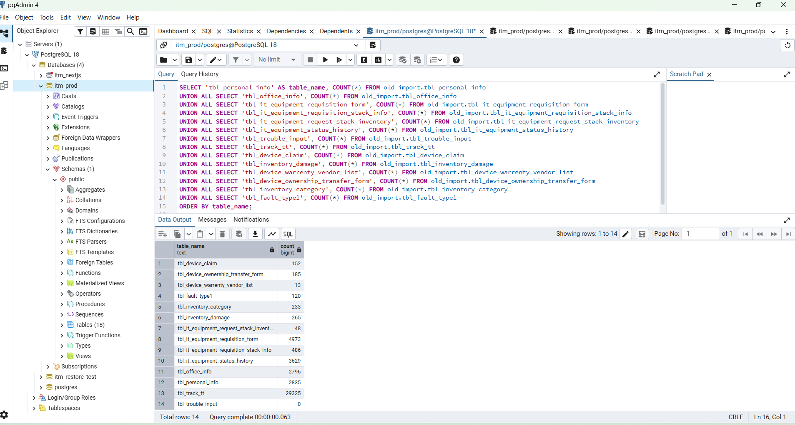

Total rows: 14
Query complete 00:00:00.063

Step 3: Check current app tables count
Run this:
SELECT 'public.users' AS table_name, COUNT(*) FROM public.users
UNION ALL SELECT 'public.employee_personal_info', COUNT(*) FROM public.employee_personal_info
UNION ALL SELECT 'public.employee_office_info', COUNT(*) FROM public.employee_office_info
UNION ALL SELECT 'public.it_equipment', COUNT(*) FROM public.it_equipment
UNION ALL SELECT 'public.stack_inventory', COUNT(*) FROM public.stack_inventory
UNION ALL SELECT 'public.equipment_status_history', COUNT(*) FROM public.equipment_status_history
UNION ALL SELECT 'public.trouble_tickets', COUNT(*) FROM public.trouble_tickets
UNION ALL SELECT 'public.tt_track', COUNT(*) FROM public.tt_track
UNION ALL SELECT 'public.device_claims', COUNT(*) FROM public.device_claims
UNION ALL SELECT 'public.damage_inventory', COUNT(*) FROM public.damage_inventory
UNION ALL SELECT 'public.warranty_vendors', COUNT(*) FROM public.warranty_vendors
UNION ALL SELECT 'public.ownership_transfers', COUNT(*) FROM public.ownership_transfers
UNION ALL SELECT 'public.inventory_categories', COUNT(*) FROM public.inventory_categories
UNION ALL SELECT 'public.fault_types', COUNT(*) FROM public.fault_types
ORDER BY table_name;

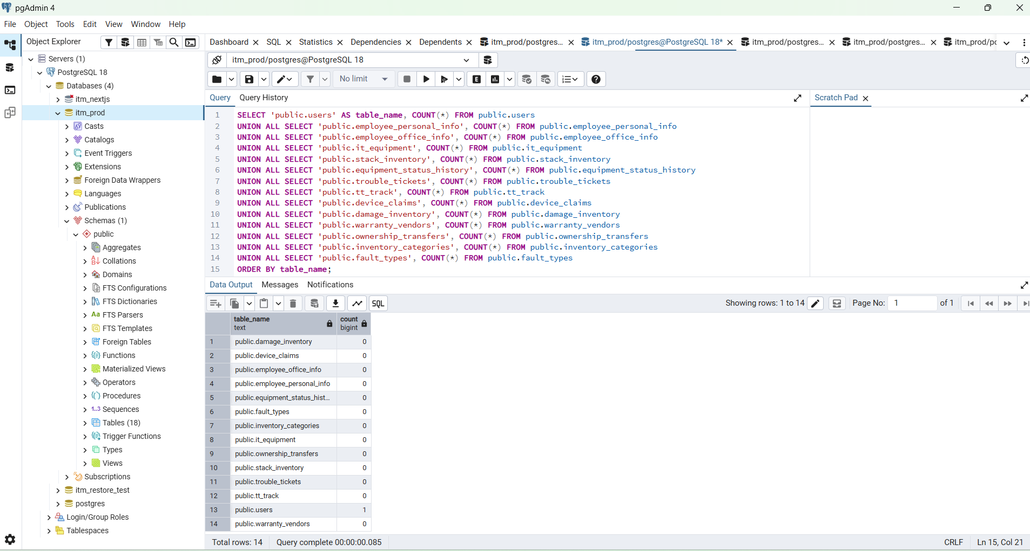

Step 4: Check columns for mapping
Run this query. It will show old table columns and current table columns side by side by schema.
SELECT
table_schema,
table_name,
ordinal_position,
column_name,
data_type
FROM information_schema.columns
WHERE
(table_schema = 'old_import' AND table_name IN (
'tbl_personal_info',
'tbl_office_info',
'tbl_it_equipment_requisition_form',
'tbl_it_equipment_requisition_stack_info',
'tbl_it_equipment_request_stack_inventory',
'tbl_it_equipment_status_history',
'tbl_trouble_input',
'tbl_track_tt',
'tbl_device_claim',
'tbl_inventory_damage',
'tbl_device_warrenty_vendor_list',
'tbl_device_ownership_transfer_form',
'tbl_inventory_category',
'tbl_fault_type1'
))
OR
(table_schema = 'public' AND table_name IN (
'employee_personal_info',
'employee_office_info',
'it_equipment',
'stack_inventory',
'equipment_status_history',
'trouble_tickets',
'tt_track',
'device_claims',
'damage_inventory',
'warranty_vendors',
'ownership_transfers',
'inventory_categories',
'fault_types'
))
ORDER BY table_schema, table_name, ordinal_position;

Mapping plan
We will move data like this:
old_import.tbl_personal_info → public.employee_personal_info
old_import.tbl_office_info → public.employee_office_info
old_import.tbl_inventory_category → public.inventory_categories
old_import.tbl_fault_type1 → public.fault_types
old_import.tbl_it_equipment_requisition_form → public.it_equipment
old_import.tbl_it_equipment_requisition_stack_info → public.stack_inventory
old_import.tbl_it_equipment_status_history → public.equipment_status_history
old_import.tbl_trouble_input → public.trouble_tickets
old_import.tbl_track_tt → public.tt_track
old_import.tbl_device_claim → public.device_claims
old_import.tbl_inventory_damage → public.damage_inventory
old_import.tbl_device_warrenty_vendor_list → public.warranty_vendors
old_import.tbl_device_ownership_transfer_form → public.ownership_transfers

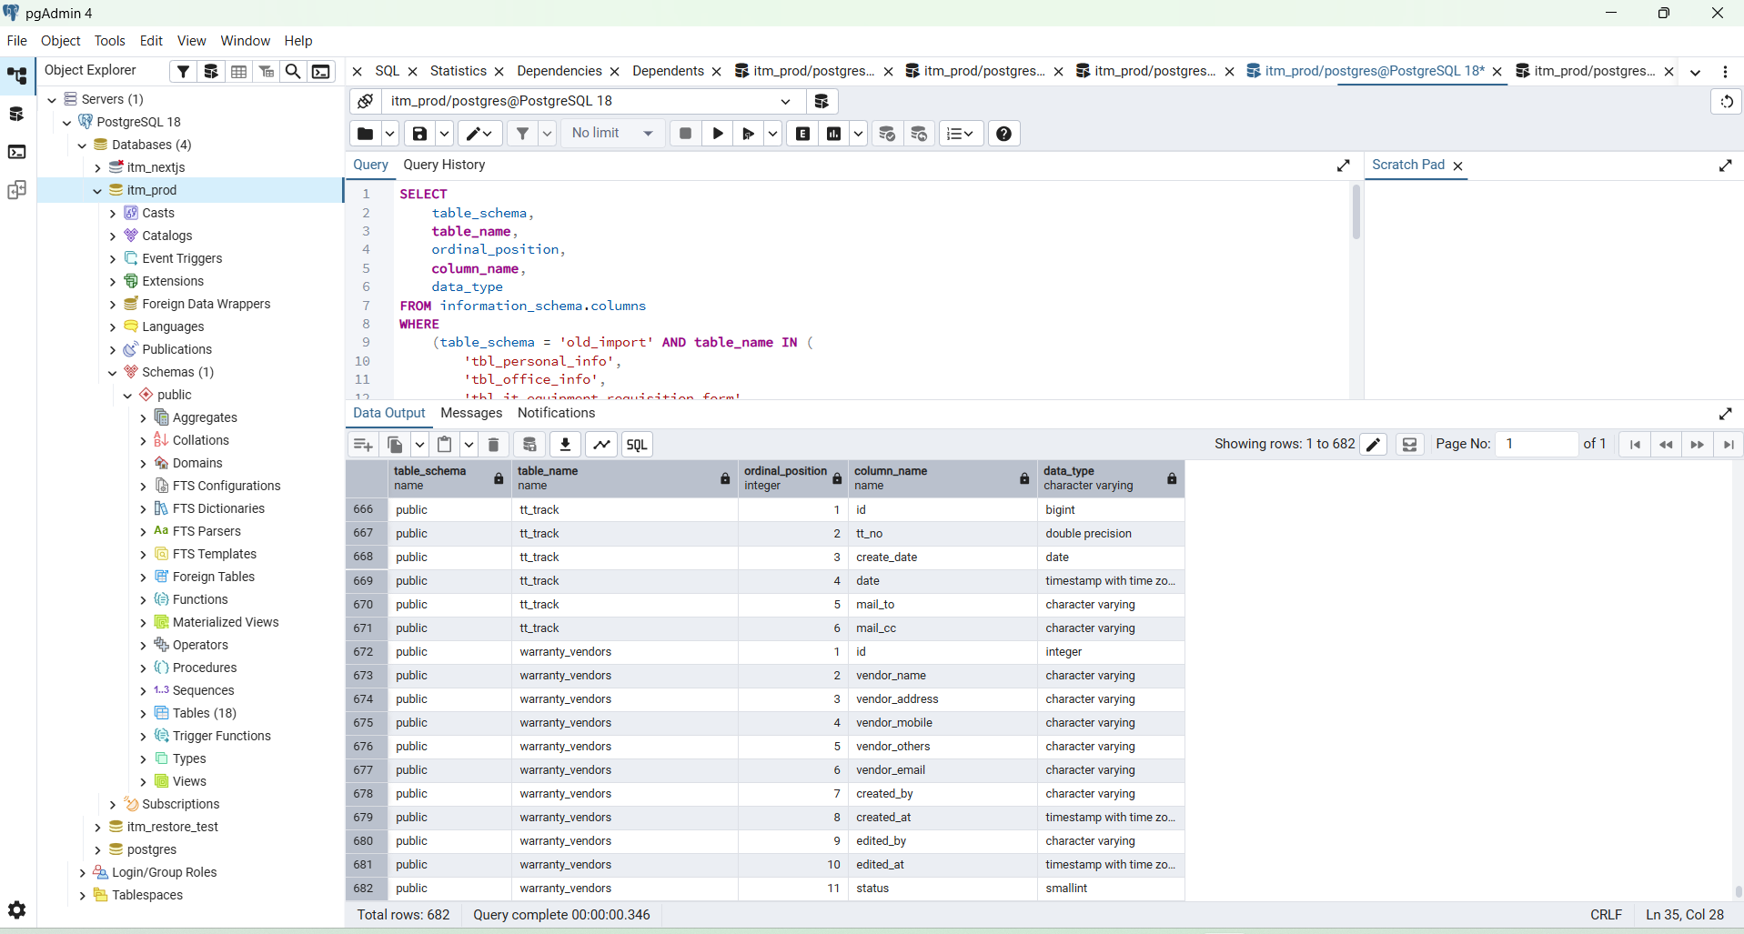

Do not import old user table into public.users now. Your current admin login must stay safe.
Send me the output of Step 2 and Step 4, then I’ll give you the exact INSERT INTO public... SELECT ... FROM old_import... SQL for each table.

